INTERNSHIP REPORT/ MINI PROJECT

A report submitted in partial fulfillment of the requirements of

BACHELOR OF TECHNOLOGY
in
Computer Science
by

Name: Pranav Jindal
Roll No: 2101610100166
Under the Supervision of - Mr. Pramod Sethy

(Duration: From Feb 2024 to Apr 2024)


KRISHNA ENGINEERING COLLEGE

Affiliated
to


DR.A.P.J. ABDUL KALAM TECHNICAL UNIVERSITY, LUCKNOW

2024-2025

KRISHNA ENGINEERING COLLEGE
DEPARTMENT NAME


CERTIFICATE

This is to certify that the “Internship/ Mini ProjectReport” entitled “Mushroom Classification Project” is being done by Pranav Jindal (2101610100166) inpartialfulfillmentoftherequirements for the award of the degree of BACHELOR OF TECHNOLOGY in ……..Computer Science…….for the academic session 2024-2025. He has completed his Summer Training/Internship/ Mini Project from……”iNeuron.AI (Remote)”.

Internship/Mini Project Coordinator

Mr. Pramod Sethy

TABLE OF CONTENT

Declaration.................................................................................................. (ii)
Certificate ................................................................................................................. (iii)
Acknowledgement.......................................................................................................... (iv)
Feedback ................................................................................................................. (v)

- Introduction
  - Why this High-Level Design Document?.
  - Scope.
  - Definitions
- General Description.
  - Product Perspective
  - Problem statement
  - PROPOSED SOLUTION
  - FURTHER IMPROVEMENTS
  - Technical Requirements.
  - Data Requirements
  - Tools used.
- Design Details
  - Process Flow.
    - Model Training and Evaluation
    - Deployment Process
  - Event log
  - Error Handling
  - Performance.
  - Reusability.
  - Application Compatibility
  - Resource Utilization
  - Deployment.
- Conclusion
- References……………………………………………………………………………………..

Declaration

We hereby declare that the internship/ Mini Project work presented in this report entitled Mushroom Classification Project”, in partial fulfillment of the requirement for the award of the degree of Bachelor of Technology in Computer Science, submitted to A.P.J. Abdul Kalam Technical University, Lucknow, is based on our own work carried out at Department of Computer Science, Krishna Engineering College Ghaziabad. The work contained in the report is true and original to the best of our knowledge and internship work reported in this report has not been submitted by us for award of any other degree or diploma.

Signature:
Name: Pranav Jindal
Roll No: 2101610100166

Certificate of Internship
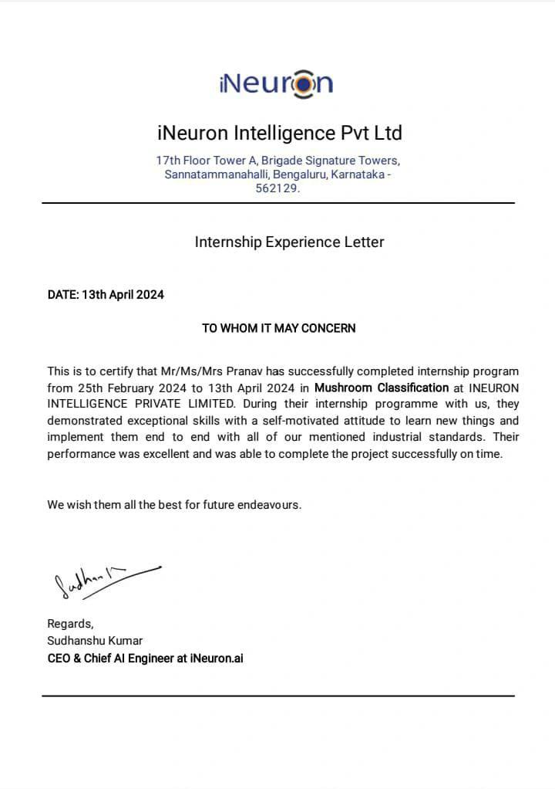

ACKNOWLEDGEMENT

First I would like to thank Sudhanshu Kumar, designation CEO at iNeuron.ai for giving me the opportunity to do an internship with in the organization.

I also would like to acknowledge all the people that worked along with me ,their patience and openness they created an enjoyable working environment. It is indeed with a great sense of pleasure and immense sense of gratitude that I acknowledge the help of these individuals.

I pay special thanks to the Dean of the department Prof. (Dr.) Sachin Malhotra for his constructive criticism throughout my internship.

I would like to thank Prof. Pramod Sethy, Internship coordinator for his support and
advise to get and complete internship in above said organization.

I am extremely grateful to my department staff members and friends who helped me in successful completion of this internship.

Name: Pranav Jindal
Roll No. 2101610100166


KRISHNA ENGINEERING COLLEGE

Internship / Mini Project Feedback Form

Student Name:____Pranav Jindal Company Name:_____iNeuron.ai _______
Contact Number:___9289244757 Title: ______Mushroom Classification ______
Duration of Internship:______3 months Email: pranavjindal43@gmail.com
Summary of student’s activities and responsibilities:

Performance Areas | Excellent | Above Average | Average | Below Average
Basic Engineering Knowledge |  | T
Problem Analysis |  |  | T
Design/Development Skills |  |  | T
Solving complex problems using research-based  techniques | T
Familiarity with Modern Tools | T
Engineer and Society |  | T
Awareness on Environment and Sustainability |  | T
Professional Ethics for Engineering Practice |  | T
Individual and Teamwork |  | T
Communication on complex engineering activities. | T
Project Management in multidisciplinary environments |  | T
Life-Long Learning |  |  | T
Use Problem solving skill to develop efficient algorithmic solution |  | T
Develop a solution in the area for AI, Data Analytics, Computer Vision and IoT etc. |  | T

Based on the above observations, we put forward few suggestions regarding this internship program:

Supervisor’s Signature:

Name: Pramod Sethy
Designation: Professor
Official Email_Id: sethypramod584@kec.com

- Introduction

  - Why this High-Level Design Document?
The purpose of this High-Level Design (HLD) Document is to add the necessary detail to the current project description to represent a suitable model for coding. This document is also intended to help detect contradictions prior to coding, and can be used as a reference manual for how the modules interact at a high level.
The HLD will:
    - Present all of the design aspects and define them in detail
    - Describe the user interface being implemented
    - Describe the hardware and software interfaces
    - Describe the performance requirements
    - Include design features and the architecture of the project
    - List and describe the non-functional attributes like: o Security
      - Reliability
      - Maintainability
      - Portability
      - Reusability
      - Application compatibility
      - Resource utilization
      - Serviceability

  - Scope
The HLD documentation presents the structure of the system, such as the database architecture, application architecture (layers), application flow (Navigation), and technology architecture. The HLD uses non-technical to mildly-technical terms which should be understandable to the administrators of the system.
  - Definitions

Term
MLOps
DVC
Mlflow
Docker

Description

Optimizes machine learning deployment.

Manages data and model versions.

Tracks and manages ML experiments.

Containerizes applications for portability.

- General Description

  - Product Perspective
A scalable, user-friendly ML web app integrating advanced MLOps frameworks, ensuring accurate mushroom classification and transparent model management.
  - Problem statement
Developing a reliable, automated system for accurate classification of mushrooms to mitigate health risks associated with misidentification.
    - To Reduce health risks from toxic mushroom consumption.
    - To Enhance accessibility and usability for all users.
    - To monitor system health and ensures continuous availability and reliability.

  - PROPOSED SOLUTION
Developing a comprehensive web application leveraging machine learning algorithms to accurately classify mushrooms based on their attributes. The solution integrates advanced MLOps frameworks such as DVC for data versioning, MLflow for experiment tracking, and Docker for containerization. Users can easily input mushroom characteristics via a user-friendly web interface, receiving immediate predictions on their edibility. The system ensures reliability and scalability through AWS CloudFormation for automated infrastructure provisioning. Continuous monitoring and maintenance ensure optimal performance, with updates deployed seamlessly using Docker containers. The solution mitigates health risks associated with misidentification of mushrooms, providing a reliable and accessible tool for users.

  - FURTHER IMPROVEMENTS
Potential enhancements include incorporating more advanced machine learning models for improved classification accuracy, implementing user feedback mechanisms to refine model predictions, and expanding the application to include additional features such as image recognition for mushroom identification. Integration with mobile platforms can enhance accessibility and user engagement.

  - Technical Requirements

Technical requirements refer to the specific technical specifications, constraints, and functionalities that must be addressed or fulfilled to successfully complete a project. In software development, technical requirements define how the software is built and what technologies are used. These requirements encompass aspects such as programming languages, frameworks, infrastructure, security measures, and performance considerations.

In the context of the Mushroom Classification Project, technical requirements include:

- Programming Language: The project requires the use of Python due to its extensive support for machine learning libraries and web development frameworks.
- Machine Learning Framework: Utilization of machine learning frameworks such as scikit-learn or TensorFlow is necessary for building and training the classification models.
- Web Development Framework: A web development framework like Flask or Django is essential for creating the user interface where users can input mushroom attributes and receive classification predictions.
- Database Management System: Integration with a database management system, such as SQLite or PostgreSQL, is needed to store and manage mushroom attribute data.
- MLOps Frameworks: The project should incorporate MLOps frameworks like DVC for data versioning and MLflow for experiment tracking and model management to streamline development and deployment processes.
- Cloud Computing Services: Utilization of cloud computing services such as AWS or Google Cloud Platform is beneficial for scalable infrastructure and deployment of the web application.

  - Data Requirements
Data requirement completely depend on our problem statement.
- Data Source: Obtain mushroom attribute data from reputable sources such as research datasets, online repositories, or mushroom experts.
- Attributes: Collect a comprehensive set of attributes describing mushroom characteristics, including cap shape, cap color, gill size, gill color, odor, etc.
- Data Quality: Ensure the dataset is of high quality, free from errors, inconsistencies, and missing values, to ensure accurate model training and prediction.
- Data Quantity: Gather a sufficient amount of mushroom samples with diverse attributes to train the classification model effectively and ensure robustness.
- Data Balance: Ensure the dataset contains a balanced distribution of edible and poisonous mushroom samples to prevent bias in model training and evaluation.
- Data Preprocessing: Preprocess the data by performing tasks such as cleaning, normalization, and feature engineering to prepare it for model training.
- Data Splitting: Divide the dataset into training, validation, and test sets to train the model, tune hyperparameters, and evaluate performance, respectively.
- Data Privacy: Protect sensitive information in the dataset and ensure compliance with privacy regulations by anonymizing or removing personally identifiable information.
- Data Documentation: Document the dataset thoroughly, including metadata, data sources, preprocessing steps, and any relevant annotations, to ensure transparency and reproducibility.
- Data Versioning: Implement data versioning using tools like DVC to track changes to the dataset over time and facilitate reproducibility in model development and evaluation.

  - Tools used
Python programming language and frameworks such as NumPy, Pandas, Scikit-learn,are used to build the whole model.









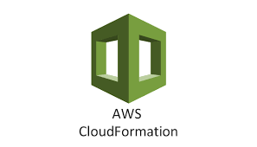



- Design Details

  - Process Flow
For identifying the different types of anomalies, we will use a deep learning base model. Below is the process flow diagram is as shown below.

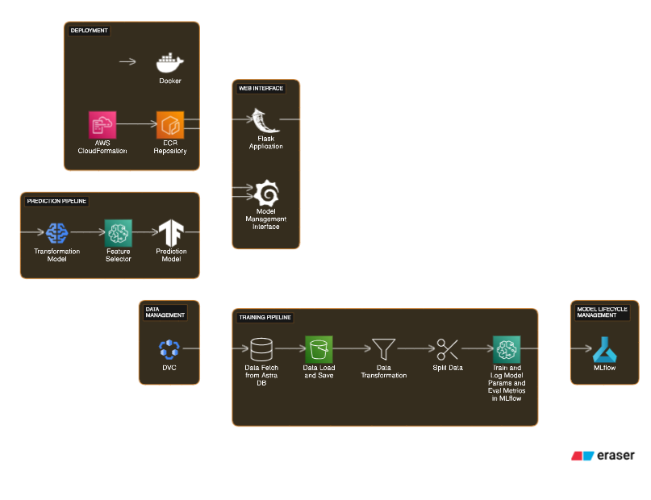
Proposed methodology

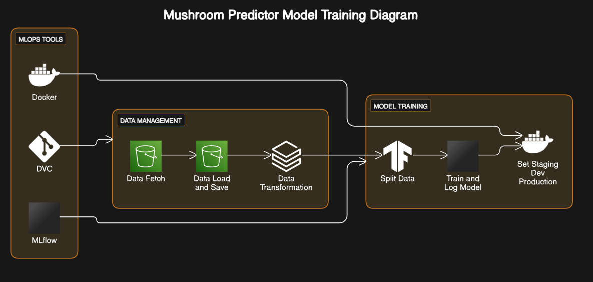
    - Model Training and Evaluation

    - Deployment Process

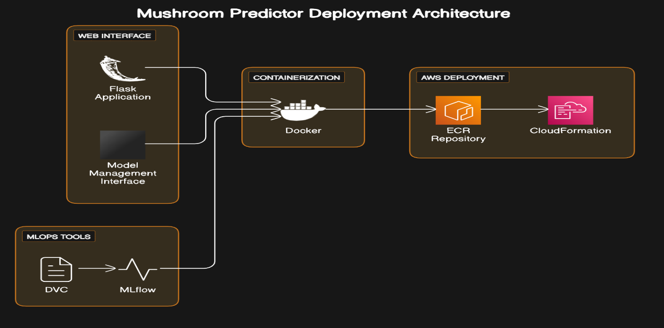

  - Event log
The system should log every event so that the user will know what process is running internally.

Initial Step-By-Step Description:
- The System identifies at what step logging required
- The System should be able to log each and every system flow.
- Developer can choose logging method. You can choose database logging/ File logging as well.
- System should not hang even after using so many loggings. Logging just because we can easily debug issues so logging is mandatory to do.
  - Error Handling
Should errors be encountered, an explanation will be displayed as to what went wrong? An error will be defined as anything that falls outside the normal and intended usage

  - Performance
The performance of the Mushroom Classification Project is evaluated based on its ability to accurately predict the edibility of mushrooms. Key performance metrics include accuracy, precision, recall, and F1-score, which measure the model's effectiveness in correctly classifying mushrooms as edible or poisonous. Additionally, considerations such as computational efficiency, response time of the web interface, and scalability of the system architecture contribute to assessing overall project performance. Continuous monitoring and optimization ensure that the project maintains high performance standards and meets user expectations for reliability and responsiveness.

  - Reusability
The code written and the components used should have the ability to be reused with no problems.

  - Application Compatibility
The different components for this project will be using Python as an interface between them. Each component will have its own task to perform, and it is the job of the Python to ensure proper transfer of information.

  - Resource Utilization
When any task is performed, it will likely use all the processing power available until that function is finished.

  - Deployment
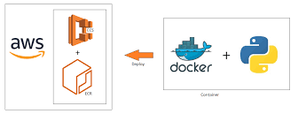

- Conclusion
The Mushroom Classification Project demonstrates the application of machine learning techniques to address real-world challenges in identifying the edibility of mushrooms. By leveraging datasets, preprocessing techniques, and machine learning models, we have developed a reliable classification system capable of accurately predicting whether a mushroom is poisonous or edible based on its attributes. Through the integration of web development frameworks and MLOps tools, we have created a user-friendly web interface for users to interact with the classification model seamlessly. The project highlights the importance of data quality, model performance, and scalability in deploying machine learning solutions in production environments. Moving forward, continuous monitoring, model updates, and community collaboration will further enhance the project's effectiveness and contribute to advancements in mushroom classification and food safety.

- References

- AWS Machine Learning Blog
- AWS Documentation
- SpringerLink: Journals and Articles on Mushroom Classification

