**NETWORKING OF HEALTH CARE SERVICES**

By Team Techie LifeSavers

HT-019

Team Members:

C. Pranav (Team Leader)

G. Sai Rathan

K. Srihari Sakshith

S. Sriraj

INDEX

1. Our Motive………………………………………………………………………...2
2. Introduction……………………………………………………………………….3
3. Features………………………………………………………………………………5
4. Benefits………………………………………………………………………………..6
5. Product Roadmap………………………………………………………………….7
6. Flow Chart on How The Platform Works…………………………………8
7. Website Demonstration…………………………………………………………..9
8. Website link……………………………………………………………………………15

Our Motive

* Generally, as we saw during the Covid-19 crisis, India does not have a good Medical Healthcare Network compared with rest of the world.
* In order to improve the emergency services, integration of some services should be made.
* In general, at some times, the hospitals have beds vacant, but no ambulances for patients. Some hospitals have ambulances, but no beds.
* Such necessary actions have no network in India. So, many times, emergency medical conditions are often becoming serious health concerns.
* A common platform is necessary and should be formed in which Hospitals and Medical colleges should register in such platform and share details of hospitals, ambulances, beds vacant, blood banks, etc in real time.
* This idea could avoid many rural deaths in India.
* NGO’s and volunteers should be able to access where ambulances are needed and should be able to give services with the platform.
* Also, the patient’s previous medical history should also be saved under his mobile number (Which acts as a personal unique ID), so that rural patients reports are accessed better at government hospitals or other private hospitals even if they miss their reports.
* This platform should also get connected to the patients Arogya-sri account or Health insurance. Then, emergency actions are handled hassle-free and faster patients treatment is ensured.

Introduction

* We designed a prototype website (MedForAll) to demonstrate how we can get medical services available to the needy person as soon as possible, without having to worry about the hospital having required medical facilities or not.
* This app will directly check whether the hospitals have the required medical facilities for treating that patient or not and take the patient to that hospital.
* The platform will note the persons medical condition and select ambulance available nearest to him and it will take him to the nearest hospital which can best treat his medical condition based on blood type, equipment required, surgeons’ availability etc.
* We will try to make it *inter-hospital platform* i.e., a hospital can get a patient from another hospital’s ambulance, making it safer and faster for patients’ treatment.
* We want to help the NGO’s and organizations reach out to the needy more easily with the help of our platform. The NGO’s can directly arrange ambulance services using our platform.
* A person will have a unique ID in this platform, all hospitals will share the medical info of the patients in this website. So that if any emergency this info can be used by the doctors to treat the person.
* We have thought of having our mobile number as ID as it is the easiest form of unique ID memorable by all.
* All the hospital’s locations and details will be provided in this platform, which helps the patients easy to access the information.
* In this platform, patients mobile number or Aadhar Number will be linked with the Patients medical info.
* If the patient is unconscious or his condition is critical, then we don’t know the ID of the person. In such cases others can directly give location and current condition in this platform which will help the ambulance to reach him take him to the necessary hospital.

Features

* Everyone can access MedForAll easily as they just have to register by their phone number or Aadhar Number.
* When they gets check their medical conditions, they can upload that information on this website.
* This will help the doctors to check the patient’s previous medical condition and treat the patient according to it.
* If the condition of the patient is very severe website will automatically suggest him to go to a hospital with more facilities.
* When an accident is happened in a place nearby people can share their location in this platform and share the condition of the victim in accident. Accordingly, the website messages the nearby hospital the medical condition of patient and sends the ambulance to take the patient to the hospital.
* As the patient is uploading the medical status of patient in website, he can take suggestions of other doctors by using that information.
* If the hospital given wrong details of hospital in website patients who taken treatment in that hospital can give feedback to improve the details of the hospital and that feedback may help other patients for their treatment.
* As the details of hospitals are given poor people can go to the hospitals according to the fee they can offer.
* As the ambulances are universalized, a common rate for usage of ambulances will be made.
* All the hospitals which are non-popular can get known to the patient while they are searching for nearby hospitals which will help the patient and the hospital to get more patients.

Benefits

* Till now, Healthcare has been a business only. Many of the hospitals have one or other problem. By making a common platform between them, many of the nursing homes and mid-tier hospitals as well as citizens get benefitted.
* In this platform, comparison between hospitals may takes place and comparing the costs of treatments, medicines, etc. People start going to hospitals which have better treatment and by this many Mid-Tier hospitals get improvised for better treatment of needy.
* Not only the real-time locations of the ambulances, but details of blood available and anti-venoms available are also shared in real-time on the app (MedForAll). Which helps the people to save time, which may save more lives.
* Whenever a person dials the emergency numbers, the ambulances should know which suitable place to take the person in the first place. Example, if patient loses a lot of blood, he is taken to the hospital which have reserves of required blood and which is nearer. Our solution to this problem can solve this and decrease the chance of mortality.
* There are some NGOs which want to give ambulance services, but they are not able to reach out to the patients. Our platform can be help them, as soon as they contact emergency numbers, then if NGO ambulances are available nearby, they are asked for help.

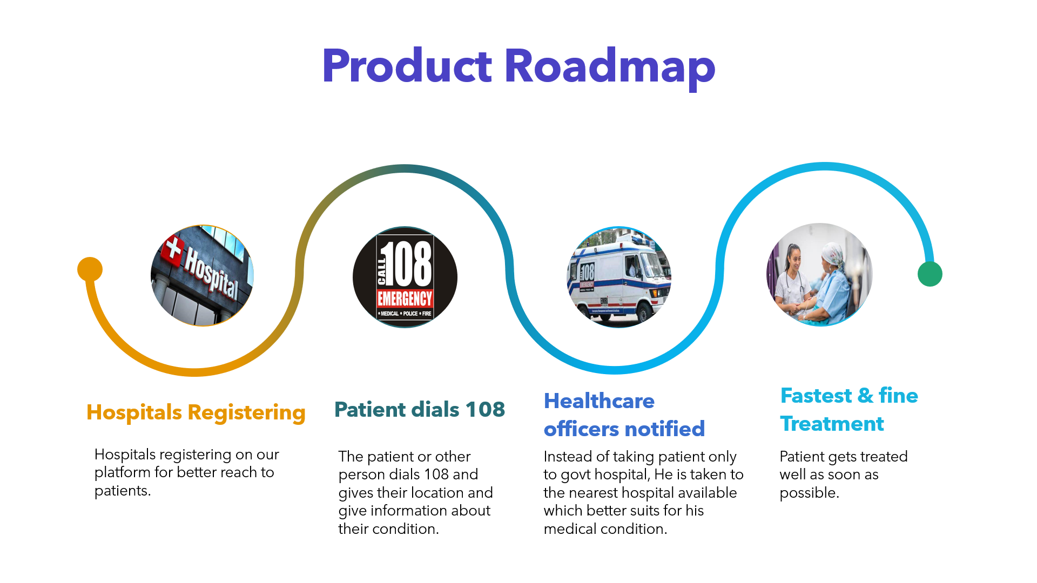

**Flowchart on how the platform works:**

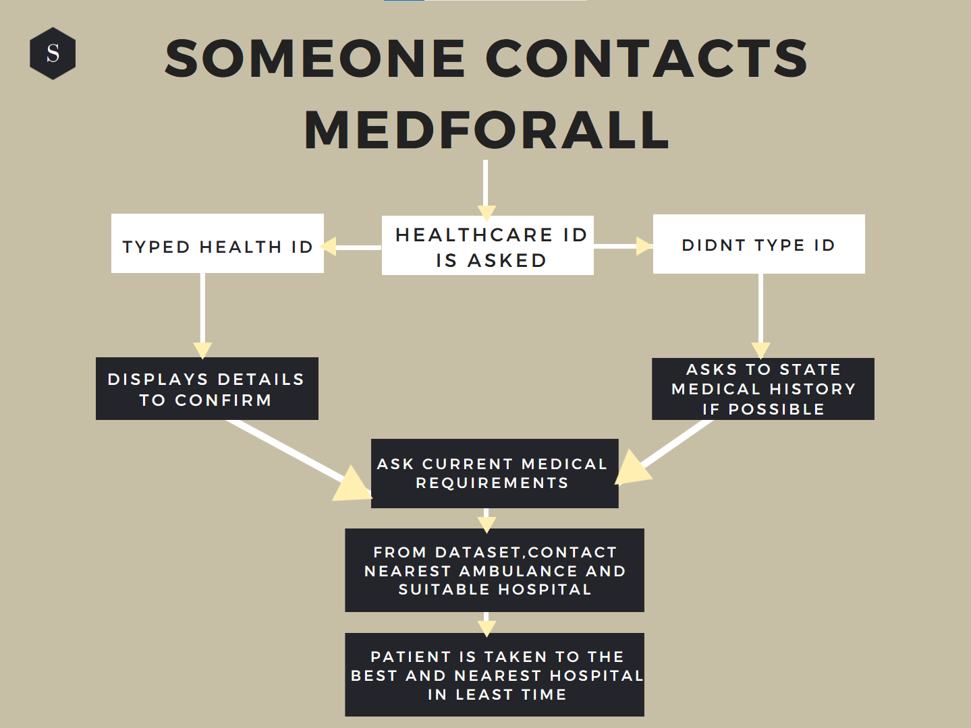

Website Demonstration:

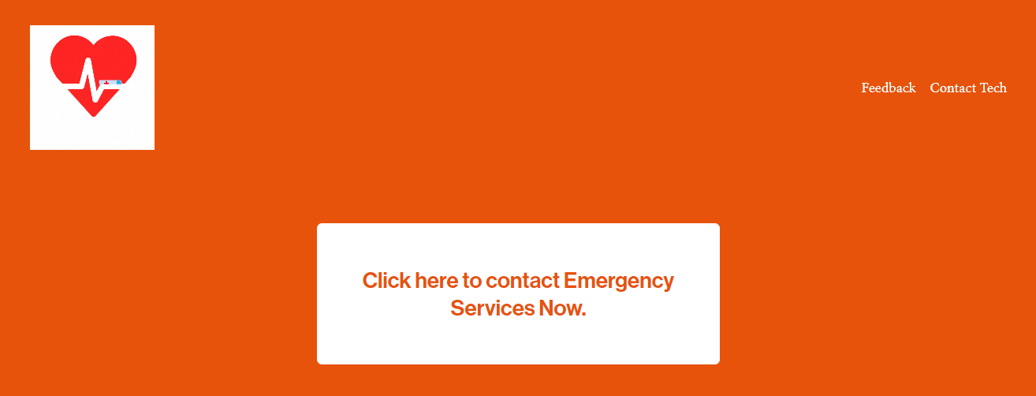

* This website is user friendly. Anyone can access this website with one click.
* When the user opens the website there will be an option for registration. The user can register by clicking on the option.
* The users Health ID mostly be his/her phone number or Aadhar number.
* The user can give his medical details for future use. Which will help the user when he concerns the doctor due to any health issue.
* In emergency, he can click on contact emergency services.



* Hospitals can share their details and information of their medical facilities by contacting the tech. For contacting the tech there is an option on the top right corner of the website.
* If there is any problem in the website they can give their feedback. There is an option for feedback at the top right corner of the website.

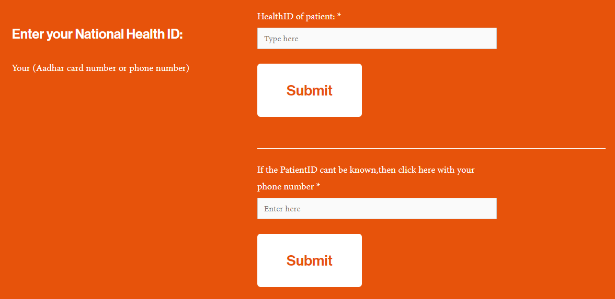

* After clicking on Contact emergency services, a page opens in which patient can enter is Health ID.
* If any person got with an accident and other person wants to contact emergency services, then he can enter his phone number by which his location gets shared.
* After entering any of the options click on submit for further details.
* For more emergency cases there is an option when we press on it directly emergency services will be contacted and their location will get shared to the emergency services.

* If you press on submit this page opens.
* In this page the persons details will appear. The person may confirm the information and go to the next step.
* If the emergency service is for the other person, then you can click on the option “If the details are wrong, click to proceed without details” to proceed for the next step.
* 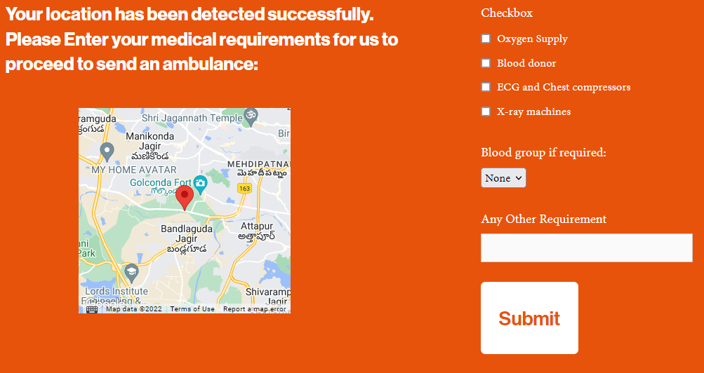Your location will be detected to send an ambulance and to find the nearby hospitals.
* You can tick what are medical facilities required depending on the medical condition of the patient.
* If there are any other requirements, you type it in the empty box.
* You can press on submit.

* Driver details will be displayed so that you can identify the driver.
* You can also see that how far the ambulance from you is.

* You will get the details of the hospital which will have the medical facilities which are required for the patient.
* Website will also display how far is the hospital from the location of the patient.

Our Website link:

The link to our website is <https://med-for-all.squarespace.com>

The password is “first”.

Please have a look and make sure you give us a feedback.