- Order Management Handling
- Orders are stored in MongoDB with a status field.
- Status changes are validated in backend APIs and persisted in the database.
- Frontend reflects updates using Redux for fast UI rendering.
- I use a dedicated backend route to fetch the resource by ID.
- The backend validates access and returns fresh data.
- Frontend state is only used as a cache, not the source of truth.

- Handling of relations without SQL
- I used MongoDB ObjectId references with populate for relational data, and snapshots for history.

- Rest API Design
- I designed REST APIs with clear request-response contracts.
- In the API of Order management, backend validates input, calculate pricing, persists orders, and controls status transitions.

- Independent from Frontend
- While placing order, I never trusted on frontend data, for price or status.
- Backend validates the pizza, calculates the total price, applies default order status, and persists the order.

- Lifecycle of order controller
  - Order status is updated via a dedicated API.
  - The order creation endpoint only initializes the order.
  - Subsequent lifecycle changes are controlled by backend logic and role-based routes.

- Javascript datatypes
- JavaScript has primitive and non-primitive data types.
- Primitives are stored by value, objects by reference.

- Individual product (order and pizza) and user
- I use a dedicated backend route to fetch the resource by ID.
- The backend validates access and returns fresh data.
- Frontend state is only used as a cache, not the source of truth.

- Order Management system
I implemented a secure order system in MERN stack where users can place, update, and cancel orders with full validation. Status transitions are controlled to prevent invalid states. I used dynamic total price calculation and ownership checks to prevent tampering. Admins have separate privileges, and we handle errors with consistent HTTP status codes. For production, I ensure DB efficiency by using populate, schema validation, and minimal queries.

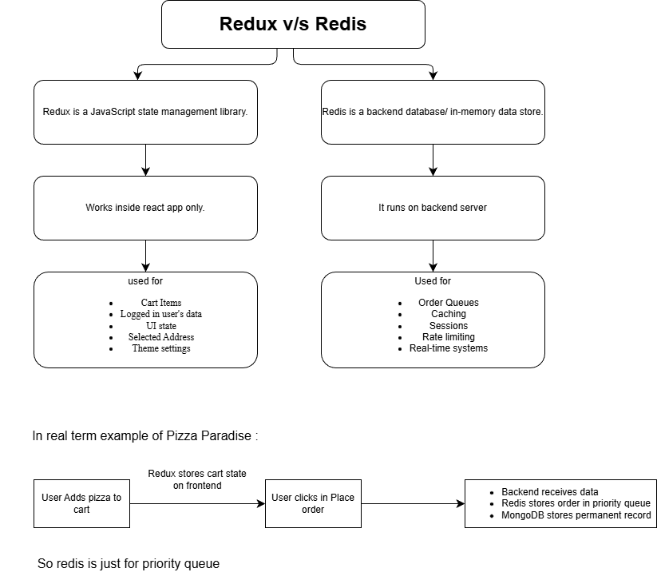
AI chatbot guide
- First built ui for it with below components:
- components/
- ChatAssistant/
- ChatWidget.jsx
- ChatMessage.jsx
- ChatInput.jsx
- Basic UI
- User Message
- AI Message
- Input Box
- Send Button

