\

>,s

: i&A

m m

flFSfosTCcf

**Certificate No.**

Certificate Issued Date Account Reference Unique Doc. Reference Purchased by Description of Document Property Description Consideration Price (Rs.)

First Party Second Party Stamp Duty Paid By Stamp Duty Amount(Rs.)

**INDIA NON JUDICIAL**

**Government of National Capital Territory of Delhi e-Stamp**

**IN-DL81534237273949N**

12-Nov-2015 01:49 PM

IMP ACC (IV)/ dl893603/ DELHI/ DL-DLH

SUBIN-DLDL89360361008889741032N

ABHISHEK MISRA

Article 5 General Agreement

Not Applicable

0

(Zero)

ABHISHEK MISRA MANIK THAPAR AND OTHERS ABHISHEK MISRA 100

(One Hundred only)



Please write or type below this line

**SHAREHOLDERS AGREEMENT**

This shareholders agreement (hereinafter referred to as the "Agreement") is entered into on this 17th day of November, 2015 at New Delhi.

**BY AND BETWEEN:**

*u*

Page 1 of 28



Statutory Alert:

1. The authenticity of this Stamp Certificate should be verified at “www.shciiestamp.com'. Any discrepancy in the details on this Certificate and as available on the website renders it invalid
2. The onus of checking the legitimacy is on the users of the certificate.

3. In case of any discrepancy piease inform the Competent Authority

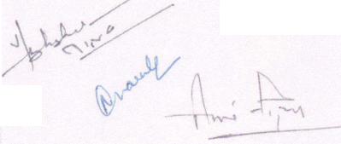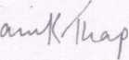

**MR. MANIK THAPAR s/o** Mr Anil tk,„ ...

110024 (hereinafter referred to as the "Mr which"8 * Defe0Ce C°l00y' NeW Delhi to the meaning and context thereof he He a expression shall unless it be repugnant administrators) of the FIRST PART- ^ t0 111630 a°d include his heirs. executors and

Delhi- 110024 (hereinafter nfenedZTs Sr 'which * ^ Defe"Ce C°l0My' NeW repugnant to the meaning and context thereof he H a exPresston shall unless it be

**executors and administrators) of the SECOND PART**;66"16 **\* ^ i0dUde h'S heirs'**

**AND**

Colony, New Delhi Fl“r; Maal'

**r-—-**

**AND**

Mwref"S * S'334' Pan!Cl,“' Park' *•» »

.0 Che meaning and context ZSta i^de hT" *

administrators) of the **FOURTH PART; 'S he'rS' executors antJ**

**M/s FCOWISE WASTE MANAGEMENT PRIVATE LIMITFO e n**

Under th, laws of India w.th its registered office at C « a , T?

nnn,, tk„ ... , icgiMerea orrice at C-92, Defence Colony, New Delhi

"Cornel l T Si8na,°ry Mr Manlk Tha|,ar (hereinafter referred to a, the

Company , which expression shall, on,ess repugnant to the contex, or meaning thereof

< an me n e us successors and permitted assigns) of the FIFTH PART

‘Compmys“ co'“vely be refarred “ - «*» — -

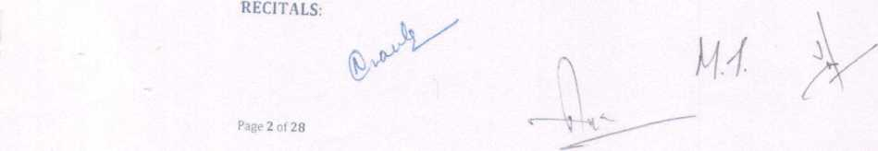

**T**

A. Whereas the Company is inter aha engaged in the business of collection, disposal recycling and management of waste and other purposes and as more specifically detailed in the Memorandum of Association of the Company.

13. Whereas MT is the chairman of the Company and holds fifty thousand (50000) Equity Shares in the Company equivalent to seventy five percent (50%) shareholding in the Company.

Whereas AT is an individual and holds twenty five thousand (25000) Equity Shares in the Company equivalent to 25% shareholding in the Company.

1. Whereas NIC is an individual and holds seventy five hundred (7500) Equity Shares in the Company equivalent to 7.5% shareholding in the Company.
2. Whereas AM is an individual and holds five hundred (7500) Equity Shares in the Company equivalent to 7.5% shareholding in the Company.
3. As on the date of this Agreement, the Company has an authorized share capital of INR 10,00,000 (Rupees Ten Lacs only), divided into One Lakh (1,00,000) Equity Shares of INR 10/- each, and a total issued and paid-up capital of INR 10,00,000 (Rupees Ten Lacs only), divided into One Lakh (1,00,000) Equity Shares of INR 10/- each.

That on the date of execution of this Agreement, the shareholding pattern of the Company as on date stands as below;

|  |  |  |  |
| --- | --- | --- | --- |
| S. No | NAME OF THE SHAREHOLDER | NUMBER OF SHARES HELD | PERCENTAGE OF SHARES |
| 1. | MR. MANIKTHAPAR | 50000 | 50% |
| 2. | MIL ANIL THAPAR | 25000 | 25% |
| 3. | MRS. NlDHi CHOPRA | 7500 | 7.5% |
| 4. | MR. ABHISHEKMISRA | 7500 | 7.5 % |
| 4. | MR. VINAY PARKASH 10000 | | 10% |

Whereas the Parties hereto, for themselves intend to set forth and record the terms and conditions on which they will regulate their relationship with each other so long as they are the Shareholders of the Company and to record their mutual rights and

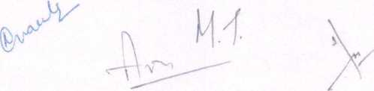

tt

obligations in relation to the operation, administration and management of the Company, and have decided to execute this Agreement.

**IT IS NOW AGREED BY AND BETWEEN THE PARTIES HERETO AS FOLLOWS:**

**1. ME1NU1Q.NS AND INTERPRETATION**

1.1 in this Agreement the following terms, to the extent not inconsistent with the context thereof, shall have the meanings assigned to them below:

Act shall mean the Indian Companies Act, 1956 and any amendments thereto or re-enactments thereof, from time to time.

Affiliate shall mean any Person that is, directly or indirectly, "controlling', "controlled" by, or under "common control" with, any such first referred Person and any officer, director or controlling Person of such Person; and a Person shall be deemed to be controlling" or in "control" of another Person if such first referred Person, alone or together with one or more of its Affiliates (a) owns, directly or indirectly, more than 50% (fifty percent) of the voting securities of such other Person, (b) has the right or power, directly or indirectly, to appoint a majority of the board of directors or other management body of such other Person, or (c) has the right or power, directly or indirectly, to direct or cause the creation of the management and policies of such other Person, whether through the ownership of voting securities, by contract or otherwise, and the term "common control" shall be construed accordingly;

"Agreement” shall mean this shareholders agreement and shall include the schedules, annexes and attachments hereto and as amended by the Parties in writing in accordance with the terms hereof.

"Applicable GAAP" in relation to the Company, means the generally accepted accounting practices in India and the accounting standards issued by the Institute of Chartered Accountants of India from time to time.

"Applicable Law(s)" shall mean all applicable statutes, ordinances, rules, by-laws, regulations, notifications, guidelines, policies, directions, judgments, directives and orders of any Governmental Authority.

“Board” or "Board of Directors" shall mean the board of directors of the Company appointed from time to time by the Parties in accordance with this Agreement, the memorandum of association, the articles of association and the Applicable Law.

**Page 4 of 28**

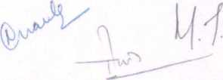

Page 5 of 28

Required be p,rformK| • ' £ «mm* accord,„g|y, Where ££

e—i

**Charter Documents" m**

==-:cr “■ a~

**"Confidential Information" shall**

business of any Party or a member Tthe gro ^ f M°rmation in respect of the prejudice to the generality of the foregoing anv id ^^ ^ lncludin& without information, prices, business, marketing Z , buS,’ness meth^S, financial customer lists or details, trade secrets t deVe,opment or manpower phns 10 *• ^rty, the

information has been disclosed; ' ' Customer or supplier whose

Deed of Adherence" shall m ,

out in Annoxnre B of ,h in f„„„

**"Director" shal, mean a director of the Company.**

Effective Date" shall be the date of signing of this Agreement "Equity Shares" shall mean a share oflNR 10/- each of the Company.

**Governmental Authority"** shall **mPan**

authority, statutory authority, government deLrernment ^ ^^Wnment P ibunal or court or other law, rule or regulation mTk" C°mmission' board,

to have iurisd,c,io„ „„ behalf of or Jr„Tl ha'"n* or P“n»rtln«

*:zz:::::izz u* — •—.

and other forms of intellectual or indus^af nj' H'8^5 °l ^ pui)lic'fy:

formulae, confidential or secret processes trad s °W h0W' ‘"ventions.

or assets and any licences and permission’in r any °ther protected rights

part of the world and whether or not registered6*'0" ther6With'in each and any -nod thereof, and al, extensions an" Il^t^td ^ "V* ^ ™

28 eor' and al1 applications for

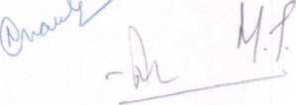

3.2

**Page 6 ol 28**

granted undernanylA^p]tiMbtri^wloran^heM^iirthewor,id;reC0^r,'Set* °P ma^ be

corporation, gonrtTpXmWpJ“nli™ted liabl"* “™Pony, association, court, tribunal asencv 27 P' ProPr'etorship, trust, union,

self-regulatory o^nizatioaT^Tlrt TT* 7*7™ , commission,

Shareholder" shall mean any Person holding shares in the Company;

assessments, levies and MhZZZZf"’ Z-13,*65’ dUt'eS' ^ preniiums- Governmental Authority, togeZr wfth a nZ WhatS°eV6r b> ^

or other additional amounts imposed in respect thereoT ^ l° **

this Agreement unless the context otherwise requires:-

1-2.1 reference to a Party hereunder shall include such PartVs

Permitted assigns and any persons deriving title under"; UCCeSS°rS>

12 2 *• supplemented or replaced from time to t mod,r,ed, varied, novated,

authorized t epresenLivesm ,1“”° "* " *™*» *•«' * *« **

:~;tr,rr - “• - ~ =«

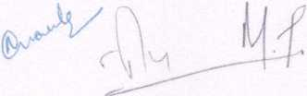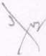

2**.**

2.1

2.2

2.4

2.5

1.2.7 This Agreement is the result of negotiations between

)y the Parties and their respective counsels. Acco

shall be deemed to be the product of the Parties

presumption that an ambiguity should be construed  
any Party solely as a result of such Party's actual

drafting of this Agreement.

filiSIN)E£g_OFTl|£ COMPANY

d i

isive

he business of the Company shall be to provide comprehen

services to residential, commercial and industrial entities by

managing and recycling the waste (hereinafter referred to as

the Charter Documents, the Company shall undertake such other

appioved by the Board from time to time.

It is agreed between the Parties that any and all the prese

licensed to the Company is owned by MT and has been licen  
it is agreed that any future Intellectual Property as creat

(including without limitation any improvements and/or

existing Intellectual Property of the Company) shall abs

Company at all times.

nt

ised

ed

2.3 Each Party shall utilize its expertise and competency a„

endeavors to promote and develop the Business of the Compa

nd use its reasonable

ny.

Subject to Applicable Law and to the extent consistent with

the objective of the Company will be to carry on the Business

teturns to the Company and profits available for distrib

maintaining high standards of quality for the long-term vim

I he Board shall be guided by, inter alia, this general statem

policy with respect to the business decisions of the Company.

The core responsibilities of MT will be as follows:

Managing and looking after the day to day functions  
Financial planning and investments:

Infusions of funds as and when required by the Compan

Participate in other core Business area of the Compa

Company

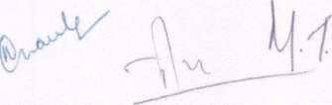

and has been reviewed

irdingly, this Agreement

nd there shall be no

n favour of or against

or alleged role in the

waste management

collecting, disposing,

Business"). Subject to

business as may be

ntellectual Property  
to the Company and

by the Shareholders

modifications to the

;olutely vest with the

good business practices,

to maximize financial

ution, consistent with  
billty of the Company,

ent when formulating

of the Company;

y;; and

ny as required by the



**Page 7 ol 28**

**2 6 The C0l e resPonsibilities of NC and AM will be as fo||ows.**

**• benorale business by way of strategic corporate alliances-**

— '~*eCo„pa„y:

Assistance in financial nhn„-

and P nin§and facilitating investm

**g investment for the Company;**

2.7

**Advisory 3rd strategic support From time to time**

Up..' ,

2.8

3.1

3.2

w time

requirements^thVr^ 35 ** bu$iness of the Con  
PaW-»P cap, JL Js°bTn?r iB «*

**k party debK ”s,u" \***

meet Hie additional fin h party debts or such dPhi y' h Cvent the

£r <sx:isrjs t r r - -

management of thp r eSP°nSlb,e for the overall direction a ! ' of Erectors

performance of the Company. The Board shall m^neri^ of ^

division of work and^' ^ 0rgani2ation structure of thcV ^ reV'eVV th°

Representatives shall «"«« the sJ^ZlT

Company from time m „■ d nd aPProved bv the Board r r, their

employment and oth 1 ' ^ to the Applicable Uw"l ^ of tbc

employees of the Com C°mpensation and benefits of the 53 dnes' terms of by Cbe Board. ' ***** “» per

**Board of Directors**

**Page 8 of**28

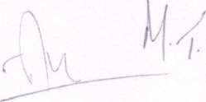

3.2.1

ApmDtouLaLandj^nimijimim^Qrs

CO

00

Currentthe^13oarld of the*com p anyc^6 °fminimUm of tw° (2) Directors  
AM shall he entitled to

Company whereby the Board of the Co P ntatIVe on the B°ard of the

'• - .ha, jz i zz::«7«*«"» pi

t'wh“h”«t £ ~

may ask f°r removal, substitution or recall for 8°'ng' 3 Shareho,de'- Directors recommended by such Shareh ih a^ reason' any of the bound by the direction of elva subs^ ^ be

requisite Shareholder who appointed teTV* in eve« *e Shareholder agrees to cooperate with the other Si C°nSe'U' Ead’

General Meeting of the Shareholders of the Ton areh° ders In convening a and to vote in favour thereof, if so required ^ ^ **** SUCh removai

Vacancy

°n the B°”4 —■ endeavour cause its '*'», and

appoint a replacement to hold office until ,h a hf ™tmB rlghts !0 as to Meeting. The failure to do so shall no eon ,, , “nual ^

prevent the exercise of such rioht ■ U 6 3 waiver ofsuch right nor shall it

individual who shall be nominated0^^6^' ^ VaCanCy shal1 be filled by an

nominated the appointment™! Z'ZZXT hold office up to the date on which the Director In! appointee shaJ'

would have held office if it had not h h P 3Ce 10 1S apb°inte(l

reappointment on the ellpiry of his office. ^ ^ W0Uld b* Sub^ to

**Board Meetings**

^:rr;-^~rrgo,,heSMrd“fD'---''

of 28

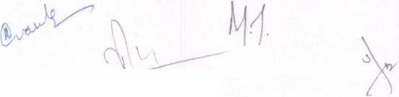

3.4.2. Minimum five (5] Business Days' notice of each meeting of the Directors shall be given to each Director entitled to attend and the notice shall be accompanied by an agenda and a board paper setting out in such reasonable detail as may be practicable in the circumstances the subject matter of the meeting.

1. J. Quorum for Board Meeting: Subject to the provisions of Applicable Law, the

Parties hereby agree that the quorum for a meeting of the Board of Directors of the Company shall be minimum two (2), provided that no valid quorum shall be ^ constituted without the presence of MT and/or his nominee. In the event that the required quorum as aforesaid is not present at a meeting, then the meeting of the Board shall be adjourned until the same day in the next week at the same time and place and if that day is a public holiday, until the next succeeding day which is not a public holiday and at such adjourned meeting directors present shall constitute a quorum provided that no decision regarding the Reserved Matters shall be taken in such meeting, unless approval in respect thereof has been obtained in writing from the Parties and that items which were not on the agenda for the original Board meeting shall not be considered at such adjourned meeting.

1. Provided that a quorum is constituted in accordance with Clause 3.4,3, the Parties agree as under:

save as otherwise provided under the Applicable Law, all resolutions of the Directors shall be decided by majority of the votes cast and each Director shall have one vote. In the case of an equality of votes, the chairman shall have a casting vote;

meetings of the Board of Directors will be held at least once in three calendar months;

(hi) No Reserved Matters specified under Annexure A, shall be taken up or . passed or resolved in any Board meeting unless the matter has been mutually approved by at least two (2) Directors wherein at least one of the directors is appointed by MT; and

(iv) subject to the Applicable Laws, the time and venue of a meeting of the Board of Directors will be determined by the Board of Directors

o.4.j. Resolution by Circulation: A resolution by circulation, in writing signed by a majority of the Directors shall, subject to the requirements of Applicable Law, constitute a valid decision of the Board, provided that a draft of such resolution was sent to all of the Directors at their usual address together with a copy of all

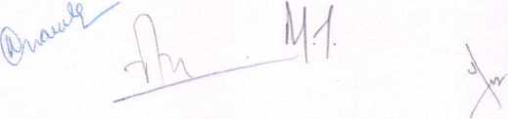

supporting papers, and provided fnrt-her t-umy i •

Reserved Matters shall not be passed as i Ut'°nS COntaininS any of the considered for adoption »y circolation. but will only „

agreed in writing by all the Directors8 ° * U"leSS otherwisc unanimously

3“ e -the cb™ - - «-*

of the l3oard and shall, subject to such s ^ SUperVISIOn' control and direction

Applicable Law, unless he vo,„„,ar„y l”e, e“"™» ^“ pi^0"

3 4 7' 2™ eaCh m"t,ns 0f the B“ard sha" * "PC" Signature by the

3'4'8, a^y a^d'nlf d^L^rke^by^SLd'in ^ riSht t0 or nullify

responsibilities entrusted in MT as D2 * ? iSi°n relates to: (a) core y/' fb) may lead to or cause loss ^0 reBu^ ? ^ 2'5 °f this dement; or ^ Company in any manner. P °r dcpreciatlon <n brand value of the

4' SHARLItQIJjj-RS' MRKTiMrx

41 Meetings

— --Actandtbehrttetesof designated in the Notice issued by the Cempanyt the ^^7 “*

4.2 **Quorum**

The quorum for a meeting of the Shareholders shall be minimum twn r21 i,

zzzzxzrr* ~ ” ™,,d — sm *—«»:

Shareholders meeting sha,ad.ZT* ‘* qU°rUm 35 af°reSaid iS "0t present'

date. If, however, a oulrumT If T* ^ ^ ^ fr0m the sa,d

Shareholders meeting such SharehTfT31 * Pr6Sent' in the adiourned ,. , ng’ such Shareholders meeting shall thereafter a„ain i

*m*

shareholders meeting unless the matter has been approved by all the Shareholder

Page 11 of 28

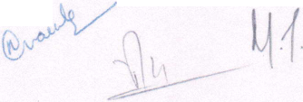

**4.3**

**Shareholder Voting Powers Resolutions**

**'* rSehouTr**"8 **of ,he *»»**

1. ti::‘za »«•*“*»«* «■

including, without limitation, to support the ann Pr°V'S10ns of this Agreement, appointment by the Parties. The Shareholders0"1 ofa Director proposed for cooperate with each other in thema”™ *T V ^ a"d U"dertal- Company at all times to exercise their voting ,mm,Stration a,,d affairs of the representatives or proxies who mav exercisp ^ °P C° CaUSL> their seParat(“ any Shareholders meeting hereunder in a "T* ^ °" their bdmlf. at comply with the provisions of hie a ^ that Shal) give effect to and

shall endeavour to ensure that every Shareh°lder (as applicablej

(as the case may be), while serving as a Direct PreSentatlve ofsuch Shareholder shall, in the performance of such duties 11 ^ repreSentative o{ the Company

diligence, s,and care ^Irld^r ^ ** «*"*«■ of

manner as coS^rtsonably'be exp'med V Shareh°'der in the ComPanV in such nghts in any manner which^d ^aSvP^nt Sha" "0t —ise those the Company of any of its obligations , / , LXpeCted t0 result ln a breach by imposed upon it under its Articles of a" 'S Agreement or any restrictions against the Company itself). ssocation (whether or not enforceable

S.l

5.2

5.3

Mli^GCRKSOl.llTinM

in accordance with claus^l^Tthe case” Matt6rS'^'* n°‘ approved written notice to the others that it regards a deadl Shareholder maV give

on,y one ——

ar,Werrshj;ts^:^r::“^rNrc",ch"ft-

understanding of the disarm™, > ■ memorandum stating its

ss s;r,::,:r rceof a — -

CO resolve the disagreement, the same shall be

V

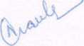

**i-**



**Page12 of 28**

6**.**

**V*'**

6.2

6.3

SHARP*;

and conditions set forth in this Agreement ThTc^ '" C°TPl'anCe Wlth the te™s its articles of association in according ’ >u ,C°mpany hereby a8rees to amend Agreement in a manner "hit no dLcr PrWided U"der this

Agreement and the provisions 00^0^“^"“” pr0vlslo”s »f this

to treatment of Shares or Otherwise. ' tlon of the Company with respect

Board ofDirect:^^:;r;nt;^rS-dthat ^ C°mpa"y and/°r thc the Shareholders (as provided under ZlnT^l^ Shareho,d,n« °f ^ resolution and/or restructuring the share capital of rh PaSS,"g a"y Spe.cial ^ through a board meeting or mho • P > the Company on its own or

Vinay Prakash. therw.se, save and except the shareholding of Mr.

A Shareholder may transfer its shareholding in tho r

Shareholder"), however, any Shareholder shall not transfer^ h^' "Sellin8 Company without first making an off • ansfer its shares in the

Shareholders (the "Other Shareholders^!"'t0 Se" the S3me to oth- Clause. Shareholders ) ,n accordance with the provisions of this

6.5

:ZZS <r 6sha"s,ate the- -»b.i«

•» ™cp;“ 7 rr r ■—«

for, p,,l„d of thirty (30) days from thy data o„he „ol (the'^OffefporMT °P'"

:: x xts shareh°J':::

Page 13 of 28

TT

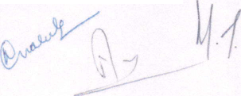

6.6

6.7

6.8

6.9

6.10

6.11

(30) days from the date of acceptance by the Intending Shareholder.

If the Selling Shareholder does not receive a notice from Other Shareholders in accordance with the provisions as provided herein stating that they are willing to purchase the Offer Shares, the rights of the Other Shareholders to purchase the Offer shares shall cease and Selling Shareholder may sell the Offer Shares to the third party at the same Offer Price and conditions.

Selling Shareholder shall not sell the Offer Shares to any third party:

1. for a purchase price less than the Offer Price; or
2. on terms more beneficial to the third party buyer than those set out in the notice to the Other Shareholders; or

(in) unless the third party has signed a deed of adherence to be bound by the terms of this Agreement and provided it to the Other Shareholders.

The Selling Shareholder must make available for inspection and review, a copy of any agreement with a third party buyer of the Offer Shares to the Other Shareholders not less than seven (7) business days before the sale to that buyer.

Any transfer to the third party pursuant to this clause must be completed within sixty (60) days following the expiry of the Offer Period, failing which the provisions ot this Agreement shall again apply to any proposed transfer of shares, and so on fiom time to time. Notwithstanding the foregoing, before consenting to any transfer of shares to the third party pursuant to the provisions of this clause, the Board shall be entitled to require proof that such transfer was completed at the price ar.d upon the othei terms and conditions contained in the third party offer.

Notwithstanding any of the provisions of this Agreement, in the event a shareholder intends (the "Selling Shareholder") to transfer all or any of its shares to a third party, it shall notify the other shareholders (the "Non-Selling Shareholders") of the details of such proposed sale and shall provide the Non-Selling Shareholders with a copy of the offer and acceptance documents. The Non Selling Shareholder shall have a right to participate in the proposed third party sale by providing written notice (the ' 1 ag-Along Notice") to the Selling Shareholder within fifteen (15) business days alter the date that the Non-Selling Shareholders receive the Third Party Sale Notice. II any Non-Selling Shareholder provides a timely Tag-Along Notice (a "Tag- Along Shareholder ), such Non-Selling Shareholder shall have the right to sell, at

Page Hof28

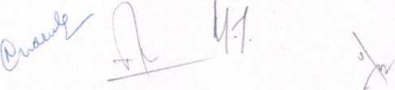

**rr**

>s are - * *

by the Non-Selling Sh.JIT* e ’

provided by a Non-Selling Shareholder'wi,3ueh fiftee'n "T “

**sr ","s - - <— - ■«\***

6.12 All acceptance notices or other

1 the Company

6-13 Any transfer of shares which is

to all Shareholders and to the r ^ Sha" be given “"currently

7.

7.1

8.1

PMMllIfrD TUAN.sfi.rc

shall be n^^»^n*.r^™^Sl^^d“^SJ^"h0,dC''

SLt ;:r ~ ~

Be»tl„„edshereh.lderMdt/beb^s^^Sa^t

Permitted Transferee pu ™To “hi’cLTe'tha, eha rehol d'er^h =,Sha ™h°l<,<ir >° » 7.2.1 not sell, transfer, assign, pledge, charge or in an, way dispose of or encumber

Its shares ofthe Permitted Transferee; °iorencumbe,

7'2'2 :r,U: tbe b0Und by a" lhe °bligations hereunder as if it continued to be S are 0|der of the Company and perform such obligations to the e en that the Permitted Transferee fails to do so; and

Shareholder ^ **'”*'** Sha1' re-transfer il shares “ such

Shareholder upon ceasing to be an affiliate of such Shareholder.

**COMEIBENTIALITV**

neTher ’<‘2”"* "**« * *• ^ N>. -Disclosing Party)

neither I arty nor any persons employed or retained by it shall disclose or mil l

available to any third party, any information concerning the terms of -1,1,

Agreement, or any confidential or proprietary materials to whfch I, may havet^

7.2.3

Page 15 of 28

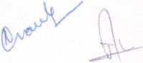

*ii*



**7-**

access, or any information or date concerning any aspect of the Disclosing Party or an affiliate of the Disclosing Party or their operations, existing or future business dealings, programming, or any other information regarding their services unless otherwise required to be disclosed by any laws, rules or regulations or stock exchange. Neither Party nor persons employed or retained by it shall make statements to the press or any media service regarding the other party, or its operations and activities without the other's prior written approval.

1. NO INDEPENDENT ANNOUNCEMENT, DECLARATION, DISCLOSURE OR PRESS STATEMENT:

In addition to the restrictions on the disclosure of Confidential Information, neither Party, their officers, employees, agents and representatives shall make any Announcements, declarations or other disclosures relating to their discussions, negotiations, and/or the terms of this Agreement or relationship created herein, or operations / business of the Company without prior written approval of the other party. For the purpose of this Agreement "Announcement" / "Disclosure" / Declaration" shall, inter alia, mean the disclosure to any person/s or entity/ies and/or public at large, by any means including, but not limited to, a press release- a written or oral statement made to the media, trades, publications or any other public audience or unauthorized third party: a written or oral statement published on website(s) or on another internet site or chat room and/or distributed by facsimile, email, voicemail, regular mail, private delivery service, newsletter and/or recorded message.

**9. IMM_AND TERMINATION**

1. This Agreement shall come into effect from the date of signing and shall remain in force until terminated in accordance with clause 9.2 below.
2. **Termination:**
3. Mutual Termination: If the Parties mutually agree to enter into a unanimous written agreement to terminate this Agreement or that the Company is wound up on mutually agreed terms and conditions including the distribution of assets of the Company and other consequences of termination.
4. **Termination on Default:**

(i) In the event that a Party (the "Defaulting Party") commits a material breach of this Agreement including its Affiliate (also a "Defaulting Party"), as the

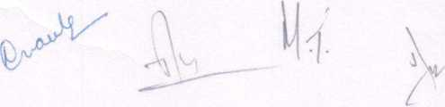

**Page** 16 **uf** 28

case may be, commits a material breach of any Agreement to which the

^faulting Party is a party, the other Party (the "Non Defaulting Party"!

may send written notice to the Defaulting Party notifying the breach

( Default Notice") and requesting the Defaulting Party to remedy such breach. J

" . 1 e Default,ng Party faiis ;,nd/°r refuses to remedy the breach notified to it

in the Default Notice within thirty (30) days from the date of receipt of the Lefault Notice (the "Remedy Period"), then the Non Defaulting Party may within thirty (30) days of the expiry of the Remedy Period, terminate this Agreement by delivering written notice to the Defaulting Partv (Termination Notice").

(hi) Nothing contained in this clause 9 shall affect the rights of the Parties in law, equity or otherwise. •

1. If any of the Parties commit any act of insolvency and/or the Company goes into iqui anon or dissolution or if the Company is placed in the hands of a receiver trustee, custodian or liquidator, or if a winding up petition is admitted against it’ then upon any Party giving written notice of termination, at the option of the Parties, this Agreement shall forthwith terminate.
2. **Consequences of Termination:**
3. In the event of termination of this Agreement, the Company shall have a right  
   to buy-back the shares of such Defaulting Party at par value.
4. Any proprietary information or materia! in which Intellectual Property rights  
   subsist, belonging to, or originating from a Party, shall be returned to it by  
   the Company, and the other Party or its Affiliate if the same is in its  
   possession or control.

(hi) Consequent to the termination of the Agreement, the constitution of the  
Board of Directors of the Company shall be modified in a manner wherein the  
Non Defaulting Party shall be entitled to remove the nominee director

appointed by the Defaulting Party from the Board of Directors of the  
Company.

(iv) Any termination of this Agreement shall be without prejudice to anv rights  
and obligations accrued or incurred prior to the date of such termination,

**10. MSIBICDONS ON THE PARTIES**

Page 1? of 28

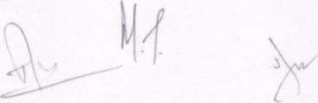

10.1

Page 18 of 28

The Parties have agreed and assured each nther n, ,  
full benefit of the goodwill of the Busing5f °fdyakje of^ Business and the  
covenants that neither Party nor any of its ' Tt ^ hereby Undertakes and  
(unless otherwise agreed in writing by the 0^^ H f? Shal1

the times specified below, shall: anc^ CornPanyJ, during

collecLtl^d^cTor rnd!™cd^e”LWhe?er "*"* indiVidually

P»r.ycan,on.or 1*engaged,c2ce“ed„rt“'s«d."JT”*"

rors“"t to this Agreement nor will L, c 1 f °n l,v ,he P»«<»  
such business or which may pre,„diCe l„t, ”,Tf hT“"’P")' S’r

Business as contemplated under this Agreement; V

**,au **r* - * ~ - »**«—**

B«.ea either „,,“s „™ heh,Z „yn Z'? '^""‘notion

(including as an employee, directly or Ind^”’' w “"P**

made, actiwty „ J , ' ““““ —W* «* the

involved pursuantthe *

(hj do or say anything which may lead to anv Pore

business with the Company o„ substantially the saTeZnw  
previously (or at all); or c me tei ms as

(il° With ”r Seek the cuslom of any person, endeavour to entice awav  
Date, does 'oTa^TnyTme" be™ ^ Wh°' * the Terminati°"

(iv) employ, engage or induce, or seek to induce m ia9 fL

Term,„a„„„ Date or a, any time before or a„er,hearer,ninatllt

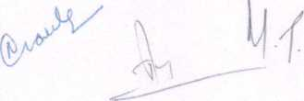

rr

10.3

10.4

(v)

shall have been employed in any capacity by the Company (including a director, officer or employee holding an executive or managerial position with the Company), or with whom it has had dealings prior to

or after the Termination Date pursuant to the terms of this Agreement; or

have any dealings with any person, firm or company who was a client customer, supplier, agent or distributor of the Company in relation to he Business before or after the Termination Date pursuant to the terms of this Agreement.

1. Each covenant in clause 10,1 is:
2. a separate undertaking by each Party and shall be enforceable by each Pnrtv separately and independently of its right to enforce any one or more of th'e covenants in clause 10.1;
3. given by each Party to the other and to the Company and apply to actions earned out by each Party (or any of its subsidiaries) in any capacity and whether directly or indirectly, on the party's (or subsidiary's) own behalf on behalf of any other person or jointly with any other person; and
4. considered fair and reasonable by the Parties. If any restriction is found to be unenforceable, but would be valid if any part of it were deleted, or the period or area of application reduced, the restriction shall apply with such modification as may be necessary to make it valid and effective.

The consideration for the undertakings contained in clause 10.1 is included in the  
agreed dividend sharing between the Parties.

If clause 10.1 is breached, the Parties agree that damages alone are not likely to be  
sufficient compensation, and that injunctive relief is reasonable and is likely to be  
essential to safeguard the interests of each of the Parties and the Shareholder and  
lhat injunctive relief (in addition to any other equitable remedies) may (subject to  
the discretion of the courts) be obtained:

10 4 1 andthe lleneflt °f thC Business and the Company (including its Shareholders);

10.4.2. regarding the duration, extent and application of each of the restrictions no  
greater than that are necessary for the protection of the interests of each of

the Party to this Agreement.

Page 19 of 28



**TT**

**ias “ •** r* **- - - -**

» undertake Business. ” « t', 7 Co “ K y rM,riCted fr0m Shareholder's ownership interest i„ ,he ComT “ 'reC,ly' trough such undertaking Business. C°mpany' restncted fr°" carrying on or

1 1 Alin it

111 The Company will maintain complete and accurate hr,«o

its affairs in a transparent manner Wh u i S' recorcis a,,d accounts of maintained at all times at the Comnanv' ■ °°kS', reCOrds and accounts will be place subject to approual of the Board f„accTd1" °' buS'n'ss " “"V oihcr - - *-—

1. ™'SXr»7rT„7

"“‘-vear. unless otherwise determined by the Board.

**IU rcmTd ™d "■*- - - \***

association of the Company and the Applicable Laws^”' W"h of

**1U aTuhJltCa°nTrep„rt ol 7,777',** ^ **ta* IB »“««ors**

statements w„, be prepared in accord^ “thTap'Z'b^p''

**1U rj; ~ws-—«» - -**

returns. purpose of filing estimated tax

12. iUVlDIiND

be mutually agreed between the Pnrtioe • , . P he ComPany as may

deduce,, of Les and extrairdil ' “ Fi™»»' Vear after the

that Financial Year. ' "em5 as shown ln the audited accounts for

12.2

Page 20 0128

Financial Year shall^^Twithm'ftfmen ns)7s'ofThe’d'"'"“T “ “y

audited accounts for that Financial Year are made up, °" "’l,lch

&

7

V



TT

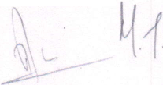

12.3

No dividend shall be declared and/or paid by the Company:

1. which is prohibited under any Applicable Law;
2. which would render the Company unable to pay its liabilities as and when they fall due;
3. the amount of which is reasonably required to be retained as prudent and proper reserves including an allowance for future working capital and capital investments required, such sum to be determined by the Board within three (3) months after the end of the relevant Financial Year;
4. the amount of which should be retained as proper provision for corporate tax or other tax liabilities or for other actual liabilities of the Company as determined by the Board.
5. Any distribution made under this clause 12 shall be made to the Parties in accordance with their proportionate shareholding in the Company.
6. **NOTICE**

Any notice to be served on any of the Party by the other will be considered sufficiently served if, delivered personally and acknowledgement is obtained or if sent via courier or registered acknowledgement post or via telegram to the respective addressee listed at the head of this Agreement. Any notice shall be deemed to have been validly received on the business date of receipt, if served personally or by courier or registered acknowledgement post or telegram.

1. **GOVERNING LAW**

I his Agreement shall be governed by and construed in accordance with laws of India. I he Parties hereby consent to exclusive jurisdiction of the courts at Delhi for any action, suit or proceeding arising out of or relating to this Agreement.

1. **Djymm RESOLUTION**

15.1 Negotiation. The Parties shall negotiate in good faith and use reasonable efforts to settle any dispute, difference or claim raised, arising out of or in connection with this Agreement including the construction, validity, execution, performance, termination or breach hereof (a "Dispute"). In the event that the Parties are unable to, within fifteen (15) days, to reach a resolution, such Dispute shall be settled by binding arbitrati

**Page 21 of 2 8**

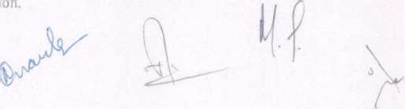

15.2

AlMiatmn The Dispute shall be referred to final and binding arbitration under  
Arbitration and Conciliation Act, 1996, as amended. Such arbitration shall be held in  
Delhi. All proceedings of such arbitration shall be in the English language. The  
arties shall mutually appoint one arbitrator. The award given by the sole arbitrator  
shall be final, conclusive and binding upon the Parties.

* 1. Interim Relief. Notwithstanding any other provision of this Agreement, any Party  
     shall be entitled to seek injunctive or other provisional relief from any court of

competent jurisdiction at Delhi pending the final decision or award of the arbitrators}.

1. **MD.EMN**1**TT**1**AND LIABILITY**
2. Notwithstanding anything contained herein, the Parties hereby undertake to indemnify and save harmless each other to the fullest extent possible from and against any and all actions, suits, claims, proceedings, orders, costs, damages, fines judgments, amounts to be paid, whether judicial, non-judicial or statutory from any person in nature relating to or arising as a result of any contravention of any laws statutory obligations, inaccuracy in or breach of duties and obligations' representations, warranties made herein by it/them.
3. It is specifically agreed to by the Parties that, without prejudice to the provisions of Clause 1(>.1 above, in case of any breach, misrepresentation or false information provided by NC and/or AM herein, NC and/or AM shall indemnify the other Parties towards the same.
4. The provisions of this Clause 16 shall survive any termination and/or expiry of this Agreement and shall also survive any clause of any other subsequent documents executed between the Parties, notwithstanding anything which may expressly or specifically supersede the provisions of this Agreement.
5. **ASSIGNMENT**

Save as otherwise provided herein, this Agreement shall be binding on and shall enure to the benefit of each Party s successors and permitted assigns, provided that neither Party shall assign any of its respective rights or obligations hereunder without the prior written consent of the other Party.

1. **REMT**1**DNSLLIP OI TIIE PARTIES**

Nothing herein shall constitute a partnership or employer-employee relationship between the Parties.

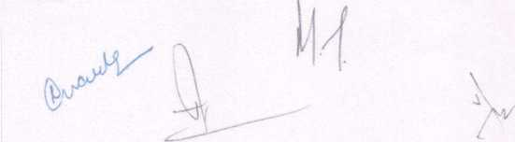

**19.**

WAMJt

Any term or condition of this Agreement may be waived at any time by the Party hat ,s entllled to the benefit thereof, but no such waiver shaii be effective unless forth in a written Instrument duly executed by or on behalf of the Party waiving

JureIT ^ WaiVer by either Party of any rieht hereunder or the’

xtrcise, or any delay in exercising a right or remedy provided by this

Agreement or by law, or the waiver of a breach by the other Party, shall not be

sucho.h' TVer °u a"y °ther rigHt hereunder or of any other breach or failure bv such other I arty whether of a similar nature or otherwise.

**20 COUNTERPARTS**

This Agreement may be executed in four (4) or more counterparts, and bv each 3i yon the same or different counterparts, but ail of such counterparts shall together constitute one and the same instrument.

21- AMENDMENT

This Agreement may only be amended, supplemented or modified  
an instrument in writing signed by the Parties.

by execution of

22. EMJ1M AGREEMENT

his Agreement, together with annexes and exhibits attached hereto, form an integral part of this Agreement. The Agreement together with all annexes and exhibits constitutes the entire agreement and understanding between the Parties with respect to the subject matter hereof and all prior agreements, understanding, promises and representations, whether written or oral, with respect thereto are superseded hereby. Each Party confirms that it is not relying on any representations or warranties of the other Party except as specifically set forth herein.

IN WITNESS WHEREOF the Parties have entered (or have caused their duly authorized representatives to enter) into this Agreement to come in force on the Effective Date.

|  |  |  |  |  |
| --- | --- | --- | --- | --- |
|  |  | u |  |  |
|  |  | | | r |

Signed and Delivered on behalf of the within named "MT" Name: Mr. Manik Thapar

**Page 2.1 of 28**

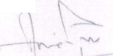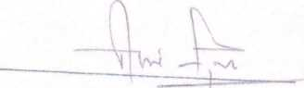

Signed and Delivered on behalf of the within named "AT" Name: Mr. Anil Thapar

Signed and Delivered by and on behalf of the within named "NC Name: Mrs. Nidhi Chopra

Signed anciDelivered on behalf of the within named "AM" Name: Mr. Abhishck Misra

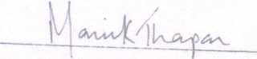

Signed and Delivered on behalf of the within named "Company' Name: Mr. Manik Thapar Title: Authorised Signatory

WITNESSES:

1.

2.

Page 24 of 28

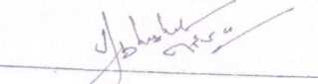

(i)

Oi)

(iii)

(iv)

(v)

(vi)

(vii)

(viii)

(ix)

(x)

(xi)

(xii)

**ANNEXUREA  
[RESERVED MATTERS]**

Any expenditure which is in excess oflNR 25,00,000-  
Transfer of all or substantially the whole of the Company's assets;

Appointment or removal of the statutory auditors of the Company;

Dissolution of the Company or filing for bankruptcy;

Declaration of dividends;

The introduction or any changes to the name, alias, logo or other branding or  
identity aspect of the Company; or oranamg or

Formation by the Company of any representative office, branch or subsidiary;

A change in the number of Directors;

Approving any capital or operating lease obligation in excess of INR 1,25,000/-, or  
such other amount as may be determined by the Board;

Lending from the Company's assets or in any way committing the Company to lend  
any of its assets;

Obtaining financing or otherwise borrowing in the Company's name or obligating  
the Company as guarantor, endorser, surety or otherwise pledging the credit of the  
Company in any way; and

Executing or cancelling any mortgage, security interest or similar document or  
mstrument purporting to encumber the real or personal property of the Company.



TT

**ANNEXURE B**

**Deed of Adherence  
[Format]**

I HIS DEED OF ADHERENCE Is made this day of

BETWEEN:

a company incorporated under the laws of India with its office at through its authorized signatory [ j or

an Indian

citizen, residing

at

(hereinafter referred to as the "Transferor", which expression shall, unless repugnant to the context or meaning thereof, mean and include its successors and permitted assigns) of the FIRST PART

' AND .

a company incorporated under the laws of India with its office at

through its authorized signatory | |

(hereinafter referred to as the "New Shareholder", which expression shall, unless repugnant to the context or meaning thereof, mean and include its successors and permitted assigns) of the SECOND PART;

**AND**

a company incorporated under the laws of India with its office at

through its authorized signatory [ |

(hereinafter referred to as the “Existing Shareholder", which expression shall, unless repugnant to the context or meaning thereof, mean and include its successors and permitted assigns) of the THIRD PART;

**AND**

a company incorporated under the laws of India with its office at

through its authorized signatory [ J

(hereinafter referred to as the "Company", which expression shall, unless repugnant to the context or meaning thereof, mean and include its successors and permitted assigns) of the FOURTH PART.

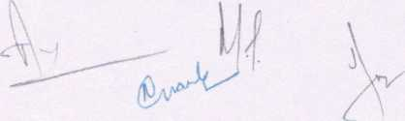

Th|s Deed 0^ Adherence is supplemental^ the Shareholders Agreement dated

—' v>J (3) .

**"Agreement") ^ ^ EC° ^ WaSte Managemem Private Limite**7**(o**7**o**

AND WITNESSES as follows:

bm n I h Tt'ltS W' SaCh °f the KXiSUng Shareh°'ders to observe, perform and be " f tSrmS ^ ** Agreement and the Articles of the Company which are

**e o,X:ps;gbto h e Ne:shareho,der to the intent ^ ^** ^**

Shareho der shall be deemed with effect from the date on which the New

Shareholder is registered as a member of the Company to be a "Party" to the Agreement ab initio, y mf'

2.

3.

4.

om

The New Shareholder hereby covenants that it shall do nothing that derogates fr  
the provisions of the Agreement or the Articles of the Company.

I his Deed shall be governed in all respects by the laws of India.

Capitahsed words and expressions used in this Deed of Adherence but not defined  
herein shall have the same meaning as in the Agreement.

EXECUTED as a deed on the day and year first hereinabove written

Signed and Delivered on behalf of the within named "Transferor"

Name:

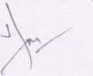

Page **27 of 28**

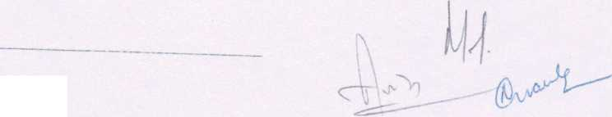

*m <mx*

Signed and Delivered by and on behalf of the within named "New Shareholder" Name:

Signed and Delivered on behalf of the within named "Existing Shareholder' Name:

Signed and Delivered on behalf of the within named "Company' Name:

Title:

**7**

