PROJECT ABSTRACT
Project Title: Campus-Trade – A Verified Student Marketplace, Academic Rental Hub, and College E-Commerce Platform
Project Group No.: 26 Number of Scholar(s): 3
Supervisor Name: Dr. Bhavesh Kataria
Abstract:
Campus-Trade is an institutional, authenticated student-to-student marketplace, academic rental hub, and university circular economy platform engineered specifically for the campus community of the Institute of Advanced Research (IAR), Gandhinagar. Within university ecosystems, students routinely acquire textbooks, laboratory coats, scientific calculators, drafters, electronic instruments, and academic notes that fall into disuse after end-semester evaluations. Simultaneously, junior and peer students require identical course resources at economical rates. Currently, students depend on informal WhatsApp chats and bulletin boards that lack authentication, search capabilities, fair pricing anchors, or physical safety guarantees. Campus-Trade resolves these challenges by delivering an authenticated, zero-commission, multi-vertical university web ecosystem.
The platform incorporates core verified capabilities: (1) Institutional domain and student ID verification (@iar.ac.in), (2) Temporary Academic Rental & Borrowing Deposit System with daily rental rates and refundable security deposit holding, (3) Academic Course Code & Semester Syllabus Tagging (CS201, BT204, MA101 across Semesters 1-8 and academic verticals: Core Textbooks, Lab Manuals, Solved PYQ Exam Papers, and Lecture Notes), (4) Campus Request & Peer Bounty Board for crowdsourcing urgent academic supplies with student rewards, (5) Senior Giveaway Hub facilitating ₹0 donations and eco-friendly cycle hand-downs, (6) Campus Lost & Found Registry featuring direct drag-and-drop photo uploads and recovery matching, (7) AI Fair-Price Suggestion Engine applying empirical 10% to 40% depreciation formulas based on physical wear and usage duration, (8) Campus Eco-Impact & Sustainability Dashboard tracking CO₂ emissions prevented, student money saved, and textbooks re-circulated, (9) Comprehensive Account Security with self-service Account Deactivation and permanent Account Deletion safeguards, and (10) Official College Event & Pass Management with automated delegate pass issuance.
The software architecture utilizes a Single Page Application (SPA) frontend developed with React.js (v18) and responsive Tailwind CSS (with universal dark/light mode and React ErrorBoundary protections). The backend server is built with Node.js and Express.js, interfacing with MongoDB Atlas via Mongoose ODM. Data protection is enforced via Bcrypt salted hashing, stateless JSON Web Tokens (JWT), and role-based route middleware. Campus-Trade creates an organized, transparent, safe, and sustainable circular student economy tailored to higher education institutions.
---------------------------------------------------------------------------------------------------------------------
Scholar(s) Details
Name of the Scholar: Pranav Jayswal — IAR/14665
Name of the Scholar: Moksh Desai — IAR/14666
Name of the Scholar: Ayush Yadav — IAR/14536
Signature of the Supervisor: __________________________
INDEX OF THE PROJECT REPORT (B. Tech CSE & IT SEM VII)
SR. NO. | CONTENTS | PAGE NO.
* | Acknowledgment | I
* | Abstract | II
* | Index of the project report | VI
* | List of Figures (if any) | VII
* | List of Tables (if any) | VIII
1 | ABOUT THE SYSTEM: | (1)
1.1 | Problem definition (Identification of needs): | 1
1.2 | Requirement Specifications (Product/System Tasks) | 2
1.3 | Tools and Technology Used (Front-End/Back-End/Framework/Protocol/API/Services/App. etc.). | 5
2 | SYSTEM DESIGN USING UML: | (7)
2.1 | Data Flow Diagrams (1 Level DFD, 2 Level DFD must). | 7
2.2 | Use Case Diagram. | 11
2.3 | Class Diagram. | 13
2.4 | Sequence Diagrams. | 15
3 | DATA DICTIONARY: | (17)
3.1 | Database tables SQL/NoSQL (Dimension if NoSQL used) | 17
4 | IMPLEMENTATION: | (21)
4.1 | Screen Layouts with validations. | 21
4.2 | Sample Coding (with Security tasks). | 32
4.3 | Steps of the execution Project and Navigation. | 36
5 | CONCLUSION: | (38)
5.1 | Importance of the worked-out tasks | 38
5.2 | Further Enhancement in future. | 39
6 | REFERENCES: | (40)
6.1 | Books, Research Papers, Experts persons, Technology, Webs, etc. | 40
Note: Here minimum pages are counted (Must be up to 40 to 50 pages, excluding Roman pages), further you can increase according to your requirements completion.
Project Coordinator: Head of the School
LIST OF FIGURES
FIGURE NO. | FIGURE TITLE | PAGE NO.
Figure 2.1 | Level-1 Data Flow Diagram (CampusTrade System Architecture) | 8
Figure 2.2 | Level-2 Data Flow Diagram (Detailed Functional Sub-processes) | 10
Figure 2.3 | Use Case Diagram for CampusTrade Platform | 12
Figure 2.4 | Class Diagram showing System Entities and Associations | 14
Figure 2.5 | Sequence Diagram for Authentication, Order Placement, Rentals & Notifications | 16
Figure 4.1 | Home Page Screen Layout with Verified Campus Spotlight & Eco-Dashboard | 21
Figure 4.2 | Shop / Product Catalog Screen Layout with Filter Controls & Academic Tags | 22
Figure 4.3 | Product Detail Screen Layout with Rental Deposit & Single Verified Call Seller Action | 23
Figure 4.4 | User Login (Sign In) Screen Layout | 24
Figure 4.5 | Student Registration Screen Layout with Institutional Validation | 25
Figure 4.6 | Shopping Cart Screen Layout with Rental Item & Security Deposit Breakdown | 26
Figure 4.7 | Campus Meeting & Trade Details Screen Layout with Schedule Picker | 27
Figure 4.8 | Product Listing Form Modal with Academic Syllabus Tagging & Course Codes | 28
Figure 4.9 | Campus Events, Fests & Department Campaigns Discovery Portal | 29
Figure 4.10 | User Profile Management with Academic ID, Passes & Account Danger Zone | 30
Figure 4.11 | Campus Request & Peer Bounty Board Layout for Academic Supplies | 31
Figure 4.12 | Campus Lost & Found Registry Layout with Drag & Drop Photo Upload | 31
Figure 4.13 | AI Fair-Price Suggestion Engine Interface with Usage Depreciation Valuation | 32
Figure 4.14 | My Orders Screen Layout showing Active Rentals, Deposit Status & Return Action | 32
LIST OF TABLES
TABLE NO. | TABLE TITLE | PAGE NO.
Table 1.1 | Tools and Technology Stack (Categorized by Architectural Layer) | 5
Table 3.1 | User Collection Schema (users) | 17
Table 3.2 | Product Collection Schema (products) with Rental & Syllabus Dimensions | 18
Table 3.3 | Order Collection Schema (orders) with Deposit Holding Parameters | 19
Table 3.4 | Campus Event & Campaign Collection Schema (events) | 19
Table 3.5 | Campus Bounty Request Collection Schema (bounty_requests) | 20
Table 3.6 | Campus Lost and Found Collection Schema (lost_and_founds) | 20
Table 4.1 | Product Detail Page Form Controls and Validation Rules | 23
Table 4.2 | User Login Page Form Fields and Validation Rules | 24
Table 4.3 | User Registration Page Form Fields and Validation Rules | 25
Table 4.4 | Cart and Campus Meeting Page Form Fields and Validation Rules | 27
Table 4.5 | Product Listing Form Fields and Academic Validation Rules | 28
Table 4.6 | User Profile Management and Danger Zone Validation Rules | 30
Table 4.7 | Campus Event RSVP & Ticket Reservation Validation Rules | 33
Table 4.8 | Admin / HOD Event Creation Form Validation Rules | 33
Table 4.9 | Campus Request & Peer Bounty Board Validation Rules | 34
Table 4.10 | Campus Lost and Found Form Fields & Upload Constraints | 34
Table 4.11 | AI Fair-Price Suggestion Engine Valuation Parameters & Reduction Bounds | 35
1. ABOUT THE SYSTEM
1.1 PROBLEM DEFINITION (IDENTIFICATION OF NEEDS):
1.1.1 Problem Definition
In higher education institutions such as the Institute of Advanced Research (IAR), Gandhinagar, students frequently acquire textbooks, scientific calculators, laboratory coats, electronics, engineering drawing instruments, and dorm necessities. At the conclusion of a semester or academic year, a substantial portion of these items remains in prime working condition but falls into disuse as students advance to higher coursework or graduate. Simultaneously, newly enrolled juniors and continuing students require identical educational materials at affordable price points.
Presently, university students predominantly depend on informal, decentralized communication channels such as peer WhatsApp groups, Telegram channels, and social media classifieds to initiate buy-and-sell interactions. These informal channels present severe operational limitations:
• Lack of Identity Verification: Group memberships are unrestricted and unauthenticated, exposing students to external scammers, fraudulent payment requests, and non-genuine buyers.
• Poor Discoverability and Message Dilution: Product listings in chat feeds are rapidly buried by general chatter within hours, preventing structured search, price benchmarking, or condition assessment.
• Disorganized Campus Meetups: Commercial public marketplaces (such as OLX or Quikr) lack institutional awareness and force students into off-campus transactions with strangers, introducing personal safety concerns.
• Absence of Rental & Borrowing Support: Students enrolled in single-semester courses often require expensive items (such as engineering drafters, lab aprons, or graphic calculators) for only a few weeks or months. Informal channels force them to purchase items at full price without rental options.
• Lack of Academic Syllabus Tagging: Students struggle to find exact syllabus-relevant items because listings lack departmental tags, semester numbers, and course codes (e.g. CS201, BT204).
• Unregulated and Unfair Second-hand Pricing: Sellers frequently overcharge peers or struggle to price used goods equitably without an objective market baseline.
• Absence of Campus Lost & Found: Lost student items (calculators, lab manuals, keys) are reported across fragmented chat rooms with low recovery rates and no centralized registry.
1.1.2 Identification of Needs
A thorough requirements analysis of university campus stakeholders identifies the following essential functional needs:
A. Student & Campus Member Needs:
1. Institutional Student Verification: Authentication restricted to genuine college members utilizing institutional emails (@iar.ac.in) and verified student enrollment numbers.
2. Academic Rental & Deposit System: Flexible rental durations (daily rates) with safe refundable security deposits to enable low-cost borrowing for short-term academic modules.
3. Course Code & Syllabus Tagging: Granular categorization by Academic Type (Core Textbook, Reference Manual, Lab Manual, Solved PYQs, Lecture Notes), Department, Semester (Sem 1-8), and Course Code.
4. Campus Request & Bounty Board: Open board allowing students to post urgent resource requests with peer rewards and needed-by deadlines.
5. Senior Giveaway Hub: Dedicated ₹0 donation listings enabling graduating seniors to pass down cycles, books, and lab coats to juniors.
6. Campus Lost & Found Registry: Interactive portal for reporting lost or recovered items with direct image drag-and-drop and recovery contact.
7. AI Fair-Price Suggestion Engine: Intelligent price guidance computing 10%–40% condition-based reductions against original purchase costs.
8. Direct Handover & Meeting Scheduling: On-campus handover time coordination with seller telephone contact to ensure transparent physical inspection.
9. Eco-Impact Dashboard & Account Controls: Real-time CO2 savings metrics and self-service account deactivation/deletion in profile settings.
B. College Administration & Department Needs:
1. Official College Merchandise Store: Centralized sales of university lab uniforms, stationery, and institutional supplies.
2. Campus Events & Campaign Management: Allowing Department Heads to publish symposiums, hackathons, and cultural fests with attendee limits.
3. Multi-tier Ticket & Pass Issuance: Supporting free student RSVP passes, paid event tickets, and external portal redirects with digital pass codes.
4. Role-Based Moderation: Administrative portal to supervise listings, manage event attendee rosters, and moderate campus boards.
1.2 REQUIREMENT SPECIFICATIONS (PRODUCT/SYSTEM TASKS)
1.2.1 Product and System Tasks (Functional Requirements)
The CampusTrade software platform is partitioned into discrete task modules based on user roles and system workflows:
1. User Authentication & Account Security Tasks:
• Secure student registration requiring Full Name, institutional email (@iar.ac.in), phone number, and password (minimum 6 characters).
• Binding with student enrollment ID (e.g., IAR/14665) or faculty staff code.
• Stateless session management utilizing signed JSON Web Tokens (JWT) stored securely in client storage.
• Self-service Account Deactivation: Temporarily freezes account and conceals active listings from campus marketplace.
• Permanent Account Deletion: Irreversible purge of student credentials, reviews, and listings requiring safety 'DELETE' confirmation text.
2. Student Marketplace, Rentals & Giveaways Tasks:
• Multi-mode listings: Standard Purchase ('buy'), Academic Rental ('rent'), and Free Senior Giveaway ('giveaway').
• Rental management: Daily rental rate calculation, customizable duration, security deposit holding, and deposit refund upon return.
• Senior Giveaway Hub: ₹0 claim price to pass down cycles, lab coats, and revision materials to incoming juniors.
• Direct peer-to-peer phone call button to connect verified buyers and sellers.
3. Academic Resources & Course Tagging Tasks:
• Classification into Academic Verticals: Core Textbooks, Reference Manuals, Lab Manuals, Solved PYQs, and Lecture Notes.
• Granular tagging by Department (Biotechnology, CSE, Chemical, etc.), Semester (1-8), and Course Code (e.g. CS201, MA101).
• Dedicated study resources hub for past examination solutions and practical manuals.
4. Campus Request / Bounty Board Tasks:
• Student posting of academic requests with bounty rewards in INR (₹) and needed-by deadlines.
• Optional course code tagging for curriculum-specific requests.
• Peer matching and status tracking (open vs fulfilled).
5. Campus Lost & Found Registry Tasks:
• Reporting of lost and found campus belongings categorized by type and location.
• Instant drag-and-drop / direct photo uploads for immediate item identification.
• Status toggling (active vs claimed/recovered) with finder phone contact.
6. AI Fair-Price Suggestion Engine Tasks:
• Dynamic valuation assistant computing fair resale prices based on original retail cost and physical condition.
• Condition reduction scaling: 10% for Brand New, 20% for Like New, 30% for Good, 40% for Fair condition.
• Usage duration factor to prevent overcharging junior students.
7. Campus Eco-Impact & Sustainability Dashboard Tasks:
• Real-time aggregation of environmental and economic metrics on homepage.
• Tracking of CO2 emissions prevented (kg), textbooks re-circulated, money saved by students (₹), and e-waste diverted.
8. Order Processing & Trade Scheduling Tasks:
• Persistent cart synchronization with rental duration modifiers and security deposit breakdown.
• Structured on-campus meetup scheduling with specific venue (Library, Canteen, Block A) and trade time.
• Automated 4-digit handover verification OTP and deposit status tracking (held, refunded, claimed).
9. Campus Event & Campaign Management Tasks:
• Departmental event publishing with attendee capacity limits and categorized tags.
• Support for Free Student RSVP passes, Paid Ticket sales, and External Portals (Unstop / Google Forms).
• Automated digital entry pass generation with unique alphanumeric pass codes (IAR-PASS-XXXX).
10. Administrative Control Tasks:
• Protected administrative dashboard restricted to users with admin roles.
• Moderation tools to review, update, or purge listings, orders, and event attendee records.
1.2.2 Non-Functional Requirements
• Security: Industry-standard Bcrypt algorithm utilized with salt hashing for password protection. JSON Web Tokens (JWT) cryptographically signed. Cross-Site Scripting (XSS) and injection mitigation via Mongoose parameterized queries.
• Performance: Single-Page Application (SPA) architecture bundled using Vite for rapid cold-start and sub-second page transitions. Backend APIs engineered for low latency with sub-100ms response times for catalog queries.
• Usability & Ergonomics: Intuitive interface designed using Tailwind CSS utility styling with full dark/light theme adaptability. Visual feedback provided via interactive toast notifications, modal confirmations, and skeleton loading states.
• Resilience & Error Handling: React ErrorBoundary tree wrapper prevents unhandled rendering exceptions from crashing the application or corrupting navigation history.
• Scalability: Modular Model-View-Controller (MVC) server organization with decoupled Express route handlers. Cloud database clustering on MongoDB Atlas supporting seamless scaling.
• Cross-Device Compatibility: Responsive layouts adapting to mobile screens (320px+), tablets (768px+), and wide desktop monitors (1280px+). Validated on Chrome, Edge, Safari, and Firefox.
1.2.3 System Environment & Minimum Specifications
A. Hardware Requirements:
• Client Machine: PC, Laptop, or Smartphone with Dual-Core 1.6 GHz Processor or higher, minimum 2 GB RAM (4 GB recommended), and active internet connectivity.
• Development / Server Machine: Quad-Core 2.4 GHz Processor, 8 GB RAM, 20 GB available solid-state storage.
B. Software Requirements:
• Operating System: Windows 10/11, Ubuntu Linux 20.04+, or macOS Sonoma.
• Runtime Environment: Node.js (v18.x or v20.x LTS) with NPM package manager.
• Database Management: MongoDB Community Server (v6.0+) or MongoDB Atlas Cloud Cluster.
• Client Web Browser: Google Chrome (v100+), Microsoft Edge (v100+), Mozilla Firefox (v98+), or Apple Safari (v15+).
• Development Tools: Visual Studio Code, Git Version Control, Postman API Platform.
1.3 TOOLS AND TECHNOLOGY USED (FRONT-END / BACK-END / FRAMEWORK / PROTOCOL / API / SERVICES / APP ETC.)
To achieve a resilient, secure, and responsive web platform, modern full-stack technologies were selected across all application tiers. Table 1.1 documents each tool, framework, protocol, and library utilized in developing CampusTrade, categorized by architectural function.
Layer / Category | Tool / Technology | Specific Purpose & Architectural Role
Front-End Library | React.js (v18) | Component-driven Single Page Application (SPA) architecture for dynamic client rendering and state management.
CSS Framework | Tailwind CSS (v3) | Utility-first responsive styling framework ensuring cohesive design, dark mode theme support, and mobile adaptability.
UI Iconography | Lucide React | Lightweight SVG icon library delivering visual indicators for verification, navigation, and campus spots.
Build Tool & Bundler | Vite (v5) | Ultra-fast frontend development server and production build bundler optimizing asset minification.
Client Routing | React Router DOM (v6) | Declarative client-side routing, protected route guards, and URL aliasing (/events, /requests, /lost-found).
HTTP Client | Axios | Promise-based HTTP client with request interceptors for automatic Bearer JWT token injection.
Back-End Runtime | Node.js (v18+ LTS) | Asynchronous, event-driven JavaScript server runtime executing non-blocking network operations.
Web Framework | Express.js (v4) | Modular backend web framework managing REST API routing, JSON body parsing, and middleware chains.
Cloud Database | MongoDB Atlas | Scalable NoSQL document database storing users, products, orders, bounties, lost & found, and events.
Data Modeling (ODM) | Mongoose (v8) | Schema-based Object Data Modeling library enforcing validation rules, defaults, and relationships.
Authentication Protocol | JSON Web Token (JWT) | Stateless authentication protocol issuing cryptographically signed bearer tokens for route security.
Password Hashing | Bcrypt.js | Cryptographic password hashing algorithm employing random salts to prevent rainbow table attacks.
AI Pricing Engine | Custom Heuristic Algorithm | Empirical fair-pricing model computing 10%-40% wear reductions against original purchase price.
Error Boundary Layer | React ErrorBoundary | Defensive component wrapper preventing unexpected render errors from breaking navigation history.
Communication Protocol | HTTP / HTTPS & REST | Standard stateless RESTful API architecture exchanging structured JSON payloads over HTTP.
Version Control | Git & GitHub | Distributed version control system managing source code repositories, commits, and collaborative tracking.
2. SYSTEM DESIGN USING UML
2.1 DATA FLOW DIAGRAMS (1 LEVEL DFD, 2 LEVEL DFD MUST)
2.1.1 Level-1 Data Flow Diagram (Level-1 DFD)
A Data Flow Diagram (DFD) models how data enters, travels through, and exits a system. The Level-1 DFD decomposes the entire CampusTrade ecosystem into major functional processes, showing interactions with external entities and persistent data stores. Figure 2.1 illustrates the Level-1 Data Flow Diagram.
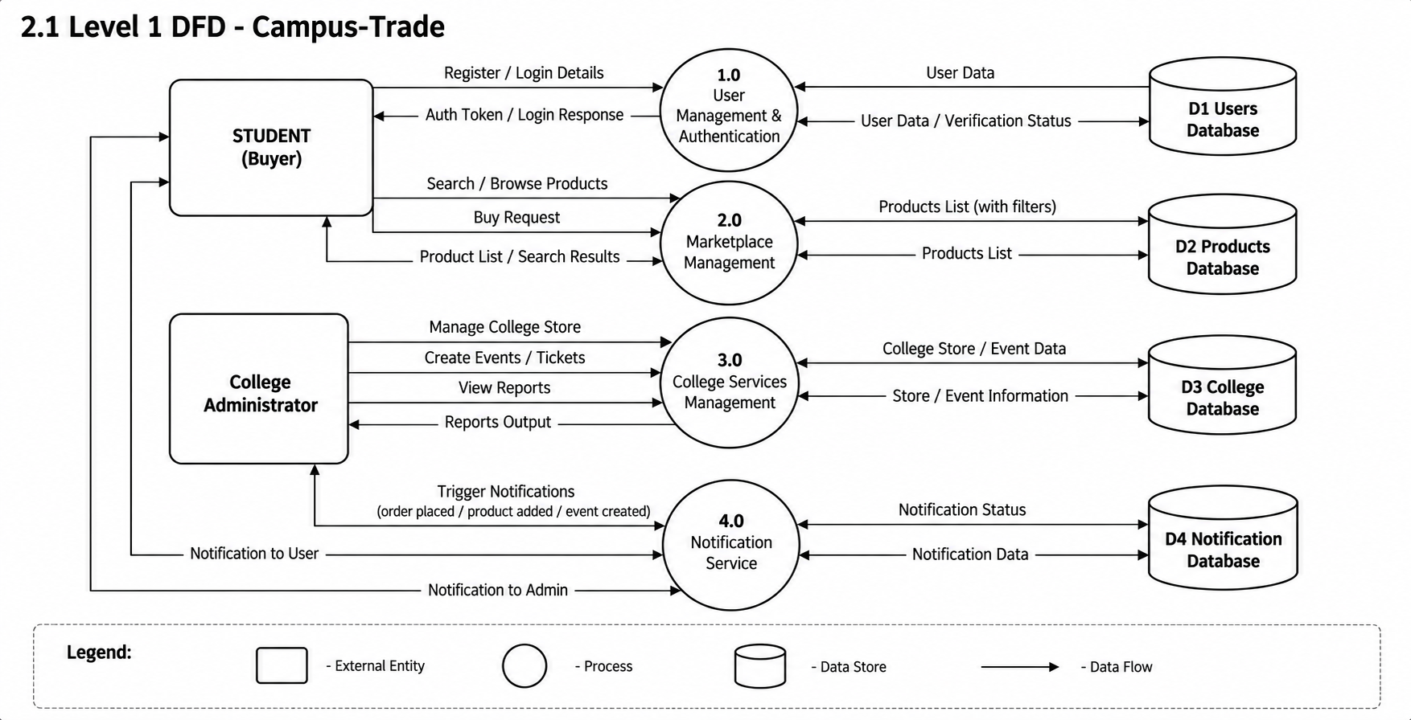
Figure 2.1: Level-1 Data Flow Diagram (CampusTrade System Architecture)
Technical Explanation of Level-1 DFD Processes and Data Stores:
1. External Entities: 'STUDENT (Buyer/Seller)' and 'College Administrator'. Students supply registration credentials, browse products, submit orders, rent equipment, post bounties, and list pre-owned items. Administrators manage official college store merchandise, publish campus events, and review reports.
2. Process 1.0 (User Management & Authentication): Validates incoming credentials, queries D1 Users Database, and issues signed JWT authorization tokens.
3. Process 2.0 (Marketplace & Rental Management): Handles catalog search queries, rental terms, and buy requests, interfacing with D2 Products Database to return filtered listings.
4. Process 3.0 (College Services & Events): Enables administrators to configure college store inventory and publish events/tickets into D3 College Database.
5. Process 4.0 (Notification & Handover Service): Dispatches transactional event notifications (order placement, deposit refund, handover OTPs) and updates D4 Notification Database.
6. Process 5.0 (Campus Boards & AI Engine): Manages academic bounty requests, lost & found logs, and executes AI valuation rules against baseline product parameters.
2.1.2 Level-2 Data Flow Diagram (Level-2 DFD)
The Level-2 DFD expands the Level-1 processes into granular sub-processes, displaying the detailed data exchanges between sub-modules and specialized data stores (D1 through D7). Figure 2.2 presents the Level-2 Data Flow Diagram.
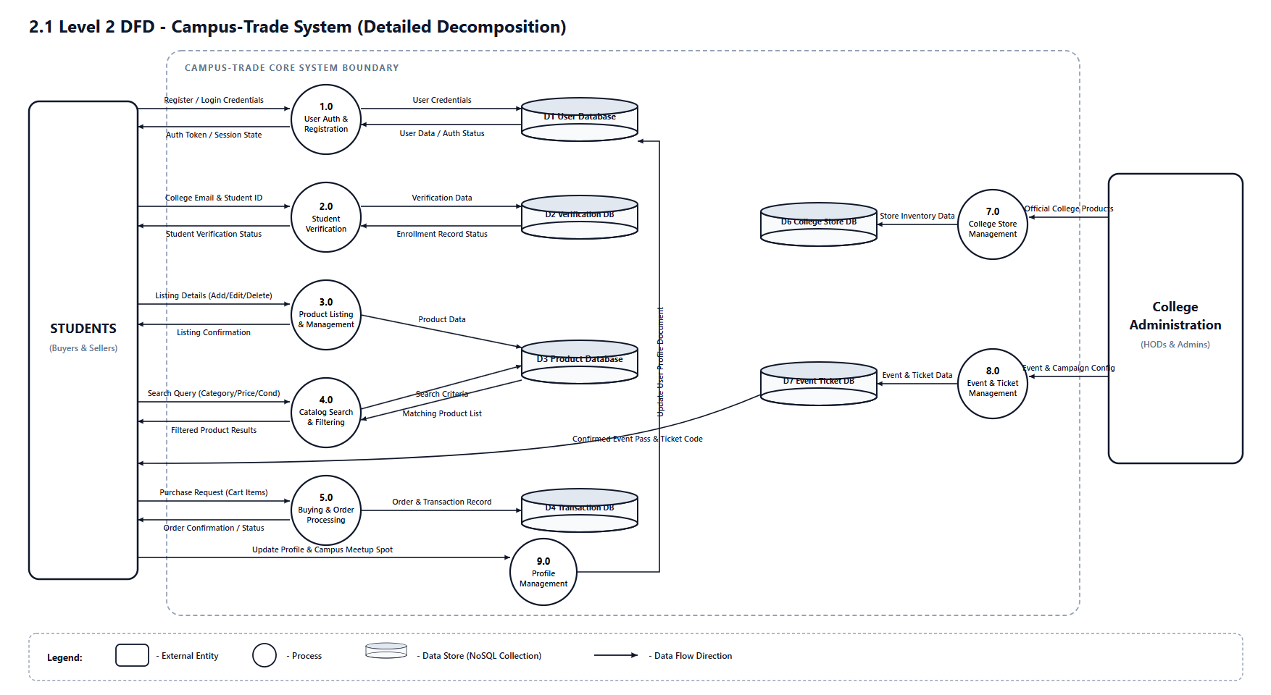
Figure 2.2: Level-2 Data Flow Diagram (Detailed Functional Sub-processes)
Technical Explanation of Level-2 DFD Sub-processes:
• Sub-process 1.0 & 2.0 (Registration, Verification & Account Lifecycle): Receives student details, validates college credentials (@iar.ac.in), handles account deactivation and deletion, updating D1 User Database.
• Sub-process 3.0 & 4.0 (Listing, Rentals & AI Pricing): Enables students to add, edit, or delete listings in D3 Product Database with academic syllabus tags, rental deposit configurations, and AI price recommendations.
• Sub-process 5.0 (Buying, Renting & Deposit Settlement): Translates purchase and rental requests into transaction records stored inside D4 Transaction Database, tracking deposit refund states.
• Sub-process 6.0 (Bounty Board & Lost-Found): Handles student requests for urgent academic items and records lost/found reports with direct image attachments in D5 Campus Boards Database.
• Sub-process 7.0 & 8.0 (College Store & Event Management): Receives administrator inputs for institutional merchandise (D6 College Store Database) and event passes/tickets (D7 Event Ticket Database).
• Sub-process 9.0 (Profile & Pass Management): Allows authenticated users to view active listings, rental orders, claimed passes, and update contact information in D1 User Database.
2.2 USE CASE DIAGRAM
A Use Case Diagram depicts the system boundary, external actors, and the operational functionalities (use cases) provided by the application. Figure 2.3 illustrates the complete Use Case Diagram for the CampusTrade platform.
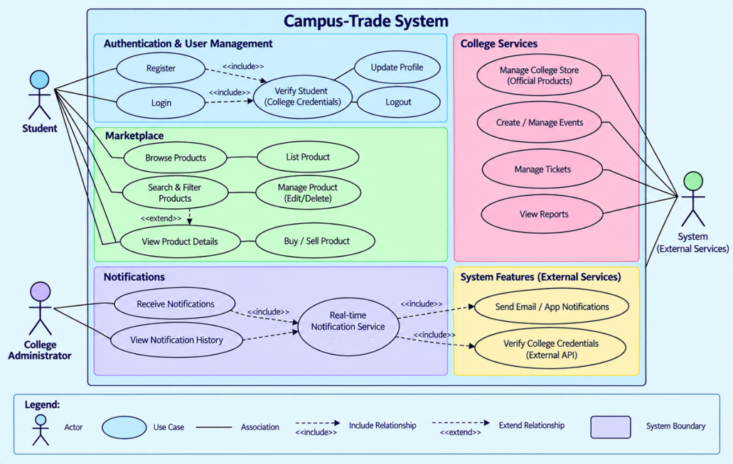
Figure 2.3: Use Case Diagram for CampusTrade Platform
Technical Description of Actors and Use Case Relationships:
1. Primary Actors: 'Student' (acting as verified buyer, seller, renter, or requester) and 'College Administrator' (representing department heads and platform managers).
2. Secondary Actor: 'System Services' providing email verification, ticket QR code generation, AI price estimation, and deposit refund management.
3. Include Relationships (<<include>>): Both 'Register' and 'Login' use cases strictly include 'Verify Student (College Credentials)' to protect platform integrity. Similarly, checkout workflows include 'Verify Trade Schedule & Spot'.
4. Extend Relationships (<<extend>>): 'Search & Filter Products' extends into 'Filter by Course Code & Semester', 'Calculate AI Fair Price', 'Claim Senior Giveaway', and 'Request Academic Rental'.
2.3 CLASS DIAGRAM
The Class Diagram provides a static structural view of the application, delineating system classes, their internal attributes, member functions, and relationships such as associations, compositions, and multiplicities. Figure 2.4 illustrates the Class Diagram.
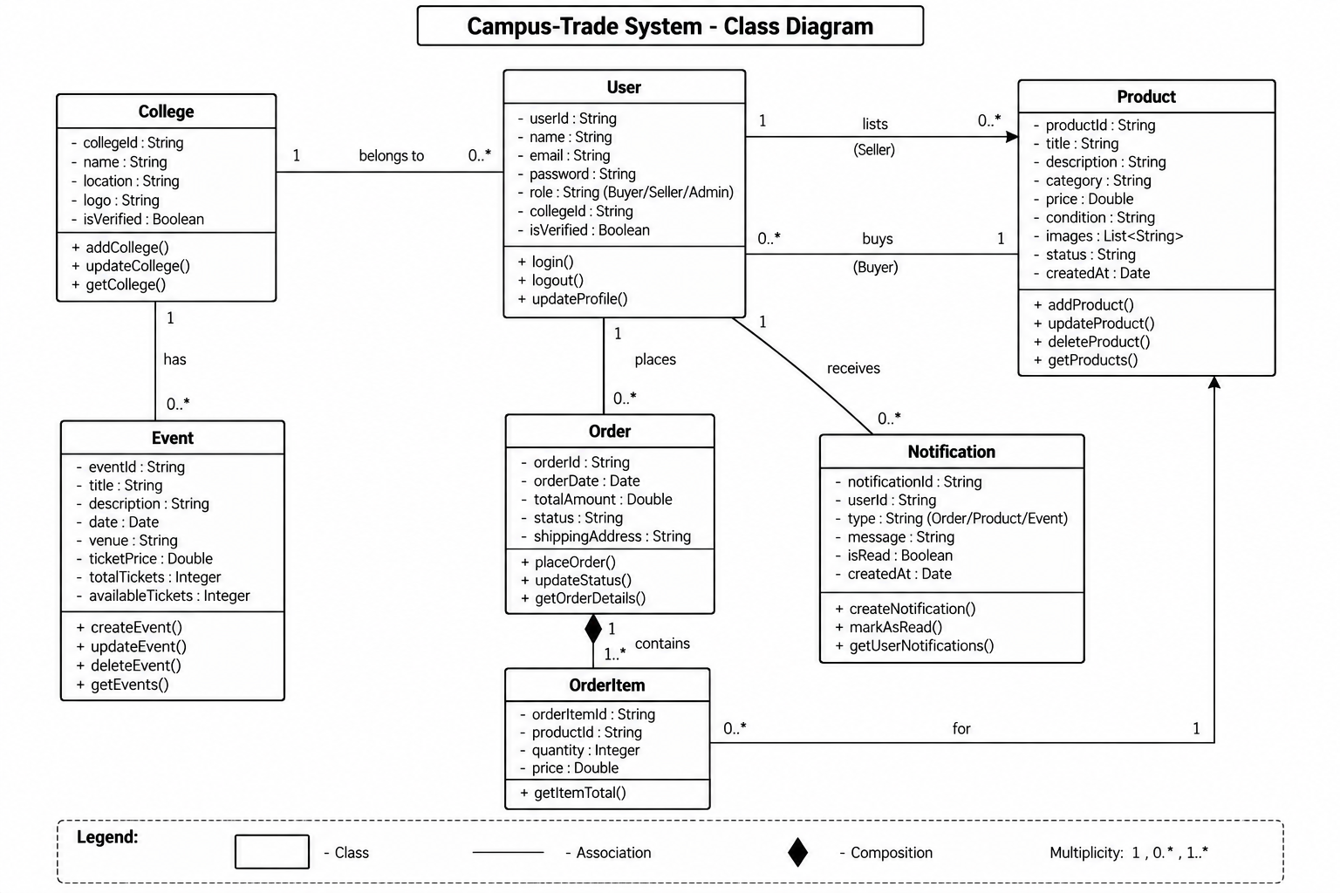
Figure 2.4: Class Diagram showing System Entities and Associations
Technical Explanation of Classes and Cardinalities:
• College: Represents IAR Gandhinagar (collegeId, name, location, isVerified). Maintains a 1-to-many (1 : 0..*) relationship with User and Event.
• User: Encapsulates user credentials (userId, name, email, password, role, isVerified, isDeactivated). Has 1-to-many associations with Product, Order, BountyRequest, and LostAndFound.
• Product: Contains productId, title, description, category, price, condition, stock, listingType ('buy'/'rent'/'giveaway'), rentPricePerDay, rentDeposit, academicType, department, semester, courseCode, and seller reference.
• Order & OrderItem: Modeled using strong composition (filled diamond). Order contains 1..* OrderItem instances along with totalDeposit, depositStatus, and meetup schedule.
• BountyRequest & LostAndFound: Model campus-specific peer assistance boards with status tracking, reward amounts, and direct phone contact references.
• Event: Represents campus events and campaigns (eventId, title, venue, ticketPrice, totalTickets, availableTickets) created and managed by administrators.
2.4 SEQUENCE DIAGRAMS
A Sequence Diagram visualizes dynamic object interactions arranged in chronological order, showing message exchanges along vertical object lifelines. Figure 2.5 details the sequence for user login, catalog browsing, order placement, rental returns, and notification dispatch.
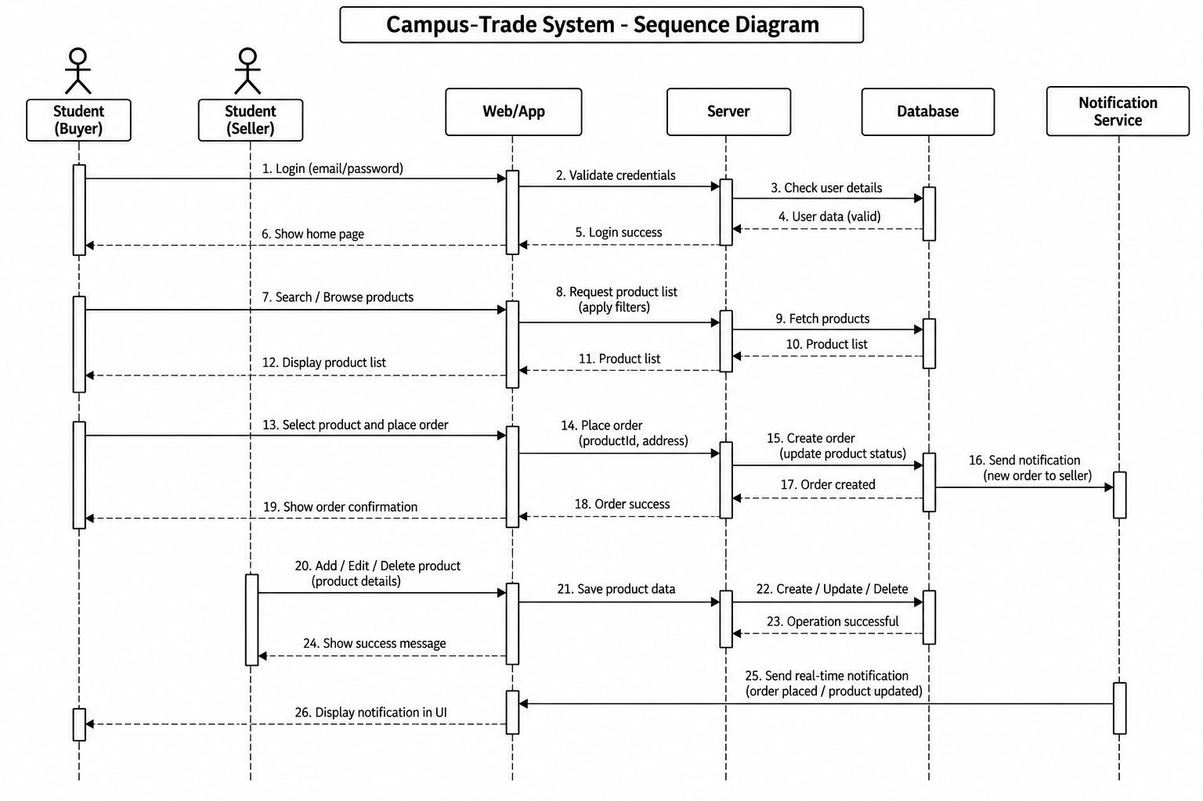
Figure 2.5: Sequence Diagram for Authentication, Order Placement, Rentals & Notifications
Chronological Execution Breakdown:
1. Authentication Flow: Student Buyer submits email and password via Web/App Interface. Server validates credentials against Database, verifies active status (!isDeactivated), and grants access to Home Page.
2. Browsing & Ordering Flow: Student searches/filters products by semester or course code. Server fetches records from Database. Buyer selects item and places order. Server writes transaction, holds rental deposit if applicable, and triggers Notification Service.
3. Rental Handover & Return Flow: Buyer inspects rental item on-campus and provides handover OTP. Upon completion of rental period, seller verifies item condition and triggers deposit refund.
4. Seller Listing Flow: Student Seller adds/updates a product listing using AI Fair-Price recommendations. Server persists changes in Database and transmits real-time confirmation.
3. DATA DICTIONARY
3.1 DATABASE TABLES SQL/NOSQL (DIMENSION IF NOSQL USED)
CampusTrade employs MongoDB Atlas, a scalable NoSQL document database, utilizing Mongoose as the Object Data Modeling (ODM) layer. In contrast to relational SQL databases where data is rigidly partitioned across normalized tables connected via foreign keys, MongoDB stores information as BSON (Binary JSON) documents organized into collections. Each collection's dimension is defined by a rigorous Mongoose schema enforcing field data types, required constraints, uniqueness, default values, and embedded sub-documents.
Table 3.1: User Collection Schema (users)
Field Name | Data Type | Validation Constraints & Schema Rules
_id | ObjectId | Primary Key, auto-generated unique 12-byte BSON identifier.
name | String | Required; trimmed string representing user's full name.
email | String | Required; unique index; trimmed; converted to lowercase; validated institutional domain format.
password | String | Required; minimum length 6 characters; stored as a salted Bcrypt hash; excluded from default query projections.
role | String | Enum: ['student', 'staff', 'admin']; default value: 'student'.
phone | String | Optional; stores mobile contact for verified buyer-seller campus meetup coordination.
campus | String | Default: 'Institute of Advanced Research, Gandhinagar'; locked institutional campus anchor.
bio | String | Optional seller bio describing branch, year, or preferred meetup timings.
enrollmentNo | String | Institutional student enrollment ID (e.g., IAR/14665); indexed for verified student lookup.
admissionYear | Number | Optional academic entry year (e.g., 2023, 2024).
isVerifiedStudent | Boolean | Flag indicating verified campus enrollment; default: false; enabled upon institutional email confirmation.
isDeactivated | Boolean | Flag indicating account status; default: false; when true, suppresses listings and blocks login.
department | String | Academic department (e.g., Computer Engineering & IT, Biotechnology, Chemical Sciences).
designation | String | Designation for faculty/staff members (e.g., Assistant Professor, Lab In-Charge).
staffCode | String | Optional employee identification code for verified faculty/staff users.
createdAt | Date | Auto-generated ISO timestamp recording user account registration date.
updatedAt | Date | Auto-generated ISO timestamp updated on any profile or credential change.
Table 3.2: Product Collection Schema (products) with Rental & Syllabus Dimensions
Field Name | Data Type | Validation Constraints & Schema Rules
_id | ObjectId | Primary Key, auto-generated unique BSON identifier.
title | String | Required; trimmed product title (e.g., 'Calculus Early Transcendentals').
description | String | Required; comprehensive product description detailing condition, usage, and semester relevance.
price | Number | Required; numeric; minimum 0; stored in Indian Rupees (₹); 0 for giveaway.
listingType | String | Enum: ['buy', 'rent', 'giveaway']; default: 'buy'; controls transaction workflow.
rentPricePerDay | Number | Numeric; daily rental rate in INR (₹) when listingType is 'rent'.
rentDeposit | Number | Numeric; refundable security deposit held during active rental period.
academicType | String | Enum: ['Core Textbook', 'Reference Manual', 'Lab Manual', 'PYQ Exam Papers', 'Lecture Notes', 'Equipment', 'General'].
department | String | Academic department affiliation (e.g. Computer Science, Biotechnology).
semester | Number | Integer (1-8); academic semester alignment for targeted discovery.
courseCode | String | Uppercase course code (e.g., CS201, BT204, MA101, EE102).
aiOriginalPrice | Number | Original retail benchmark price used for AI fair-price computation.
category | String | Required; enum: ['Textbooks', 'Electronics', 'Dorm Gear', 'Lab Coats', 'Stationery', 'Study Notes'].
condition | String | Enum: ['Brand New', 'Like New', 'Good', 'Fair']; indicates physical wear.
stock | Number | Required; integer; minimum value 0; default: 1; inventory decremented upon checkout.
imageUrl | String | Required; valid URL string referencing product photo hosted on CDN/cloud storage.
seller | ObjectId | Reference -> User (_id); tracks product ownership for peer-to-peer handovers.
ratings | Number | Numeric; range 1.0 to 5.0; calculated average score based on verified product condition.
numReviews | Number | Integer; default: 0; total count of reviews posted by verified buyers.
createdAt | Date | Auto-generated ISO timestamp recording initial listing creation time.
updatedAt | Date | Auto-generated ISO timestamp updated on price, stock, or description edits.
Table 3.3: Order Collection Schema (orders) with Deposit Holding Parameters
Field Name | Data Type | Validation Constraints & Schema Rules
_id | ObjectId | Primary Key, auto-generated unique BSON identifier.
user | ObjectId | Required; Reference -> User (_id); links order to purchasing student.
orderItems | Array | Required; array of embedded sub-documents (product ref, name, quantity, price, listingType, rentDeposit).
totalAmount | Number | Required; numeric; minimum value 0; aggregate sum of order items in INR (₹).
totalDeposit | Number | Numeric; total refundable security deposit held for active rental items.
depositStatus | String | Enum: ['none', 'held', 'refunded', 'claimed']; tracks return settlement.
shippingAddress | Embedded Doc | Required; contains address (meeting/trading spot), city ('At IAR Campus'), meetupTime (trade schedule), postalCode, country.
orderStatus | String | Enum: ['pending', 'processing', 'shipped', 'delivered', 'cancelled']; default: 'pending'.
paymentStatus | String | Enum: ['pending', 'paid', 'failed', 'refunded']; default: 'pending'.
handoverOtp | String | Unique 4-digit verification OTP generated upon order placement; shared by buyer upon meetup.
completedAt | Date | ISO timestamp recorded when trade is marked successfully completed & paid.
cancelledAt | Date | ISO timestamp recorded when trade is marked unsuccessful; triggers automatic stock restoration.
Table 3.4: Campus Event & Campaign Collection Schema (events)
Field Name | Data Type | Validation Constraints & Schema Rules
_id | ObjectId | Primary Key, auto-generated unique BSON identifier.
title | String | Required; event or campaign title (e.g., 'IAR HackFest 2026', 'CRISPR Masterclass').
description | String | Required; comprehensive event syllabus, schedule, and departmental overview.
category | String | Enum: ['Tech Fest & Hackathon', 'Workshop & Seminar', 'Cultural & Sports', 'Campus Campaign'].
venue | String | Required campus facility (e.g., 'IAR Central Computing Labs & Main Auditorium').
eventDate | Date | Required calendar date of the scheduled event.
eventTime | String | Required timing interval (e.g., '09:00 AM - 05:00 PM').
registrationType | String | Enum: ['free_rsvp', 'paid_ticket', 'external_link']; dictates pass issuance workflow.
price | Number | Numeric; ticket price in INR (₹); locked to 0 for free_rsvp.
totalCapacity | Number | Integer; maximum permitted attendees based on lab/auditorium seat capacity.
registeredCount | Number | Integer; default: 0; real-time count of confirmed attendee registrations.
attendees | Array | Embedded array of delegate passes: studentName, enrollmentNo, email, ticketCode, registeredAt.
Table 3.5: Campus Bounty Request Collection Schema (bounty_requests)
Field Name | Data Type | Validation Constraints & Schema Rules
_id | ObjectId | Primary Key, auto-generated unique BSON identifier.
user | ObjectId | Required; Reference -> User (_id); requesting student identity.
title | String | Required; summary of requested item (e.g. 'CS201 Data Structures Solved PYQs').
description | String | Required; detailed specifications, required edition, or specific lab tools needed.
rewardBounty | Number | Required; numeric bounty budget offered in INR (₹); min: 0.
neededBy | Date | Required deadline date when the student urgently requires the item.
department | String | Academic department tag for peer filtering.
courseCode | String | Optional course syllabus code (e.g., CS201, ME102).
contactPhone | String | Required phone contact for direct peer response.
status | String | Enum: ['open', 'fulfilled', 'cancelled']; default: 'open'.
createdAt | Date | Auto-generated ISO timestamp.
Table 3.6: Campus Lost and Found Collection Schema (lost_and_founds)
Field Name | Data Type | Validation Constraints & Schema Rules
_id | ObjectId | Primary Key, auto-generated unique BSON identifier.
reporter | ObjectId | Required; Reference -> User (_id); reporting student/staff identity.
itemType | String | Enum: ['lost', 'found']; specifies report nature.
title | String | Required; item description (e.g. 'Casio fx-991EX Calculator').
category | String | Enum: ['Electronics', 'ID Cards & Keys', 'Textbooks & Notes', 'Clothing', 'Accessories', 'Other'].
locationFound | String | Required campus venue spot where item was lost or found.
dateFound | Date | Required date of loss or discovery.
description | String | Required identifying characteristics, stickers, or marks.
contactPhone | String | Required contact number for claim coordination.
imageUrl | String | Optional photo URL uploaded via drag-and-drop or file selector.
status | String | Enum: ['active', 'claimed', 'resolved']; default: 'active'.
createdAt | Date | Auto-generated ISO timestamp.
4. IMPLEMENTATION
4.1 SCREEN LAYOUTS WITH VALIDATIONS
This section presents the live graphical user interface layouts of CampusTrade along with the comprehensive validation logic implemented across the application. Every user interaction enforces a two-tier defense-in-depth validation paradigm:
1. Client-Side Validation (React & HTML5): Executes synchronously in the user's browser, providing instant visual feedback, regex format checks, disabled submission states, and preventing unnecessary network payloads.
2. Server-Side Validation (Express & Mongoose): Acts as the authoritative security barrier. Validates request schemas, sanitizes inputs, enforces role-based authorization headers, and generates standardized HTTP status codes (200, 201, 400, 401, 403, 404, 500).
4.1.1 Home Page Layout & Sustainability Dashboard
The Home Page serves as the primary entry point to CampusTrade. It features the institutional navigation bar with the verified campus badge (Institute of Advanced Research, Gandhinagar), an animated live campaign ticker, hero banner, search exploration buttons, and the Campus Eco-Impact & Sustainability Dashboard tracking environmental metrics. Figure 4.1 presents the live homepage layout.
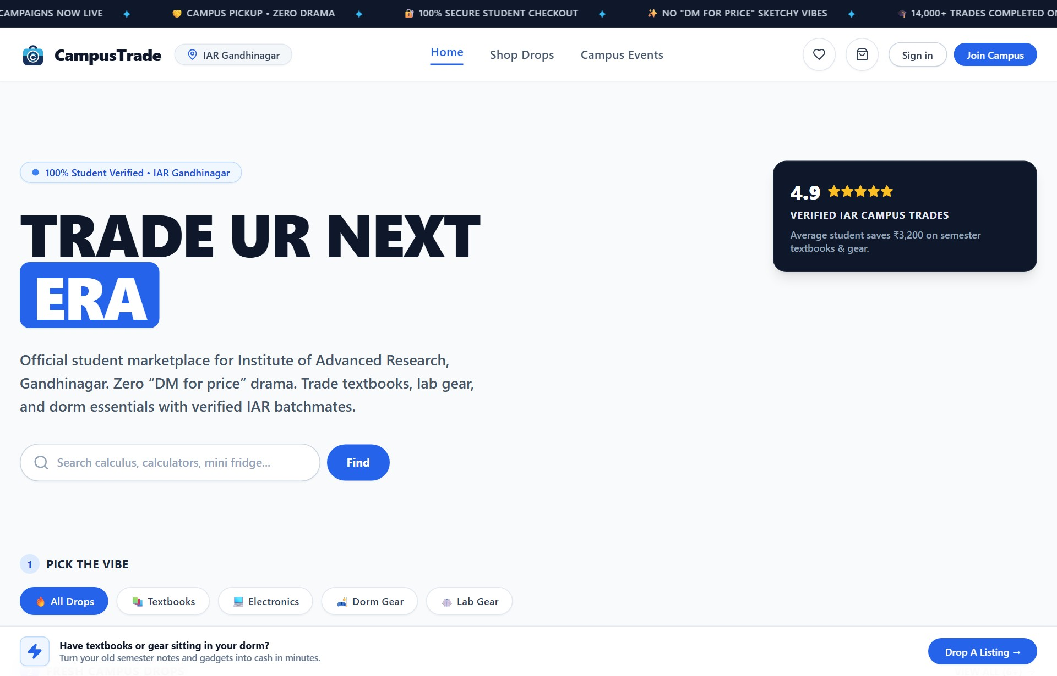
Figure 4.1: Home Page Screen Layout with Verified Campus Spotlight & Eco-Dashboard
Validation Specification: The Home Page contains navigation links, eco-impact aggregate displays, and search redirect triggers. No mutable form inputs exist on this screen; client routing redirects unauthenticated visitors attempting restricted operations directly to the Sign In interface.
4.1.2 Shop / Product Catalog Page Layout
The Shop Page presents active product drops in a responsive multi-column grid. Users can search by title or keywords and filter by categories including All, Textbooks, Electronics, Lab Coats, Dorm Gear, Stationery, and Study Notes. In addition, users can toggle listing types between Standard Purchase ('buy'), Academic Rentals ('rent'), and Free Senior Giveaways ('giveaway'). Figure 4.2 presents the live catalog.
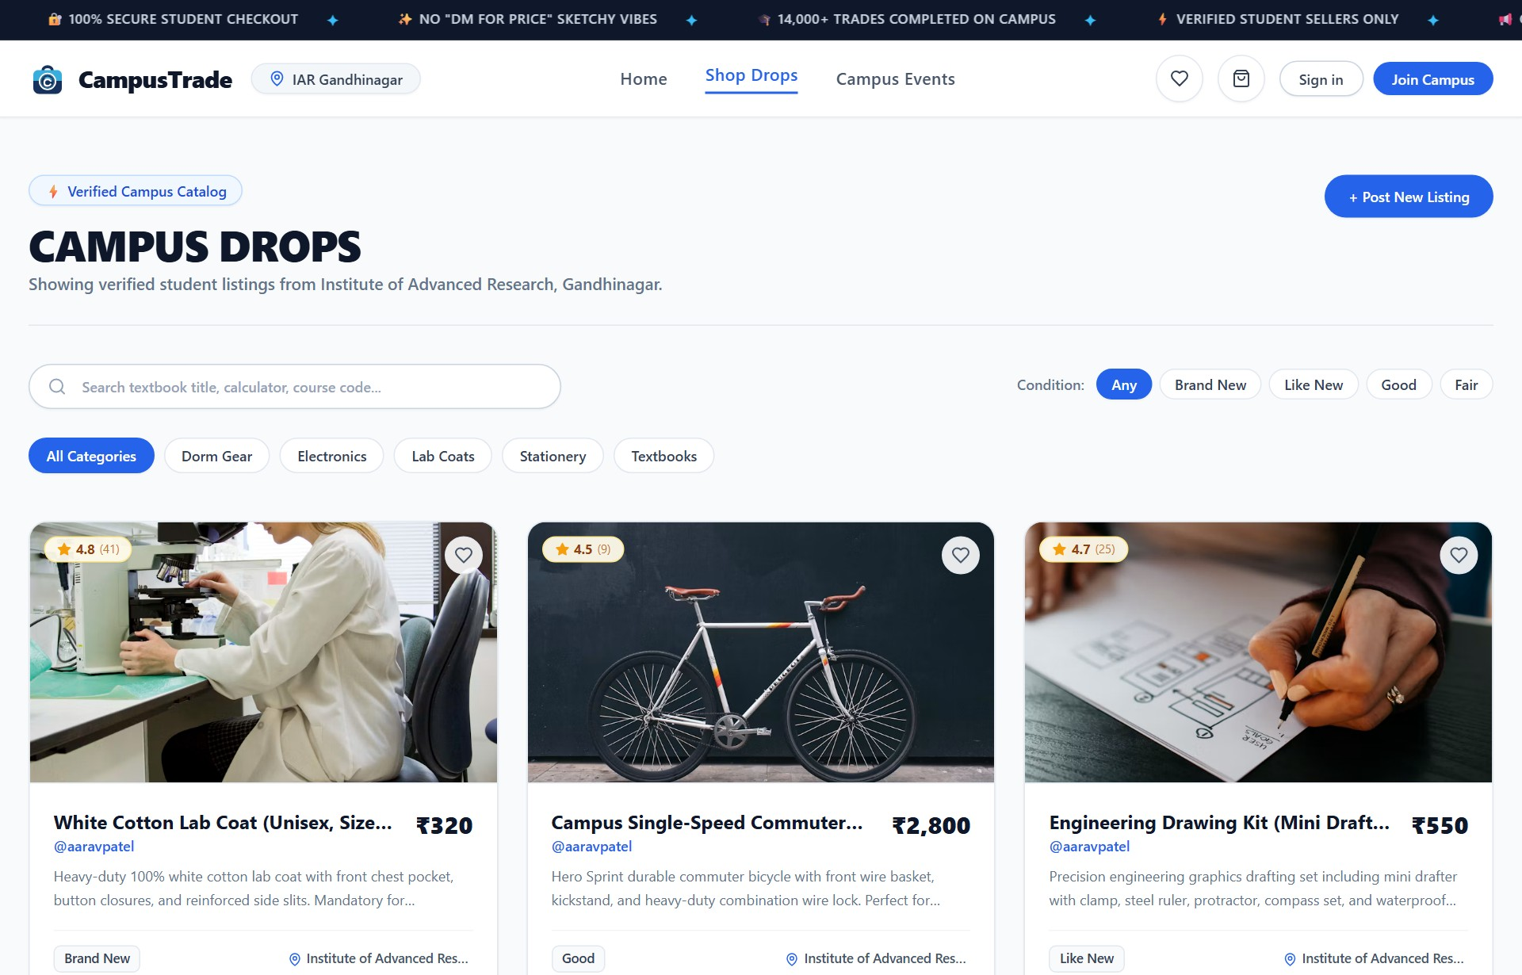
Figure 4.2: Shop / Product Catalog Screen Layout with Filter Controls & Academic Tags
Validation Specification: The search input is bounded with a 300ms debounce interval to avoid redundant server API requests. Category filter pills are strictly constrained to valid pre-defined categories. Numeric prices are parsed and formatted with the Indian Rupee symbol (₹).
4.1.3 Product Detail Page Layout
The Product Detail Page provides comprehensive information regarding a selected item, including high-resolution imagery, verified condition tags, academic vertical pills, rental deposit indicators, live stock counter, dynamic star rating breakdown, and seller handover details. A single, clear 'Call Seller' button allows verified campus buyers to initiate direct peer-to-peer meetups. Figure 4.3 illustrates the product detail view.
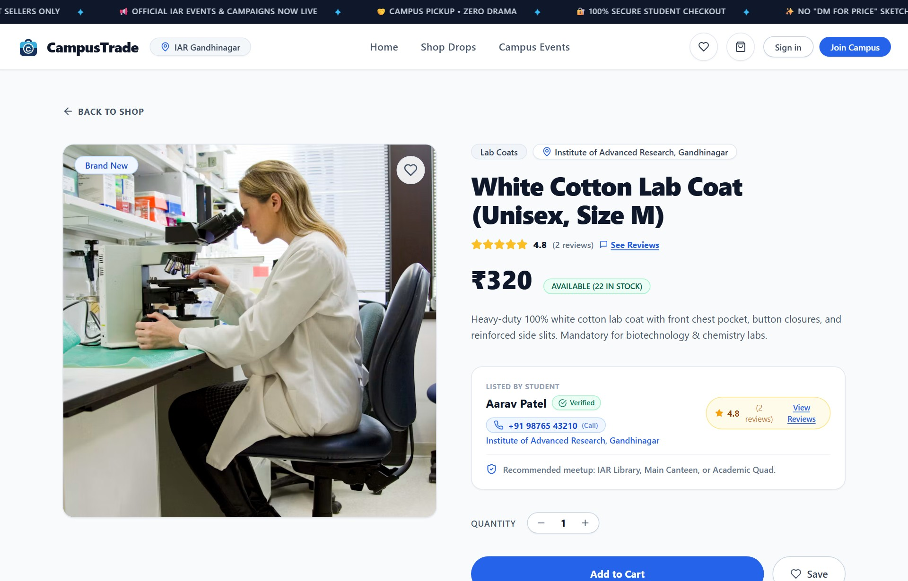
Figure 4.3: Product Detail Screen Layout with Rental Deposit & Single Verified Call Seller Action
Table 4.1: Product Detail Page Controls and Validation Rules
Field / Control | Client-Side Validation (React) | Server-Side Validation (Mongoose / Express)
Quantity Selector | Clamped strictly between 1 and available live stock count. | Ensures requested quantity <= product.stock; returns 400 if quantity exceeds.
Rental Duration / Deposit | Displays daily rate (₹/day) and required refundable deposit badge. | Server calculates total rental fee and binds deposit parameters to line items.
Add to Cart Button | Disabled and visually muted when product stock is 0 (Out of stock). | Server checks product inventory before allowing cart checkout creation.
Call Seller Action | Single verified telephone action link (tel:); displays seller phone. | Protected endpoint ensures seller contact is only exposed to authenticated users.
Product Reviews Modal | Rating stars interactive breakdown (1 to 5) with review text input. | Rejects empty review strings; computes rolling average for product rating.
4.1.4 User Login (Sign In) Page Layout
The Sign In Page allows registered students, faculty members, and administrators to authenticate using their credentials. Figure 4.4 presents the login screen layout.
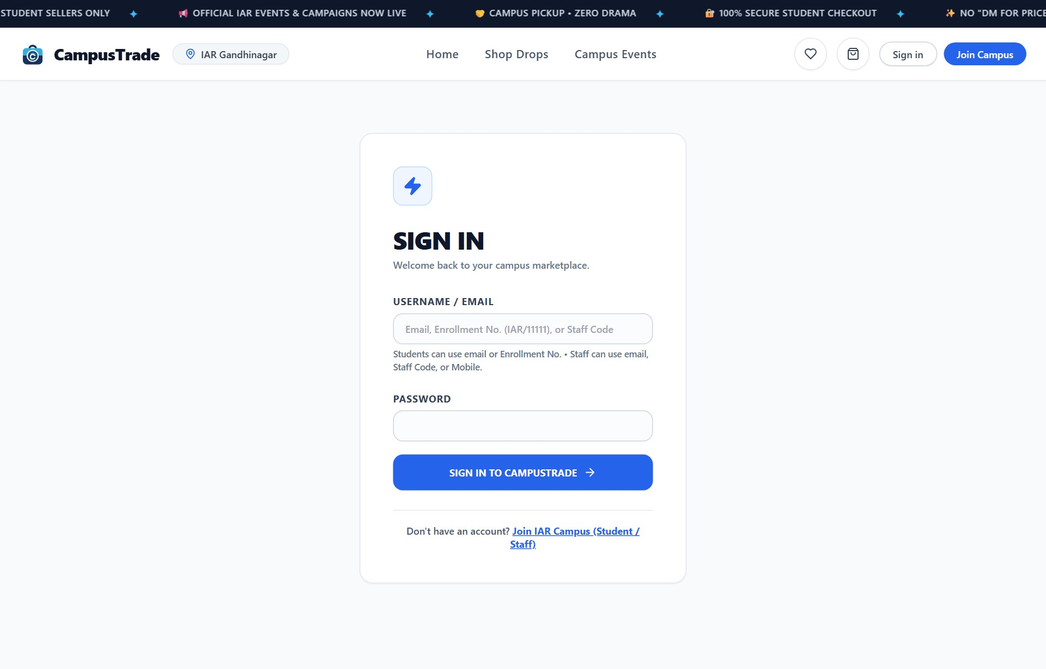
Figure 4.4: User Login (Sign In) Screen Layout
Table 4.2: User Login Page Form Fields and Validation Rules
Field Name | Client-Side Validation (React) | Server-Side Validation (Mongoose / Express)
Email / ID | Required; accepts institutional email, student enrollment ID, or phone. | Queries user collection; verifies account exists and is not deactivated (isDeactivated: false).
Password | Required; obscured characters (type='password'); submit blocked if empty. | Compared against salted Bcrypt hash using bcrypt.compare(); returns 401 on failure.
Account Status Check | Displays warning message if account has been deactivated. | Server returns HTTP 403: 'This account has been deactivated. Please contact campus admin.'
4.1.5 User Registration Page Layout
The Registration Page allows prospective campus members to establish a verified account by providing their Full Name, institutional email, phone number, and password confirmation. Figure 4.5 shows the registration interface.
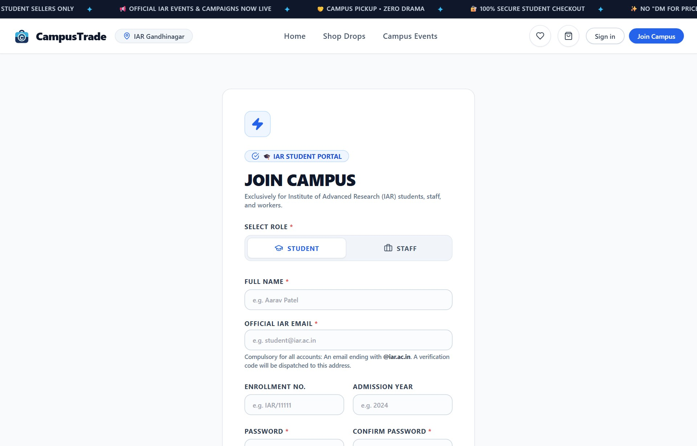
Figure 4.5: Student Registration Screen Layout with Institutional Validation
Table 4.3: User Registration Page Form Fields and Validation Rules
Field Name | Client-Side Validation (React) | Server-Side Validation (Mongoose / Express)
Full Name | Required; trimmed string; minimum 2 characters; letters and spaces only. | Schema validation enforces required: true, trim: true.
Email Address | Required; valid RFC 5322 format; encourages institutional @iar.ac.in domain. | Enforces unique index in MongoDB; rejects duplicate emails with HTTP 400.
Password | Required; minimum length 6 characters; password strength indicator. | Re-validates minimum length >= 6; automatically executes Bcrypt salt hashing.
Confirm Password | Required; validated against Password in real-time; submit disabled if mismatch. | Controller verifies req.body.password equality before invoking user creation.
Phone Number | Required; 10-digit Indian mobile format regex check (+91 / standard). | Stores verified phone number for peer-to-peer campus handover communication.
4.1.6 Cart & Campus Meeting / Trade Details Page Layout
The Cart and Campus Meeting pages manage selected order items, subtotal calculations, rental deposit summaries, and structured peer-to-peer trade scheduling. Figure 4.6 illustrates the interactive shopping cart with live items, while Figure 4.7 presents the campus meeting and trading details screen.
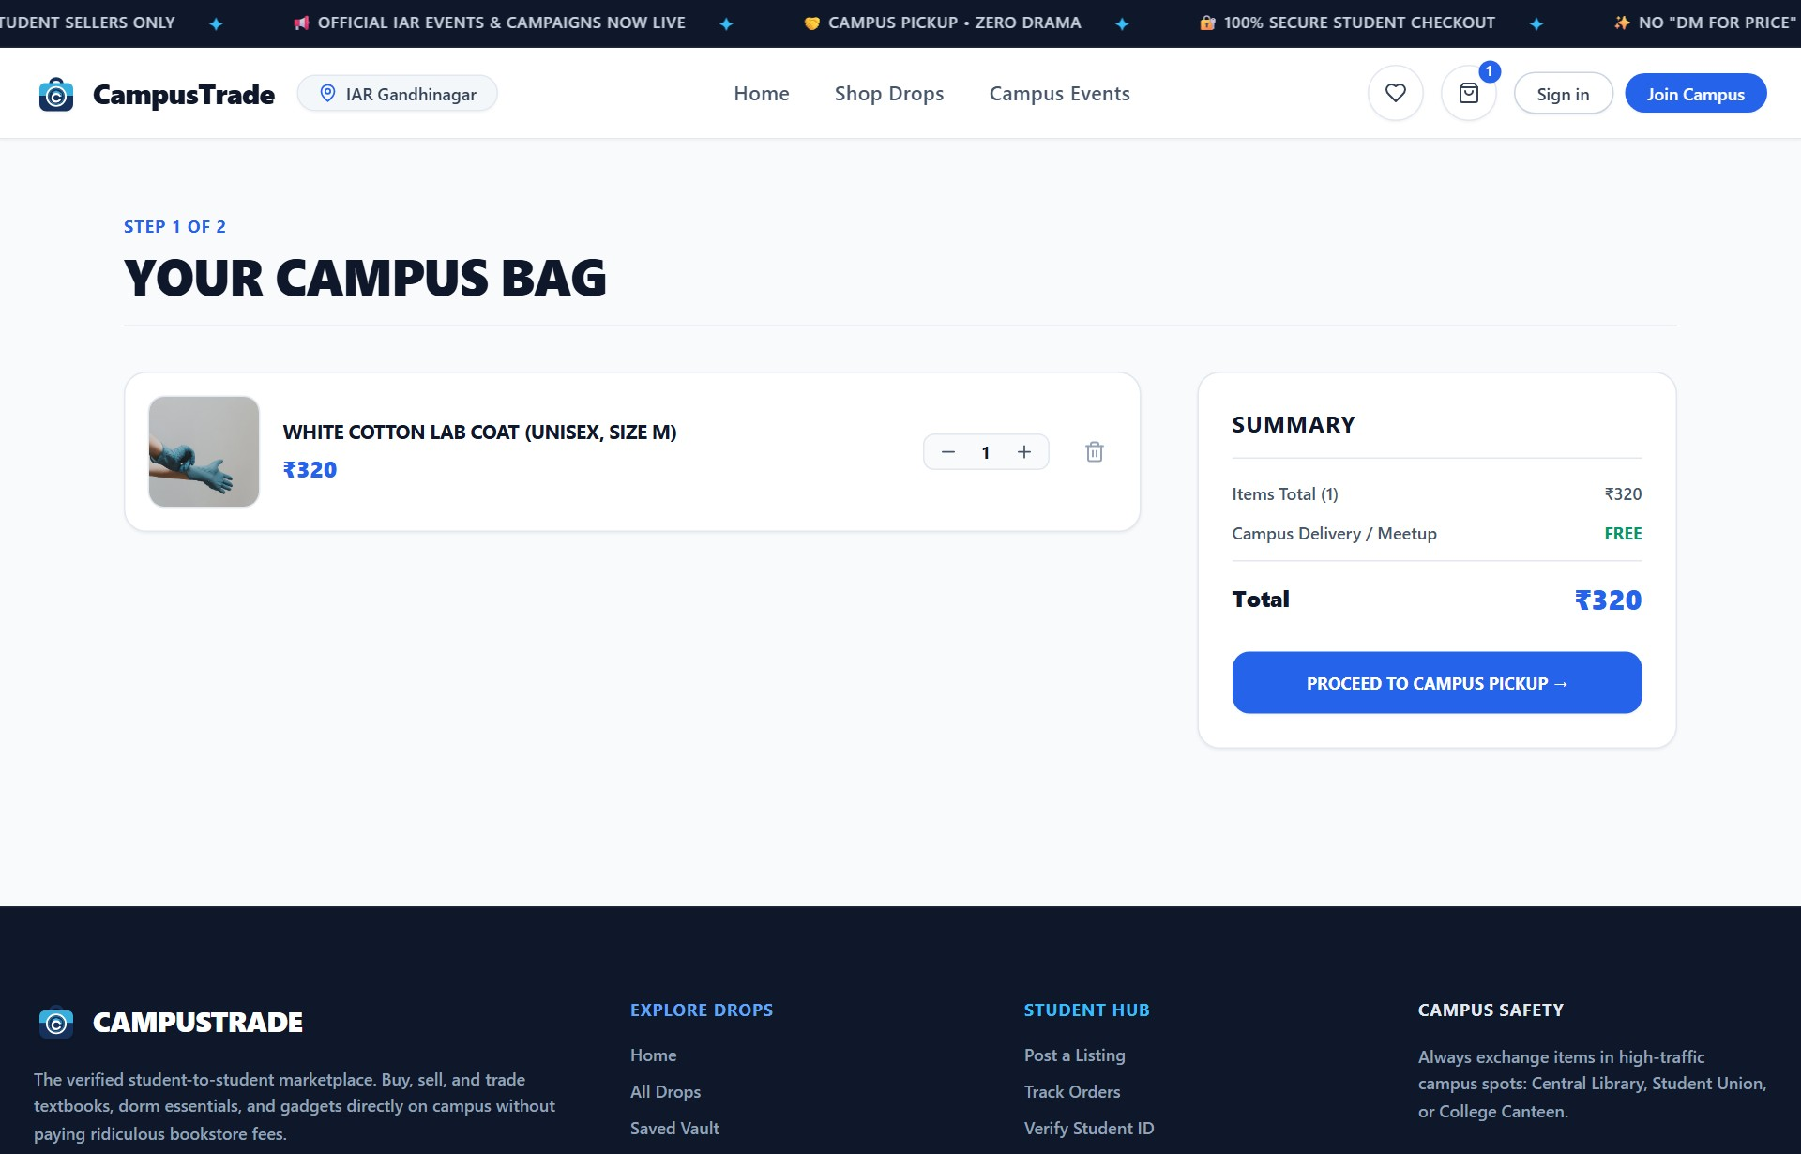
Figure 4.6: Shopping Cart Screen Layout with Rental Item & Security Deposit Breakdown
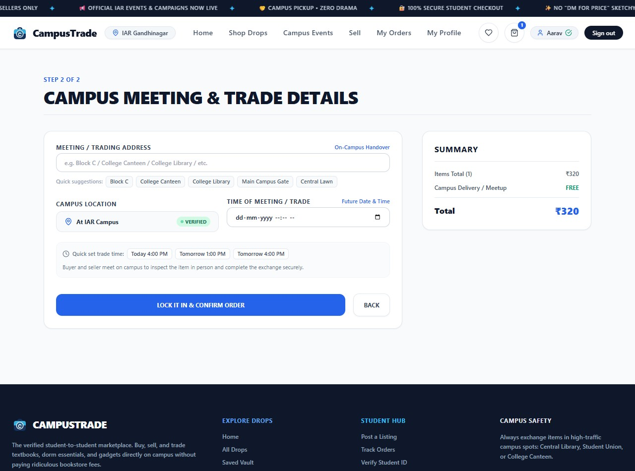
Figure 4.7: Campus Meeting & Trade Details Screen Layout with Schedule Picker
Table 4.4: Cart and Campus Meeting Page Form Fields and Validation Rules
Field Name | Client-Side Validation (React) | Server-Side Validation (Mongoose / Express)
Cart Quantity & Rental Days | Clamped between 1 and available stock; rental days selectable (1-30). | Order controller verifies stock and calculates total rental cost + deposit.
Refundable Deposit | Displays aggregate refundable deposit held during active rental. | Stored in order.totalDeposit with initial depositStatus: 'held'.
Meeting / Trading Spot | Required on-campus venue selection (Central Library, Canteen, Block A). | Required string field inside embedded shippingAddress sub-document.
Time of Meeting / Trade | Required datetime-local picker; validates future trade schedule. | Stored in shippingAddress.meetupTime; guarantees verified inspection.
Handover OTP Verification | Generates unique 4-digit code displayed to buyer upon checkout. | Stored in order.handoverOtp for physical exchange validation.
4.1.7 Product Listing Form with Academic Syllabus Tagging
The Product Listing modal supports product creation, photo uploads, physical condition specification, academic resource vertical selection, department, semester, uppercase course code (e.g., CS201), and campus handover spots. Figure 4.8 presents the live product listing modal with syllabus tagging.
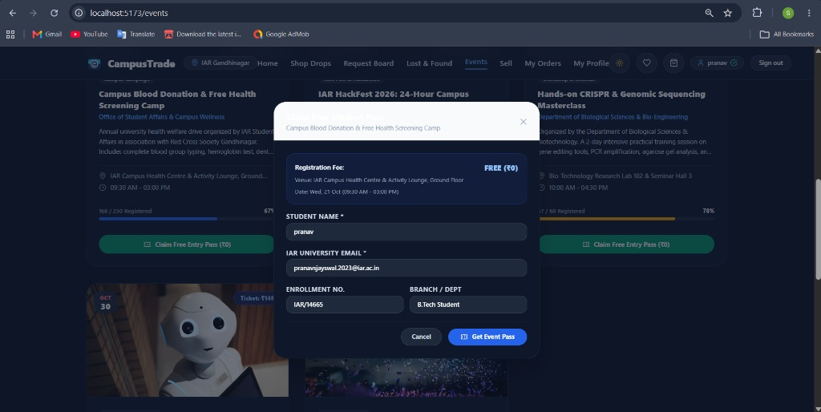
Figure 4.8: Product Listing Form Modal with Academic Syllabus Tagging & Course Codes
Table 4.5: Product Listing Form Fields and Academic Validation Rules
Field Name | Client-Side Validation (React) | Server-Side Validation (Mongoose / Express)
Listing Type | Pill selector: 'buy' (Standard Sale), 'rent' (Rental), 'giveaway' (Free). | Enforces valid enum string; sets price = 0 when listingType is 'giveaway'.
Academic Vertical | Select buttons: Core Textbook, Notes, PYQs, Lab Manual, Equipment. | Stored in academicType field for structured syllabus filtering.
Department & Semester | Dropdown selection: Engineering, Biotech, Chem; Semesters 1 to 8. | Validates allowed department strings and numeric semesters 1-8.
Course Code | Uppercase auto-formatting input (e.g. CS201, BT204, MA101). | Stored as trimmed uppercase string; indexed for syllabus search queries.
Rental Rates & Deposit | Enabled when type is 'rent'; requires daily rate and deposit amount. | Enforces min: 0 for rentPricePerDay and rentDeposit.
Campus Handover Spot | Free-form text with suggestions (IAR Central Library, Main Canteen). | Required string field inside product document for exchange spot.
4.1.8 Campus Events & Official Campaigns Portal Layout
The Campus Events module facilitates official university event announcements, symposium registrations, and digital delegate pass generation. Students can filter events by category (Tech Fests, Workshops, Sports & Cultural, Campaigns) or registration type (Free RSVP ₹0, Paid Tickets, External Portals). Figure 4.9 illustrates the active campus events portal.

Figure 4.9: Campus Events, Fests & Department Campaigns Discovery Portal
4.1.9 User Profile Management & Danger Zone Layout
The User Profile module enables students, staff, and administrators to maintain academic identity details, mobile contacts, preferred campus handover spots, track claimed event passes, and manage account security. The Password & Security tab provides a dedicated Danger Zone with Deactivate Account and Delete Account options. Figure 4.10 presents the user profile interface.
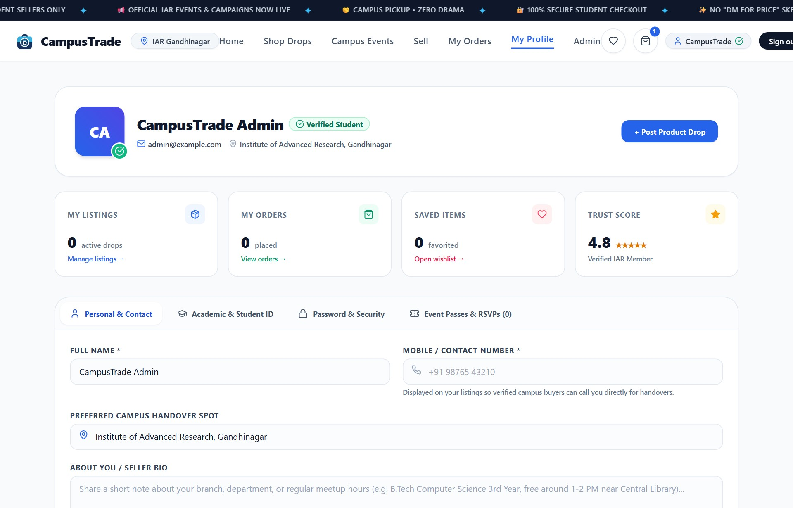
Figure 4.10: User Profile Management with Academic ID, Passes & Account Danger Zone
Table 4.6: User Profile Management and Danger Zone Validation Rules
Field / Action | Client-Side Validation (React) | Server-Side Validation (Mongoose / Express)
Academic & Student ID | Format check (e.g., IAR/XXXXX); locked upon institutional verification. | Updates enrollmentNo field in database; indexed for verification queries.
Password Change | Requires Current Password; New Password must be >= 6 chars and confirmed. | Bcrypt verification of existing hash; salts and saves updated password.
Deactivate Account | Prompts confirmation modal; warns active listings will be hidden. | PUT /api/auth/deactivate: Sets user.isDeactivated = true; logs out session.
Delete Account Permanently | Safety modal requires user to type 'DELETE' in uppercase before enabling. | DELETE /api/auth/delete-account: Cascades removal of user doc & all listings.
4.1.10 Campus Request & Peer Bounty Board Layout
The Campus Request and Bounty Board enables students to post urgent requests for academic materials, lab equipment, or textbooks that are currently unavailable in the marketplace. Requesters specify a bounty reward in INR (₹) and a needed-by deadline. Figure 4.11 illustrates the active bounty board.
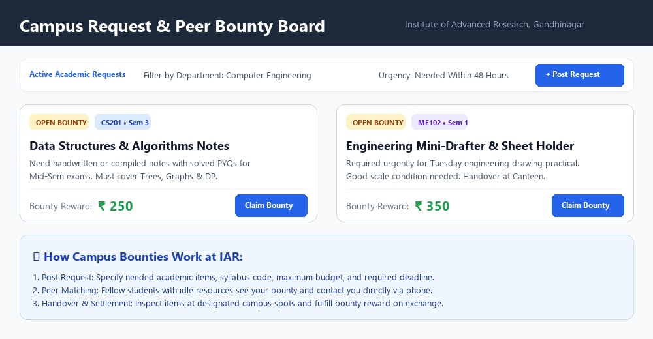
Figure 4.11: Campus Request & Peer Bounty Board Layout for Academic Supplies
Table 4.9: Campus Request & Peer Bounty Board Validation Rules
Field Name | Client-Side Validation (React) | Server-Side Validation (Mongoose / Express)
Request Title | Required; minimum 3 characters describing needed item. | Mongoose schema required: true, trim: true.
Reward Bounty (INR) | Required; numeric; minimum 0; accepts student-funded reward. | Validates min: 0, type: Number.
Needed By Date | Required date picker; client validates future date. | Validates date >= current timestamp.
Course Code | Optional uppercase course identifier (e.g. CS201, ME102). | Stored as optional trimmed string.
Contact Phone | Required 10-digit mobile number for direct peer calling. | Validates numeric phone string; exposed only on board.
4.1.11 Campus Lost & Found Registry Layout
The Campus Lost & Found module centralizes reporting for misplaced student items, textbooks, calculators, and personal belongings. The submission form supports direct drag-and-drop image uploads for immediate visual identification. Figure 4.12 presents the live registry.
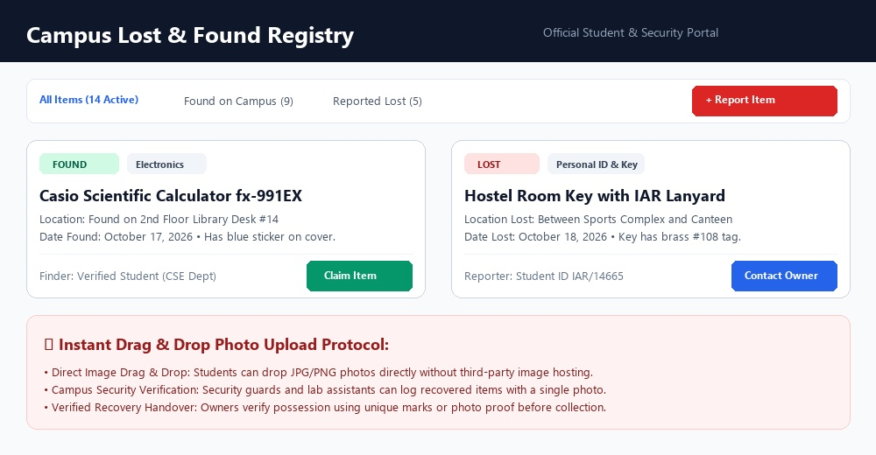
Figure 4.12: Campus Lost & Found Registry Layout with Drag & Drop Photo Upload
Table 4.10: Campus Lost and Found Form Fields & Upload Constraints
Field Name | Client-Side Validation (React) | Server-Side Validation (Mongoose / Express)
Item Type | Radio selector: 'lost' or 'found'. | Validates against enum: ['lost', 'found'].
Title & Category | Required item title and category dropdown (Electronics, Keys, Textbooks). | Schema required: true; validates category enum.
Campus Venue Spot | Required text field detailing specific spot (Library, Canteen, Block A). | Schema required: true; trimmed string.
Drag & Drop Photo | HTML5 drag & drop supporting PNG/JPG/WebP; displays instant preview. | Accepts image data URL / file string; validates file format.
Contact Phone | Required 10-digit phone number for recovery coordination. | Schema required: true; stored for verified student lookup.
4.1.12 AI Fair-Price Suggestion Engine Interface
The AI Fair-Price Suggestion Engine assists student sellers in pricing second-hand educational items equitably. It prompts for the original retail purchase cost and calculates a realistic market resale value using empirical wear deductions bounded between 10% and 40%. Figure 4.13 illustrates the live AI pricing engine interface.
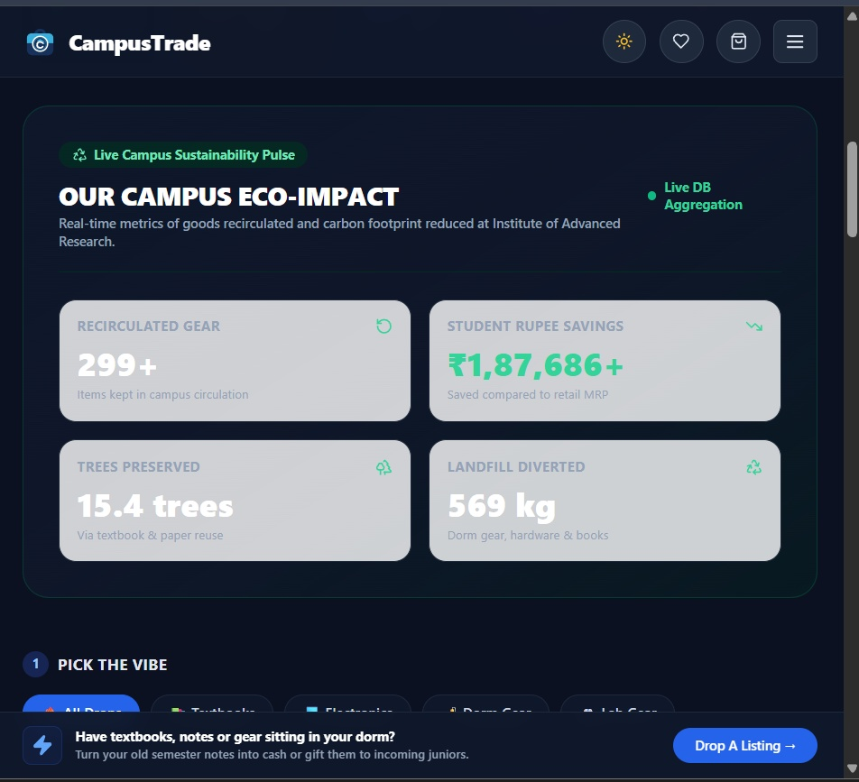
Figure 4.13: AI Fair-Price Suggestion Engine Interface with Usage Depreciation Valuation
Table 4.11: AI Fair-Price Suggestion Engine Valuation Parameters & Reduction Bounds
Condition State | Wear Deduction % | Valuation Rationale & Formula
Brand New | 10% Reduction | Unopened / unused packaging; formula: Fair Price = Original Price * 0.90.
Like New | 20% Reduction | Minor inspection wear, no marks or damage; formula: Fair Price = Original Price * 0.80.
Good | 30% Reduction | Standard semester usage, highlighted text, clean binding; formula: Fair Price = Original Price * 0.70.
Fair | 40% Reduction | Substantial physical wear, annotated margins, intact text; formula: Fair Price = Original Price * 0.60.
4.1.13 Campus Orders & Rental Deposit Refund Flow
The My Orders dashboard enables students to inspect placed orders, review physical meeting venue details, track handover OTPs, and monitor active rentals. For rental orders, sellers can mark returned items to trigger automatic security deposit refunds. Figure 4.14 illustrates the orders management layout.
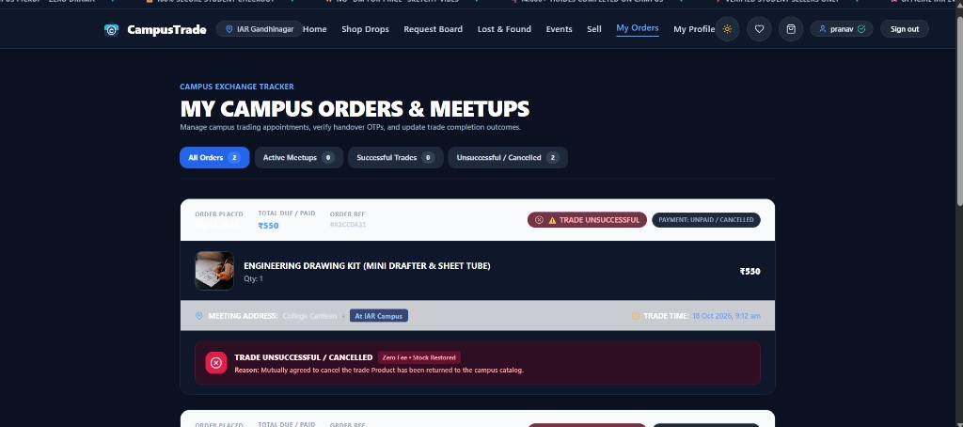
Figure 4.14: My Orders Screen Layout showing Active Rentals, Deposit Status & Return Action
Table 4.7: Campus Event RSVP & Ticket Reservation Validation Rules
Field / Action | Client-Side Validation (React) | Server-Side Validation (Mongoose / Express)
Delegate Name | Required; auto-populated from logged-in user session. | Ensures non-empty attendee name.
Institutional Email | Required; verified against student session (@iar.ac.in). | Validates attendee email; prevents duplicate registrations for same event.
Enrollment No. | Required student enrollment code (e.g., IAR/2023/CSE/014). | Records student identifier in event attendee sub-document.
Capacity Check | RSVP button disabled and labeled 'Full' when registeredCount >= totalCapacity. | Atomic check in event controller: throws 400 if event capacity is exceeded.
Pass Code Generation | Modal renders printable pass with QR barcode and pass ID. | Server generates unique pass identifier (e.g., IAR-PASS-XXXX) upon confirmation.
Table 4.8: Admin / HOD Event Creation Form Validation Rules
Field Name | Client-Side Validation (React) | Server-Side Validation (Mongoose / Express)
Event Title | Required; minimum 5 characters; trimmed. | Schema required: true.
Category | Select dropdown: Tech Fest, Workshop, Cultural & Sports, Campaign. | Validates against allowed category enum values.
Campus Venue | Required; specific lab, hall, or campus block. | Schema required: true; trimmed.
Event Date & Time | Date picker (must be today or future date); time interval string. | Validates Date object >= current date; rejects past dates.
Registration Type | Radio selection: 'free_rsvp' (₹0), 'paid_ticket', 'external_link'. | Enforces valid enum string; sets price = 0 for free_rsvp.
Ticket Price (INR) | Disabled and locked to ₹0 for free_rsvp; numeric > 0 for paid_ticket. | Rejects negative numbers; stores price in INR (₹).
Total Seat Capacity | Required; positive integer >= 1 (e.g., 50, 100, 500). | Validates integer > 0; initial registeredCount set to 0.
External Portal Link | Required when type is 'external_link'; validates http/https format. | Stores verified URL string (Google Forms, Unstop, or university portal).
4.2 SAMPLE CODING (WITH SECURITY TASKS)
To validate technical rigor and implementation security, this section highlights core server controllers, security middleware, and client protection algorithms deployed across CampusTrade.
Listing 4.1: JWT Authentication & Account Deactivation Guard Middleware (authMiddleware.js)
const jwt = require('jsonwebtoken');
const asyncHandler = require('express-async-handler');
const User = require('../models/User');
const protect = asyncHandler(async (req, res, next) => {
let token;
if (req.headers.authorization && req.headers.authorization.startsWith('Bearer')) {
token = req.headers.authorization.split(' ')[1];
const decoded = jwt.verify(token, process.env.JWT_SECRET || 'iar_secret');
const user = await User.findById(decoded.id).select('-password');
if (!user || user.isDeactivated) {
res.status(403);
throw new Error('Account deactivated or not found. Access denied.');
}
req.user = user;
next();
} else {
res.status(401);
throw new Error('Not authorized, token missing.');
}
});
Listing 4.2: AI Fair-Price Depreciation Valuation Algorithm (ProductFormModal.jsx)
const calculateAiFairPrice = (originalPrice, condition) => {
const base = Number(originalPrice);
if (!base || base <= 0) return 0;
// Depreciation rate clamped strictly between 10% and 40%
const depreciationMap = {
'Brand New': 0.10, // 10% minimum discount
'Like New': 0.20, // 20% discount
'Good': 0.30, // 30% discount
'Fair': 0.40 // 40% maximum discount
};
const rate = depreciationMap[condition] || 0.25;
const suggested = Math.round(base * (1 - rate));
return Math.max(1, suggested);
};
Listing 4.3: Account Deactivation & Cascading Deletion Safeguards (authController.js)
const deactivateAccount = asyncHandler(async (req, res) => {
await User.findByIdAndUpdate(req.user._id, { isDeactivated: true });
res.json({ success: true, message: 'Account deactivated successfully.' });
});
const deleteAccount = asyncHandler(async (req, res) => {
const userId = req.user._id;
await User.findByIdAndDelete(userId);
await Product.deleteMany({ seller: userId }); // Cascade delete listings
res.json({ success: true, message: 'Account and listings permanently purged.' });
});
Listing 4.4: Defensive Error Boundary Architecture (ErrorBoundary.jsx)
class ErrorBoundary extends React.Component {
constructor(props) { super(props); this.state = { hasError: false }; }
static getDerivedStateFromError(error) { return { hasError: true }; }
componentDidCatch(error, errorInfo) { console.error('Error caught:', error, errorInfo); }
render() {
if (this.state.hasError) {
return (
<div className='p-6 text-center'>
<h3>Something went wrong loading this view.</h3>
<button onClick={() => window.location.reload()}>Reload Page</button>
</div>
);
}
return this.props.children;
}
}
4.3 STEPS OF THE EXECUTION PROJECT AND NAVIGATION
Execution Guide for Local & Server Deployment:
1. Clone Repository & Install Dependencies: Execute 'npm install' in both /server and /client directories to restore required Node packages.
2. Environment Variable Configuration: Configure .env in /server with PORT=5000, MONGO_URI, and JWT_SECRET.
3. Backend Server Execution: Execute 'npm run dev' inside /server to launch the Express API server on port 5000.
4. Frontend Client Execution: Execute 'npm run dev' inside /client to spin up the Vite development server on http://localhost:5173.
5. System Navigation Flow: Unauthenticated users land on Home Page -> Register with @iar.ac.in -> Browse Catalog / Rentals -> Filter by Course Code (CS201) -> Calculate AI Price -> Schedule Handover Meetup -> Confirm Trade with OTP.
5. CONCLUSION
5.1 IMPORTANCE OF THE WORKED-OUT TASKS
The implementation of the CampusTrade platform establishes an essential technological infrastructure for the academic community of the Institute of Advanced Research (IAR), Gandhinagar. By transforming unstructured, informal buy-sell transactions into a verified, authenticated, and centralized digital marketplace, the project delivers major institutional benefits:
1. Student Economic Relief & Affordability
Through the Academic Rental and Senior Giveaway hubs, students save substantial financial resources by borrowing expensive lab instruments (drafters, calculators) for single semesters rather than making full-price retail investments.
2. Targeted Academic Discoverability
Course code and semester tagging (CS201, BT204, Sem 1-8) eliminates dilution, enabling students to pinpoint exact syllabus textbooks, solved PYQ question papers, and lab manuals within seconds.
3. Fair Peer-to-Peer Pricing
The AI Fair-Price Suggestion Engine enforces transparent market valuations, providing 10%-40% wear reductions that prevent overcharging and build mutual student trust.
4. Campus Environmental Sustainability
The circular re-circulation of physical educational resources directly prevents paper waste, plastic manufacturing, and electronic disposal. Real-time metrics tracked on the Eco-Impact Dashboard motivate green campus stewardship.
5. Personal Safety & Campus Accountability
Restricting platform membership to verified institutional email holders (@iar.ac.in) and scheduling physical meetups at designated campus spots (Library, Canteen) eliminates meeting strangers off-campus.
6. Institutional Integration
Official event announcement capabilities, digital pass issuance, and lost-and-found tracking furnish university departments with unified student engagement tools.
5.2 FURTHER ENHANCEMENT IN FUTURE
1. Dynamic UPI QR Code & In-App Escrow: Implementing automatic UPI deep-linking and escrow holding where funds are released to sellers only upon buyer OTP entry.
2. Automated Text Book Barcode & ISBN Scanning: Utilizing mobile camera barcode scanning to auto-populate textbook author, publisher, and syllabus metadata from open academic registries.
3. Central Library Integration: Interfacing with university library management systems to synchronize physical circulation records and course reserve lists.
4. Cross-Campus Multi-Tenant Clustering: Expanding the microservices architecture to support federated campus instances across sister universities in Gujarat and nationwide.
6. REFERENCES
6.1 BOOKS, RESEARCH PAPERS, TECHNOLOGY DOCUMENTATION & WEBSITES
1. React Documentation: 'React.js v18 Official Reference Manual', Meta Open Source (2024). https://react.dev
2. Tailwind CSS Documentation: 'Utility-First CSS Framework Specification', Tailwind Labs (2024). https://tailwindcss.com
3. Node.js Architecture: 'Node.js v20 LTS Runtime Environment Documentation', OpenJS Foundation (2024). https://nodejs.org
4. Express Framework: 'Express.js Web Application Framework Guide', StrongLoop / OpenJS (2024). https://expressjs.com
5. MongoDB Atlas & Mongoose: 'MongoDB Cloud Database & Mongoose ODM Reference Guide' (2024). https://mongoosejs.com
6. JSON Web Token RFC 7519: 'RFC 7519: JSON Web Token (JWT) Standard', Internet Engineering Task Force (IETF) (2015).
7. Circular Economy in Higher Education: Ellen MacArthur Foundation, 'Circular Economy Approaches for Higher Education Campuses' (2022).
8. Pressman, R. S., & Maxim, B. R. 'Software Engineering: A Practitioner's Approach', 9th Edition, McGraw-Hill Education (2020).

