Project Report
On
VAARI – CROP WATER FOOTPRINT INFORMATION APP
In partial fulfillment of requirements for the degree
of
BACHELOR OF TECHNOLOGY
IN
COMPUTER SCIENCE AND ENGINEERING
Submitted by:
Pranav Bhagwat 23100BTCSE15010
Mohanish Lowanshi 23100BTCSE14964
Neha Agrawal 23100BTCSE14980
Under the guidance of
Prof. Akash Kanugo
SHRI VAISHNAV VIDYAPEETH VISHWAVIDYALAYA, INDORE
SHRI VAISHNAV INSTITUTE OF INFORMATION TECHNOLOGY
DEPARTMENT OF COMPUTER SCIENCE ENGINEERING
Jan-June 2026

DECLARATION
We hereby declare that the work presented in the project entitled "Vaari – Crop Water Footprint Information App" in partial fulfillment of the degree of Bachelor of Technology in Computer Science and Engineering is an authentic record of our work carried out under the supervision and guidance of [Guide Name], Assistant Professor, Department of Computer Science Engineering. The matter embodied in this project has not been submitted for the award of any other degree.

PROJECT APPROVAL SHEET
The following team has done appropriate work related to "Vaari – Crop Water Footprint Information App" in partial fulfillment for the award of Bachelor of Technology in Computer Science and Engineering of Shri Vaishnav Institute of Information Technology and is being submitted to Shri Vaishnav Vidyapeeth Vishwavidyalaya, Indore.

CERTIFICATE
This is to certify that the students working in a team have satisfactorily completed the project entitled "Vaari – Crop Water Footprint Information App" under the guidance of [Guide Name] in partial fulfillment of the degree of Bachelor of Technology in Computer Science and Engineering awarded by Shri Vaishnav Institute of Information Technology affiliated to Shri Vaishnav Vidyapeeth Vishwavidyalaya, Indore during the academic year Jan-June 2026.

ACKNOWLEDGEMENTS
We are grateful to a number of persons for their advice and support during the completion of our project. We extend our sincere thanks to our guide, Head of Department, Director, Project Coordinator, faculty members, family, and friends for their support and encouragement.

ABSTRACT
Vaari is a multilingual Android application that helps users understand the water footprint of agricultural crops. It allows a user to search for a crop and view its footprint in litres, including green, blue, and grey water values. The app uses a Kotlin-based Android front end, a Python Flask backend API, and a Room database for local history storage. Vaari is designed to make crop water data easy to access and understand, supporting the goal of promoting better water awareness in agriculture.

LIST OF FIGURES
Figure 4.1: Use Case Diagram
Figure 4.2: Object Diagram
Figure 4.3: Initial Class Diagram
Figure 4.4: Activity Diagram
Figure 5.1: Sequence Diagram
Figure 5.2: Detailed Class Diagram
Figure 5.3: Package Diagram
Figure 5.4: Component Diagram
Figure 5.5: Deployment Diagram

TABLE OF CONTENTS
Declaration
Project Approval Sheet
Certificate
Acknowledgements
Abstract
List of Figures
Chapter 1 Introduction
Chapter 2 Literature Survey
Chapter 3 Requirements Analysis
Chapter 4 Design
Chapter 5 System Modeling
Chapter 6 Conclusion & Future Work
Chapter 7 Bibliography & References

CHAPTER 1 – INTRODUCTION
_____________________________________________________________________
1. INTRODUCTION
Vaari is a mobile application designed to provide accessible and accurate information about the water footprint of agricultural crops. The growing concern over freshwater scarcity makes it increasingly important for people to understand how much water is consumed in growing different crops. Vaari bridges this information gap by offering a simple and interactive search-based interface on Android devices. The application is aligned with the National Water Mission and the Bureau of Water Use Efficiency under the Ministry of Jal Shakti, Government of India.
1.1 Problem Statement
Agriculture accounts for a large share of freshwater consumption, yet most users do not have an easy way to access crop-wise water footprint data. Existing tools are often technical, web-based, or not mobile-friendly. Vaari solves this by creating a simple, multilingual, Android-based crop water footprint lookup system.
1.2 Need for the System
There is a need for water literacy among citizens, farmers, and policymakers. A smartphone app that provides quick and clear crop footprint data can improve awareness and help support better water management decisions.
1.3 Objective
- Provide instant crop water footprint data.
- Display green, blue, and grey water values in litres.
- Store past searches locally.
- Support multiple languages.
- Align with India's National Water Mission goals.
1.4 Modules of the System
- Home Module – Crop search input.
- Result Module – Display footprint details.
- History Module – Saved searches.
- Language Module – Switch app language.
1.5 Scope
Vaari covers crop water footprint lookup for agricultural products using a curated dataset. The application targets Android devices and provides information in multiple regional languages. Camera-based crop detection is excluded from the final scope.

CHAPTER 2 – LITERATURE SURVEY
_____________________________________________________________________
2. LITERATURE SURVEY
2.1 Existing System
Existing tools for water footprint data include online calculators and desktop-based agricultural tools. These systems are often web-based and not mobile-friendly, may lack multilingual support, and are not optimized for quick crop lookups on handheld devices.
2.2 Proposed System
Vaari proposes a lightweight Android application that enables quick crop searches, shows footprint data in a clear visual format, stores user history locally, and supports multiple languages. Unlike existing systems, Vaari is designed specifically for mobile use and general public access.
2.3 Feasibility Study
Technical feasibility is strong because the project uses Kotlin, Jetpack Compose, Flask, and Room Database. Economic feasibility is high because the tools are open-source and low-cost. Operational feasibility is also high because the application is simple to use on Android smartphones.

CHAPTER 3 – REQUIREMENTS ANALYSIS
_____________________________________________________________________
3. REQUIREMENTS ANALYSIS
3.1 Functional Requirements
- Search for a crop by name.
- Display green, blue, and grey water values in litres.
- Save search history locally.
- Support multiple languages.
- Show an error if a crop is not found.
3.2 Non-Functional Requirements
- Fast response time.
- Simple and accessible UI.
- Reliable crop lookup.
- Maintainable MVVM architecture.
3.3 Hardware Specification
- Android device running Android 8.0 or higher.
- Minimum 2GB RAM.
- Internet connection for API calls.
3.4 Software Specification
- Android Studio with Kotlin.
- Jetpack Compose for UI.
- Python Flask for backend API.
- Room Database for local storage.
- Retrofit for network calls.
- GitHub for version control.

CHAPTER 4 – DESIGN
_____________________________________________________________________
4. DESIGN
4.1 Use Case Model
The use case model defines the interactions between the system and the user. The primary actor is the General User who can search for crops, view results, view history, and change language. The Administrator manages the crop data on the backend.
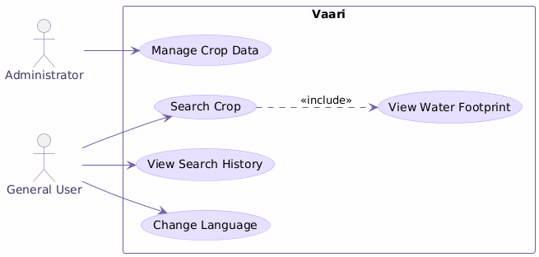
Figure 4.1: Use Case Diagram

4.2 Conceptual Class Diagram
The initial class diagram identifies the core entities of the system: CropEntity, SearchHistoryEntity, CropViewModel, CropRepository, CropApiService, and CropDao.
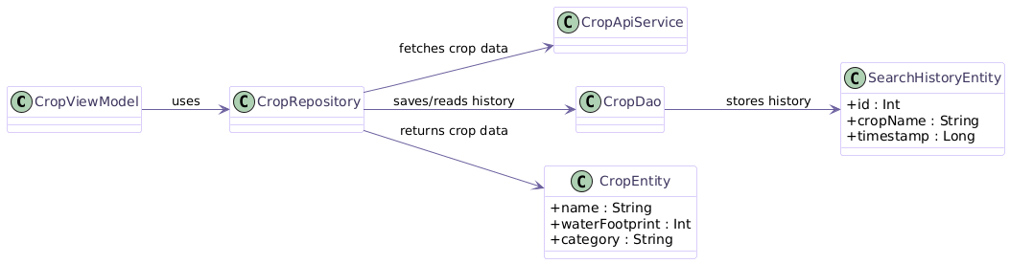
Figure 4.2: Conceptual Class Diagram
4.3 Activity Diagram
The activity diagram models the main user flow: the user opens the app, enters a crop name, taps search, the system fetches data, and either displays the result or shows an error. The user can also view history and switch language.
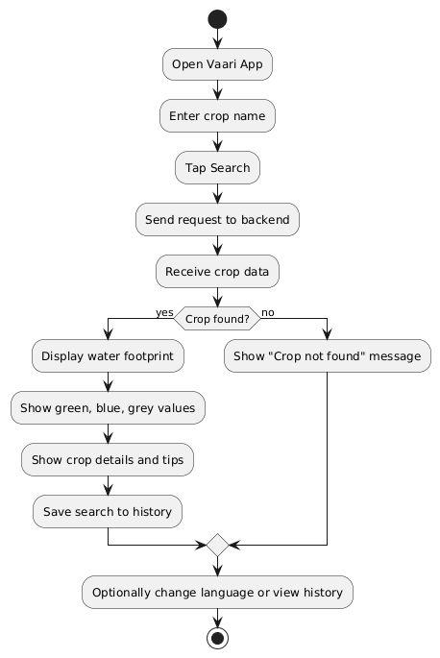
Figure 4.3: Activity Diagram
4.4 Database Design
The local database contains the SearchHistoryEntity table with fields for id, cropName, and timestamp. Crop data is fetched from the backend API and is not stored permanently on the device.
CHAPTER 5 – SYSTEM MODELING
_____________________________________________________________________
5. SYSTEM MODELING
5.1 Detailed Class Diagram
The detailed class diagram includes all core classes with methods and visibility. CropViewModel exposes search and history functions. CropRepository coordinates data from the API and local database. CropApiService handles network calls. CropDao manages local database operations.
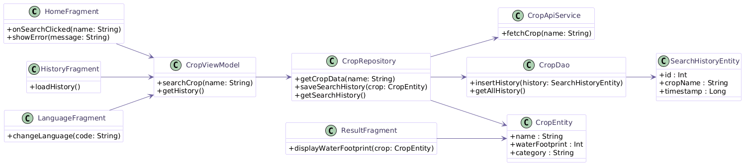
Figure 5.1: Detailed Class Diagram
5.2 Sequence Diagram
The sequence diagram shows the runtime interaction between HomeFragment, CropViewModel, CropRepository, CropApiService, CropDao, and ResultFragment. It models the crop search flow from user input to result display and history saving.
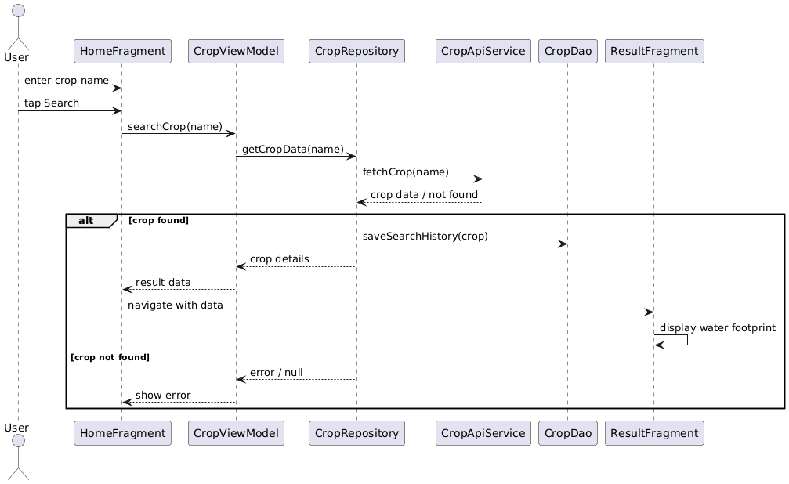
Figure 5.2: Sequence Diagram
5.3 Object Diagram
The object diagram shows a snapshot of the system with sample instances. For example, a CropEntity instance may represent Wheat with a water footprint of 1827 litres. A SearchHistoryEntity instance shows the saved record with a timestamp.
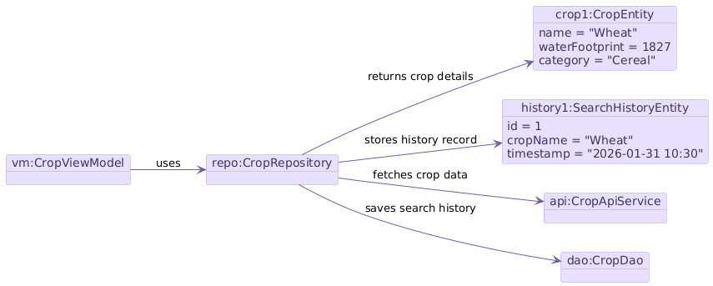
Figure 5.3: Object Diagram
5.4 Component Diagram
The component diagram shows the major software modules: Android UI, ViewModel, Repository, API Service, Room Database, and Backend Server.
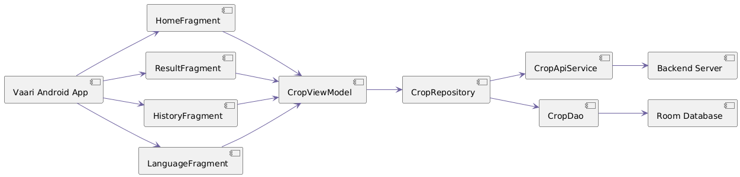
Figure 5.4: Component Diagram

5.5 Deployment Diagram
The deployment diagram shows the physical arrangement: the Android app and Room database run on the user device, while the Flask API and crop dataset are hosted on the backend server.
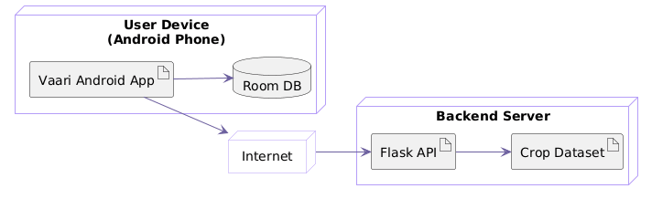
Figure 5.5: Deployment Diagram
5.6 Package Diagram
The package diagram organizes the codebase into four logical packages: ui, data, model, and network.
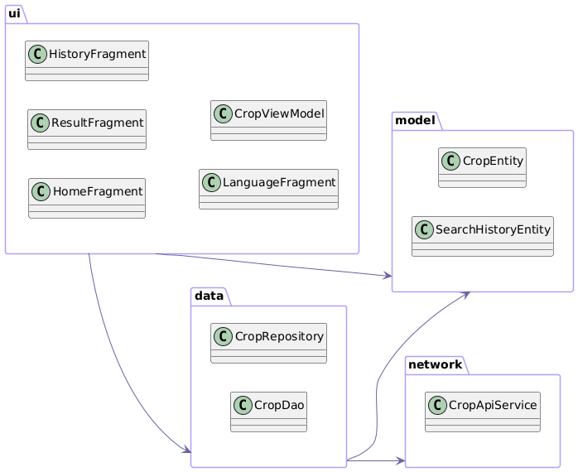
Figure 5.6: Package Diagram
5.7 Testing
Unit testing was performed to verify crop search logic, data parsing, and history storage. Integration testing confirmed that the full flow from user input to result display and history saving works correctly.

CHAPTER 6 – CONCLUSION & FUTURE WORK
_____________________________________________________________________
6. CONCLUSION & FUTURE WORK
6.1 Limitations
- The app currently works only on Android devices.
- Crop data is limited to the available backend dataset.
- Offline search is not supported for new crops.
- Camera-based crop detection is not included in this version.
6.2 Future Enhancements
- Add offline crop data support.
- Expand the crop dataset.
- Develop an iOS version.
- Add visual charts for footprint breakdown.
- Integrate government water advisory notifications.

CHAPTER 7 – BIBLIOGRAPHY & REFERENCES
_____________________________________________________________________
7. BIBLIOGRAPHY & REFERENCES
7.1 Reference Books
- Hoekstra, A.Y. et al. – The Water Footprint Assessment Manual, Earthscan, 2011.
- Pressman, R.S. – Software Engineering: A Practitioner's Approach, McGraw-Hill, 2014.
7.2 Online Resources
- Water Footprint Network – https://waterfootprint.org
- Android Developers Documentation – https://developer.android.com
- Python Flask Documentation – https://flask.palletsprojects.com
- Bureau of Water Use Efficiency – https://jalshakti-dowr.gov.in
7.3 Snapshots
Add screenshots of the application here with captions below each figure and centered.

