DBMS Lab Assignment 3

Pranav K M (19BCS088)

1. Add, Modify and Delete Column using Alter Command

CREATE DATABASE T8_Hospital_Database;

CREATE TABLE Doctor

(DID INT NOT NULL

CONSTRAINT AK_DID UNIQUE(DID),

Doctor_Name VARCHAR(45) NOT NULL,

Current_Case VARCHAR(45),

DPhone_Number VARCHAR(10) NOT NULL

CONSTRAINT AK_DPhone_Number UNIQUE(DPhone_Number),

Qualification VARCHAR(45) NOT NULL,

Salary INT NOT NULL,);

ALTER TABLE Doctor

ADD testcol INT;

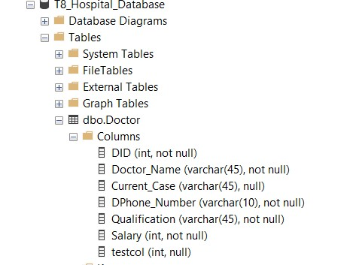

ALTER TABLE Doctor

ALTER COLUMN testcol VARCHAR(5);

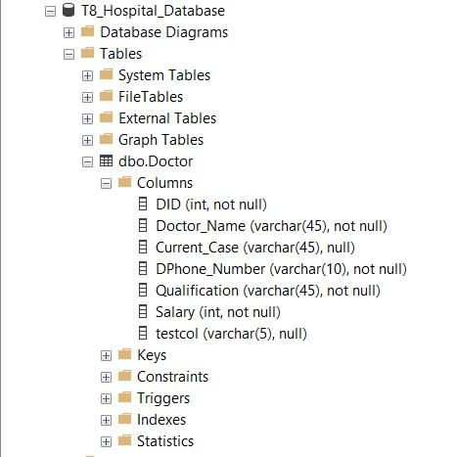

ALTER TABLE Doctor

DROP COLUMN testcol;

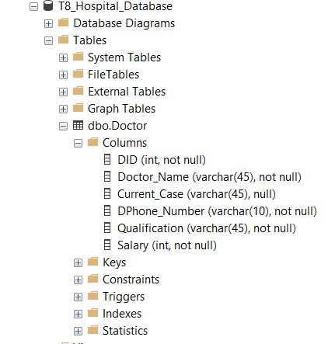

2. Insert 20 Employees Data into all the tables. Use all the 3 methods that have been showcased

INSERT INTO Doctor(DID, Doctor_Name, Current_Case, Dphone_Number, Qualification, Salary)

VALUES(1,'Abhishek Kumar','Covid','1111111111','Flu Expert',58000);

INSERT INTO Doctor(DID, Doctor_Name, Current_Case, Dphone_Number, Qualification, Salary)

VALUES(2,'Gabru','Covid','1111111112','Flu Expert',58000);

INSERT INTO Doctor(DID, Doctor_Name, Current_Case, Dphone_Number, Qualification, Salary)

VALUES(3,'Mehndi','Bird flu','1111111113','Flu Expert',38000);

INSERT INTO Doctor

VALUES(4,'Bassi','Bird flu','1111111114','Bird Watcher',38000),

(5,'Brar','Fever','1111111115','Cook',48000),

(6,'Shaan','Cold','1111111116','Singer',48000),

(7,'Dawood','','1111111117','Drug Lord',88000),

(8,'Mahes','Stomach Ache','1111111118','Flu Expert',18000),

(9,'Bhangar','','1111111119','Hacker',28000),

(10,'Bhau','','1111111120','Brother',28000),

(11,'Shankar','Gas','1111111121','Tribal',38000),

(12,'Lakshman','Nuclear Radiation','1111111130','Medical',18000),

(13,'Sweta','Burns','1111111122','Call Center',48000),

(14,'Pewds','Amnesia','1111111123','Gamer',98000),

(15,'Kevin','Amnosea','1111111124','Chaotic',68000),

(16,'Ken','','1111111125','Stramer',28000);

INSERT INTO Doctor(DID, Doctor_Name, Current_Case, Dphone_Number, Qualification, Salary)

SELECT 17,'Buff','','1111111126','Flu Expert',38000;

INSERT INTO Doctor(DID, Doctor_Name, Current_Case, Dphone_Number, Qualification, Salary)

SELECT 18,'Kalki','','1111111127','Neurologist',38000;

INSERT INTO Doctor(DID, Doctor_Name, Current_Case, Dphone_Number, Qualification, Salary)

SELECT 19,'Reva','Stress','1111111128','Psychologist',38000;

INSERT INTO Doctor(DID, Doctor_Name, Current_Case, Dphone_Number, Qualification, Salary)

SELECT 20,'Mercedes','','1111111129','Enterprenaur',38000;

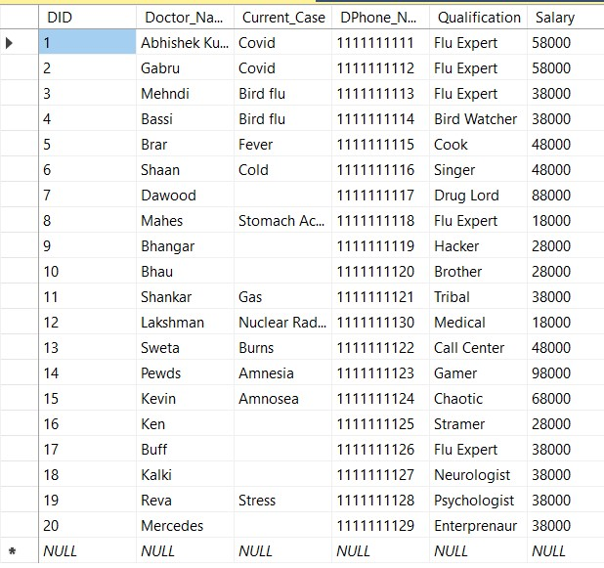

3. Show Violation of Primary Key, Unique Not Null and default key constraints through insertion.

Violation of UNIQUE KEY constraint 'AK_DPhone_Number'. Cannot insert duplicate key in object 'dbo.Doctor'. The duplicate key value is (1111111111).

Msg 207, Level 16, State 1, Line 2

Invalid column name 'Gabru'.

4. Insert tuples into the table and see how foreign key constraint works if you try to insert into dependent table first.

Use T8_Hospital_Database

SELECT DID,Current_Case INTO FEE from Doctor;

Use T8_Hospital_Database

INSERT INTO FEE(DID)

VALUES(30);

Msg 547, Level 16, State 0, Line 2

The INSERT statement conflicted with the FOREIGN KEY constraint "FK__FEE__DID__276EDEB3". The conflict occurred in database "T8_Hospital_Database", table "dbo.Doctor", column 'DID'.

The statement has been terminated.

5. Show Violation of Foreign Key Constraint when you try to delete from a base table. If you get an error explain why deletion gives an error

Use T8_Hospital_Database

ALTER TABLE FEE

ADD FOREIGN KEY (DID) REFERENCES Doctor(DID)

Use T8_Hospital_Database

ALTER TABLE Doctor

DROP COLUMN DID

Msg 5074, Level 16, State 1, Line 2

The object 'AK_DID' is dependent on column 'DID'.

Msg 5074, Level 16, State 1, Line 2

The object 'FK__FEE__DID__276EDEB3' is dependent on column 'DID'.

Msg 4922, Level 16, State 9, Line 2

ALTER TABLE DROP COLUMN DID failed because one or more objects access this column.

6. Try to update a non-existing entity data and check for error.

Use T8_Hospital_Database

UPDATE Doctor SET Dphone_Number='123456789'

WHERE DID=1;



7. Add a column which has default value.

Use T8_Hospital_Database

ALTER TABLE FEE

ADD paydate date default getdate()

8. 5 Simple Select queries to retrieve data from your database.

Use T8_Hospital_Database

SELECT Current_case FROM Doctor WHERE DID=3;

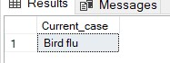

Use T8_Hospital_Database

SELECT * FROM Doctor;

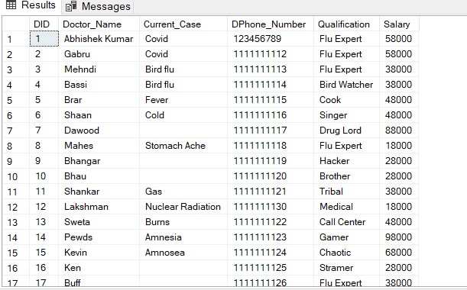

Use T8_Hospital_Database

SELECT DID,Current_Case FROM FEE;

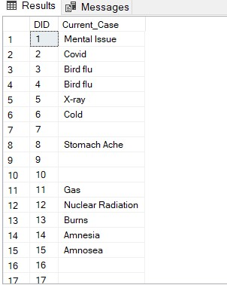

9. Show how foreign key constraint effects updating a dependent table when value is not existing and in Base table where the value is referred and you want to update it.

Use T8_Hospital_Database

UPDATE FEE SET Current_Case='Mental Issue'

WHERE DID=1;

(1 row affected)

Use T8_Hospital_Database

UPDATE FEE SET Current_Case='X-ray'

WHERE DID=5;

(1 row affected)

Use T8_Hospital_Database

UPDATE FEE SET Current_Case='X-ray'

WHERE DID=37;

(0 rows affected)