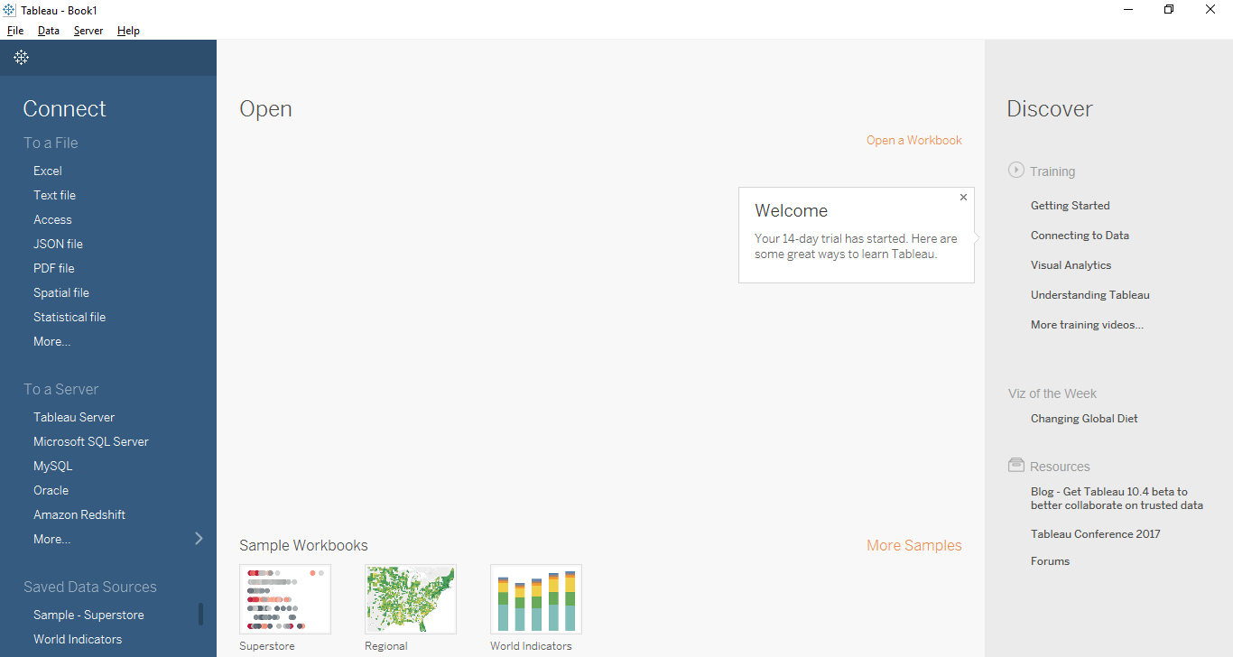

This is the GUI of Tableau.We go to help>Manage External Service Connection.Server name is localhost and port is 6311.

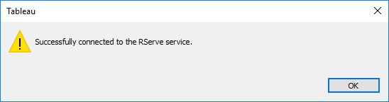

We click on “Test Connection” to see if the connection between R and Tableau is active or not.

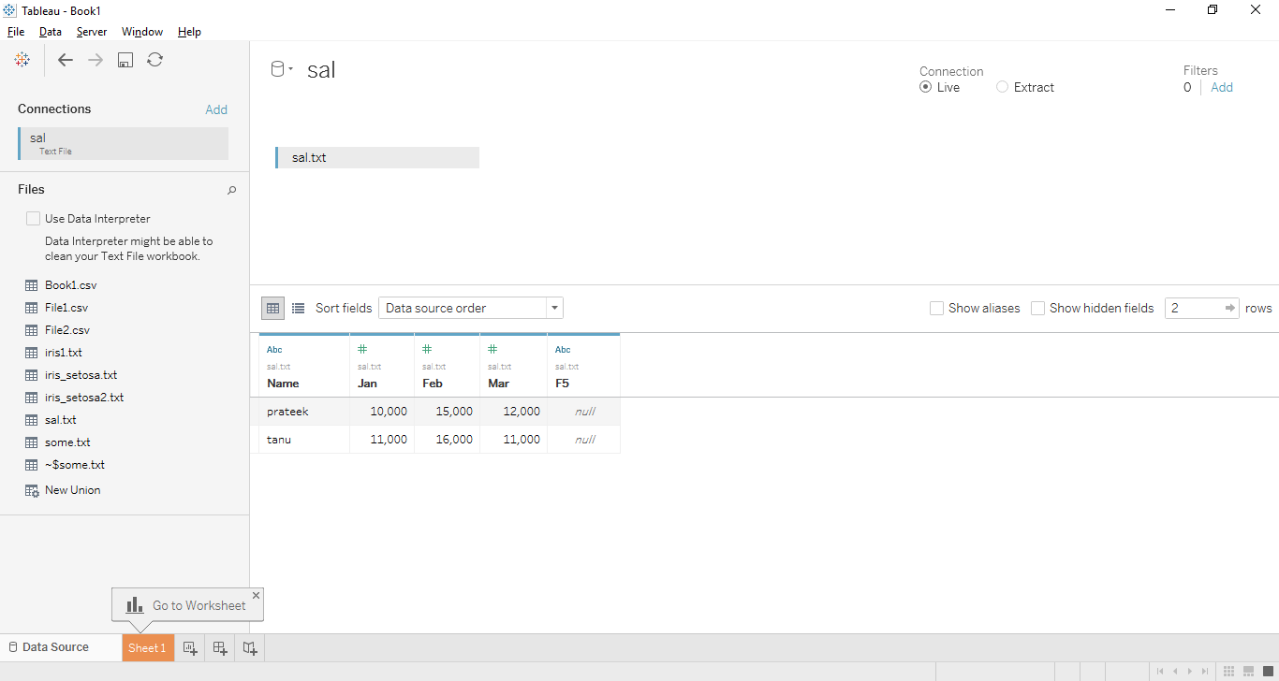

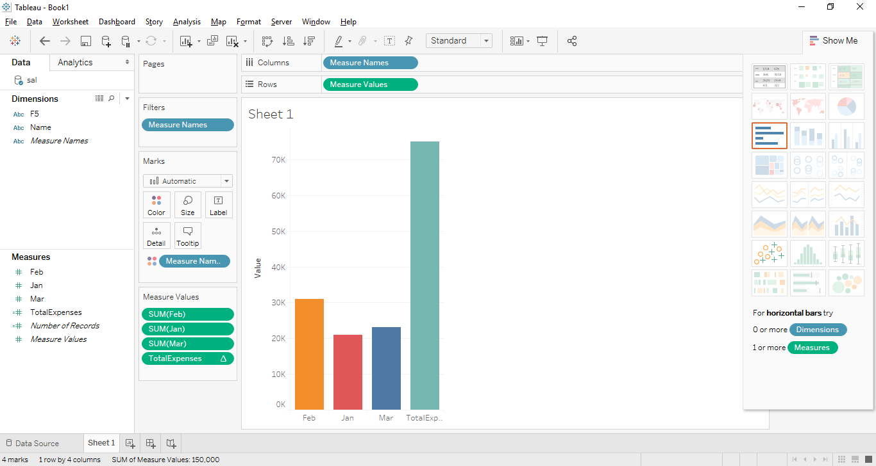

Bar graph constructed in Tableau by using the month Jan,Feb and Mar and TotalExpenses on X axis and Value on Y axis.Pointing mouse over the bar tells you the value it corresponds to.

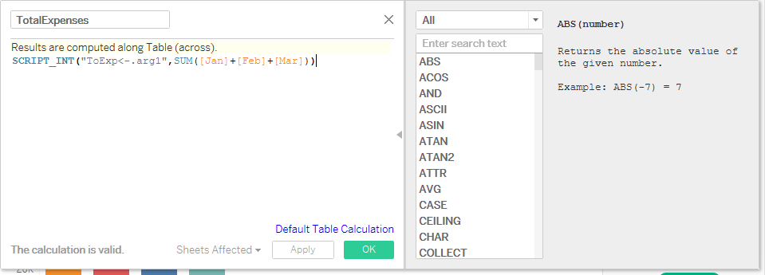

This a new calculation which is created by going Analysis tab and “Create Calculated Field”.Then we type in the name of the calculation field we want to create and write a corresponding R script for it in the space below the text box.