LEARNHUB
Architecture & Design Document

Table of Contents
Table of Contents 1
1. Introduction 2
1.1 Purpose 2
1.2 Scope 2
1.3 Definitions and Abbreviations 2
2. Architecture Overview 3
2.1 Architectural Style 3
2.2 High-Level Architecture Diagram 3
2.3 Architecture Layers 3
2.3.1 Presentation Layer 3
2.3.2 Business Logic Layer (Flow Services) 4
2.3.3 Data Access Layer (Adapter Services) 4
2.3.4 Asynchronous Messaging Layer (Pub/Sub) 4
2.3.5 External Integration Layer 4
3. Design Patterns Used 5
3.1 Service-Oriented Architecture (SOA) 5
3.2 Layered Architecture 5
3.3 Publisher/Subscriber Pattern 5
3.4 Retry Pattern (REPEAT / EXIT) 6
3.5 Update Adapter Pattern (Student Count) 6
3.6 Flat File Processing 6
4. Component Design 7
4.1 Component Diagram 7
4.2 Service Catalog 7
5. Data Design 9
5.1 Database Schema 9
5.2 Entity Relationship Diagram 10
5.3 Auto-Generation Mechanisms 10
5.3.1 Oracle Sequences 10
5.3.2 Oracle Trigger for Course ID 11
5.3.3 Student Count — IS Update SQL Adapters 11
6. Sequence Diagrams 12
6.1 enrollUser Sequence — Sync + Async Paths 12
6.2 updateProgress Sequence — REPEAT / EXIT + Transaction 13
7. Pub/Sub Event Flow 13
7.1 Event Flow Description 14
7.2 Pub/Sub Components 14
8. REST API Descriptor — LearnHubAPI 15
9. Transaction Boundaries 15
10. Non-Functional Requirements 16
10.1 Performance 16
10.2 Security 16
10.3 Reliability 17
10.4 Maintainability 17
11. Deployment Architecture 17
11.1 Deployment Steps 17
11.2 Configuration 18
12. Conclusion 18

1. Introduction

1.1 Purpose
This Architecture and Design Document describes the technical architecture, design patterns, and implementation approach for LearnHub — a full-stack enterprise learning platform built on IBM webMethods SoftwareAG Integration Server 10.15. The document serves as a reference for developers, reviewers, and stakeholders to understand the system structure, component interactions, and design decisions.

1.2 Scope
LearnHub automates the complete learning lifecycle from student registration through course enrollment to lesson completion and progress tracking. The system supports two user roles (Student and Admin) and integrates with Oracle Database, Gmail SMTP, and Gemini AI API via pub.client:http. The frontend is served as HTML files (index.html, admin.html) from the IS pub folder.

1.3 Definitions and Abbreviations
Term | Definition
IS | Integration Server (webMethods)
SOA | Service-Oriented Architecture
JDBC | Java Database Connectivity — adapter type used for all Oracle operations
SMTP | Simple Mail Transfer Protocol — used via pub.client:smtp for email
Pub/Sub | Publish/Subscribe messaging pattern — IS Adapter Notifications + Triggers
REST | Representational State Transfer — exposed via restAPIs namespace
IS Package | LearnHub_Project — the single IS package containing all services
SAGAPPLICATION | Oracle containing all LearnHub tables
courseDoc | Publishable Document Type in documents namespace — used for course events
courseImportSchema | Flat File Schema in flatFile namespace — parses course CSV files
Update Adapter | IS JDBC Update SQL adapter — used to increment/decrement courses.students

2. Architecture Overview

2.1 Architectural Style
LearnHub implements a layered Service-Oriented Architecture (SOA) on the webMethods Integration Server platform. The architecture emphasises separation of concerns, asynchronous event processing via Pub/Sub adapter notifications, and loose coupling. The frontend is React 18 served as HTML files from the IS pub folder — same-origin removes CORS complexity.

2.2 High-Level Architecture Diagram
The following diagram illustrates the complete system architecture spanning from the browser client through the webMethods Integration Server down to the Oracle database, including the Pub/Sub messaging layer and external service integrations:
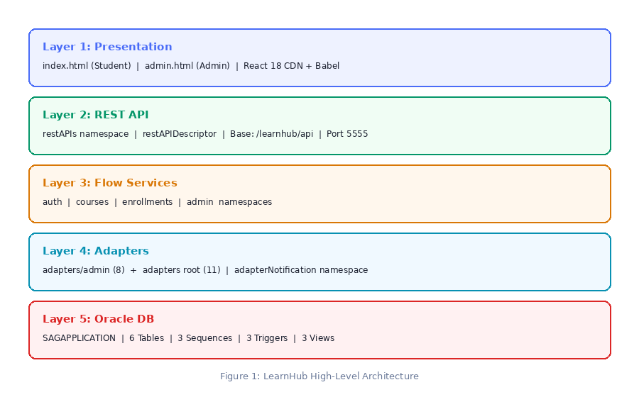
Figure 1: LearnHub High-Level Architecture

2.3 Architecture Layers

2.3.1 Presentation Layer
React 18 SPA served as index.html (student portal) and admin.html (admin panel) from the IS pub folder. All API calls use /invoke paths — same-origin, no CORS. sessionStorage stores {id, name, email, role}. admin.html reads sessionStorage on load and redirects to index.html if no token or role is not admin.

2.3.2 Business Logic Layer (Flow Services)
Flow services in auth, courses, enrollments, and admin namespaces orchestrate adapter calls, apply business rules, and format responses. enrollments:updateProgress uses REPEAT/EXIT retry pattern (count=3, label=retryLoop) with transaction boundary — demonstrates retry, atomicity, and idempotency together.

2.3.3 Data Access Layer (Adapter Services)
All database operations encapsulated in JDBC adapter services. Split into adapters/admin (8 admin-specific services) and adapters root (11 shared services). Student count maintained by two Update SQL adapters: updateCourseStudentCount (called by enrollUser — Expression: students+1) and decrementCourseStudentCount (called by unenrollUser — Expression: CASE WHEN students > 0 THEN students - 1 ELSE 0 END).

2.3.4 Asynchronous Messaging Layer (Pub/Sub)
enrollmentInsertNotification in adapterNotification namespace polls LEARNHUB_ENROLLMENTS for INSERT events and publishes documents. The onEnrollment IS trigger in triggers namespace subscribes and invokes admin:onEnrollmentChange asynchronously — sends enrollment confirmation email. courseDoc in documents namespace is used for course add events.

2.3.5 External Integration Layer
Gemini AI called via pub.client:http in courses:getChatbotResponse. API key stored in IS flow only — never sent to browser. Gmail SMTP via pub.client:smtp in admin:onEnrollmentChange and admin:sendDailyReport. IS scheduler configured as Complex Repeating at 09:00 daily.

3. Design Patterns Used

3.1 Service-Oriented Architecture (SOA)
All business logic and data access exposed as discrete, reusable services with single responsibility. Adapter services split into adapters/admin and adapters root for separation of admin vs shared operations. Each service has a clearly defined contract enabling independent development and testing.

3.2 Layered Architecture
Strict layering: frontend talks only to flow services via /invoke, flow services call adapter services, adapter services interact with the database. No cross-layer communication. The restAPIs namespace cleanly separates the REST descriptor layer from flow service logic.

3.3 Publisher/Subscriber Pattern
enrollmentInsertNotification polls LEARNHUB_ENROLLMENTS and publishes EnrollmentEvent documents via enrollmentInsertNotificationPublishDocument. The onEnrollment IS trigger asynchronously invokes admin:onEnrollmentChange. Similarly, courseDoc is published by addCourseFromFlatFile and batchAddCourses; onCourseAdd trigger invokes admin:onCourseAdd. This decouples enrollment/course-add from notification handling.

3.4 Retry Pattern (REPEAT / EXIT)
enrollments:updateProgress: REPEAT count=3, label=retryLoop. startTransaction runs inside REPEAT but outside TRY. TRY: pub.math:divideFloats → pub.math:multiplyFloats → adapters:updateProgress → adapters:insertProgressEvent (MERGE) → commitTransaction → EXIT 'retryLoop'. CATCH: rollbackTransaction. MERGE makes retries idempotent — no duplicate progress_events rows.

3.5 Update Adapter Pattern (Student Count)
Student count in learnhub_courses table is maintained using two dedicated IS Update SQL adapter services rather than Oracle triggers. updateCourseStudentCount is invoked by enrollUser after insertEnrollment — Expression field: students + 1. decrementCourseStudentCount is invoked by unenrollUser after deleteEnrollment — Expression field: CASE WHEN students > 0 THEN students - 1 ELSE 0 END. This keeps all logic in IS and makes the flow explicit and traceable.

3.6 Flat File Processing
flatFile namespace contains courseImportSchema and courseImportDictionary. Both addCourseFromFlatFile and batchAddCourses use pub.flatFile:convertToValues. Admin CSV is 9 columns — frontend auto-injects color at position 9 before POST. Critical: map individual fields from ffValues/recordWithNoID[0] — NOT whole ffValues — to avoid @record-id error.

4. Component Design

4.1 Component Diagram
The component diagram below shows how UI pages connect to flow service components, how flow services call adapter services, and how adapter notifications and triggers form the Pub/Sub layer:
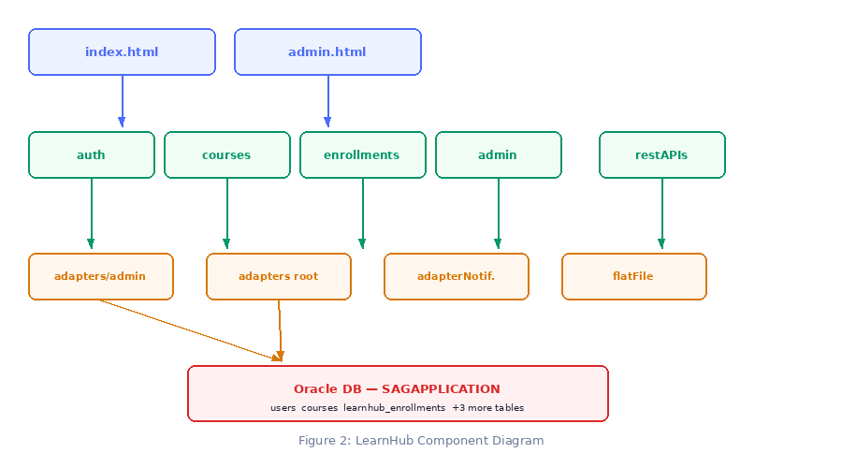
Figure 2: LearnHub Component Diagram

4.2 Service Catalog
Service | Namespace | Type | Purpose
loginUser | auth | Flow | Authenticate user. Returns ID, NAME, EMAIL, ROLE for role-based frontend redirect.
registerUser | auth | Flow | Register new user with duplicate email check.
getCourses | courses | Flow | Return all courses. STUDENTS column reflects live enrollment count.
getChatbotResponse | courses | Flow | pub.client:http → Gemini AI. Plain text prompt. API key in IS only.
enrollUser | enrollments | Flow | Enroll student. After insertEnrollment invokes updateCourseStudentCount (students+1).
unenrollUser | enrollments | Flow | Unenroll. After deleteEnrollment invokes decrementCourseStudentCount (CASE WHEN...).
getEnrollments | enrollments | Flow | Returns all enrollments for a user.
updateProgress | enrollments | REPEAT/EXIT | REPEAT x3. Transaction. divideFloats+multiplyFloats compute %. Idempotent.
getAllProgress | enrollments | Flow | Returns progress for all enrolled courses.
getProgress | enrollments | Flow | Returns progress for specific user+course.
getStats | admin | Flow | Live counts from Oracle ADMIN_STATS view.
getAllUsers | admin | Flow | All registered users.
getAllEnrollments | admin | Flow | All enrollments from ENROLLMENT_DETAILS view.
getAdminEvents | admin | Flow | Unprocessed ENROLLMENT_NOTIFICATIONS for Live Events page.
deleteUser | admin | Flow | Delete user from Oracle.
addCourseFromFlatFile | admin | Flow | Single course: CSV → courseImportSchema → courseDoc publish → onCourseAdd.
batchAddCourses | admin | Flow | Batch CSV: LOOP → courseDoc publish per row + insertBatchLog audit per row.
onCourseAdd | admin | Trigger Handler | Subscribes to CourseAddEvent. Calls adapters/admin:insertCourse.
onEnrollmentChange | admin | Trigger Handler | Subscribes to EnrollmentEvent. Sends SMTP email. Email failure non-critical.
sendDailyReport | admin | Scheduled | IS Complex Repeating 09:00 daily. pub.client:smtp reminder to admin.

5. Data Design

5.1 Database Schema
Oracle database, schema SAGAPPLICATION. Five tables form the core data model. The learnhub_courses.students column is maintained by two IS Update SQL adapter services called explicitly from enrollUser and unenrollUser flow services.
Table | Column | Type | Notes
learnhub_users | id | NUMBER | PK — DEFAULT users_seq.NEXTVAL
 | name, email | VARCHAR2 | email UNIQUE NOT NULL
 | password_hash | VARCHAR2(255) | NOT NULL
 | role | VARCHAR2(10) | DEFAULT 'student' — student / admin
learnhub_courses | id | NUMBER | PK — courses_seq + courses_before_insert TRIGGER
 | title, category, instructor | VARCHAR2
 | course_level | VARCHAR2(20) | NOT 'LEVEL' — Oracle reserved word
 | color | VARCHAR2(20) | Auto-assigned by frontend from category
 | course_desc | VARCHAR2(500) | NOT 'DESCRIPTION' — Oracle reserved word
 | students | NUMBER | Maintained by Update SQL adapters: +1 on enroll, -1 on unenroll via IS flow
learnhub_enrollments | id | NUMBER | PK — enrollments_seq
 | user_id, course_id | NUMBER | FK → users.id, courses.id
 | progress | NUMBER | 0–100 percentage
 | current_lesson | NUMBER | Last completed lesson
learnhub_enrollment_notification | id | IDENTITY | GENERATED ALWAYS AS IDENTITY
 | user_id, course_id, enrollment_id | NUMBER | processed DEFAULT 'N'
learnhub_progress_events | id | IDENTITY | GENERATED ALWAYS AS IDENTITY — MERGE prevents duplicates
 | user_id, course_id, lesson_number, progress_pct | NUMBER

5.2 Entity Relationship Diagram
The following diagram shows the relationships between the five core tables. learnhub_users and learnhub_enrollments connect via user_id. learnhub_courses and learnhub_enrollments connect via course_id. The students column in courses is kept accurate via dedicated IS Update SQL adapter calls:
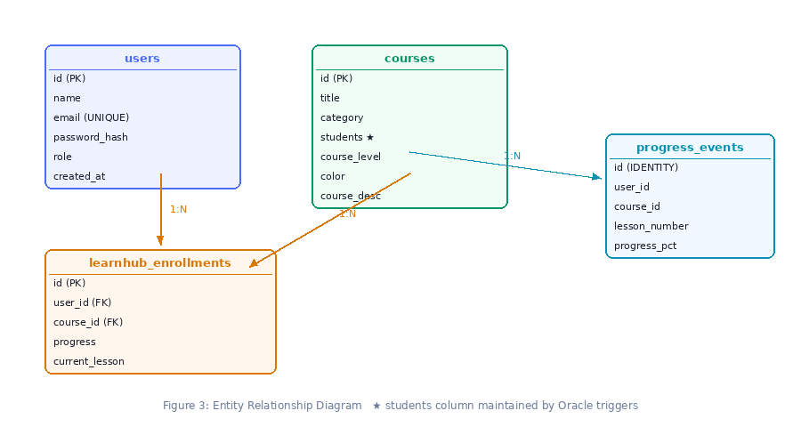
Figure 3: Entity Relationship Diagram (★ students maintained by IS Update SQL adapters)

5.3 Auto-Generation Mechanisms

5.3.1 Oracle Sequences
Sequence | Used By | Notes
users_seq | users.id column | DEFAULT users_seq.NEXTVAL on column — auto-assigned on INSERT
enrollments_seq | adapters:insertEnrollment | Assigned in adapter service
courses_seq | courses_before_insert trigger | Starts at 9 — courses 1–8 seeded at setup. Trigger assigns NEXTVAL.

5.3.2 Oracle Trigger for Course ID
courses_before_insert: BEFORE INSERT on courses — assigns courses_seq.NEXTVAL to id when null. This is the only Oracle DB trigger used. Student count is handled by IS Update SQL adapters, not Oracle triggers.
Trigger | Event | Action
courses_before_insert | BEFORE INSERT on courses | SELECT courses_seq.NEXTVAL INTO :NEW.id FROM DUAL — assigns ID when null

5.3.3 Student Count — IS Update SQL Adapters
Two dedicated JDBC Update SQL adapter services maintain the learnhub_courses.students column. These are called explicitly from enrollUser and unenrollUser flow services:
Adapter Service | Called By | Expression (SET clause) | WHERE
updateCourseStudentCount | enrollments:enrollUser | students + 1 | ID = ? (course_id input)
decrementCourseStudentCount | enrollments:unenrollUser | students - 1 | ID = ? (course_id input)

6. Sequence Diagrams

6.1 enrollUser Sequence
This diagram traces the complete enrollment flow. The synchronous path (steps 1–4) returns success to the student immediately. The asynchronous path (steps 5–10) handles the adapter notification and confirmation email in the background. Note step 3 also invokes the updateCourseStudentCount adapter atomically:
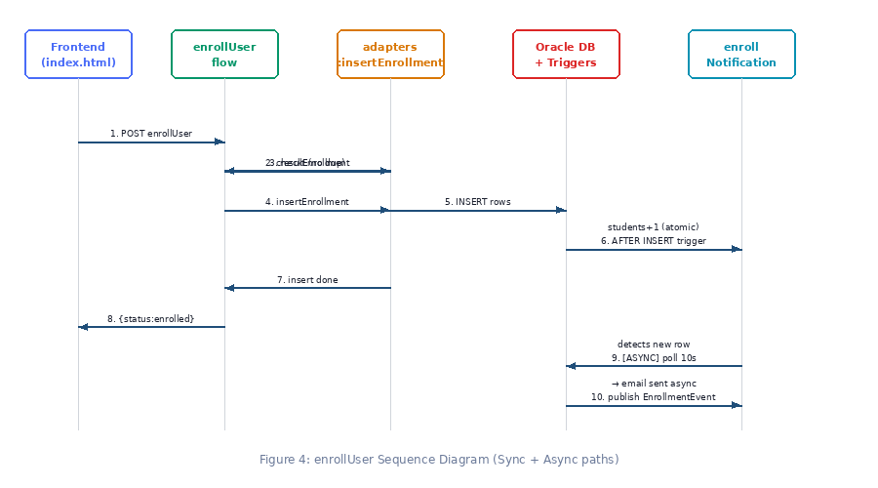
Figure 4: enrollUser Sequence Diagram

6.2 updateProgress Sequence — REPEAT / EXIT + Transaction
This diagram shows the REPEAT/EXIT retry pattern and transaction boundary in updateProgress. startTransaction is outside TRY but inside REPEAT. divideFloats and multiplyFloats compute the percentage. MERGE ensures idempotent progress event inserts on retry:
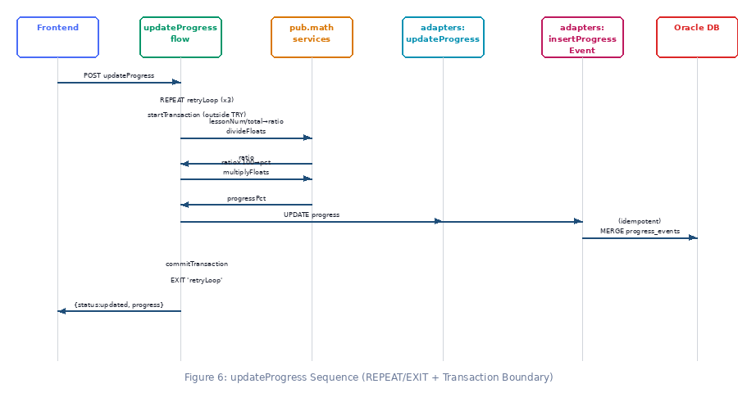
Figure 6: updateProgress Sequence (REPEAT/EXIT + Transaction Boundary)

7. Pub/Sub Event Flow
The Pub/Sub pattern decouples enrollment operations from notification handling. The synchronous path returns success immediately after the DB insert. The asynchronous path processes email notification in the background via adapter notification → IS trigger → subscriber service:
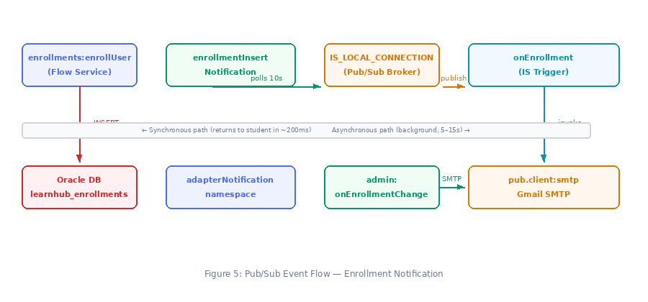
Figure 5: Pub/Sub Event Flow — Enrollment Notification Architecture

7.1 Event Flow Description
Steps 1–4 represent the synchronous user-facing path. The student clicks Enroll and within ~200ms the system returns success after insertEnrollment completes and updateCourseStudentCount increments the students column. The user sees immediate feedback.
Steps 5–10 occur asynchronously in the background. The enrollmentInsertNotification adapter polls LEARNHUB_ENROLLMENTS every 10 seconds, detects the new row, and publishes EnrollmentEvent via enrollmentInsertNotificationPublishDocument to IS_LOCAL_CONNECTION. The onEnrollment IS trigger fires and calls admin:onEnrollmentChange. The handler fetches user and course details, builds the email, and sends via pub.client:smtp. Email failure is caught and logged — it never rolls back the enrollment.

7.2 Pub/Sub Components
Component | Namespace | Role
enrollmentInsertNotification | adapterNotification | Polls LEARNHUB_ENROLLMENTS for INSERT events every 10 seconds
enrollmentInsertNotificationPublishDocument | adapterNotification | Defines published document structure — USER_ID, COURSE_ID, ID, ENROLLED_AT
courseDoc | documents | Publishable document type for course add events — 10 course fields
onEnrollment | triggers | IS Trigger — subscribes to EnrollmentEvent → invokes admin:onEnrollmentChange
onCourseAdd | triggers | IS Trigger — subscribes to CourseAddEvent → invokes admin:onCourseAdd

8. REST API Descriptor — LearnHubAPI
Namespace: restAPIs | Components: restAPIDescriptor, restResource, restResource_ | Base path: /learnhub/api | Port: 5555
Method | Path | IS Service | Description
POST | /register | auth:registerUser | Register new user
POST | /login | auth:loginUser | Authenticate — returns ROLE
GET | /courses | courses:getCourses | All courses with live students count
POST | /courses/add | admin:addCourseFromFlatFile | Add single course via flat file
POST | /enrollments/enroll | enrollments:enrollUser | Enroll — IS adapter increments students
POST | /enrollments/unenroll | enrollments:unenrollUser | Unenroll — IS adapter decrements students
GET | /enrollments/{userId} | enrollments:getEnrollments | Get enrollments for user
GET | /admin/stats | admin:getStats | Stats from admin_stats view
GET | /admin/users | admin:getAllUsers | All registered users
GET | /admin/enrollments | admin:getAllEnrollments | All enrollments with progress
DELETE | /admin/users/{userId} | admin:deleteUser | Delete user

9. Transaction Boundaries
All JDBC adapter services use LOCAL transaction type. IS manages commit/rollback explicitly via pub.art.transaction services.
Flow Service | Writes | Boundary | Reason
enrollments:updateProgress | 2 | REQUIRED | UPDATE progress + MERGE progress_events must be atomic. REPEAT/EXIT retry.
enrollments:enrollUser | 2 | REQUIRED | insertEnrollment + updateCourseStudentCount should be atomic.
enrollments:unenrollUser | 2 | REQUIRED | deleteEnrollment + decrementCourseStudentCount should be atomic.
auth:registerUser | 1 | Optional | Single INSERT into USERS.
admin:onCourseAdd | 1 | Optional | Single INSERT via adapters/admin:insertCourse.
auth:loginUser | 0 | Not needed | SELECT only.
admin:onEnrollmentChange | 0 | Not needed | SMTP only — email failure must not roll back enrollment.
admin:sendDailyReport | 0 | Not needed | SMTP only — never retry email.

10. Non-Functional Requirements

10.1 Performance
- Course list auto-refresh every 30 seconds on Courses page
- Progress polling: on login + tab focus + every 60 seconds (smart polling)
- Admin enrollments auto-refresh every 10 seconds
- Admin Live Events polls every 5 seconds
- getChatbotResponse marked Stateless=True, Cache Results=True (5 min) for repeated questions

10.2 Security
- Role-based access: ROLE from Oracle USERS table, stored in sessionStorage on login
- admin.html reads sessionStorage on load — redirects to index.html if no token or role != admin
- Gemini API key stored in courses:getChatbotResponse IS flow — never sent to browser
- Gmail SMTP uses 16-character App Password not regular account password

10.3 Reliability
- Adapter notification decoupling: SMTP failure never blocks enrollment transaction
- REPEAT/EXIT retry on updateProgress: handles transient Oracle connection failures up to 3 times
- MERGE in insertProgressEvent: idempotent retries — no duplicate progress_events rows
- updateCourseStudentCount and decrementCourseStudentCount called explicitly — traceable in IS logs
- insertProgressEvent MERGE ensures idempotent lesson completion events

10.4 Maintainability
- IS package structure mirrors architecture: each namespace has single clear responsibility
- Adapters split: adapters/admin (8 admin ops) vs adapters root (11 shared ops)
- All SQL in adapter services — no inline SQL anywhere in flow services
- Update SQL adapters use Expression field for students count — no stored procedures or Oracle triggers needed
- flatFile namespace centralises courseImportSchema and courseImportDictionary

11. Deployment Architecture
The deployment architecture is shown below. IS Designer connects to local IS which manages all package contents. IS connects to Oracle via JDBC. External calls go out to Gemini API and Gmail SMTP:
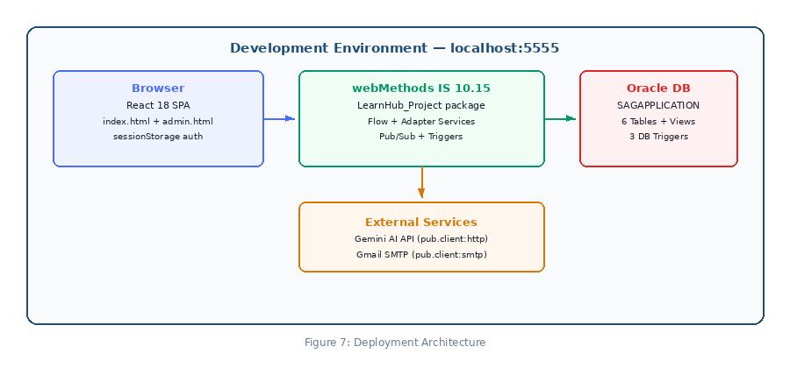
Figure 7: LearnHub Deployment Architecture

11.1 Deployment Steps
- Start Oracle database service from Windows Services
- Run: C:\wMServiceDesigner\IntegrationServer\bin\startup.bat
- IS Admin → Packages → Management → LearnHub_Project → Reload
- Verify jdbcConnection is Active (Adapters → JDBC → Connections)
- Enable IS Triggers: triggers/onCourseAdd and triggers/onEnrollment
- Enable Adapter Notification: adapterNotification/enrollmentInsertNotification
- Create files folder: C:\wMServiceDesigner\IntegrationServer\packages\LearnHub_Project\files\
- Update fileAccessControl.cnf — add LearnHub_Project/files/ to all three path settings
- Place index.html and admin.html in IS pub folder

11.2 Configuration
Configuration Item | Location | Notes
JDBC Connection | jdbcConnection (package root) | Oracle SAGAPPLICATION / SAGAPPLICATION user
SMTP Credentials | admin:onEnrollmentChange Set Value | smtp.gmail.com:465 + Gmail App Password
Gemini API Key | courses:getChatbotResponse Set Value | In URL ?key=YOUR_API_KEY
File Access | config/fileAccessControl.cnf | allowedWritePaths, allowedReadPaths, allowedDeletePaths = ...\LearnHub_Project\files\
Student App | IS pub folder | http://localhost:5555/LearnHub_Project/index.html
Admin Panel | IS pub folder | http://localhost:5555/LearnHub_Project/admin.html (admin role required)
IS Admin Console | http://localhost:5555 | Username: Administrator / Password: manage

12. Conclusion
LearnHub demonstrates enterprise-grade integration design through a clear IS package structure, layered SOA architecture, asynchronous event-driven Pub/Sub via adapter notifications, and resilient flow services using REPEAT/EXIT retry patterns with transaction boundaries.
A key design decision is using dedicated IS Update SQL adapter services (updateCourseStudentCount and decrementCourseStudentCount) to maintain the learnhub_courses.students column — keeping all business logic within IS and making the flow fully traceable via IS logs and service monitoring. The Pub/Sub layer with adapter notifications, IS triggers, and SMTP integration demonstrates enterprise messaging patterns, while the flat file + batch import with courseImportSchema demonstrates IS file processing capabilities.

