**TUBERCULOSIS CLASSIFICATION BY USING ARTIFICIAL INTELLIGENCE**

**TABLE OF CONTENT**

|  |  |  |
| --- | --- | --- |
| **SL.NO** | **TITLE** | **PAGE.NO** |
| **01.** | **ABSTRACT** |  |
| **02.** | **EXISTING SYSTEM**  2.1 DRAWBACKS |  |
| **03.** | **INTRODUCTION**  3.1 DATA SCIENCE  3.2 ARTIFICIAL INTELLIGENCE |  |
| **04.** | **MACHINE LEARNING** |  |
| **05.** | **DEEP LEARNING** |  |
| **06.** | **PREPARING THE DATASET** |  |
| **07.** | **PROPOSED SYSTEM**  7.1 ADVANTAGES |  |
| **08.** | **LITERATURE SURVEY** |  |
| **09.** | **SYSTEM STUDY**  9.1 PROJECT GOAL  9.2 OBJECTIVES  9.3 SCOPE OF THE PROJECT |  |
| **10.** | **OUTLINE OF THE PROJECT**  10.1 OVERVIEW OF THE SYSTEM |  |
| **11.** | **PROJECT REQUIREMENT**  11.1 FUNCTIONAL REQUIREMENT  11.2 NON-FUNCTIONAL REQUIREMENT |  |
| **12.** | **FEASIBILITY STUDY**  12.1 DATAFLOW DIAGRAM |  |
| **13.** | **SYSTEM ARCHITECTURE** |  |
| **14.** | **WORKFLOW DIAGRAM** |  |
| **15.** | **USECASE DIAGRAM** |  |
| **16.** | **CLASS DIAGRAM** |  |
| **17.** | **ACTIVITY DIAGRAM** |  |
| **18.** | **SEQUENCE DIAGRAM** |  |
| **19.** | **E.R – DIAGRAM** |  |
| **20.** | **COLLABORATION DIAGRAM** |  |
| **21.** | **ENVIRONMENT REQUIREMENT** |  |
| **22.** | **SOFTWARE DESCRIPTION**  22.1 ANACONDA NAVIGATOR  22.2 JUPYTER NOTEBOOK  22.3 PYCHARM |  |
| **23.** | **PYTHON** |  |
| **24.** | **METHODOLOGY** |  |
| **25.** | **ARTIFICIAL NEURAL NETWORK (ANN)** |  |
| **26.** | **ARCHITECTURE OF CNN** |  |
| **27.** | **TYPES OF CNN**  27.1 VGG-16  27.2 LENET |  |
| **28.** | **LIST OF MODULES** |  |
| **29.** | **MODULE DESCRIPTION**  29.1 IMPORT THE GIVEN IMAGE FROM DATASET  29.2 TO TRAIN THE MODULE BY GIVEN IMAGE DATASET  29.3 WORKING PROCESS OF LAYERS IN CNN MODEL  29.4 CLASSIFICATION IDENTIFICATION |  |
| **30.** | **DEPLOY**  30.1 DJANGO  30.2 HTML  30.3 CSS |  |
| **31.** | **CODING** |  |
| **32.** | **CONCLUSION** |  |
| **33.** | **FUTURE WORK** |  |

**LIST OF FIGURES**

|  |  |  |
| --- | --- | --- |
| **SL.NO** | **TITLE** | **PAGE.NO** |
| **1.** | **DATAFLOW DIAGRAM** |  |
| **2.** | **SYSTEM ARCHITECTURE** |  |
| **3.** | **WORKFLOW DIAGRAM** |  |
| **4.** | **USECASE DIAGRAM** |  |
| **5.** | **CLASS DIAGRAM** |  |
| **6.** | **ACTIVITY DIAGRAM** |  |
| **7.** | **SEQUENCE DIAGRAM** |  |
| **8.** | **E.R – DIAGRAM** |  |
| **9.** | **COLLABORATION DIAGRAM** |  |

**LIST OF SYSMBOLS**

|  |  |  |  |
| --- | --- | --- | --- |
| **S.NO** | **NOTATION**  **NAME** | **NOTATION** | **DESCRIPTION** |
| 1. | Class | *+ public*  *-private*  *# protected*  *Class Name*  *-attribute*  *-attribute*  *+operation*  *+operation*  *+operation* | Represents a collection of similar entities grouped together. |
| 2. | Association | nAME  Class B  Class A    Class A  Class B | Associations represents static relationships between classes. Roles represents the way the two classes see each other. |
| 3. | Actor | Class A  Class A  Class B  Class B | It aggregates several classes into a single classes. |
| 4. | Aggregation | Interaction between the system and external environment |

|  |  |  |  |
| --- | --- | --- | --- |
| 5. | Relation  (uses) | uses | Used for additional process communication. |
| 6. | Relation  (extends) | EXTENDS | Extends relationship is used when one use case is similar to another use case but does a bit more. |
| 7. | Communication |  | Communication between various use cases. |
| 8. | State | State | State of the process. |
| 9. | Initial State |  | Initial state of the object |
| 10. | Final state |  | Final state of the object |
| 11. | Control flow |  | Represents various control flow between the states. |
| 12. | Decision box |  | Represents decision making process from a constraint |
| 13. | Usecase |  | Interact ion between the system and external environment. |

|  |  |  |  |
| --- | --- | --- | --- |
| 14. | Component |  | Represents physical modules which is a collection of components. |
| 15. | Node |  | Represents physical modules which are a collection of components. |
| 16. | Data Process/State |  | A circle in DFD represents a state or process which has been triggered due to some event or acion. |
| 17. | External entity |  | Represents external entities such as keyboard,sensors,etc. |
| 18. | Transition |  | Represents communication that occurs between processes. |
| 19. | Object Lifeline |  | Represents the vertical dimensions that the object communications. |
| 20. | Message | Message | Represents the message exchanged. |

**TUBERCULOSIS CLASSIFICATION BY USING ARTIFICIAL INTELLIGENCE**

**Abstract:**

Tuberculosis (TB) is a disease that mainly affects human lungs. It can be fatal if the treatment is delayed. Tuberculosis (TB) is a potentially serious infectious disease that mainly affects the lungs. The bacteria that cause tuberculosis are spread from person to person through tiny droplets released into the air via coughs and sneezes. Most people infected with the bacteria that cause tuberculosis don’t have symptoms. When symptoms do occur, they usually include a cough (sometimes blood-tinged), weight loss, night sweats and fever. Treatment is not always required for those without symptoms. Patients with active symptoms will require a long course of treatment involving multiple antibiotics. We proposed the system to find out the Tuberculosis disease based on the x-ray images. We train the dataset by CNN Architectures and gets more accuracy. Finally we can deploy the project by using Django framework.

**Keywords:** Tuberculosis, Deep Learning, Tensor Flow, Keras, CNN

**Existing System:**

Rapid detection of mycobacterium tuberculosis bacteria is very important in reducing tuberculosis disease. We propose a label-free graphene-based refractive index sensor using a machine learning approach that detects mycobacterium tuberculosis bacteria. The biosensor is designed for higher sensitivity by analysing different parameters like substrate thickness, resonator thickness, and angle of incidence. We have presented a biosensor design for detecting mycobacterium tuberculosis bacteria. The biosensor is designed using a plus-shape meta-surface based on graphene material. The novel machine learning approach is used for predicting the best values of different parameters such as graphene chemical potential, substrate thickness, resonator thickness, and angle of incidence. Graphene material used in the design gives a good impact on the sensitivity. Mycobacterium tuberculosis bacteria concentrations with different values of refractive index are analysed and the highest sensitivity is achieved. The highest sensitivity is achieved 1000 nm/RIU. The sensitivity results are also compared with previously published results.

**2.1 Drawback:**

* They are not using CNN Architecture for getting better predictions.
* Image classification is not done.
* Deep Learning Technique is not implemented.
* Deployment is not done.

**INTRODUCTION**

Tuberculosis (TB) is a disease caused by bacteria that are spread from person to person through the air. TB usually affects the lungs, but it can also affect other parts of the body, such as the brain, the kidneys, or the spine. In most cases, TB is treatable and curable; however, people with TB can die if they do not get proper treatment. Sometimes drug-resistant TB occurs when bacteria become resistant to the drugs used to treat TB. This means that the drug can no longer kill the TB bacteria.

Drug-resistant TB (DR TB) is spread the same way that drug-susceptible TB is spread. TB is spread through the air from one person to another. The TB bacteria are put into the air when a person with TB disease of the lungs or throat coughs, sneezes, speaks, or sings. People nearby may breathe in these bacteria and become infected.

**Domain overview:**

**Data Science:**

Data science is an interdisciplinary field that uses scientific methods, processes, algorithms and systems to extract knowledge and insights from structured and unstructured data, and apply knowledge and actionable insights from data across a broad range of application domains.

The term "data science" has been traced back to 1974, when Peter Naur proposed it as an alternative name for computer science. In 1996, the International Federation of Classification Societies became the first conference to specifically feature data science as a topic. However, the definition was still in flux.

The term “data science” was first coined in 2008 by D.J. Patil, and Jeff Hammer bacher, the pioneer leads of data and analytics efforts at LinkedIn and Facebook. In less than a decade, it has become one of the hottest and most trending professions in the market.

Data science is the field of study that combines domain expertise, programming skills, and knowledge of mathematics and statistics to extract meaningful insights from data.

Data science can be defined as a blend of mathematics, business acumen, tools, algorithms and machine learning techniques, all of which help us in finding out the hidden insights or patterns from raw data which can be of major use in the formation of big business decisions.

**Data Scientist:**

Data scientists examine which questions need answering and where to find the related data. They have business acumen and analytical skills as well as the ability to mine, clean, and present data. Businesses use data scientists to source, manage, and analyze large amounts of unstructured data.

**Required Skills for a Data Scientist:**

* **Programming**: Python, SQL, Scala, Java, R, MATLAB.
* **Machine Learning**: Natural Language Processing, Classification, Clustering.
* **Data Visualization**: Tableau, SAS, D3.js, Python, Java, R libraries.
* **Big data platforms**: MongoDB, Oracle, Microsoft Azure, Cloudera.
  1. **ARTIFICIAL INTELLIGENCE**:

Artificial intelligence (AI) refers to the simulation of human intelligence in machines that are programmed to think like humans and mimic their actions. The term may also be applied to any machine that exhibits traits associated with a human mind such as learning and problem-solving.

Artificial intelligence (AI) is [intelligence](https://en.wikipedia.org/wiki/Intelligence) demonstrated by [machines](https://en.wikipedia.org/wiki/Machine), as opposed to the natural intelligence [displayed by humans](https://en.wikipedia.org/wiki/Human_intelligence) or [animals](https://en.wikipedia.org/wiki/Animal_cognition). Leading AI textbooks define the field as the study of “[intelligent agents](https://en.wikipedia.org/wiki/Intelligent_agent)” any system that perceives its environment and takes actions that maximize its chance of achieving its goals.

Some popular accounts use the term “artificial intelligence” to describe machines that mimic “cognitive” functions that humans associate with the [human mind](https://en.wikipedia.org/wiki/Human_mind), such as “learning” and “problem solving”, however this definition is rejected by major AI researchers.

Artificial intelligence is the simulation of human intelligence processes by machines, especially computer systems. Specific applications of AI include expert systems, natural language processing, speech recognition and machine vision.

AI applications include advanced web search engines, recommendation systems (used by Youtube, Amazon and Netflix), Understanding human speech (such as Siri or Alexa), self-driving cars (e.g. Tesla), and competing at the highest level in strategic game systems (such as chess and Go), As machines become increasingly capable, tasks considered to require “intelligence” are often removed from the definition of AI, a phenomenon known as the AI effect. For instance, optical character recognition is frequently excluded from things considered to be AI, having become a routine technology.

Artificial intelligence was founded as an academic discipline in 1956, and in the years since has experienced several waves of optimism, followed by disappointment and the loss of funding (known as an “AI winter”), followed by new approaches, success and renewed funding.

AI research has tried and discarded many different approaches during its lifetime, including simulating the Tuberculosis, modeling human problem solving, formal logic, large databases of knowledge and imitating animal behavior. In the first decades of the 21st century, highly mathematical statistical machine learning has dominated the field, and this technique has proved highly successful, helping to solve many challenging problems throughout industry and academia.

The various sub-fields of AI research are centered around particular goals and the use of particular tools. The traditional goals of AI research include reasoning, knowledge representation, planning, learning, natural language processing, perception and the ability to move and manipulate objects. General intelligence (the ability to solve an arbitrary problem) is among the field’s long-term goals.

To solve these problems, AI researchers use versions of search and mathematical optimization, formal logic, artificial neural networks, and methods based on statistics, probability and economics. AI also draws upon computer science, psychology, linguistics, philosophy, and many other fields.

The field was founded on the assumption that human intelligence “can be so precisely described that a machine can be made to simulate it”. This raises philosophical arguments about the mind and the ethics of creating artificial beings endowed with human-like intelligence.

These issues have been explored by myth, fiction and philosophy since antiquity. Science fiction and futurology have also suggested that, with its enormous potential and power, AI may become an existential risk to humanity.

As the hype around AI has accelerated, vendors have been scrambling to promote how their products and services use AI. Often what they refer to as AI is simply one component of AI, such as machine learning.

AI requires a foundation of specialized hardware and software for writing and training machine learning algorithms. No one programming language is synonymous with AI, but a few, including Python, R and Java, are popular.

In general, AI systems work by ingesting large amounts of labeled training data, analyzing the data for correlations and patterns, and using these patterns to make predictions about future states.

In this way, a chatbot that is fed examples of text chats can learn to produce life like exchanges with people, or an image recognition tool can learn to identify and describe objects in images by reviewing millions of examples.

AI programming focuses on three cognitive skills: learning, reasoning and self-correction.

**Learning processes.** This aspect of AI programming focuses on acquiring data and creating rules for how to turn the data into actionable information. The rules, which are called algorithms, provide computing devices with step-by-step instructions for how to complete a specific task.

**Reasoning processes.** This aspect of AI programming focuses on choosing the right algorithm to reach a desired outcome.

**Self-correction processes.** This aspect of AI programming is designed to continually fine-tune algorithms and ensure they provide the most accurate results possible.

AI is important because it can give enterprises insights into their operations that they may not have been aware of previously and because, in some cases, AI can perform tasks better than humans. Particularly when it comes to repetitive, detail-oriented tasks like analyzing large numbers of legal documents to ensure relevant fields are filled in properly, AI tools often complete jobs quickly and with relatively few errors.

Artificial neural networks and deep learning artificial intelligence technologies are quickly evolving, primarily because AI processes large amounts of data much faster and makes predictions more accurately than humanly possible.

* 1. **DEEP LEARNING**

Deep learning is a branch of machine learning which is completely based on artificial neural networks, as neural network is going to mimic the human disease so deep learning is also a kind of mimic of human disease. It’s on hype nowadays because earlier we did not have that much processing power and a lot of data. A formal definition of deep learning is- neurons Deep learning is a particular kind of machine learning that achieves great power and flexibility by learning to represent the world as a nested hierarchy of concepts, with each concept defined in relation to simpler concepts, and more abstract representations computed in terms of less abstract ones. In disease approximately 100 billion neurons all together this is a picture of an individual neuron and each neuron is connected through thousands of their neighbors. The question here is how it recreates these neurons in a computer. So, it creates an artificial structure called an artificial neural net where we have nodes or neurons. It has some neurons for input value and some for output value and in between, there may be lots of neurons interconnected in the hidden layer.

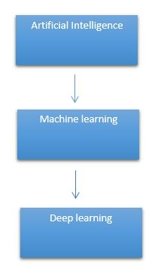

It need to identify the actual problem in order to get the right solution and it should be understood, the feasibility of the Deep Learning should also be checked (whether it should fit Deep Learning or not). It needs to identify the relevant data which should correspond to the actual problem and should be prepared accordingly. Choose the Deep Learning Algorithm appropriately. Algorithm should be used while training the dataset. Final testing should be done on the dataset

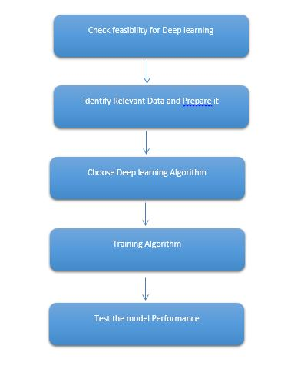

Deep learning (also known as deep structured learning) is part of a broader family of machine learning methods based on artificial neural networks with representation learning. Learning can be supervised, semi-supervised or unsupervised.

Deep-learning architectures such as deep neural networks, deep belief networks, deep reinforcement learning, recurrent neural networks and convolutional neural networks have been applied to fields including computer vision, speech recognition, natural language processing, machine translation, bioinformatics, drug design, medical image analysis, material inspection and board game programs, where they have produced results comparable to and in some cases surpassing human expert performance.

Artificial neural networks (ANNs) were inspired by information processing and distributed communication nodes in biological systems. ANNs have various differences from biological disease. Specifically, neural networks tend to be static and symbolic, while the biological disease of most living organisms is dynamic (plastic) and analogue.

The adjective "deep" in deep learning refers to the use of multiple layers in the network. Early work showed that a linear perceptron cannot be a universal classifier, but that a network with a non-polynomial activation function with one hidden layer of unbounded width can. Deep learning is a modern variation which is concerned with an unbounded number of layers of bounded size, which permits practical application and optimized implementation, while retaining theoretical universality under mild conditions. In deep learning the layers are also permitted to be heterogeneous and to deviate widely from biologically informed connectionist models, for the sake of efficiency, trainability and understandability, whence the "structured" part.

Deep learning is a class of [machine learning](https://en.wikipedia.org/wiki/Machine_learning) [algorithms](https://en.wikipedia.org/wiki/Algorithm) that uses multiple layers to progressively extract higher-level features from the raw input. For example, in [image processing](https://en.wikipedia.org/wiki/Image_processing), lower layers may identify edges, while higher layers may identify the concepts relevant to a human such as digits or letters or faces.

**Interpretations:**

Deep neural networks are generally interpreted in terms of the universal approximation theorem or probabilistic inference.

The classic universal approximation theorem concerns the capacity of feed-forward neural networks with a single hidden layer of finite size to approximate continuous functions. In 1989, the first proof was published by George Cybenko for sigmoid activation functions and was generalised to feed-forward multi-layer architectures in 1991 by Kurt Hornik. Recent work also showed that universal approximation also holds for non-bounded activation functions such as the rectified linear unit.

The universal approximation theorem for deep neural networks concerns the capacity of networks with bounded width but the depth is allowed to grow proved that if the width of a deep neural network with ReLU activation is strictly larger than the input dimension, then the network can approximate any Lebesgue integrable function; If the width is smaller or equal to the input dimension, then deep neural network is not a universal approximator.

The probabilistic interpretation derives from the field of machine learning. It features inference, as well as the optimization concepts of training and testing, related to fitting and generalization, respectively. More specifically, the probabilistic interpretation considers the activation nonlinearity as a cumulative distribution function. The probabilistic interpretation led to the introduction of dropout as regularizer in neural networks. The probabilistic interpretation was introduced by researchers including Hopfield, Widrow and Narendra and popularized in surveys such as the one by Bishop.

### Deep learning revolution:

### In 2012, a team led by George E. Dahl won the "Merck Molecular Activity Challenge" using multi-task deep neural networks to predict the biomolecular target of one drug. In 2014, Hochreiter's group used deep learning to detect off-target and toxic effects of environmental chemicals in nutrients, household products and drugs and won the "Tox21 Data Challenge" of NIH, FDA and NCATS.

Significant additional impacts in image or object recognition were felt from 2011 to 2012. Although CNNs trained by back-propagation had been around for decades, and GPU implementations of NNs for years, including CNNs, fast implementations of CNNs on GPUs were needed to progress on computer vision. In 2011, this approach achieved for the first time superhuman performance in a visual pattern recognition contest. Also in 2011, it won the ICDAR Chinese handwriting contest, and in May 2012, it won the ISBI image segmentation contest. Until 2011, CNNs did not play a major role at computer vision conferences, but in June 2012, a paper by Ciresan et al. at the leading conference CVPR showed how max-pooling CNNs on GPU can dramatically improve many vision benchmark records.

In October 2012, a similar system by Krizhevsky et al. won the large-scale ImageNet competition by a significant margin over shallow machine learning methods. In November 2012, Ciresan et al.'s system also won the ICPR contest on analysis of large medical images for cancer detection, and in the following year also the MICCAI Grand Challenge on the same topic. In 2013 and 2014, the error rate on the ImageNet task using deep learning was further reduced, following a similar trend in large-scale speech recognition.

Image classification was then extended to the more challenging task of generating descriptions (captions) for images, often as a combination of CNNs and LSTMs.

Some researchers state that the October 2012 ImageNet victory anchored the start of a "deep learning revolution" that has transformed the AI industry.

In March 2019, Yoshua Bengio, Geoffrey Hinton and Yann LeCun were awarded the Turing Award for conceptual and engineering breakthroughs that have made deep neural networks a critical component of computing.

**PROPOSED SYSTEM:**

The proposed method is to train a deep learning algorithm capable of classifying Tuberculosis x-ray images. We classify the images based on Convolutional Neural Network (CNN) Algorithm. Initially we analyse the dataset and implemented the CNN Architectures for train our dataset. It is predicted that the success of the obtained results will increase if the CNN method is supported by adding extra feature extraction methods to classify the images successfully. We are using Tensorflow, Keras packages for creating CNN architectures. Most of the predefined packages are available in python, so we go for the python programming language. More than two architectures were implemented, so we can get different accuracies in different architectures. We compare to select the best architecture by the result of accuracy. Once we get more accuracy then we can save the model. After deploying Django Framework for User Interface purpose.

**5.1 Advantages:**

* We are using proper CNN Architecture to classify the disease. It is a proper way to analyse the disease.
* We are using more than two architectures for getting better accuracy results.
* Deployment can be done.

**PREPARING THE DATASET:**

This dataset is collected from a website which contains overall 1000 image records of features extracted, which were then split into train and test data. We also differentiated the data as normal and Tuberculosis.

**LITERATURE SURVEY**

**General**

A literature review is a body of text that aims to review the critical points of current knowledge on and/or methodological approaches to a particular topic. It is secondary sources and discuss published information in a particular subject area and sometimes information in a particular subject area within a certain time period.

Its ultimate goal is to bring the reader up to date with current literature on a topic and forms the basis for another goal, such as future research that may be needed in the area and precedes a research proposal and may be just a simple summary of sources. Usually, it has an organizational pattern and combines both summary and synthesis.

A summary is a recap of important information about the source, but a synthesis is a re-organization, reshuffling of information. It might give a new interpretation of old material or combine new with old interpretations or it might trace the intellectual progression of the field, including major debates. Depending on the situation, the literature review may evaluate the sources and advise the reader on the most pertinent or relevant of them. Loan default trends have been long studied from a socio-economic stand point.

Most economics surveys believe in empirical modeling of these complex systems in order to be able to predict the loan default rate for a particular individual. The use of machine learning for such tasks is a trend which it is observing now. Some of the survey’s to understand the past and present perspective of loan approval or not.

**Review of Literature Survey**

**Title** : Can we predict tuberculosis cure? What tools are available?

**Author** : Delia Goletti1 , Cecilia S. Lindestam Arlehamn

**Year** : 2018

Antibiotic treatment of tuberculosis takes ⩾6 months, putting a major burden on patients and health systems in large parts of the world. Treatment beyond 2 months is needed to prevent tuberculosis relapse by clearing remaining, drug-tolerant Mycobacterium tuberculosis bacilli. However, the majority of patients treated for only 2–3 months will cure without relapse and do not need prolonged treatment. Assays that can identify these patients at an early stage of treatment may significantly help reduce the treatment burden, while a test to identify those patients who will fail treatment may help target host-directed therapies. In this review we summarise the state of the art with regard to discovery of biomarkers that predict relapse-free cure for pulmonary tuberculosis. Positron emission tomography/computed tomography scanning to measure pulmonary inflammation enhances our understanding of “cure”. Several microbiological and immunological markers seem promising; however, they still need a formal validation. In parallel, new research strategies are needed to generate reliable tests

**Title** : Predicting Active Pulmonary Tuberculosis Using an Artificial Neural Network

**Author** : Ali A. El-Solh, MD; Chiu-Bin Hsiao

**Year** : 1999

The most important aspect of a tuberculosis (TB) infection control program is to identify patients who may have contagious active TB, to isolate them while they are contagious, and to treat them effectively. The process of recognizing those persons with active TB is, however, fraught with difficulty. As a result, numerous outbreaks of Mycobacterium tuberculosis have been reported in several types of facilities. At least 21 episodes of nosocomial transmission of M tuberculosis have been documented in the United States medical literature. Among the factors that have been associated with missed or delayed diagnosis are failure to consider the diagnosis, nonclassical or atypical radiographic presentation, delayed recognition of drug resistance, lapses in TB isolation practices, and lack of adequate respiratory protection. Prediction models to identify patients with active TB have been lacking. The reason for this lies in the complexity of the clinical and radiographic presentation, the relatively small patient samples, and the use of modeling techniques that are poorly suited for the task. Recently, El-Solh et al introduced a classification tree to assist physicians in their decision regarding whether respiratory isolation for suspicion of active pulmonary TB is needed. The model achieved a high degree of sensitivity at the expense of low specificity

**Title** : Evolution of Machine Learning in Tuberculosis Diagnosis: A Review of Deep Learning-Based Medical Applications

**Author** : Manisha Singh 1 , Gurubasavaraj Veeranna Pujar

**Year** : 2022

Tuberculosis (TB) is an infectious disease that has been a major menace to human health globally, causing millions of deaths yearly. Well-timed diagnosis and treatment are an arch to full recovery of the patient. Computer-aided diagnosis (CAD) has been a hopeful choice for TB diagnosis. Many CAD approaches using machine learning have been applied for TB diagnosis, specific to the artificial intelligence (AI) domain, which has led to the resurgence of AI in the medical field. Deep learning (DL), a major branch of AI, provides bigger room for diagnosing deadly TB disease. This review is focused on the limitations of conventional TB diagnostics and a broad description of various machine learning algorithms and their applications in TB diagnosis. Furthermore, various deep learning methods integrated with other systems such as neuro-fuzzy logic, genetic algorithm, and artificial immune systems are discussed. Finally, multiple state-of-the-art tools such as CAD4TB, Lunit INSIGHT, qXR, and InferRead DR Chest are summarized to view AI-assisted future aspects in TB diagnosis.

**Title** : Predicting bovine tuberculosis status of dairy cows from mid-infrared spectral data of milk using deep learning

**Author** : S. J. Denholm, W. Brand

**Year** : 2020

Bovine tuberculosis (bTB) is a zoonotic disease in cattle that is transmissible to humans, distributed worldwide, and considered endemic throughout much of England and Wales. Mid-infrared (MIR) analysis of milk is used routinely to predict fat and protein concentration, and is also a robust predictor of several other economically important traits including individual fatty acids and body energy. This study predicted bTB status of UK dairy cows using their MIR spectral profiles collected as part of routine milk recording. Bovine tuberculosis data were collected as part of the national bTB testing program for Scotland, England, and Wales; these data provided information from over 40,500 bTB herd breakdowns. Corresponding individual cow life–history data were also available and provided information on births, movements, and deaths of all cows in the study. Data relating to single intradermal comparative cervical tuberculin (SICCT) skin-test results, culture, slaughter status, and presence of lesions were combined to create a binary bTB phenotype labeled 0 to represent nonresponders (i.e., healthy cows) and 1 to represent responders (i.e., bTB-affected cows). Contemporaneous individual milk MIR spectral data were collected as part of monthly routine milk recording and matched to bTB status of individual animals on the single intradermal comparative cervical tuberculin test date (±15 d). Deep learning, a sub-branch of machine learning, was used to train artificial neural networks and develop a prediction pipeline for subsequent use in national herds as part of routine milk recording. Spectra were first converted to 53 × 20-pixel PNG images, then used to train a deep convolutional neural network. Deep convolutional neural networks resulted in a bTB prediction accuracy (i.e., the number of correct predictions divided by the total number of predictions) of 71% after training for 278 epochs. This was accompanied by both a low validation loss (0.71) and moderate sensitivity and specificity (0.79 and 0.65, respectively). To balance data in each class, additional training data were synthesized using the synthetic minority over sampling technique. Accuracy was further increased to 95% (after 295 epochs), with corresponding validation loss minimized (0.26), when synthesized data were included during training of the network. Sensitivity and specificity also saw a 1.22- and 1.45-fold increase to 0.96 and 0.94, respectively, when synthesized data were included during training. We believe this study to be the first of its kind to predict bTB status from milk MIR spectral data. We also believe it to be the first study to use milk MIR spectral data to predict a disease phenotype, and posit that the automated prediction of bTB status at routine milk recording could provide farmers with a robust tool that enables them to make early management decisions on potential reactor cows, and thus help slow the spread of bTB.

**Title** : Predicting the Outcome of Therapy for Pulmonary Tuberculosis

**Author** : ROBERT S. WALLIS, MARK D. PERKINS

**Year** : 2000

Patients vary considerably in their response to treatment of pulmonary tuberculosis. Although several studies have indicated that adverse outcomes are more likely in those patients with delayed sputum sterilization, few tools are available to identify those patients prospectively. In this study, multivariate models were developed to predict the response to therapy in a prospectively recruited cohort of 42 HIV-uninfected subjects with drug-sensitive tuberculosis. The cohort included 2 subjects whose initial response was followed by drug-sensitive relapse. The total duration of culture positivity was best predicted by a model that included sputum M. tuberculosis antigen 85 concentration on Day 14 of therapy, days-to-positive in BACTEC on Day 30, and the baseline radiographic extent of disease (R 5 0.63). A model in which quantitative AFB microscopy replaced BACTEC also performed adequately (R 5 0.58). Both models predicted delayed clearance of bacilli in both relapses (. 85th percentile of all subjects) using information collected during the first month of therapy. Stratification of patients according to anticipated response to therapy may allow TB treatment to be individualized, potentially offering superior outcomes and greater efficiency in resource utilization, and aiding in the conduct of clinical trials.

**SYSTEM STUDY**

**8.1 Aim:**

We are aiming to detect the tuberculosis as fast as possible so we went for radiological diagnostics and detect pulmonary tuberculosis by chest X-ray scans. So we can avoid patient with a certain distance. It is an infectious disease that causes inflammation, the formation of tubercles and other growths within tissue, and can cause tissue death. These chest x-rays show advanced pulmonary tuberculosis

#### **8.2 Objectives:**

The goal is to develop a deep learning model for tuberculosis Disease image prediction by convolutional neural network algorithm for potentially classifying the results in the form of best accuracy by comparing the CNN architectures.

**8.3 Scope:**

We can do Chest X-rays for the tuberculosis patients and we can furtherly observe abnormalities associated with tuberculosis. So these all are diagnosed using Chest X-ray. So in future with a huge data set we can classify the range of severity of tuberculosis. Because now a days tuberculosis is emerging with multi drug resistance variant. So it is essential to update the process of identification in the Tuberculosis

**OUTLINE OF THE PROJECT**

**Overview of the system:**

* Define a problem
* Gathering image data set
* Evaluating algorithms
* Detecting results

**Data collection** (Splitting Training set & Test) set)

**Pre Processing** (Sequential)

**Building classification Model**

**Prediction (**Identification of Tuberculosis**)**

Fig: data flow diagram for CNN model

**PROJECT REQUIREMENTS**

**General:**

Requirements are the basic constrains that are required to develop a system. Requirements are collected while designing the system. The following are the requirements that are to be discussed.

1. Functional requirements

2. Non-Functional requirements

3. Environment requirements

A. Hardware requirements

B. software requirements

**9.1 Functional requirements:**

The software requirements specification is a technical specification of requirements for the software product. It is the first step in the requirements analysis process. It lists requirements of a particular software system. The following details to follow the special libraries like tensorflow, keras, matplotlib.

**9.2 Non-Functional Requirements:**

Process of functional steps,

1. Problem define
2. Preparing data
3. Evaluating algorithm
4. Improving results
5. Prediction the result

**Environment Requirements:**

**Framework :** Keras.

**Software Requirements:**

* Operating System : Windows / Linux
* Simulation Tool : Anaconda with Jupyter Notebook
* Language : Python

**Hardware requirements:**

* Processor : Intel i3
* Hard disk : minimum 400 GB
* RAM : minimum 4 GB

**FEASIBILITY STUDY**

**Splitting the dataset:**

The data use is usually split into training data and test data. The training set contains a known output and the model learns on this data in order to be generalized to other data later on. It has the test dataset (or subset) in order to test our models and it will do this using Tensor flow library in Python using the Keras method.

**Construction of a Detecting Model:**

## Deep learning needs data gathering have lot of past image data’s. Training and testing this model working and predicting correctly.

Data Gathering

CNN Algorithm

Train model

Prediction

Test model

Fig: Steps of dataflow diagram

**11. DESIGN ARCHITECTURE**

**General**

Design is meaningful engineering representation of something that is to be built. Software design is a process design is the perfect way to accurately translate requirements in to a finished software product. Design creates a representation or model, provides detail about software data structure, architecture, interfaces and components that are necessary to implement a system.

**11.1 Data Flow Diagram:**

Image Details

Test dataset

Preprocessing

Identification of Tuberculosis

CNN Algorithm

Training dataset

Fig: Process of dataflow diagram

A data flow diagram (DFD) is a graphical representation of the "flow" of data through an information system, modeling its process aspects. A DFD is often used as a preliminary step to create an overview of the system without going into great detail, which can later be elaborated. DFDs can also be used for the visualization of data processing (structured design). A DFD shows what kind of information will be input to and output from the system, how the data will advance through the system, and where the data will be stored. It does not show information about process timing or whether processes will operate in sequence or in parallel, unlike a traditional structured flowchart which focuses on control flow, or a UML activity workflow diagram, which presents both control and data flows as a unified model. Data flow diagrams are also known as bubble charts. DFD is a designing tool used in the top down approach to Systems Design. Symbols and Notations Used in DFDs Using any convention’s DFD rules or guidelines, the symbols depict the four components of data flow diagrams.

External entity: an outside system that sends or receives data, communicating with the system being diagrammed. They are the sources and destinations of information entering or leaving the system. They might be an outside organization or person, a computer system or a business system. They are also known as terminators, sources and sinks or actors. They are typically drawn on the edges of the diagram.

Process: any process that changes the data, producing an output. It might perform computations, or sort data based on logic, or direct the data flow based on business rules.

Data store: files or repositories that hold information for later use, such as a database table or a membership form.

Data flow: the route that data takes between the external entities, processes and data stores. It portrays the interface between the other components and is shown with arrows, typically labeled with a short data name, like “Billing details.”

DFD levels and layers A data flow diagram can dive into progressively more detail by using levels and layers, zeroing in on a particular piece. DFD levels are numbered 0, 1 or 2, and occasionally go to even Level 3 or beyond. The necessary level of detail depends on the scope of what you are trying to accomplish. DFD Level 0 is also called a Context Diagram. It’s a basic overview of the whole system or process being analyzed or modeled. It’s designed to be an at-a-glance view, showing the system as a single high-level process, with its relationship to external entities. It should be easily understood by a wide audience, including stakeholders, business analysts, data analysts and developers.

* 1. **System Architecture:**

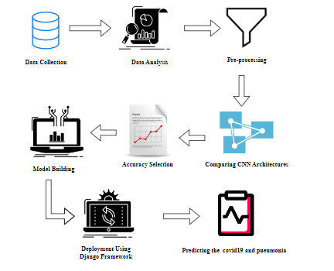

* 1. **Work flow diagram:**

Source images

Testing Dataset

Training Dataset

CNN algorithm

Identification of

Fig: Workflow Diagram

* 1. **USECASE DIAGRAM:**

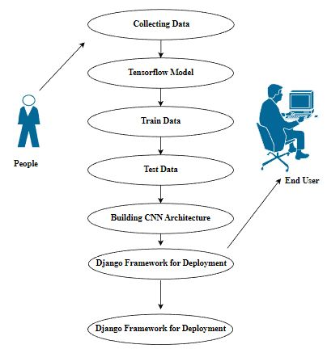

Use case diagrams are considered for high level requirement analysis of a system. So when the requirements of a system are analyzed the functionalities are captured in use cases. So, it can say that uses cases are nothing but the system functionalities written in an organized manner.

* 1. **CLASS DIAGRAM:**

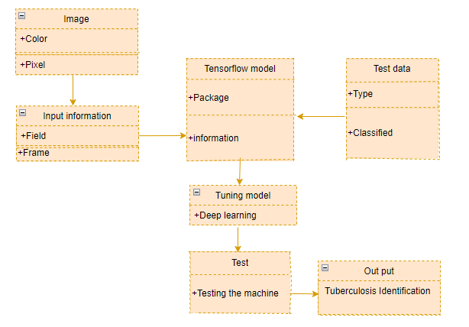

Class diagram is basically a graphical representation of the static view of the system and represents different aspects of the application. So a collection of class diagrams represent the whole system. The name of the class diagram should be meaningful to describe the aspect of the system. Each element and their relationships should be identified in advance Responsibility (attributes and methods) of each class should be clearly identified for each class minimum number of properties should be specified and because, unnecessary properties will make the diagram complicated. Use notes whenever required to describe some aspect of the diagram and at the end of the drawing it should be understandable to the developer/coder. Finally, before making the final version, the diagram should be drawn on plain paper and rework as many times as possible to make it correct.

* 1. **ACTIVITY DIAGRAM:**

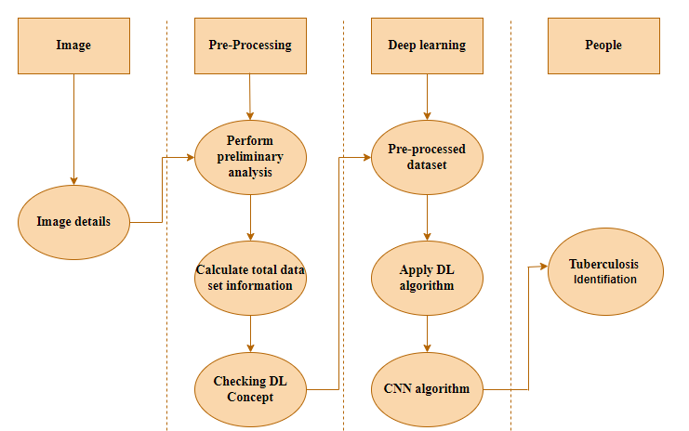

Activity is a particular operation of the system. Activity diagrams are not only used for visualizing dynamic nature of a system but they are also used to construct the executable system by using forward and reverse engineering techniques. The only missing thing in activity diagram is the message part. It does not show any message flow from one activity to another. Activity diagram is some time considered as the flow chart. Although the diagrams looks like a flow chart but it is not. It shows different flow like parallel, branched, concurrent and single.

* 1. **SEQUENCE DIAGRAM:**

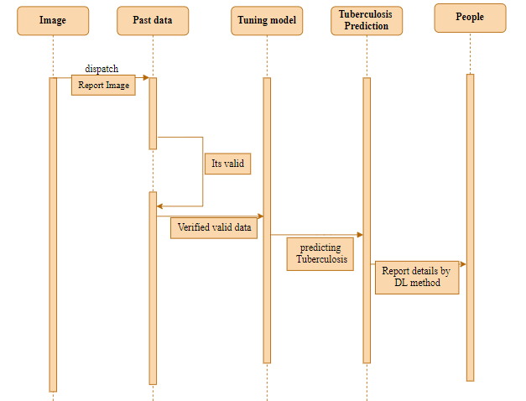

Sequence diagrams model the flow of logic within your system in a visual manner, enabling you both to document and validate your logic, and are commonly used for both analysis and design purposes. Sequence diagrams are the most popular UML artifact for dynamic modelling, which focuses on identifying the behaviour within your system. Other dynamic modelling techniques include [activity diagramming](http://agilemodeling.com/artifacts/activityDiagram.htm), [communication diagramming](http://agilemodeling.com/artifacts/communicationDiagram.htm), [timing diagramming](http://agilemodeling.com/artifacts/timingDiagram.htm), and [interaction overview diagramming](http://agilemodeling.com/artifacts/interactionOverviewDiagram.htm). Sequence diagrams, along with [class diagrams](http://agilemodeling.com/artifacts/classDiagram.htm) and [physical data models](http://agiledata.org/essays/dataModeling101.html) are in my opinion the most important design-level models for modern business application development.

**ER DIAGRAM:**

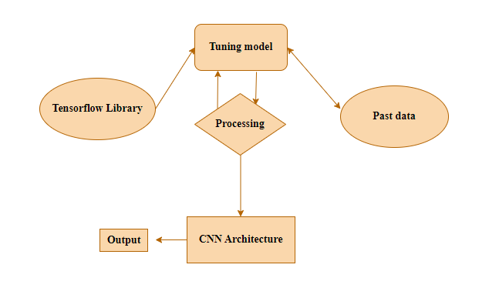

An entity relationship diagram (ERD), also known as an entity relationship model, is a graphical representation of an information system that depicts the relationships among people, objects, places, concepts or events within that system. An ERD is a data modeling technique that can help define business processes and be used as the foundation for a relational database. Entity relationship diagrams provide a visual starting point for database design that can also be used to help determine information system requirements throughout an organization. After a relational database is rolled out, an ERD can still serve as a referral point, should any debugging or business process re-engineering be needed later.

* 1. **COLLABORATION DIAGRAM:**

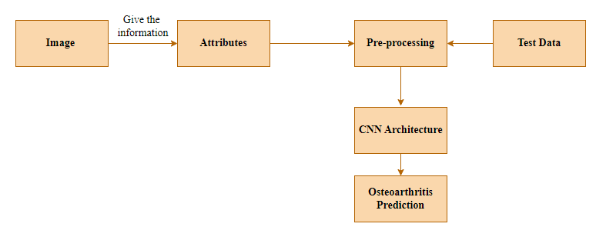

A collaboration diagram show the objects and relationships involved in an interaction, and the sequence of messages exchanged among the objects during the interaction.

The collaboration diagram can be a decomposition of a class, class diagram, or part of a class diagram.it can be the decomposition of a use case, use case diagram, or part of a use case diagram.

The collaboration diagram shows messages being sent between classes and object (instances). A diagram is created for each system operation that relates to the current development cycle (iteration).

**SOFTWARE DESCRIPTION**

Anaconda is a [free and open-source](https://en.wikipedia.org/wiki/Free_and_open-source) distribution of the [Python](https://en.wikipedia.org/wiki/Python_(programming_language)) and [R](https://en.wikipedia.org/wiki/R_(programming_language)) programming languages for [scientific computing](https://en.wikipedia.org/wiki/Scientific_computing) ([data science](https://en.wikipedia.org/wiki/Data_science), [machine learning](https://en.wikipedia.org/wiki/Machine_learning) applications, large-scale data processing, [predictive analytics](https://en.wikipedia.org/wiki/Predictive_analytics), etc.), that aims to simplify [package management](https://en.wikipedia.org/wiki/Package_management) and deployment. Package versions are managed by the [package management system](https://en.wikipedia.org/wiki/Package_manager) “Conda”. The Anaconda distribution is used by over 12 million users and includes more than 1400 popular data-science packages suitable for Windows, Linux, and MacOS. So, Anaconda distribution comes with more than 1,400 packages as well as the [Conda](https://en.wikipedia.org/wiki/Conda_(package_manager)) package and virtual environment manager called Anaconda Navigator and it eliminates the need to learn to install each library independently. The open source packages can be individually installed from the Anaconda repository with the conda install command or using the pip install command that is installed with Anaconda. [Pip packages](https://en.wikipedia.org/wiki/Pip_(package_manager)) provide many of the features of conda packages and in most cases they can work together. Custom packages can be made using the conda build command, and can be shared with others by uploading them to Anaconda Cloud, [PyPI](https://en.wikipedia.org/wiki/Python_Package_Index) or other repositories. The default installation of Anaconda2 includes Python 2.7 and Anaconda3 includes Python 3.7. However, you can create new environments that include any version of Python packaged with conda.

**12.1 ANACONDA NAVIGATOR:**

Anaconda Navigator is a desktop graphical user interface (GUI) included in Anaconda® distribution that allows you to launch applications and easily manage conda packages, environments, and channels without using command-line commands. Navigator can search for packages on Anaconda.org or in a local Anaconda Repository.

Anaconda. Now, if you are primarily doing data science work, Anaconda is also a great option. Anaconda is created by Continuum Analytics, and it is a Python distribution that comes preinstalled with lots of useful python libraries for data science.

Anaconda is a distribution of the Python and R programming languages for scientific computing (data science, machine learning applications, large-scale data processing, predictive analytics, etc.), that aims to simplify package management and deployment.

In order to run, many scientific packages depend on specific versions of other packages. Data scientists often use multiple versions of many packages and use multiple environments to separate these different versions.

The command-line program conda is both a package manager and an environment manager. This helps data scientists ensure that each version of each package has all the dependencies it requires and works correctly.

Navigator is an easy, point-and-click way to work with packages and environments without needing to type conda commands in a terminal window. You can use it to find the packages you want, install them in an environment, run the packages, and update them – all inside Navigator.

The following applications are available by default in Navigator:

* [JupyterLab](https://jupyterlab.readthedocs.io/en/stable/)
* [Jupyter Notebook](https://jupyter.readthedocs.io/en/latest/)
* [Spyder](https://www.spyder-ide.org/)
* [PyCharm](https://www.jetbrains.com/pycharm/documentation/)
* [VSCode](https://code.visualstudio.com/docs)
* [Glueviz](http://glueviz.org/en/stable/)
* [Orange 3 App](http://orange.biolab.si/docs/)
* [RStudio](http://docs.rstudio.com/)
* Anaconda Prompt (Windows only)
* Anaconda PowerShell (Windows only)

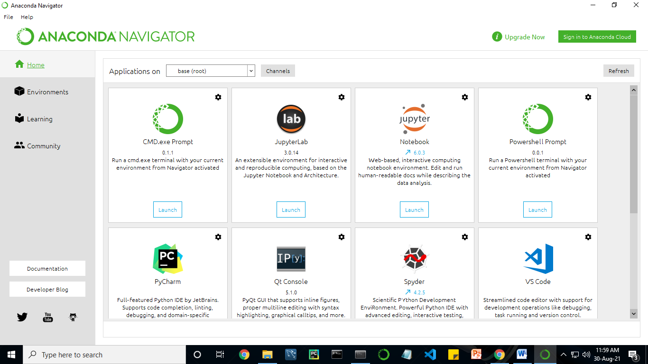

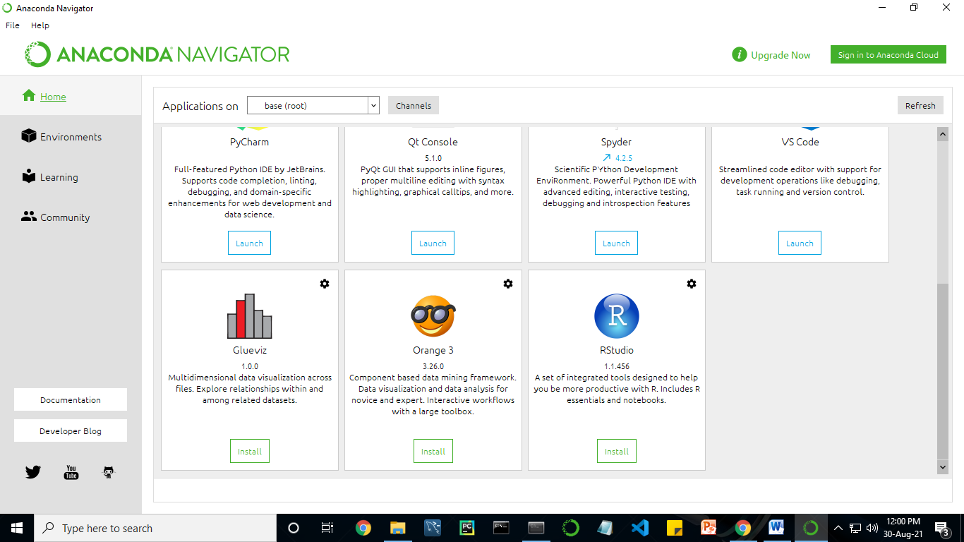

Anaconda Navigator is a desktop graphical user interface (GUI) included in Anaconda distribution.

Navigator allows you to launch common Python programs and easily manage conda packages, environments, and channels without using command-line commands. Navigator can search for packages on Anaconda Cloud or in a local Anaconda Repository.

Anaconda comes with many built-in packages that you can easily find with conda list on your anaconda prompt. As it has lots of packages (many of which are rarely used), it requires lots of space and time as well. If you have enough space, time and do not want to burden yourself to install small utilities like JSON, YAML, you better go for Anaconda.

**11.2 JUPYTER NOTEBOOK:**

This website acts as “meta” documentation for the Jupyter ecosystem. It has a collection of resources to navigate the tools and communities in this ecosystem, and to help you get started.

Project Jupyter is a project and community whose goal is to "develop open-source software, open-standards, and services for interactive computing across dozens of programming languages". It was spun off from IPython in 2014 by Fernando Perez.

Notebook documents are documents produced by the [Jupyter Notebook App](https://jupyter-notebook-beginner-guide.readthedocs.io/en/latest/what_is_jupyter.html#notebook-app), which contain both computer code (e.g. python) and rich text elements (paragraph, equations, figures, links, etc…). Notebook documents are both human-readable documents containing the analysis description and the results (figures, tables, etc.) as well as executable documents which can be run to perform data analysis.

## Installation: The easiest way to install the Jupyter Notebook App is installing a scientific python distribution which also includes scientific python packages. The most common distribution is called **Anaconda**

# Running the Jupyter Notebook

## Launching Jupyter Notebook App: The [Jupyter Notebook App](https://jupyter-notebook-beginner-guide.readthedocs.io/en/latest/what_is_jupyter.html#notebook-app) can be launched by clicking on the Jupyter Notebook icon installed by Anaconda in the start menu (Windows) or by typing in a terminal (cmd on Windows): “jupyter notebook”

## This will launch a new browser window (or a new tab) showing the [Notebook Dashboard](https://jupyter-notebook-beginner-guide.readthedocs.io/en/latest/what_is_jupyter.html#dashboard), a sort of control panel that allows (among other things) to select which notebook to open.

## When started, the [Jupyter Notebook App](https://jupyter-notebook-beginner-guide.readthedocs.io/en/latest/what_is_jupyter.html#notebook-app) can access only files within its start-up folder (including any sub-folder). No configuration is necessary if you place your notebooks in your home folder or subfolders. Otherwise, you need to choose a [Jupyter Notebook App](https://jupyter-notebook-beginner-guide.readthedocs.io/en/latest/what_is_jupyter.html#notebook-app) start-up folder which will contain all the notebooks.

## Save notebooks: Modifications to the notebooks are automatically saved every few minutes. To avoid modifying the original notebook, make a copy of the notebook document (menu file -> make a copy…) and save the modifications on the copy.

## Executing a notebook: Download the notebook you want to execute and put it in your notebook folder (or a sub-folder of it).

* Launch the jupyter notebook app
* In the [Notebook Dashboard](https://jupyter-notebook-beginner-guide.readthedocs.io/en/latest/what_is_jupyter.html#dashboard) navigate to find the notebook: clicking on its name will open it in a new browser tab.
* Click on the menu Help -> User Interface Tour for an overview of the [Jupyter Notebook App](https://jupyter-notebook-beginner-guide.readthedocs.io/en/latest/what_is_jupyter.html#notebook-app) user interface.
* You can run the notebook document step-by-step (one cell a time) by pressing shift + enter.
* You can run the whole notebook in a single step by clicking on the menu Cell -> Run All.
* To restart the [kernel](https://jupyter-notebook-beginner-guide.readthedocs.io/en/latest/what_is_jupyter.html#kernel) (i.e. the computational engine), click on the menu Kernel -> Restart. This can be useful to start over a computation from scratch (e.g. variables are deleted, open files are closed, etc…).

[**Purpose**](https://www.google.com/search?q=project+jupyter+purpose&sa=X&ved=2ahUKEwin49vtmdjyAhXx4zgGHXSOCuwQ6BMoADAkegQINxAC&cshid=1630307847256010)**:** To support [interactive](https://www.google.com/search?q=interactive&stick=H4sIAAAAAAAAAONgVuLUz9U3MM0uyYpfxMqdmVeSWpSYXJJZlgoApkTFPhsAAAA&sa=X&ved=2ahUKEwin49vtmdjyAhXx4zgGHXSOCuwQmxMoATAkegQINxAD&cshid=1630307847256010) data science and scientific computing across all programming languages.

**File Extension:** An IPYNB file is a notebook document created by Jupyter Notebook, an interactive computational environment that helps scientists manipulate and analyze data using Python.

**JUPYTER Notebook App:** The Jupyter Notebook Appis a server-client application that allows editing and running [notebook documents](https://jupyter-notebook-beginner-guide.readthedocs.io/en/latest/what_is_jupyter.html#notebook-document) via a web browser. The Jupyter Notebook App can be executed on a local desktop requiring no internet access (as described in this document) or can be installed on a remote server and accessed through the internet.

In addition to displaying/editing/running notebook documents, the Jupyter Notebook App has a “Dashboard” ([Notebook Dashboard](https://jupyter-notebook-beginner-guide.readthedocs.io/en/latest/what_is_jupyter.html#dashboard)), a “control panel” showing local files and allowing to open notebook documents or shutting down their [kernels](https://jupyter-notebook-beginner-guide.readthedocs.io/en/latest/what_is_jupyter.html#kernel).

## [**kernel**](https://jupyter-notebook-beginner-guide.readthedocs.io/en/latest/what_is_jupyter.html#id7)**:** A notebook kernel is a “computational engine” that executes the code contained in a [Notebook document](https://jupyter-notebook-beginner-guide.readthedocs.io/en/latest/what_is_jupyter.html#notebook-document). The ipython kernel*,* referenced in this guide, executes python code. Kernels for many other languages exist ([official kernels](http://jupyter.readthedocs.org/en/latest/#kernels)).

When you open a [Notebook document](https://jupyter-notebook-beginner-guide.readthedocs.io/en/latest/what_is_jupyter.html#notebook-document), the associated kernel is automatically launched. When the notebook is executed (either cell-by-cell or with menu Cell -> Run All), the kernel performs the computation and produces the results. Depending on the type of computations, the kernel may consume significant CPU and RAM. Note that the RAM is not released until the kernel is shut-down

## [Notebook Dashboard](https://jupyter-notebook-beginner-guide.readthedocs.io/en/latest/what_is_jupyter.html#id8): The Notebook Dashboard is the component which is shown first when you launch [Jupyter Notebook App](https://jupyter-notebook-beginner-guide.readthedocs.io/en/latest/what_is_jupyter.html#notebook-app). The Notebook Dashboard is mainly used to open [notebook documents](https://jupyter-notebook-beginner-guide.readthedocs.io/en/latest/what_is_jupyter.html#notebook-document), and to manage the running [kernels](https://jupyter-notebook-beginner-guide.readthedocs.io/en/latest/what_is_jupyter.html#kernel) (visualize and shutdown).

The Notebook Dashboard has other features similar to a file manager, namely navigating folders and renaming/deleting files

**Working Process:**

* Download and install anaconda and get the most useful package for machine learning in Python.
* Load a dataset and understand its structure using statistical summaries and data visualization.
* Machine learning models, pick the best and build confidence that the accuracy is reliable.

Python is a popular and powerful interpreted language. Unlike R, Python is a complete language and platform that you can use for both research and development and developing production systems. There are also a lot of modules and libraries to choose from, providing multiple ways to do each task. It can feel overwhelming.

The best way to get started using Python for machine learning is to complete a project.

* It will force you to install and start the Python interpreter (at the very least).
* It will give you a bird’s eye view of how to step through a small project.
* It will give you confidence, maybe to go on to your own small projects.

When you are applying machine learning to your own datasets, you are working on a project. A machine learning project may not be linear, but it has a number of well-known steps:

* Define Problem.
* Prepare Data.
* Evaluate Algorithms.
* Improve Results.
* Present Results.

The best way to really come to terms with a new platform or tool is to work through a machine learning project end-to-end and cover the key steps. Namely, from loading data, summarizing data, evaluating algorithms and making some predictions.

Here is an overview of what we are going to cover:

1. Installing the Python anaconda platform.
2. Loading the dataset.
3. Summarizing the dataset.
4. Visualizing the dataset.
5. Evaluating some algorithms.
6. Making some predictions.

**11.3 PYCHARM:**

PyCharm is a dedicated Python Integrated Development Environment (IDE) providing a wide range of essential tools for Python developers, tightly integrated to create a convenient environment for productive [Python](https://www.jetbrains.com/help/pycharm/python.html), [web](https://www.jetbrains.com/help/pycharm/web-frameworks.html), and [data science](https://www.jetbrains.com/help/pycharm/scientific-tools.html) development. Code faster and with more easily in a smart and configurable editor with code completion, snippets, code folding and split windows support.

**PyCharm Features**

* **Intelligent Coding Assistance** – PyCharm provides smart code completion, code inspections, on-the-fly error highlighting and quick-fixes, along with automated code refactorings and rich navigation capabilities.
* **Intelligent Code Editor** – PyCharm’s smart code editor provides first-class support for Python, JavaScript, CoffeeScript, TypeScript, CSS, popular template languages and more. Take advantage of language-aware code completion, error detection, and on-the-fly code fixes!
* **Smart Code Navigation** – Use smart search to jump to any class, file or symbol, or even any IDE action or tool window. It only takes one click to switch to the declaration, super method, test, usages, implementation, and more.
* **Fast and Safe Refactorings** – Refactor your code the intelligent way, with safe Rename and Delete, Extract Method, Introduce Variable, Inline Variable or Method, and other refactorings. Language and framework-specific refactorings help you perform project-wide changes.
* **Built-in Developer Tools** – PyCharm’s huge collection of tools out of the box includes an integrated debugger and test runner; Python profiler; a built-in terminal; integration with major VCS and built-in database tools; remote development capabilities with remote interpreters; an integrated ssh terminal; and integration with Docker and Vagrant.
* **Debugging, Testing and Profiling** – Use the powerful debugger with a graphical UI for Python and JavaScript. Create and run your tests with coding assistance and a GUI-based test runner. Take full control of your code with Python Profiler integration.
* **VCS, Deployment and Remote Development** – Save time with a unified UI for working with Git, SVN, Mercurial or other version control systems. Run and debug your application on remote machines. Easily configure automatic deployment to a remote host or VM and manage your infrastructure with Vagrant and Docker.
* **Database tools** – Access Oracle, SQL Server, PostgreSQL, MySQL and other databases right from the IDE. Rely on PyCharm’s help when editing SQL code, running queries, browsing data, and altering schemas.
* **Web Development** – In addition to Python, PyCharm provides first-class support for various Python web development frameworks, specific template languages, JavaScript, CoffeeScript, TypeScript, HTML/CSS, AngularJS, Node.js, and more.
* **Python Web frameworks** – PyCharm offers great framework-specific support for modern web development frameworks such as Django, Flask, Google App Engine, Pyramid, and web2py, including Django templates debugger, manage.py and appcfg.py tools, special auto completion and navigation, just to name a few.
* **JavaScript & HTML –**PyCharm provides first-class support for JavaScript, Coffee Script, Type Script, HTML and CSS, as well as their modern successors. The JavaScript debugger is included in PyCharm and is integrated with the Django server run configuration.
* **Live Edit** – Live Editing Preview lets you open a page in the editor and the browser and see the changes being made in code instantly in the browser. PyCharm auto-saves your changes, and the browser smartly updates the page on the fly, showing your edits.
* **Scientific Tools** – PyCharm integrates with Ipython Notebook, has an interactive Python console, and supports Anaconda as well as multiple scientific packages including Matplotlib and NumPy.
* **Interactive Python console** – You can run a REPL Python console in PyCharm which offers many advantages over the standard one: on-the-fly syntax check with inspections, braces and quotes matching, and of course code completion.
* **Scientific Stack Support** – PyCharm has built-in support for scientific libraries. It supports Pandas, Numpy, Matplotlib, and other scientific libraries, offering you best-in-class code intelligence, graphs, array viewers and much more.
* **Conda Integration** – Keep your dependencies isolated by having separate Conda environments per project, PyCharm makes it easy for you to create and select the right environment.
* **Customizable and Cross-platform IDE** – Use PyCharm on Windows, Mac OS and Linux with a single license key. Enjoy a fine-tuned workspace with customizable color schemes and key-bindings, with VIM emulation available.
* **Customizable UI** – Enjoy a fine-tuned workspace with customizable color schemes and key-bindings.
* **Plugins** – More than 10 years of IntelliJ platform development gives PyCharm 50+ IDE plugins of different nature, including support for additional VCS, integrations with different tools and frameworks, and editor enhancements such as Vim emulation.
* **Cross-platform IDE** – PyCharm works on Windows, Mac OS or Linux. You can install and run PyCharm on as many machines as you have, and use the same environment and functionality across all your machines.
  1. **PYTHON**

**Introduction:**

**Python** is an [interpreted](https://en.wikipedia.org/wiki/Interpreted_language) [high-level](https://en.wikipedia.org/wiki/High-level_programming_language) [general-purpose programming language](https://en.wikipedia.org/wiki/General-purpose_programming_language). Its design philosophy emphasizes [code readability](https://en.wikipedia.org/wiki/Code_readability) with its use of [significant indentation](https://en.wikipedia.org/wiki/Off-side_rule). Its [language constructs](https://en.wikipedia.org/wiki/Language_construct) as well as its [object-oriented](https://en.wikipedia.org/wiki/Object-oriented_programming) approach aim to help [programmers](https://en.wikipedia.org/wiki/Programmers) write clear, logical code for small and large-scale projects.

Python is [dynamically-typed](https://en.wikipedia.org/wiki/Type_system#DYNAMIC) and [garbage-collected](https://en.wikipedia.org/wiki/Garbage_collection_(computer_science)). It supports multiple [programming paradigms](https://en.wikipedia.org/wiki/Programming_paradigms), including [structured](https://en.wikipedia.org/wiki/Structured_programming)  (particularly, [procedural](https://en.wikipedia.org/wiki/Procedural_programming)), object-oriented and [functional programming](https://en.wikipedia.org/wiki/Functional_programming). It is often described as a "batteries included" language due to its comprehensive [standard library](https://en.wikipedia.org/wiki/Standard_library).

[Guido van Rossum](https://en.wikipedia.org/wiki/Guido_van_Rossum) began working on Python in the late 1980s, as a successor to the [ABC programming language](https://en.wikipedia.org/wiki/ABC_(programming_language)), and first released it in 1991 as Python 0.9.0. Python 2.0 was released in 2000 and introduced new features, such as [list comprehensions](https://en.wikipedia.org/wiki/List_comprehension) and a garbage collection system using [reference counting](https://en.wikipedia.org/wiki/Reference_counting). Python 3.0 was released in 2008 and was a major revision of the language that is not completely [backward-compatible](https://en.wikipedia.org/wiki/Backward_compatibility). Python 2 was discontinued with version 2.7.18 in 2020.

Python consistently ranks as one of the most popular programming languages

**History:**

Python was conceived in the late 1980s by [Guido van Rossum](https://en.wikipedia.org/wiki/Guido_van_Rossum) at [Centrum Wiskunde & Informatica](https://en.wikipedia.org/wiki/Centrum_Wiskunde_%26_Informatica) (CWI) in the [Netherlands](https://en.wikipedia.org/wiki/Netherlands) as a successor to [ABC programming language](https://en.wikipedia.org/wiki/ABC_(programming_language)), which was inspired by [SETL](https://en.wikipedia.org/wiki/SETL),  capable of [exception handling](https://en.wikipedia.org/wiki/Exception_handling) and interfacing with the [Amoeba](https://en.wikipedia.org/wiki/Amoeba_(operating_system)) operating system. Its implementation began in December 1989.  Van Rossum shouldered sole responsibility for the project, as the lead developer, until 12 July 2018, when he announced his "permanent vacation" from his responsibilities as Python's [Benevolent Dictator For Life](https://en.wikipedia.org/wiki/Benevolent_Dictator_For_Life), a title the Python community bestowed upon him to reflect his long-term commitment as the project's chief decision-maker. In January 2019, active Python core developers elected a 5-member "Steering Council" to lead the project.  As of 2021, the current members of this council are Barry Warsaw, Brett Cannon, Carol Willing, Thomas Wouters, and Pablo Galindo Salgado.

Python 2.0 was released on 16 October 2000, with many major new features, including a [cycle-detecting](https://en.wikipedia.org/wiki/Cycle_detection) [garbage collector](https://en.wikipedia.org/wiki/Garbage_collection_(computer_science)) and support for [Unicode](https://en.wikipedia.org/wiki/Unicode).

Python 3.0 was released on 3 December 2008. It was a major revision of the language that is not completely [backward-compatible](https://en.wikipedia.org/wiki/Backward_compatibility). Many of its major features were [backported](https://en.wikipedia.org/wiki/Backporting) to Python 2.6.x and 2.7.x version series. Releases of Python 3 include the 2 to 3 utility, which automates (at least partially) the translation of Python 2 code to Python 3.

Python 2.7's [end-of-life](https://en.wikipedia.org/wiki/End-of-life_(product)) date was initially set at 2015 then postponed to 2020 out of concern that a large body of existing code could not easily be forward-ported to Python 3. No more security patches or other improvements will be released for it. With Python 2's [end-of-life](https://en.wikipedia.org/wiki/End-of-life_(product)), only Python 3.6.x  and later are supported.

Python 3.9.2 and 3.8.8 were expeditedas all versions of Python (including 2.7) had security issues, leading to possible [remote code execution](https://en.wikipedia.org/wiki/Remote_code_execution) and [web cache poisoning](https://en.wikipedia.org/wiki/Cache_poisoning).

**Design Philosophy & Feature**

Python is a [multi-paradigm programming language](https://en.wikipedia.org/wiki/Multi-paradigm_programming_language). [Object-oriented programming](https://en.wikipedia.org/wiki/Object-oriented_programming) and [structured programming](https://en.wikipedia.org/wiki/Structured_programming) are fully supported, and many of its features support functional programming and [aspect-oriented programming](https://en.wikipedia.org/wiki/Aspect-oriented_programming) (including by [meta-programming](https://en.wikipedia.org/wiki/Metaprogramming) and [meta-objects](https://en.wikipedia.org/wiki/Metaobject) (magic methods)). Many other paradigms are supported via extensions, including [design by contract](https://en.wikipedia.org/wiki/Design_by_contract) and [logic programming](https://en.wikipedia.org/wiki/Logic_programming).

Python uses [dynamic typing](https://en.wikipedia.org/wiki/Dynamic_typing) and a combination of [reference counting](https://en.wikipedia.org/wiki/Reference_counting) and a cycle-detecting garbage collector for [memory management](https://en.wikipedia.org/wiki/Memory_management). It also features dynamic [name resolution](https://en.wikipedia.org/wiki/Name_resolution_(programming_languages)) ([late binding](https://en.wikipedia.org/wiki/Late_binding)), which binds method and variable names during program execution.

Python's design offers some support for functional programming in the [Lisp](https://en.wikipedia.org/wiki/Lisp_(programming_language)) tradition. It has filter, map and reduce functions;  [list comprehensions](https://en.wikipedia.org/wiki/List_comprehension), [dictionaries](https://en.wikipedia.org/wiki/Associative_array), sets, and [generator](https://en.wikipedia.org/wiki/Generator_(computer_programming)) expressions. The standard library has two modules (itertools and functools) that implement functional tools borrowed from [Haskell](https://en.wikipedia.org/wiki/Haskell_(programming_language)) and [Standard ML](https://en.wikipedia.org/wiki/Standard_ML).

The language's core philosophy is summarized in the document The [Zen of Python](https://en.wikipedia.org/wiki/Zen_of_Python) (PEP 20), which includes [aphorisms](https://en.wikipedia.org/wiki/Aphorism) such as:

* Beautiful is better than ugly.
* Explicit is better than implicit.
* Simple is better than complex.
* Complex is better than complicated.
* Readability counts.

Rather than having all of its functionality built into its core, Python was designed to be highly [extensible](https://en.wikipedia.org/wiki/Extensibility) (with modules). This compact modularity has made it particularly popular as a means of adding programmable interfaces to existing applications. Van Rossum's vision of a small core language with a large standard library and easily extensible interpreter stemmed from his frustrations with [ABC](https://en.wikipedia.org/wiki/ABC_(programming_language)), which espoused the opposite approach.

Python strives for a simpler, less-cluttered syntax and grammar while giving developers a choice in their coding methodology. In contrast to [Perl](https://en.wikipedia.org/wiki/Perl)'s "[there is more than one way to do it](https://en.wikipedia.org/wiki/There_is_more_than_one_way_to_do_it)" motto, Python embraces a "there should be one— and preferably only one —obvious way to do it" design philosophy. [Alex Martelli](https://en.wikipedia.org/wiki/Alex_Martelli), a [Fellow](https://en.wikipedia.org/wiki/Fellow) at the [Python Software Foundation](https://en.wikipedia.org/wiki/Python_Software_Foundation) and Python book author, writes that "To describe something as 'clever' is not considered a compliment in the Python culture."

Python's developers strive to avoid [premature optimization](https://en.wikipedia.org/wiki/Premature_optimization), and reject patches to non-critical parts of the [C-Python](https://en.wikipedia.org/wiki/CPython) reference implementation that would offer marginal increases in speed at the cost of clarity. When speed is important, a Python programmer can move time-critical functions to extension modules written in languages such as C, or use [PyPy](https://en.wikipedia.org/wiki/PyPy), a [just-in-time compiler](https://en.wikipedia.org/wiki/Just-in-time_compilation). [Cython](https://en.wikipedia.org/wiki/Cython) is also available, which translates a Python script into C and makes direct C-level API calls into the Python interpreter.

Python's developers aim to keep the language fun to use. This is reflected in its name a tribute to the British comedy group [Monty Python](https://en.wikipedia.org/wiki/Monty_Python) and in occasionally playful approaches to tutorials and reference materials, such as examples that refer to spam and eggs (a reference to a [Monty Python sketch](https://en.wikipedia.org/wiki/Spam_(Monty_Python))) instead of the standard [foo and bar](https://en.wikipedia.org/wiki/Foobar).

A common [neologism](https://en.wikipedia.org/wiki/Neologism) in the Python community is pythonic, which can have a wide range of meanings related to program style. To say that code is pythonic is to say that it uses Python idioms well, that it is natural or shows fluency in the language, that it conforms with Python's minimalist philosophy and emphasis on readability. In contrast, code that is difficult to understand or reads like a rough transcription from another programming language is called unpythonic.

Users and admirers of Python, especially those considered knowledgeable or experienced, are often referred to as Pythonistas

**Syntax and Semantics :**

Python is meant to be an easily readable language. Its formatting is visually uncluttered, and it often uses English keywords where other languages use punctuation. Unlike many other languages, it does not use [curly brackets](https://en.wikipedia.org/wiki/Curly_bracket_programming_language) to delimit blocks, and semicolons after statements are allowed but are rarely, if ever, used. It has fewer syntactic exceptions and special cases than [C](https://en.wikipedia.org/wiki/C_(programming_language)) or [Pascal](https://en.wikipedia.org/wiki/Pascal_(programming_language)).

**Indentation :**

Main article: [Python syntax and semantics & Indentation](https://en.wikipedia.org/wiki/Python_syntax_and_semantics#Indentation)

Python uses [whitespace](https://en.wikipedia.org/wiki/Whitespace_character) indentation, rather than [curly brackets](https://en.wikipedia.org/wiki/Curly_bracket_programming_language) or keywords, to delimit [blocks](https://en.wikipedia.org/wiki/Block_(programming)). An increase in indentation comes after certain statements; a decrease in indentation signifies the end of the current block. Thus, the program's visual structure accurately represents the program's semantic structure. This feature is sometimes termed the [off-side rule](https://en.wikipedia.org/wiki/Off-side_rule), which some other languages share, but in most languages indentation does not have any semantic meaning. The recommended indent size is four spaces.

**Statements and control flow :**

Python's [statements](https://en.wikipedia.org/wiki/Statement_(computer_science)) include:

* The [assignment](https://en.wikipedia.org/wiki/Assignment_(computer_science)) statement, using a single equals sign =.
* The if statement, which conditionally executes a block of code, along with else and elif (a contraction of else-if).
* The for statement, which iterates over an iterable object, capturing each element to a local variable for use by the attached block.
* The while statement, which executes a block of code as long as its condition is true.
* The Try statement, which allows exceptions raised in its attached code block to be caught and handled by except clauses; it also ensures that clean-up code in a finally block will always be run regardless of how the block exits.
* The raise statement, used to raise a specified exception or re-raise a caught exception.
* The class statement, which executes a block of code and attaches its local namespace to a [class](https://en.wikipedia.org/wiki/Class_(computer_science)), for use in object-oriented programming.
* The def statement, which defines a [function](https://en.wikipedia.org/wiki/Function_(computing)) or [method](https://en.wikipedia.org/wiki/Method_(computing)).
* The with statement, which encloses a code block within a context manager (for example, acquiring a [lock](https://en.wikipedia.org/wiki/Lock_(computer_science)) before the block of code is run and releasing the lock afterwards, or opening a [file](https://en.wikipedia.org/wiki/Computer_file) and then closing it), allowing [resource-acquisition-is-initialization](https://en.wikipedia.org/wiki/Resource_acquisition_is_initialization) (RAII) - like behavior and replaces a common try/finally idiom.
* The break statement, exits from a loop.
* The continue statement, skips this iteration and continues with the next item.
* The del statement, removes a variable, which means the reference from the name to the value is deleted and trying to use that variable will cause an error. A deleted variable can be reassigned.
* The pass statement, which serves as a [NOP](https://en.wikipedia.org/wiki/NOP_(code)). It is syntactically needed to create an empty code block.
* The assert statement, used during debugging to check for conditions that should apply.
* The yield statement, which returns a value from a [generator](https://en.wikipedia.org/wiki/Generator_(computer_programming)#Python) function and yield is also an operator. This form is used to implement [co-routines](https://en.wikipedia.org/wiki/Coroutine).
* The return statement, used to return a value from a function.
* The import statement, which is used to import modules whose functions or variables can be used in the current program.

The assignment statement (=) operates by binding a name as a [reference](https://en.wikipedia.org/wiki/Pointer_(computer_programming)) to a separate, dynamically-allocated [object](https://en.wikipedia.org/wiki/Object_(computer_science)). Variables may be subsequently rebound at any time to any object. In Python, a variable name is a generic reference holder and does not have a fixed [data type](https://en.wikipedia.org/wiki/Type_system) associated with it. However, at a given time, a variable will refer to some object, which will have a type. This is referred to as [dynamic typing](https://en.wikipedia.org/wiki/Dynamic_type) and is contrasted with [statically-typed](https://en.wikipedia.org/wiki/Statically-typed) programming languages, where each variable may only contain values of a certain type.

Python does not support [tail call](https://en.wikipedia.org/wiki/Tail_call) optimization or [first-class continuations](https://en.wikipedia.org/wiki/First-class_continuations), and, according to Guido van Rossum, it never will.[[80]](https://en.wikipedia.org/wiki/Python_(programming_language)#cite_note-AutoNT-55-80)[[81]](https://en.wikipedia.org/wiki/Python_(programming_language)#cite_note-AutoNT-56-81) However, better support for [co-routine](https://en.wikipedia.org/wiki/Coroutine)-like functionality is provided, by extending Python's [generators](https://en.wikipedia.org/wiki/Generator_(computer_programming)). Before 2.5, generators were [lazy](https://en.wikipedia.org/wiki/Lazy_evaluation) [iterators](https://en.wikipedia.org/wiki/Iterator); information was passed uni-directionally out of the generator. From Python 2.5, it is possible to pass information back into a generator function, and from Python 3.3, the information can be passed through multiple stack levels.

**Expressions** :

Some Python [expressions](https://en.wikipedia.org/wiki/Expression_(computer_science)) are similar to those found in languages such as C and [Java](https://en.wikipedia.org/wiki/Java_(programming_language)), while some are not:

* Addition, subtraction, and multiplication are the same, but the behavior of division differs. There are two types of divisions in Python. They are floor division (or integer division) // and floating-point/division. Python also uses the ** operator for exponentiation.
* From Python 3.5, the new @ infix operator was introduced. It is intended to be used by libraries such as [NumPy](https://en.wikipedia.org/wiki/NumPy) for [matrix multiplication](https://en.wikipedia.org/wiki/Matrix_multiplication).
* From Python 3.8, the syntax :=, called the 'walrus operator' was introduced. It assigns values to variables as part of a larger expression.
* In Python, == compares by value, versus Java, which compares numerics by value and objects by reference. (Value comparisons in Java on objects can be performed with the equals() method.) Python's is operator may be used to compare object identities (comparison by reference). In Python, comparisons may be chained, for example A<=B<=C.
* Python uses the words and, or, not for or its boolean operators rather than the symbolic &&, ||, ! used in Java and C.
* Python has a type of expression termed a [list comprehension](https://en.wikipedia.org/wiki/List_comprehension#Python) as well as a more general expression termed a [generator](https://en.wikipedia.org/wiki/Generator_(computer_programming)) expression.
* [Anonymous functions](https://en.wikipedia.org/wiki/Anonymous_function) are implemented using [lambda expressions](https://en.wikipedia.org/wiki/Lambda_(programming)); however, these are limited in that the body can only be one expression.
* Conditional expressions in Python are written as x if c else y (different in order of operands from the c ? x : y operator common to many other languages).
* Python makes a distinction between [lists](https://en.wikipedia.org/wiki/List_(computer_science)) and [tuples](https://en.wikipedia.org/wiki/Tuple). Lists are written as [1, 2, 3], are mutable, and cannot be used as the keys of dictionaries (dictionary keys must be [immutable](https://en.wikipedia.org/wiki/Immutable) in Python). Tuples are written as (1, 2, 3), are immutable and thus can be used as the keys of dictionaries, provided all elements of the tuple are immutable. The + operator can be used to concatenate two tuples, which does not directly modify their contents, but rather produces a new tuple containing the elements of both provided tuples. Thus, given the variable t initially equal to (1, 2, 3), executing t = t + (4, 5) first evaluates t + (4, 5), which yields (1, 2, 3, 4, 5), which is then assigned back to t, thereby effectively "modifying the contents" of t, while conforming to the immutable nature of tuple objects. Parentheses are optional for tuples in unambiguous contexts.
* Python features sequence unpacking wherein multiple expressions, each evaluating to anything that can be assigned to (a variable, a writable property, etc.), are associated in an identical manner to that forming tuple literals and, as a whole, are put on the left-hand side of the equal sign in an assignment statement. The statement expects an iterable object on the right-hand side of the equal sign that produces the same number of values as the provided writable expressions when iterated through and will iterate through it, assigning each of the produced values to the corresponding expression on the left.
* Python has a "string format" operator %. This functions analogously ton printf format strings in C, e.g. “spam=%s eggs=%d” % (“blah”,2) evaluates to “spam=blah eggs=2”. In Python 3 and 2.6+, this was supplemented by the format() method of the str class, e.g. “spam={0} eggs={1}”.format(“blah”,2). Python 3.6 added "f-strings": blah = “blah”; eggs = 2; f‘spam={blah} eggs={eggs}’
* Strings in Python can be [concatenated](https://en.wikipedia.org/wiki/Concatenation), by "adding" them (same operator as for adding integers and floats). E.g. “spam” + “eggs” returns “spameggs”. Even if your strings contain numbers, they are still added as strings rather than integers. E.g. “2” + “2” returns “2”.
* Python has various kinds of [string literals](https://en.wikipedia.org/wiki/String_literal):
  + Strings delimited by single or double quote marks. Unlike in [Unix shells](https://en.wikipedia.org/wiki/Unix_shell), [Perl](https://en.wikipedia.org/wiki/Perl) and Perl-influenced languages, single quote marks and double quote marks function identically. Both kinds of string use the backslash (\) as an [escape character](https://en.wikipedia.org/wiki/Escape_character). [String interpolation](https://en.wikipedia.org/wiki/String_interpolation) became available in Python 3.6 as "formatted string literals".
  + Triple-quoted strings, which begin and end with a series of three single or double quote marks. They may span multiple lines and function like [here documents](https://en.wikipedia.org/wiki/Here_document) in shells, Perl and [Ruby](https://en.wikipedia.org/wiki/Ruby_(programming_language)).
  + [Raw string](https://en.wikipedia.org/wiki/Raw_string) varieties, denoted by prefixing the string literal with an r. Escape sequences are not interpreted; hence raw strings are useful where literal backslashes are common, such as [regular expressions](https://en.wikipedia.org/wiki/Regular_expression) and [Windows](https://en.wikipedia.org/wiki/Microsoft_Windows)-style paths. Compare "@-quoting" in [C#](https://en.wikipedia.org/wiki/C_Sharp_(programming_language)).
* Python has [array index](https://en.wikipedia.org/wiki/Array_index) and [array slicing](https://en.wikipedia.org/wiki/Array_slicing) expressions on lists, denoted as a[Key], a[start:stop] or a[start:stop:step]. Indexes are [zero-based](https://en.wikipedia.org/wiki/Zero-based_numbering), and negative indexes are relative to the end. Slices take elements from the start index up to, but not including, the stop index. The third slice parameter, called step or stride, allows elements to be skipped and reversed. Slice indexes may be omitted, for example a[:] returns a copy of the entire list. Each element of a slice is a [shallow copy](https://en.wikipedia.org/wiki/Shallow_copy).

In Python, a distinction between expressions and statements is rigidly enforced, in contrast to languages such as [Common Lisp](https://en.wikipedia.org/wiki/Common_Lisp), [Scheme](https://en.wikipedia.org/wiki/Scheme_(programming_language)), or [Ruby](https://en.wikipedia.org/wiki/Ruby_(programming_language)). This leads to duplicating some functionality. For example:

* [List comprehensions](https://en.wikipedia.org/wiki/List_comprehensions) vs. for-loops
* [Conditional](https://en.wikipedia.org/wiki/Conditional_(programming)) expressions vs. if blocks
* The eval() vs. exec() built-in functions (in Python 2, exec is a statement); the former is for expressions, the latter is for statements.

Statements cannot be a part of an expression, so list and other comprehensions or [lambda expressions](https://en.wikipedia.org/wiki/Lambda_(programming)), all being expressions, cannot contain statements. A particular case of this is that an assignment statement such as a=1 cannot form part of the conditional expression of a conditional statement. This has the advantage of avoiding a classic C error of mistaking an assignment operator = for an equality operator == in conditions: if (c==1) {…} is syntactically valid (but probably unintended) C code but if c=1: … causes a syntax error in Python.

**Methods** :

[Methods](https://en.wikipedia.org/wiki/Method_(programming)) on objects are [functions](https://en.wikipedia.org/wiki/Function_(programming)) attached to the object's class; the syntax instance.method(argument) is, for normal methods and functions, [syntactic sugar](https://en.wikipedia.org/wiki/Syntactic_sugar) for Class.method(instance, argument). Python methods have an explicit self parameter access [instance data](https://en.wikipedia.org/wiki/Instance_data), in contrast to the implicit self (or this) in some other object-oriented programming languages (e.g., [C++](https://en.wikipedia.org/wiki/C%2B%2B), Java, [Objective-C](https://en.wikipedia.org/wiki/Objective-C), or [Ruby](https://en.wikipedia.org/wiki/Ruby_(programming_language))). Apart from this Python also provides methods, sometimes called d-under methods due to their names beginning and ending with double-underscores, to extend the functionality of custom class to support native functions such as print, length, comparison, support for arithmetic operations, type conversion, and many more.

### Typing :

Python uses duck typing and has typed objects but untyped variable names. Type constraints are not checked at compile time; rather, operations on an object may fail, signifying that the given object is not of a suitable type. Despite being dynamically-typed, Python is strongly-typed, forbidding operations that are not well-defined (for example, adding a number to a string) rather than silently attempting to make sense of them.

Python allows programmers to define their own types using [classes](https://en.wikipedia.org/wiki/Class_(computer_science)), which are most often used for object-oriented programming. New instances of classes are constructed by calling the class (for example, SpamClass() or EggsClass()), and the classes are instances of the metaclass type (itself an instance of itself), allowing meta-programming and reflection.

Before version 3.0, Python had two kinds of classes: old-style and new-style.The syntax of both styles is the same, the difference being whether the class object is inherited from, directly or indirectly (all new-style classes inherit from object and are instances of type). In versions of Python 2 from Python 2.2 onwards, both kinds of classes can be used. Old-style classes were eliminated in Python 3.0.

The long-term plan is to support gradual typing and from Python 3.5, the syntax of the language allows specifying static types but they are not checked in the default implementation, CPython. An experimental optional static type checker named mypy supports compile-time type checking.

1. **METHODOLOGY**

Preprocessing and Training the model (CNN): The dataset is preprocessed such as Image reshaping, resizing and conversion to an array form. Similar processing is also done on the test image. We have already divided tuberculosis and normal chest X-ray image dataset and also has test images for the software.

CNN Weights

Pulmonary Tuberculosis prediction

Raw image

Build a sequential model

CNN train

The train dataset is used to train the model (CNN) so that it can identify the test image and the disease it has CNN has different layers that are Dense, Dropout, Activation, Flatten, Convolution2D, and MaxPooling2D. After the model is trained successfully, the software can identify the Tuberculosis and normal images contained in the dataset. After successful training and preprocessing, comparison of the test image and trained model takes place to predict the Tuberculosis.

**CNN Model steps:**

**Conv2d:**

The 2D convolution is a fairly simple operation at heart: you start with a kernel, which is simply a small matrix of weights. This kernel “slides” over the 2D input data, performing an elementwise multiplication with the part of the input it is currently on, and then summing up the results into a single output pixel.

The kernel repeats this process for every location it slides over, converting a 2D matrix of features into yet another 2D matrix of features. The output features are essentially, the weighted sums (with the weights being the values of the kernel itself) of the input features located roughly in the same location of the output pixel on the input layer.

Whether or not an input feature falls within this “roughly same location”, gets determined directly by whether it’s in the area of the kernel that produced the output or not. This means the size of the kernel directly determines how many (or few) input features get combined in the production of a new output feature.

This is all in pretty stark contrast to a fully connected layer. In the above example, we have 5×5=25 input features, and 3×3=9 output features. If this were a standard fully connected layer, you’d have a weight matrix of 25×9 = 225 parameters, with every output feature being the weighted sum of every single input feature. Convolutions allow us to do this transformation with only 9 parameters, with each output feature, instead of “looking at” every input feature, only getting to “look” at input features coming from roughly the same location. Do take note of this, as it’ll be critical to our later discussion.

**MaxPooling2D layer**

Down samples the input along its spatial dimensions (height and width) by taking the maximum value over an input window (of size defined by pool_size) for each channel of the input. The window is shifted by strides along each dimension.

The resulting output, when using the "valid" padding option, has a spatial shape (number of rows or columns) of: output_shape = math.floor((input_shape - pool_size) / strides) + 1 (when input_shape >= pool_size)

The resulting output shape when using the "same" padding option is: output_shape = math.floor((input_shape - 1) / strides) + 1

**Arguments**

• pool_size: integer or tuple of 2 integers, window size over which to take the maximum. (2, 2) will take the max value over a 2x2 pooling window. If only one integer is specified, the same window length will be used for both dimensions.

• strides: Integer, tuple of 2 integers, or None. Strides values. Specifies how far the pooling window moves for each pooling step. If None, it will default to pool_size.

• padding: One of "valid" or "same" (case-insensitive). "valid" means no padding. "same" results in padding evenly to the left/right or up/down of the input such that output has the same height/width dimension as the input.

• data_format: A string, one of channels_last (default) or channels_first. The ordering of the dimensions in the inputs. channels_last corresponds to inputs with shape (batch, height, width, channels) while channels_first corresponds to inputs with shape (batch, channels, height, width). It defaults to the image_data_format value found in your Keras config file at ~/.keras/keras.json. If you never set it, then it will be "channels_last".

**Input shape**

• If data_format='channels_last': 4D tensor with shape (batch_size, rows, cols, channels).

• If data_format='channels_first': 4D tensor with shape (batch_size, channels, rows, cols).

**Output shape**

• If data_format='channels_last': 4D tensor with shape (batch_size, pooled_rows, pooled_cols, channels).

• If data_format='channels_first': 4D tensor with shape (batch_size, channels, pooled_rows, pooled_cols).

**Flatten layer**

It is used to flatten the dimensions of the image obtained after convolving it. Dense: It is used to make this a fully connected model and is the hidden layer. Dropout: It is used to avoid over fitting on the dataset and dense is the output layer contains only one neuron which decide to which category image belongs.

Flatten is used to flatten the input. For example, if flatten is applied to layer having input shape as (batch_size, 2,2), then the output shape of the layer will be (batch_size, 4)

Flatten has one argument as follows

keras.layers.Flatten(data_format = None)

data_format is an optional argument and it is used to preserve weight ordering when switching from one data format to another data format. It accepts either channels_last or channels_first as value. channels_last is the default one and it identifies the input shape as (batch_size, ..., channels) whereas channels_first identifies the input shape as (batch_size, channels, ...)

**Dense layer**

Dense implements the operation: output = activation(dot(input, kernel) + bias) where activation is the element-wise activation function passed as the activation argument, kernel is a weights matrix created by the layer, and bias is a bias vector created by the layer (only applicable if use_bias is True). These are all attributes of Dense.

Note: If the input to the layer has a rank greater than 2, then Dense computes the dot product between the inputs and the kernel along the last axis of the inputs and axis 0 of the kernel (using tf.tensordot). For example, if input has dimensions (batch_size, d0, d1), then we create a kernel with shape (d1, units), and the kernel operates along axis 2 of the input, on every sub-tensor of shape (1, 1, d1) (there are batch_size * d0 such sub-tensors). The output in this case will have shape (batch_size, d0, units).

Besides, layer attributes cannot be modified after the layer has been called once (except the trainable attribute). When a popular kwarg input_shape is passed, then keras will create an input layer to insert before the current layer. This can be treated equivalent to explicitly defining an Input Layer.

**Arguments**

• units: Positive integer, dimensionality of the output space.

• activation: Activation function to use. If you don't specify anything, no activation is applied (ie. "linear" activation: a(x) = x).

• use_bias: Boolean, whether the layer uses a bias vector.

• kernel_initializer: Initializer for the kernel weights matrix.

• bias_initializer: Initializer for the bias vector.

• kernel_regularizer: Regularizer function applied to the kernel weights matrix.

• bias_regularizer: Regularizer function applied to the bias vector.

• activity_regularizer: Regularizer function applied to the output of the layer (its "activation").

• kernel_constraint: Constraint function applied to the kernel weights matrix.

• bias_constraint: Constraint function applied to the bias vector.

**Input shape**

N-D tensor with shape: (batch_size, ..., input_dim). The most common situation would be a 2D input with shape (batch_size, input_dim).

**Output shape**

N-D tensor with shape: (batch_size, ..., units). For instance, for a 2D input with shape (batch_size, input_dim), the output would have shape (batch_size, units).

# **Dropout layer**

The Dropout layer randomly sets input units to 0 with a frequency of rate at each step during training time, which helps prevent overfitting. Inputs not set to 0 are scaled up by 1/(1 - rate) such that the sum over all inputs is unchanged.

Note that the Dropout layer only applies when training is set to True such that no values are dropped during inference. When using model.fit, training will be appropriately set to True automatically, and in other contexts, you can set the kwarg explicitly to True when calling the layer.

(This is in contrast to setting trainable=False for a Dropout layer. trainable does not affect the layer's behavior, as Dropout does not have any variables/weights that can be frozen during training.)

**Arguments**

* **rate**: Float between 0 and 1. Fraction of the input units to drop.
* **noise_shape**: 1D integer tensor representing the shape of the binary dropout mask that will be multiplied with the input. For instance, if your inputs have shape (batch_size, timesteps, features) and you want the dropout mask to be the same for all timesteps, you can use noise_shape=(batch_size, 1, features).

**seed**: A Python integer to use as random seed.

**Image Data Generator:**

It is that rescales the image, applies shear in some range, zooms the image and does horizontal flipping with the image. This Image Data Generator includes all possible orientation of the image.

**Training Process:**

train_datagen.flow_from_directory is the function that is used to prepare data from the train_dataset directory Target_size specifies the target size of the image. Test_datagen.flow_from_directory is used to prepare test data for the model and all is similar as above. fit_generator is used to fit the data into the model made above, other factors used are steps_per_epochs tells us about the number of times the model will execute for the training data.

**Epochs:**

It tells us the number of times model will be trained in forward and backward pass.

**Validation process:**

Validation_data is used to feed the validation/test data into the model. Validation_steps denotes the number of validation/test samples.

**ARCHITECTURE OF CNN**

**CONVOLUTIONAL NEURAL NETWORK:**

A Convolutional neural network (CNN) is one type of Artificial Neural Network. A Convolutional neural network (CNN) is a neural network that has one or more convolutional layers and are used mainly for image processing, classification, segmentation and also for other auto correlated data.

**Models API:**

**There are three ways to create Keras models:**

• The Sequential model, which is very straightforward (a simple list of layers), but is limited to single-input, single-output stacks of layers (as the name gives away).

• The Functional API, which is an easy-to-use, fully-featured API that supports arbitrary model architectures. For most people and most use cases, this is what you should be using. This is the Keras "industry strength" model.

• Model subclassing, where you implement everything from scratch on your own. Use this if you have complex, out-of-the-box research use cases.

**Types of Keras Models**

**Models in keras are available in two types:**

• Keras Sequential Model

• Keras Functional API

**1. Sequential Model in Keras**

It allows us to create models layer by layer in sequential order. But it does not allow us to create models that have multiple inputs or outputs.

It is best for simple stack of layers which have 1 input tensor and 1 output tensor.

This model is not suited when any of the layer in the stack has multiple inputs or outputs. Even if we want non-linear topology, it is not suited.

**2. Functional API in Keras**

It provides more flexibility to define a model and add layers in keras. Functional API allows us to create models that have multiple input or output.

It also allows us to share these layers. In other words. we can make graphs of layers using Keras functional API.

As functional API is a data structure, it is easy to save it as a single file that helps in recreating the exact model without having the original code. Also its easy to model the graph here and access its nodes as well.

**Model Subclassing in Keras**

Sequential model does not allow you much flexibility to create your models. Functional API also only has a little of customization available for you. But you may create your own fully-customizable models in Keras. This is done by subclassing the Model class and implementing a call method.

Input() is used to instantiate a Keras tensor.

A Keras tensor is a symbolic tensor-like object, which we augment with certain attributes that allow us to build a Keras model just by knowing the inputs and outputs of the model.

For instance, if a, b and c are Keras tensors, it becomes possible to do: model = Model(input=[a, b], output=c)

# **kernels:**

Each convolutional layer contains a series of filters known as convolutional kernels. The filter is a matrix of integers that are used on a subset of the input pixel values, the same size as the kernel. Each pixel is multiplied by the corresponding value in the kernel, then the result is summed up for a single value for simplicity representing a grid cell, like a pixel, in the output channel/feature map. These are linear transformations, each convolution is a type of affine function.

In computer vision the input is often a 3 channel RGB image. For simplicity, if we take a greyscale image that has one channel (a two dimensional matrix) and a 3x3 convolutional kernel (a two dimensional matrix). The kernel strides over the input matrix of numbers moving horizontally column by column, sliding/scanning over the first rows in the matrix containing the images pixel values. Then the kernel strides down vertically to subsequent rows. Note, the filter may stride over one or several pixels at a time, this is detailed further below.

In other non-vision applications, a one dimensional convolution may slide vertically over an input matrix.

**Padding:**

To handle the edge pixels there are several approaches:

* Losing the edge pixels
* Padding with zero value pixels
* Reflection padding

Reflection padding is by far the best approach, where the number of pixels needed for the convolutional kernel to process the edge pixels are added onto the outside copying the pixels from the edge of the image. For a 3x3 kernel, one pixel needs to be added around the outside, for a 7x7 kernel then three pixels would be reflected around the outside. The pixels added around each side is the dimension, halved and rounded down.

Traditionally in many research papers, the edge pixels are just ignored, which loses a small proportion of the data and this gets increasing worse if there are many deep convolutional layers. For this reason, I could not find existing diagrams to easily convey some of the points here without being misleading and confusing stride 1 convolutions with stride 2 convolutions.

With padding, the output from a input of width w and height h would be width w and height h (the same as the input with a single input channel), assuming the kernel takes a stride of one pixel at a time.

# **Strides:**

It is common to use a stride two convolution rather than a stride one convolution, where the convolutional kernel strides over 2 pixels at a time, for example our 3x3 kernel would start at position (1,1), then stride to (1,3), then to 1, 5) and so on, halving the size of the output channel/feature map, compared to the convolutional kernel taking strides of one.

With padding, the output from an input of width w, height h and depth 3 would be the ceiling of width w/2, height h/2 and depth 1, as the kernel outputs a single summed output from each stride.

# **Rectified Linear Unit (ReLU):**

A Rectified Linear Unit is used as a non-linear activation function. A ReLU says if the value is less than zero, round it up to zero.

# **Normalisation:**

Normalisation is the process of subtracting the mean and dividing by the standard deviation. It transforms the range of the data to be between -1 and 1 making the data use the same scale, sometimes called Min-Max scaling.

It is common to normalize the input features, standardising the data by removing the mean and scaling to unit variance. It is often important the input features are centred around zero and have variance in the same order. With some data, such as images the data is scaled so that it’s range is between 0 and 1, most simply dividing the pixel values by 255.

**Batch normalisation:**

Batch normalisation has the benefits of helping to make a network output more stable predictions, reduce overfitting through regularisation and speeds up training by an order of magnitude.

Batch normalisation is the process of carrying normalisation within the scope activation layer of the current batch, subtracting the mean of the batch’s activations and dividing by the standard deviation of the batches activations.

This is necessary as even after normalizing the input as some activations can be higher, which can cause the subsequent layers to act abnormally and makes the network less stable.

Batch normalization applies a transformation that maintains the mean output close to 0 and the output standard deviation close to 1.

Importantly, batch normalization works differently during training and during inference.

**During training** (i.e. when using fit() or when calling the layer/model with the argument training=True), the layer normalizes its output using the mean and standard deviation of the current batch of inputs. That is to say, for each channel being normalized, the layer returns gamma * (batch - mean(batch)) / sqrt(var(batch) + epsilon) + beta, where:

* epsilon is small constant (configurable as part of the constructor arguments)
* gamma is a learned scaling factor (initialized as 1), which can be disabled by passing scale=False to the constructor.
* beta is a learned offset factor (initialized as 0), which can be disabled by passing center=False to the constructor.

**During inference** (i.e. when using evaluate() or predict() or when calling the layer/model with the argument training=False (which is the default), the layer normalizes its output using a moving average of the mean and standard deviation of the batches it has seen during training. That is to say, it returns gamma * (batch - self.moving_mean) / sqrt(self.moving_var + epsilon) + beta.

self.moving_mean and self.moving_var are non-trainable variables that are updated each time the layer in called in training mode, as such:

* moving_mean = moving_mean * momentum + mean(batch) * (1 - momentum)
* moving_var = moving_var * momentum + var(batch) * (1 - momentum)

As such, the layer will only normalize its inputs during inference after having been trained on data that has similar statistics as the inference data.

**Arguments**

* **axis**: Integer, the axis that should be normalized (typically the features axis). For instance, after a Conv2D layer with data_format="channels_first", set axis=1 in BatchNormalization.
* **momentum**: Momentum for the moving average.
* **epsilon**: Small float added to variance to avoid dividing by zero.
* **center**: If True, add offset of beta to normalized tensor. If False, beta is ignored.
* **scale**: If True, multiply by gamma. If False, gamma is not used. When the next layer is linear (also e.g. nn.relu), this can be disabled since the scaling will be done by the next layer.
* **beta_initializer**: Initializer for the beta weight.
* **gamma_initializer**: Initializer for the gamma weight.
* **moving_mean_initializer**: Initializer for the moving mean.
* **moving_variance_initializer**: Initializer for the moving variance.
* **beta_regularizer**: Optional regularizer for the beta weight.
* **gamma_regularizer**: Optional regularizer for the gamma weight.
* **beta_constraint**: Optional constraint for the beta weight.
* **gamma_constraint**: Optional constraint for the gamma weight.

**Call arguments**

* **inputs**: Input tensor (of any rank).
* **training**: Python boolean indicating whether the layer should behave in training mode or in inference mode.

1. **TYPES OF CNN:**

* VGG-16
* LeNET

**15.1 LENET:**

LeNet is one of the most fundamental deep learning models that is primarily used to classify handwritten digits. LeNet is one of the earliest neural networks that employ the convolution operation. Combining newly developed back-propagation algorithms with convolutional neural networks, LeCun et al. became pioneers of image classification using deep learning. The name LeNet is mostly used interchangeably with LeNet-5 which indicates the kernel size of the convolution masks.

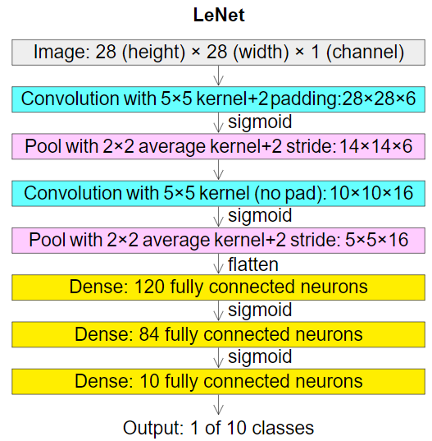

**Convolutional layers:**

Convolutional layers are the layers where filters are applied to the original image, or to other feature maps in a deep CNN. This is where most of the user-specified parameters are in the network. The most important parameters are the number of kernels and the size of the kernels.

**Pooling layers:**

Pooling layers are similar to convolutional layers, but they perform a specific function such as max pooling, which takes the maximum value in a certain filter region, or average pooling, which takes the average value in a filter region. These are typically used to reduce the dimensionality of the network.

**Dense or Fully connected layers:**

Fully connected layers are placed before the classification output of a CNN and are used to flatten the results before classification. This is similar to the output layer of an MLP.

**15.2. VGG 16:**

VGG16 is object detection and classification algorithm which is able to classify 1000 images of 1000 different categories with 92.7% accuracy. It is one of the popular algorithms for image classification and is easy to use with transfer learning

## **Architecture of VGG-16:**

VGG16 is a convolution neural net (CNN ) architecture which was used to win ILSVR(Image net) competition in 2014. It is considered to be one of the excellent vision model architecture till date.

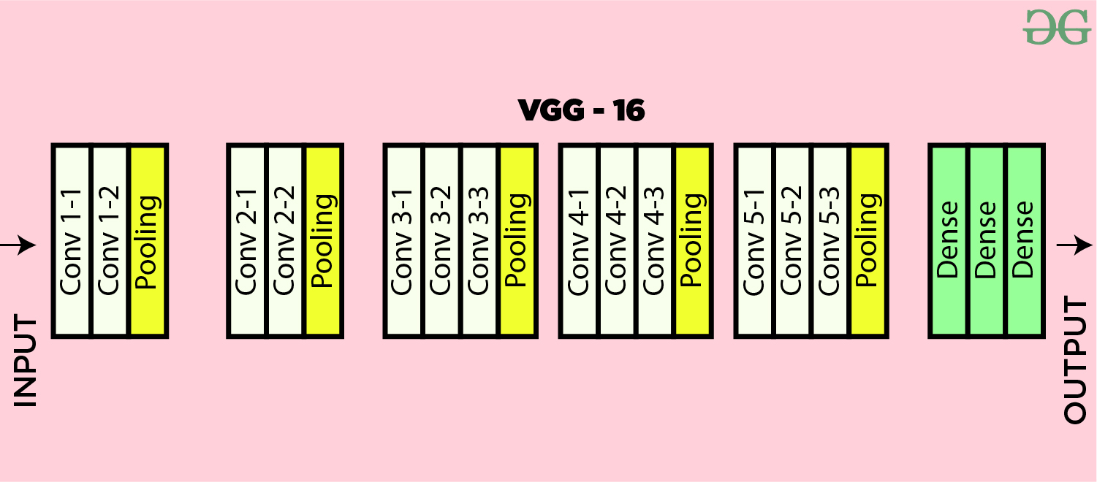

Architecture of VGG-16

**Convolutional layers:**

Convolutional layers are the layers where filters are applied to the original image, or to other feature maps in a deep CNN. This is where most of the user-specified parameters are in the network. The most important parameters are the number of kernels and the size of the kernels.

**Pooling layers:**

Pooling layers are similar to convolutional layers, but they perform a specific function such as max pooling, which takes the maximum value in a certain filter region, or average pooling, which takes the average value in a filter region. These are typically used to reduce the dimensionality of the network.

**Dense or Fully connected layers:**

Fully connected layers are placed before the classification output of a CNN and are used to flatten the results before classification. This is similar to the output layer of an MLP.

1. **LIST OF MODULES**

1. Manual Net

2. VGG-16

3. LeNET

4. Deploy

1. **MODULE DESCRIPTION**

**29.1 IMPORT THE GIVEN IMAGE FROM DATASET:**

## We have to import our data set using keras preprocessing image data generator function also we create size, rescale, range, zoom range, horizontal flip. Then we import our image dataset from folder through the data generator function. Here we set train, test, and validation also we set target size, batch size and class-mode from this function we have to train using our own created network by adding layers of CNN.

**Tuberculosis**

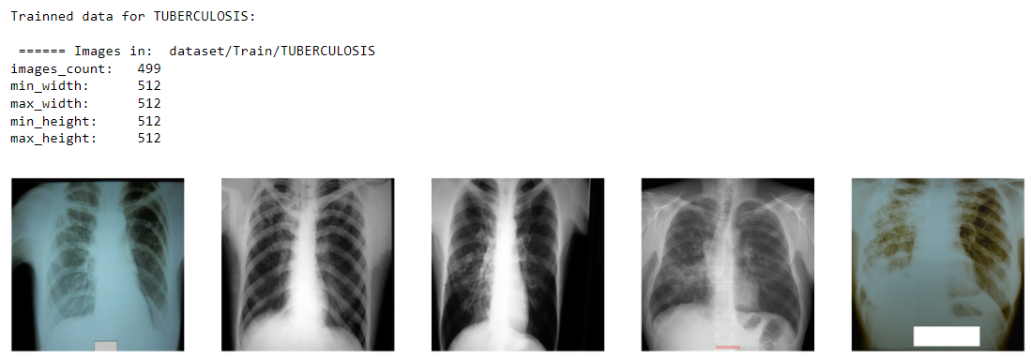

**NORMAL**

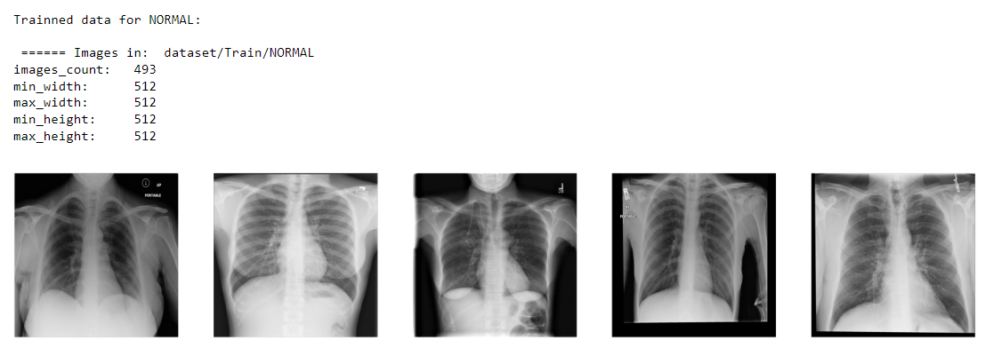

**29.2 TO TRAIN THE MODULE BY GIVEN IMAGE DATASET:**

To train our dataset using classifier and fit generator function also we make training steps per epoch’s then total number of epochs, validation data and validation steps using this data we can train our dataset.

_________________________________________________________________

Layer (type) Output Shape Param #

=================================================================

conv2d (Conv2D) (None, 256, 256, 64) 1792

_________________________________________________________________

conv2d_1 (Conv2D) (None, 256, 256, 64) 36928

_________________________________________________________________

max_pooling2d (MaxPooling2D) (None, 128, 128, 64) 0

_________________________________________________________________

conv2d_2 (Conv2D) (None, 128, 128, 128) 73856

_________________________________________________________________

conv2d_3 (Conv2D) (None, 128, 128, 128) 147584

_________________________________________________________________

max_pooling2d_1 (MaxPooling2 (None, 64, 64, 128) 0

_________________________________________________________________

conv2d_4 (Conv2D) (None, 64, 64, 256) 295168

_________________________________________________________________

conv2d_5 (Conv2D) (None, 64, 64, 256) 590080

_________________________________________________________________

conv2d_6 (Conv2D) (None, 64, 64, 256) 590080

_________________________________________________________________

max_pooling2d_2 (MaxPooling2 (None, 32, 32, 256) 0

_________________________________________________________________

conv2d_7 (Conv2D) (None, 32, 32, 512) 1180160

_________________________________________________________________

conv2d_8 (Conv2D) (None, 32, 32, 512) 2359808

_________________________________________________________________

conv2d_9 (Conv2D) (None, 32, 32, 512) 2359808

_________________________________________________________________

max_pooling2d_3 (MaxPooling2 (None, 16, 16, 512) 0

_________________________________________________________________

conv2d_10 (Conv2D) (None, 16, 16, 512) 2359808

_________________________________________________________________

conv2d_11 (Conv2D) (None, 16, 16, 512) 2359808

_________________________________________________________________

conv2d_12 (Conv2D) (None, 16, 16, 512) 2359808

_________________________________________________________________

max_pooling2d_4 (MaxPooling2 (None, 8, 8, 512) 0

_________________________________________________________________

flatten (Flatten) (None, 32768) 0

_________________________________________________________________

dense (Dense) (None, 256) 8388864

_________________________________________________________________

dense_1 (Dense) (None, 128) 32896

_________________________________________________________________

dense_2 (Dense) (None, 2) 258

=================================================================

Total params: 23,136,706

Trainable params: 23,136,706

Non-trainable params: 0

_________________________________________________________________

CNN Model Summary details

**29.3 WORKING PROCESS OF LAYERS IN CNN MODEL:**

A Convolutional Neural Network (ConvNet/CNN) is a Deep Learning algorithm which can take in an input image, assign importance (learnable weights and biases) to various aspects/objects in the image and be able to differentiate one from the other. The pre-processing required in a ConvNet is much lower as compared to other classification algorithms. While in primitive methods filters are hand-engineered, with enough training, ConvNets have the ability to learn these filters/characteristics. The architecture of a ConvNet is analogous to that of the connectivity pattern of Neurons in the Human disease and was inspired by the organization of the Visual Cortex. Individual neurons respond to stimuli only in a restricted region of the visual field known as the Receptive Field. Their network consists of four layers with 1,024 input units, 256 units in the first hidden layer, eight units in the second hidden layer, and two output units.

Input Layer:

Input layer in CNN contain image data. Image data is represented by three dimensional matrixes. It needs to reshape it into a single column. Suppose you have image of dimension 28 x 28 =784, it need to convert it into 784 x 1 before feeding into input.

## **Convo Layer:**

Convo layer is sometimes called feature extractor layer because features of the image are get extracted within this layer. First of all, a part of image is connected to Convo layer to perform convolution operation as we saw earlier and calculating the dot product between receptive field (it is a local region of the input image that has the same size as that of filter) and the filter. Result of the operation is single integer of the output volume. Then the filter over the next receptive field of the same input image by a Stride and do the same operation again. It will repeat the same process again and again until it goes through the whole image. The output will be the input for the next layer.

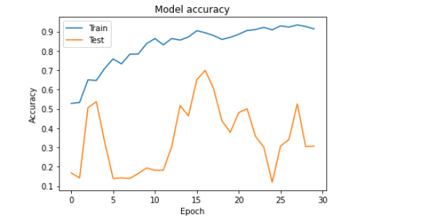

CNN model trained dataset accuracy

**Pooling Layer:**

Pooling layer is used to reduce the spatial volume of input image after convolution. It is used between two convolution layers. If it applies FC after Convo layer without applying pooling or max pooling, then it will be computationally expensive. So, the max pooling is only way to reduce the spatial volume of input image. It has applied max pooling in single depth slice with Stride of 2. It can observe the 4 x 4 dimension input is reducing to 2 x 2 dimensions.

## **Fully Connected Layer (FC):**

Fully connected layer involves weights, biases, and neurons. It connects neurons in one layer to neurons in another layer. It is used to classify images between different categories by training.

## **Softmax / Logistic Layer:**

Softmax or Logistic layer is the last layer of CNN. It resides at the end of FC layer. Logistic is used for binary classification and softmax is for multi-classification.

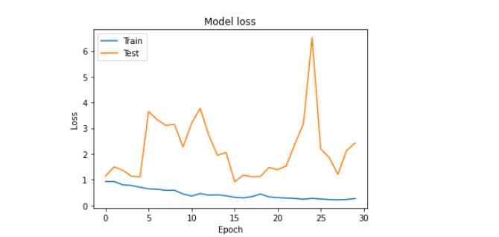

CNN model trained dataset loss values

## **Output Layer:**

Output layer contains the label which is in the form of one-hot encoded. Now you have a good understanding of CNN.

**29.4 PULMONARY TUBERCULOSIS IDENTIFICATION:**

We give input image using keras pre-processing package. That input Image converted into array value using pillow and image to array function package. We have already divided tuberculosis and normal chest X-ray image dataset. It identifies whether the scan is normal or affected with Tuberculosis.

Given dataset

Tuberculosis Identification

Feature Extractions

CNN Model

Input image

The tuberculosis Disease classification method is based on a two-channel architecture that is able to recognize classification of data. The tuberculosis CXR image and normal CXR images are used as the input into the inception layer of the CNN. The Training phase involves the feature extraction and classification using convolution neural network.

**Libraries Required:**

* **tensorflow**: Just to use the tensor board to compare the loss and adam curve our result data or obtained log.
* **keras**: To pre-process the image dataset.
* **matplotlib**: To display the result of our predictive outcome.
* **os**: To access the file system to read the image from the train and test directory from our machines.

**TensorFlow:**

TensorFlow is a Python library for fast numerical computing created and released by Google. It is a foundation library that can be used to create Deep Learning models directly or by using wrapper libraries that simplify the process built on top of TensorFlow.

TensorFlow is a software library or framework, designed by the Google team to implement machine learning and deep learning concepts in the easiest manner. It combines the computational algebra of optimization techniques for easy calculation of many mathematical expressions.

Let us now consider the following important features of TensorFlow −

* It includes a feature of that defines, optimizes and calculates mathematical expressions easily with the help of multi-dimensional arrays called tensors.
* It includes a programming support of deep neural networks and machine learning techniques.
* It includes a high scalable feature of computation with various data sets.
* TensorFlow uses GPU computing, automating management. It also includes a unique feature of optimization of same memory and the data used.

**Keras:**

Keras runs on top of open source machine libraries like TensorFlow, Theano or Cognitive Toolkit (CNTK). Theano is a python library used for fast numerical computation tasks. TensorFlow is the most famous symbolic math library used for creating neural networks and deep learning models. TensorFlow is very flexible and the primary benefit is distributed computing. CNTK is deep learning framework developed by Microsoft. It uses libraries such as Python, C#, C++ or standalone machine learning toolkits. Theano and TensorFlow are very powerful libraries but difficult to understand for creating neural networks.

Keras is based on minimal structure that provides a clean and easy way to create deep learning models based on TensorFlow or Theano. Keras is designed to quickly define deep learning models. Well, Keras is an optimal choice for deep learning applications.

## **Features**

Keras leverages various optimization techniques to make high level neural network API easier and more performant. It supports the following features −

* Consistent, simple and extensible API.
* Minimal structure - easy to achieve the result without any frills.
* It supports multiple platforms and backends.
* It is user friendly framework which runs on both CPU and GPU.
* Highly scalability of computation.

**Matplotlib:**

Matplotlib is one of the most popular Python packages used for data visualization. It is a cross-platform library for making 2D plots from data in arrays. Matplotlib is written in Python and makes use of NumPy, the numerical mathematics extension of Python. It provides an object-oriented API that helps in embedding plots in applications using Python GUI toolkits such as PyQt, WxPythonotTkinter. It can be used in Python and IPython shells, Jupyter notebook and web application servers also.

Matplotlib has a procedural interface named the Pylab, which is designed to resemble MATLAB, a proprietary programming language developed by MathWorks. Matplotlib along with NumPy can be considered as the open source equivalent of MATLAB.

**os:**

The OS module in Python comes with various functions that enables developers to interact with the Operating system that they are currently working on. In this article we’ll be learning mainly to create and delete a directory/folder, rename a directory and even basics of file handling.

Python OS module provides the facility to establish the interaction between the user and the operating system. It offers many useful OS functions that are used to perform OS-based tasks and get related information about operating system.

The OS comes under Python's standard utility modules. This module offers a portable way of using operating system dependent functionality.

1. **DEPLOY**

**Deploying the model in Django Framework and predicting output**

In this module the trained deep learning model is converted into hierarchical data format file (.h5 file) which is then deployed in our django framework for providing better user interface and predicting the output.

**30.1 Django**

Django is a high-level Python web framework that enables rapid development of secure and maintainable websites. Built by experienced developers, Django takes care of much of the hassle of web development, so you can focus on writing your app without needing to reinvent the wheel. It is free and open source, has a thriving and active community, great documentation, and many options for free and paid-for support.

Django helps you write software that is:

**Complete**

Django follows the "Batteries included" philosophy and provides almost everything developers might want to do "out of the box". Because everything you need is part of the one "product", it all works seamlessly together, follows consistent design principles, and has extensive and [up-to-date documentation](https://docs.djangoproject.com/en/stable/).

**Versatile**

Django can be (and has been) used to build almost any type of website — from content management systems and wikis, through to social networks and news sites. It can work with any client-side framework, and can deliver content in almost any format (including HTML, RSS feeds, JSON, XML, etc). The site you are currently reading is built with Django!  
  
Internally, while it provides choices for almost any functionality you might want (e.g. several popular databases, templating engines, etc.), it can also be extended to use other components if needed.

**Secure**

* Django helps developers avoid many common security mistakes by providing a framework that has been engineered to "do the right things" to protect the website automatically. For example, Django provides a secure way to manage user accounts and passwords, avoiding common mistakes like putting session information in cookies where it is vulnerable (instead cookies just contain a key, and the actual data is stored in the database) or directly storing passwords rather than a password hash.  
    
  A password hash is a fixed-length value created by sending the password through a [cryptographic hash function](https://en.wikipedia.org/wiki/Cryptographic_hash_function). Django can check if an entered password is correct by running it through the hash function and comparing the output to the stored hash value. However due to the "one-way" nature of the function, even if a stored hash value is compromised it is hard for an attacker to work out the original password.  
    
  Django enables protection against many vulnerabilities by default, including SQL injection, cross-site scripting, cross-site request forgery and clickjacking (see [Website security](https://developer.mozilla.org/en-US/docs/Learn/Server-side/First_steps/Website_security) for more details of such attacks).

**Scalable**

Django uses a component-based “[shared-nothing](https://en.wikipedia.org/wiki/Shared_nothing_architecture)” architecture (each part of the architecture is independent of the others, and can hence be replaced or changed if needed). Having a clear separation between the different parts means that it can scale for increased traffic by adding hardware at any level: caching servers, database servers, or application servers. Some of the busiest sites have successfully scaled Django to meet their demands (e.g. Instagram and Disqus, to name just two).

**Maintainable**

Django code is written using design principles and patterns that encourage the creation of maintainable and reusable code. In particular, it makes use of the Don't Repeat Yourself (DRY) principle so there is no unnecessary duplication, reducing the amount of code. Django also promotes the grouping of related functionality into reusable "applications" and, at a lower level, groups related code into modules (along the lines of the [Model View Controller (MVC)](https://developer.mozilla.org/en-US/docs/Glossary/MVC) pattern).

**Portable**

Django is written in Python, which runs on many platforms. That means that you are not tied to any particular server platform, and can run your applications on many flavours of Linux, Windows, and Mac OS X. Furthermore, Django is well-supported by many web hosting providers, who often provide specific infrastructure and documentation for hosting Django sites.

**30.2 HTML**

**HTML** stands for HyperText Markup Language. It is used to design web pages using a markup language. HTML is the combination of Hypertext and Markup language. Hypertext defines the link between the web pages. A markup language is used to define the text document within tag which defines the structure of web pages. This language is used to annotate (make notes for the computer) text so that a machine can understand it and manipulate text accordingly. Most markup languages (e.g. HTML) are human-readable. The language uses tags to define what manipulation has to be done on the text.

#### **Basic Construction of an HTML Page**

These tags should be placed underneath each other **at the top of every HTML page** that you create.

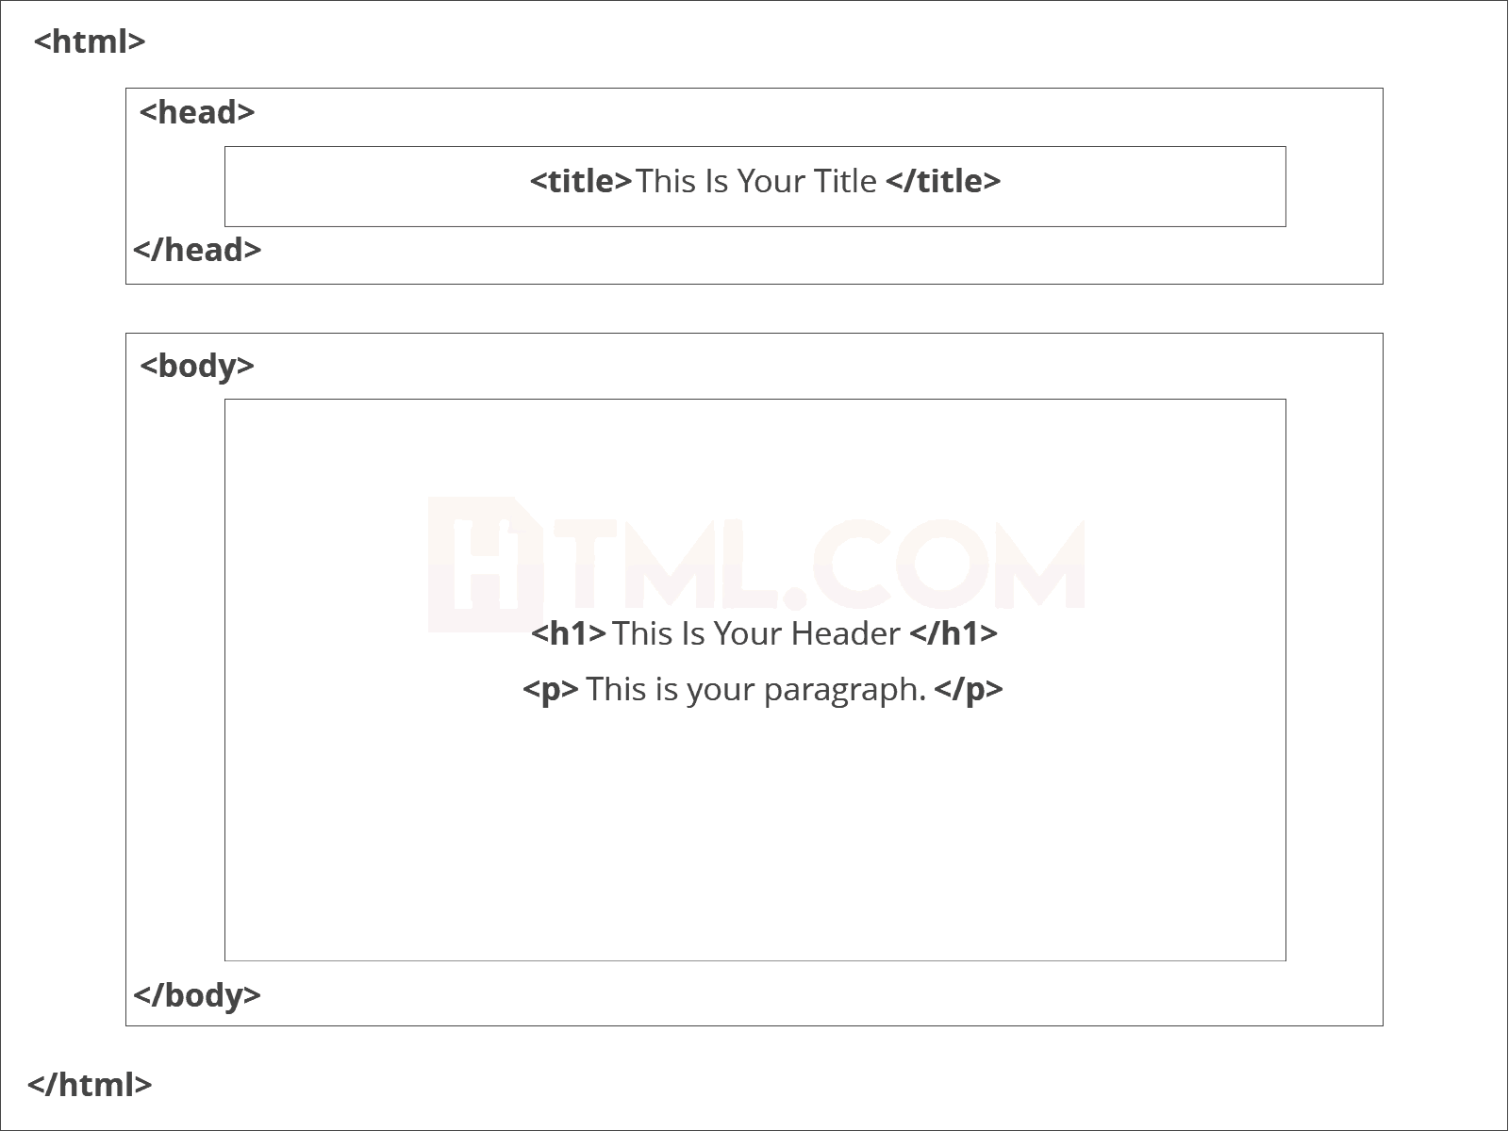

[<!DOCTYPE html>](https://html.com/tags/doctype/) — This tag **specifies the language** you will write on the page. In this case, the language is HTML 5.

[<html>](https://html.com/tags/html/) — This tag signals that from here on we are going to write in HTML code.

[<head>](https://html.com/tags/head/) — This is where all the **metadata for the page** goes — stuff mostly meant for search engines and other computer programs.

[<body>](https://html.com/tags/body/) — This is where the **content of the page** goes.

#### **Further Tags**

Inside the <head> tag, there is one tag that is always included: <title>, but there are others that are just as important:

[**<title>**](https://html.com/tags/title/)

This is where we **insert the page name** as it will appear at the top of the browser window or tab.

[**<meta>**](https://html.com/tags/meta/)

This is where information about the document is stored: character encoding, name (page context), description.

**HeadTag**  
<head>

<title>My First Webpage</title>

<meta charset="UTF-8">

<meta name="description" content="This field contains information about your page. It is usually around two sentences long.">.

<meta name="author" content="Conor Sheils">

</header>

### Adding Content

Next, we will make [<body>](https://html.com/tags/body/) tag.

The HTML <body> is where we add the content which is designed for viewing by human eyes.

This includes **text, images, tables, forms**and everything else that we see on the internet each day.

#### How to Add HTML Headings To Your Web Page

In HTML, [headings](https://html.com/tags/heading/) are written in the following elements:

* <h1>
  + <h2>
    - <h3>
      * <h4>
        + <h5>

<h6>

As you might have guessed <h1> and <h2> should be used for the most important titles, while the remaining tags should be used for sub-headings and less important text.

**Search engine bots use this order** when deciphering which information is most important on a page.

##### Creating Your Heading

Let’s try it out. On a new line in the HTML editor, type:

<h1>Welcome to My Page</h1>

And hit save. We will save this file as “index.html” in a new folder called “my webpage.”

***The Moment of Truth****: Click the newly saved file and your first ever web page should open in your default browser. It may not be pretty it’s yours… all yours. *Evil laugh\**

**Add Text In HTML**

Adding text to our HTML page is simple using an element opened with the tag [<p>](https://html.com/tags/p/) which **creates a new paragraph**. We place all of our regular text inside the element <p>.

| **Element** | **Meaning** | **Purpose** |
| --- | --- | --- |
| **<b>** | Bold | Highlight important information |
| **<strong>** | Strong | Similarly to bold, to highlight key text |
| **<i>** | Italic | To denote text |
| **<em>** | Emphasised Text | Usually used as image captions |
| **<mark>** | Marked Text | Highlight the background of the text |
| **<small>** | Small Text | To shrink the text |
| **<strike>** | Striked Out Text | To place a horizontal line across the text |
| **<u>** | Underlined Text | Used for links or text highlights |
| **<ins>** | Inserted Text | Displayed with an underline to show an inserted text |
| **<sup>** | Superscript Text | Another typographical presentation style |
|  |  |  |

When we write text in HTML, we also have a number of other elements we can use to **control the text or make it appear in a certain way**.

#### **Add Links In HTML**

As you may have noticed, the internet is made up of lots of [links](https://html.com/anchors-links/).

Almost everything you click on while surfing the web is a link **takes you to another page** within the website you are visiting or to an external site.

Links are included in an attribute opened by the [**<a>**](https://html.com/tags/a/) tag. This element is the first that we’ve met which uses an attribute and so it **looks different to previously mentioned tags**.

<a href="[http://www.google.com](https://www.google.com/)">Google</a>

**Image Tag**

In today’s modern digital world, [images](https://html.com/blog/100-legal-sources-free-stock-images/) are everything. The [**<img>**](https://html.com/tags/img/) tag has everything you need to display images on your site. Much like the <a> anchor element, <img> also contains an attribute.

The attribute *features information* for your computer regarding the **source**, **height**, **width** and **alt text** of the image

<img src="yourimage.jpg" alt="Describe the image" height="X" width="X">

**30.3 CSS**

CSS stands for Cascading Style Sheets. It is the language for describing the presentation of Web pages, including colours, layout, and fonts, thus making our web pages presentable to the users.

CSS is designed to make style sheets for the web. It is independent of HTML and can be used with any XML-based markup language. Now let’s try to break the acronym:

* Cascading: Falling of Styles
* Style: Adding designs/Styling our HTML tags
* Sheets: Writing our style in different documents

## **CSS Syntax**

Selector {

Property 1 : value;

Property 2 : value;

Property 3 : value;

}

For example:

h1

{

Color: red;

Text-align: center;

}

#unique

{

color: green;

}

* Selector: selects the element you want to target
* Always remains the same whether we apply internal or external styling
* There are few basic selectors like tags, id’s, and classes
* All forms this key-value pair
* Keys: properties(attributes) like color, font-size, background, width, height,etc
* Value: values associated with these properties

## **CSS Comment**

* Comments don’t render on the browser
* Helps to understand our code better and makes it readable.
* Helps to debug our code
* Two ways to  comment:
  + Single line

## **CSS How-To**

* There are 3 ways to write CSS in our HTML file.
  + Inline CSS
  + Internal CSS
  + External CSS
* Priority order

Inline > Internal > External

**Inline CSS**

* Before CSS this was the only way to apply styles
* Not an efficient way to write as it has a lot of redundancy
* Self-contained
* Uniquely applied on each element
* The idea of separation of concerns was lost
* Example:

<h3 style=” color:red”> Have a great day </h3>

<p style =” color: green”> I did this , I did that </p>

**Internal CSS**

* With the help of style tag, we can apply styles within the HTML file
* Redundancy is removed
* But the idea of separation of concerns still lost
* Uniquely applied on a single document
* Example:

< style>

h1{

color:red;

}

</style>

<h3> Have a great day </h3>

**External CSS**

* With the help of <link> tag in the head tag, we can apply styles
* Reference is added
* File saved with .css extension
* Redundancy is removed
* The idea of separation of concerns is maintained
* Uniquely applied to each document
* Example:

<head>

<link rel=”stylesheet” type=”text/css” href=”name of the Css file”>

</head>

h1{

color:red; //.css file

}

## **CSS Selectors**

* The selector is used to target elements and apply CSS
* Three simple selectors
  + Element Selector
  + Id Selector
  + Class Selector
* Priority of Selectors

## **CSS Colors**

* There are different colouring schemes in CSS
* **RGB**-This starts with RGB and takes 3 parameter
* **HEX**-Hex code starts with # and comprises of 6 numbers which are further divided into 3 sets
* **RGBA**-This starts with RGB and takes 4 parameter

## **CSS Background**

* There are different ways by which CSS can have an effect on HTML elements
* Few of them are as follows:
  + Color – used to set the color of the background
  + Repeat – used to determine if the image has to repeat or not and if it is repeating then how it should do that
  + Image – used to set an image as the background
  + Position – used to determine the position of the image
  + Attachment – It basically helps in controlling the mechanism of scrolling

## **CSS BoxModel**

* Every element in CSS can be represented using the BOX model
* It allows us to add a border and define space between the content
* It helps the developer to develop and manipulate the elements
* It consists of 4 edges
  + Content edge – It comprises of the actual content
  + Padding edge – It lies in between content and border edge
  + Border edge – Padding is followed by the border edge

Margin edge – It is an outside border and controls the margin of the element.

1. **CODING:**

**Module 1:**

**import** warnings

warnings**.**filterwarnings('ignore')

In [ ]:

**import** os

**import** glob

**import** pandas **as** pd

**import** numpy **as** np

**from** PIL **import** Image

**import** matplotlib.pyplot **as** plt

In [ ]:

**from** tensorflow.keras.preprocessing.image **import** ImageDataGenerator

**from** tensorflow.keras.callbacks **import** ModelCheckpoint

**from** tensorflow.keras.layers **import** Activation, Convolution2D, Dropout, MaxPool2D, MaxPooling2D, Flatten, Dense

**from** tensorflow.keras.models **import** Sequential

In [ ]:

dir_name_train_NORMAL **=** 'dataset/Train/NORMAL'

dir_name_train_TUBERCULOSIS **=** 'dataset/Train/TUBERCULOSIS'

In [ ]:

**def** plot_images(item_dir, n**=**6):

all_item_dir **=** os**.**listdir(item_dir)

item_files **=** [os**.**path**.**join(item_dir, file) **for** file **in** all_item_dir][:n]

plt**.**figure(figsize**=**(80, 40))

**for** idx, img_path **in** enumerate(item_files):

plt**.**subplot(3, n, idx**+**1)

img **=** plt**.**imread(img_path)

plt**.**imshow(img, cmap**=**'gray')

plt**.**axis('off')

plt**.**tight_layout()

In [ ]:

**def** Images_details_Print_data(data, path):

print(" ====== Images in: ", path)

**for** k, v **in** data**.**items():

print("%s:\t%s" **%** (k, v))

**def** Images_details(path):

files **=** [f **for** f **in** glob**.**glob(path **+** "**/*.*", recursive**=True**)]

data **=** {}

data['images_count'] **=** len(files)

data['min_width'] **=** 10**\*\***100 *# No image will be bigger than that*

data['max_width'] **=** 0

data['min_height'] **=** 10**\*\***100 *# No image will be bigger than that*

data['max_height'] **=** 0

**for** f **in** files:

im **=** Image**.**open(f)

width, height **=** im**.**size

data['min_width'] **=** min(width, data['min_width'])

data['max_width'] **=** max(width, data['max_height'])

data['min_height'] **=** min(height, data['min_height'])

data['max_height'] **=** max(height, data['max_height'])

Images_details_Print_data(data, path)

In [ ]:

print("")

print("Trainned data for NORMAL:")

print("")

Images_details(dir_name_train_NORMAL)

print("")

plot_images(dir_name_train_NORMAL, 5)

In [ ]:

print("")

print("Trainned data for TUBERCULOSIS:")

print("")

Images_details(dir_name_train_TUBERCULOSIS)

print("")

plot_images(dir_name_train_TUBERCULOSIS, 5)

In [ ]:

train_datagen**=**ImageDataGenerator(rescale**=**1.**/**255,shear_range**=**0.2,zoom_range**=**0.2,horizontal_flip**=True**)

training_set**=**train_datagen**.**flow_from_directory('dataset/train',target_size**=**(256,256),batch_size**=**32,class_mode**=**'categorical')

In [ ]:

test_datagen**=**ImageDataGenerator(rescale**=**1.**/**255)

test_set**=**test_datagen**.**flow_from_directory('dataset/test',target_size**=**(256,256),batch_size**=**32,class_mode**=**'categorical')

In [ ]:

Classifier**=**Sequential()

Classifier**.**add(Convolution2D(32,(3,3),input_shape**=**(256,256,3),activation**=**'relu'))

Classifier**.**add(MaxPooling2D(pool_size**=**(2,2)))

Classifier**.**add(Flatten())

Classifier**.**add(Dense(38, activation**=**'relu'))

Classifier**.**add(Dense(2, activation**=**'softmax'))

Classifier**.**compile(optimizer**=**'rmsprop',loss**=**'categorical_crossentropy',metrics**=**['accuracy'])

In [ ]:

epochs **=** 10

batch_size **=** 64

In [ ]:

*#### Fitting the model*

history **=** Classifier**.**fit(

training_set, steps_per_epoch**=**training_set**.**samples **//** batch_size,

epochs**=**epochs,

validation_data**=**test_set,validation_steps**=**test_set**.**samples **//** batch_size)

In [ ]:

**def** graph():

*#Plot training & validation accuracy values*

plt**.**plot(history**.**history['acc'])

plt**.**plot(history**.**history['val_acc'])

plt**.**title('Model accuracy')

plt**.**ylabel('Accuracy')

plt**.**xlabel('Epoch')

plt**.**legend(['Train', 'Test'], loc**=**'upper left')

plt**.**show()

*# Plot training & validation loss values*

plt**.**plot(history**.**history['loss'])

plt**.**plot(history**.**history['val_loss'])

plt**.**title('Model loss')

plt**.**ylabel('Loss')

plt**.**xlabel('Epoch')

plt**.**legend(['Train', 'Test'], loc**=**'upper left')

plt**.**show()

graph()

In [ ]:

**Module 2:**

# VGG 16

In [ ]:

**import** warnings

warnings**.**filterwarnings('ignore')

In [ ]:

**import** os

**import** glob

**import** numpy **as** np

**import** pandas **as** pd

**from** PIL **import** Image

**import** numpy **as** np

**import** matplotlib.pyplot **as** plt

**from** tensorflow.keras.preprocessing.image **import** ImageDataGenerator

**from** keras.callbacks **import** EarlyStopping, ModelCheckpoint

**from** tensorflow.keras.models **import** Sequential

**from** tensorflow.keras.layers **import** Conv2D

**from** tensorflow.keras.layers **import** MaxPool2D

**from** tensorflow.keras.layers **import** Flatten

**from** tensorflow.keras.layers **import** Dense

In [ ]:

train_datagen**=**ImageDataGenerator(rescale**=**1.**/**255,shear_range**=**0.2,zoom_range**=**0.2,horizontal_flip**=True**)

training_set**=**train_datagen**.**flow_from_directory('dataset/train',target_size**=**(256,256),batch_size**=**32,class_mode**=**'categorical')

In [ ]:

test_datagen**=**ImageDataGenerator(rescale**=**1.**/**255)

test_set**=**test_datagen**.**flow_from_directory('dataset/test',target_size**=**(256,256),batch_size**=**32,class_mode**=**'categorical')

In [ ]:

model **=** Sequential()

model**.**add(Conv2D(input_shape**=**(256,256,3), filters**=**64, kernel_size**=**(3,3), padding**=**"same", activation**=**"relu"))

model**.**add(Conv2D(filters**=**64, kernel_size**=**(3,3), padding**=**"same", activation**=**"relu"))

model**.**add(MaxPool2D(pool_size**=**(2,2), strides**=**(2,2)))

model**.**add(Conv2D(filters**=**128, kernel_size**=**(3,3), padding**=**"same", activation**=**"relu"))

model**.**add(Conv2D(filters**=**128, kernel_size**=**(3,3), padding**=**"same", activation**=**"relu"))

model**.**add(MaxPool2D(pool_size**=**(2,2),strides**=**(2,2)))

model**.**add(Conv2D(filters**=**256, kernel_size**=**(3,3), padding**=**"same", activation**=**"relu"))

model**.**add(Conv2D(filters**=**256, kernel_size**=**(3,3), padding**=**"same", activation**=**"relu"))

model**.**add(Conv2D(filters**=**256, kernel_size**=**(3,3), padding**=**"same", activation**=**"relu"))

model**.**add(MaxPool2D(pool_size**=**(2,2),strides**=**(2,2)))

model**.**add(Conv2D(filters**=**512, kernel_size**=**(3,3), padding**=**"same", activation**=**"relu"))

model**.**add(Conv2D(filters**=**512, kernel_size**=**(3,3), padding**=**"same", activation**=**"relu"))

model**.**add(Conv2D(filters**=**512, kernel_size**=**(3,3), padding**=**"same", activation**=**"relu"))

model**.**add(MaxPool2D(pool_size**=**(2,2),strides**=**(2,2)))

model**.**add(Conv2D(filters**=**512, kernel_size**=**(3,3), padding**=**"same", activation**=**"relu"))

model**.**add(Conv2D(filters**=**512, kernel_size**=**(3,3), padding**=**"same", activation**=**"relu"))

model**.**add(Conv2D(filters**=**512, kernel_size**=**(3,3), padding**=**"same", activation**=**"relu"))

model**.**add(MaxPool2D(pool_size**=**(2,2),strides**=**(2,2)))

model**.**add(Flatten())

model**.**add(Dense(256, activation**=**'relu'))

model**.**add(Dense(128, activation**=**'relu'))

model**.**add(Dense(2, activation**=**'softmax'))

model**.**compile(optimizer**=**'adam',loss**=**'categorical_crossentropy',metrics**=**['accuracy'])

model**.**summary()

In [ ]:

es **=** EarlyStopping(monitor **=** 'accuracy', patience **=** 10)

mc **=** ModelCheckpoint('vggmodel.h5', monitor **=** 'accuracy', verbose**=**1, save_best_only **=** **True**)

In [ ]:

epochs **=** 10

batch_size **=** 32

In [ ]:

*#### Fitting the model*

history **=** model**.**fit(

training_set, steps_per_epoch**=**training_set**.**samples **//** batch_size,

epochs**=**epochs,

validation_data**=**test_set,validation_steps**=**test_set**.**samples **//** batch_size,

callbacks**=**[es, mc])

In [ ]:

**def** graph():

*#Plot training & validation accuracy values*

plt**.**plot(history**.**history['acc'])

plt**.**plot(history**.**history['val_acc'])

plt**.**title('Model accuracy')

plt**.**ylabel('Accuracy')

plt**.**xlabel('Epoch')

plt**.**legend(['Train', 'Test'], loc**=**'upper left')

plt**.**show()

*# Plot training & validation loss values*

plt**.**plot(history**.**history['loss'])

plt**.**plot(history**.**history['val_loss'])

plt**.**title('Model loss')

plt**.**ylabel('Loss')

plt**.**xlabel('Epoch')

plt**.**legend(['Train', 'Test'], loc**=**'upper left')

plt**.**show()

graph()

In [ ]:

**Module 3:**

# LeNet

In [ ]:

**import** warnings

warnings**.**filterwarnings('ignore')

In [ ]:

**import** pandas **as** pd

**import** numpy **as** np

**from** tensorflow.keras.layers **import** Convolution2D, MaxPool2D, MaxPooling2D, Dropout, Conv2D, Flatten, Dense, Activation

**from** tensorflow.keras.models **import** Sequential

**from** tensorflow.keras.preprocessing.image **import** ImageDataGenerator

**from** PIL **import** Image

**from** keras.callbacks **import** ModelCheckpoint

**import** matplotlib.pyplot **as** plt

**import** os

**import** glob

In [ ]:

train_datagen**=**ImageDataGenerator(rescale**=**1.**/**255,shear_range**=**0.2,zoom_range**=**0.2,horizontal_flip**=True**)

training_set**=**train_datagen**.**flow_from_directory('dataset/train',target_size**=**(256,256),batch_size**=**32,class_mode**=**'categorical')

In [ ]:

test_datagen**=**ImageDataGenerator(rescale**=**1.**/**255)

test_set**=**test_datagen**.**flow_from_directory('dataset/test',target_size**=**(256,256),batch_size**=**32,class_mode**=**'categorical')

In [ ]:

Classifier**=**Sequential()

Classifier**.**add(Convolution2D(32,3,3,input_shape**=**(256,256,3),activation**=**'relu'))

Classifier**.**add(MaxPooling2D(pool_size**=**(2,2)))

Classifier**.**add(Convolution2D(128,3,3,activation**=**'relu'))

Classifier**.**add(MaxPooling2D(pool_size**=**(2,2)))

Classifier**.**add(Flatten())

Classifier**.**add(Dense(256, activation**=**'relu'))

Classifier**.**add(Dense(2, activation**=**'softmax'))

Classifier**.**compile(optimizer**=**'rmsprop',loss**=**'categorical_crossentropy',metrics**=**['accuracy'])

Classifier**.**summary()

In [ ]:

model_path **=** "LeNet.h5"

callbacks **=** [

ModelCheckpoint(model_path, monitor**=**'accuracy', verbose**=**1, save_best_only**=True**)

]

In [ ]:

epochs **=** 25

batch_size **=** 32

In [ ]:

*#### Fitting the model*

history **=** Classifier**.**fit(

training_set, steps_per_epoch**=**training_set**.**samples **//** batch_size,

epochs**=**epochs,

validation_data**=**test_set,validation_steps**=**test_set**.**samples **//** batch_size,

callbacks**=**callbacks)

In [ ]:

plt**.**figure(figsize**=**(20, 8))

plt**.**plot(history**.**history['acc'])

**for** i **in** range(epochs):

**if** i**%5** == 0:

plt**.**annotate(np**.**round(history**.**history['acc'][i]**\***100,2),xy**=**(i,history**.**history['acc'][i]))

plt**.**title('Model accuracy')

plt**.**ylabel('Accuracy')

plt**.**xlabel('Epoch')

plt**.**show()

In [ ]:

plt**.**figure(figsize**=**(20, 8))

plt**.**plot(history**.**history['loss'])

**for** i **in** range(epochs):

**if** i**%5** == 0:

plt**.**annotate(np**.**round(history**.**history['loss'][i]**\***100,2),xy**=**(i,history**.**history['loss'][i]))

plt**.**title('Model Loss')

plt**.**ylabel('Loss')

plt**.**xlabel('Epoch')

plt**.**show()

In [ ]:

**import** h5py

Classifier**.**save('Lenet.h5')

**Output Screenshot:**

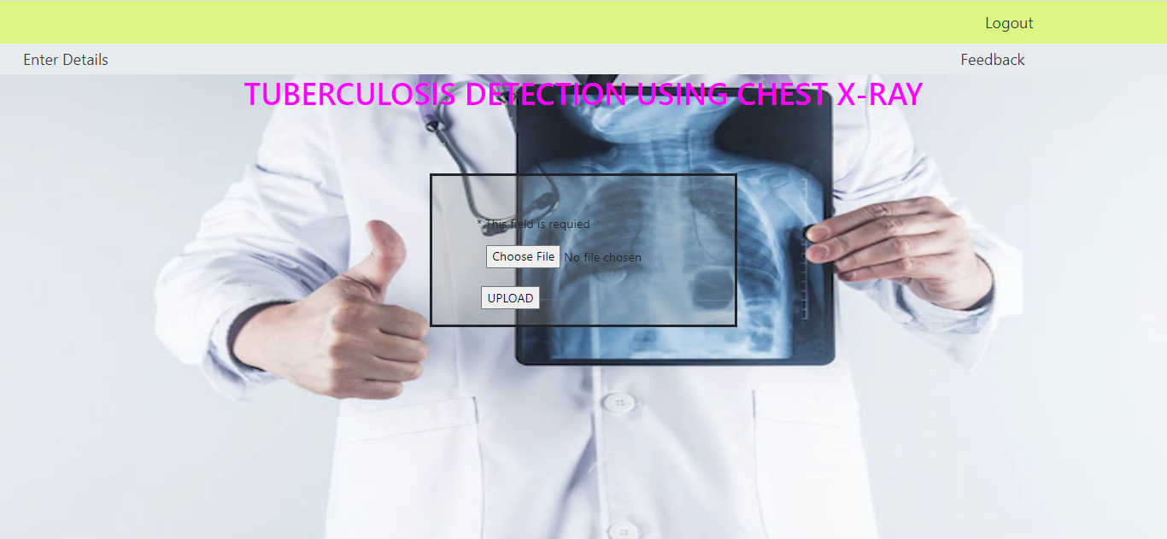

**Conclusion:**

In this project, a research to identify Tuberculosis disease images and normal chest X-rays using deep learning techniques was developed. This is a complex problem that has already been approached several times with different technique. While good results have been achieved using deep learning, this project focused on deep learning. Nowadays, pulmonary tuberculosis was emerging with multi drug resistant mycobacterium tuberculous. Thus, Tuberculosis or not classification has to be done for better enhancement for identification. So we did the project with 94.66% accuracy in tuberculosis identification.

**Future Work:**

* We can even connect it in cloud, so patients with their scans can able to identify their diagnosis on their own.
* We can also use IOT and send a alert message for the people who were in the patients contact.