1)

* - This is a expression

'hello' - This is a value(str)

-87.8 - This is a Value

- - This is a expression

/ This is a expression

* This is a expression

6 This is a value

2) Difference between string and variable is that string is a data type of a identifier while variable is a storage unit of values .

Variable can have values stored in any datatype While string is one among the datatype.

Eg:

V=3,v=”hello”,v=4.5 # This variable of different data type.

V=”str” #This is string

3)

The different data types are :

Numeric – int , float , complex

Test – str

Sequence- list,tuple,range

Mapping-dict

Boolean – bool

4)Expressions are made up of operators , operands and values .

Eg: v=x+10

Expression produces some value after being processed by python interpretor.

5) A statement in Python is used for creating variables or for displaying values. The expression in Python produces some value or result after being interpreted by the Python interpreter.

Eg:

A=15; Statement

B=A+15;Expression

6)

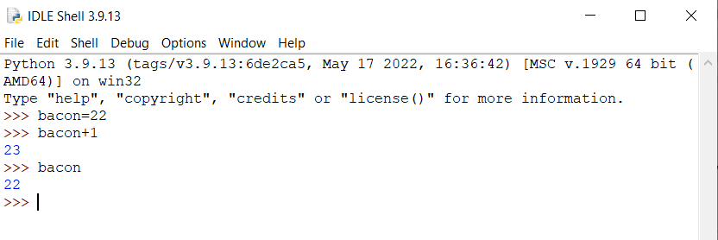

The variable will have 22 as bacon+1 is not assigned to bacon.

7)

'spam' + 'spamspam' = 'spamspamspam'

'spam' * 3 = 'spamspamspam'

8)

eggs is a valid varable name while 100 is not because variable names cannot start while numbers or special characters .

9)The **int() , float() , and str( ) functions** will evaluate to the integer, floating-point number, and string versions of the value passed to them.

10) The expression 'I have eaten ' + 99 + ' burritos.' Causes error because we cannot concatenate string and integer datatype . To solve the error we should make 99 as string .

'I have eaten ' +’99’ + ' burritos.' This expression will be valid