VISVESVARAYA TECHNOLOGICAL UNIVERSITY
“JnanaSangama”, Belgaum -590014, Karnataka.

LAB REPORT
on
Artificial Intelligence (23CS5PCAIN)
Submitted by
Pranav Hegde (1BM22CS202)
in partial fulfillment for the award of the degree of
BACHELOR OF ENGINEERING
in
COMPUTER SCIENCE AND ENGINEERING



B.M.S. COLLEGE OF ENGINEERING
(Autonomous Institution under VTU)
BENGALURU-560019
Sep-2024 to Jan-2025

B.M.S. College of Engineering,
Bull Temple Road, Bangalore 560019
(Affiliated To Visvesvaraya Technological University, Belgaum)

Department of Computer Science and Engineering

CERTIFICATE

This is to certify that the Lab work entitled “Artificial Intelligence (23CS5PCAIN)” carried out by Pranav Hegde (1BM22CS202), who is bonafide student of B.M.S. College of Engineering. It is in partial fulfillment for the award of Bachelor of Engineering in Computer Science and Engineering of the Visvesvaraya Technological University, Belgaum. The Lab report has been approved as it satisfies the academic requirements in respect of an Artificial Intelligence (23CS5PCAIN) work prescribed for the said degree.

Prof. Sneha S Bagalkot Dr. Kavitha Sooda

Assistant Professor Professor & HOD

Department of CSE, BMSCE Department of CSE, BMSCE

Index

Sl.  No. | Date | Experiment Title | Page No.
1 | 4-10-2024 | Implement Tic –Tac –Toe Game Implement vacuum cleaner agent | 1-7
2 | 18-10-2024 | Implement 8 puzzle problems using Depth  First Search (DFS)  Implement Iterative deepening search algorithm | 8-15
3 | 25-10-2024 | Implement A* search algorithm | 16-22
4 | 8-11-2024 | Implement Hill Climbing search algorithm to solve N-Queens problem | 23-25
5 | 15-11-2024 | Simulated Annealing to Solve 8-  Queens problem  A* to Solve 8-Queens problem | 26-28
6 | 22-11-2024 | Create a knowledge base using propositional logic and show that the given query entails the knowledge base or not. | 29-30
7 | 29-12-2024 | Implement unification in first order logic | 31-34
8 | 6-12-2024 | Create a knowledge base consisting of first order logic statements and prove the given query using forward reasoning. | 35-37
9 | 6-12-2024 | Create a knowledge base consisting of first order logic statements and prove the given query using Resolution | 38-40
10 | 13-12-2024 | Implement MinMax Algorithm for TicTacToe Implement Alpha-Beta Pruning. | 41-43

Github Link: https://github.com/pranav0hegde/AI

Implement Tic-Tac-Toe Game.
Algorithm:
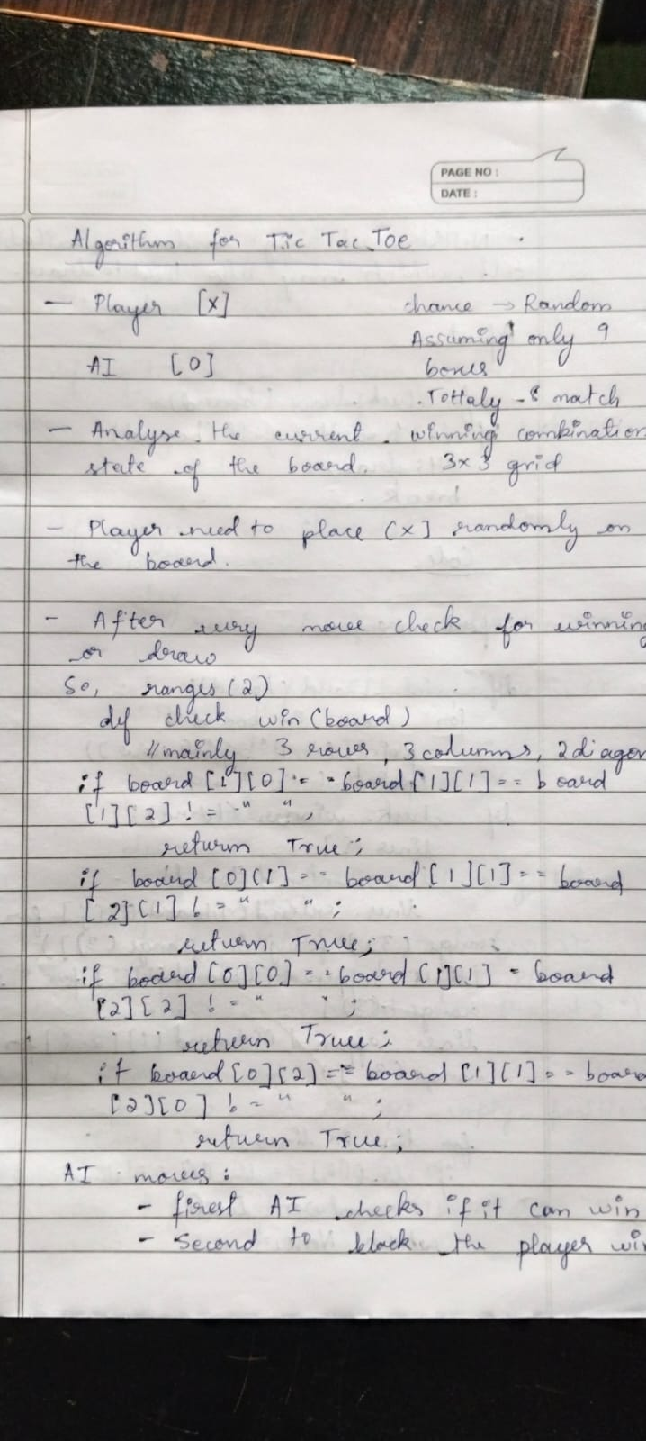

Code:
import random import numpy as np

board = [["-"] * 3 for _ in range(3)]

def check_win(): for i in range(3): if board[i][0] == board[i][1] == board[i][2] != "-":
return True if board[0][i] == board[1][i] == board[2][i] != "-":
return True

if board[0][0] == board[1][1] == board[2][2] != "-": return True if board[0][2] == board[1][1] == board[2][0] != "-":
return True

return False

def full():
return all(cell != "-" for row in board for cell in row)

def can_win(m): for i in range(3): row = board[i] if row.count(m) == 2 and row.count("-") == 1: return (i, row.index("-"))

for i in range(3):
col = [board[j][i] for j in range(3)] if col.count(m) == 2 and col.count("-") == 1:
return (col.index("-"), i)

diag1 = [board[i][i] for i in range(3)] if diag1.count(m) == 2 and diag1.count("-") == 1:
return (diag1.index("-"), diag1.index("-"))

diag2 = [board[i][2 - i] for i in range(3)] if diag2.count(m) == 2 and diag2.count("-") == 1: return (diag2.index("-"), 2 - diag2.index("-"))

return None

def display():
print(np.array(board))

while True: display()
u = tuple(map(int, input("Enter row and column for X (0-2): ").strip().split())) if board[u[0]][u[1]] != "-":
print("Invalid move, try again.") continue

board[u[0]][u[1]] = "X"

if check_win(): display() print("X wins!") break
if full(): display() print("It's a tie!") break

move = can_win("O") print(move) if move is None:
move = can_win("X") if move is None:
empty = [(i, j) for i in range(3) for j in range(3) if board[i][j] == "-"] move = random.choice(empty) if board[1][1]=="-":
move=(1 ,1) board[move[0]][move[1]] = "O"

if check_win(): display() print("O wins!") break

Output:
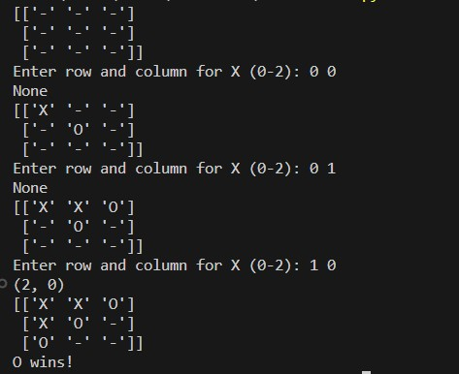
Implement Vacuum Cleaner Agent.
Algorithm:
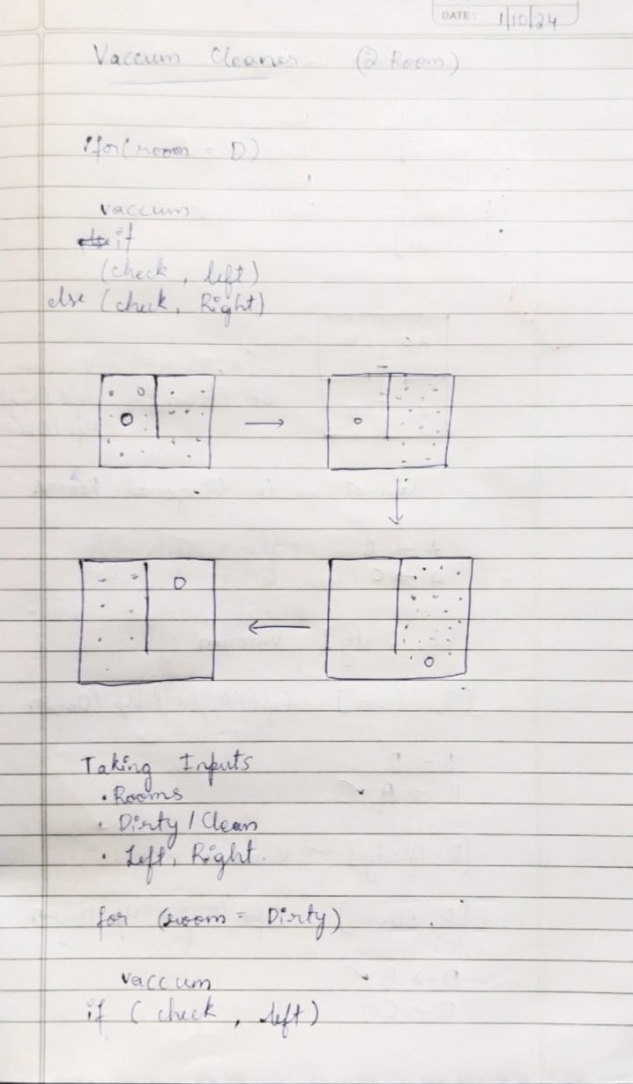

Code: import random
l=[random.choice([0,1]),random.choice([0,1])] def check(i): if l[i]==0: l[i]=1
print(f"Cleaned Room {i}") print(f"Moved to Room {(i+1)%2}") return (i+1)%2 i=random.choice([0,1])

print(f"{i} is the start index") print("0 is dirty and 1 is clean") print(f"{l} is the initial state of room")

while sum(l)!=2: i=check(i) if l[(i+1)%2]==1:
l[(i+1)%2]=random.choice([0,1]) if l[(i+1)%2]==0:
print(f"Room {(i+1)%2} got dirty") print(f"{l} is current state of rooms") print("Rooms are clean")

Output:
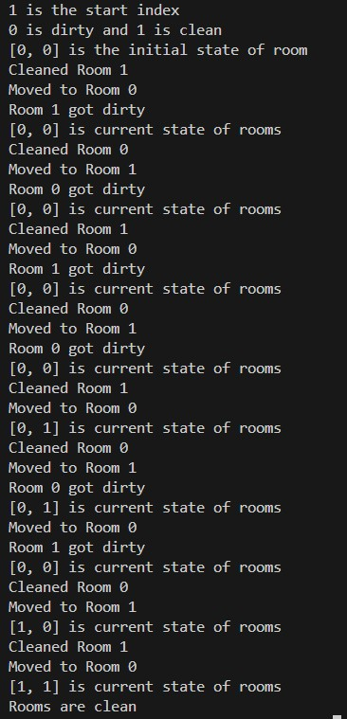

Implement 8 puzzle problems using Depth First Search (DFS).
Algorithm:
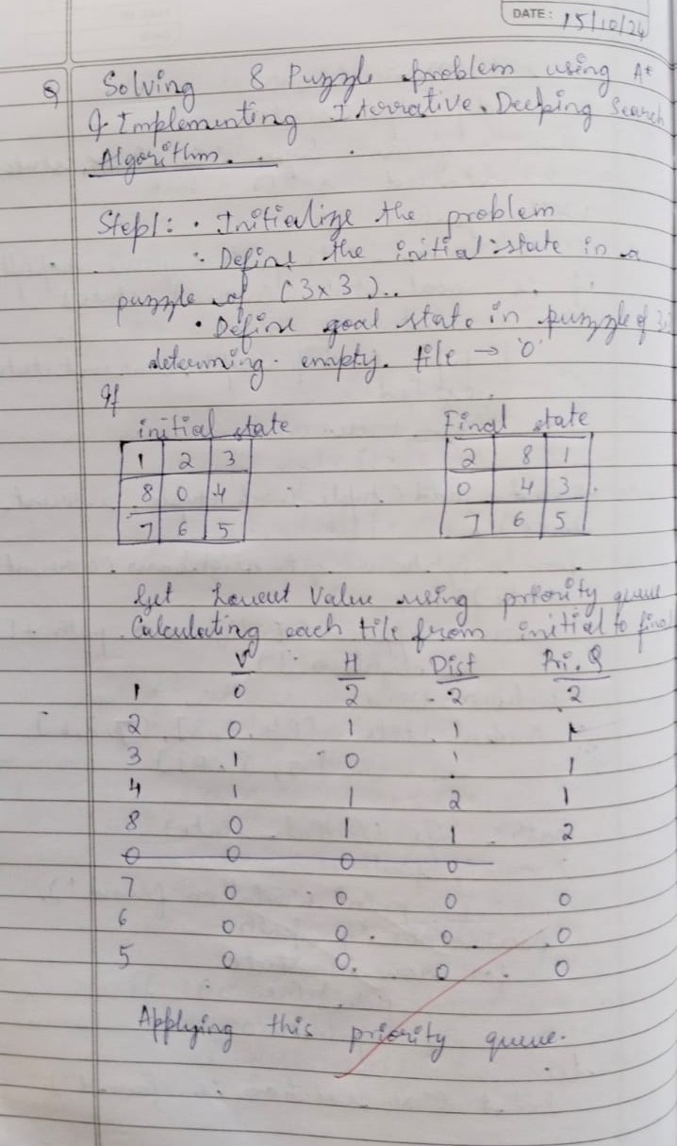
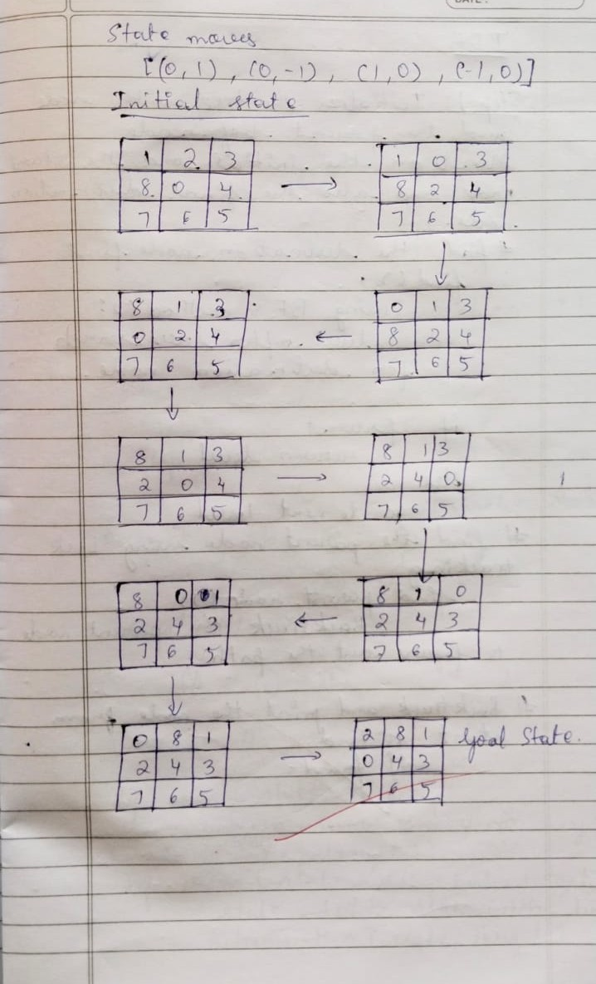
Code:
import heapq import numpy as np

goal = [[0,1,2], [3,4,5], [6,7,8]] vis = set() q = [] parent_map = {} move_map = {}

def manhattan(curr):
ans = 0
pos = {goal[i][j]: (i, j) for i in range(3) for j in range(3)} for i in range(3): for j in range(3):
x, y = pos[curr[i][j]] ans += abs(i - x) + abs(j - y) return ans

def moves(curr):
x, y = [(i, j) for i in range(3) for j in range(3) if curr[i][j] == 0][0] poss = [[0, -1, 'left'], [-1, 0, 'up'], [1, 0, 'down'], [0, 1, 'right']] for dx, dy, direction in poss: nx, ny = x + dx, y + dy if 0 <= nx < 3 and 0 <= ny < 3: curr1 = [row[:] for row in curr]
curr1[x][y], curr1[nx][ny] = curr1[nx][ny], curr1[x][y] tuple_curr1 = tuple(map(tuple, curr1)) if tuple_curr1 not in vis: heapq.heappush(q, (manhattan(curr1), curr1)) vis.add(tuple_curr1)
parent_map[tuple(map(tuple, curr1))] = curr move_map[tuple(map(tuple, curr1))] = direction

def dfs(curr):
vis.add(tuple(map(tuple, curr))) if curr == goal: return True moves(curr) if q:
curr = heapq.heappop(q)[1] if dfs(curr): return True return False

def display_board(board): print("+---+---+---+") for row in board:
print("| " + " | ".join(str(x) if x != 0 else ' ' for x in row) + " |") print("+---+---+---+")

c =[[] for i in range(3)] for i in range(3):
print(f"Enter elements of row {i+1}") c[i]=list(map(int,input().split())) dfs(c)

result_path = [] directions = [] state = goal while state:
result_path.append(state)
directions.append(move_map.get(tuple(map(tuple, state)), None)) state = parent_map.get(tuple(map(tuple, state)))

for ind, (state, direction) in enumerate(reversed(list(zip(result_path, directions)))):
print(f"Step {ind}:") display_board(state) if ind==0:
print("Initial state") if direction:
print(f" Move empty space {direction}") print()

print(f"Steps taken: {len(result_path) - 1}")

Output:
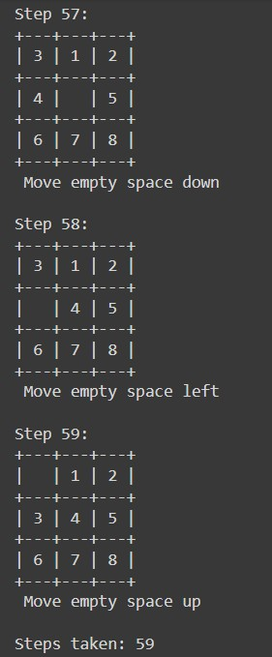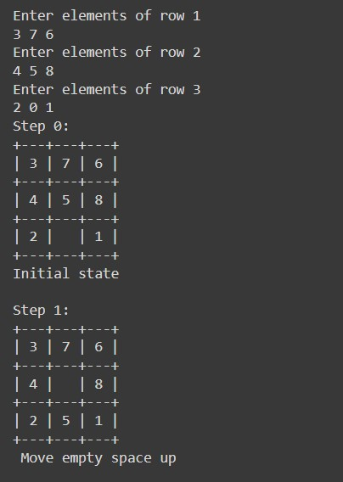

Implement Iterative deepening search algorithm.
Algorithm:
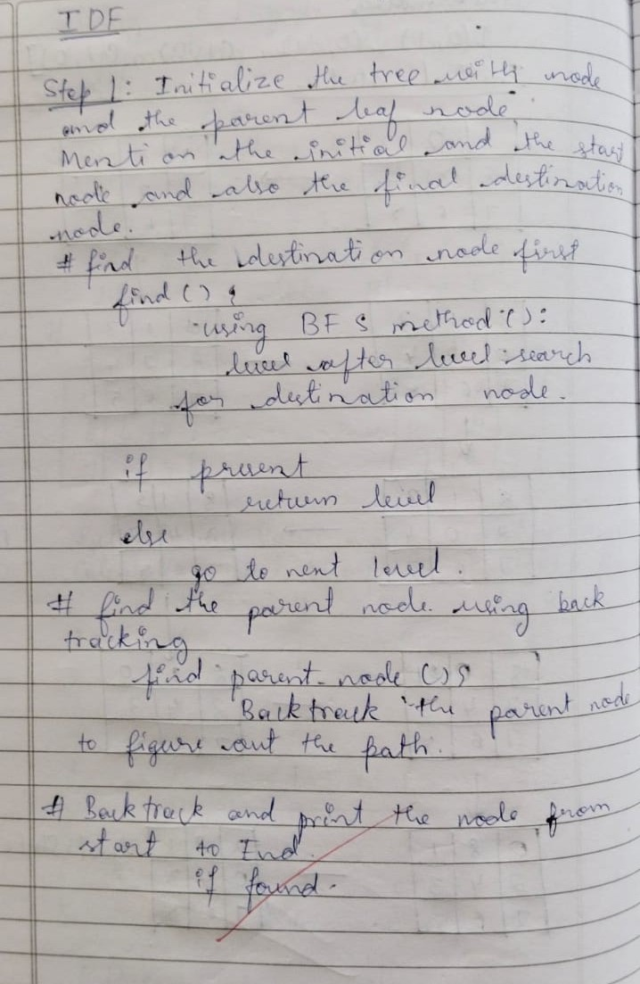
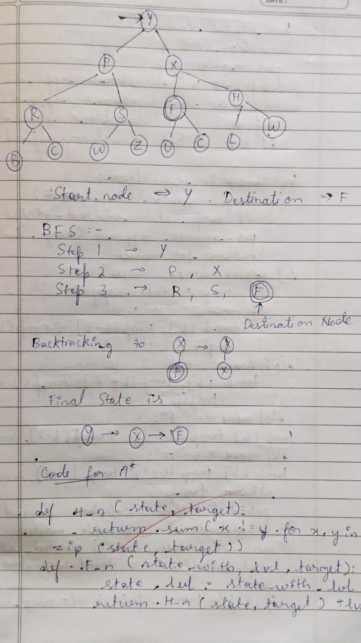

Code:
class TreeNode: def __init__(self, value): self.value = value
self.children = [] # List to hold children nodes

def add_child(self, child_node): self.children.append(child_node)

def iddfs(root, goal): for i in range(0,100000): res=dls(root,goal,i) if res:
print("Found") return
print("Not found")

def dls(root,goal,depth):
if depth==0: if root.value==goal:
return True return False for child in root.children: if dls(child,goal,depth-1):
return True
return False

root=TreeNode("Y") node1=TreeNode("P") node2=TreeNode("X") node3=TreeNode("R") node4=TreeNode("S") node5=TreeNode("F") node6=TreeNode("H") node7=TreeNode("B") node8=TreeNode("C")
node9=TreeNode("S") root.add_child(node1) root.add_child(node2) node1.add_child(node3) node1.add_child(node4) node2.add_child(node5) node2.add_child(node6) node3.add_child(node7) node3.add_child(node8) node4.add_child(node9) iddfs(root, "F") iddfs(root, "A")

Output:

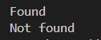

Implement A* search algorithm.
Algorithm:
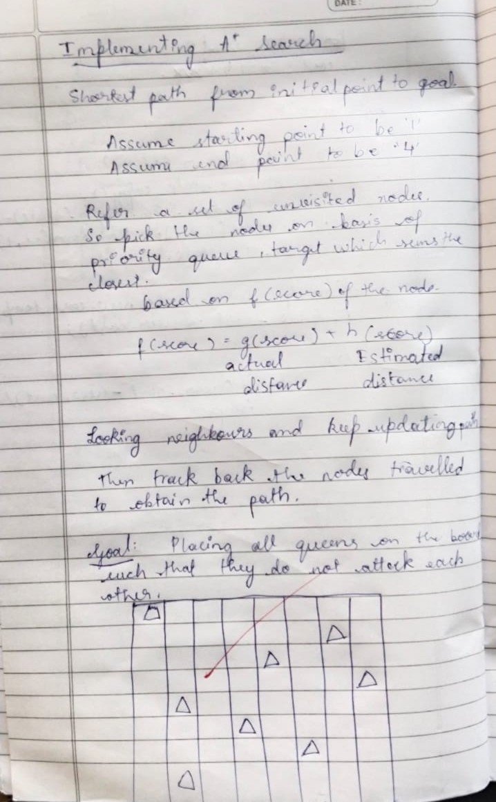
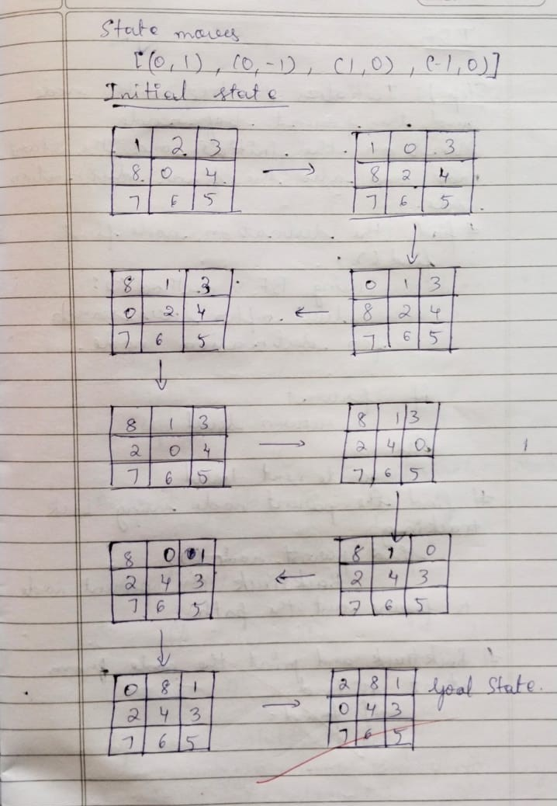

Code:
import heapq
import numpy as np

goal = [[2,8,1], [0,4,3], [7,6,5]] vis = set() q = [] parent_map = {}
move_map = {}

def manhattan(curr):
ans = 0 pos = {goal[i][j]: (i, j) for i in range(3) for j in range(3)} for i in range(3): for j in range(3):
x, y = pos[curr[i][j]] ans += abs(i - x) + abs(j - y) return ans

def moves(curr,g):
x, y = [(i, j) for i in range(3) for j in range(3) if curr[i][j] == 0][0] poss = [[0, -1, 'left'], [-1, 0, 'up'], [1, 0, 'down'], [0, 1, 'right']] for dx, dy, direction in poss: nx, ny = x + dx, y + dy if 0 <= nx < 3 and 0 <= ny < 3: curr1 = [row[:] for row in curr]
curr1[x][y], curr1[nx][ny] = curr1[nx][ny], curr1[x][y] tuple_curr1 = tuple(map(tuple, curr1)) if tuple_curr1 not in vis: f=g+1+manhattan(curr1) heapq.heappush(q, (f, curr1,g+1)) vis.add(tuple_curr1) parent_map[tuple(map(tuple, curr1))] = curr
move_map[tuple(map(tuple, curr1))] = direction

def a_star(curr,g):
vis.add(tuple(map(tuple, curr))) if curr == goal: return True moves(curr,g) if q:
curr = heapq.heappop(q) if a_star(curr[1],curr[2]):
return True
return False

def display_board(board): print("+---+---+---+") for row in board:
print("| " + " | ".join(str(x) if x != 0 else ' ' for x in row) + " |") print("+---+---+---+")

c =[[] for i in range(3)] for i in range(3):
print(f"Enter elements of row {i+1}") c[i]=list(map(int,input().split())) a_star(c,0)

result_path = [] directions = [] state = goal while state: result_path.append(state)
directions.append(move_map.get(tuple(map(tuple, state)), None)) state = parent_map.get(tuple(map(tuple, state)))

for ind, (state, direction) in enumerate(reversed(list(zip(result_path, directions)))): print(f"Step {ind}:") display_board(state) if ind==0:
print("Initial state") if direction:
print(f" Move empty space {direction}") print()

print(f"Steps taken: {len(result_path) - 1}")

Output:
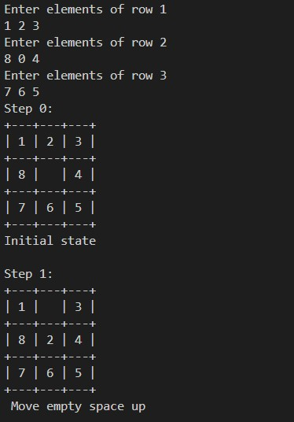

Implement Hill Climbing search algorithm to solve N-Queens problem.
Algorithm:
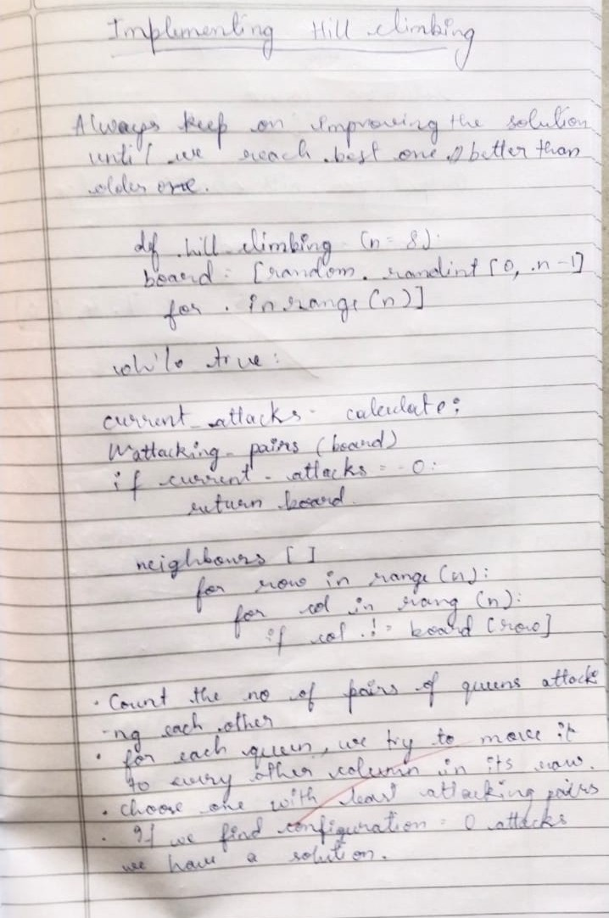
Code:
import random def h(s): h = 0 n = len(s) for i in range(n): for j in range(i + 1, n): if s[i] == s[j] or abs(s[i] - s[j]) == abs(i - j):
h += 1
return h

def new(s): best=s for i in range(len(s)): for j in range(1,9): if j!=s[i]:
n=s[:i]+[j]+s[i+1:] if h(n)<h(best):
best=n
return best

def hc():
curr=[random.randint(1,8) for i in range(8)] while True: ch=h(curr) curr=new(curr) if h(curr)==0: return curr if h(curr)>=ch: curr=[random.randint(1,8) for i in range(8)]

def print_board(solution):
print("Solution for 8 Queens Hill climbing is: ",solution) if solution is None:
print("No solution found.")
return

board = [['.' for _ in range(8)] for _ in range(8)]

for row in range(len(solution)): col = solution[row] - 1
board[row][col] = 'Q'

for row in board: print(' '.join(row)) print_board(hc())

Output:
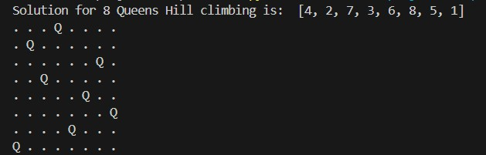

Implement A star algorithm to solve N-Queens problem.
Algorithm:
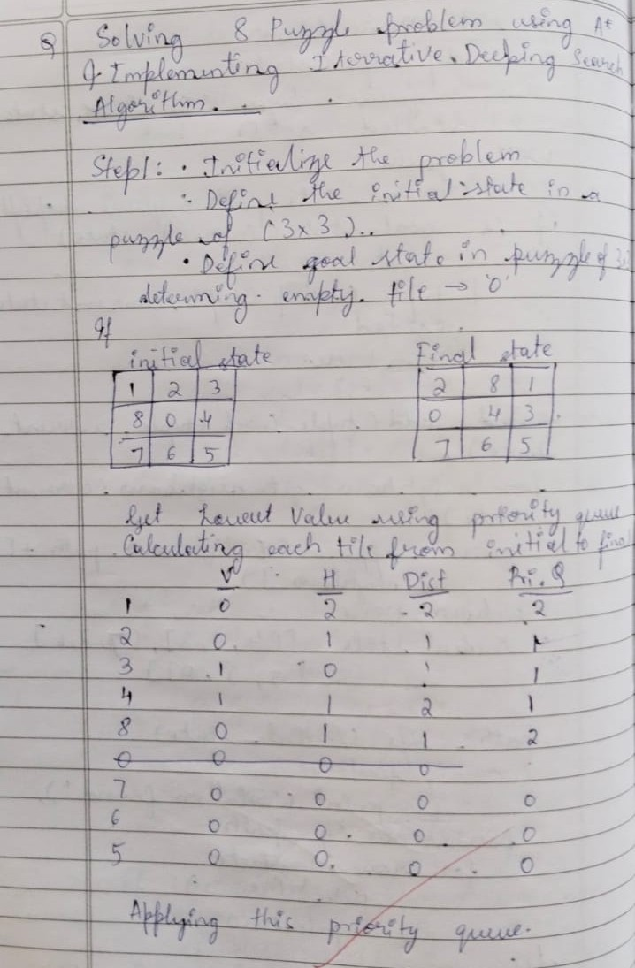

Code:
import heapq

def h(s):

h = 0 n = len(s) for i in range(n): for j in range(i + 1, n): if s[i] == s[j] or abs(s[i] - s[j]) == abs(i - j):
h += 1 return h

def a_star(): initial_state = [] q = [] g = 8
heapq.heappush(q, (h(initial_state), initial_state, g))

while q:
f, state, g = heapq.heappop(q)

if len(state) == 8 and h(state) == 0:
return state

for i in range(1, 9): if i not in state: new_state = state + [i]
heapq.heappush(q, (h(new_state) + g, new_state, g - 1))

return None

solution = a_star() print("Solution:", solution)

Output:
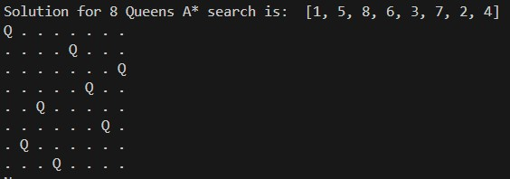

Implement Simulated Annealing:
Algorithm:
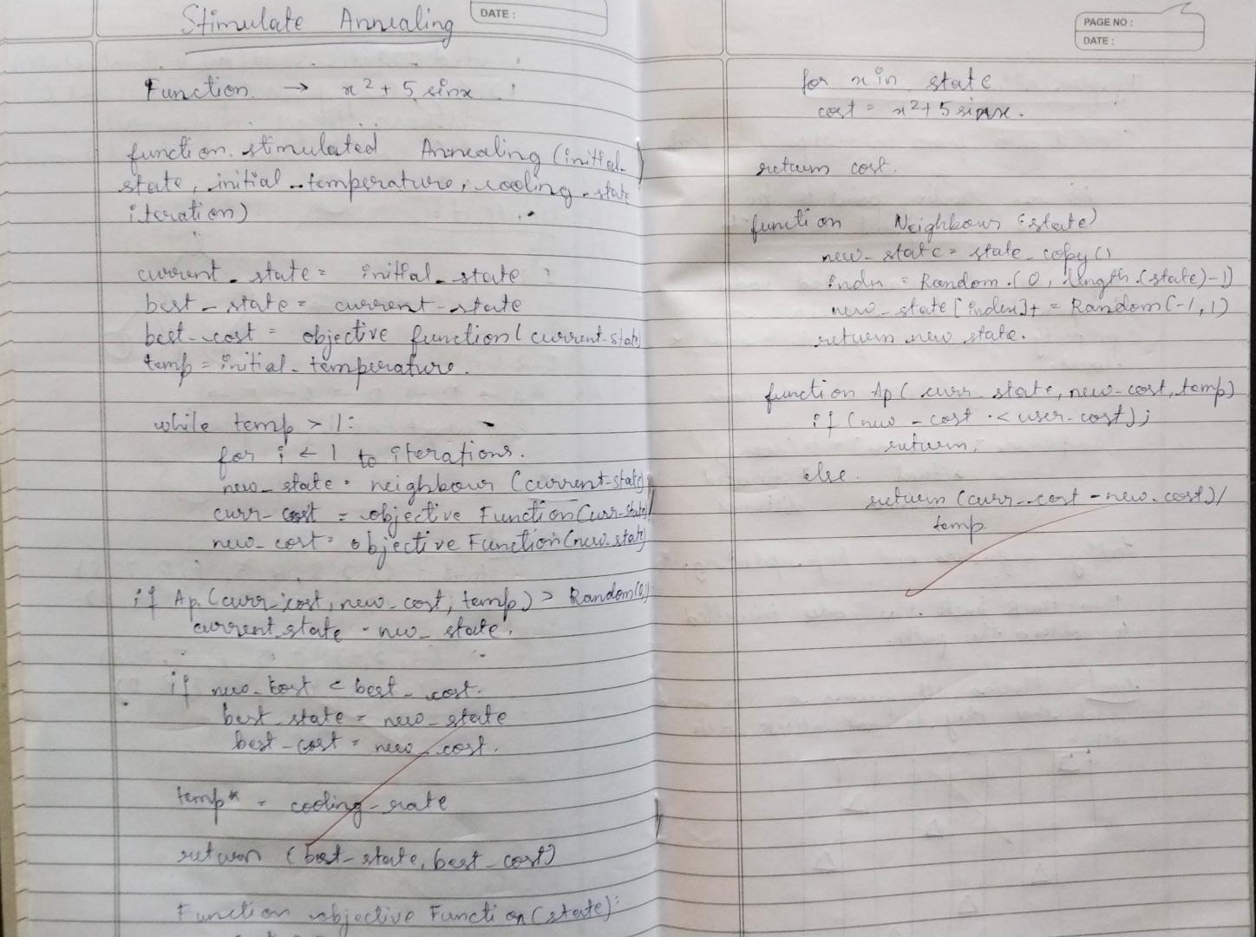

Code:
import random
import math

def sim_anneal(ini, in_temp, max_iter, cool): # Initialize current state and best state curr_s = ini best_s = curr_s best_c = obj(best_s)
temp = in_temp # Set the initial temperature

# While the temperature is above a threshold while temp > 1:
for i in range(max_iter): new_s = neig(curr_s) curr_c = obj(curr_s)
new_c = obj(new_s)

if ap(curr_c, new_c, temp) > random.random(): curr_s = new_s # Move to the new state if new_c < best_c: best_s = new_s best_c = new_c
temp *= cool

return best_s, best_c

def neig(state):
new_s = state.copy() ind = random.randint(0, len(state) - 1) new_s[ind] += random.uniform(-1, 1)
return new_s

def obj(state):
c = 1 for i in state: c += i**2 + 2*i + 1 return c

def ap(curr_c, new_c, temp): if new_c < curr_c: return 1 else:
return math.exp((curr_c - new_c) / temp)

print(sim_anneal([1, 2, 3, 4, 5], 1000, 1000, 0.99))
Output:
Create a knowledge base using propositional logic and show that the given query entails the knowledge base or not.
Algorithm:
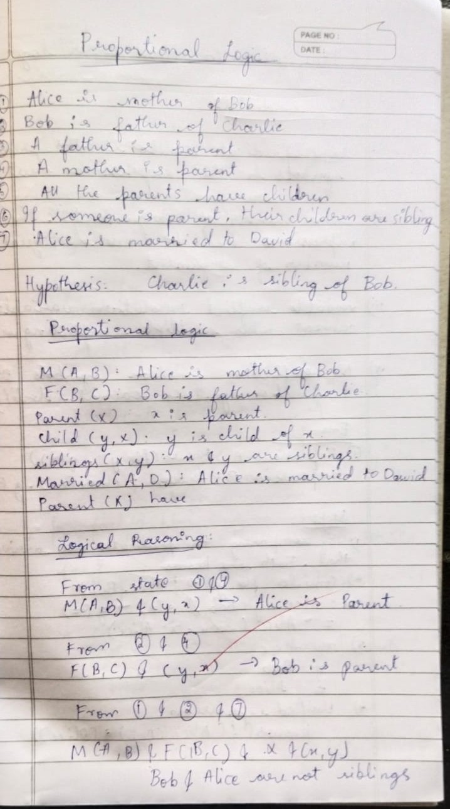

Code:
from sympy.logic.boolalg import Or, And, Not from sympy.abc import A, B, C, D, E, F
from sympy import simplify_logic

def is_entailment(kb, query):

# Negate the query negated_query = Not(query)

# Add negated query to the knowledge base
kb_with_negated_query = And(*kb, negated_query)

# Simplify the combined KB to CNF
simplified_kb = simplify_logic(kb_with_negated_query, form="cnf")

# If the simplified KB evaluates to False, the query is entailed return simplified_kb == False

# Define a larger Knowledge Base kb = [
Or(A, B), # A ∨ B
Or(Not(A), C), # ¬A ∨ C Or(Not(B), D), # ¬B ∨ D
Or(Not(D), E), # ¬D ∨ E
Or(Not(E), F), # ¬E ∨ F
F # F
]
# Query to check
query = Or(C, F) # C ∨ F

# Check entailment result = is_entailment(kb, query)
print(f"Is the query '{query}' entailed by the knowledge base? {'Yes' if result else 'No'}")

Output:
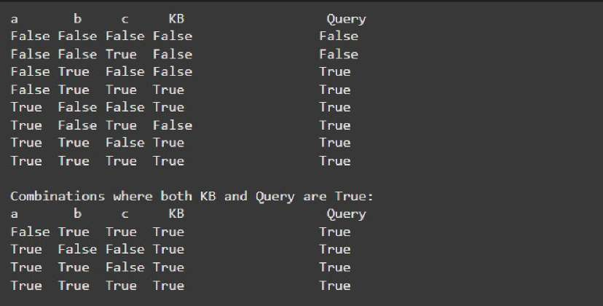

Implement unification in first order logic.
Algorithm:
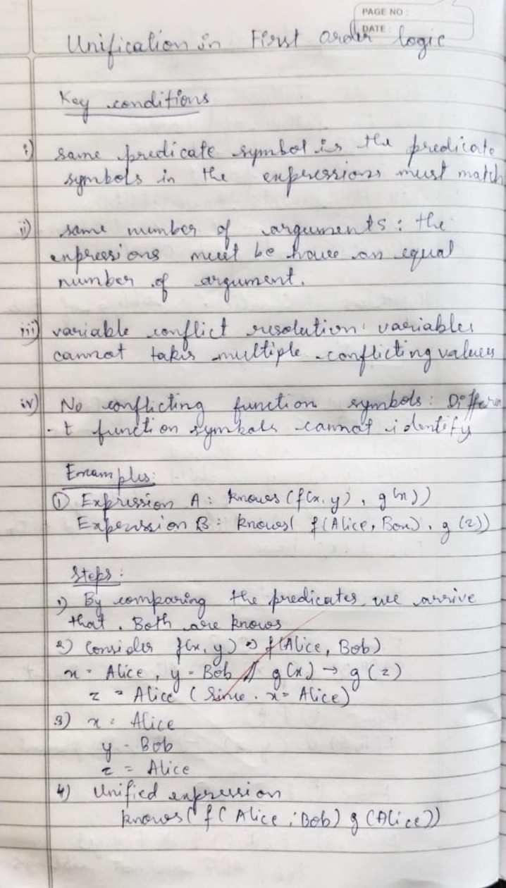
Code:
import re

def occurs_check(var, x): if var == x: return True elif isinstance(x, list):
return any(occurs_check(var, xi) for xi in x) return False

def unify_var(var, x, subst): if var in subst: return unify(subst[var], x, subst) elif isinstance(x, (list, tuple)) and tuple(x) in subst:
return unify(var, subst[tuple(x)], subst) elif occurs_check(var, x): return "FAILURE" else:
subst[var] = tuple(x) if isinstance(x, list) else x return subst

def unify(x, y, subst=None): if subst is None: subst = {} if x == y: return subst elif isinstance(x, str) and x.islower(): return unify_var(x, y, subst) elif isinstance(y, str) and y.islower(): return unify_var(y, x, subst) elif isinstance(x, list) and isinstance(y, list):
if len(x) != len(y): return "FAILURE" if x[0] != y[0]:
return "FAILURE" for xi, yi in zip(x[1:], y[1:]): subst = unify(xi, yi, subst) if subst == "FAILURE": return "FAILURE" return subst else:
return "FAILURE"

def unify_and_check(expr1, expr2): result = unify(expr1, expr2) if result == "FAILURE":
return False, None
return True, result

def display_result(expr1, expr2, is_unified, subst): print("Expression 1:", expr1) print("Expression 2:", expr2) if not is_unified: print("Result: Unification Failed") else:
print("Result: Unification Successful")
print("Substitutions:", {k: list(v) if isinstance(v, tuple) else v for k, v in subst.items()})

def parse_input(input_str):
input_str = input_str.replace(" ", "") def parse_term(term): if '(' in term: match = re.match(r'([a-zA-Z0-9_]+)(.*)', term) if match:
predicate = match.group(1) arguments_str = match.group(2)
arguments = [parse_term(arg.strip()) for arg in arguments_str.split(',')] return [predicate] + arguments return term
return parse_term(input_str)

def main(): while True: expr1_input = input("Enter the first expression (e.g., p(x, f(y))): ") expr2_input = input("Enter the second expression (e.g., p(a, f(z))): ") expr1 = parse_input(expr1_input) expr2 = parse_input(expr2_input)
is_unified, result = unify_and_check(expr1, expr2) display_result(expr1, expr2, is_unified, result) another_test = input("Do you want to test another pair of expressions? (yes/no):
").strip().lower() if another_test != 'yes':
break

if __name__ == "__main__": main()

Output:
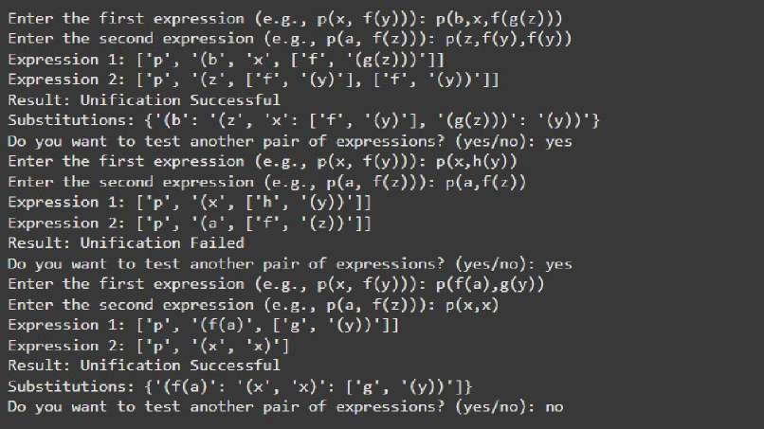

Create a knowledge base consisting of first order logic statements and prove the given query using forward reasoning.
Algorithm:
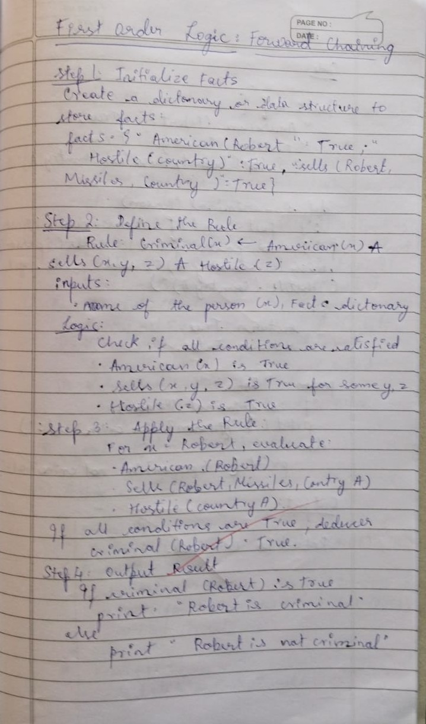
Code:
KB = set()

KB.add('American(Robert)')
KB.add('Enemy(America, A)')
KB.add('Missile(T1)')
KB.add('Owns(A, T1)')

def modus_ponens(fact1, fact2, conclusion): if fact1 in KB and fact2 in KB: KB.add(conclusion) print(f"Inferred: {conclusion}")

def forward_chaining(): if 'Missile(T1)' in KB: KB.add('Weapon(T1)')
print(f"Inferred: Weapon(T1)")

if 'Owns(A, T1)' in KB and 'Weapon(T1)' in KB: KB.add('Sells(Robert, T1, A)')
print(f"Inferred: Sells(Robert, T1, A)")

if 'Enemy(America, A)' in KB: KB.add('Hostile(A)') print(f"Inferred: Hostile(A)") if 'American(Robert)' in KB and 'Weapon(T1)' in KB and 'Sells(Robert, T1, A)' in KB and 'Hostile(A)' in KB:
KB.add('Criminal(Robert)')
print("Inferred: Criminal(Robert)")

if 'Criminal(Robert)' in KB:
print("Robert is a criminal!") else:
print("No more inferences can be made.")

forward_chaining()

Output:
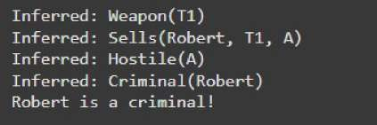

Create a knowledge base consisting of first order logic statements and prove the given query using Resolution.
Algorithm:
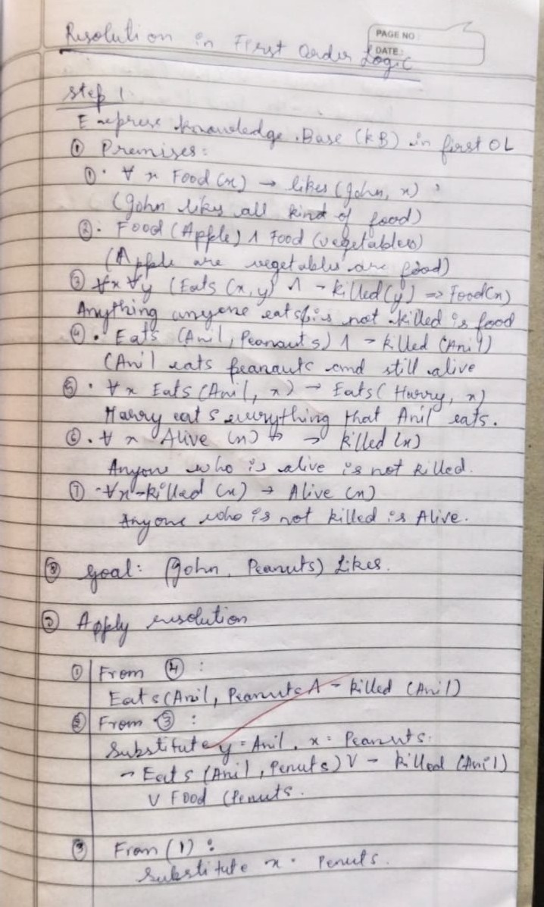

Code:
# Define the knowledge base (KB)
KB = {
# Rules and facts
"philosopher(X)": "human(X)", # Rule 1: All philosophers are humans
"human(Socrates)": True, # Socrates is human (deduced from philosopher)
"teachesAtUniversity(X)": "philosopher(X) or scientist(X)", # Rule 2
"some(philosopher, not scientist)": True, # Rule 3: Some philosophers are not scientists
"writesBooks(X)": "teachesAtUniversity(X) and philosopher(X)", # Rule 4
"philosopher(Socrates)": True, # Fact: Socrates is a philosopher
"teachesAtUniversity(Socrates)": True, # Fact: Socrates teaches at university }

# Function to evaluate a predicate based on the KB def resolve(predicate): # If it's a direct fact in KB if predicate in KB and isinstance(KB[predicate], bool): return KB[predicate]

# If it's a derived rule if predicate in KB:
rule = KB[predicate]

if " and " in rule: # Handle conjunction sub_preds = rule.split(" and ")
return all(resolve(sub.strip()) for sub in sub_preds) elif " or " in rule: # Handle disjunction sub_preds = rule.split(" or ")
return any(resolve(sub.strip()) for sub in sub_preds) elif "not " in rule: # Handle negation sub_pred = rule[4:] # Remove "not " return not resolve(sub_pred.strip()) else: # Handle single predicate
return resolve(rule.strip())

# If the predicate contains variables if "(" in predicate: func, args = predicate.split("(")
args = args.strip(")").split(", ") # Handle philosopher and human link if func == "philosopher": return resolve(f"human({args[0]})") # Handle writesBooks rule explicitly if func == "writesBooks":
return resolve(f"teachesAtUniversity({args[0]})") and resolve(f"philosopher({args[0]})") # Default to False if no rule or fact applies return False

# Query to check if Socrates writes books query = "writesBooks(Socrates)"
result = resolve(query)

# Print the result print("Output: 1BM22CS200")
print(f"Does Socrates write books? {'Yes' if result else 'No'}")

Output:
Does Socrates write books? YES


Implement MinMax Algorithm for TicTacToe.
Algorithm:
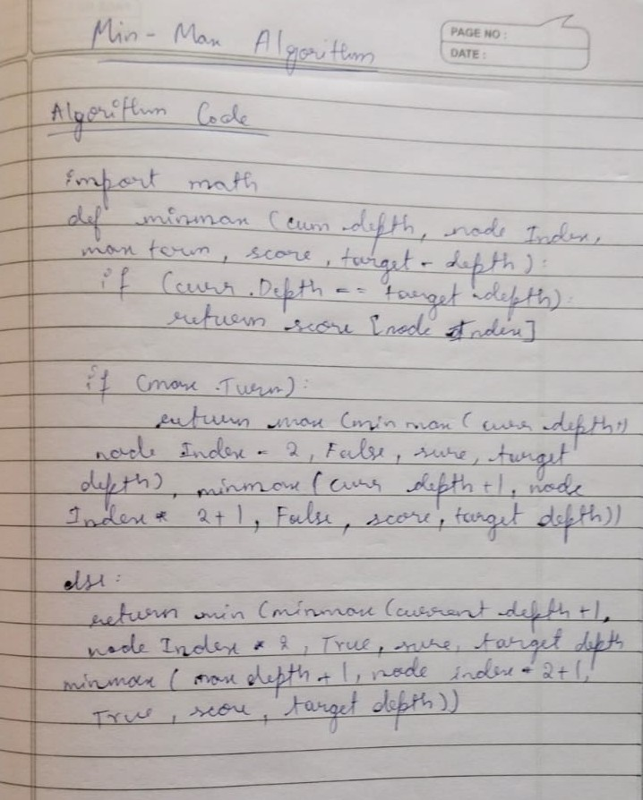

Code:
import math

def printBoard(board): for row in board: print(" | ".join(cell if cell != "" else " " for cell in row)) print("-" * 9)

def evaluateBoard(board): for row in board: if row[0] == row[1] == row[2] and row[0] != "":
return 10 if row[0] == 'X' else -10 for col in range(3): if board[0][col] == board[1][col] == board[2][col] and board[0][col] != "":
return 10 if board[0][col] == 'X' else -10 if board[0][0] == board[1][1] == board[2][2] and board[0][0] != "":
return 10 if board[0][0] == 'X' else -10 if board[0][2] == board[1][1] == board[2][0] and board[0][2] != "":
return 10 if board[0][2] == 'X' else -10 return 0

def isDraw(board): for row in board: if "" in row: return False return True

def minimax(board, depth, isMaximizing):
score = evaluateBoard(board) if score == 10 or score == -10:
return score if isDraw(board):
return 0

if isMaximizing:
bestScore = -math.inf for i in range(3): for j in range(3): if board[i][j] == "": board[i][j] = 'X'
score = minimax(board, depth + 1, False) board[i][j] = "" bestScore = max(bestScore, score) return bestScore else:
bestScore = math.inf for i in range(3): for j in range(3): if board[i][j] == "": board[i][j] = 'O'
score = minimax(board, depth + 1, True) board[i][j] = "" bestScore = min(bestScore, score) return bestScore

def findBestMove(board): bestValue = -math.inf bestMove = (-1, -1) for i in range(3): for j in range(3): if board[i][j] == "": board[i][j] = 'X'
moveValue = minimax(board, 0, False) board[i][j] = "" if moveValue > bestValue: bestMove = (i, j) bestValue = moveValue return bestMove

def playGame():
board = [["" for _ in range(3)] for _ in range(3)] print("Tic Tac Toe!") print("You are 'O'. The AI is 'X'.") printBoard(board)

while True: while True: try:
row, col = map(int, input("Enter your move (row and column: 0, 1, or 2): ").split()) if board[row][col] == "": board[row][col] = 'O'
break else:
print("Cell is already taken. Choose another.") except (ValueError, IndexError):
print("Invalid input. Enter row and column as two numbers between 0 and 2.")

print("Your move:") printBoard(board)

if evaluateBoard(board) == -10:
print("You win!") break if isDraw(board):
print("It's a draw!") break

print("AI is making its move...") bestMove = findBestMove(board) board[bestMove[0]][bestMove[1]] = 'X'

print("AI's move:") printBoard(board)

if evaluateBoard(board) == 10:
print("AI wins!") break if isDraw(board): print("It's a draw!") break

playGame()

Output:
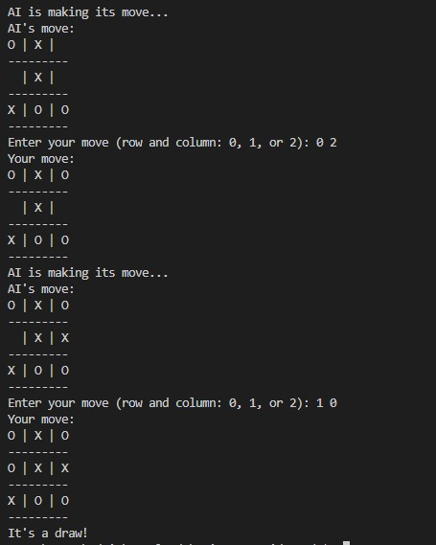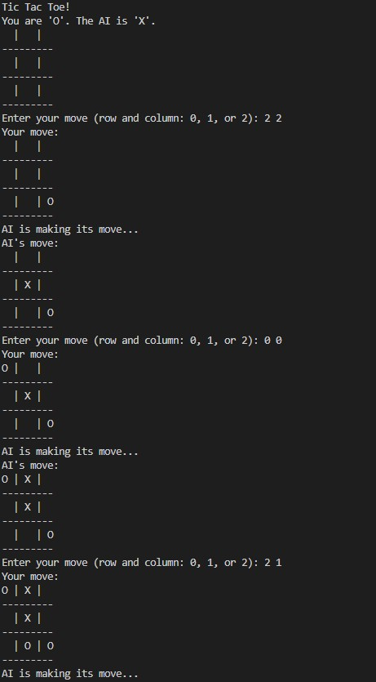

Implement Alpha-Beta Pruning for 8Queens.
Algorithm:
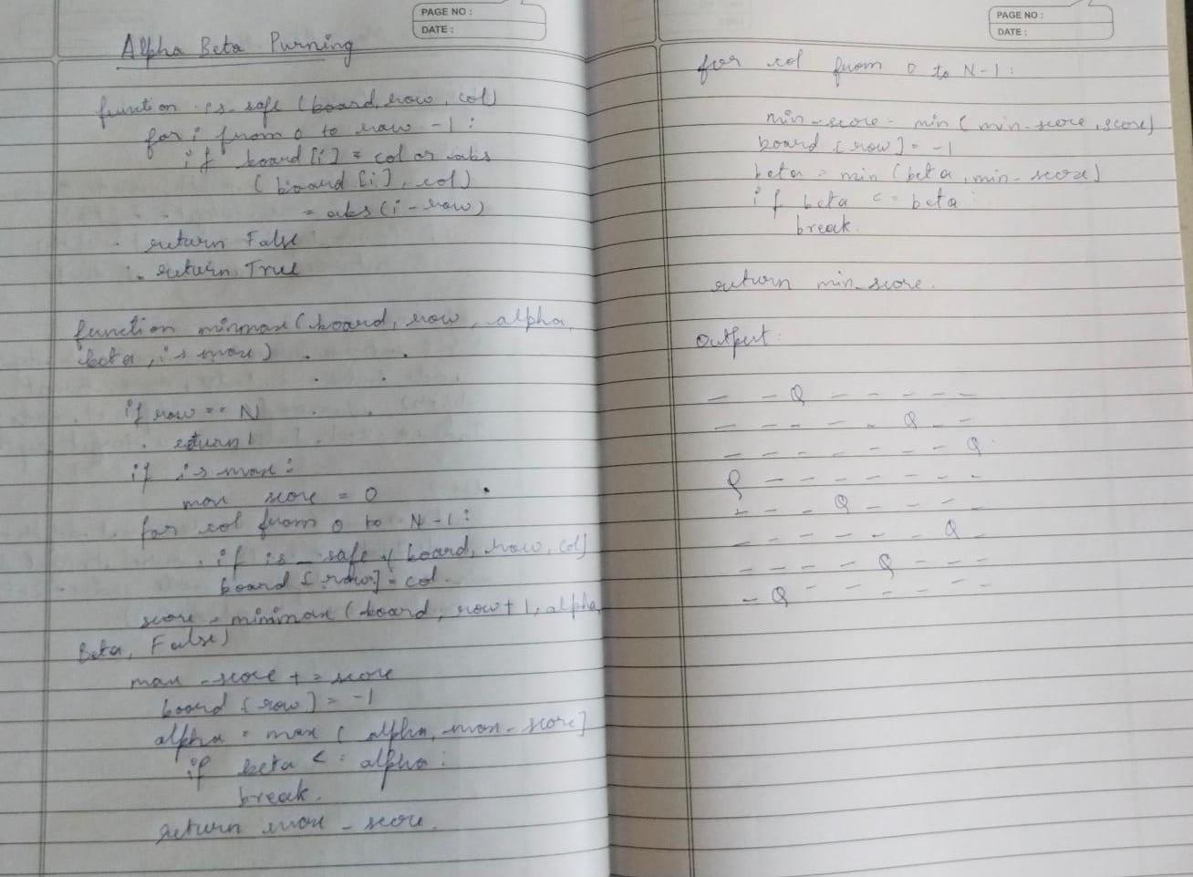
Code:
def is_valid(board, row, col):

for i in range(row):
if board[i] == col or \ abs(board[i] - col) == abs(i - row):
return False
return True

def alpha_beta(board, row, alpha, beta, isMaximizing):

if row == len(board):
return 1

if isMaximizing: max_score = 0 for col in range(len(board)): if is_valid(board, row, col): board[row] = col
max_score += alpha_beta(board, row + 1, alpha, beta, False) board[row] = -1 alpha = max(alpha, max_score) if beta <= alpha:
break
return max_score else:
min_score = float('inf') for col in range(len(board)): if is_valid(board, row, col): board[row] = col
min_score = min(min_score, alpha_beta(board, row + 1, alpha, beta, True)) board[row] = -1 beta = min(beta, min_score) if beta <= alpha:
break
return min_score

def solve_8_queens():

board = [-1] * 8 alpha = -float('inf') beta = float('inf')
return alpha_beta(board, 0, alpha, beta, True)

solutions = solve_8_queens()
print(f"Number of solutions for the 8 Queens problem: {solutions}")

Output:
