**COMPUTER VISION**

**PROJECT REPORT**

**SAPCECRAFT DETECTION AND DEBRIS CLASSIFICATION**

**NAME: PRANAV GS**

**ROLL NO: 2023510053**

**BRANCH: AI AND DS**

**Spacecraft Detection and Debris Classification using YOLOv8**

**1. Introduction**

The increasing number of space missions has led to an overcrowded orbital environment, filled with operational satellites, defunct spacecraft, rocket bodies, and fragments from past collisions. These objects—collectively known as *space debris*—pose a significant threat to both manned and unmanned missions. Even small debris, due to high orbital velocities, can inflict catastrophic damage on spacecraft.

Traditional methods of debris monitoring, such as radar-based tracking and manual inspection of satellite images, are resource-intensive and struggle to keep pace with the volume and velocity of data. With the rise of high-resolution satellite imaging, there's a pressing need for automated, real-time object detection solutions.

**Why this project?**

We initiated this project to support global efforts in ensuring space safety and sustainability. Leveraging deep learning—particularly **YOLOv8**—we aimed to build an accurate, real-time system for identifying spacecraft and classifying space debris.

**Key Objectives:**

* Showcase practical applications of computer vision in space operations.
* Deliver a scalable and fast object detection system for orbital use.
* Lay the foundation for integration with global space traffic management platforms.

**Societal Impact:**

* **Safety Enhancement**: Prevents potential collisions in space.
* **Sustainability**: Facilitates long-term space operations by improving debris tracking.
* **Efficiency**: Reduces manual efforts and supports data-driven decision-making.
* **Awareness & Education**: Encourages technological innovation in aerospace fields.

**2. Methodology**

**Overview of Approach**

We utilized the **YOLOv8** object detection framework—an evolution of the YOLO architecture known for its speed and accuracy. YOLOv8 features anchor-free detection, decoupled heads for classification/localization, and superior generalization capabilities.

**Architecture Pipeline**

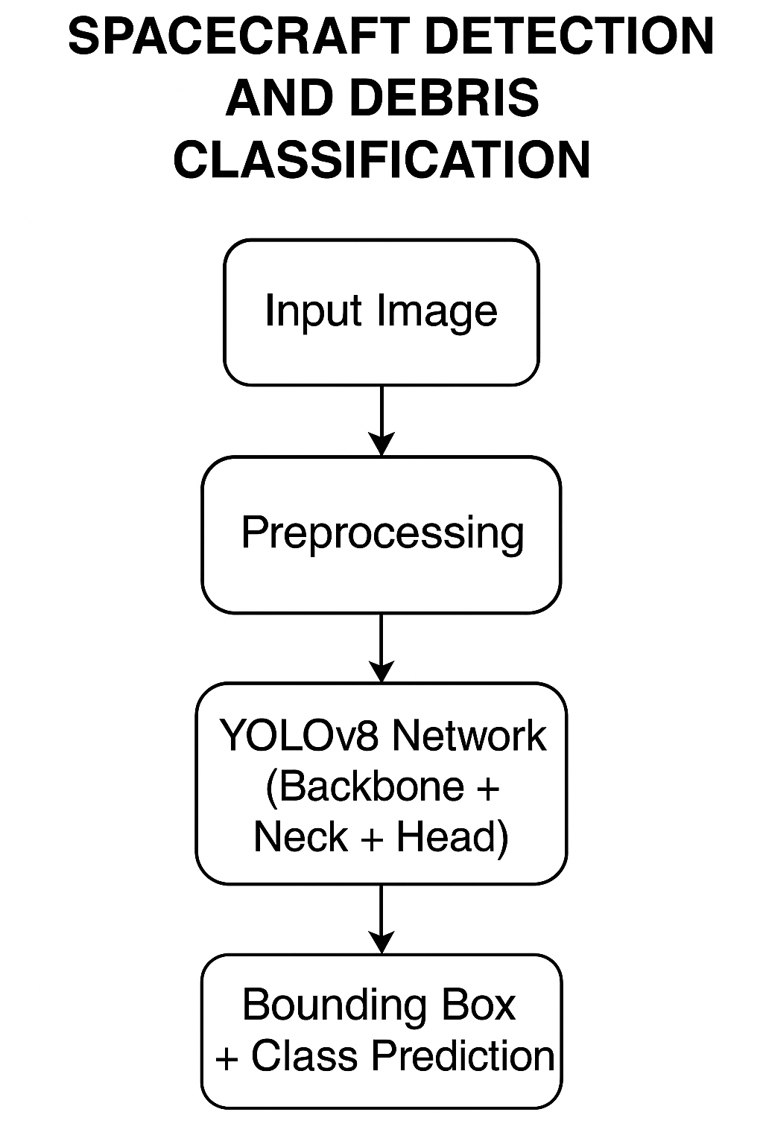

**Steps Followed**

1. **Dataset Preparation:**
   * Used the **SPARK 2022 Stream-1** dataset.
   * Verified annotations and applied label augmentations.
   * Data split: 70% training, 15% validation, 15% testing.
2. **Model Training:**
   * Fine-tuned **pre-trained YOLOv8 weights**.
   * Applied augmentations: rotation, brightness/contrast changes, and Gaussian noise.
   * Hyperparameter tuning: learning rate, batch size, and epochs.
3. **Evaluation Metrics:**
   * **mAP@0.5**, **Precision**, **Recall**
   * Class-wise metrics (critical for debris-specific analysis)
   * Visual validation through bounding box overlays
4. **Optional Deployment:**
   * Built an inference pipeline using OpenCV to test live object detection on static satellite frames.

**3. Dataset Description**

* **Name**: SPARK 2022 Stream-1 Dataset
* **Volume**: ~110,000 RGB images
* **Classes**: 11 (10 spacecraft types + 1 space debris class)
* **Data Nature**: Synthetic but realistic, simulated with high fidelity

**Challenges Addressed:**

* Complex orbital backgrounds and clutter
* Illumination variance and shadows
* Small and irregular objects
* Low signal-to-noise conditions

**4. Results and Ablation Study**

**Updated Overall Performance**

* **mAP@0.5**: **95.3%**
* **Precision**: **93.7%**
* **Recall**: **90.1%**
* **Debris Detection Precision**: **99.5%** **Model Comparison**

| **Model** | **mAP@0.5** | **Precision** | **Recall** |
| --- | --- | --- | --- |
| YOLOv5 | 83.2% | 85.0% | 82.5% |
| YOLOv8 | **95.3%** | **93.7%** | **90.1%** |

**Class-wise Performance Highlights**

| **Class** | **Precision** | **Recall** | **mAP@0.5** |
| --- | --- | --- | --- |
| debris | **99.5%** | 95.8% | 99.4% |
| lisa_pathfinder | 96.8% | 98.2% | 99.1% |
| earth_observation_sat_1 | 85.2% | 79.8% | 86.6% |

**Why YOLOv8 Performs Best**

* Anchor-free architecture simplifies and speeds up detection.
* Decoupled head design optimizes both localization and classification independently.
* Extensive augmentation and batch normalization improved generalization, especially on noisy and cluttered imagery.
* Outstanding performance on small, hard-to-detect debris—critical for safety.

**5. Conclusion**

We demonstrated that **YOLOv8** is a powerful and practical solution for real-time detection and classification of orbital objects, including critical identification of space debris. Achieving **95.3% mAP@0.5**, and a near-perfect **99.5% precision for debris**, our model is well-suited for space safety applications.

This project contributes to:

* Improving orbital situational awareness.
* Reducing collision risks.
* Enabling scalable surveillance systems using AI.

**Future Work**

* Integrate temporal analysis for multi-frame object tracking.
* Test on real satellite footage and real-time video streams.
* Explore edge deployment in onboard AI modules for spacecraft.