***Breadboard***

**Diagram:**

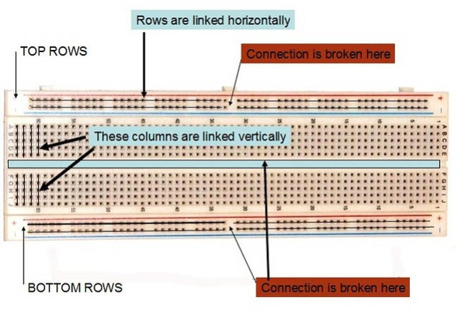

**Theory:**

A **breadboard** is a solderless device for temporary prototype with electronics and test circuit designs. Most electronic components in electronic circuits can be interconnected by inserting their leads or terminals into the holes and then making connections through wires where appropriate.

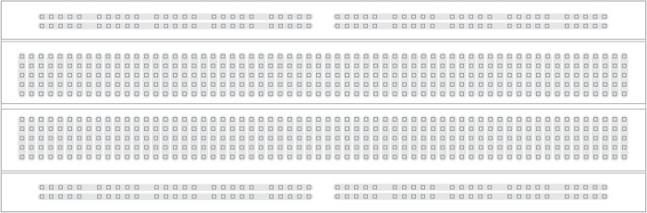

Note how all holes in the selected row are connected together, so the holes in the selected column. The set of connected holes can be called a node:

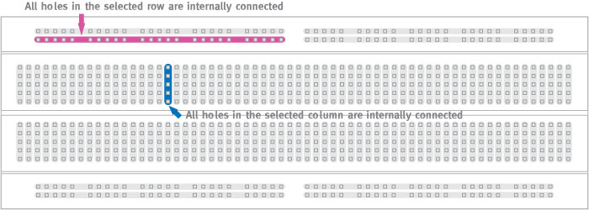

To interconnect the selected row (node A) and column (node B) a cable going from any hole in the row to any hole in the column is needed:

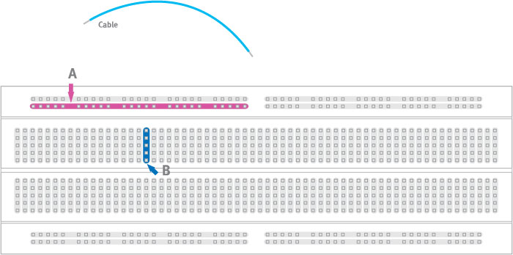

Now the selected column (node B) and row (node A) are interconnected:

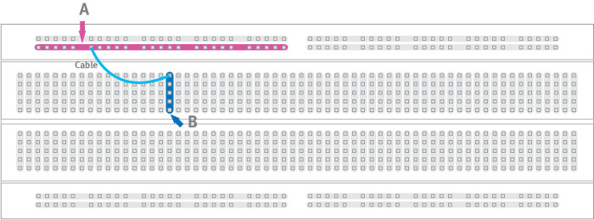

**Precautions:**

**1. Avoid live heat-sinks**

**2. Consider switching from mains electricity to low voltage electricity**

**3. Don’t overload your circuit.**