***Multimeter***

**Diagram:**

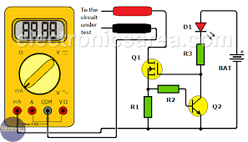

**Theory:**

A [**digital multimeter**](https://www.fluke.com/en-in/products/electrical-testing/digital-multimeters) is a test tool used to measure two or more electrical values—principally voltage (volts), current (amps) and resistance (ohms). It is a standard diagnostic tool for technicians in the electrical/electronic industries.

Digital multimeters combine the testing capabilities of single-task meters—the voltmeter (for measuring volts), ammeter (amps) and ohmmeter (ohms). Often, they include several additional specialized features or advanced options. Technicians with specific needs, therefore, can seek out a model targeted to meet their needs.

The face of a digital multimeter typically includes four components:

* Display: Where measurement readouts can be viewed.
* Buttons: For selecting various functions; the options vary by model.
* Dial (or rotary switch): For selecting primary measurement values (volts, amps, ohms).
* Input jacks: Where test leads are inserted.

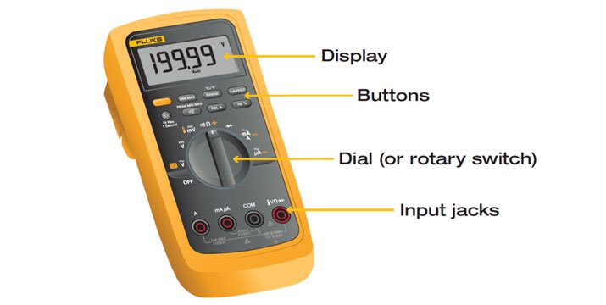

Test leads are flexible, insulated wires (red for positive, black for negative) that plug into the DMM. They serve as the conductor from the item being tested to the multimeter. The probe tips on each lead are used for testing circuits.

The terms counts and digits are used to describe a digital multimeter's resolution—how fine a measurement a meter can make. By knowing a multimeter's resolution, a technician can determine if it is possible to see a small change in a measured signal.

**Precautions:**

Each application with a digital multimeter presents potential safety hazards that must be considered when taking electrical measurements. Before using any electrical test equipment, people should always first refer to the user's manual for proper operating procedures, safety precautions, and limits.