* Starting index page of website

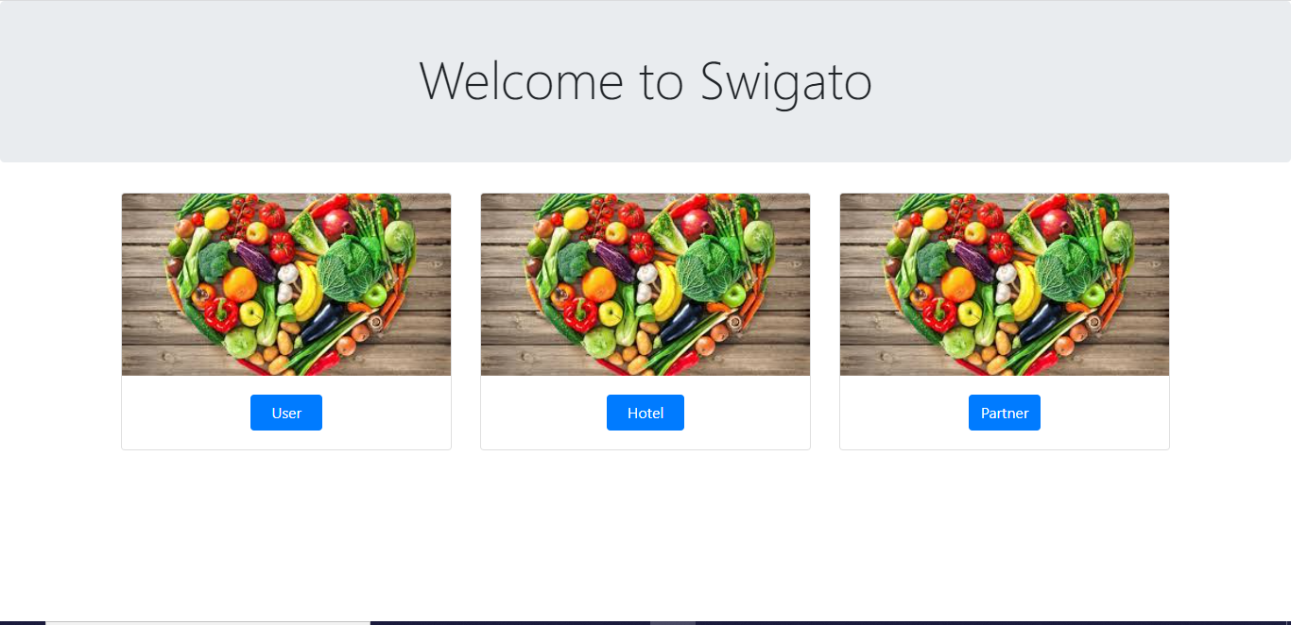

* Index page of user module

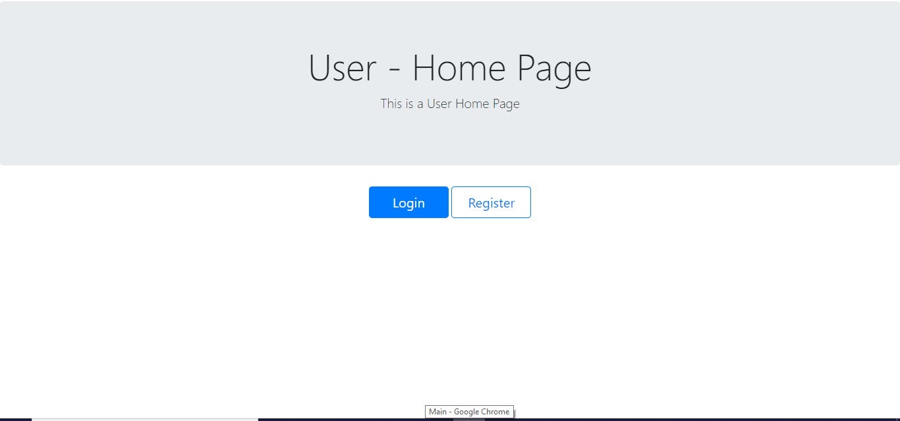

* User can register on this website

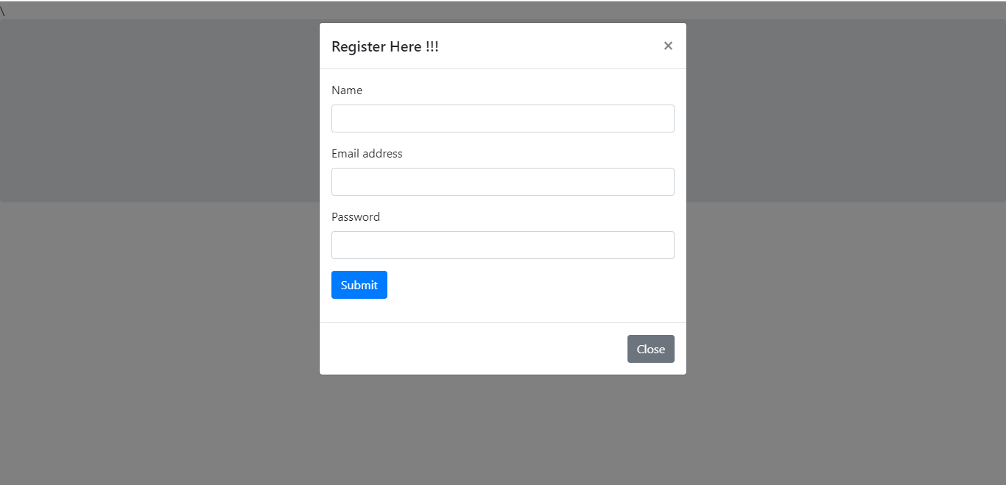

* Already registered user can log into website

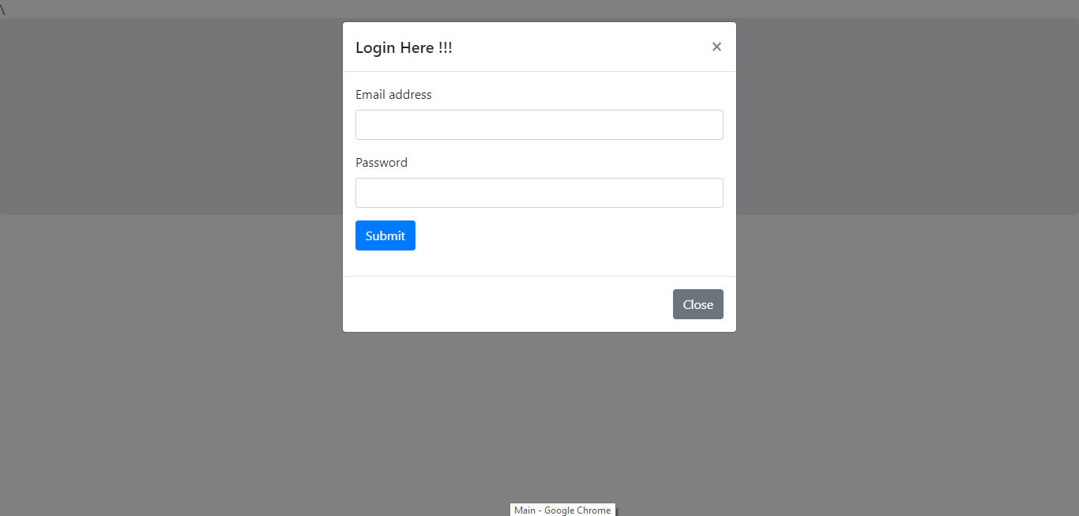

* User home page after successful login

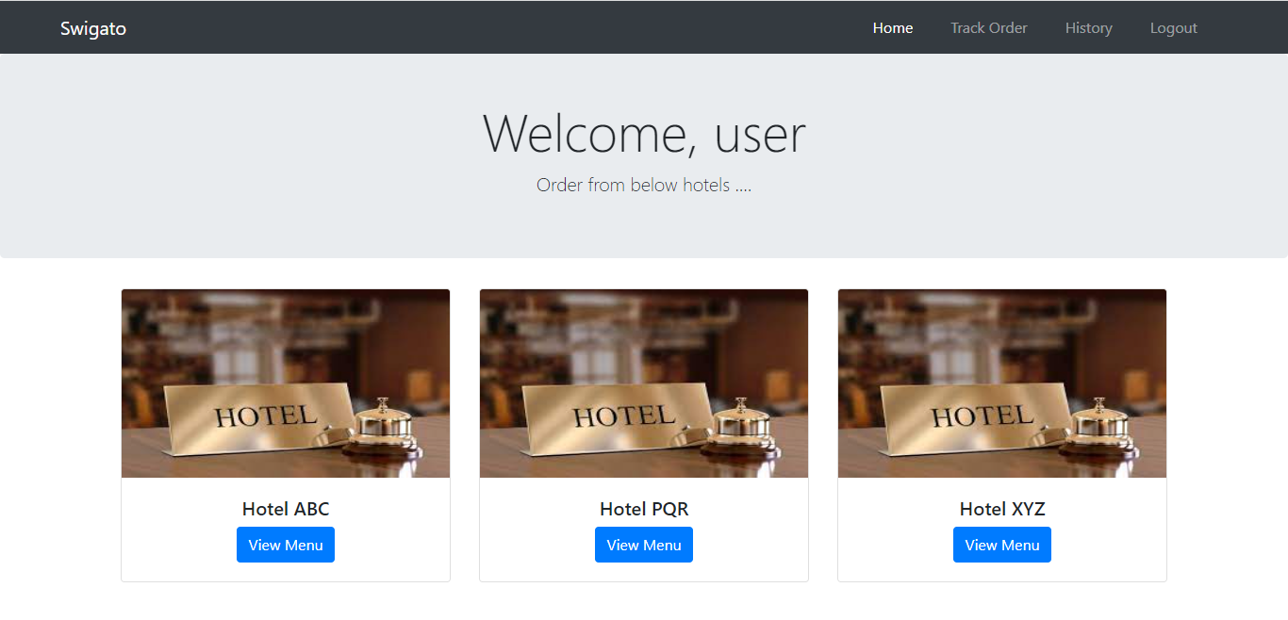

* User selected hotel to view menus

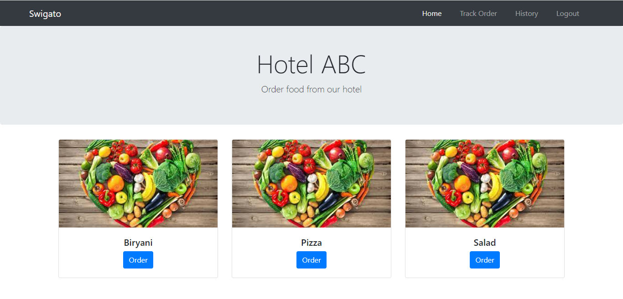

* User selected item from hotel menu

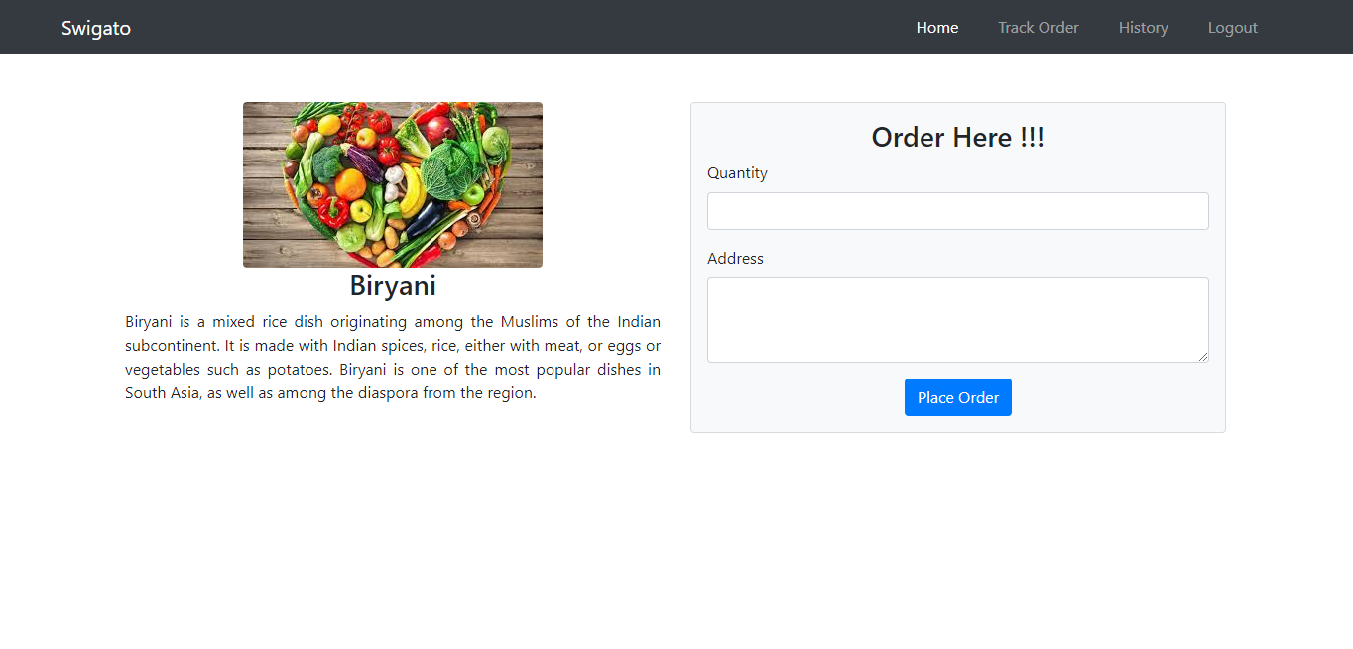

* User has confirmed his order

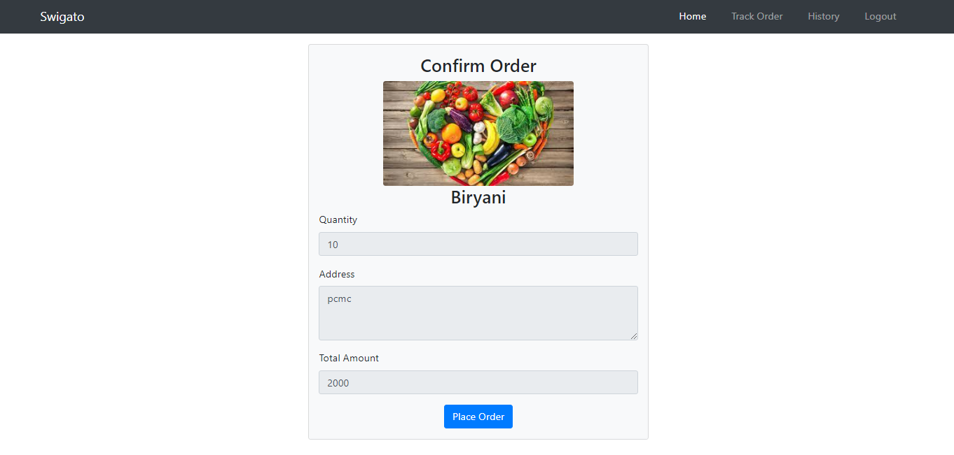

* Order is being placed

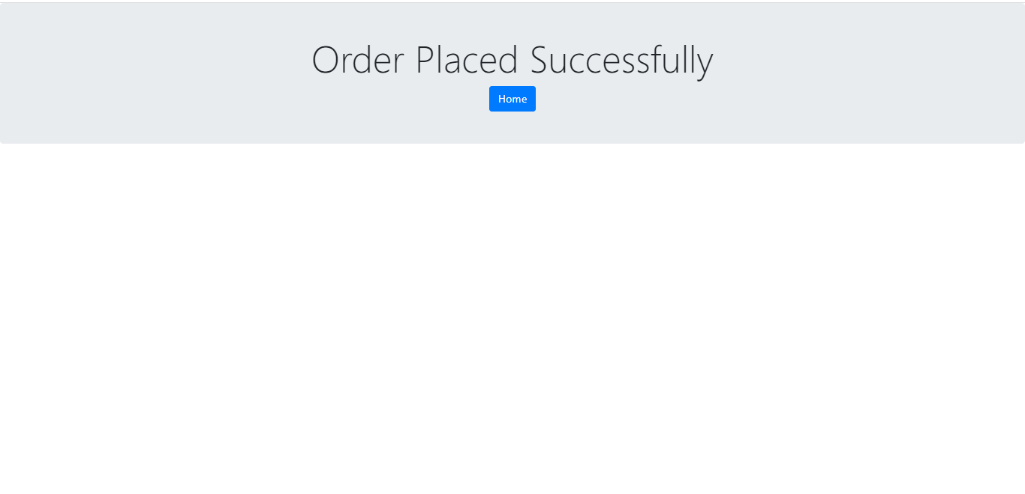

* Registered hotels can see received orders from users after login into hotel module and can accept or reject the orders

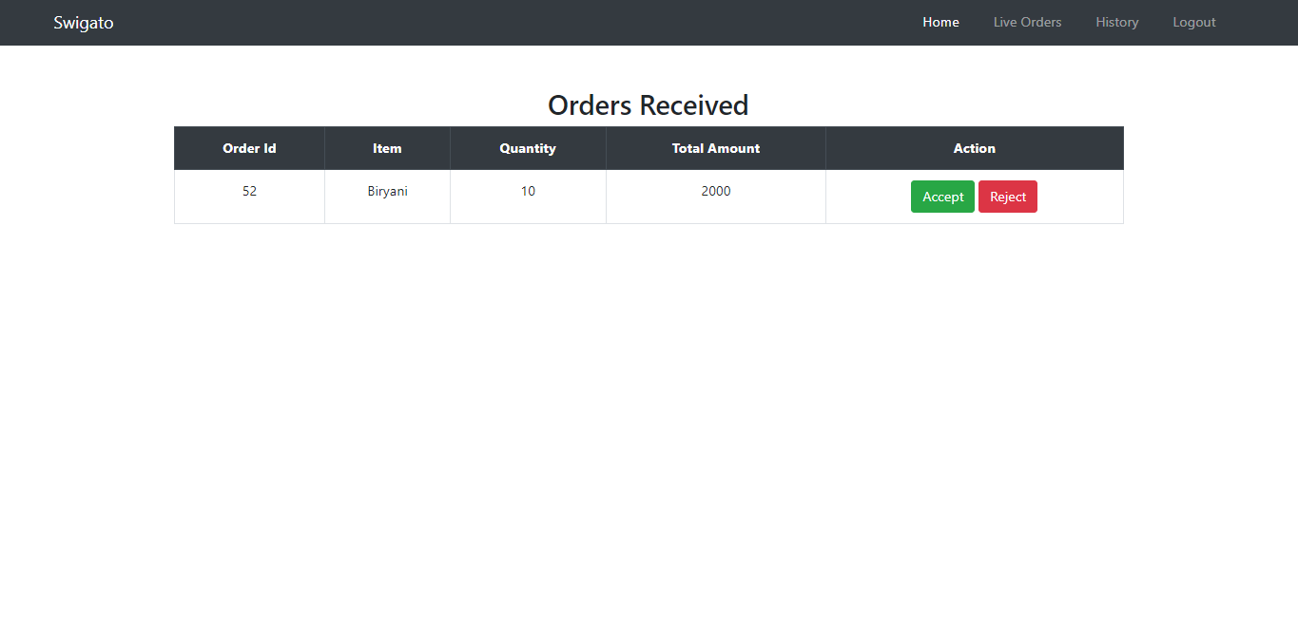

* Hotel can see ongoing orders and after making it ready hotel can mark it as Completed

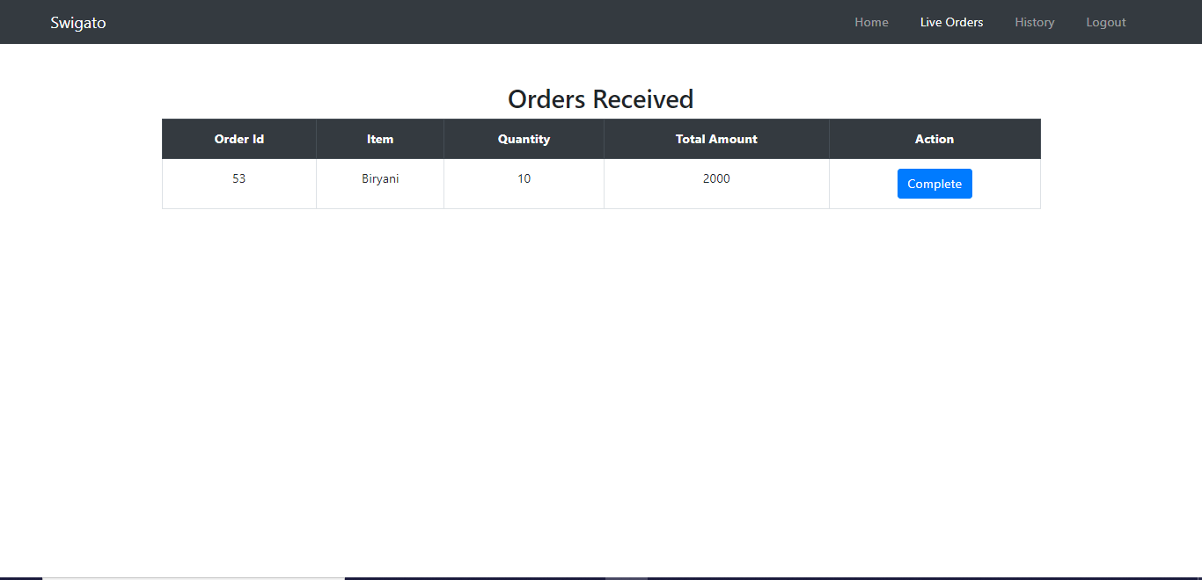

* Delivery partners can Register and login into the system and receive orders to be delivered with its pickup and delivery location

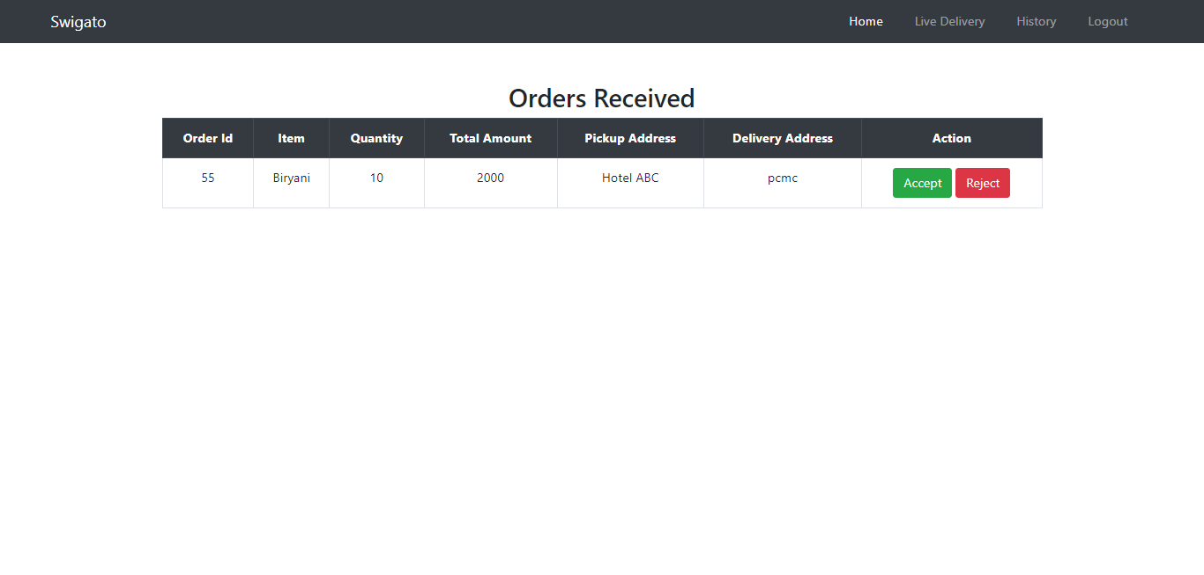

* After accepting order partner can see ongoing orders

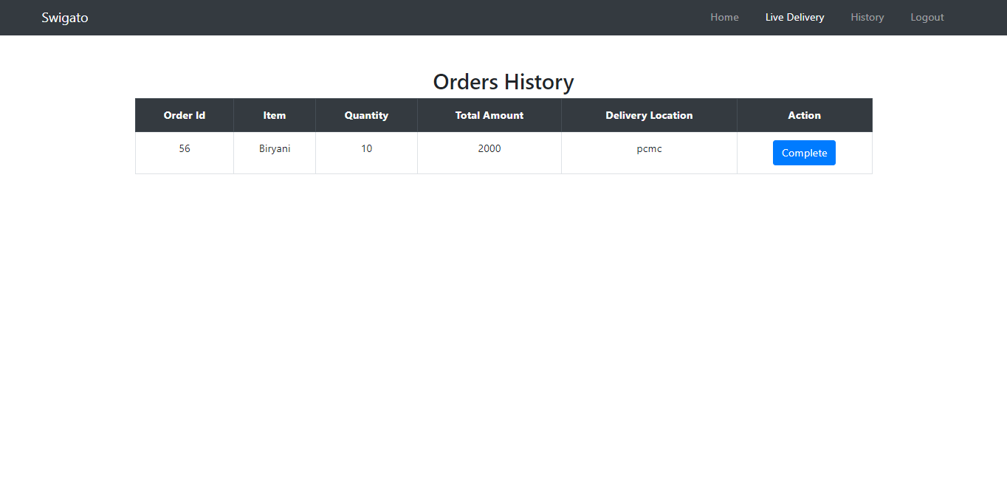

* After successful delivery Hotel, User and Partner can see their Orders history

