Name: K.Pranav | Roll No: 2520030477
DBMS Joins & Transactions Lab Report
Complete Screenshot Record & Query Execution Log (13 Screenshots)

1. Step 1: Database Creation & Initial Table Definitions
Initializes the lab database environment and creates the core entity tables along with primary keys and foreign key relationships.
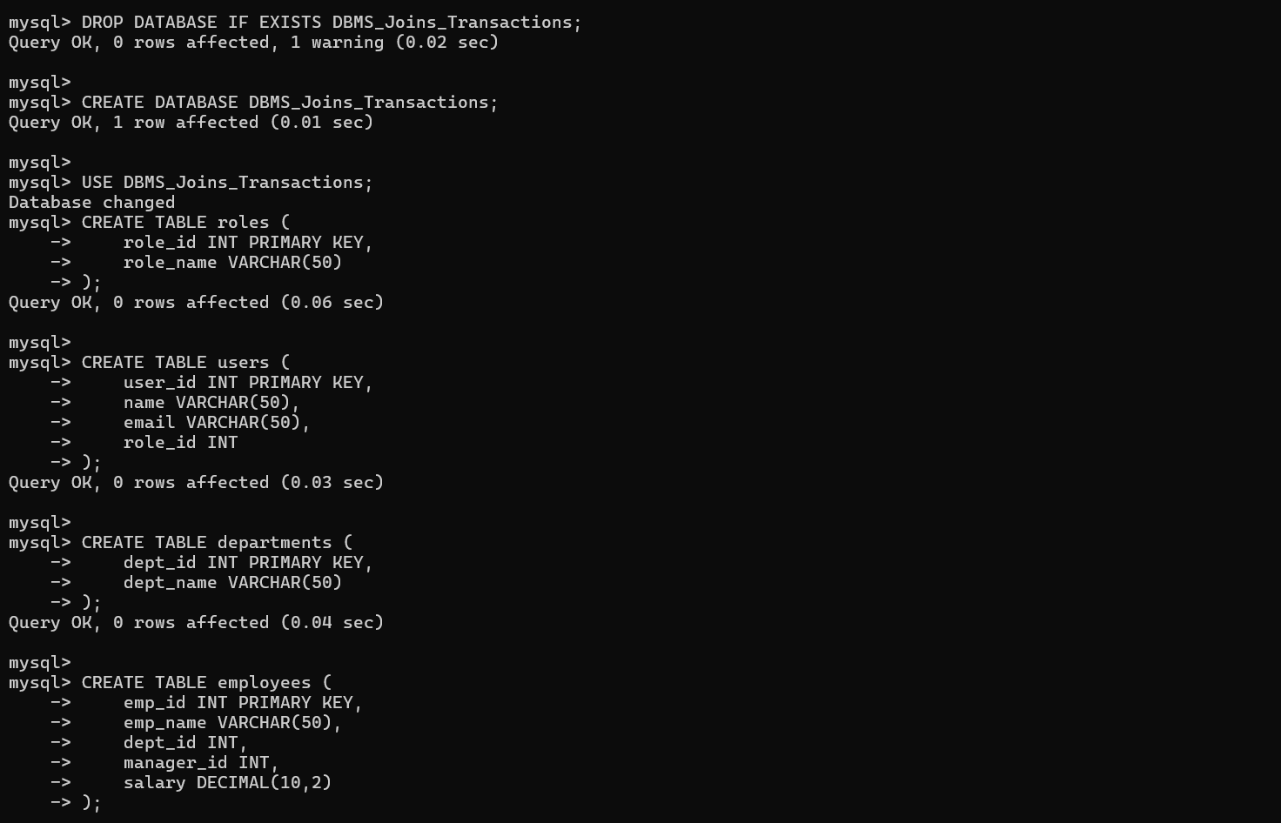
Screenshot 1: Database creation (`DBMS_Joins_Transactions`) and schema definition for `roles`, `users`, `departments`, and `employees` tables.

2. Step 2: Table Schema Definition (Customers, Orders, Accounts)
Completes table structures for transactional entities and populates reference tables (`roles` and `users`).
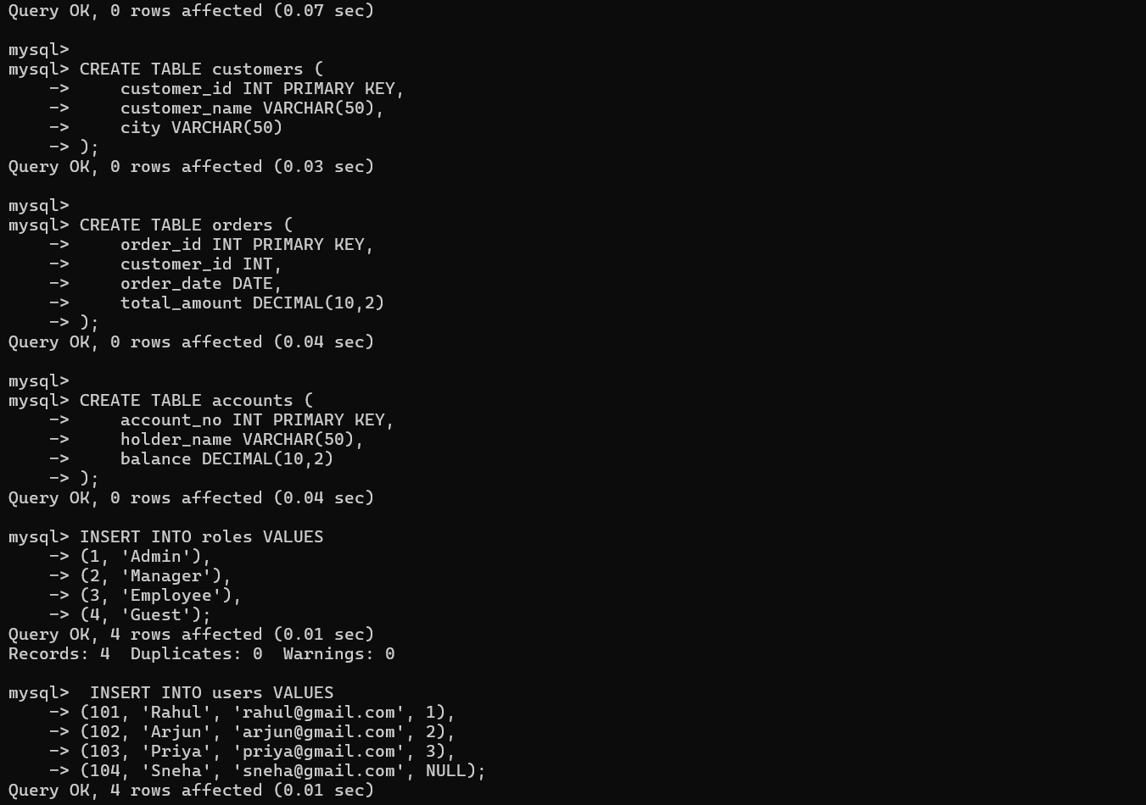
Screenshot 2: Schema definition for `customers`, `orders`, and `accounts` tables, followed by initial data insertions into `roles` and `users`.

3. Step 3: Populating Core Lab Data (Departments, Employees, Customers, Orders)
Inserts test datasets across multiple related tables to facilitate join queries and aggregate calculations.
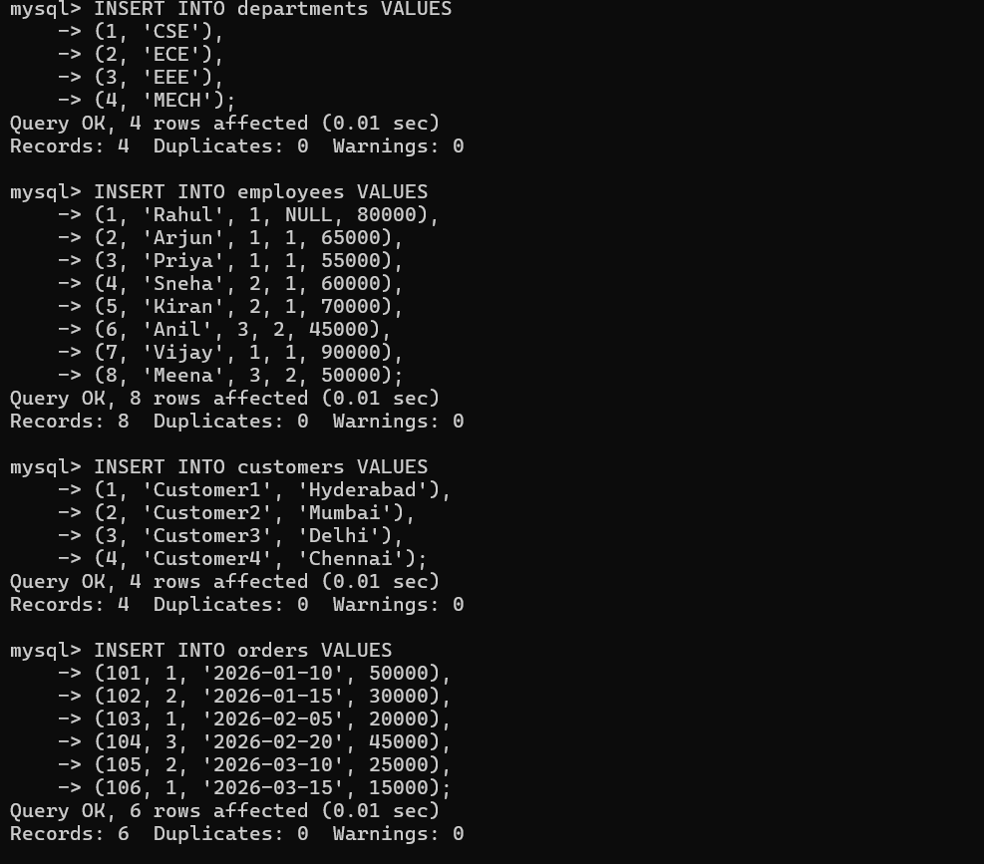
Screenshot 3: Data insertion queries into `departments`, `employees`, `customers`, and `orders` tables.

4. Step 4: Populating Accounts & Database Table Verification
Verifies that all 7 required tables are properly registered in MySQL and checks initial records for user roles.
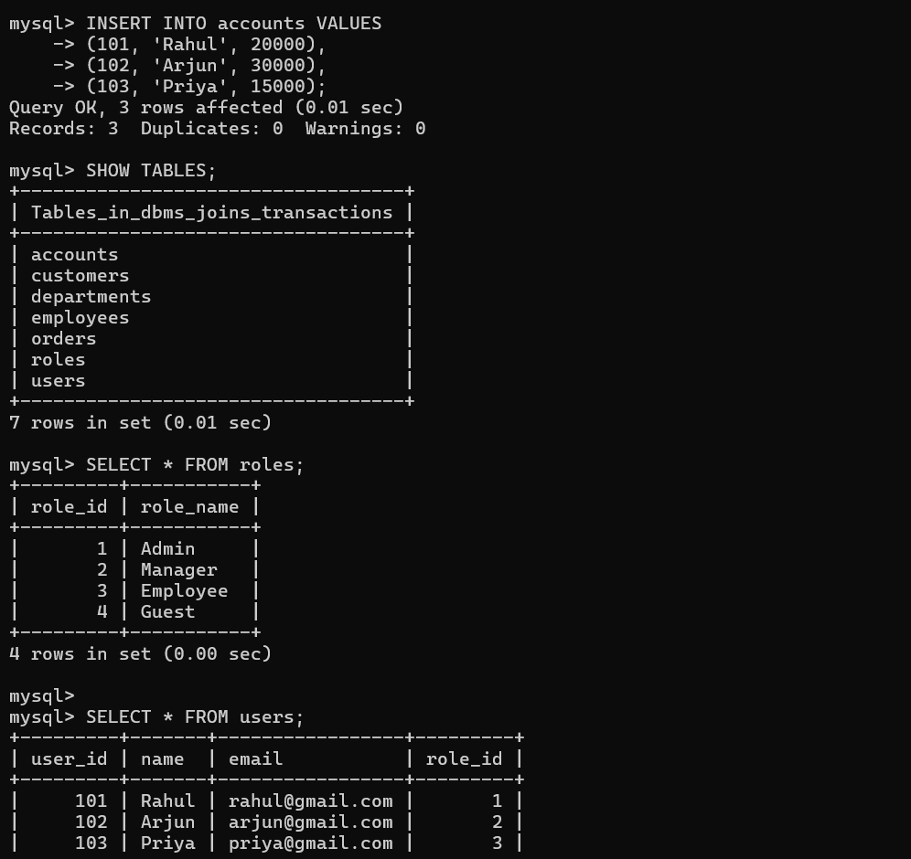
Screenshot 4: Insertion into `accounts`, `SHOW TABLES` listing, and verifying `roles` and `users` contents.

5. Step 5: Verifying Departments, Employees, and Customers Tables
Ensures all employee records (8 rows) and department associations are stored correctly prior to performing join operations.
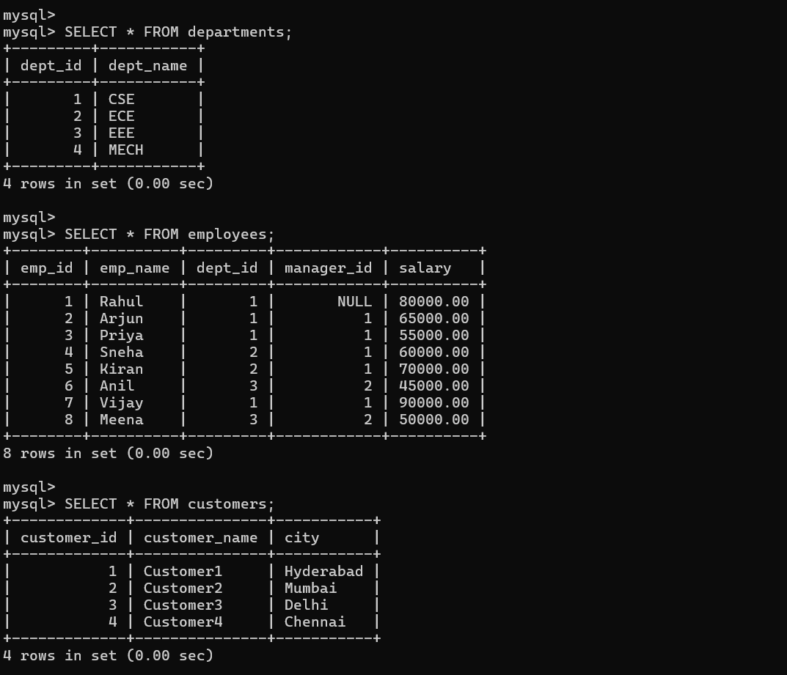
Screenshot 5: Full select queries verifying data in `departments`, `employees`, and `customers` tables.

6. Step 6: Verifying Orders, Accounts & Executing Query Q1 (INNER JOIN)
Executes Query Q1: Retrieves employee names paired with their respective department names using `INNER JOIN`.
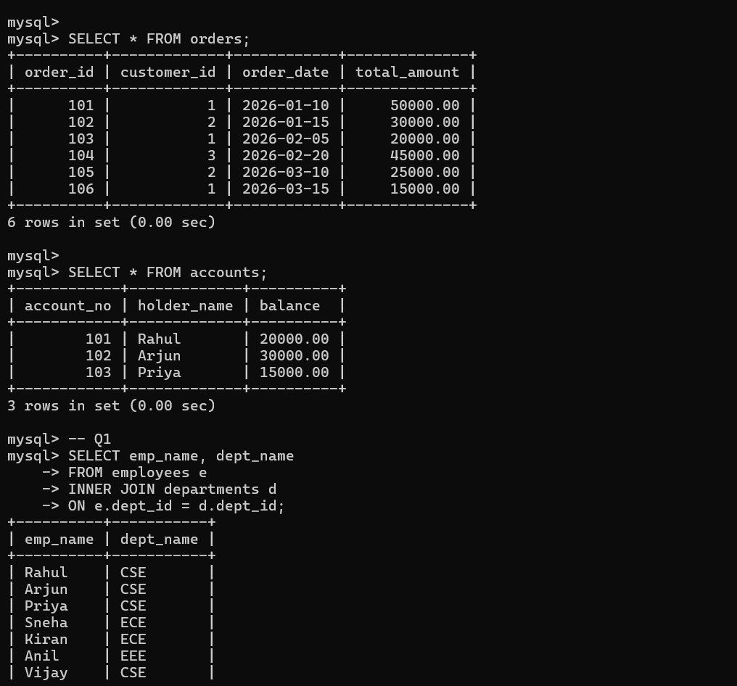
Screenshot 6: Verifying `orders` and `accounts`, followed by Query Q1 (INNER JOIN between Employees and Departments).

7. Step 7: Queries Q2 (LEFT JOIN), Q3 (RIGHT JOIN), and Q4 (FULL OUTER JOIN Start)
Demonstrates `LEFT JOIN` (including unmatched user records with NULL roles) and `RIGHT JOIN` (including unmatched roles).
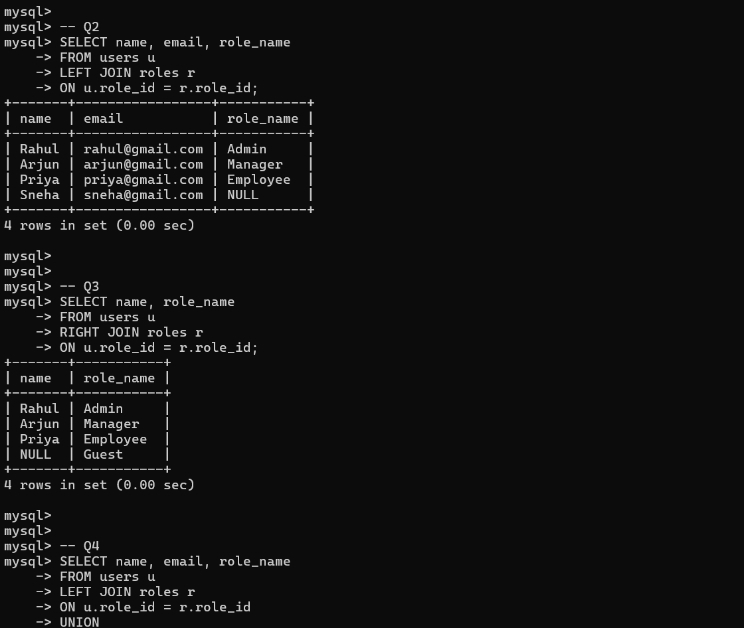
Screenshot 7: Queries Q2, Q3, and beginning of Q4 testing LEFT, RIGHT, and emulated FULL OUTER JOINs.

8. Step 8: Completing Q4 (UNION) & Query Q5 (SELF JOIN)
Q4 combines LEFT and RIGHT joins using `UNION`. Q5 performs a `SELF JOIN` mapping each employee to their respective manager.
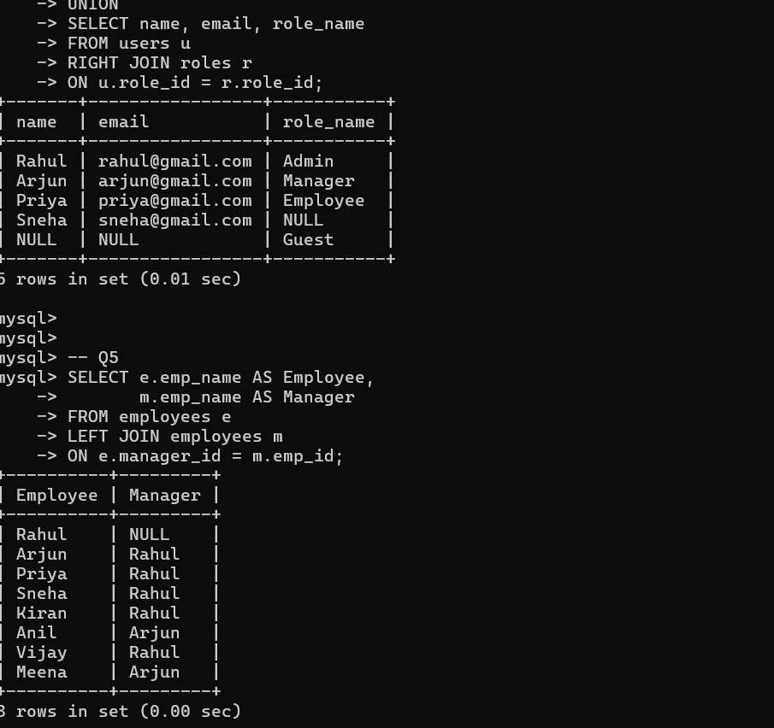
Screenshot 8: Results of Q4 (FULL OUTER JOIN via UNION) and Query Q5 (SELF JOIN on Employees for Manager hierarchy).

9. Step 9: Queries Q6 (Customer Orders JOIN) & Q7 (Department Salary Aggregation)
Q6 lists customer purchases with order details. Q7 calculates `COUNT(*)`, `AVG(salary)`, and `MAX(salary)` grouped by department.
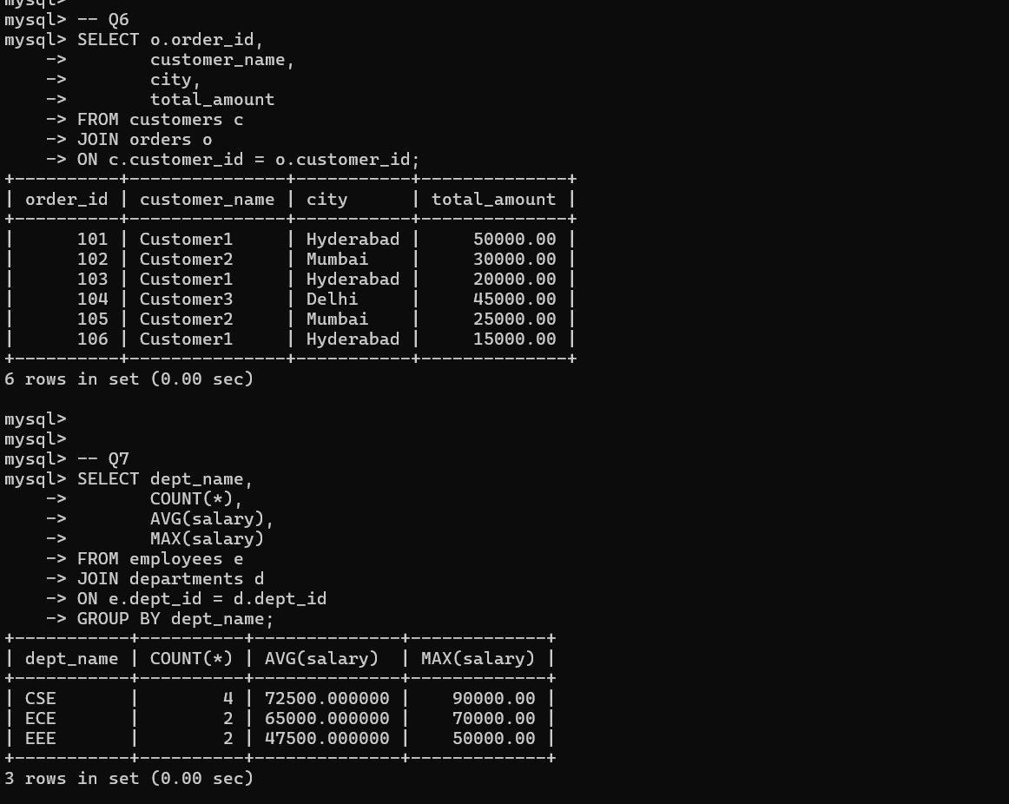
Screenshot 9: Execution of Q6 (Joining Customers & Orders) and Q7 (GROUP BY Department with aggregate functions).

10. Step 10: Queries Q8 (Filtered Department Join) & Q9 (Customer Total Spend Ranking)
Q8 filters CSE employees earning over 50,000. Q9 computes total purchase amounts per customer ordered in descending order.
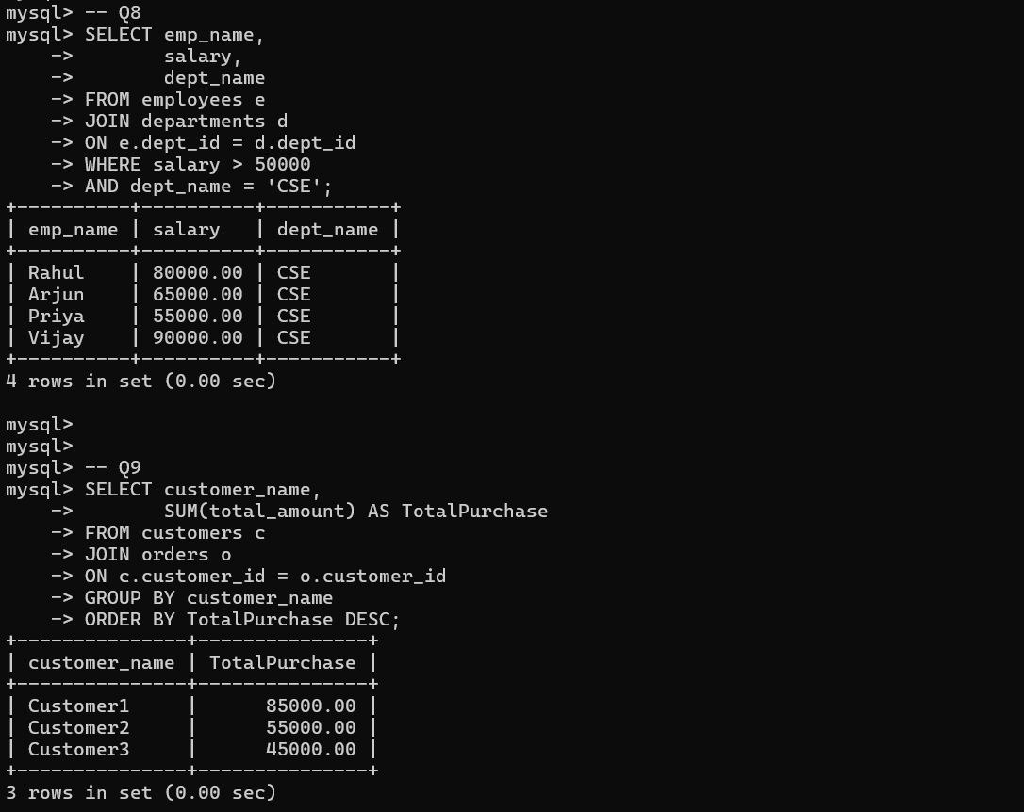
Screenshot 10: Execution of Q8 (CSE department filtered by salary > 50,000) and Q9 (Top spending customers).

11. Step 11: Queries Q10 (Error Handling), Q11 (COMMIT), and Q12 (ROLLBACK)
Q10 demonstrates MySQL error handling when joining non-existent tables. Q11 and Q12 illustrate basic TCL commands (`COMMIT` and `ROLLBACK`).
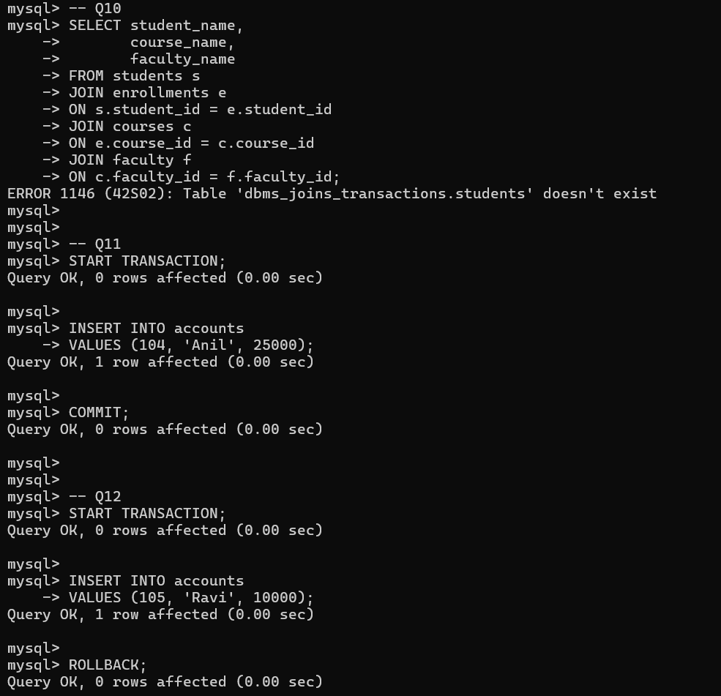
Screenshot 11: Execution of Q10 (Missing table error handling), Q11 (Transaction COMMIT), and Q12 (Transaction ROLLBACK).

12. Step 12: Queries Q13 (Successful Fund Transfer) & Q14 (Failed Fund Transfer Start)
Q13 demonstrates an atomic fund transfer between account 101 and 102. Q14 initiates a transfer attempt that encounters a target account error.
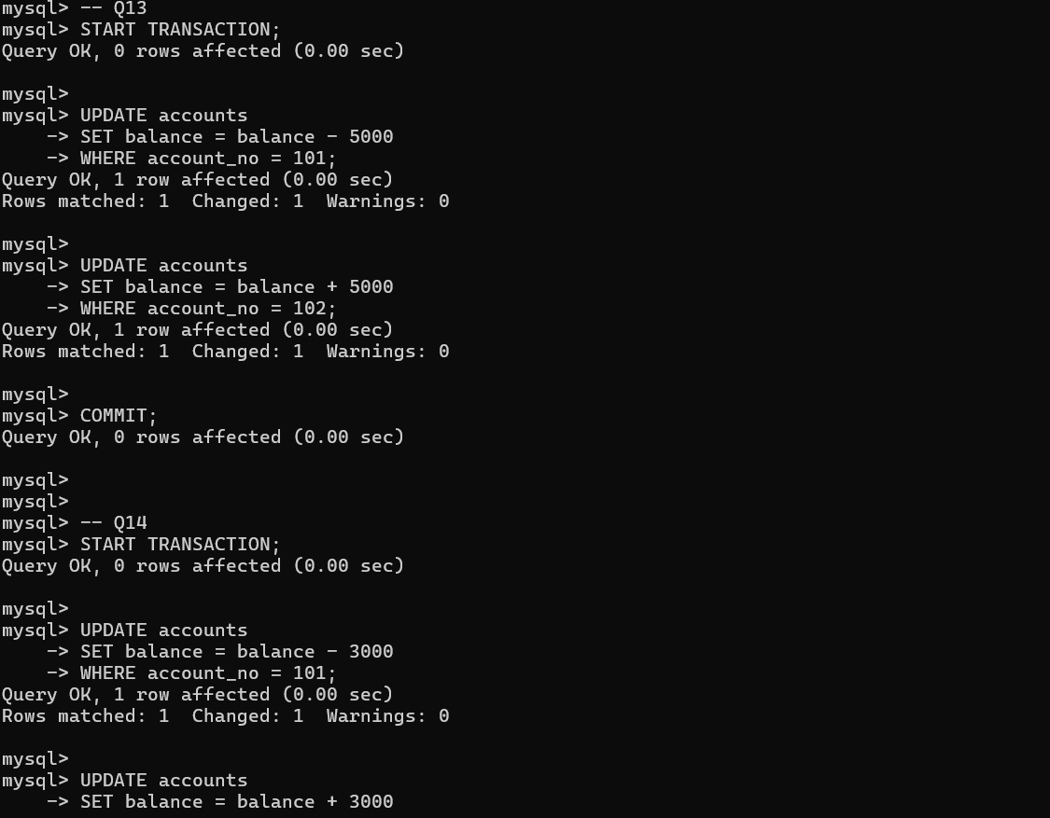
Screenshot 12: Execution of Q13 (2-step account balance transfer with COMMIT) and Q14 initiation.

13. Step 13: Completing Q14 (ROLLBACK on Error) & Query Q15 (SAVEPOINT & Partial Rollback)
Q14 reverts failed changes. Q15 sets a `SAVEPOINT s1`, performs a second update, rolls back specifically to `s1`, and commits the initial state.
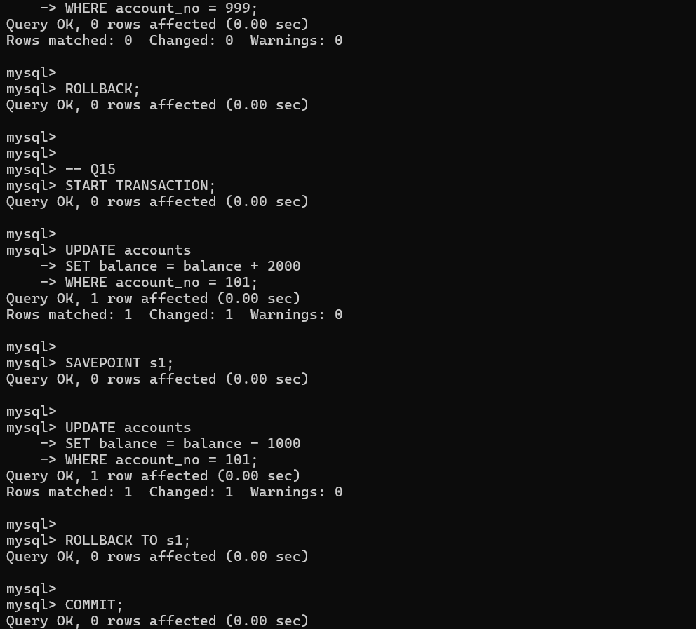
Screenshot 13: Completion of Q14 ROLLBACK and execution of Q15 (SAVEPOINT s1 with ROLLBACK TO s1).

