**Microprocessor Based Systems Design (UCS617)**

**Lab Assignment – 2 (Intel 8086)**

**Submitted To:**

Dr. Shivani Sharma

**Submitted By:**

|  |  |
| --- | --- |
| **Name of student** | **Roll number** |
| Raghav Garg | 102103283 |
| Abhinav Maheshwari | 102103284 |
| Swasti | 102103285 |
| Mridul Kalia | 102103286 |
| Daksh Raheja | 102103287 |



**DEPARTMENT OF COMPUTER SCIENCE & ENGINEERING** THAPAR INSTITUTE OF ENGINEERING AND TECHNOLOGY (DEEMED TO BE UNIVERSITY)

PATIALA, PUNJAB (INDIA)

JAN – JUNE 2024

**Index**

|  |  |  |
| --- | --- | --- |
| **S.No** | **Name of Experiments** | **Page No.** |
| 1 | Write an assembly language program to add two 16-bit numbers in 8086. | 2 |
| 2 | Write an assembly language program to subtract two 16-bit numbers in 8086. | 4 |
| 3 | Write an assembly language program to multiply two 16-bit numbers in 8086. | 6 |
| 4 | Write an assembly language program to divide two 16-bit numbers in 8086. | 8 |
| 5 | Write an assembly language program to demonstrate AAA, AAS, AAM, AAD, DAA and DAS in 8086. | 10 |
| 6 | Write an assembly language program to find out the count of positive numbers and negative numbers from a series of signed numbers in 8086. | 15 |
| 7 | Write an assembly language program to find out the largest number from a given unordered array of 8-bit numbers, stored in the locations starting from a known address in 8086. | 17 |
| 8 | Write an assembly language program to find out the largest number from a given unordered array of 16-bit numbers, stored in the locations starting from a known address in 8086. | 19 |
| 9 | Write an assembly language program to print Fibonacci series in 8086. | 21 |
| 10 | Write an assembly language program to perform the division 15/6 using the ASCII codes. Store the ASCII codes of the result in register DX. | 23 |

# Experiment 1

**Aim:-** Write an assembly language program to add two 16-bit numbers in 8086.

# Soln. -

MOV AX,1234H MOV BX,1236H ADD AX,BX HLT

**Output:**

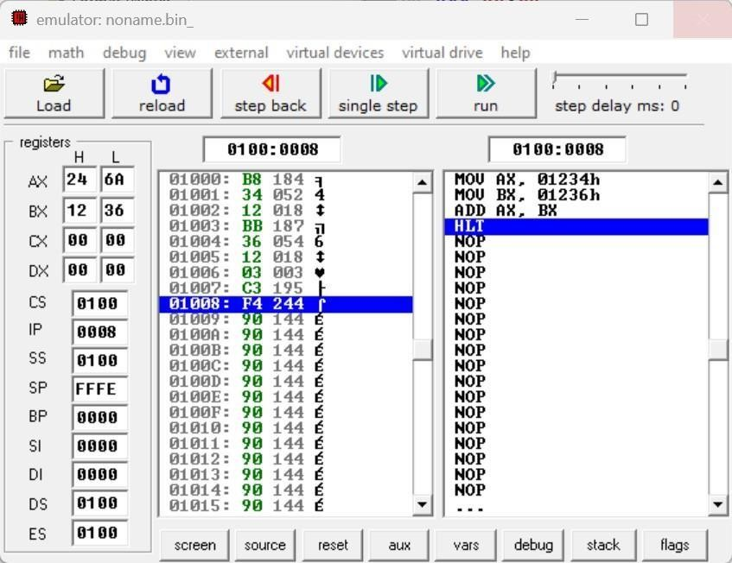

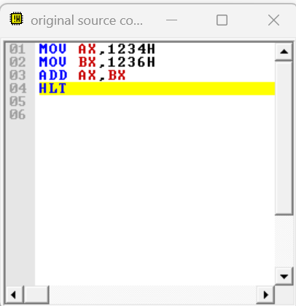

# Experiment 2

**Aim:-**Write an assembly language program to subtract two 16-bit numbers in 8086.

# Soln. -

MOV AX,1234H MOV BX,1236H SUB AX,BX HLT

**Output:**

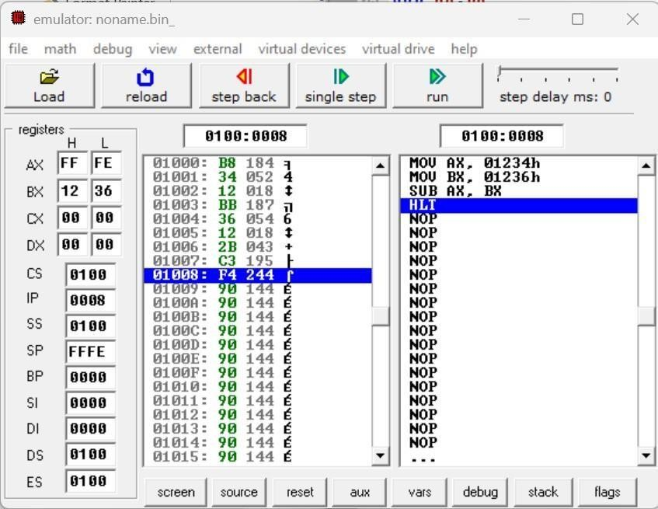

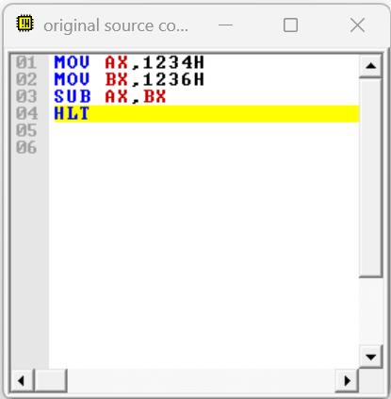

# Experiment 3

**Aim:-** Write an assembly language program to multiply two 16-bit numbers in 8086.

# Soln. -

MOV AX,[0301H] MOV BX,[0303H] MUL BX

HLT

**Output:**

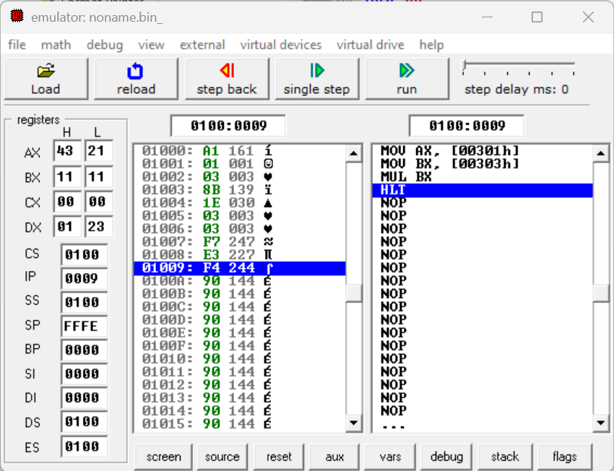

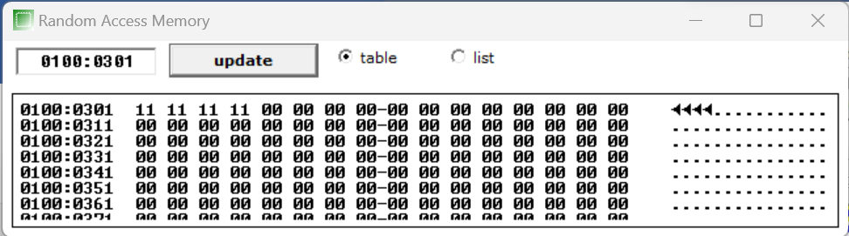

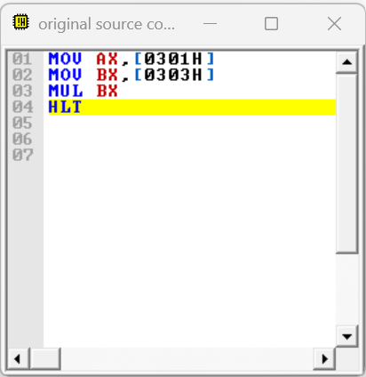

# Experiment 4

**Aim:-** Write an assembly language program to divide two 16-bit numbers in 8086.

# Soln. -

MOV AX,[0301H] MOV BX,[0303H] DIV BX

HLT

**Output:**

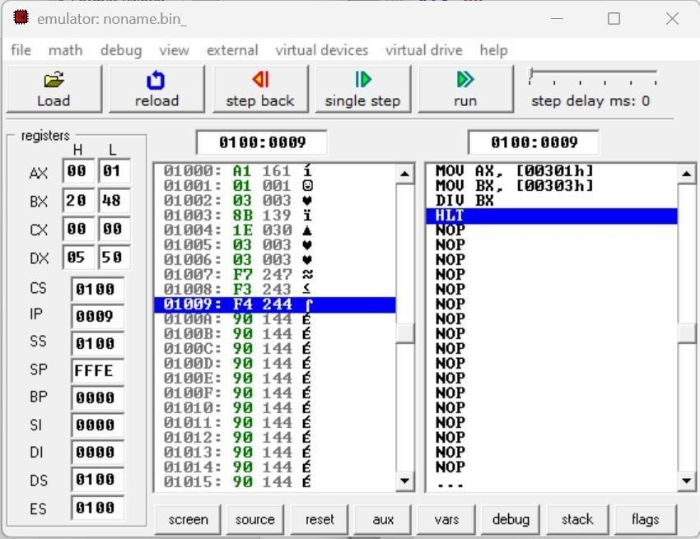

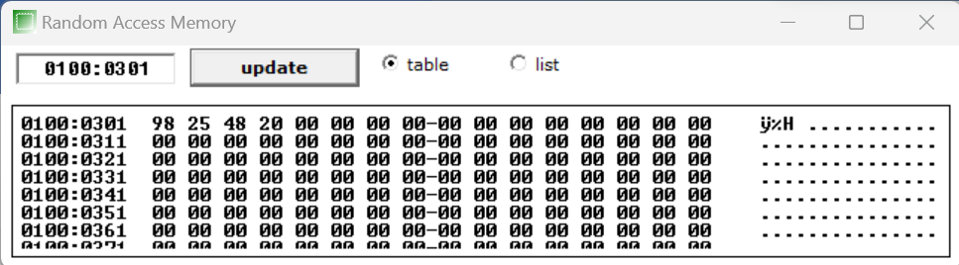

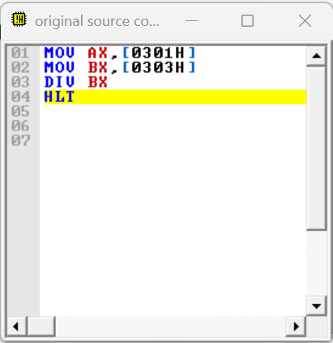

# Experiment 5

**Aim:-** Write an assembly language program to demonstrate AAA, AAS, AAM, AAD, DAA and DAS in 8086

# Soln.

|  |  |
| --- | --- |
| **AAA** | **AAS** |
| MOV AX,0032H | MOV AL,0033H |
| MOV BX,0033H | SUB AX,0039H |
| ADD AX,BX | AAS |
| AAA | OR AL,0030H |
| HLT | HLT |

|  |  |
| --- | --- |
| **AAM** | **AAD** |
| MOV AL,03H | MOV AX,0033H |
| MOV BL,09H | MOV BX,0032H |
| MUL BL | AAD |
| AAM | DIV BX |
| OR AX,3030H | HLT |
| HLT |  |

|  |  |
| --- | --- |
| **DAA** | **DAS** |

|  |  |
| --- | --- |
| MOV AL,71H | MOV AL,71H |
| ADD AL,43H' | SUB AL,43H' |
| DAA | DAS |
| HLT | HLT |

**AAA Instruction**

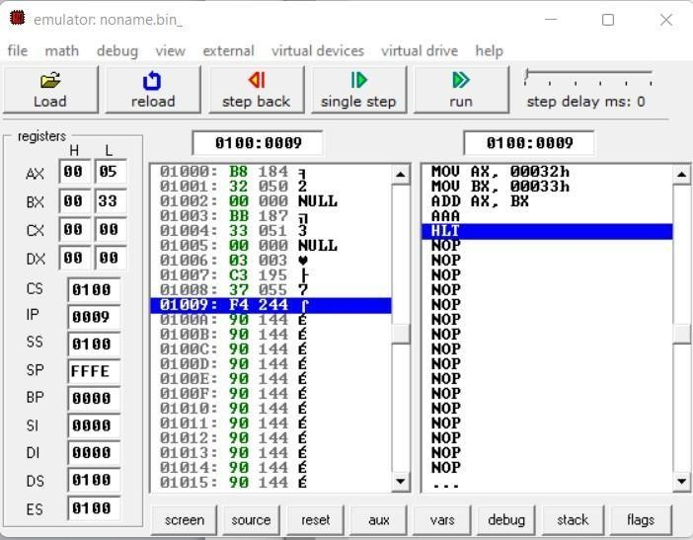

# AAS Instruction

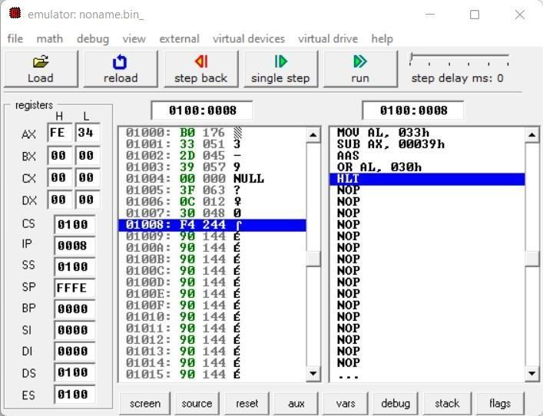

**AAM Instruction**

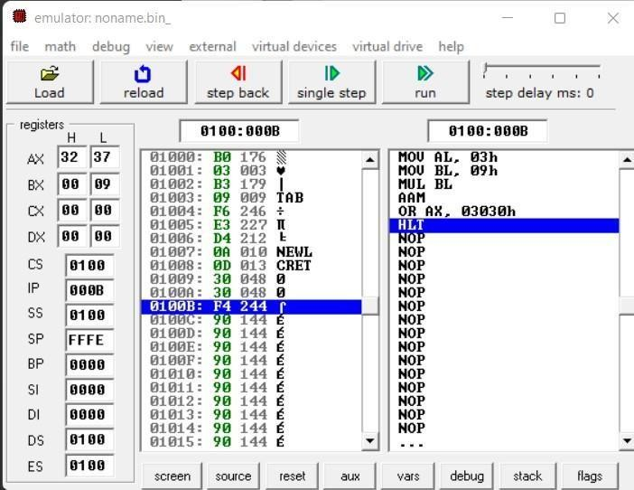

# AAD Instruction

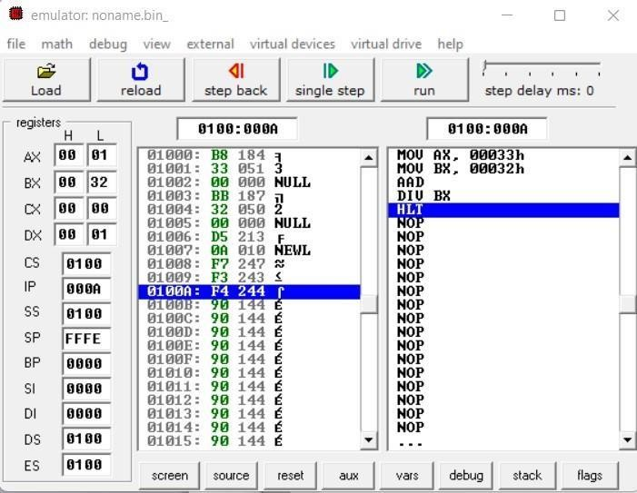

**DAA Instruction**

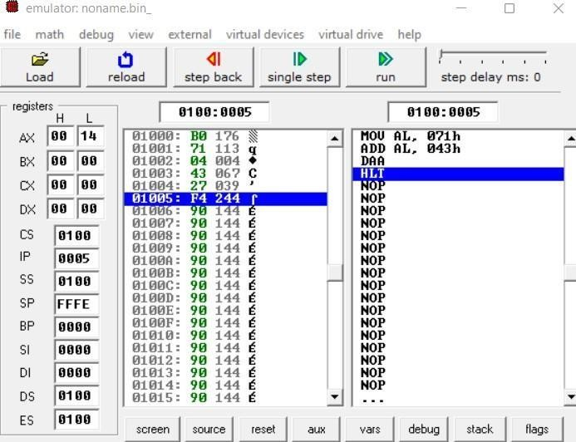

# DAS Instruction

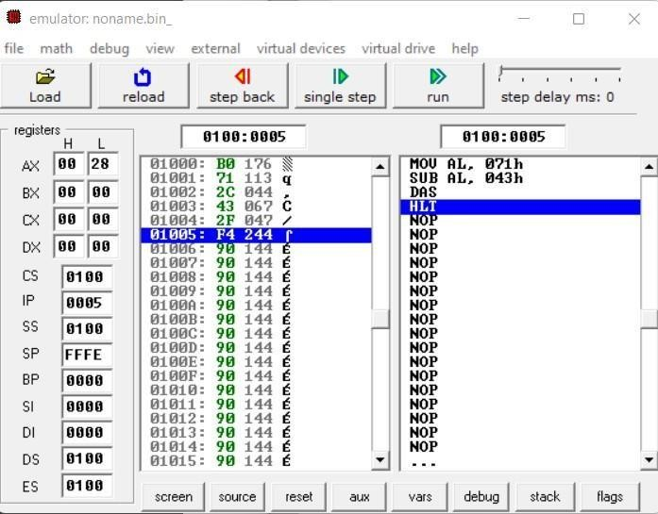

**Experiment 6**

**Aim:-** Write an assembly language program to find out the count of positive numbers and negative numbers from a series of signed numbers in 8086.

# Soln. -

MOV CL,0AH MOV BL,00H MOV DL,00H LEA SI, [1000H] L1: MOV AL, [SI] SHL AL, 01

JNC L2 INC DL JMP L3 L2: INC BL L3: INC SI DEC CL JNZ L1

MOV [100AH], BL MOV [100BH], DL HLT

**OUTPUT:-**

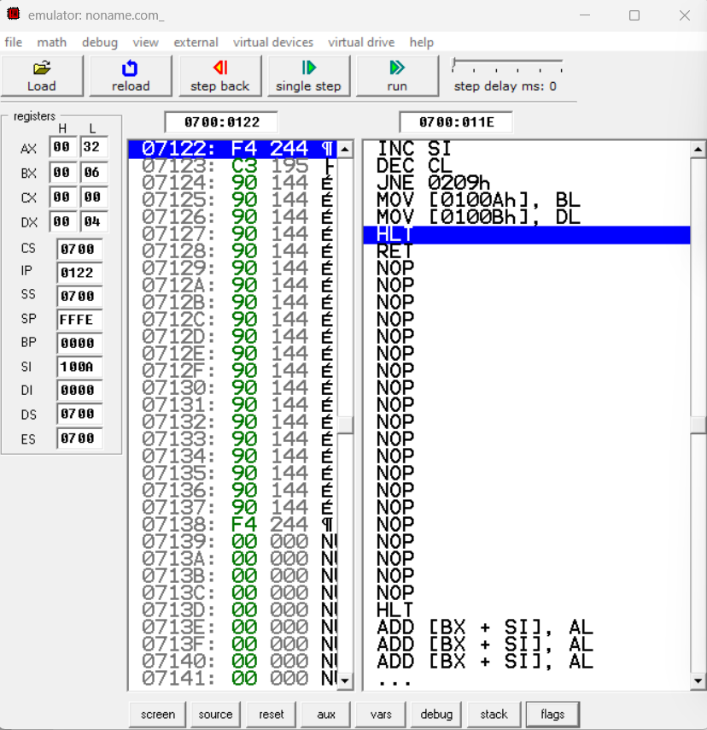

# Experiment 7

**Aim:-** Write an assembly language program to convert to find out the largest number from a given unordered array of 8-bit numbers, stored in the locations starting from a known address in 8086.

**Soln. -**

MOV CL, 0AH LEA SI, [1000H] MOV AL, [SI] L1: INC SI MOV BL, [SI] CMP AL, BL

JC L2 JMP L3

L2: MOV AL, BL L3: DEC CL

JNZ L1

MOV [100AH], AL HLT

**Output:-**

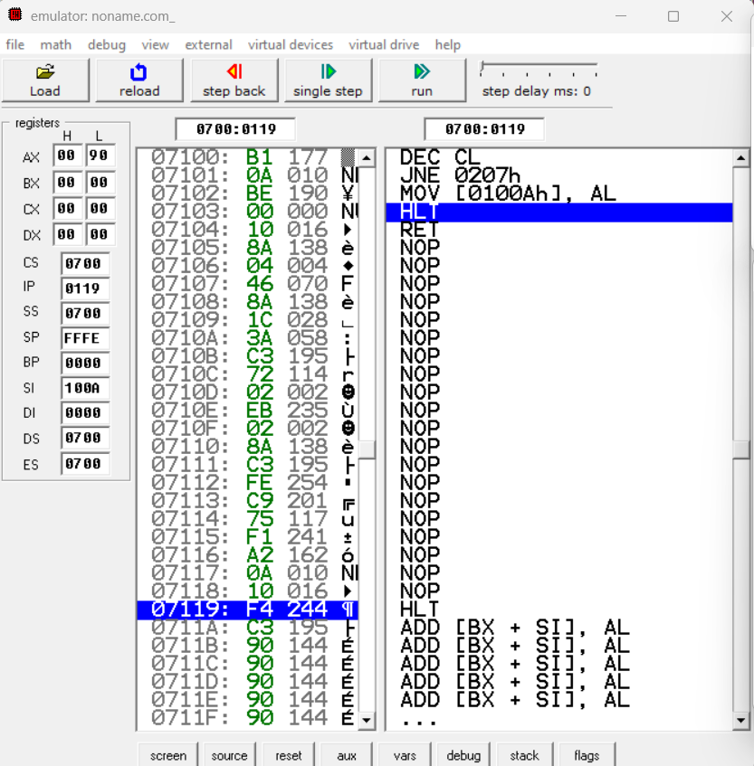

# Experiment 8

**Aim:-** Write an assembly language program to find out the largest number from a given unordered array of 16-bit numbers, stored in the locations starting from a known address in 8086.

# Soln. -

MOV BX, 1000H MOV CL, [BX] INC BX

MOV AX, [BX] DEC CL

Back: INC BX INC BX

CMP AX, [BX]

JNC Next MOV AX, [BX] Next: DEC CL JNZ Back

MOV [1020H], AX HLT

**OUTPUT**

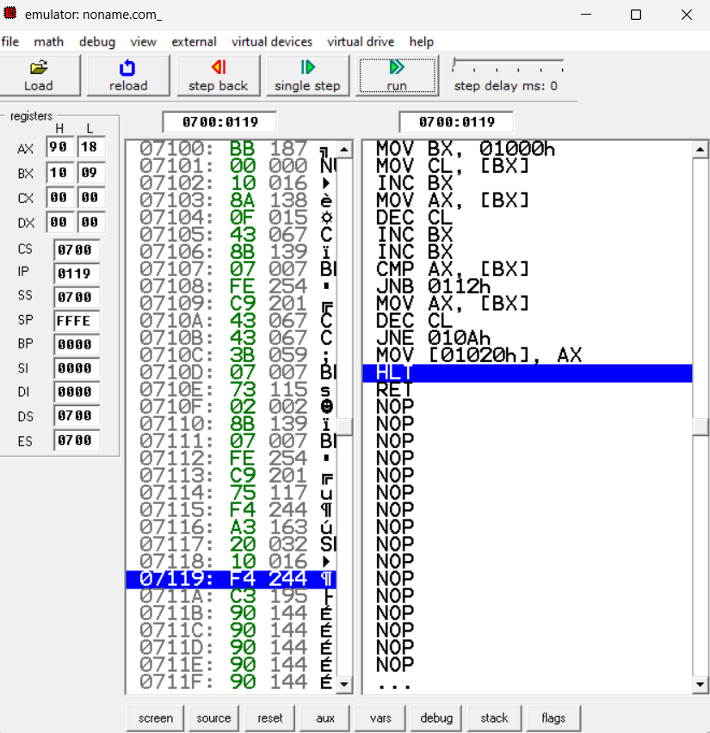

# Experiment 9

**Aim:-** Write an assembly language program to print Fibonacci series in 8086.

# Soln. -

MOV AL,00H MOV SI,500H MOV [SI],AL ADD SI,01H ADD AL,01H MOV [SI],AL MOV CX,[0000H] SUB CX,0002H L1:MOV AL,[SI-1] ADD AL,[SI] ADD SI,01H

MOV [SI],AL LOOP L1 HLT

**Output**:

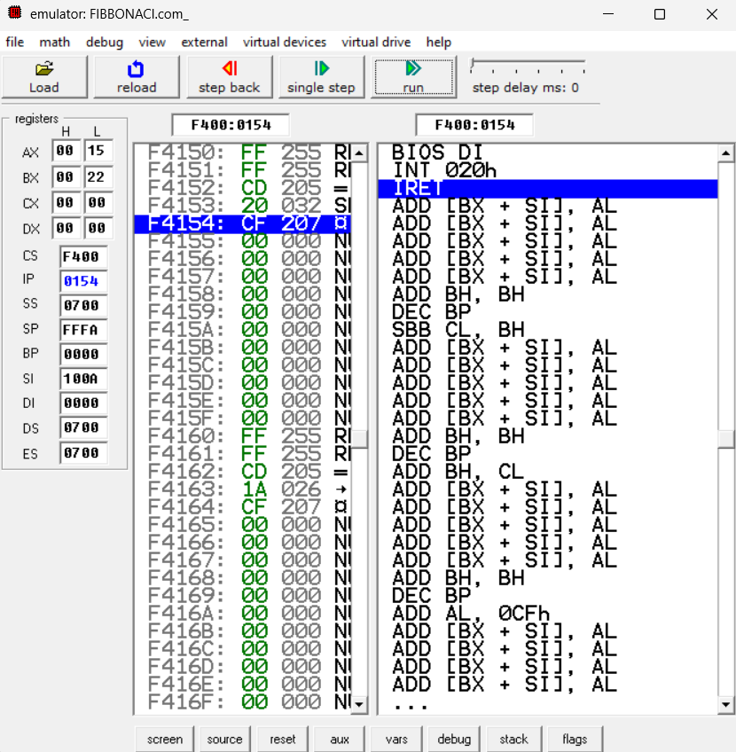

# Experiment 10

**Aim:-** Write an assembly language program to perform the division 15/6 using the ASCII codes. Store the ASCII codes of the result in register DX.

# Soln. -

MOV AX,‟15‟ MOV BX, „6‟ SUB AX, 3030H SUB BH, 30H AAD

DIV BH

ADD AX, 3030H MOV [SI ], AX HLT

**OUTPUT:**



