Hi guys,  
  
You might have seen me repeatedly leaving class and missing lectures since the class started. Sadly this meant that I'm far behind when it comes to actually knowing the course material. This is okay. I firmly believe that I learn a subject material best when I learn it on my own and get an intuitive sense of how all the pieces fit together. I've spent some time over the last week going through 7 weeks worth of lecture notes to understand what the course is about and how it fits into the bigger picture of machine learning. I'll use the term machine learning since it's more accurate than the term "AI." Machine learning is about developing techniques and methods to summarize a very large (think gigabytes to terabytes) dataset into a manageable "sketch." This sketch is then used to make predictions on elements of never-before-seen data drawn from the original dataset.  
  
Although many of you are excited about neural networks and the deep learning revolution, the machine learning field has existed prior to these fields. It is an honest question as to why are probabilistic graphical models worth learning after all? There are a few reasons why:  
  
1: The datasets may be stochastic in nature, and not deterministic. Weather prediction assigns probabilities to an occurrence such as rain, snow, dry, windy even given every conceivable feature to learn from.  
2: A (feedforward) neural network can’t easily capture the mutually affecting relationships of undirected graphical models.  
3: These models are simpler and come with better theoretical guarantees that neural networks. This makes mathematicians happy.  
4: These models are more interpretable and explainable than neural networks.  
  
Point number 4 is actually very important and I’ll come back to it in a second.  
  
  
This course (so far) is about how to take a dataset, learn a graphical model from it, and how to use that graphical model to make predictions. We can ask very flexible questions like “what’s the most likely thing that can happen, ” or “what is the probability of this thing happening,” or “which variable is dependent on which other variable?”  
  
At the end of the day, graphical models are worth learning as another tool in your toolkit and as way to think about problems. They can be used to decompose an engineering or research problem you’re having, and that decomposition helps give insight on possible approaches to solve it. Just like an electrician has more than a flathead screwdriver in his toolkit, so should you have as many tools in your toolkit.  
  
As promised, I wanted to talk about interpretable machine learning models (point 4 from above). There is currently a huge push in machine learning for interpretable models. This is tied into many things including the fact that these models are making real world decisions such as making yes/no decisions on loan applications, medical diagnoses, and being used in self-driving cars. Traditionally when something goes wrong in these scenarios, there is a need for an explanation as to why it happened for implication, post-mortem, and debugging/patching reasons. This is also now being formally regulated under EU General Data Protection Regulations (GDPR) as a “right to explanation.” The GDPR regulations allow for EU citizens to ask for an explanation for any machine learning or “AI” system which takes an action adversely against them (for example denying a financial loan, or even rating their dating profile as “unattractive”). I assure you as of right now neural networks are mostly unexplainable. Therefore, it’s important to learn interpretable, explainable, models.  
  
In a nutshell, a researcher's life (or machine learning engineer or data scientist) will be governed by the following optimization problem:  
  
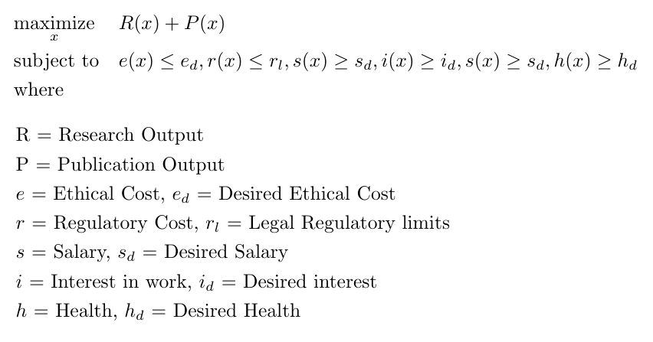  
  
Some of the above constraints you can set yourself (for example desired salary level, interest level, health level). Others, however, are set by government regulation and ethical boards (which is also to say government regulations). So in some sense it’s best to know these topics since they will help you better optimize your life in the future.  
  
It behooves me as mathematician to push the above analogy further. An optimization problem such as above, once solved, also has an alternative interpretation. Indeed, if you solve the dual you get what are known as “shadow prices,” which assign values to relaxation of constraints. To make this example more concrete, shadow prices represent “how much more research or publication output I could have if I chose to take a paycut, or sacrifice my health, or do boring uninteresting work.” Given these shadow prices you can make better informed decision as to what you actually value: research or salary/health/boredom.  
  
It also answers the question: “How much more research output could I have if I were a little bit more unethical?” Of course, now you say well you can’t really mess with ethics. As a mathematician, I assure you “ethics,” is just another word in the dictionary along with many others. As long as you’re willing to invent your own dictionary (or take over existing dictionary publishing houses), you can redefine it as you wish.  
  
It further answers the question: “How much more research output could I have if I were a little less constrained by regulatory laws?” Answering this question as a startup may cause you to accept a less than optimal buyout by say Google, in return for having Google’s \*ahem\* team of Legal Representatives helping you. On the other hand, if you’re on the scale of Google itself, it might answer the question of whether a strategy of Regulatory Capture is worth it or not. The salary of a large team of Legal Representatives is not too high and is falling every day thanks to automation.  
  
Thanks,  
  
Mohit Rajpal  
[mohitr@u.nus.edu](mailto:mohitr@u.nus.edu)  
  
P.S. The above interpretation may shed some light on other social matters as well. For example replace Research and Publishing output with, “having enough natural resources for a nation-state,” and constraints with something more topically appropriate and shadow prices indicate the value of breaking constraints placed on nation-states.  
  
For better or for worse, mathematics and science exist outside of ethics. Ethics is a human concept, and math and science are studies of things that exist without humans. The laws of physics and calculus governed the cosmos long before they were discovered by us, and they will continue governing the cosmos long after we’re gone. Far better scientists than me have written about the relationship between humans, science, and math.