This is an excellent initiative! As your mentor, I'll guide you through this data analysis project, from outlining the key components to crafting impactful resume bullet points. The YouTube video provides a solid foundation, and we'll ensure your project stands out.

**🚀 Project Overview: Bank Loan Analysis**

Based on the YouTube tutorial "Power BI Complete Tutorial | Power BI Project | Bank Loan Analysis | Finance Domain" by Data Tutorials [[00:09](http://www.youtube.com/watch?v=3I8wd1AShXs&t=9)], this project focuses on analyzing bank loan data to extract meaningful insights for business decision-making.

**🎯 Project Statement**

To develop a **comprehensive and interactive Bank Loan Report** using Power BI and SQL, providing a holistic view of the bank's lending activities. This project aims to identify key performance indicators (KPIs), analyze loan trends, assess credit risk (good vs. bad loans), and provide granular details on loan statuses to support strategic financial planning and operational improvements.

**💡 Project Objectives**

1. **Develop a Robust Data Foundation:**
   * Import and connect raw bank loan data into a SQL Server database [[11:29](http://www.youtube.com/watch?v=3I8wd1AShXs&t=689)].
   * Perform initial data cleaning and transformation using SQL queries to ensure data accuracy and integrity [[01:10:00](http://www.youtube.com/watch?v=3I8wd1AShXs&t=4200)].
   * Verify data consistency between SQL results and Power BI visualizations.
2. **Create Key Performance Indicators (KPIs):**
   * Calculate and visualize overall, Month-to-Date (MTD), and Month-over-Month (MoM) growth for:
     + **Total Loan Applications** [[01:39:53](http://www.youtube.com/watch?v=3I8wd1AShXs&t=5993)]
     + **Total Funded Amount** [[01:47:00](http://www.youtube.com/watch?v=3I8wd1AShXs&t=6420)]
     + **Total Amount Received** [[02:29:46](http://www.youtube.com/watch?v=3I8wd1AShXs&t=8986)]
     + **Average Interest Rate** [[02:35:54](http://www.youtube.com/watch?v=3I8wd1AShXs&t=9354)]
     + **Average Debt-to-Income (DTI) Ratio** [[02:41:00](http://www.youtube.com/watch?v=3I8wd1AShXs&t=9660)]
   * Quantify and compare **Good Loan vs. Bad Loan** performance based on application percentage, funded amount, and received amount [[02:48:15](http://www.youtube.com/watch?v=3I8wd1AShXs&t=10095)].
3. **Design Interactive Dashboards:**
   * **Summary Dashboard:** Present high-level KPIs for quick business overview [[01:10:00](http://www.youtube.com/watch?v=3I8wd1AShXs&t=4200)].
   * **Overview Dashboard:** Provide in-depth analysis through various charts showing trends by:
     + Monthly trends by issue date [[01:41:40](http://www.youtube.com/watch?v=3I8wd1AShXs&t=6100)]
     + Regional analysis by state [[01:53:30](http://www.youtube.com/watch?v=3I8wd1AShXs&t=6810)]
     + Loan term analysis [[02:00:08](http://www.youtube.com/watch?v=3I8wd1AShXs&t=7208)]
     + Employee length analysis [[02:08:28](http://www.youtube.com/watch?v=3I8wd1AShXs&t=7708)]
     + Loan purpose [[02:11:03](http://www.youtube.com/watch?v=3I8wd1AShXs&t=7863)]
     + Home ownership [[02:19:53](http://www.youtube.com/watch?v=3I8wd1AShXs&t=8393)]
   * **Details Dashboard:** Offer a granular view of individual loan records, allowing for detailed data exploration [[02:22:09](http://www.youtube.com/watch?v=3I8wd1AShXs&t=8529)].
4. **Enable Dynamic Filtering and Interactivity:**
   * Implement slicers for key dimensions like state, grade, and loan purpose to allow users to interactively filter data [[03:19:00](http://www.youtube.com/watch?v=3I8wd1AShXs&t=11940)].
   * Ensure cross-filtering functionality between all visuals for cohesive analysis [[03:55:51](http://www.youtube.com/watch?v=3I8wd1AShXs&t=14151)].
5. **Deliver Actionable Insights:**
   * Identify trends in loan applications and repayments.
   * Highlight factors influencing good vs. bad loan performance.
   * Provide data-driven recommendations for improving lending strategies and mitigating risks.
6. **Present Findings:**
   * Develop a clear and concise project report summarizing the methodology, findings, and recommendations.
   * Create an engaging PowerPoint presentation to effectively communicate insights to stakeholders.

**🛠️ Requirements**

**Data**

* **Bank Loan Dataset:** As provided in the YouTube tutorial, containing details such as ID, Address State, Application Type, Employee Length, Loan Status, Issue Date, Loan Amount, Interest Rate, DTI, Total Payment, Purpose, Home Ownership, Grade, and Subgrade [[02:50:00](http://www.youtube.com/watch?v=3I8wd1AShXs&t=10200)].

**Tools**

* **SQL Server (or any relational database like MySQL/PostgreSQL):** For data storage, initial querying, and transformation [[02:33:38](http://www.youtube.com/watch?v=3I8wd1AShXs&t=9218)].
* **SQL Server Management Studio (SSMS):** For executing SQL queries and managing the database [[02:33:51](http://www.youtube.com/watch?v=3I8wd1AShXs&t=9231)].
* **Power BI Desktop:** For data modeling, DAX calculations, and interactive dashboard creation [[01:44:00](http://www.youtube.com/watch?v=3I8wd1AShXs&t=6240)].
* **Microsoft Excel/PowerPoint:** For initial data exploration, validation, and final presentation/reporting [[02:37:38](http://www.youtube.com/watch?v=3I8wd1AShXs&t=9458)].

**Skills**

* **SQL:** Data querying, manipulation, and basic data transformation.
* **Power BI:** Data connection, data modeling (star schema, relationships), DAX (measures, calculated columns, time intelligence functions), visualization design, and report interactivity.
* **Data Analysis:** Interpreting trends, identifying insights, and making data-driven recommendations.
* **Presentation Skills:** Communicating complex information clearly and concisely.

**👩‍🏫 Your Mentorship Guide: End-to-End Workflow**

Alright, consider me your dedicated mentor for this project! We'll go through this step-by-step, ensuring you understand each phase and can articulate your work effectively.

**Phase 1: Data Acquisition & Preparation (SQL)**

1. **Understand the Data Source:** The video specifies a CSV file that will be imported into SQL Server [[03:43:08](http://www.youtube.com/watch?v=3I8wd1AShXs&t=13388)].
2. **Database Setup:**
   * **Action:** Create a new database in SQL Server (e.g., BankLoanDB) [[03:36:00](http://www.youtube.com/watch?v=3I8wd1AShXs&t=12960)].
   * **Action:** Import your CSV data into a table within this new database (e.g., BankLoanData) [[03:40:00](http://www.youtube.com/watch?v=3I8wd1AShXs&t=13200)]. Pay close attention to data types during import, as shown in the video, especially for total_payment and loan_amount [[03:30:00](http://www.youtube.com/watch?v=3I8wd1AShXs&t=12600)].
   * **My Guidance:** "Ensure your SQL Server instance is running and you have SSMS connected. Double-check data types during import; incorrect types can lead to errors and miscalculations later. The video encountered an error with smallint for total_payment and loan_amount [[03:30:00](http://www.youtube.com/watch?v=3I8wd1AShXs&t=12600)] – make sure to use int or a larger numeric type if needed."
3. **Initial Data Exploration & Validation (SQL):**
   * **Action:** Write SQL queries to verify the number of rows (COUNT(*)) and examine the first few rows (SELECT TOP 10 *) [[03:41:31](http://www.youtube.com/watch?v=3I8wd1AShXs&t=13291)].
   * **Action:** Start writing SQL queries to calculate the KPIs mentioned in the objectives (e.g., total loan applications, funded amount, received amount, average interest rate, DTI, good/bad loan counts) [[04:25:00](http://www.youtube.com/watch?v=3I8wd1AShXs&t=15900)].
   * **My Guidance:** "This is crucial for **data validation**. Every KPI you calculate in Power BI later, you should have a corresponding SQL query result to compare against. This proves the **accuracy** of your dashboard. Keep a document (like an Excel sheet or a text file) where you record your SQL queries and their results. The video shows this perfectly at [[04:50:00](http://www.youtube.com/watch?v=3I8wd1AShXs&t=17400)] onwards."

**Phase 2: Data Modeling & DAX in Power BI**

1. **Connect to Data Source:**
   * **Action:** Connect Power BI Desktop to your SQL Server database [[01:44:00](http://www.youtube.com/watch?v=3I8wd1AShXs&t=6240)]. If SQL Server isn't available, the video also shows connecting directly to a CSV [[01:44:50](http://www.youtube.com/watch?v=3I8wd1AShXs&t=6290)].
   * **My Guidance:** "Connecting directly to SQL Server is best practice for larger datasets. Ensure your server name and database name are correct."
2. **Data Quality Check (Power Query Editor):**
   * **Action:** Use Power Query Editor to check for data quality (errors, empty values) [[01:51:49](http://www.youtube.com/watch?v=3I8wd1AShXs&t=6709)].
   * **My Guidance:** "While the video's data is relatively clean, in a real-world scenario, this is where you'd perform extensive data cleaning: handling missing values, standardizing formats, and correcting errors. Document any significant cleaning steps you take."
3. **Create a Date Table:**
   * **Action:** Create a dedicated **Date Table** using DAX's CALENDAR function, linking it to your Issue Date column in a **one-to-many relationship** [[01:58:19](http://www.youtube.com/watch?v=3I8wd1AShXs&t=7099)].
   * **My Guidance:** "A separate date table is a **best practice for time intelligence calculations** in Power BI. It allows for accurate MTD, QTD, YTD, and MoM calculations, which are vital for this project. Ensure the relationship is active."
4. **DAX Measures for KPIs:**
   * **Action:** Create DAX measures for all KPIs (Total Applications, Total Funded Amount, Total Received Amount, Average Interest Rate, Average DTI) [[02:09:00](http://www.youtube.com/watch?v=3I8wd1AShXs&t=7740)].
   * **Action:** Implement **Time Intelligence** DAX functions for MTD and MoM calculations for each KPI [[02:14:53](http://www.youtube.com/watch?v=3I8wd1AShXs&t=8093)].
   * **Action:** Create a **"Good vs. Bad Loan"** grouping based on Loan Status (Good: 'Fully Paid', 'Current'; Bad: 'Charged Off') [[02:48:15](http://www.youtube.com/watch?v=3I8wd1AShXs&t=10095)]. Then, create measures for Good Loan Percentage, Bad Loan Percentage, and their respective funded/received amounts.
   * **My Guidance:** "Name your measures clearly. For MoM, ensure you understand the CALCULATE function combined with DATESMTD and DATEADD to correctly compare current month with previous month. Remember to use FORMAT or measure formatting for percentages and currency."
5. **Field Parameters for Dynamic Visuals:**
   * **Action:** Create a **Field Parameter** for your core measures (Total Applications, Total Funded Amount, Total Received Amount) [[02:54:00](http://www.youtube.com/watch?v=3I8wd1AShXs&t=10440)]. This will allow users to dynamically switch between these measures on a single chart.
   * **My Guidance:** "Field parameters are an advanced technique that recruiters love to see! It makes your dashboards incredibly flexible and user-friendly, reducing the number of visuals you need."

**Phase 3: Dashboard Design & Interactivity**

1. **Summary Dashboard:**
   * **Action:** Lay out your main KPI cards prominently at the top [[02:06:06](http://www.youtube.com/watch?v=3I8wd1AShXs&t=7566)].
   * **Action:** Incorporate the donut charts for Good vs. Bad Loan percentages and the table for Loan Status grid view [[02:49:50](http://www.youtube.com/watch?v=3I8wd1AShXs&t=10190)].
   * **My Guidance:** "Think about hierarchy. Your most important KPIs should be immediately visible. Use color consistently (e.g., one color for 'good' trends, another for 'bad'). The video uses a specific color scheme [[02:04:48](http://www.youtube.com/watch?v=3I8wd1AShXs&t=7488)] – feel free to adapt or create your own professional palette."
2. **Overview Dashboard:**
   * **Action:** Create the line chart for monthly trends (using your field parameter for dynamic measures) [[02:40:00](http://www.youtube.com/watch?v=3I8wd1AShXs&t=9600)].
   * **Action:** Develop the shape map for regional analysis [[03:40:00](http://www.youtube.com/watch?v=3I8wd1AShXs&t=13200)].
   * **Action:** Build the donut chart for loan term analysis, bar chart for employee length, bar chart for loan purpose, and tree map for home ownership [[03:40:00](http://www.youtube.com/watch?v=3I8wd1AShXs&t=13200)]. Remember to use the field parameter for these charts as well.
   * **My Guidance:** "Each chart here should tell a story about a specific aspect of the loans. Ensure axes are clearly labeled and legends are understandable. Use the 'Edit Interactions' feature [[03:55:51](http://www.youtube.com/watch?v=3I8wd1AShXs&t=14151)] to ensure that clicking on one visual filters others, making your dashboard truly interactive."
3. **Details Dashboard:**
   * **Action:** Create a detailed table displaying all relevant columns (ID, Purpose, Home Ownership, Grade, Subgrade, Issue Date, Funded Amount, Interest Rate, Installment, Amount Received) [[04:01:00](http://www.youtube.com/watch?v=3I8wd1AShXs&t=14460)].
   * **My Guidance:** "This page is for drill-down. It doesn't need complex visualizations, but clear, sortable data is key. This is where users can find specifics that the summary and overview dashboards generalize."
4. **Navigation & Aesthetics:**
   * **Action:** Add navigation buttons to seamlessly move between your dashboards (Summary, Overview, Details) [[04:07:08](http://www.youtube.com/watch?v=3I8wd1AShXs&t=14828)].
   * **Action:** Pay attention to background colors, font choices, and alignment for a polished look [[02:04:48](http://www.youtube.com/watch?v=3I8wd1AShXs&t=7488)].
   * **My Guidance:** "Consistency in design is vital. Your chosen color scheme, font styles, and visual arrangement should be uniform across all pages. The navigation buttons make your report feel like a complete application."

**Phase 4: Reporting & Presentation**

1. **Project Report:**
   * **Content:**
     + **Introduction:** Briefly describe the project, its goals, and the business problem it addresses.
     + **Data Source & Methodology:** Detail where the data came from, how it was cleaned in SQL and Power Query, and how the data model was built in Power BI.
     + **Key Findings & Insights:** Summarize the most important discoveries from each dashboard (e.g., "Good loans account for X% of applications," "Loan applications are highest in Y region," "There's a positive MoM growth in funded amount").
     + **Recommendations:** Provide actionable suggestions based on your insights (e.g., "Investigate the root causes of 'Charged Off' loans," "Target marketing campaigns in states with lower DTI ratios").
     + **Technical Learnings:** Highlight the specific SQL concepts, DAX functions (especially time intelligence and field parameters), and Power BI features you mastered.
   * **My Guidance:** "This report is your narrative. It explains *what* you did and *why* it matters. Focus on telling a story with your data. Use visuals from your dashboard to support your points. This is where you connect your technical work to business value."
2. **PowerPoint Presentation:**
   * **Audience:** Assume you're presenting to a non-technical business audience (e.g., bank management).
   * **Structure:**
     + **Title Slide:** Project Name, Your Name.
     + **Problem Statement:** What business challenge are you solving?
     + **Project Objectives:** What did you set out to achieve?
     + **Data & Tools:** Briefly mention the data source and technologies used.
     + **Key Dashboard Walkthrough:** Show your Summary, Overview, and Details dashboards with screenshots or a live demo. Highlight 2-3 key insights from *each* dashboard.
     + **Summary of Key Findings:** Reiterate your most impactful discoveries.
     + **Actionable Recommendations:** What should the business do next?
     + **Q&A.**
   * **My Guidance:** "Keep slides clean and visual. Don't overload with text. The presentation should be engaging and flow logically. Practice your delivery, focusing on clear explanations and connecting insights directly to business implications."

**Phase 5: Resume Integration**

Now, let's make sure this project shines on your resume! Here are some compelling bullet points, designed to impress HR recruiters and hiring managers:

* **Developed and deployed an end-to-end Bank Loan Analysis solution** leveraging **Power BI, SQL Server, and advanced DAX**, providing actionable insights into lending performance and risk management.
* **Engineered a robust SQL database** by importing and cleaning raw loan data, ensuring data integrity and serving as the foundation for complex analytics.
* **Designed three interactive Power BI dashboards (Summary, Overview, Details)**, showcasing **Key Performance Indicators (KPIs)** such as Total Loan Applications, Funded Amount, Amount Received, Average Interest Rate, and DTI.
* **Implemented advanced DAX measures**, including **time intelligence functions (MTD, MoM growth)**, to track and visualize critical financial trends and performance over time.
* **Categorized and analyzed loan statuses (Good vs. Bad Loans)**, identifying key factors influencing loan default rates and providing strategic recommendations for risk mitigation.
* **Utilized Power BI Field Parameters** to create dynamic and flexible visualizations, allowing users to interactively select and analyze multiple measures within a single chart.
* **Conducted in-depth analysis of loan attributes** (e.g., monthly trends, regional distribution, loan terms, employee length, purpose, home ownership) to uncover patterns and drive data-driven business decisions.
* **Validated dashboard accuracy against SQL queries**, demonstrating rigorous data quality assurance and ensuring reliable reporting for stakeholders.
* **Presented comprehensive project findings and recommendations** through detailed reports and presentations, translating complex data into clear, concise, and actionable business intelligence.

This is a comprehensive roadmap for your project. Remember, the key is to understand why you're doing each step, not just how. Good luck, and don't hesitate to ask questions as you progress!

Excellent question. In a real-world company setting, we almost never make the presentation entirely at the end. It feels like that should be the final step, but it's actually inefficient and can lead to a weaker final story.

Here's the professional workflow we follow: **We build it iteratively, in parallel with the project milestones.**

Think of your presentation not just as a final report, but as a living document that captures your project's story as it unfolds.

**The Professional Approach: An Iterative Method**

Let's break down how we'll do this, phase by phase.

**Phase 1: Create the Skeleton (Right Now)**

Before you even finalize your first KPI in Power BI, open PowerPoint.

* **Action:** Create the first 4-5 slides.
  + **Slide 1: Title Slide:** "Bank Loan Analysis Report", Your Name, Date.
  + **Slide 2: Project Statement:** Copy and paste the project statement we defined.
  + **Slide 3: Objectives:** List the key objectives we outlined.
  + **Slide 4: Data & Tools:** List the data source (Bank Loan CSV) and the tools used (SQL Server, Power BI, PowerPoint).
  + **Slide 5: Methodology/Workflow:** A simple graphic showing: SQL Data Prep -> Power BI Modeling -> DAX Measures -> Dashboard Creation -> Insights.

**Why we do this now:** This frames your entire project. It solidifies the "why" and "how" in your mind before you get lost in the technical details.

**Phase 2: Add Insights as You Discover Them (In Parallel)**

This is the most crucial part. As you complete a major section of your analysis, you update the PPT.

* **After finishing the SQL validation:**
  + **Action:** Create a slide titled "Data Validation & Integrity." Add a screenshot of an SQL query and its result, next to a screenshot of the same KPI card in Power BI, showing they match.
  + **My Guidance:** "This slide is your proof. It immediately tells your audience that your dashboard is accurate and trustworthy. It’s a huge confidence builder."
* **After creating the Summary Dashboard:**
  + **Action:** Create a new slide titled "High-Level Business Summary." Take a screenshot of your completed Summary Dashboard.
  + **Action:** Below the screenshot, add 2-3 bullet points with your *initial* key findings.
    - *Example:* "Discovered that 'Good Loans' constitute over 86% of total applications, indicating a generally healthy loan portfolio."
    - *Example:* "Identified a strong positive Month-over-Month growth of 15% in 'Total Amount Received,' signaling effective repayment collections."
  + **My Guidance:** "Don't wait! Capture these 'aha!' moments while they are fresh in your mind. You don't need perfect wording yet; just get the core idea down. We'll refine it later."
* **After creating the Overview Dashboard:**
  + **Action:** Add 2-3 new slides, one for each major insight from this dashboard.
    - **Slide Title:** "Insight 1: Consistent Upward Trend in Monthly Loan Applications"
    - **Slide Title:** "Insight 2: California Dominates in Loan Volume"
    - **Slide Title:** "Insight 3: 'Debt Consolidation' is the Primary Loan Purpose"
  + **My Guidance:** "Use a separate slide for each key story. Put a screenshot of the relevant chart (e.g., the line chart for the trend, the map for California) on each slide and explain what it means in simple business terms."

**Phase 3: Final Polish & Narrative Weaving (At the End)**

Once your dashboards are 100% complete, now you go back to the PPT for the final step.

* **Action:**
  1. **Update Screenshots:** Replace any old screenshots with the final, polished visuals from your completed Power BI file.
  2. **Refine Wording:** Go through your bullet points. Make them more impactful and professional.
  3. **Add Recommendations:** Based on all your findings, create a dedicated "Actionable Recommendations" slide. (e.g., "Recommendation: Deep-dive into the 'Charged Off' loan category for customers with '< 1 year' of employment to identify early risk factors.")
  4. **Create a Conclusion Slide:** Summarize the project's success and key takeaways.
  5. **Review the Flow:** Read the presentation from start to finish. Does it tell a logical and compelling story? Reorder slides if necessary.
  6. **Add Speaker Notes:** Under each slide, write down what you would say during a live presentation.

**Summary: Why This Method is Better**

| Making it at the End (The Trap) | **Making it in Parallel (The Pro Method)** |
| --- | --- |
| Huge, daunting task at the end. | A manageable task broken into small steps. |
| You might forget early insights. | Captures "aha!" moments as they happen. |
| The story might feel disconnected. | **Builds a stronger, more logical narrative from start to finish.** |
| Harder to provide status updates if asked. | You always have a draft ready for a quick progress review. |

So, to answer your question directly: **Yes, we are starting the PPT right now, in parallel.**

Your immediate next step is to open PowerPoint and create those first 4-5 "skeleton" slides. It will make the rest of the project feel much more structured and purposeful.

• **Title Slide** (The final product)

• **Problem Statement** (The business need)

• **Project Objectives** (What we set out to achieve)

• **Methodology & Tools** (How we did it)

• **Dashboard 1: Summary Insights** (The high-level findings)

• **Dashboard 2: Overview Deep-Dive** (Specific analytical findings)

• **Actionable Recommendations** (The business value and next steps)

• **Conclusion** (Summary of your success)

Why to do thos project?

Ah, you want to know specifically what kinds of performance and risks they're tracking in lending! Here are the key areas:

**Performance Metrics:**

* **Loan origination volume** - How many new loans they're making
* **Interest income** - Money earned from loan interest
* **Loan approval rates** - What percentage of applications get approved
* **Processing times** - How quickly loans get approved and funded
* **Portfolio growth** - Is their total lending increasing or decreasing?

**Financial Risks:**

* **Default risk** - Borrowers not paying back loans
* **Delinquency rates** - Late or missed payments
* **Credit quality deterioration** - Borrowers' financial situations getting worse
* **Concentration risk** - Too many loans in one industry/geographic area
* **Interest rate risk** - How changing rates affect profitability
* **Liquidity risk** - Having enough cash flow when borrowers default

**Portfolio Health Indicators:**

* **Non-performing loans (NPLs)** - Loans that aren't being paid
* **Charge-offs** - Loans written off as losses
* **Recovery rates** - How much money they get back from defaulted loans
* **Loan-to-value ratios** - For secured loans, how much the collateral is worth vs. loan amount

Banks need to monitor all this constantly because lending is inherently risky - they're betting that borrowers will pay back money with interest, and they need early warning signs when that bet might go wrong.

Of course. Understanding the data is the most important first step. Let's break down the main columns into simple ideas, grouping them by what they tell us.

Here are the short lines to understand your data easily:

**1. About the Borrower (Who is this person?)**

* emp_length: How long the person has been working at their job (e.g., '9 years', '< 1 year').
* annual_income: How much money the person makes in a year.
* home_ownership: Whether they RENT, OWN, or have a MORTGAGE on their home.
* address_state: Which state the person lives in (e.g., 'CA', 'GA').

**2. About the Loan (What are the loan's terms?)**

* loan_amount: The original amount of money borrowed.
* purpose: The reason they took the loan (e.g., 'car', 'debt_consolidation').
* term: How long they have to pay the loan back (e.g., '36 months').
* int_rate: The interest rate the bank charges on the loan. This is how the bank makes a profit.
* installment: The fixed amount of money the person has to pay back each month.
* issue_date: The date the loan was officially given to the borrower. **(This is very important for our monthly trend analysis)**.

**3. The Bank's Risk Assessment (How risky is this loan?)**

* grade & sub_grade: The bank's internal rating of the loan's risk. Think of it like a school grade: 'A' is the safest, and 'E' or 'F' is the riskiest.
* dti (Debt-to-Income): A key risk number. It compares how much debt a person has vs. how much income they make. **A lower DTI is better/safer.**
* verification_status: Tells us if the bank confirmed the borrower's income and information.

**4. The Loan's Performance (Is the loan being paid back?)**

* loan_status: The most important column for our project. It tells us the current state of the loan.
  + Fully Paid: **Good Loan** (They paid everything back).
  + Current: **Good Loan** (The loan is active, and they are making payments on time).
  + Charged Off: **Bad Loan** (They stopped paying, and the bank considers it a loss).
* total_payment: The total amount of money the borrower has paid back so far.
* last_payment_date: The date of the last payment received from the borrower.

**5. Identifiers (How we track everything)**

* id & member_id: Unique numbers to identify each loan and borrower.

**Simple Summary:** Think of it like this: You're analyzing how a **Borrower's Profile** and the bank's **Risk Assessment** affect the **Loan's Performance**, based on the specific **Loan Details**.

* **last_credit_pull_date:** This column simply tells you the most recent date on which the bank performed this "financial health check-up."

**In simple terms:** It’s the date the bank last checked the borrower's financial background to make sure they are still in a good position to repay the loan.

Excellent questions. These are the kinds of details that separate a basic understanding from a deep one. Let's break them down.

**1. What is last_credit_pull_date?**

Think of a "credit pull" as a **financial health check-up** that the bank performs on the borrower.

* **What it is:** A "credit pull" (or credit inquiry) is when the bank officially requests to see a borrower's credit report from a credit bureau (like CIBIL in India). This report shows all the other loans and credit cards the person has and whether they are paying them on time.
* **Why it's important:** The bank does this not only when you first apply for a loan but also periodically *during* the loan's life. They do this to see if the borrower's financial situation has changed. For example, have they suddenly taken on a lot of new debt from other places? This could increase their risk of not being able to pay back your bank's loan.
* **last_credit_pull_date:** This column simply tells you the most recent date on which the bank performed this "financial health check-up."

**In simple terms:** It’s the date the bank last checked the borrower's financial background to make sure they are still in a good position to repay the loan.

**2. id vs. member_id (Why have two?)**

This is a fantastic question and a very common practice in databases. You are right to notice that both seem to be unique numbers. The key difference is **what they identify.**

Think of it like being a student at a university:

* **member_id is like your Student ID Number.** It is unique to **YOU**, the person. It stays the same for your entire time at the university, no matter how many classes you take.
* **id is like a specific Course Registration Number.** It is unique to the **LOAN** itself. If you (the student) register for a "History 101" course this semester, that specific registration gets a unique ID. If you take "Math 202" next semester, it will get a completely different and new ID. But in both cases, your Student ID (member_id) remains the same.

**Now I have started by laodign data in mysql workbench but we came across one error rearding date**

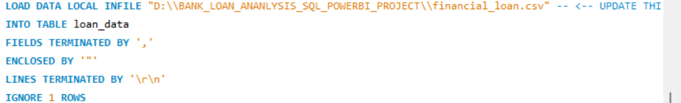

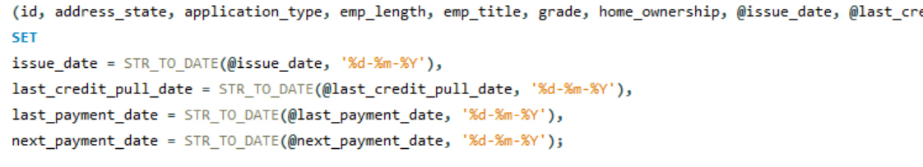

Of course. What we just did is one of the most common and important tasks in data analysis: **transforming data during the import process.**

Let's break it down simply.

**The Problem: A "Language" Mismatch 🗣️**

Think of your CSV file and your MySQL table as two people who speak different dialects of the "date language."

* **Your CSV File's Dialect:** It writes dates as DD-MM-YYYY (e.g., 11-02-2021). This is common for people to read.
* **MySQL's Native Dialect:** For a DATE column, it strictly expects YYYY-MM-DD (e.g., 2021-02-11). This is the international standard for databases because it sorts correctly.

When you first tried to load the data, you were forcing the CSV's "dialect" into the MySQL column. MySQL didn't understand it and gave you the "Data truncated" warning, essentially saying, "I don't know what this means, so I'm storing it incorrectly."

**The Solution: Using a "Translator" 📖**

To fix this, we used a powerful "translator" function in our LOAD DATA command.

Here's what our revised script did:

1. **Read the Dates as Plain Text:** Instead of loading the dates directly into the final columns, we first loaded them into temporary placeholders called **user variables** (the names starting with @, like @issue_date). This is like copying the foreign text onto a temporary notepad.
2. **Translate the Text:** We then used the SET command with the translator function STR_TO_DATE(). The command issue_date = STR_TO_DATE(@issue_date, '%d-%m-%Y') tells MySQL:
   * **@issue_date**: "Take the text from the temporary notepad."
   * **'%d-%m-%Y'**: "I'm telling you this text is written in the 'Day-Month-Year' format."
   * **STR_TO_DATE(...)**: "Now, translate it into the proper YYYY-MM-DD format that the real issue_date column can understand."

**Why We Did It This Way:**

We did this to ensure **data integrity**. By converting the text to a proper DATE type, you can now:

* Correctly sort your data by date.
* Perform calculations, like finding the number of days between two dates.
* Use time intelligence functions in Power BI without any errors.

This is a fundamental skill in data preparation (ETL - Extract, Transform, Load). You successfully extracted data from a CSV, transformed it on the fly, and loaded it cleanly into your database.

WE ARE USIGG SQL BECAUSE::

To cross verify our results given by sql in power bi

Yes, absolutely. This is a brilliant and crucial step that the video instructor is teaching you. He is 100% correct, and as your mentor, I want to emphasize that this is not just a tutorial step—this is **standard professional practice** for any serious data analyst.

**Why This "Query Document" is Your Most Important File**

The reason he gave is perfect: you need to **cross-verify** your results. Let's break down why this is non-negotiable in a real job:

1. **The Database is the "Single Source of Truth":** Your SQL database holds the raw, true data. Power BI is a tool that sits *on top* of that data. If your Power BI dashboard shows a different number than your SQL query, the Power BI dashboard is considered **wrong** until proven otherwise. Your SQL query result is the benchmark for accuracy.
2. **It's Your Quality Assurance (QA) Log:** This document is your proof that you have tested and validated every single number on your dashboard. When you show this project to a hiring manager, being able to say, "Every KPI was validated against the source database" demonstrates a level of rigor and professionalism that many junior candidates miss.
3. **It Helps You Debug:** Later, if a number on your dashboard looks strange, your first step will be to go back to this document and re-run the SQL query.
   * If the SQL result is also strange, the problem is in the source data.
   * If the SQL result is correct, the problem is in your Power BI DAX formula or data model. This document makes troubleshooting systematic and efficient.
4. **It Serves as Project Documentation:** If you ever hand this project off to another analyst, this document is their instruction manual. It tells them exactly how every key metric was calculated at the source.

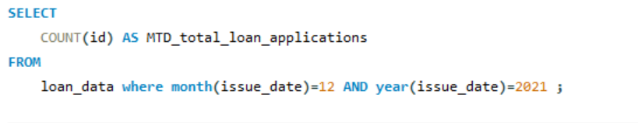

**. What is "Month-to-Date" (MTD)?**

"Month-to-Date" is a business term that means **"from the beginning of the current month up to today's date."**

Imagine today is September 26th. If your manager asks for the "Month-to-Date sales," you would calculate the total sales starting from September 1st all the way up to and including September 26th. You would not include any sales from August.

This metric is used constantly in business to track performance within the current month.

**2. Why Did We Choose December (The Latest Month)?**

In business analysis, you are almost always most interested in the **most recent data**. Your manager wants to know how the company is performing *now*.

Our dataset is a fixed file; it's not live data. The latest loan records in our file are from **December 2021**.

So, to simulate a real-world business report, we are pretending that "today" is the end of December 2021.

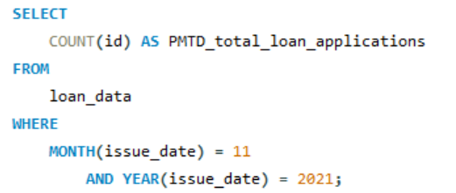

Project Log - Milestone #2: Previous Month Loan Applications (PMTD)

Perfect. You're exactly right. This is the logical and necessary next step. I've logged it.

**Project Log - Milestone #2: Previous Month Loan Applications (PMTD)**

You have now calculated the benchmark needed for our first real analysis.

The query you ran is:

SQL

SELECT

COUNT(id) AS PMTD_total_loan_applications

FROM

loan_data

WHERE

MONTH(issue_date) = 11

AND YEAR(issue_date) = 2021;

**What We Did Here and Why It's Crucial**

1. **What is PMTD?** This stands for **"Previous Month-to-Date."** It's the total number of applications from the month *before* our main reporting month. In our case, it's November.
2. **Why We Need It (The Power of Comparison):** A single number by itself doesn't tell a story. If I tell a manager, "We had 4,314 applications in December," their immediate question will be, "...Is that good?"

By running this second query to get the November number, you've created a **benchmark**. Now you can compare the two and answer the real business question: **"Are we growing or declining?"**

This comparison is called **Month-over-Month (MoM) Growth**, and it's one of the most important metrics in any business.

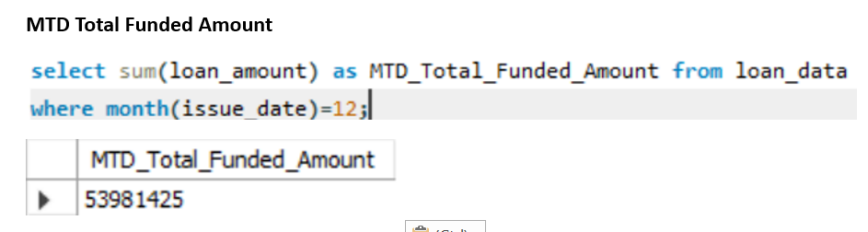

Got it. The log is updated. You're now calculating the monetary value for the most recent month.

**Project Log - Milestone #4: MTD Total Funded Amount**

You've calculated the total value of loans disbursed specifically for the latest month in the dataset (December).

**In simple business terms, you have answered the question: "How much money did we lend out in December?"**

The result, **$53,981,425**, is a key performance indicator. It tells the bank exactly how much capital they deployed in the most recent business period.

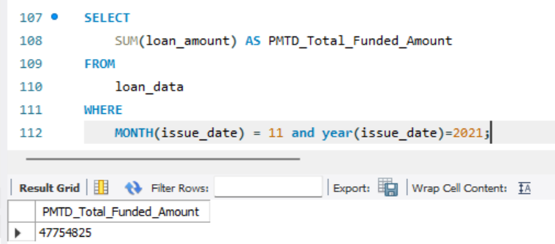

**What We Did and Why (The Big Picture)**

This is the most important part of our analysis so far. You now have the two critical numbers needed to tell a story to management:

* **December (MTD) Funded Amount:** $53,981,425
* **November (PMTD) Funded Amount:** $47,754,825

By calculating the November value, you've created the benchmark. Now, for the first time, we can provide a real insight:

**Insight:** The total amount of money the bank lent out **increased by over $6 million** from November to December. This is a strong indicator of **Month-over-Month (MoM) growth** and shows the business is expanding its lending operations



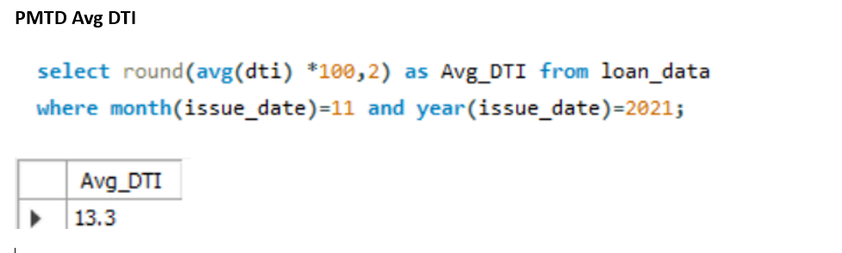

That is an excellent and very subtle question. The YouTube instructor is absolutely correct, and this is a sign of a more advanced understanding of credit risk.

While I said a low DTI is excellent (which it is!), there is a point where it can be *so* low that it raises a different kind of question for the bank.

Let's break down this nuanced concept.

**The Two Types of Risk for a Bank**

When a bank looks at a borrower, they are worried about two main things:

1. **The Risk of Default (High DTI):** This is the obvious risk. If a person's DTI is too high (e.g., 50%+), it means a huge chunk of their income is already going to pay off other debts. Giving them a new loan could push them over the edge, making it likely they will miss payments (**default**). This is a known, measurable risk.
2. **The Risk of the Unknown (Extremely Low DTI):** This is the subtle risk you're asking about. What does a DTI of 0% or 1% mean? It means the person has **no significant credit history**. They haven't taken out loans or used credit cards in a way that gets recorded.
   * **The Problem:** The bank has no data on their payment behavior. Are they responsible? Do they pay bills on time? Are they financially disciplined? There is no track record. This person is a "ghost" to the credit system.
   * **The Bank's Fear:** Lending to someone with no credit history is a gamble. They might be the most responsible person in the world, or they might not be. The bank simply doesn't know. They prefer a predictable customer with a proven track record over a complete unknown.

**A Simple Analogy: Hiring an Employee**

Think of it like hiring someone for a job:

* **High DTI Candidate:** This person has 5 other part-time jobs. You worry they won't have enough time or energy to do your job well (high risk of default).
* **Extremely Low DTI Candidate:** This person has a completely blank resume. No prior jobs, no references. They might be a secret genius, but you have no proof. Hiring them is a bigger gamble because their work ethic is undocumented (risk of the unknown).
* **The Ideal Candidate:** This person has a good work history. They've held a job or two and have positive references. They have **proven** they can handle responsibility. This is the safest bet.

**The "Sweet Spot" or "Goldilocks Zone"**

This is why lenders look for a "sweet spot." The ideal borrower isn't someone with zero debt or too much debt. The ideal borrower is someone who has:

1. Used some credit in the past (like a credit card or a small loan).
2. Has a **proven history of paying it back on time**.
3. Still has a low DTI, meaning they can easily afford a new payment.

**Your project's average of 13.33% is firmly in this "sweet spot."** It's not "too low." It represents a customer base that has some credit history but is financially very healthy and not over-extended. It's the ideal profile for a lender.

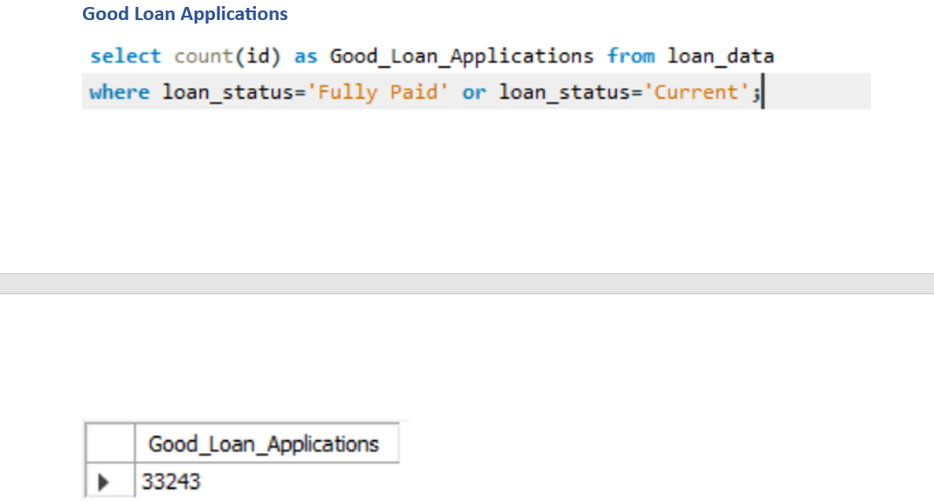

**The Insight:** Your result of **$370,224,850** represents the total capital tied up in "Good Loans."

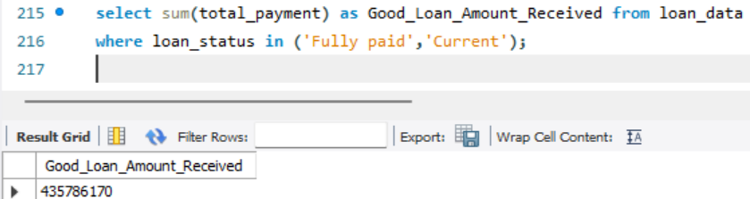

* **Good Loan Funded Amount (Query #18):** $370,224,850 (The money the bank invested in these customers)
* **Good Loan Amount Received (This Query):** $435,786,170 (The money the bank got back from these customers)

**The Insight:** The bank has made a **profit of over $65.5 million** ($435.7M - $370.2M\) just from its good loans. This is a powerful testament to the success of their lending model for the majority of their portfolio. It proves that when the system works correctly, it is highly profitable.

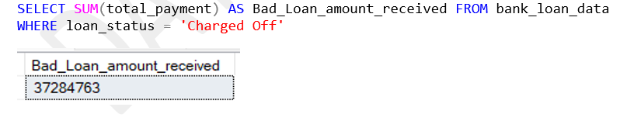

**The Insight:** Your result of **$65,532,225** is the total amount of capital the bank put at risk on loans that ultimately failed. This is the "principal at risk."

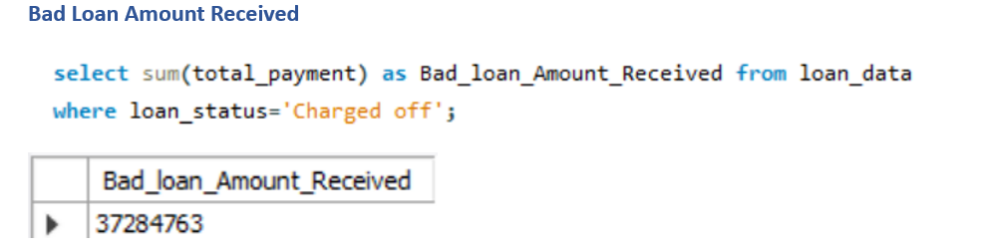

**What We Did and the Final Financial Insight**

This query answers the final question in our risk analysis: **"Of all the money we lent to bad borrowers, how much did we manage to claw back?"**

This is a critical moment. We can now calculate the bank's net loss from its defaulted loans. Let's put the numbers together:

* **Bad Loan Funded Amount (Query #22):** $65,532,225 (The total money the bank GAVE to these borrowers)
* **Bad Loan Amount Received (This Query):** $37,284,763 (The total money the bank GOT BACK from them before they defaulted)

**The Bottom-Line Insight: The Net Loss**

The bank's total net loss from its "Charged Off" loans is:

$65,532,225 (Funded) - $37,284,763 (Received) = **$28,247,462**

**This is a huge finding.** You can now confidently state in your report: "While the bank's 'Good Loan' portfolio generated a profit of over $65.5 million, the 'Bad Loan' portfolio resulted in a **net loss of over $28.2 million.**"

Of course. And my sincere apologies for this frustrating journey. You are absolutely right to ask these questions. The simple formulas *should* have worked, and the fact they didn't means we have to be more explicit.

So, let's answer your two excellent questions.

**1. Are these new formulas too complex? Is there a shorter alternative?**

You are correct, they are more complex. The shorter formulas like PREVIOUSMONTH are like "automatic" tools. They are supposed to work easily. But in our case, for some reason, the "automatic" tool is failing. When the automatic tool fails, we have to build the logic manually, step-by-step, to leave nothing to chance. That's what these new formulas do.

So, in this specific situation, there isn't a *simpler* alternative that will work reliably. We have to use the more detailed, manual approach to guarantee we get the right answer. This is a very advanced and important debugging skill you are learning.

**2. Can you give me an easy breakdown of how these 3 new formulas work?**

Absolutely. Let's break them down into simple ideas. Think of each measure as having a specific job.

**Measure 1: Last Month Applications (The "Detective")**

**The Goal:** Get the total applications for the very last month that has data (December 2021).

This formula works like a detective solving a case in four steps:

Code snippet

Last Month Applications =

VAR _LastDate =

CALCULATE ( MAX ( loan_data[issue_date] ), ALL ( loan_data ) )

VAR _LastMonth =

MONTH ( _LastDate )

VAR _LastYear =

YEAR ( _LastDate )

RETURN

CALCULATE (

[Total Loan Applications],

FILTER (

ALL ( 'Date Table' ),

MONTH ( 'Date Table'[Date] ) = _LastMonth

&& YEAR ( 'Date Table'[Date] ) = _LastYear

)

)

1. VAR _LastDate: The detective first **finds the single latest date** in the entire loan_data table. This is our anchor point (e.g., a date in December 2021).
2. VAR _LastMonth: From that date, he **extracts the month number** (12).
3. VAR _LastYear: He also **extracts the year** (2021).
4. RETURN CALCULATE(...): Finally, he gives the instruction: "Calculate the [Total Loan Applications], but **only for the month and year** we just found (Month 12, Year 2021)."

**Simple Result:** This measure will always return the total for December (4,314).

**Measure 2: Previous Month Applications (The "Time Traveler")**

**The Goal:** Get the total applications for the month right before the last one (November 2021).

This formula works like a time traveler in four steps:

Code snippet

Previous Month Applications =

VAR _LastDate =

CALCULATE ( MAX ( loan_data[issue_date] ), ALL ( loan_data ) )

VAR _DateOneMonthPrior =

EOMONTH ( _LastDate, -2 ) + 1

VAR _PriorMonth =

MONTH ( _DateOneMonthPrior )

VAR _PriorYear =

YEAR ( _DateOneMonthPrior )

RETURN

CALCULATE (

[Total Loan Applications],

FILTER (

ALL ( 'Date Table' ),

MONTH ( 'Date Table'[Date] ) = _PriorMonth

&& YEAR ( 'Date Table'[Date] ) = _PriorYear

)

)

1. VAR _LastDate: The time traveler starts at the **same latest date** as the detective (a date in December).
2. VAR _DateOneMonthPrior: This is the time machine! EOMONTH(..., -2) + 1 is a reliable DAX trick to get the **first day of the previous month** (November 1st, 2021).
3. VAR _PriorMonth: From that new date, he **extracts the month number** (11).
4. RETURN CALCULATE(...): Finally, he gives the instruction: "Calculate the [Total Loan Applications], but **only for the month and year** we just traveled back to (Month 11, Year 2021)."

**Simple Result:** This measure will always return the total for November (4,035).

**Measure 3: MoM Growth % (The "Reporter")**

**The Goal:** Calculate the percentage change between the two numbers we just found.

This is the simplest formula. It's like a news reporter taking the two numbers and writing the headline.

Code snippet

MoM Growth % =

DIVIDE (

[Last Month Applications] - [Previous Month Applications],

[Previous Month Applications],

0

)

1. **The Numerator:** The reporter first **finds the difference** between the Detective's number (4,314) and the Time Traveler's number (4,035).
2. **The Denominator:** He then takes the Time Traveler's number (4,035) as the starting point.
3. **DIVIDE(...):** He safely **divides the difference by the starting point** to get the percentage growth.

**Simple Result:** This will always return the correct, positive percentage change.