Statistics — Interview Questions & Answers
Q1. 🔴 What is Statistics, and why is it important in Data Science?
Answer
Statistics is the science of collecting, organizing, analyzing, interpreting, and presenting data to identify patterns and draw meaningful conclusions.
Statistics is important in Data Science because it helps us:
- understand and summarize data,
- identify patterns and relationships,
- measure variability and uncertainty,
- make conclusions about a population using samples,
- test assumptions using hypothesis testing,
- evaluate models and experiments, and
- make data-driven decisions.
Example
Suppose an e-commerce company has customer transaction data. Statistics can help determine:
- average customer spending,
- variation in spending,
- relationships between customer age and spending,
- whether a new marketing campaign significantly increased sales.
🎯 Interview-ready answer
Statistics is the science of collecting, organizing, analyzing, interpreting, and presenting data to identify patterns and draw meaningful conclusions. In Data Science, it helps us understand data, quantify uncertainty, test hypotheses, identify relationships between variables, and make data-driven decisions.

Q2. 🔴 What is the difference between Descriptive and Inferential Statistics?
This is directly covered in your course interview PDF.
Answer
Descriptive statistics summarizes and describes the data that we have observed.
Examples:
Mean, Median, Mode, Variance, Standard DeviationMean,\ Median,\ Mode,\ Variance,\ Standard\ Deviation
Inferential statistics uses sample data to make estimates or draw conclusions about a larger population.
Examples:
- confidence intervals,
- hypothesis testing,
- z-tests,
- t-tests,
- chi-square tests.
Descriptive Statistics | Inferential Statistics
Describes observed data | Draws conclusions about a population
Summarizes data | Generalizes from sample to population
Mean, median, mode | Confidence intervals, hypothesis tests
Variance, SD, skewness | z-test, t-test, chi-square test
🎯 Interview-ready answer
Descriptive statistics is used to summarize and describe the characteristics of observed data using measures such as mean, median, variance, and standard deviation. Inferential statistics uses sample data to make estimates, predictions, or conclusions about a larger population.

Q3. 🔴 Give a real-world example of Descriptive and Inferential Statistics.
Answer
Suppose a company has 100,000 customers, and we survey 1,000 customers.
We find that the average monthly spending of those 1,000 customers is:
₹2,500₹2,500
Descriptive
If we say:
The average spending of the 1,000 surveyed customers is ₹2,500.
we are simply describing the collected data.
Therefore, this is:
Descriptive Statistics\boxed{Descriptive\ Statistics}
Inferential
If we use those 1,000 customers to estimate:
The average monthly spending of all 100,000 customers is approximately ₹2,500.
we are generalizing from a sample to the population.
Therefore:
Inferential Statistics\boxed{Inferential\ Statistics}
🎯 Interview-ready answer
Suppose a company surveys 1,000 customers. Calculating the average spending of those 1,000 customers is descriptive statistics. If we use that sample to estimate the average spending of all the company's customers, that becomes inferential statistics.

Q4. 🔴 What is the difference between Population and Sample?
Answer
A population is the entire group of individuals, objects, or observations that we are interested in studying.
A sample is a subset of that population selected for analysis.
Example
Suppose we want to determine the average salary of software engineers in India.
Population:
All software engineers in India\text{All software engineers in India}
Sample:
5,000 selected software engineers\text{5,000 selected software engineers}
We analyze the sample because studying every member of a population can be expensive, time-consuming, or impractical.
🎯 Interview-ready answer
A population is the complete group about which we want to draw conclusions, whereas a sample is a subset of that population selected for analysis. We often study a representative sample when analyzing the entire population is impractical.

Q5. 🔴 What is the difference between a Parameter and a Statistic?
This is closely connected to population vs sample.
Answer
A parameter is a numerical value that describes a population.
A statistic is a numerical value calculated from a sample.
For example:
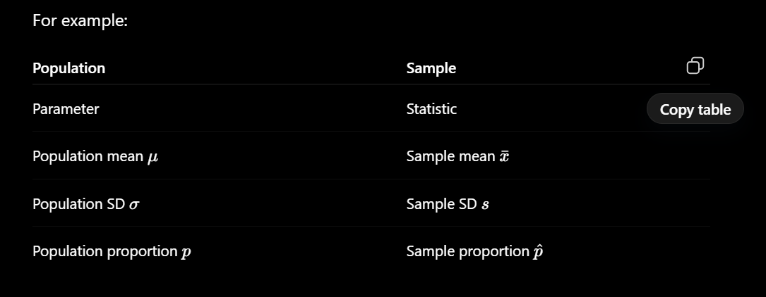
Example
Suppose the actual average salary of all employees in a company is:
μ=₹60,000\mu = ₹60,000
That is a parameter.
We select 100 employees and calculate:
xˉ=₹58,500\bar{x}=₹58,500
That is a statistic.
We may then use the statistic xˉ\bar{x} to estimate the unknown parameter μ\mu.
🎯 Interview-ready answer
A parameter is a numerical characteristic of an entire population, whereas a statistic is a numerical characteristic calculated from a sample. For example, the population mean μ\mu is a parameter, while the sample mean xˉ\bar{x} is a statistic.
🧠 Easy trick
Population→Parameter\boxed{Population \rightarrow Parameter} Sample→Statistic\boxed{Sample \rightarrow Statistic}
Both start with the same letter: P–P and S–S.

Q6. 🟡 Can Descriptive Statistics be performed on a very large dataset?
Answer
Yes, absolutely.
Descriptive statistics is not defined by dataset size.
This is important because your handwritten notes roughly associate:
Descriptive → small data
Inferential → large data
Don't use that distinction in an interview.
You can have a dataset containing 10 million transactions and calculate:
- mean transaction value,
- median transaction value,
- standard deviation,
- minimum and maximum,
- quartiles,
- frequency distributions.
That's still descriptive statistics because we're describing the observed dataset.
🎯 Interview-ready answer
Yes. Descriptive statistics can be applied to datasets of any size. The distinction between descriptive and inferential statistics is not based on dataset size. Descriptive statistics summarizes observed data, while inferential statistics uses sample data to make conclusions about a larger population.

Q7. 🟡 When would you use Inferential Statistics instead of Descriptive Statistics?
This is also directly asked in your course PDF.
Answer
We use inferential statistics when we want to go beyond simply describing the available data and make conclusions about a larger population using a sample.
It is particularly useful when studying the entire population is:
- too expensive,
- too time-consuming,
- impractical,
- or impossible.
Example
Suppose a company wants to know whether customers prefer a new website design.
It has:
5,000,000 customers5,000,000\ customers
Instead of asking every customer, the company studies a representative sample and uses statistical methods to determine whether the observed preference is likely to exist across the larger customer population.
That's inferential statistics.
🎯 Interview-ready answer
I would use inferential statistics when I have sample data and want to make estimates or draw conclusions about a larger population. It is especially useful when collecting data from the entire population is impractical, expensive, or time-consuming.

⭐ What I Would Memorize for Interviews
Don't memorize every paragraph above word-for-word. Make sure these relationships are crystal clear:
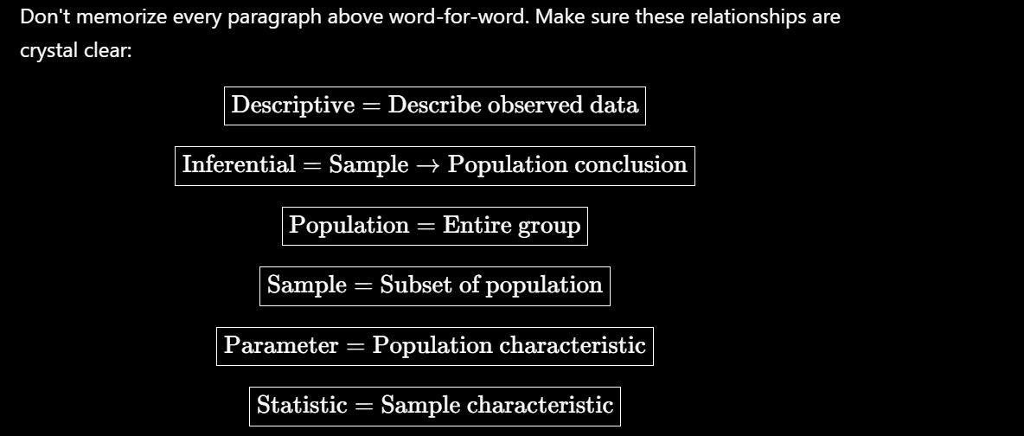

📘 Statistics Interview Questions
Sampling — Q8 to Q17
Q8. 🔴 What is sampling, and why is it important in statistics?
Answer:
Sampling is the process of selecting a subset of observations or individuals from a larger population to study and draw conclusions about that population.
Sampling is important because studying the entire population may be:
- expensive,
- time-consuming,
- difficult,
- or practically impossible.
A properly selected and representative sample allows us to make reliable conclusions about the population using less time and resources.
Example: If a company has 1 million customers, instead of surveying every customer, it may survey 5,000 representative customers and use their responses to understand overall customer satisfaction.
Interview-ready answer:
Sampling is the process of selecting a representative subset of a population for analysis. It is important because analyzing an entire population may be expensive, time-consuming, or impractical, so a properly selected sample allows us to make inferences about the population efficiently.

Q9. 🔴 What are the different sampling techniques?
This corresponds directly to a question in your PDF.
Answer:
Sampling techniques can broadly be divided into:
1. Probability Sampling: Every population member has a known, non-zero probability of being selected.
Important methods:
- Simple Random Sampling
- Stratified Sampling
- Cluster Sampling
- Systematic Sampling
2. Non-Probability Sampling: Selection is not based purely on randomization, and the probability of each member being selected is generally unknown.
Examples from/around your notes include:
- Convenience sampling
- Quota sampling
- Accidental sampling
For your interviews, the four probability techniques are the priority.
Interview-ready answer:
Sampling techniques are broadly divided into probability and non-probability sampling. Important probability methods include simple random, stratified, cluster, and systematic sampling. Non-probability methods include convenience and quota sampling.

Q10. 🔴 Explain Simple Random Sampling with an example.
Answer:
Simple Random Sampling (SRS) is a probability sampling technique in which every member of the population has an equal chance of being selected.
Example: Suppose a university has 10,000 students and we need a sample of 500 students. We randomly select 500 student IDs from the complete list.
Each student has an equal chance of selection.
Advantages:
- Simple to understand.
- Reduces deliberate selection bias.
- Works well when the population is relatively homogeneous and a complete sampling frame is available.
Limitation: Smaller subgroups may be underrepresented simply due to random chance.
Interview-ready answer:
Simple Random Sampling is a probability sampling technique in which every member of the population has an equal chance of selection. For example, randomly selecting 500 student IDs from a university containing 10,000 students is simple random sampling.

Q11. 🔴 What is the difference between Simple Random Sampling and Stratified Sampling?
This is specifically Q10 in your course PDF.
Answer:
In Simple Random Sampling, individuals are randomly selected directly from the entire population.
In Stratified Sampling, the population is first divided into meaningful subgroups called strata, and random samples are taken from each stratum.
Simple Random | Stratified
Population treated as one group | Population divided into strata
Random selection from entire population | Random selection within each stratum
Subgroups can be underrepresented by chance | Ensures representation of important subgroups
Simpler | Requires knowledge of strata
Example: Suppose a company has Engineering, HR, Finance and Sales departments.
SRS → randomly select employees from the entire company.
Stratified → divide employees by department and randomly select employees from each department.
Interview-ready answer:
In simple random sampling, individuals are randomly selected directly from the entire population. In stratified sampling, the population is first divided into relevant subgroups or strata, and random samples are selected from each stratum. Stratified sampling is useful when we want to ensure representation of important subgroups.

Q12. 🔴 What is the difference between Stratified Sampling and Cluster Sampling?
Answer:
This is one of the easiest sampling concepts to confuse.
Stratified Sampling
Divide the population into strata and select some individuals from every stratum.
Some from ALL\boxed{\text{Some from ALL}}
Cluster Sampling
Divide the population into clusters, randomly select some clusters, and in basic one-stage cluster sampling include all individuals from those selected clusters.
ALL from SOME\boxed{\text{ALL from SOME}}
Example:
Suppose we want to survey school students across a city.
Stratified: Divide students by grade and randomly select students from every grade.
Cluster: Treat schools as clusters, randomly select a few schools and survey all students in those selected schools.
Interview-ready answer:
In stratified sampling, we divide the population into strata and sample individuals from every stratum to ensure representation. In cluster sampling, we divide the population into natural clusters, randomly select some clusters, and typically study all individuals within the selected clusters in one-stage cluster sampling.
🧠 Remember:
Stratified=Some from All\boxed{Stratified = Some\ from\ All} Cluster=All from Some\boxed{Cluster = All\ from\ Some}

Q13. 🟡 Explain Cluster Sampling and when you would use it.
This is explicitly asked in your PDF.
Answer:
Cluster sampling divides the population into naturally occurring groups called clusters. Some clusters are randomly selected for study.
It is particularly useful when the population is geographically dispersed and collecting observations across the entire population would be expensive or difficult.
Example: Suppose researchers want to survey students throughout India. Schools can be treated as clusters. Instead of visiting every school, researchers randomly select certain schools and collect data from those selected schools.
Interview-ready answer:
Cluster sampling divides a population into natural groups called clusters and randomly selects some of those clusters for analysis. It is useful when the population is geographically dispersed because it can reduce data-collection cost, travel, and logistical complexity.

Q14. 🟡 What is Systematic Sampling? What are its advantages and disadvantages?
Your PDF specifically asks for advantages and disadvantages of systematic sampling.
Answer:
Systematic sampling selects observations at a fixed interval after choosing a random starting point.
The sampling interval is:
k=Nnk=\frac{N}{n}
where:
- NN = population size
- nn = desired sample size
- kk = sampling interval
Example:
Population:
N=1000N=1000
Required sample:
n=100n=100
Therefore:
k=1000100=10k=\frac{1000}{100}=10
If the random starting point is 7:
7,17,27,37,47,…7,17,27,37,47,\ldots
are selected.
Advantages: It is simple, quick and easy to implement, especially with an ordered list.
Disadvantage: If the data contains a periodic pattern that matches the sampling interval, the resulting sample may be biased.
Interview-ready answer:
Systematic sampling selects every kthk^{th} observation after choosing a random starting point, where k=N/nk=N/n. It is simple and efficient, but it can introduce bias if the population has a periodic pattern that aligns with the sampling interval.

Q15. 🔴 What is Sampling Bias?
Answer:
Sampling bias occurs when the method used to select a sample causes certain members of the population to be systematically more or less likely to be included, resulting in a sample that does not properly represent the population.
Example: Suppose a company wants to measure satisfaction among all customers, but surveys only its premium customers.
Premium customers may have a different experience from regular customers.
Therefore:
Biased Sample→Misleading ConclusionBiased\ Sample \rightarrow Misleading\ Conclusion
Interview-ready answer:
Sampling bias occurs when the sampling process systematically overrepresents or underrepresents certain groups in the population, causing the sample to be unrepresentative and potentially leading to misleading conclusions.

Q16. 🟡 What is the difference between Probability and Non-Probability Sampling?
Answer:
Probability Sampling
Selection involves randomization, and each population member has a known, non-zero chance of selection.
Examples:
- Simple Random
- Stratified
- Cluster
- Systematic
Non-Probability Sampling
Selection is not based on a random mechanism, and individual selection probabilities are generally unknown.
Examples:
- Convenience
- Quota
Probability Sampling | Non-Probability Sampling
Uses random selection | Does not require random selection
Selection probability is known/non-zero | Selection probability generally unknown
Better suited for statistical inference | More prone to selection bias
Usually more rigorous | Often faster/easier
Example: Randomly selecting 1,000 customers from a customer database is probability sampling. Interviewing whichever customers happen to be standing near a store entrance is convenience/non-probability sampling.
Interview-ready answer:
Probability sampling uses random selection so population members have known, non-zero probabilities of selection. Non-probability sampling does not rely on random selection, so selection probabilities are generally unknown and the sample is more vulnerable to selection bias.

Q17. 🟡 When would you prefer Stratified Sampling over Simple Random Sampling?
Answer:
I would prefer stratified sampling when the population contains important subgroups that differ from one another and I want to ensure that those groups are adequately represented in the sample.
Example: Suppose a company consists of:
- 70% Engineering
- 15% Sales
- 10% Finance
- 5% HR
With simple random sampling, the relatively small HR group could be poorly represented by chance.
With stratified sampling, we divide employees by department and sample from each group.
Therefore, stratified sampling is useful when subgroup representation matters.
Interview-ready answer:
I would prefer stratified sampling when the population contains distinct and important subgroups and I want to ensure representation from each group. For example, when surveying employees across different departments, stratified sampling can ensure that even smaller departments are represented.

✅ Interview Question Tracker
We've now completed:
Q1–Q7: Introduction to Statistics, Descriptive/Inferential, Population/Sample, Parameter/Statistic.
Q8–Q17: Sampling and Sampling Techniques.

