ABSTRACT

This report presents the design and implementation of a comprehensive data-driven system developed during an internship at Varid Computing Services (India) Private Limited (VaridX), integrating data analytics, machine learning, and backend validation to address real-world business challenges. The project focuses on building an end-to-end data analytics pipeline for logistics and customer data, utilizing API-based data extraction, Python-based ETL processes, PostgreSQL database storage, and interactive Power BI dashboards to enable near real-time monitoring of delivery performance, operational efficiency, and customer behavior. In addition, a machine learning-based customer segmentation and predictive analytics system was developed using K-Means clustering and an XGBoost classifier, supported by a complete pipeline including data validation, feature engineering, transformation, dimensionality reduction, model training, and deployment through a FastAPI-based interface. A key highlight of the project is the integration of unit testing and backend validation as a core component throughout the development lifecycle, implemented using Python’s unittest framework and mocking techniques to ensure correctness, reliability, and robustness of complex business logic, including data processing, time-based operations, and asynchronous tasks. The system enables critical business insights such as delivery efficiency tracking, identification of operational bottlenecks, and data-driven decision-making, while demonstrating scalability, maintainability, and production readiness. Overall, the project reflects a practical and industry-oriented implementation of modern data engineering and machine learning techniques, emphasizing continuous validation and real-time analytics in a production-level environment.

ACKNOWLEDGEMENT

I have made sincere efforts in completing this project. However, it would not have been possible without the valuable support and guidance of many individuals. I would like to express my heartfelt gratitude to all of them.
I am highly indebted to my Internal Guide, Avani Khokhariya, for her continuous guidance, valuable suggestions, and constant supervision, as well as for providing essential support throughout the project work.
I would also like to express my sincere thanks to my External Guide, Yash Pal from Varid Computing Services (India) Private Limited (VaridX), for providing me with the opportunity to work on real-time industry projects and for his continuous support, guidance, and valuable inputs during my internship. His insights into practical system development, data analytics, and backend validation significantly contributed to the successful completion of this project.
I extend my gratitude to the Head of Department, Dr. Amit Thakkar, and all the faculty members of Chandubhai S. Patel Institute of Technology for their cooperation, encouragement, and academic support throughout the project work and report preparation.
I would also like to thank my friends and classmates for their cooperation, valuable suggestions, and support throughout the project. Their discussions and feedback helped in improving the overall quality of this work.
Last but not least, I express my deepest gratitude to my family for their continuous support, encouragement, and motivation throughout my academic journey.

“Success is the result of guidance, hard work, and perseverance.”

Pranav Patel (22CS060)

TABLE OF CONTENT

ABSTRACT iv
ACKNOWLEDGEMENT v
TABLE OF CONTENT vi
List of Figures viii
List of Tables ix
CHAPTER 1: INTRODUCTION 1
1.1 PROJECT SUMMARY 1
1.2 PURPOSE 1
1.3 OBJECTIVE 2
1.4 SCOPE 3
1.5 TECHNOLOGIES AND LITERATURE REVIEW 4
CHAPTER 2: PROJECT MANAGEMENT 6
2.1 PROJECT PLANNING 6
2.1.1 Project Development approach and Justification 6
2.1.2 Project Effort and Time, Cost Estimation 7
2.1.3 Roles and Responsibilities 7
2.2 PROJECT SCHEDULING 8
CHAPTER 3: SYSTEM REQUIREMENTS STUDY 10
3.1 USER CHARACTERISTICS 10
3.1.1 Use Case Diagram 11
3.2 HARDWARE & SOFTWARE REQUIREMENTS 11
3.3 Assumptions & Constraints 12
CHAPTER 4: SYSTEM ANALYSIS 14
4.1 STUDY OF EXISTING SYSTEMS 14
4.2 PROBLEM AND WEAKNESS OF CURRENT SYSTEM 14
4.3 REQUIREMENT OF PURPOSED SYSTEM 15
4.3.1 Function requirements 16
4.3.2 Non-functional requirements 17
4.4 SYSTEM WORKFLOW 17
4.5 STATE DIAGRAM 19
4.6 ACTIVITY DIAGRAM 20
4.7 SEQUENCE DIAGRAM 22
CHAPTER 5: SYSTEM DESIGN 24
5.1 SYSTEM APPLICATION DESIGN 24
5.2 INPUT/OUTPUT AND INTERFACE DESIGN 25
5.3 DATA DICTIONARY 28
5.4 METHOD PSEUDO CODE 29
CHAPTER 6:IMPLEMENTATION PLANNING AND TESTING 30
6.1 CODING STANDARDS 30
6.2 TESTING METHODS 30
6.3 TEST SUITES DESIGN 31
6.4 TEST CASES 32
CHAPTER 7: CONCLUSION 32
7.1 SELF ANALYSIS OF PROJECT VIABILITIES 33
7.2 PROBLEMS ENCOUNTERED AND THEIR SOLUTION 33
7.3 SUMMARY OF THE PROJECT 34
CHAPTER 8:LIMITATIONS & FUTURE ENHANCEMENTS 35
REFERENCES 37

List of Figures

Figure 1 3.1(A) Use Case Diagram of Data Analytics and Dashboard System 11
Figure 2 3.1(B) Use Case Diagram of Customer Segmentation and Prediction System 11
Figure 3 4.4(A) System Workflow of Data Analytics and Dashboard System 18
Figure 4 4.4(B) System Workflow of Customer Segmentation and Prediction System 18
Figure 5 4.5(A) State Diagram of Data Analytics and Dashboard System 19
Figure 6 4.5(B) State Diagram of Customer Segmentation and Prediction System 19
Figure 7 4.6(A) Activity Diagram of Data Analytics and Dashboard System 20
Figure 8 4.6(B) Activity Diagram of Customer Segmentation and Prediction System 21
Figure 9 4.7(A) Sequence Diagram of Data Analytics and Dashboard System 22
Figure 10 4.7(B) Sequence Diagram of Customer Segmentation and Prediction System 23
Figure 11 5.1 Kobo Collection PipeLine 24
Figure 12 5.2 Kobo Question API Result Stored in MongoDb 24
Figure 13 5.3 Kobo Answer API Result Stored in MongoDb 24
Figure 14 5.4 Log table in MongoDb 25
Figure 15 5.5 API Hosted on both local and company server 25
Figure 16 5.6 Transfer API that transfers records from MongoDB to MSSQL Server 26
Figure 17 5.7 Record/Detail Endpoint 26
Figure 18 5.8 NL to SQL Chatsystem 26
Figure 19 5.9 Fast API of NL to SQL Chatsystem 27
Figure 20 5.10 Result of NL to SQL Chatsystem 27
Figure 21 5.11 Graph Visulisation 27
Figure 22 5.12 Household's Table/Data Dictionary in Company Server 28
Figure 23 5.13 Member's Table/Data Dictionary in Company Server 28
Figure 24 5.14 Ask Endpoint 29
Figure 25 5.15 Transfer Endpoint 29

List of Tables

Table 17.3.1 Test Suites Design 23

CHAPTER 1: INTRODUCTION

1.1 PROJECT SUMMARY

The project titled “Data-Driven Analytics for Pharmacy Supply Chain Operations at eBoxchain” was developed during an internship at Varid Computing Services (India) Private Limited. The primary aim of this project is to design and implement a scalable and efficient data-driven system capable of handling real-time logistics and customer data. The system follows a structured end-to-end pipeline that includes API-based data extraction using secure token authentication, data processing and transformation using Python (Pandas), storage in a PostgreSQL database, and visualization through interactive Power BI dashboards. These dashboards provide insights into key operational metrics such as order volume, delivery performance, cancellation trends, and transporter efficiency, enabling effective monitoring and decision-making.
In addition to the analytics component, the project incorporates a machine learning-based system for customer segmentation and predictive analysis. K-Means clustering is used to identify meaningful customer groups, which are further utilized to train an XGBoost model for accurate prediction of customer segments. The project also emphasizes the integration of unit testing and backend validation as a core part of the development process. Using Python’s unittest framework along with mocking techniques, the system ensures correctness of business logic, proper handling of edge cases, and overall system reliability. This integrated approach highlights the practical application of data engineering, analytics, and machine learning techniques in a real-world industry environment, with a strong focus on scalability, accuracy, and robustness.

1.2 PURPOSE

The purpose of this project is to develop a comprehensive and data-driven system for analyzing and optimizing pharmacy supply chain operations at eBoxchain. In modern supply chain environments, large volumes of operational data are generated continuously, but without proper processing and analysis, this data cannot be effectively utilized for decision-making. This project aims to bridge that gap by designing a structured pipeline that transforms raw data into meaningful insights through data engineering, analytics, and visualization techniques.
Another key purpose of the project is to enable real-time monitoring of critical operational metrics such as order processing, delivery performance, inventory movement, and supply chain efficiency. By integrating Power BI dashboards with a robust backend data pipeline, the system allows stakeholders to track performance, identify delays, detect inefficiencies, and make informed decisions to improve overall operations. This contributes to enhanced transparency and operational control within the pharmacy supply chain.
In addition, the project aims to incorporate machine learning techniques to support predictive analytics and customer segmentation. By analyzing historical data and identifying patterns, the system assists in forecasting trends and improving business strategies. Furthermore, a significant purpose of this work is to ensure system reliability and robustness through the integration of unit testing and backend validation. By validating business logic, handling edge cases, and simulating real-world scenarios, the system is designed to be stable, maintainable, and production-ready.
Overall, the purpose of this project is not only to build a technical solution but also to demonstrate the practical application of data analytics, machine learning, and software engineering principles in solving real-world industry problems.

1.3 OBJECTIVE

The main objective of this project is to design and develop a scalable and data-driven system for analyzing and optimizing pharmacy supply chain operations at eBoxchain. The project focuses on integrating data engineering, analytics, machine learning, and backend validation to build a reliable and efficient solution.
The specific objectives of the project are as follows:
- To develop a complete data ingestion pipeline that extracts data from REST APIs using secure token-based authentication, handles pagination, and ensures reliable data fetching.
- To design and implement an ETL (Extract, Transform, Load) process using Python (Pandas) for data cleaning, transformation, and preparation of analytics-ready datasets.
- To create a structured PostgreSQL database for storing processed data with proper schema design, enabling efficient querying and analysis.
- To develop interactive Power BI dashboards for real-time visualization of key performance indicators such as order volume, delivery rate, cancellation trends, and operational efficiency.
- To implement a machine learning-based system using K-Means clustering for customer segmentation and XGBoost for predictive analysis of customer behavior.
- To perform feature engineering and data transformation techniques to improve model performance and analytical insights.
- To integrate unit testing and backend validation using Python’s unittest framework and mocking techniques to ensure correctness, reliability, and robustness of the system.
- To handle edge cases, error conditions, and asynchronous operations to ensure system stability and production readiness.
- To enable data-driven decision-making by providing meaningful insights into supply chain performance and operational bottlenecks.

1.4 SCOPE

The scope of this project includes the design and implementation of an end-to-end data-driven system for analyzing pharmacy supply chain operations at eBoxchain. The system covers the complete pipeline starting from data extraction through REST APIs, data processing and transformation using Python-based ETL techniques, storage in a PostgreSQL database, and visualization through interactive Power BI dashboards. It enables real-time monitoring of key operational metrics such as order flow, delivery performance, cancellation trends, and transporter efficiency. Additionally, the project incorporates a machine learning component for customer segmentation and predictive analytics using K-Means clustering and XGBoost algorithms. The system is further strengthened by integrating unit testing and backend validation to ensure reliability, correctness, and stability of the application in a production-like environment.
The system is capable of performing automated data ingestion, incremental data updates, feature engineering, and generation of analytical insights through dashboards. It supports decision-making by identifying patterns, trends, and operational bottlenecks within the supply chain. The backend is designed to handle structured data processing, validation, and error handling, making it scalable and maintainable.
However, the scope of the project is limited to analytics, prediction, and monitoring functionalities. The system does not perform real-time control of supply chain operations such as inventory management, order execution, or direct intervention in logistics processes. It is not designed as a full enterprise resource planning (ERP) system and does not include advanced deployment features such as cloud-based scalability, distributed processing, or large-scale real-time streaming. Additionally, the machine learning models are trained on available historical data and may require further tuning and retraining for different datasets or production environments.

1.5 TECHNOLOGIES AND LITERATURE REVIEW

This project utilizes a combination of modern technologies and established methodologies to develop a scalable and efficient data-driven system for pharmacy supply chain analytics. Python serves as the core programming language due to its versatility in data processing, machine learning, and backend development. Libraries such as Pandas and NumPy are used for data cleaning, transformation, and numerical operations, enabling efficient handling of structured and semi-structured datasets. For machine learning, Scikit-learn and XGBoost are applied to perform customer segmentation and predictive analysis, as these algorithms are widely recognized for their performance and accuracy in real-world applications.
Data extraction is performed through REST APIs using secure token-based authentication, followed by an ETL process that transforms raw data into an analytics-ready format. The processed data is stored in a PostgreSQL database, which provides a robust and scalable environment for managing large volumes of data and performing complex queries. For visualization, Power BI is used to develop interactive dashboards that support real-time monitoring of key performance indicators such as delivery efficiency, order trends, and operational performance. Additionally, FastAPI is utilized to enable real-time machine learning predictions through a lightweight and efficient backend service, while YAML configuration enhances pipeline flexibility and maintainability.
From a research and industry perspective, modern supply chain systems heavily rely on data analytics and visualization tools to improve operational efficiency and decision-making. Machine learning techniques such as clustering and classification are commonly used for identifying patterns and predicting future outcomes. Furthermore, the integration of unit testing and backend validation using Python’s unittest framework and mocking techniques reflects current best practices in software engineering, ensuring system reliability, correctness, and maintainability. The combination of these technologies and practices demonstrates a practical implementation of an industry-oriented, data-driven system.

CHAPTER 2: PROJECT MANAGEMENT

2.1 PROJECT PLANNING

The project was planned and executed during the internship period from December 2025 to April 2026. An iterative and incremental approach was followed for planning and development, where the project was divided into multiple phases and each phase was completed progressively. At the beginning of each phase, specific goals and objectives were defined, and at the end of the phase, the outcomes were evaluated and refined based on results and feedback.
The development initially started with building a basic data pipeline for API data extraction and storage. Gradually, additional components such as data transformation, database design, and Power BI dashboard development were incorporated. As the project progressed, advanced features such as machine learning-based customer segmentation and predictive analytics were introduced. Unit testing and backend validation were integrated throughout the development lifecycle to ensure system correctness and reliability. This phased approach helped in managing complexity, improving system quality, and ensuring timely completion of the project.

2.1.1 Project Development approach and Justification

The project follows an iterative and incremental development approach, which is a key methodology under Agile practices. This approach is suitable for complex and evolving systems, as it allows development to be carried out in smaller manageable phases rather than implementing the entire system at once.
Initially, a basic version of the system was developed, focusing on core functionalities such as data ingestion and storage. In subsequent iterations, additional features such as ETL processing, dashboard visualization, machine learning models, and backend validation were progressively added and improved. This approach enabled continuous testing and validation of each component, ensuring that errors were identified and resolved at an early stage.
The iterative model also provided flexibility to incorporate improvements and optimizations based on intermediate results. For example, the ETL pipeline was refined to handle incremental data loading, dashboards were enhanced with better visualizations, and machine learning models were optimized for improved accuracy. Additionally, integrating unit testing at each stage ensured that the system remained stable and reliable throughout development.

2.1.2 Project Effort and Time, Cost Estimation

The total duration of the internship was approximately 16 weeks, during which the project was developed with consistent effort and time management. On average, 25 to 30 hours per week were dedicated to project development, learning, testing, and refinement activities.
The project development timeline can be broadly divided into phases. During the initial weeks, the focus was on understanding requirements, exploring datasets, and building a basic data ingestion pipeline using APIs. In the subsequent phase, data cleaning, transformation, and database design were implemented along with initial dashboard creation in Power BI. The next phase involved enhancing dashboards, performing feature engineering, and developing machine learning models for customer segmentation and prediction. In the final phase, emphasis was placed on backend validation, unit testing, performance optimization, and system integration.
Since the project was developed as part of an internship, no direct development cost was involved apart from time and effort investment. The tools and technologies used, such as Python, PostgreSQL, and Power BI, were either open-source or available through institutional or organizational access, making the project cost-effective.

2.1.3 Roles and Responsibilities

During the internship, I worked as a Data Science and Analytics Intern and was primarily responsible for the end-to-end development of the project. My responsibilities included designing the system architecture, developing the data pipeline, implementing machine learning models, creating dashboards, and performing testing and validation of the system.
I was involved in all major stages of the project, including data extraction from APIs, data preprocessing and transformation, database design, dashboard development, and backend validation. I also implemented unit testing strategies to ensure the correctness and reliability of the system. Continuous debugging, performance optimization, and documentation were also part of my responsibilities.
- Designed and developed the complete system architecture and data pipeline
- Implemented ETL processes, database schema, and API integrations
- Developed Power BI dashboards for data visualization and insights
- Built machine learning models for customer segmentation and prediction
- Performed unit testing, debugging, and backend validation
- Ensured system reliability, scalability, and performance
I am highly grateful to my Academic Mentor, Prof. Avani Khokhariya, for her continuous guidance, support, and valuable suggestions throughout the project. She provided insights into structuring the project and preparing the report as per university standards.
I would also like to express my sincere gratitude to my Industry Mentor, Yash Pal from Varid Computing Services (India) Private Limited, for providing industry-level guidance, practical insights, and continuous feedback. His support played a crucial role in aligning the project with real-world applications and improving its overall quality.

2.2 PROJECT SCHEDULING

The project development during the internship was systematically planned and executed over a period of approximately sixteen weeks. The entire work was divided into four major phases to ensure structured progress, timely completion, and continuous improvement of the system. Each phase focused on specific objectives, allowing gradual development of the data pipeline, analytics dashboards, machine learning models, and backend validation components.
The first phase, covering weeks one to four, focused on understanding the project requirements, analyzing the pharmacy supply chain domain, and setting up the development environment. During this phase, emphasis was placed on exploring data sources, understanding API structures, and developing an initial data ingestion pipeline. Basic data extraction using REST APIs and preliminary data processing techniques were implemented to create a foundation for further development.
The second phase, covering weeks five to eight, focused on strengthening the core system by implementing data transformation and database integration. The ETL pipeline was enhanced using Python (Pandas) for data cleaning and feature engineering, and a structured PostgreSQL database was designed for storing analytics-ready data. Additionally, initial Power BI dashboards were developed to visualize key performance indicators such as order trends and delivery performance. Attention was also given to improving data accuracy and handling inconsistencies.
The third phase, covering weeks nine to twelve, focused on system enhancement and the introduction of advanced functionalities. During this phase, Power BI dashboards were refined with improved visualizations and additional metrics for better insights. Simultaneously, the machine learning component was introduced, where K-Means clustering was used for customer segmentation and XGBoost was applied for predictive analysis. Feature engineering and data preprocessing techniques were further optimized to improve model performance.
The fourth and final phase, covering weeks thirteen to sixteen, focused on system validation, testing, and optimization. A strong emphasis was placed on implementing unit testing and backend validation using Python’s unittest framework and mocking techniques. This phase ensured that the system handled edge cases, errors, and real-world scenarios effectively. Final improvements were made to the dashboards, machine learning models, and overall system performance, followed by documentation and preparation of the project for evaluation.

CHAPTER 3: SYSTEM REQUIREMENTS STUDY

3.1 USER CHARACTERISTICS

The system developed in this project is designed to support multiple types of users involved in pharmacy supply chain operations and data analysis. The primary users of the system include business analysts, operations managers, and decision-makers who require meaningful insights from large volumes of operational data. These users primarily interact with the system through Power BI dashboards, where they can monitor key performance indicators such as order volume, delivery performance, cancellation trends, and overall supply chain efficiency. The system is designed to provide a user-friendly interface with interactive visualizations, enabling users with limited technical knowledge to easily interpret and utilize data for decision-making purposes.
Another category of users includes data analysts and technical team members who are responsible for managing and processing data. These users interact with the backend components of the system, including the ETL pipeline, database, and machine learning models. Their responsibilities include monitoring data ingestion processes, ensuring data quality, analyzing processed datasets, and maintaining system performance. They also utilize the system for running data transformations, validating outputs, and improving analytical models.
Additionally, developers and system maintainers form an important group of users who are responsible for system development, testing, and maintenance. These users interact with the system at a deeper level, including API integration, database management, and implementation of unit testing and backend validation. They ensure that the system operates reliably, handles edge cases effectively, and remains scalable and maintainable.
The system is primarily designed as an analytics and backend processing platform and does not involve direct interaction with end-users through conversational interfaces. Instead, it focuses on delivering accurate, reliable, and timely data insights that can be used by stakeholders to improve decision-making and optimize supply chain operations.

3.1.1 Use Case Diagram

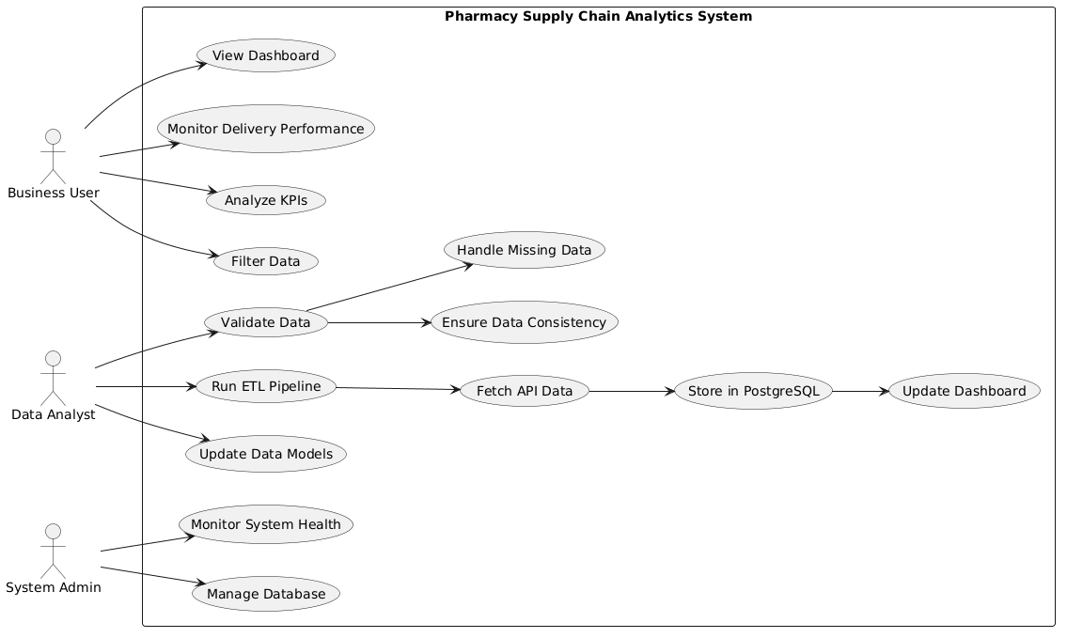
Figure 1 3.1(A) Use Case Diagram of Data Analytics and Dashboard System

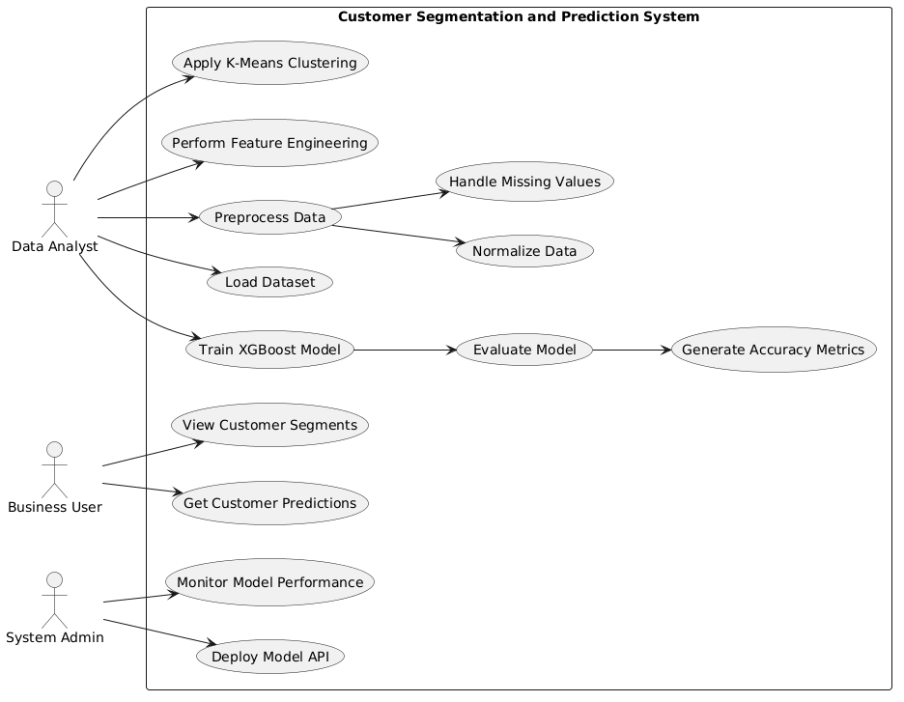
Figure 2 3.1(B) Use Case Diagram of Customer Segmentation and Prediction System

3.2 HARDWARE & SOFTWARE REQUIREMENTS

Hardware Requirements:
- Processor: Intel Core i5 or equivalent (minimum) for ETL operations and model training.
- RAM: 8 GB minimum; 16 GB recommended for large datasets and efficient machine learning.
- Storage: 20–50 GB free space minimum for datasets, databases, and project resources.
- Connectivity: Stable internet connection for API data extraction and external integration.
Software requirements:
- Operating System: Windows 10/11 or Linux-based systems such as Ubuntu
- Programming Language: Python (version 3.10 or higher) for data processing, machine learning, and backend development
- Data Processing Libraries: Pandas and NumPy for data cleaning, transformation, and numerical computations
- Machine Learning Libraries: Scikit-learn and XGBoost for clustering and predictive modeling
- Database: PostgreSQL for storing structured and analytics-ready data
- Visualization Tool: Power BI for developing interactive dashboards and reports
- Backend Framework: FastAPI for building lightweight and high-performance APIs
- Development Tools: Visual Studio Code for coding and development
- Version Control: Git for managing source code and collaboration
- API Testing Tool: Postman/Swagger for testing and validating API endpoints

3.3 Assumptions & Constraints

The design and implementation of the system are based on certain assumptions and constraints that influence its functionality and performance.
Assumptions:
The system assumes that the data received from APIs is consistent and follows a predefined structure, enabling smooth data extraction and transformation. It is also assumed that the PostgreSQL database schema is properly designed and remains stable during system execution. Users interacting with the Power BI dashboards are expected to have basic knowledge of interpreting data visualizations and key performance indicators. Additionally, it is assumed that sufficient computational resources are available for executing ETL processes and machine learning models efficiently.
- Data sources provide consistent and structured data
- Database schema remains stable during operation
- Users have basic understanding of dashboards and analytics
- Required computational resources are available
Constraints:
Despite its capabilities, the system has certain limitations. The project is primarily focused on data analytics, visualization, and predictive modeling, and does not include direct control over supply chain operations such as inventory management or order execution. The accuracy of machine learning predictions depends on the quality and quantity of available data and may vary with different datasets. Additionally, the system operates in a semi-real-time environment and does not support large-scale real-time streaming or distributed processing. Data validation is performed at the application level, and any inconsistencies in source data may affect the final outputs.
- The system is limited to analytics and does not control operational processes
- Machine learning accuracy depends on data quality and availability
- No large-scale real-time streaming or distributed processing
- Data inconsistencies from source systems may impact results

CHAPTER 4: SYSTEM ANALYSIS

4.1 STUDY OF EXISTING SYSTEMS

Before the development of the proposed system, the organization primarily relied on conventional and semi-manual approaches for managing and analyzing pharmacy supply chain data. Data was collected from various sources and stored in raw formats such as spreadsheets or basic database systems. Most of the data analysis tasks were performed manually or required technical expertise, making the process time-consuming and inefficient.
Business users and operations teams depended heavily on technical personnel to extract and process data using SQL queries. This created delays in accessing critical information, especially when quick decision-making was required. Additionally, the absence of a centralized and automated data pipeline made it difficult to maintain data consistency and accuracy across the system.
Visualization of data was limited, as there were no advanced dashboarding tools integrated into the system. Reports were often generated in static formats, making it difficult to analyze trends, patterns, and key performance indicators effectively. Furthermore, there was no structured approach for monitoring delivery performance, tracking operational metrics, or identifying bottlenecks within the supply chain.
From a data processing perspective, the lack of automated ETL pipelines resulted in manual data cleaning and transformation, increasing the chances of errors and inconsistencies. Additionally, there was no integration of machine learning techniques for predictive analysis or customer segmentation, limiting the system’s ability to generate intelligent insights.

4.2 PROBLEM AND WEAKNESS OF CURRENT SYSTEM

The existing system has several limitations that affect efficiency, reliability, and decision-making capabilities. These weaknesses are described below:
The dependency on technical teams for data extraction and querying leads to delays in obtaining required information, reducing operational efficiency. Business users are unable to directly access or analyze data without technical assistance, which creates bottlenecks in the workflow.
There is no centralized and automated data processing mechanism, resulting in inconsistent data handling and increased chances of errors. Manual data cleaning and transformation processes are time-consuming and prone to inaccuracies.
The absence of interactive visualization tools limits the ability to analyze data effectively. Reports are mostly static and do not provide real-time insights, making it difficult to monitor key performance indicators such as delivery efficiency and order trends.
The system lacks predictive capabilities, as no machine learning models are implemented for customer segmentation or forecasting. This restricts the ability to make proactive and data-driven decisions.
Data validation and quality checks are not consistently applied, leading to unreliable and inconsistent data. Additionally, there is no structured mechanism for handling duplicate records or ensuring data integrity.
Overall, the existing system is not scalable, lacks automation, and does not support advanced analytics, making it insufficient for modern data-driven supply chain management.

4.3 REQUIREMENT OF PURPOSED SYSTEM

The proposed solution consists of two independent systems developed to address different aspects of data-driven operations in the organization. The first system focuses on data analytics and visualization for pharmacy supply chain operations, while the second system focuses on customer segmentation and predictive analysis using machine learning techniques. Both systems are designed to automate processes, improve decision-making, and enhance operational efficiency.
The Data Analytics Dashboard System is developed to replace manual data analysis by providing an automated pipeline and interactive dashboards. The Machine Learning System is developed to analyze customer data and generate predictive insights. In addition to these systems, unit testing and backend validation are continuously performed as part of the backend development process to ensure system reliability and correctness.

4.3.1 Function requirements

The proposed systems have been developed to achieve specific functional requirements for both analytics and machine learning components.
Data Analytics and Dashboard System:
- Extract data from REST APIs using secure authentication and handle pagination
- Perform data cleaning, transformation, and feature engineering using Python-based ETL processes
- Store processed data in a structured PostgreSQL database for efficient querying
- Generate interactive Power BI dashboards for visualization of key performance indicators
- Provide filtering, slicing, and drill-down capabilities for better data analysis
- Enable monitoring of supply chain metrics such as order volume, delivery performance, and operational efficiency
- Support incremental data loading for near real-time analytics
Machine Learning Customer Segmentation System:
- Load and preprocess customer dataset including handling missing values and normalization
- Perform feature engineering to derive meaningful attributes
- Apply K-Means clustering to segment customers into distinct groups
- Train and evaluate XGBoost model for predicting customer segments
- Provide prediction results through a backend API interface
- Generate performance metrics such as accuracy and model evaluation results
Backend Validation and Testing (Support Activity):
- Perform unit testing to validate backend logic and system functionality
- Handle edge cases, exceptions, and error scenarios effectively
- Ensure correctness of data processing and transformations
- Maintain logs for debugging and system monitoring

4.3.2 Non-functional requirements

Apart from functional requirements, the systems must satisfy certain non-functional requirements to ensure quality, performance, and maintainability.
- The system must be reliable and should handle errors without failure
- The data analytics system should provide fast and efficient dashboard loading
- The machine learning system should generate accurate and consistent predictions
- The system should be scalable to handle increasing data volume
- ETL processes should be optimized for performance and time efficiency
- Proper logging and monitoring should be implemented for tracking system behavior
- The system should ensure data security and controlled access
- The code should follow proper coding standards for maintainability
- The system should support future enhancements and integration

4.4 SYSTEM WORKFLOW

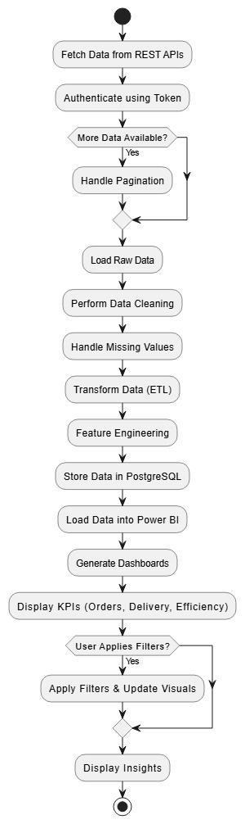
Figure 3 4.4(A) System Workflow of Data Analytics and Dashboard System
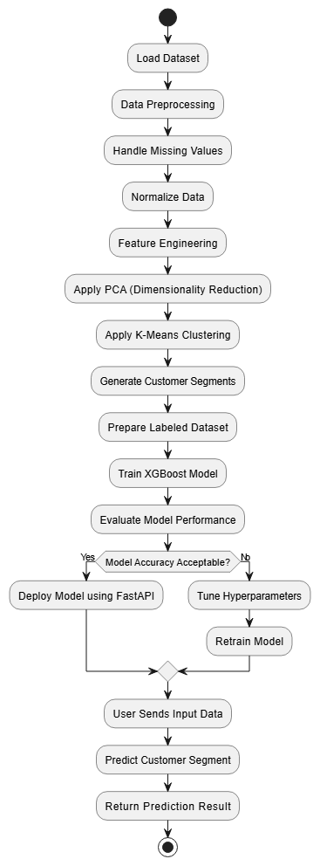
Figure 4 4.4(B) System Workflow of Customer Segmentation and Prediction System

4.5 STATE DIAGRAM

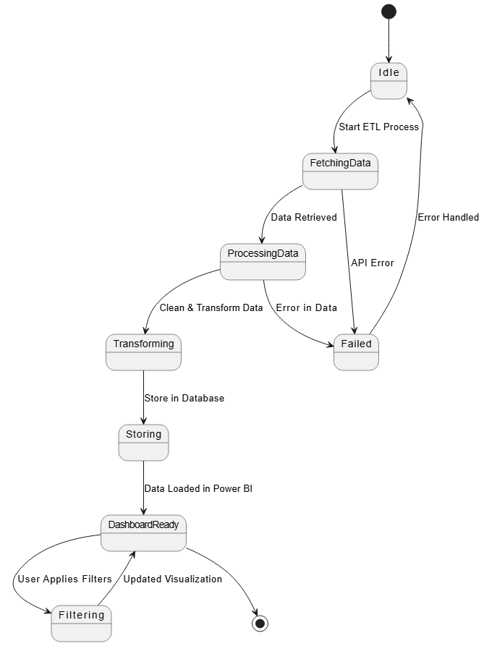
Figure 5 4.5(A) State Diagram of Data Analytics and Dashboard System

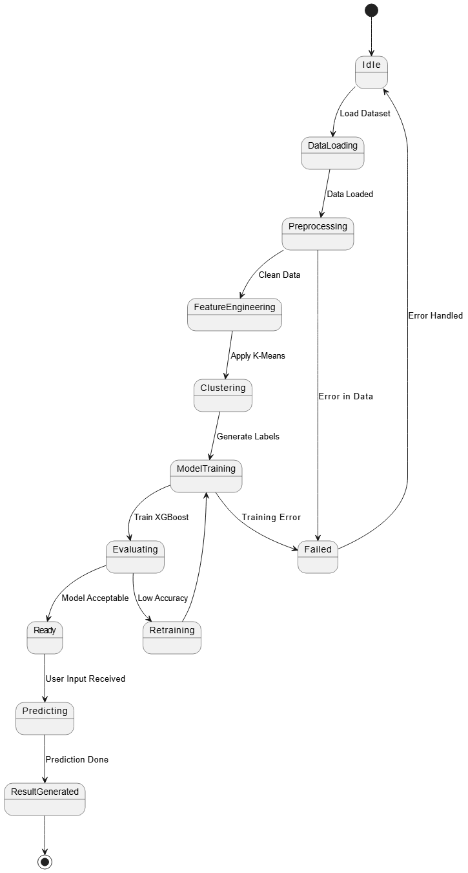
Figure 6 4.5(B) State Diagram of Customer Segmentation and Prediction System

4.6 ACTIVITY DIAGRAM

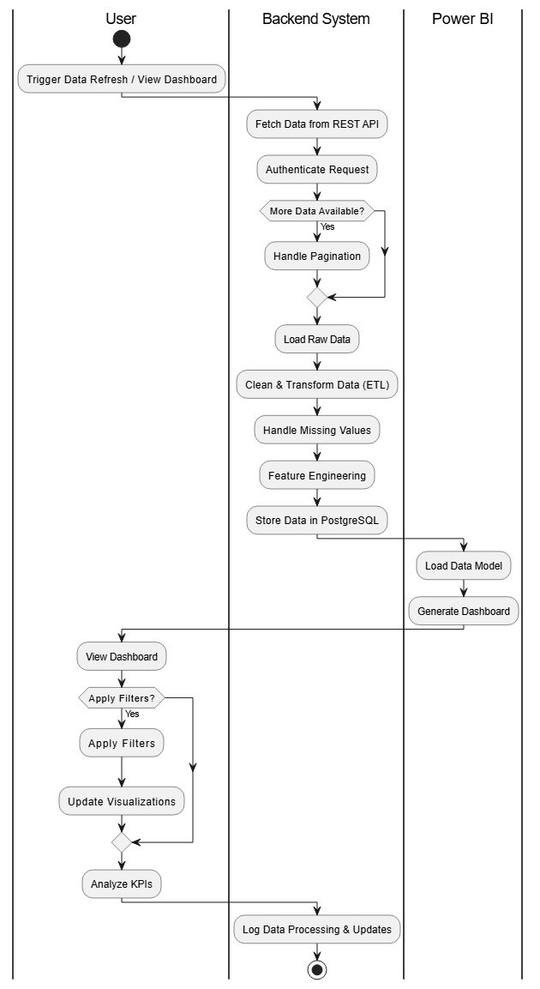
` Figure 7 4.6(A) Activity Diagram of Data Analytics and Dashboard System

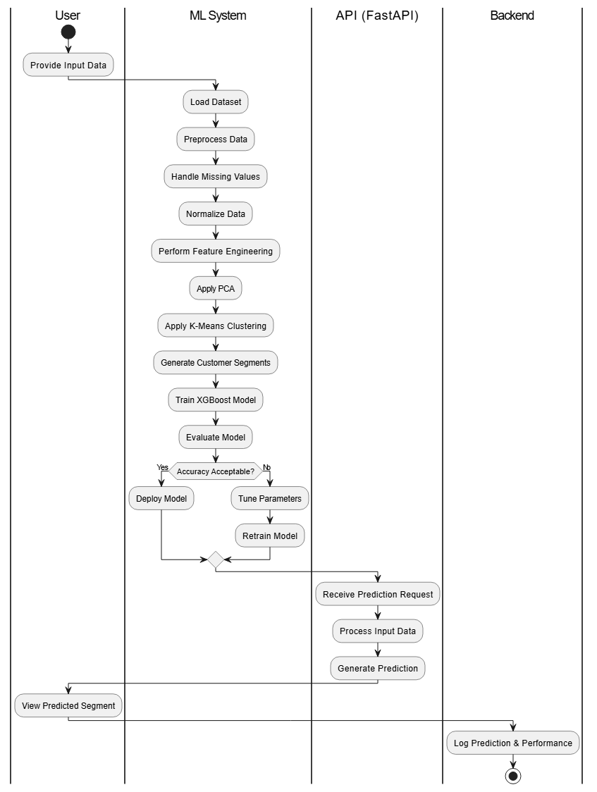
Figure 8 4.6(B) Activity Diagram of Customer Segmentation and Prediction System

4.7 SEQUENCE DIAGRAM

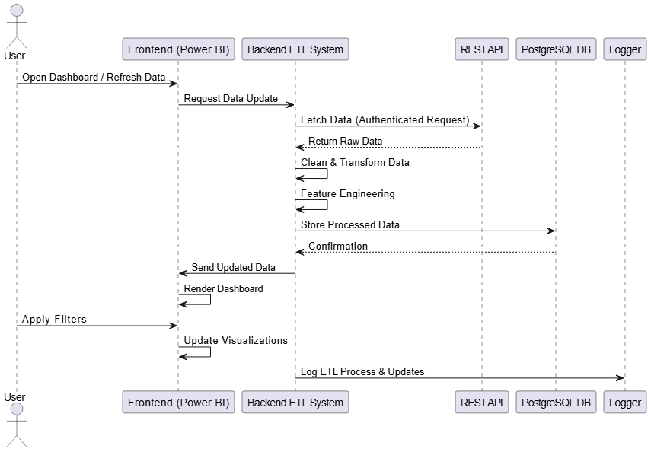
Figure 9 4.7(A) Sequence Diagram of Data Analytics and Dashboard System

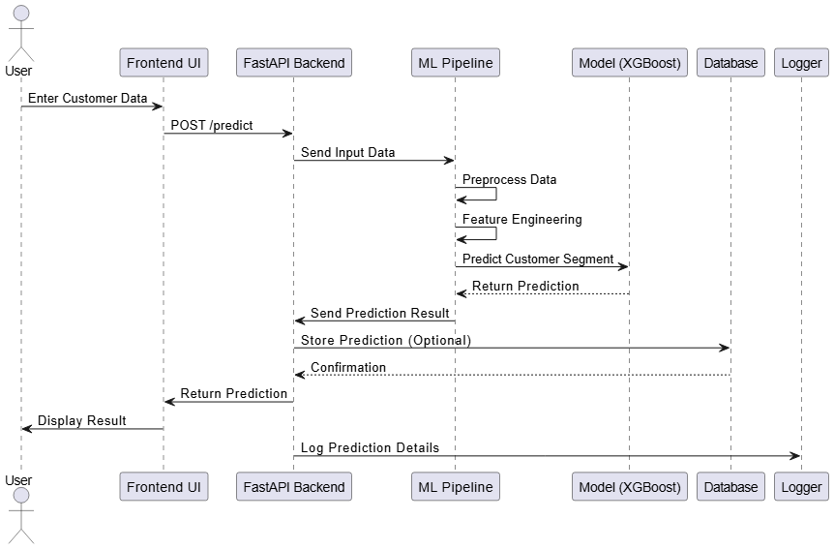
Figure 10 4.7(B) Sequence Diagram of Customer Segmentation and Prediction System

CHAPTER 5: SYSTEM DESIGN

5.1 SYSTEM APPLICATION DESIGN

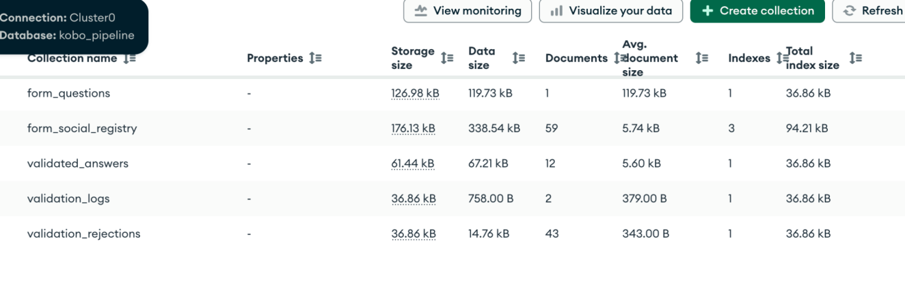

Figure 11 5.1 Kobo Collection PipeLine

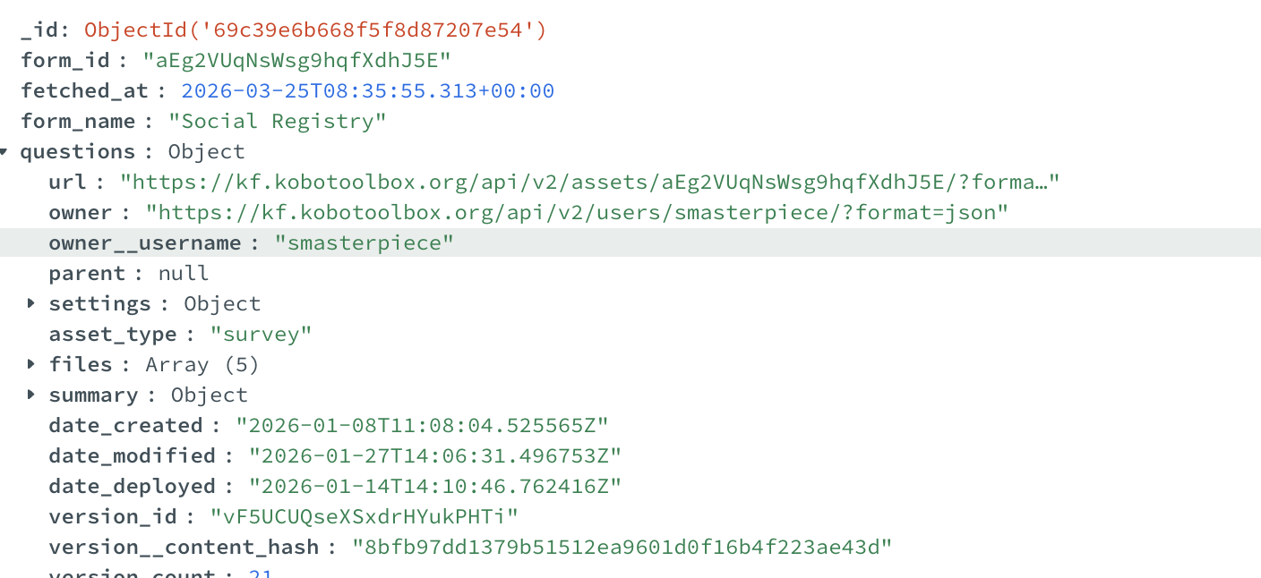

Figure 12 5.2 Kobo Question API Result Stored in MongoDb

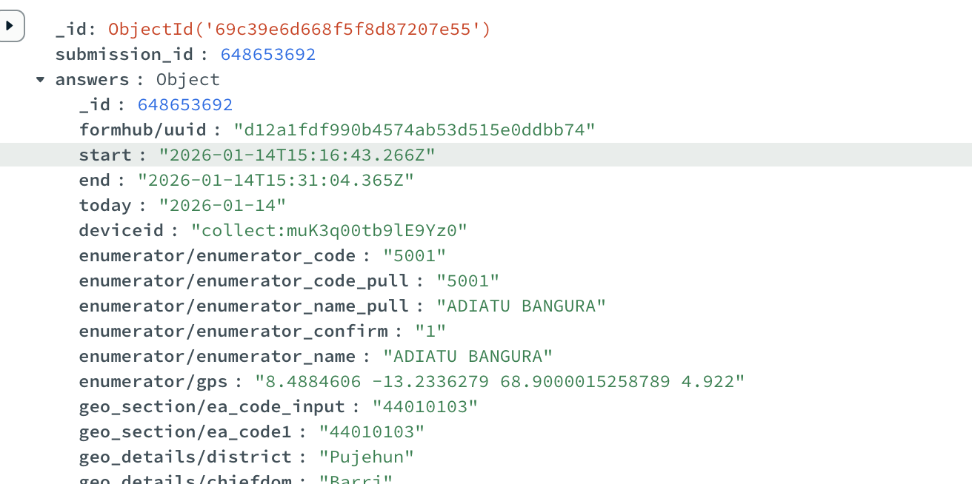

Figure 13 5.3 Kobo Answer API Result Stored in MongoDb
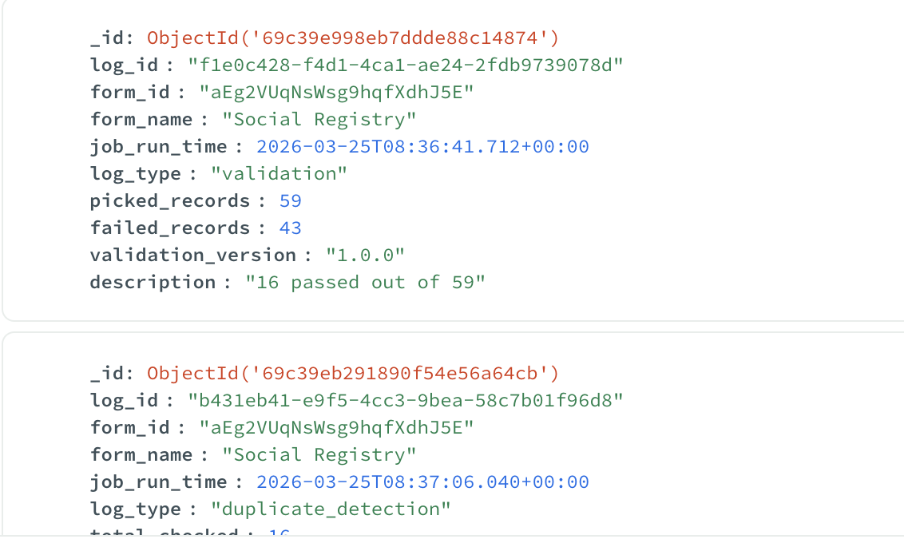

Figure 14 5.4 Log table in MongoDb

5.2 INPUT/OUTPUT AND INTERFACE DESIGN

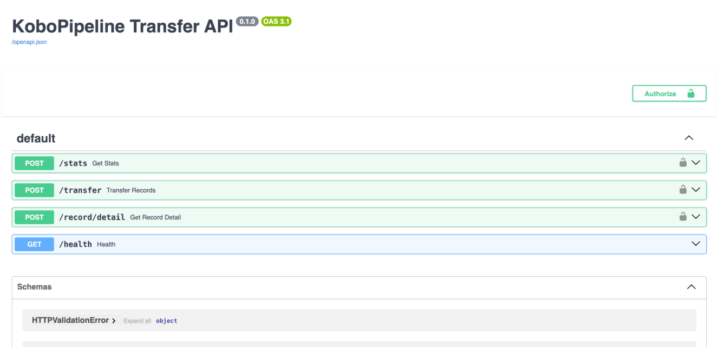

Figure 15 5.5 API Hosted on both local and company server

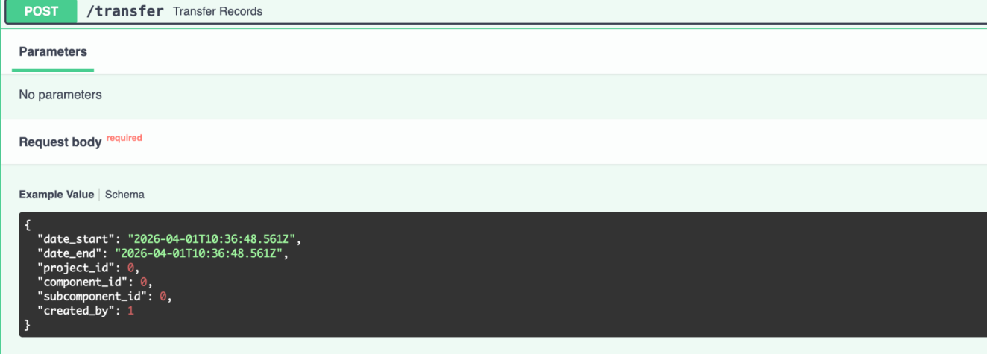

Figure 16 5.6 Transfer API that transfers records from MongoDB to MSSQL Server

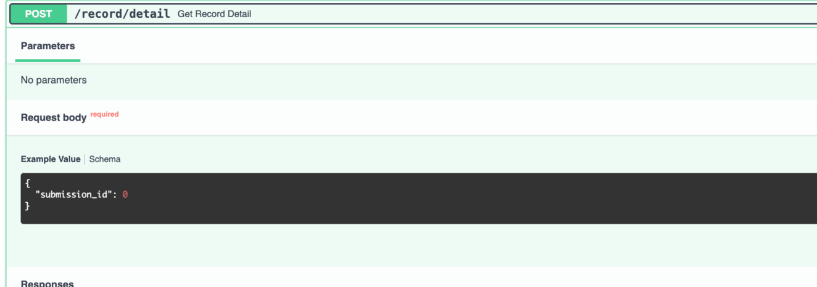

Figure 17 5.7 Record/Detail Endpoint

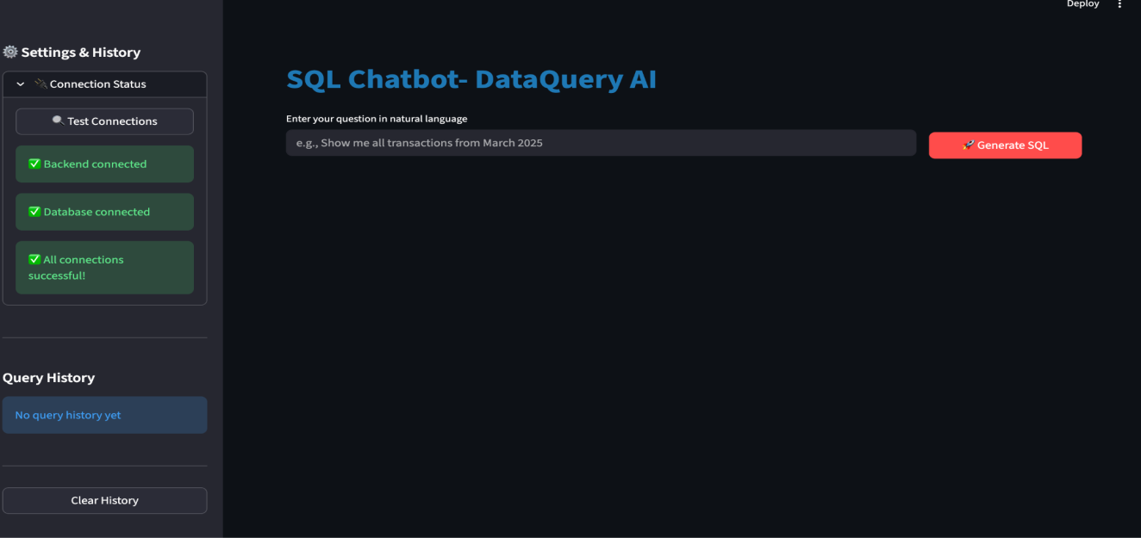

Figure 18 5.8 NL to SQL Chatsystem

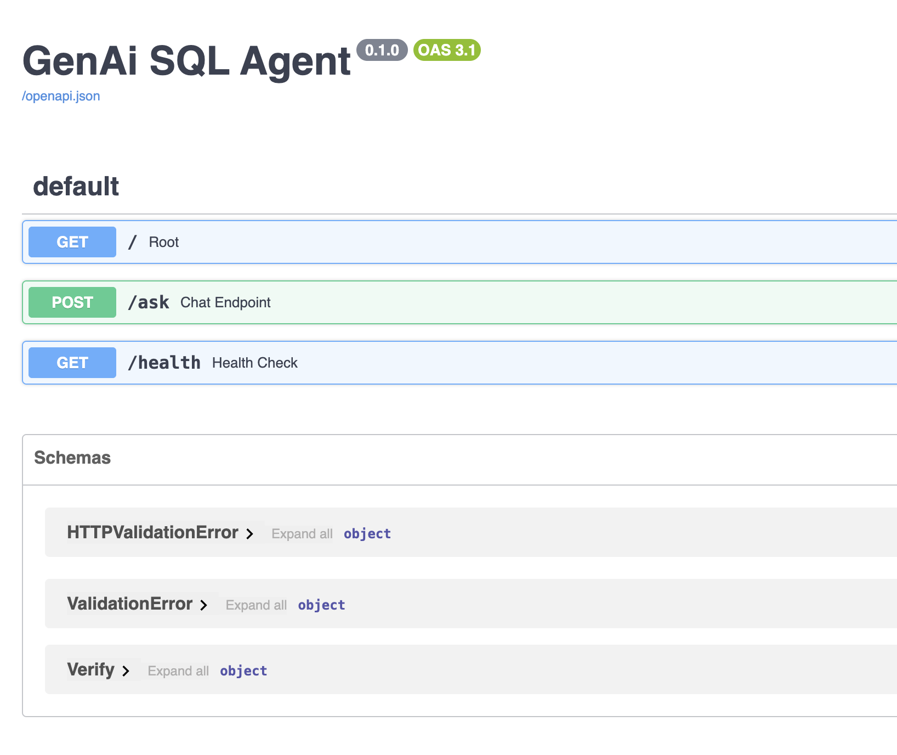
Figure 19 5.9 Fast API of NL to SQL Chatsystem
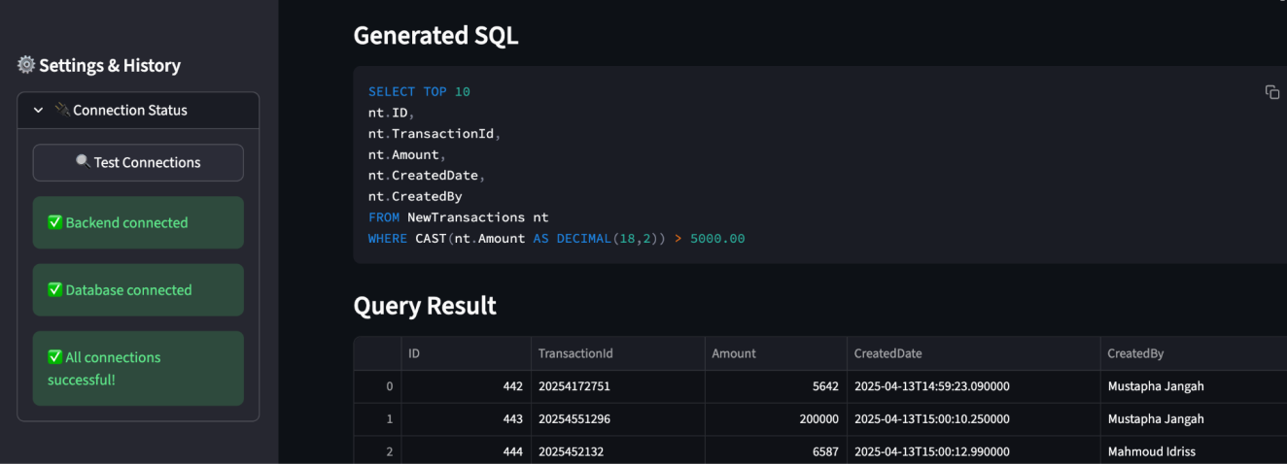
Figure 20 5.10 Result of NL to SQL Chatsystem

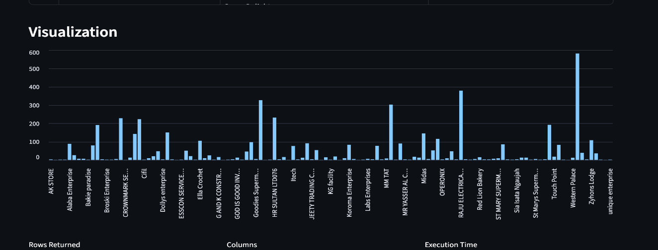
Figure 21 5.11 Graph Visulisation

5.3 DATA DICTIONARY

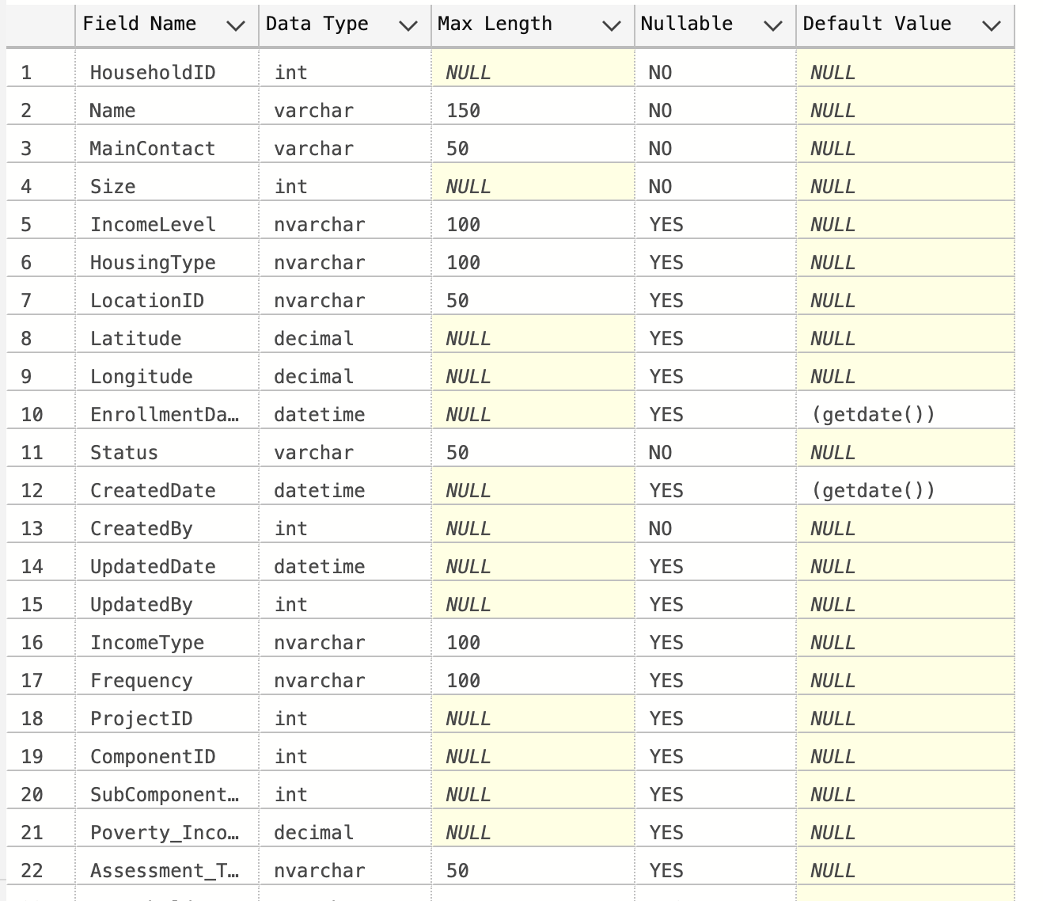
Figure 22 5.12 Household's Table/Data Dictionary in Company Server

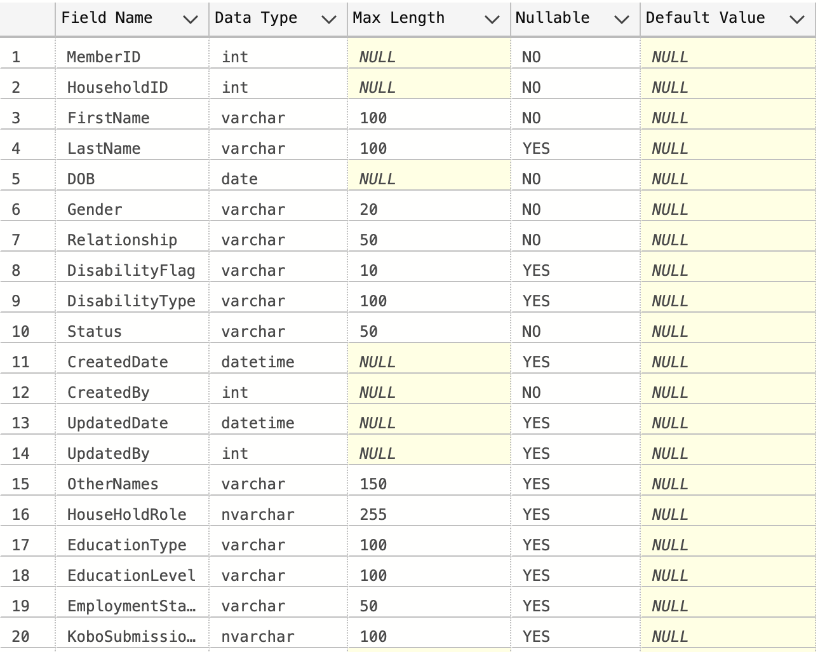
Figure 23 5.13 Member's Table/Data Dictionary in Company Server

5.4 METHOD PSEUDO CODE

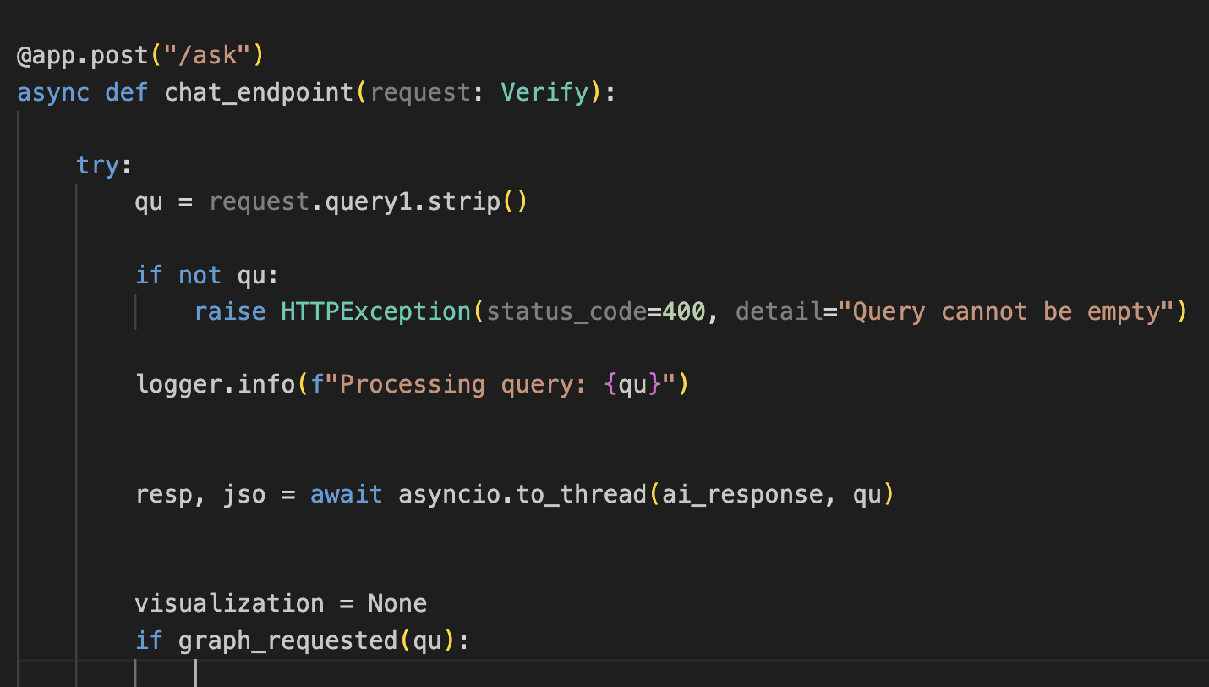
Figure 24 5.14 Ask Endpoint

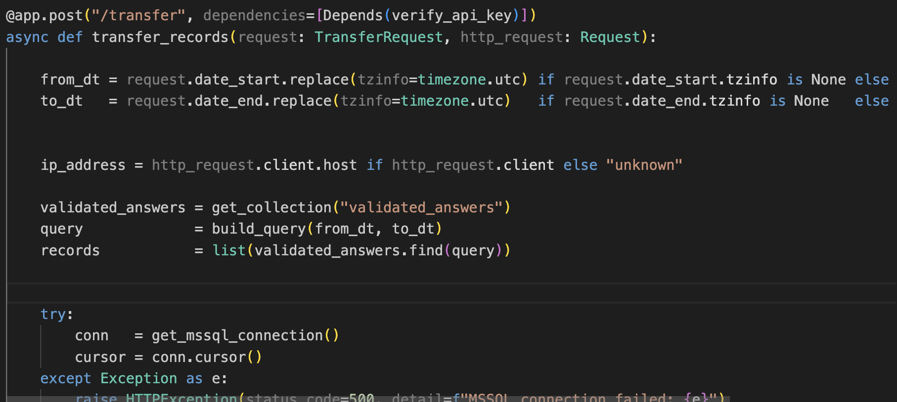
Figure 25 5.15 Transfer Endpoint

CHAPTER 6:IMPLEMENTATION PLANNING AND TESTING

6.1 CODING STANDARDS

Both projects have followed consistent coding standards for better readability, maintainability, and collaboration. Best practices in Python have been followed during the entire project development process. Naming conventions and modular design principles have been followed in both projects. The project has followed snake_case conventions in naming functions and variables, and PascalCase conventions in naming classes. Modular design has been followed in both projects by dividing each project into different modules in different files based on their responsibility.

Error handling has been implemented in both projects using try-except blocks for better error handling in critical operations, particularly when interacting with databases. FastAPI route handlers have been designed in a way that is lightweight and easier to maintain by separating business logic into different service layers. Prompt templates used in NL-SQL systems have been kept separate from project code in both projects.

MongoDB operations have been implemented in a way that is more efficient by using MongoDB’s inbuilt features like unique indexing and upsert operations in cases of duplicates. All constants in both projects have been defined in a way that is centralized.
- Use of snake_case conventions in naming functions and variables, and PascalCase conventions in naming classes
- Use of modular design
- Use of centralized configurations
- Use of robust error handling
- Use of separate API routes and business logic
- Use of separate prompt templates
- Use of efficient MongoDB operations
Use of centralized configurations for constants and settings in both projects.

6.2 TESTING METHODS

Unit Testing: We tested each function on its own with inputs and the results we expected to see. For the Natural Language to SQL system we tested the builder, the SQL extractor, the graph intent detector and the health check functions. For the Kobo pipeline we tested each of the four validation rule functions the logic that handles pagination, the field mapping builder and the functions that compute derived fields.
Integration Testing: We checked how the different components work together to make sure data moves correctly through each layer. For the Natural Language to SQL system our integration tests made sure that a question that comes into the FastAPI endpoint goes through all the steps like building the prompt making a model inference, running SQL and formatting the results before it gets sent back. For the Kobo pipeline our integration tests checked that records that get stored during ingestion get picked up by the validation engine that valid records get identified correctly by the detector and that the transfer API can read from MongoDB and write to SQL Server correctly.
System Testing: We did testing from start to finish using real questions and real data. For the Natural Language to SQL system we tested it with kinds of natural language inputs like simple questions questions that use multiple tables, aggregations, date filters and graph requests. For the Kobo pipeline we ran the four-stage process with a real form that had records we knew were valid records we knew were not valid and records we knew were duplicates and we checked the output at each stage.
API Testing: We used Postman to test all the FastAPI endpoints with inputs, bad inputs, missing authentication headers and unusual date ranges. We checked the response codes the response bodies and the error messages to make sure they were what we expected to see. We tested the Natural Language, to SQL system and the Kobo pipeline to make sure they work as expected.

6.3 TEST SUITES DESIGN

The tests were divided into four suites, each corresponding to one of the primary functional domains in the two projects. The first suite dealt with the NL to SQL query processing pipeline, including natural language input handling, SQL generation correctness, and result formatting. The second suite dealt with the graph detection and rendering feature, including correctness in intent detection and axis mapping. The third suite dealt with various stages in the Kobo pipeline for data processing, including ingestion, validation, deduplication, and transfer. The fourth suite dealt with API endpoint correctness for both projects, including security aspects such as authentication and error handling.
For each test case, there is a corresponding expected output and pass/fail criterion.
Tests were done manually during development and repeated after each significant modification to ensure that no regression had been introduced in the code.

6.4 TEST CASES

Test Case ID | Test Description | Input Data | Expected Result | Actual Result | Status
TC01 | Simple NL query | "Show all transactions above 5000" | Valid SQL generated, results returned | As expected | Pass
TC02 | Multi-table query | "Top 10 merchants by transaction count" | JOIN query generated correctly | As expected | Pass
TC03 | Graph request | "Show bar chart of monthly sales" | Chart rendered with correct axes | As expected | Pass
TC04 | Health check | GET /health | Backend and DB status returned | As expected | Pass
TC05 | Query history | Run 3 queries, open history panel | All 3 queries shown with execution time | As expected | Pass
TC06 | GPS validation | Record with out-of-range coordinates | Record rejected, reason logged | As expected | Pass
TC07 | Phone validation | Record with malformed phone number | Record rejected, reason logged | As expected | Pass
TC08 | Household size check | Declared size 4, only 2 members present | Record rejected | As expected | Pass
 |  | Table 17.3.1 Test Cases

CHAPTER 7: CONCLUSION

7.1 SELF ANALYSIS OF PROJECT VIABILITIES
It is clear that both projects have successfully delivered a system that meets the production requirements of the problem domain. The NL to SQL system has successfully shown that it is possible for a locally hosted model of a language, in combination with well-designed prompts and a simple API, to act as a viable intermediary between non-technical users and complex relational databases. The system has successfully handled the 19-table schema following refinement of the prompt and has successfully been able to generate queries over multiple tables, apply date and amount filters, and even produce a graph following user demand. The migration from the Groq model to the Ollama model has been a significant technical achievement in reducing external dependence and improving data privacy.
The Kobo pipeline has successfully addressed a genuinely complex problem in data processing, namely the transformation of messy, nested, field-collected data into clean, structured, relational data. It has done so in a manner that is maintainable, auditable, and repeatable. The choice of MongoDB has been well justified in the context of nested data, and the four-stage processing has ensured that each stage can be monitored and debugged independently..

7.2 PROBLEMS ENCOUNTERED AND THEIR SOLUTION
- Problem 1 – Low SQL Accuracy with Initial Model: The first locally run model gave incorrect queries with hallucinated table names. Solution: Change to use the hosted LLM from Groq and then later the Ollama model, and modify the prompt to include the full schema and add constraints against making assumptions.
- Problem 2: Database Connection Instability: The program experienced timeouts while repeatedly executing the queries due to the maintenance of a single persistent database connection. The solution was to open the database connection before every individual query execution.
- Problem 3: Ollama Response Format Inconsistency: When the program was migrated from the Groq system to the Ollama system, the response format for the generated SQL code was slightly different. The solution was to modify the instructions given to the prompt to ensure the strict response format is followed.
- Problem 4: KoboToolbox Pagination: The ingestion script was fetching only the first page of the submissions from the KoboToolbox server. The solution was to modify the script to ensure that the response metadata is checked after every call.
- Problem 5: Nested Data Structure of the Surveys: The forms contained repeat groups with nested array data structures, which made the data difficult to handle in the flat data structure. The solution was to store the raw data as is in MongoDB.
- Problem 6: Preventing the Transfer of Duplicate Data: The program was designed to be executed multiple times, resulting in the possibility of transferring the same data multiple times. The solution was to mark the MongoDB record as transferred after the successful execution of the INSERT statement.
- Problem 7: SQL Server Column Type Inconsistency: The fields from the KoboToolbox server were string types but were required to be inserted into INT or DECIMAL columns in the database. The solution was to develop safe conversion methods that handle null values and invalid formats.

7.3 SUMMARY OF THE PROJECT
During this internship, two fully functional and production-ready systems were designed, developed, tested, and documented. The Gen AI-Based NL-to-SQL system is designed to make database querying possible for non-technical users through the implementation of a conversational interface with a locally hosted language model, FastAPI REST backend, graphing functionality, and extensive monitoring tools. The Kobo Survey Data Integration & Migration Pipeline is an automated system that covers the entire process from raw Kobo ToolBox survey data to validated, deduplicated, structured data loaded into a SQL Server database with extensive audit trails and clean REST API controls for data transfer. All the above systems demonstrate real-world engineering best practices.

CHAPTER 8:LIMITATIONS & FUTURE ENHANCEMENTS

Both systems, although functionally sound and ready for production, also have a few limitations, which can be considered areas for future enhancements and improvements.

With regards to the NL-to-SQL system, the current implementation has been designed to perform only SELECT queries, ensuring data security and avoiding any potential data manipulation errors. Although this has provided a much safer system, this limitation also restricts its use in situations where data needs to be inserted, updated, or deleted from a database. Further, the accuracy of the generated SQL queries also relies on the quality of prompt generation and its proper interpretation by the model. Although rare, ambiguous or uncommon phrasing of queries might sometimes result in erroneous or substandard SQL queries being generated by the system. The current implementation of the graph generation feature also has limitations, supporting only basic visualization, and can be enhanced to support more complex chart types and visualization tools.
- Supports only SELECT queries (no data modification allowed)
- Accuracy relies on prompt generation and model interpretation
- Limited ability to handle ambiguous or complex natural language queries
- Current implementation supports basic visualization
Future Enhancements for NL-to-SQL System:
- Supporting INSERT, UPDATE, and DELETE queries with proper security checks
- Advanced support for data visualization, including heatmaps, scatter plots, and time series analysis
- Support for user authentication and role-based access control
In the Kobo Survey Data Integration and Migration Pipeline, currently, the validation rules are written directly in code, which limits flexibility if there are changes in survey structure. If this could be made more flexible, this would enhance flexibility. The current mechanism for duplicate detection, though good, only supports exact and proximity matching, which might not be enough given the many ways users might be represented. Additionally, currently, the pipeline only supports one context, which would be limited if made more versatile.

- Validation rules are hardcoded and cannot be made more flexible
- The current mechanism might not be enough given that users might be represented differently in various data sets
- The pipeline currently only supports one context, which would be limited if made more versatile
- No user interface has been developed to view rejected data and duplicates
Possible future enhancements that could be made to the Kobo pipeline:
- Making the validation rules more versatile through database-driven configurations
- Improving the current mechanism through fuzzy matching techniques
- Making the pipeline support more than one context, including multi-project and multi-organization support
- Development of a user interface that will be used to view rejected data, duplicates, and data that has been processed

REFERENCES

- FastAPI Documentation. (2025). Modern Web Framework for Building APIs with Python. Retrieved fromhttps://fastapi.tiangolo.com/
- Ollama Documentation. (2025). Local Large Language Model Serving. Retrieved fromhttps://ollama.com/
- Microsoft SQL Server Documentation. (2025). Relational Database Management System. Retrieved fromhttps://docs.microsoft.com/en-us/sql/
- MongoDB Documentation. (2025). NoSQL Document Database. Retrieved fromhttps://www.mongodb.com/docs/
- KoboToolbox API Documentation. (2025). Data Collection and Survey Management Platform. Retrieved fromhttps://support.kobotoolbox.org/api.html
- Python Documentation. (2025). Python 3.11 Standard Library. Retrieved fromhttps://docs.python.org/3/
- Pymongo Documentation. (2025). Python Driver for MongoDB. Retrieved fromhttps://pymongo.readthedocs.io/
- Pyodbc Documentation. (2025). Python Database API for ODBC. Retrieved fromhttps://github.com/mkleehammer/pyodbc/wiki
- Zhong, V., Xiong, C., & Socher, R. (2017). Seq2SQL: Generating Structured Queries from Natural Language using Reinforcement Learning. arXiv preprint.
- Yu, T., et al. (2018). Spider: A Large-Scale Human-Labeled Dataset for Complex and Cross-Domain Semantic Parsing and Text-to-SQL Task. EMNLP 2018.
- Postman API Platform. (2025). API Testing and Documentation Tool. Retrieved fromhttps://www.postman.com/
- Git Documentation. (2025). Version Control System. Retrieved fromhttps://git-scm.com/doc

