

**PLACEMENT EMPOWERMENT PROGRAM**

**Cloud Computing & DevOps centre**

**Cloud Based Monitoring:** Basic monitoring in Azure, Viewing metrices for my Storage Account.

**Name:** Pranav Karunakaran

**Dept:** IT

**INTRODUCTION**

Cloud-Based Monitoring in Azure provides essential insights into the performance and health of storage accounts. By leveraging Azure Monitor, users can track vital metrics such as data ingress/egress, transaction counts, blob capacity, and availability. These metrics help ensure optimal storage performance, troubleshoot issues, and maintain service reliability. With powerful visualization tools and alert configurations, Azure enables proactive resource management, making it easier to meet operational goals while optimizing costs and resource usage.

**Step-by-step process:**

Step 1: Go to the Azure portal.

 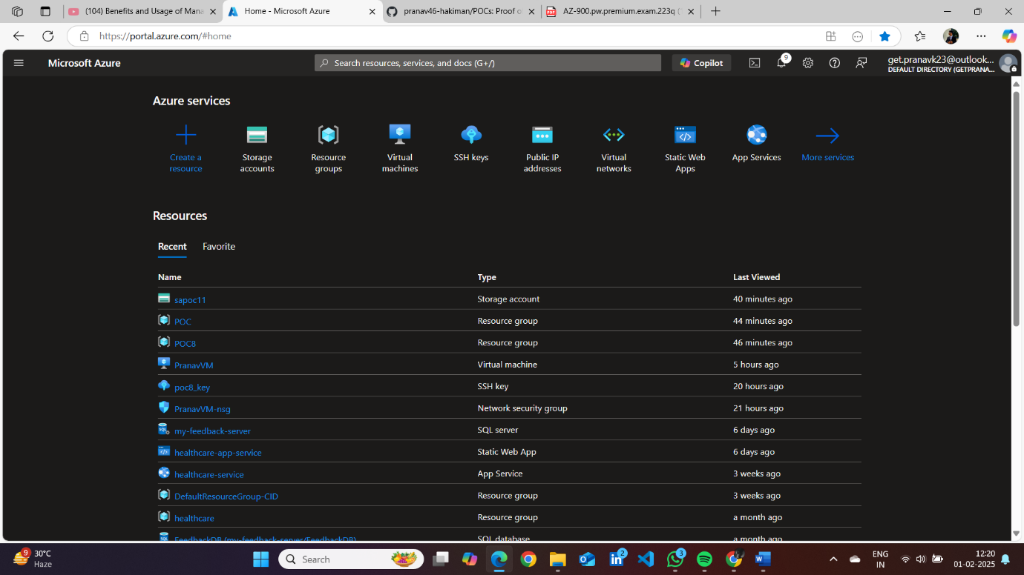

Step 2: Enable Azure Monitor for the Storage account. Monitoring > Insights > Storage Account

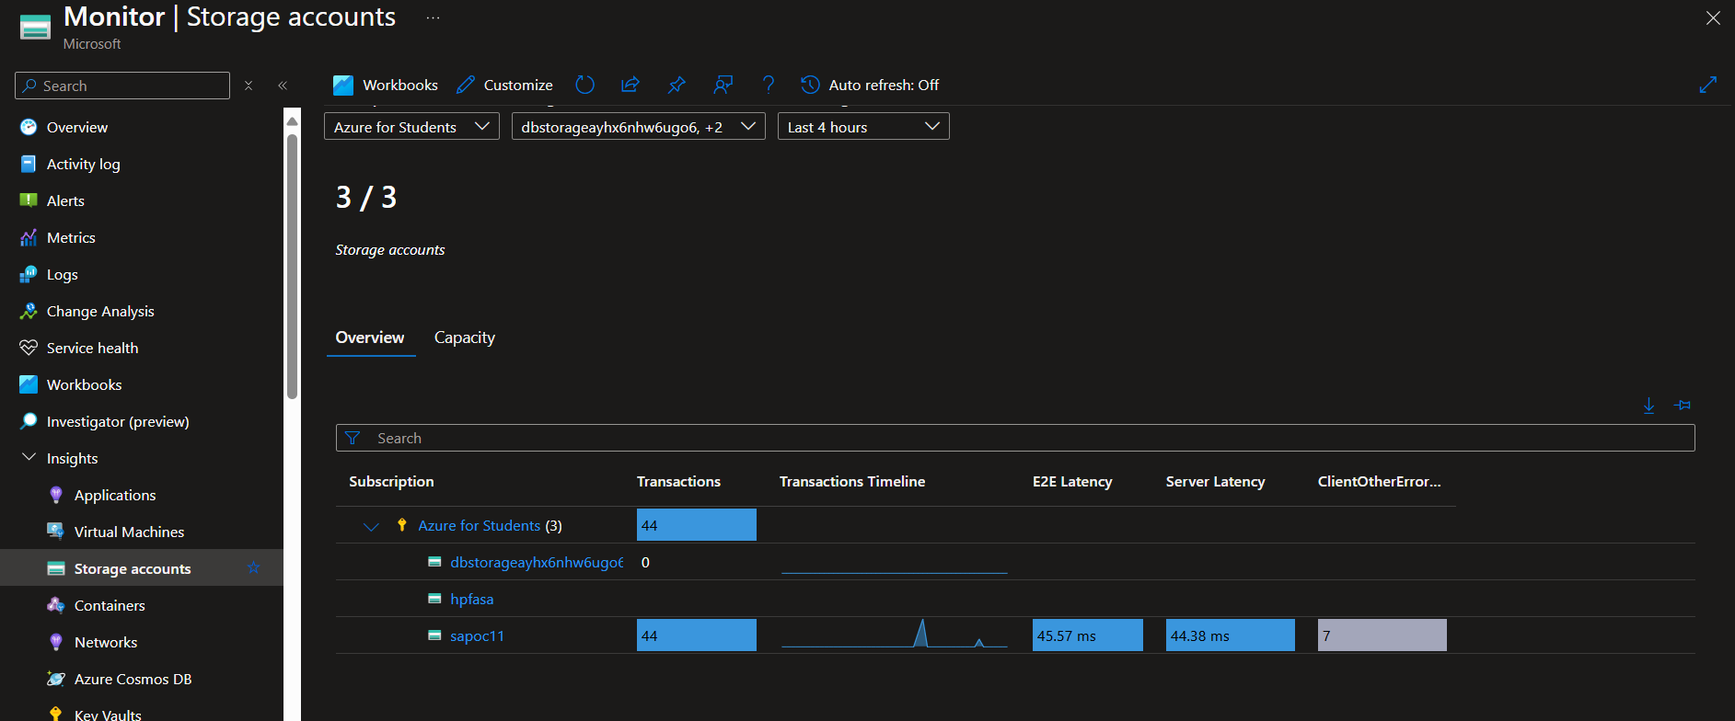

Step 3: Now view key metrices (CPU usage and I/O disks)

Insights > Performance 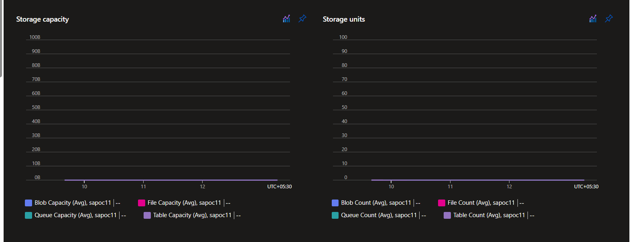

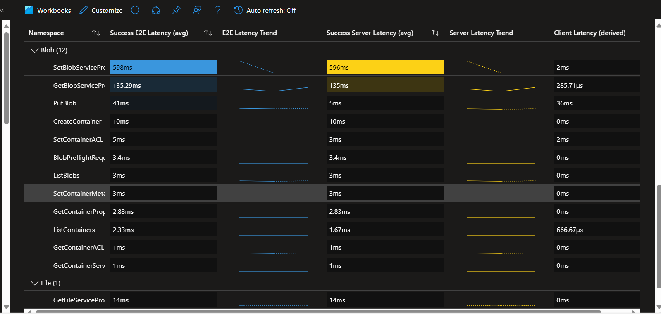 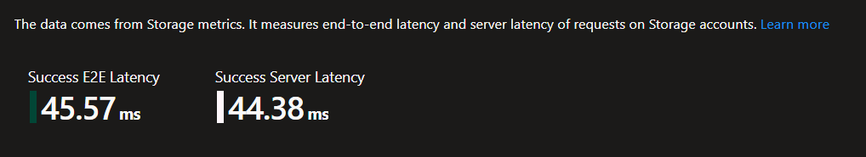

* Availability 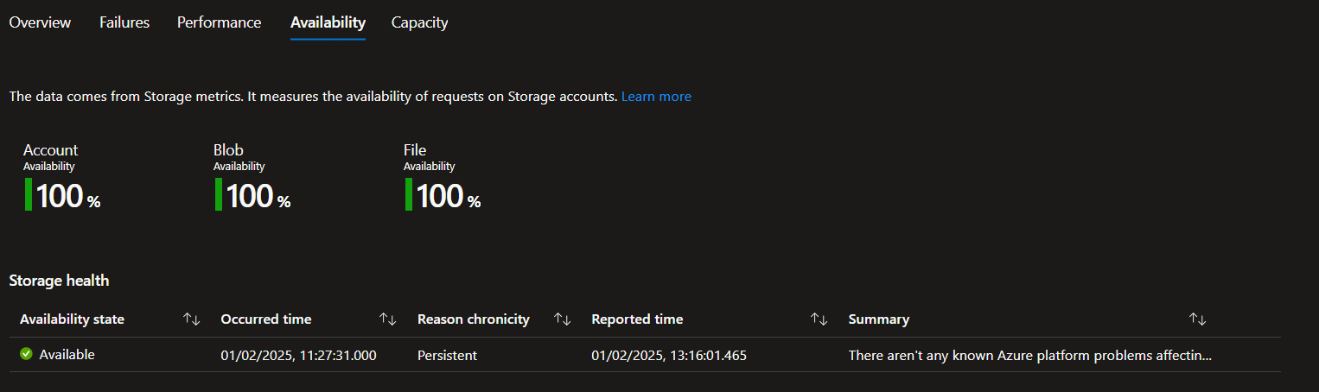
* Capacity 

**Creating an Alert Rule optional:**

