**PLACEMENT EMPOWERMENT PROGRAM**

**Cloud Computing & DevOps Center**

Writing a simple Python Flask application, deploying it on an Azure Virtual Machine.

**Name:** Pranav Karunakaran

**Dept:** IT

INTRODUCTION

**Step-by-step process:**

**Step 1:** Install Flask and write the following cmd in Azure Bash.

Cmd: pip install Flask

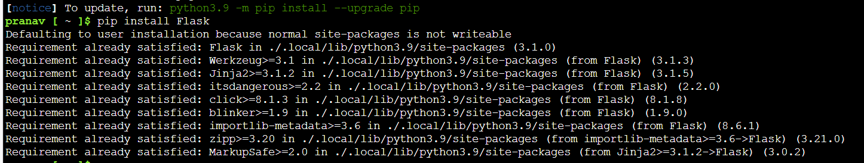

**NOTE: If pip doesn’t work**

**run: pip install --upgrade pip**

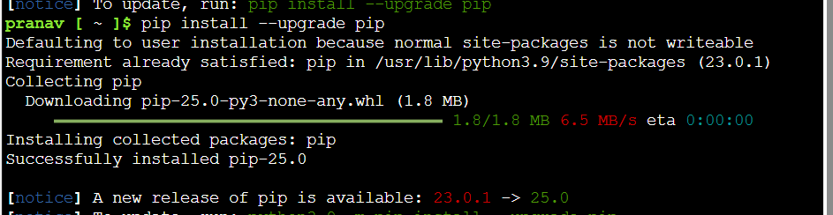

**Step 2:** Create a Flask App. You can use any editor. Enter this code in a file and save it with .py extension.

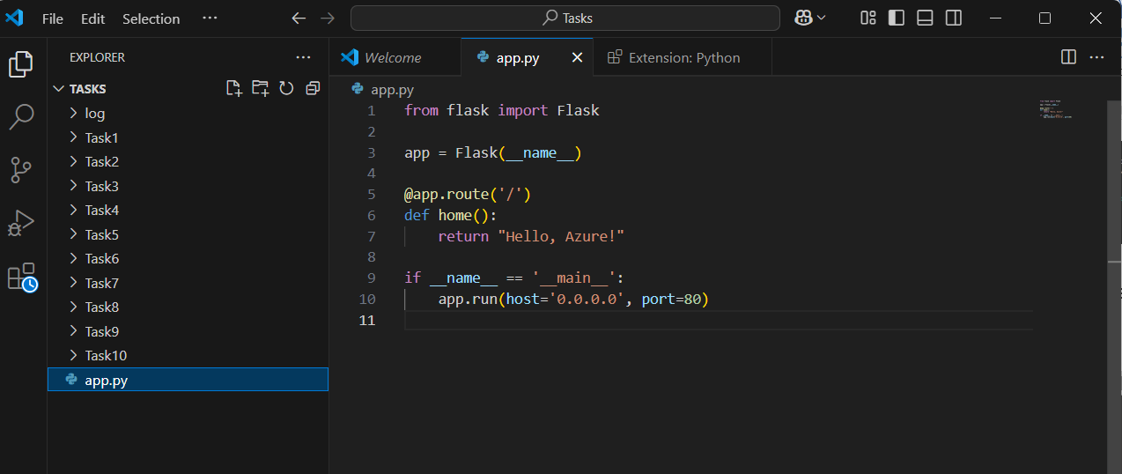

Step 3: Create an Azure VM. You can refer POC 10 for the detailed steps. 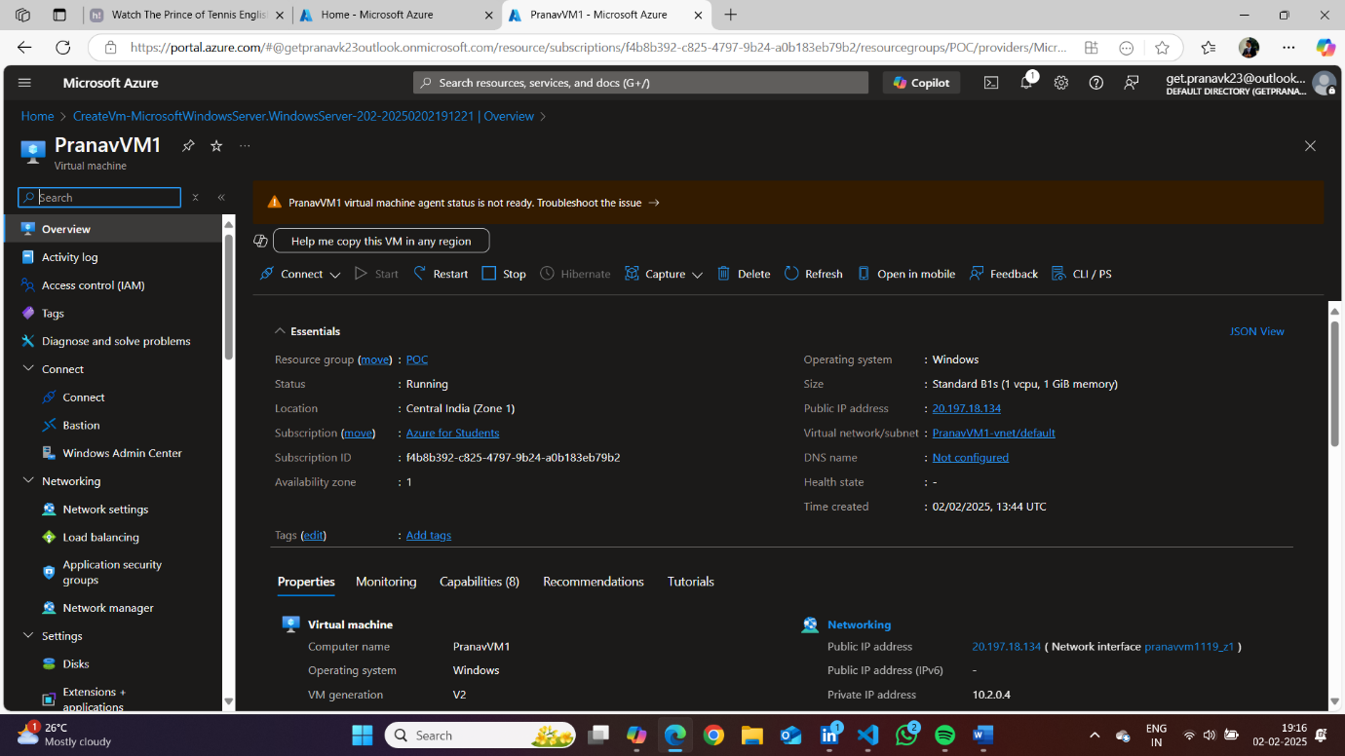

Step 4:

* Connect your VM via RDP. Go to the Overview of your VM and click on connect, then download the RDP file.
* Once downloaded open the file and click on “CONNECT”.

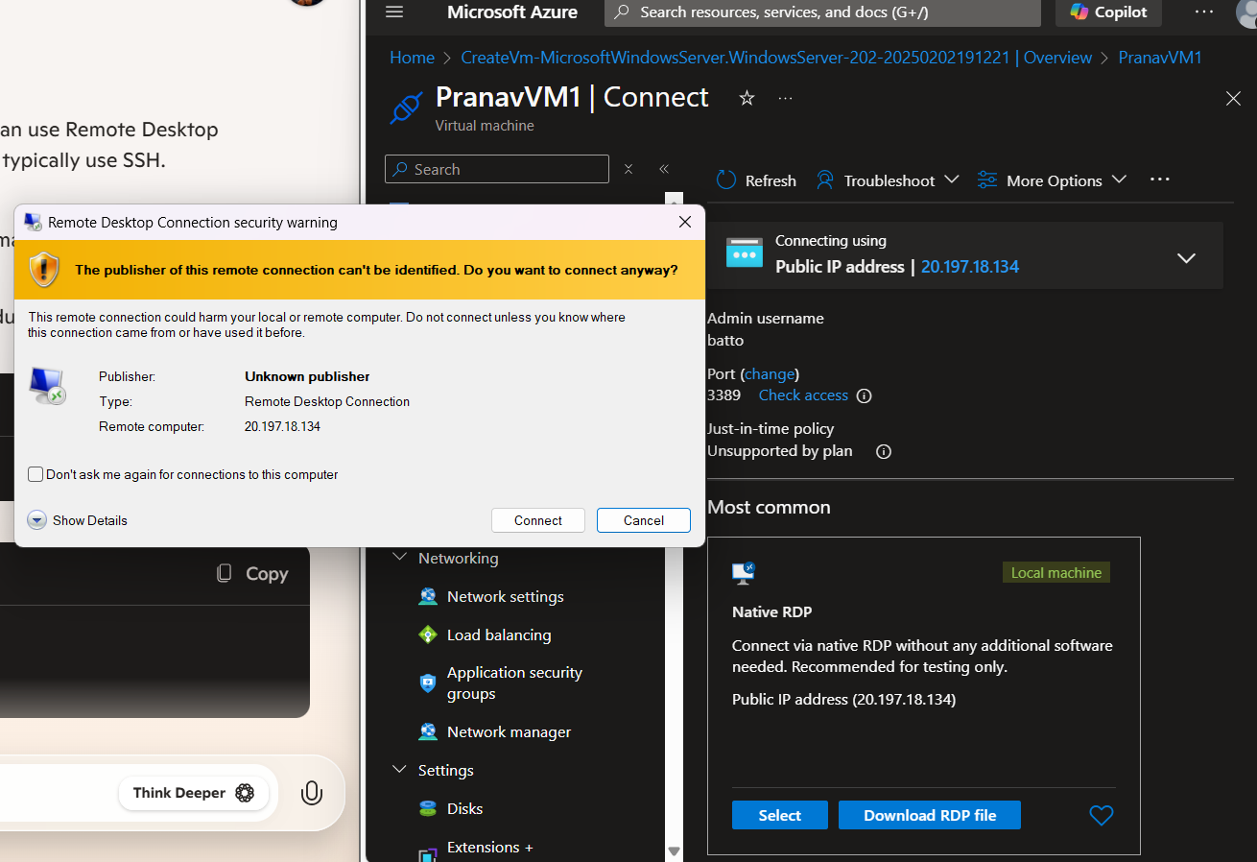

Step 5: Enter your username and passwd for connection.4