

**PLACEMENT EMPOWERMENT PROGRAM**

**Cloud Computing & DevOps Centre**

Install CLI in Azure. Use it to list resources, upload files to storage, and manage Virtual Machines.

**Name**: Pranav Karunakaran

**Dept:** IT

**INTRODUCTION**

Installing the Azure CLI is the first step to accessing and automating tasks in your Azure environment. Once installed, you can use it to list and manage resources like virtual machines, storage accounts, and more. The CLI provides commands for interacting with your Azure subscription, such as listing all resources, uploading files to Azure Storage, and managing virtual machines. Whether you're creating new VMs, uploading blobs to a storage container, or performing routine management tasks, the Azure CLI enables you to work efficiently and effectively with your Azure resources. This guide will walk you through installing the Azure CLI and using it to perform these tasks.

**Step-by-step process:**

**Step 1:** Open Azure CLI and enter the following command for creating a “Storage Account”.

**Cmd: az storage account create --name <your_storage_account_name> --resource-group <your_resource_group_name> --location <your_location> --sku Standard_LRS**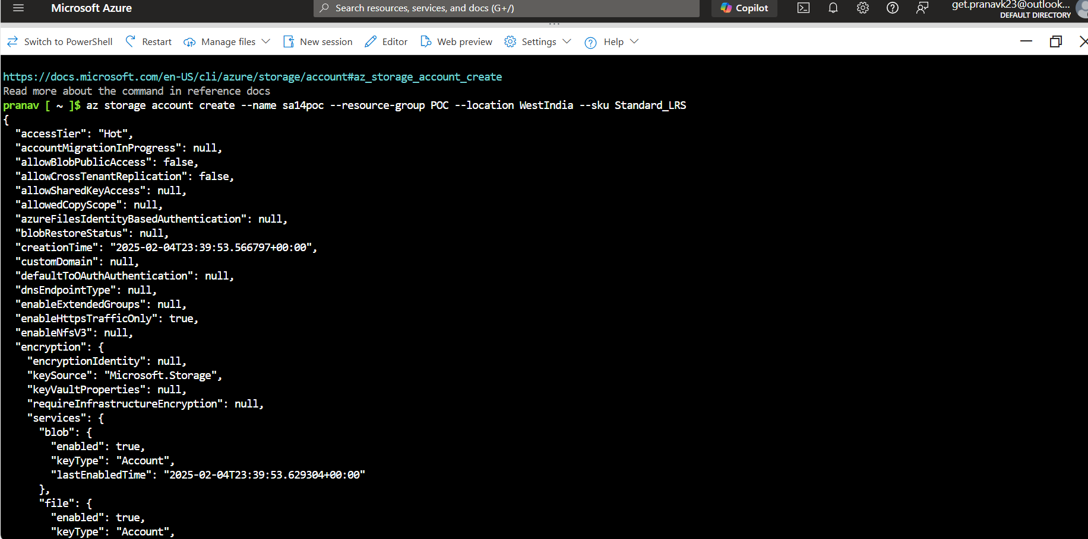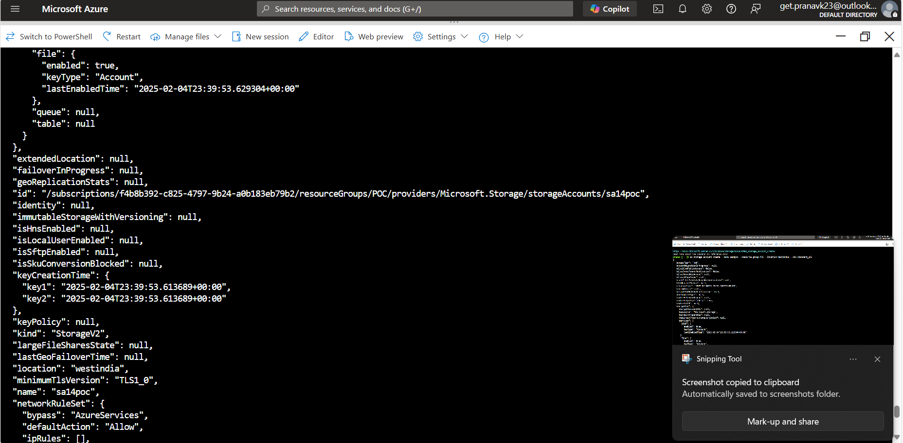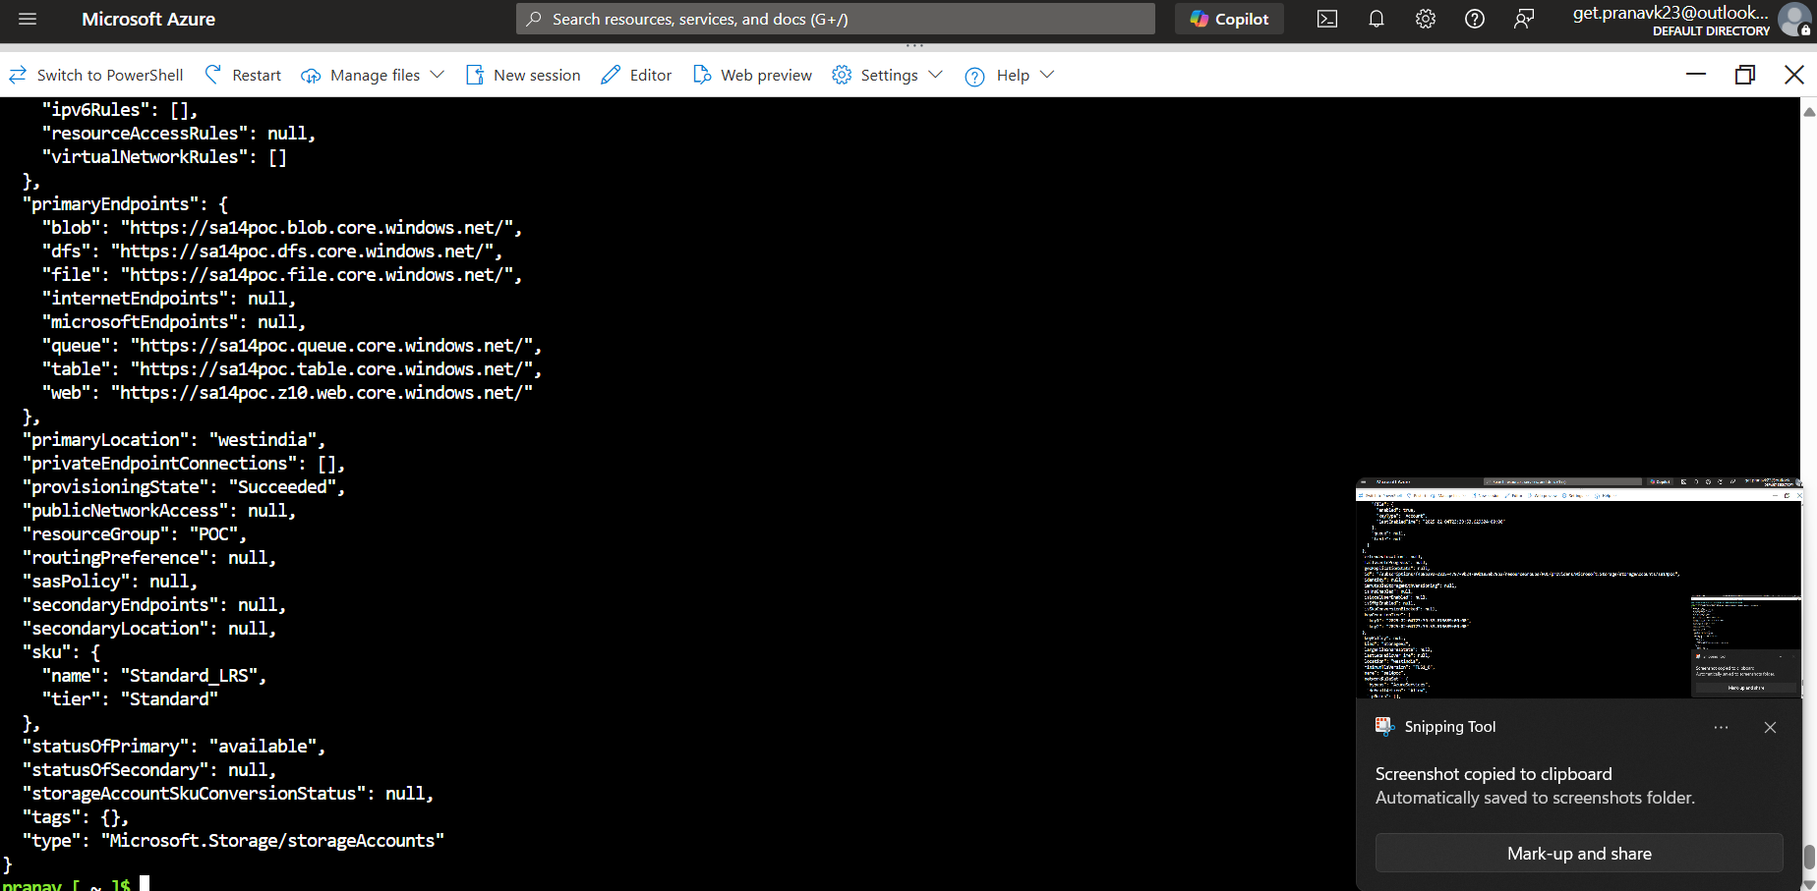

**Step 2:** Create a “BLOB CONTAINER” for uploading files. Run the following command.

**Cmd: az storage container create --name <your_container_name> --account-name <your_storage_account_name>**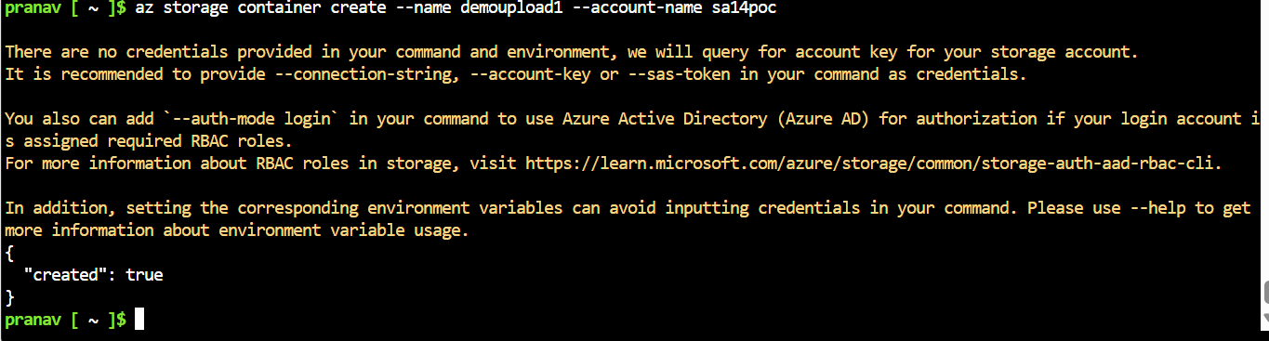

**Step 3:** Upload a file to the “Blob Container”. Open the container you created it in your Storage Account. 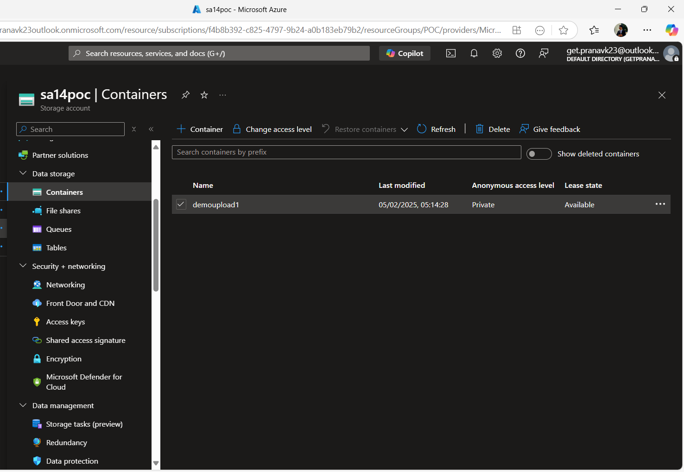

Upload:

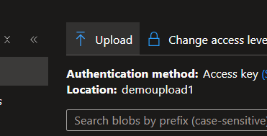

Once you drop your file, then click on upload. 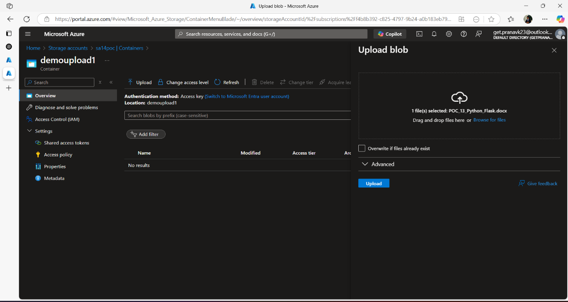

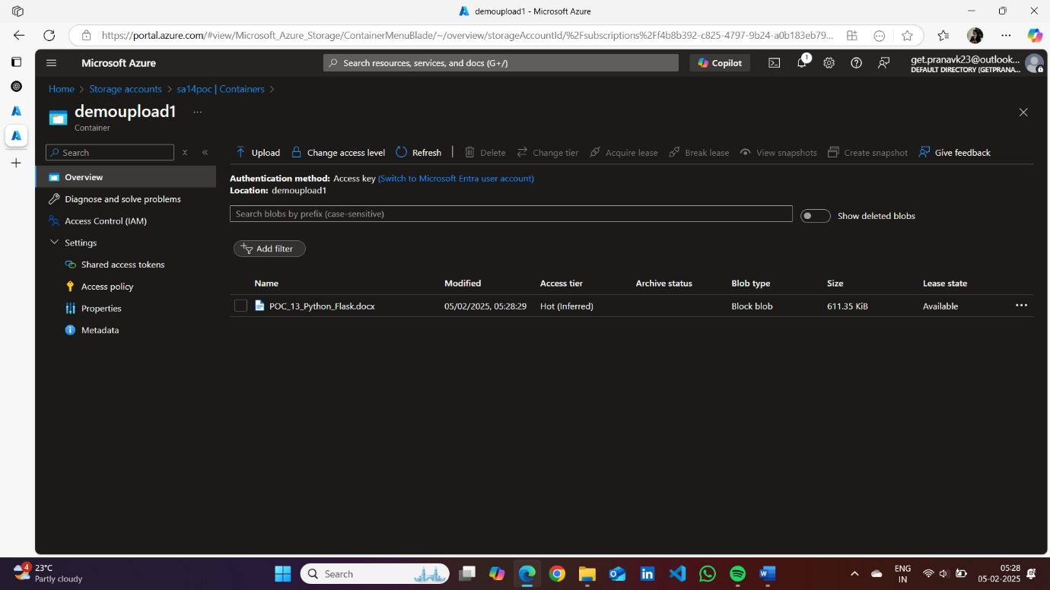

**Step 4:** Start the VM by running the Following command or you can open the portal, go to your VM and click on Start.

**Cmd: az vm start --name <your_vm_name> --resource-group <your_resource_group_name>**



**For stopping: az vm stop --name <your_vm_name> --resource-group <your_resource_group_name>**

