

**PLACEMENT EMPOWERMENT PROGRAM**

**Cloud Computing & DevOps Centre**

**Implementing auto-scaling in Azure:** Set up an auto-scaling groups in Azure VMs for handling various workloads.

**Name:** Pranav Karunakaran

**Dept:** IT

**INTRODUCTION**

Setting up auto-scaling groups in Azure VMs involves creating Virtual Machine Scale Sets (VMSS), which allow you to manage and scale a group of load-balanced VMs automatically. You can configure autoscale rules based on performance metrics like CPU or memory usage, ensuring that the number of VM instances increases or decreases in response to demand. This setup provides high availability, application resiliency, and cost efficiency by running only the necessary number of instances.

**Step-by-step process:**

**Step 1:** Open the Azure portal and navigate to VM Scale Sets.

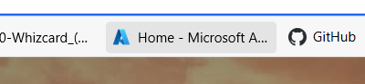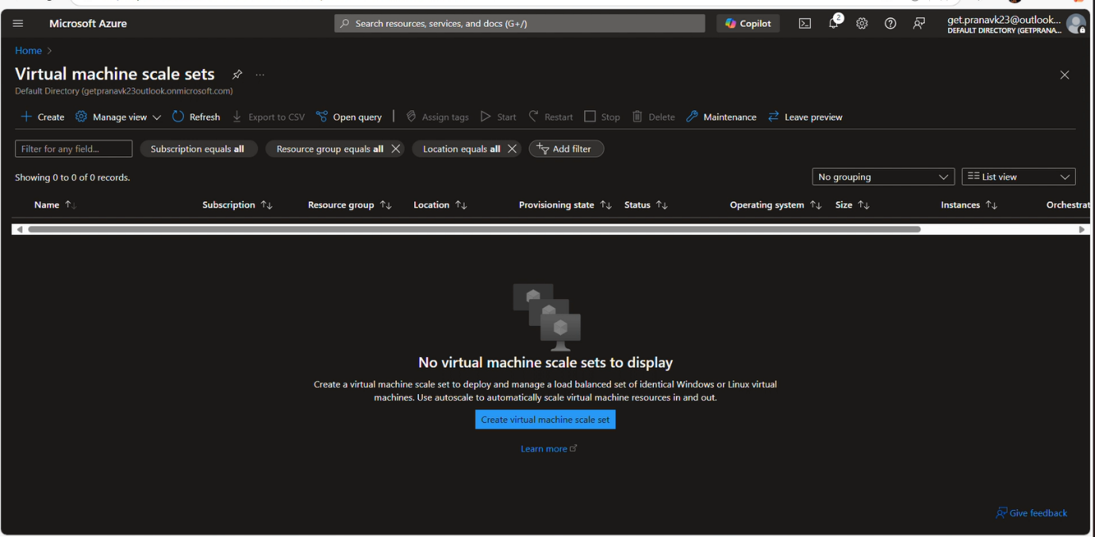

**Step 2**: Enter the necessary details.

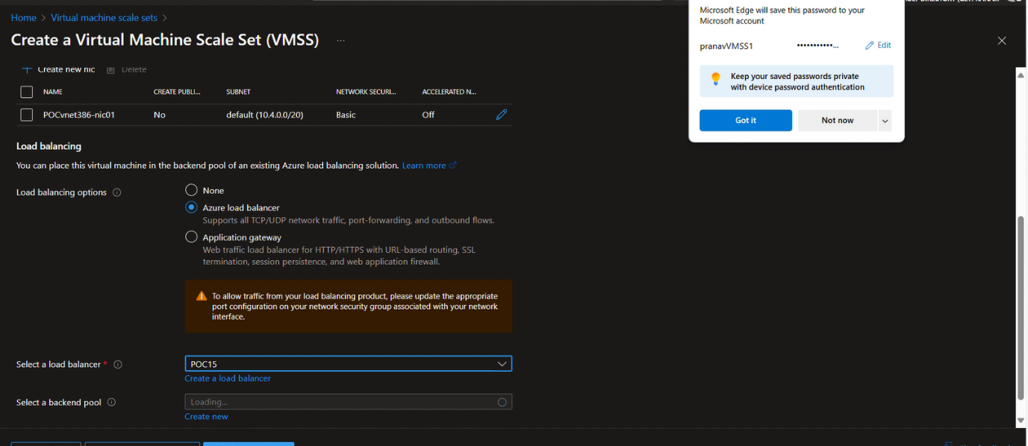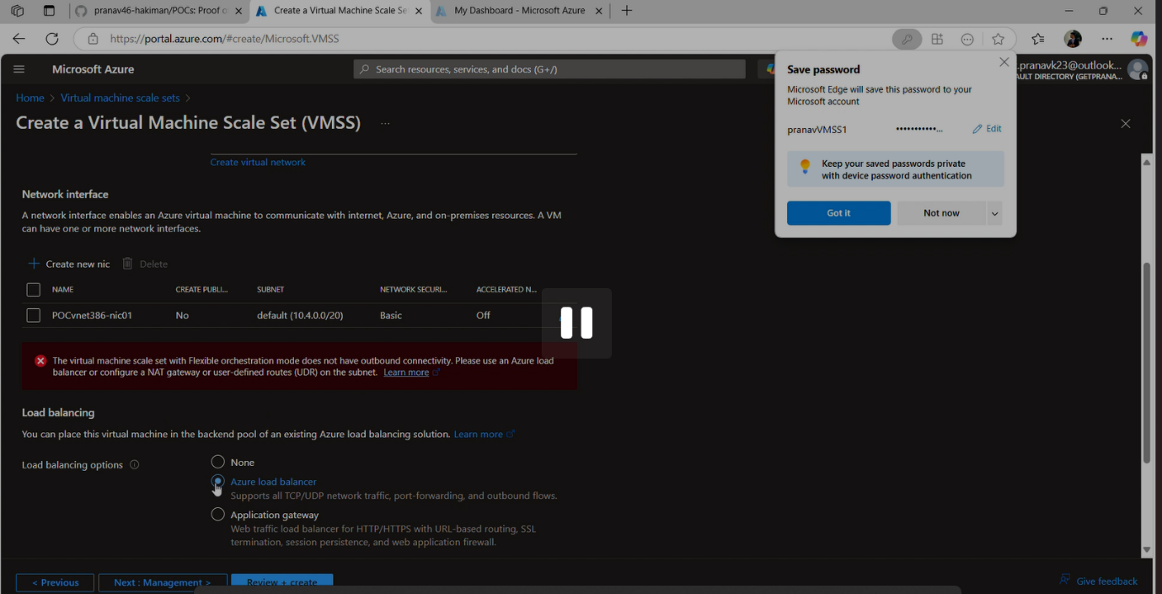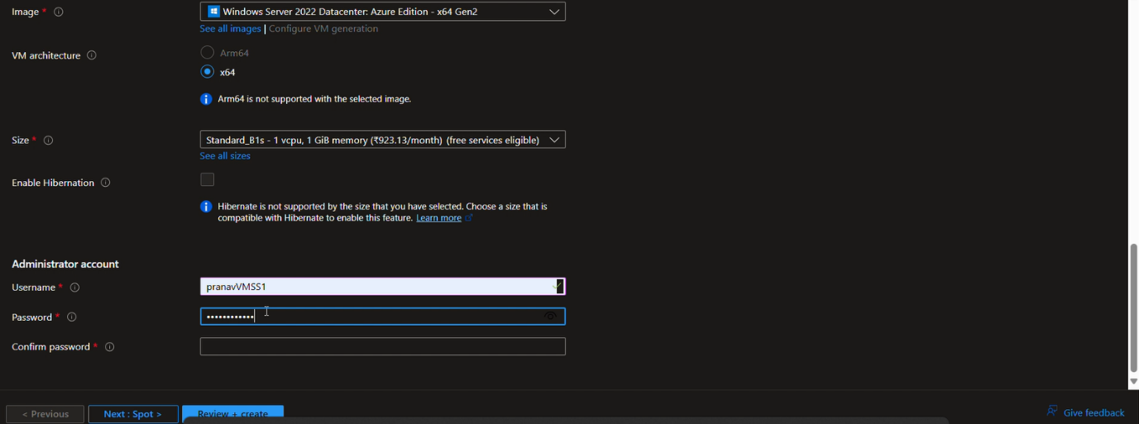

**Step 3:** Enable Auto-Scaling configuration and enter the necessary details. 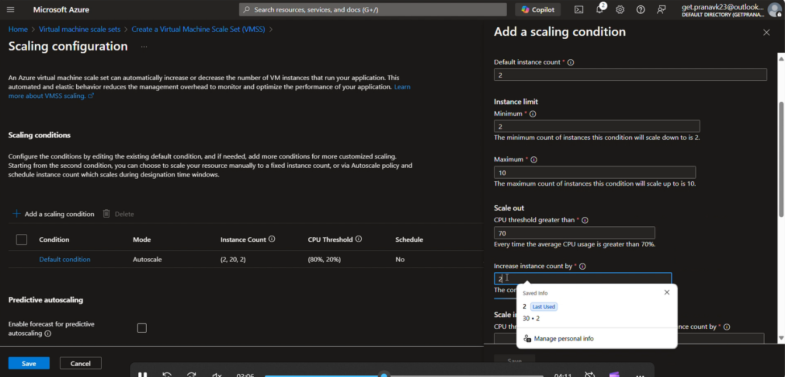 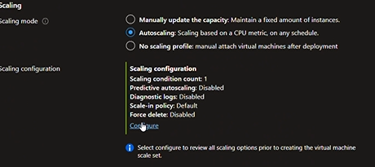

**Step 4:** Go to the Scaling page in your VMSS.

Then add scale-out rule and scale-in rule.

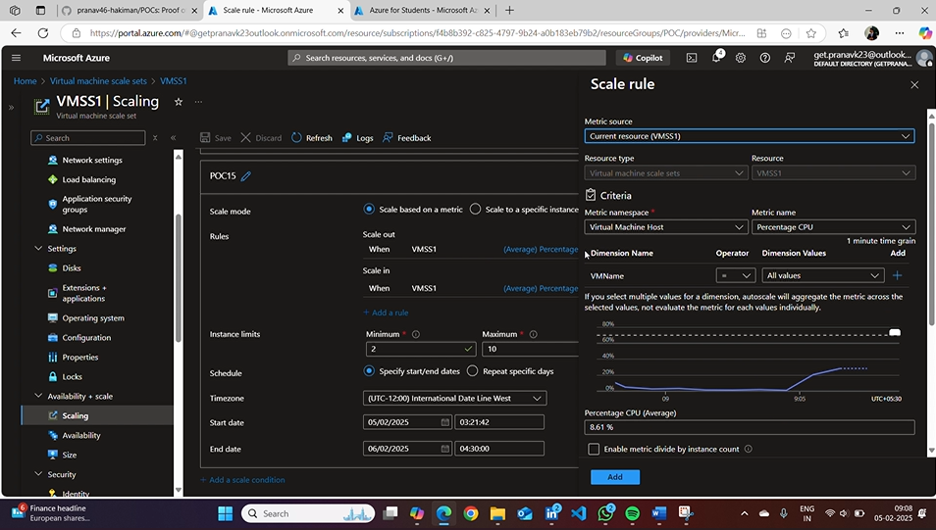

**Step 5:** Testing 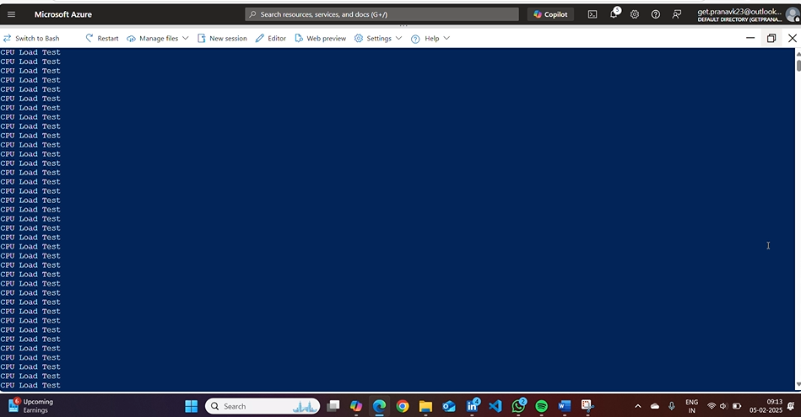

**Step 6:** Go to Azure Monitor for viewing the metrices of your VMSS. 