

**PLACEMENT EMPOWERMENT PROGRAM**

**Cloud Computing & DevOps Centre**

**Set up a load balancer in Azure: Configure a load balancer to distribute traffic across multiple VMs hosting my web Application.**

**Name:** Pranav Karunakaran

**Dept:** IT

**INTRODUCTION**

To set up a load balancer in Azure for distributing traffic across multiple VMs hosting your web application, you'll need to create an Azure Load Balancer resource. After configuring the load balancer with a public or internal frontend IP, you define backend pools, which will include your VMs. Health probes are set up to monitor the health of VMs, ensuring traffic is only sent to healthy instances. Finally, load balancing rules are configured to distribute incoming traffic based on these probes, effectively balancing the load and improving the availability and responsiveness of your application.

**Step-by-step process:**

**Step 1:** Create a VMSS - refer POC_15.

If already done go to step 2.

**Step 2:** Create an Azure Load Balancer. Enter the following details while creating LB. 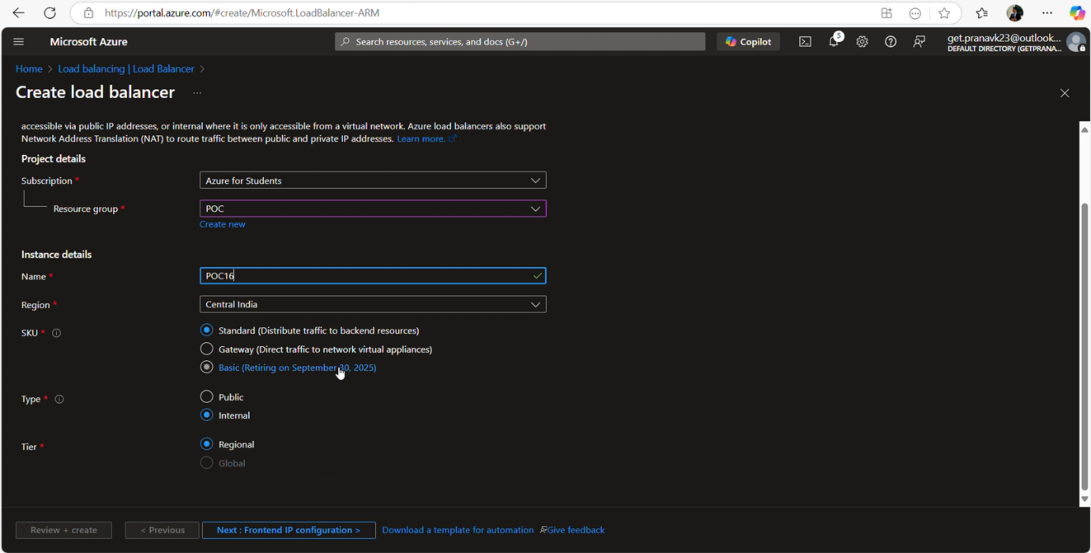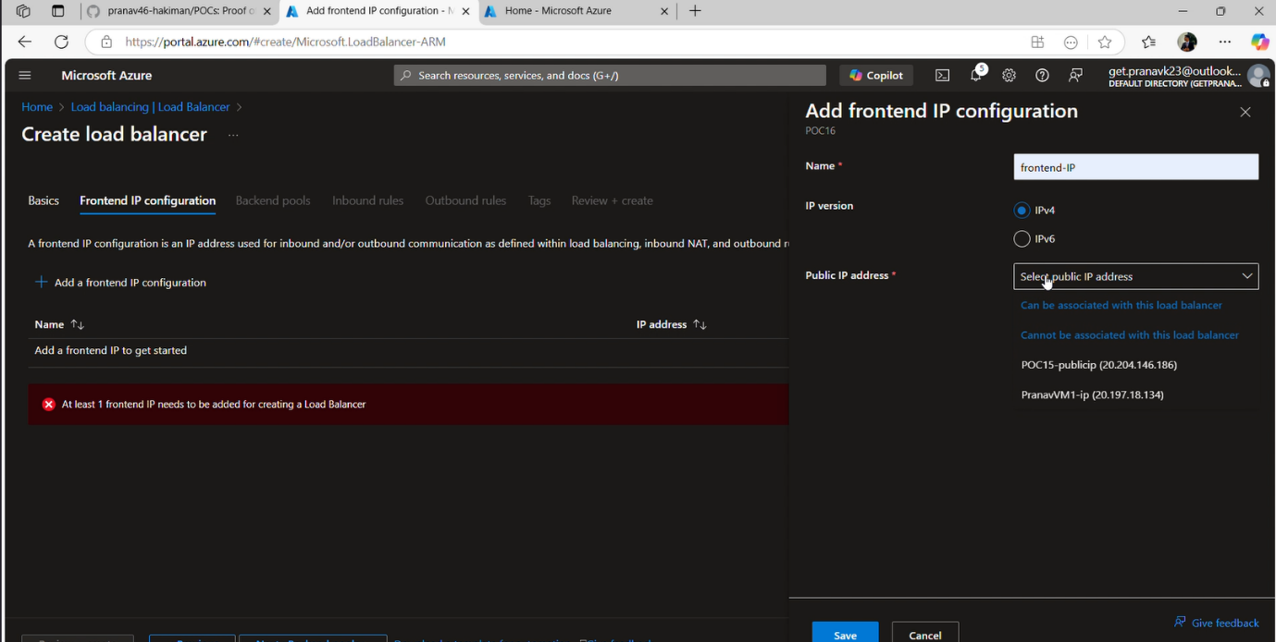

**Step 3:** Configure Backend-Pool which is located in the menus of LB that you created. Enter the following details (refer img). 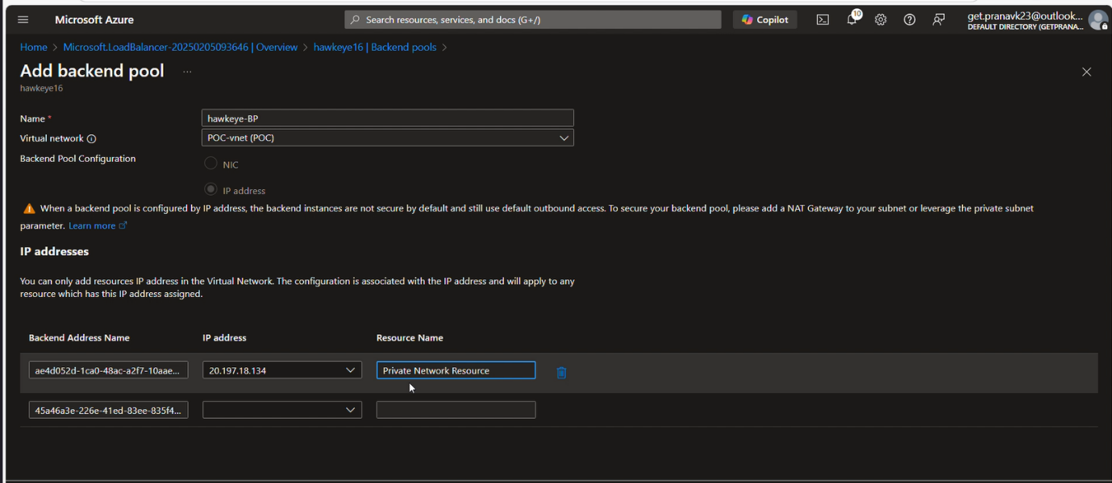

Step 4: Configure LB rules. 