

**PLACEMENT EMPOWERMENT PROGRAM**

**Cloud Computing & DevOps Centre**

**Back up and restoring cloud instance:** Take a snapshot of your cloud VM. Terminate the VM and restore it in your snapshot.

**Name:** Pranav Karunakaran

**Dept:** IT

**INTRODUCTION**

In cloud computing, ensuring the availability and recoverability of your virtual machines (VMs) is critical for maintaining business continuity and minimizing downtime. One of the most effective ways to safeguard your cloud infrastructure is by leveraging snapshots—a point-in-time backup of your VM's disk state. This process allows you to capture the exact state of your VM, including its operating system, applications, and data, at a specific moment.

In this guide, we’ll walk you through the process of **taking a snapshot of your cloud VM**, **terminating the VM**, and **restoring it from the snapshot**. This approach is particularly useful for scenarios such as disaster recovery, testing new configurations, or migrating instances across regions or cloud providers. By following these steps, you can ensure that your cloud environment remains resilient and recoverable, even in the face of unexpected issues.

**Step-by-step process:**

**Step 1:** Open the VM you created or if you don’t have one create a Virtual Machine. 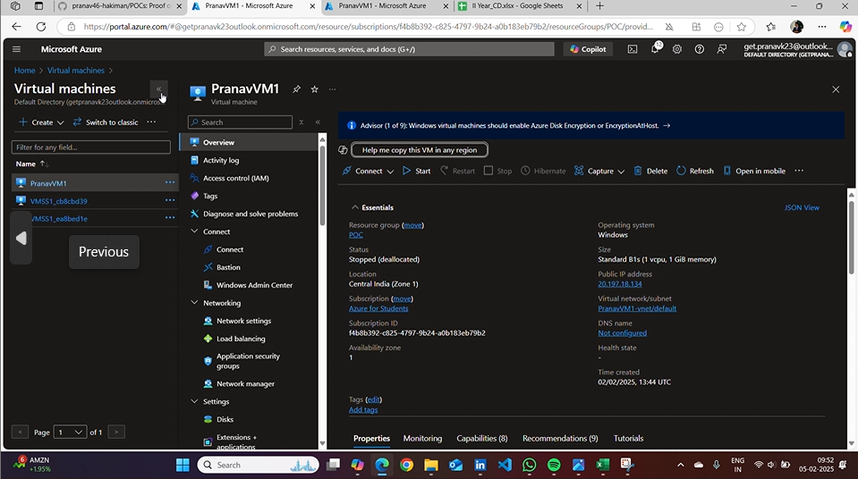

**Step 2:** Go to disks and open the existing disk. Then click on create “+Snapshot”. And enter the following details. 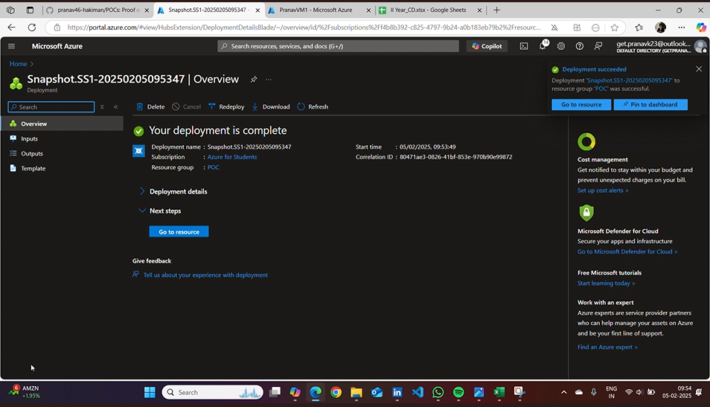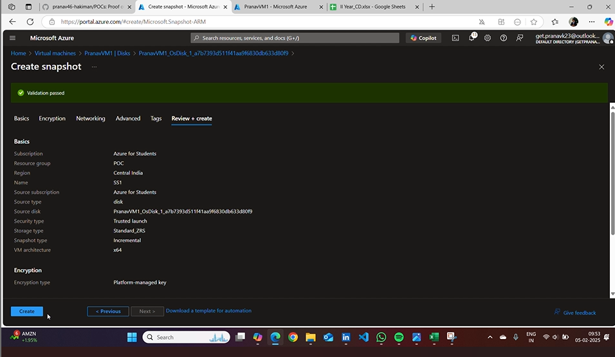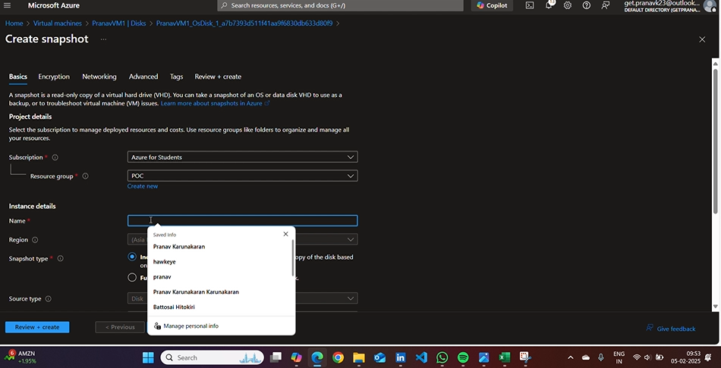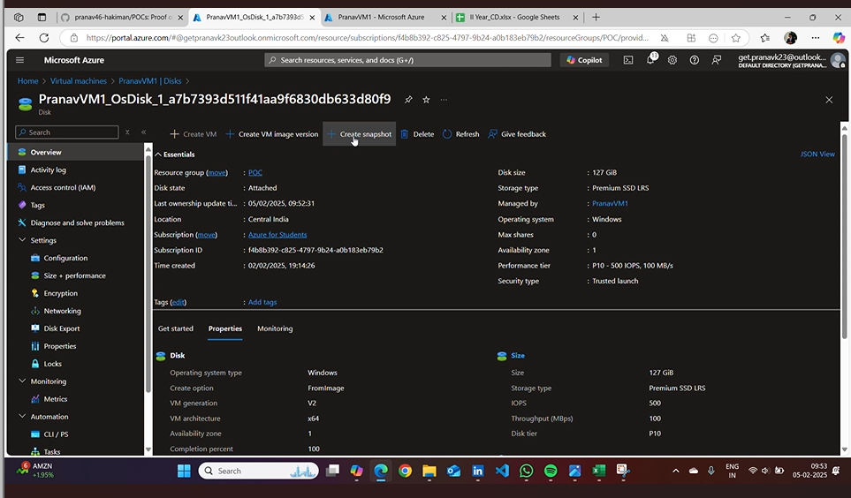

**Step 3:** Open the “Snapshot you created” 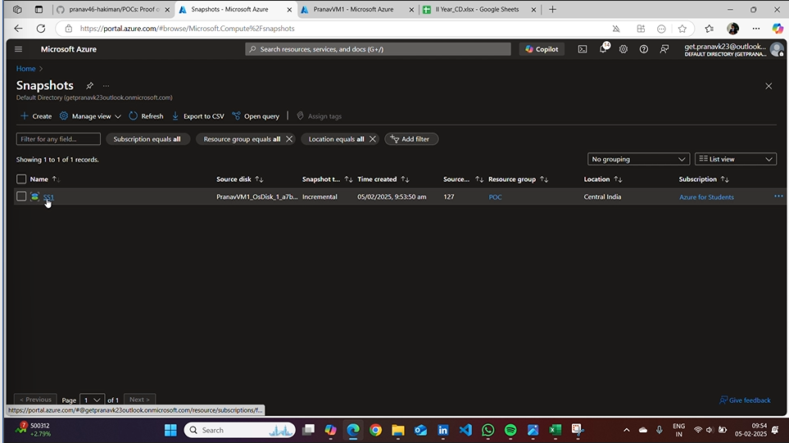

**Step 4:** Delete the existing VM. 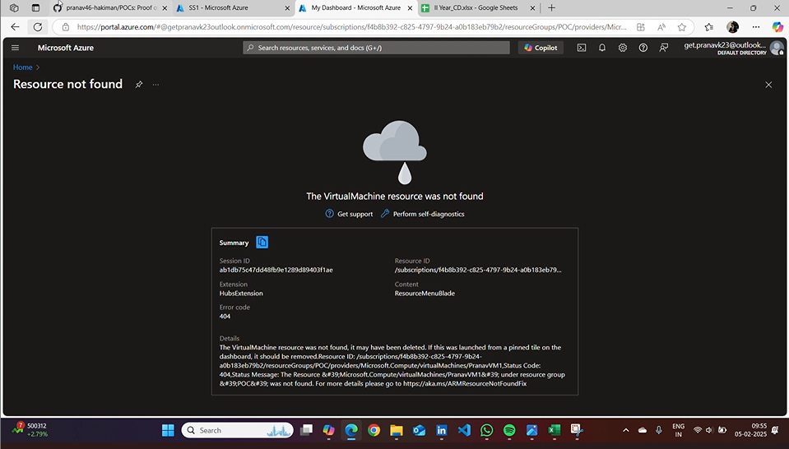

**Step 5:** Restore the VM from the SNAPSHOT. Then create a new disk with same resource group as your SNAPSHOT.

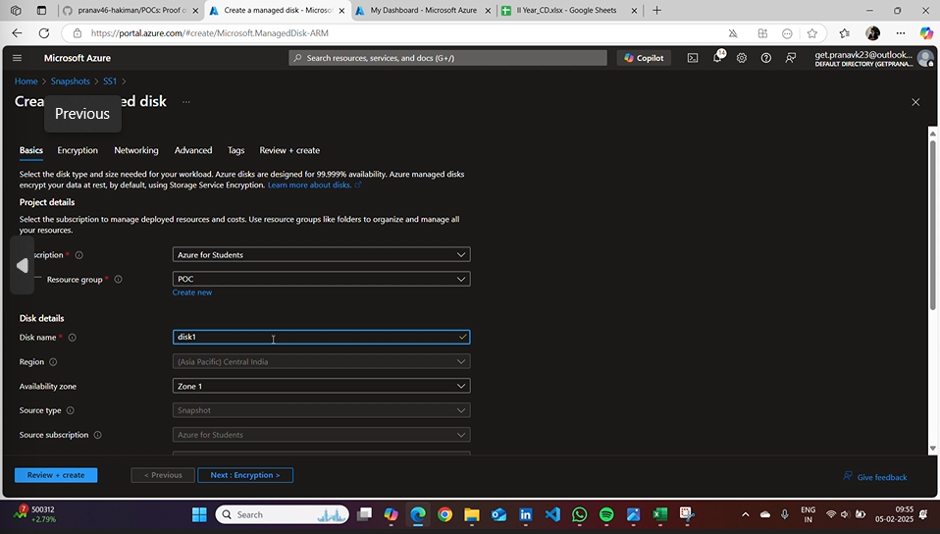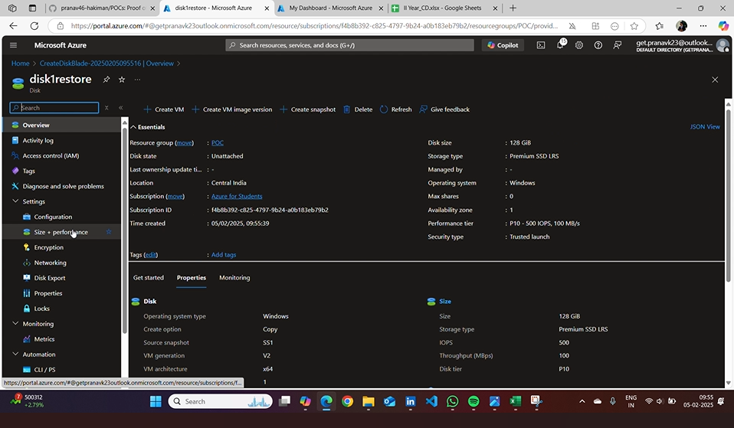

**Step 6:** Create a new VM using the restore disk that you created for restoring.

Got to overview and check the name of the disk. 