

**PLACEMENT EMPOWERMENT PROGRAM**

**Cloud Computing & DevOps Center**

**Set up a VIRTUAL MACHINE on a cloud VM: Launch a Virtual Machine and SSH into it.**

**Name:** Pranav Karunakaran

**Dept:** IT

**INTRODUCTION**

In Azure, setting up a virtual machine (VM) involves several steps to provision and access your VM. First, you need to log into the Azure portal and navigate to the "Virtual Machines" section. There, you can create a new VM by selecting the desired operating system, size, region, and other configurations like networking and security settings. After configuring the VM, Azure will generate a public IP address that you'll use to SSH into the machine.

To SSH into the VM, you’ll need the private key associated with the VM's SSH key pair (unless you used a password for authentication). Using an SSH client, such as the terminal on Linux/macOS or PuTTY on Windows, you can connect to the VM by entering the command ssh username@public-ip-address, where "username" is the name you set up during the VM creation process and "public-ip-address" is the IP assigned by Azure.

Once connected, you can begin managing the VM, install software, and run applications remotely. Azure also provides additional tools, like the Azure CLI and Azure Bastion, for easier and more secure access to your virtual machines.

**Step-by-step process:**

**Step 1:** Open the Azure portal.

[Home - Microsoft Azure](https://portal.azure.com/#home)



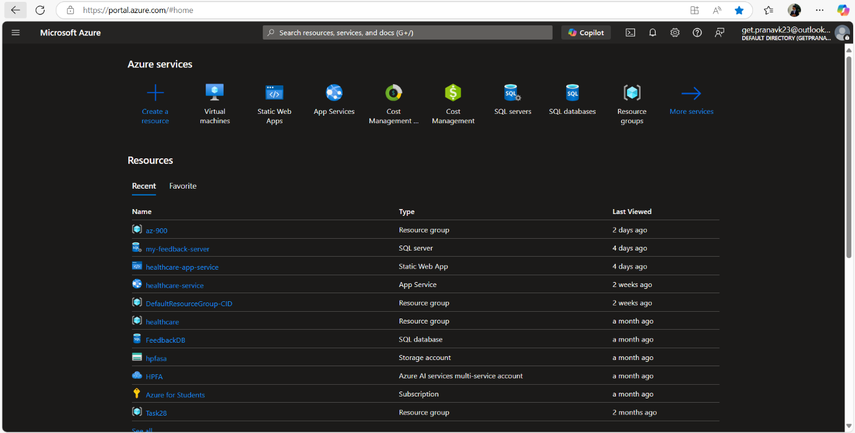

**Step 2:** Navigate to Virtual Machines in menu bar [Located in top left corner of home] (or) you can search Virtual machines in Search bar. 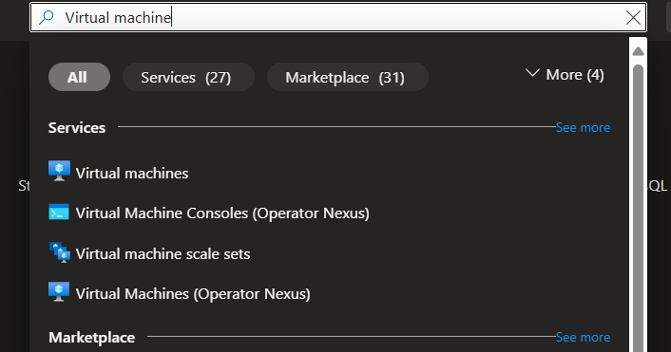

**Step 3**: Select Azure Virtual Machine. 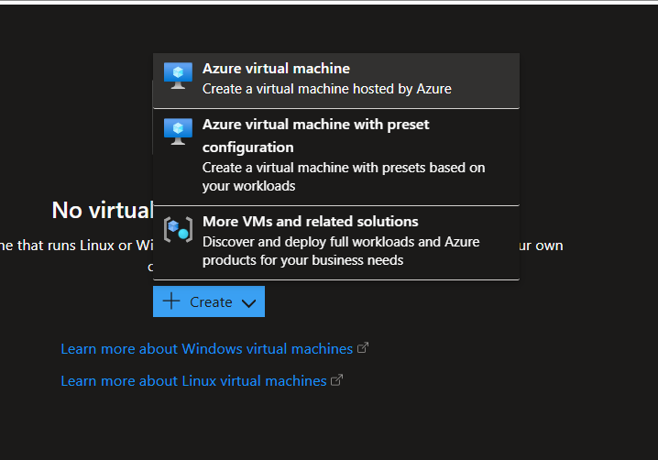

**Step 4:** Enter the following details:

-> Resource Group: you can create a new one or select the existing one. [ your choice ]

-> Virtual Machine name

-> Region

-> Image

-> Size

-> In administrator account : enter Username, password and Confirm Password.

-> Inbound port rules – SSH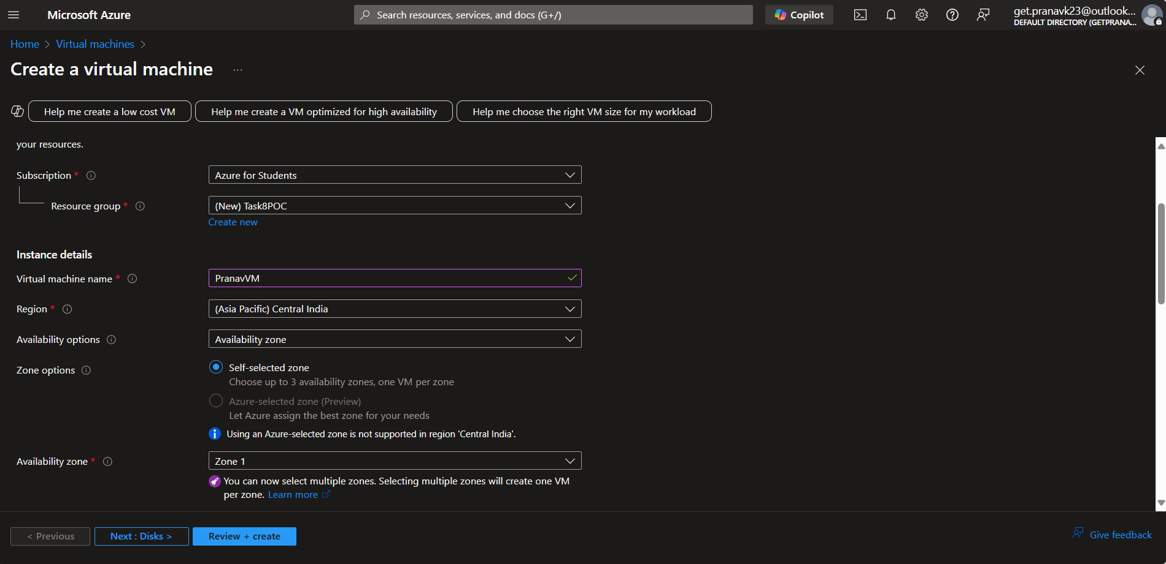

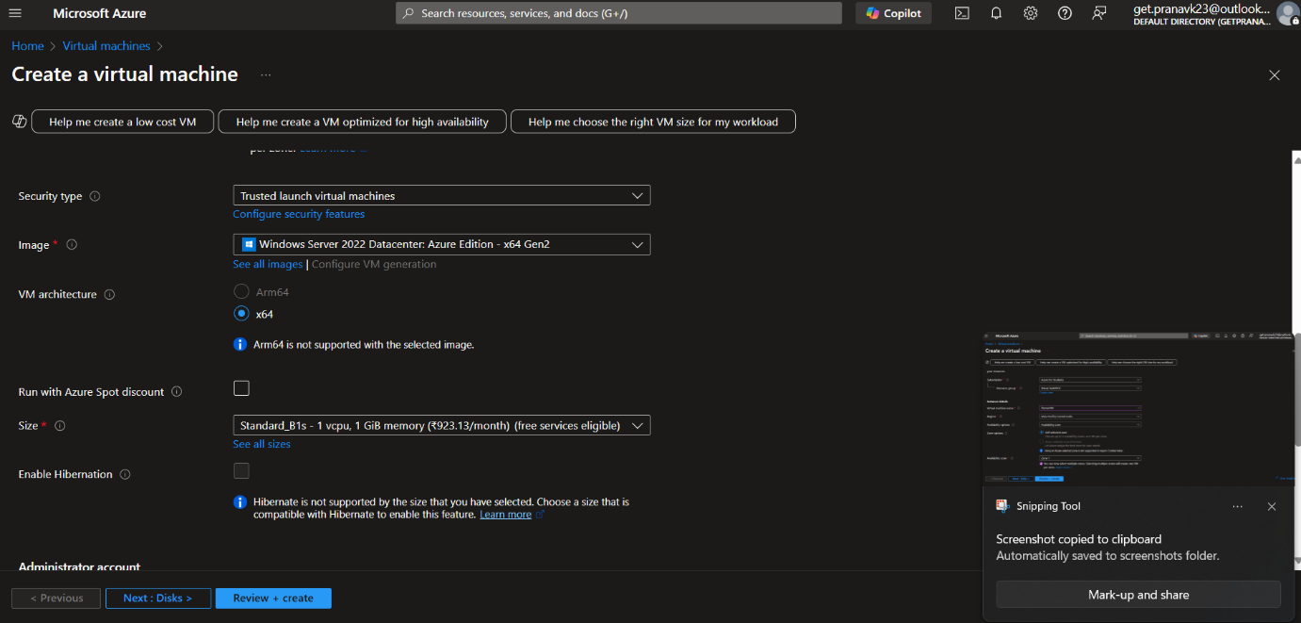

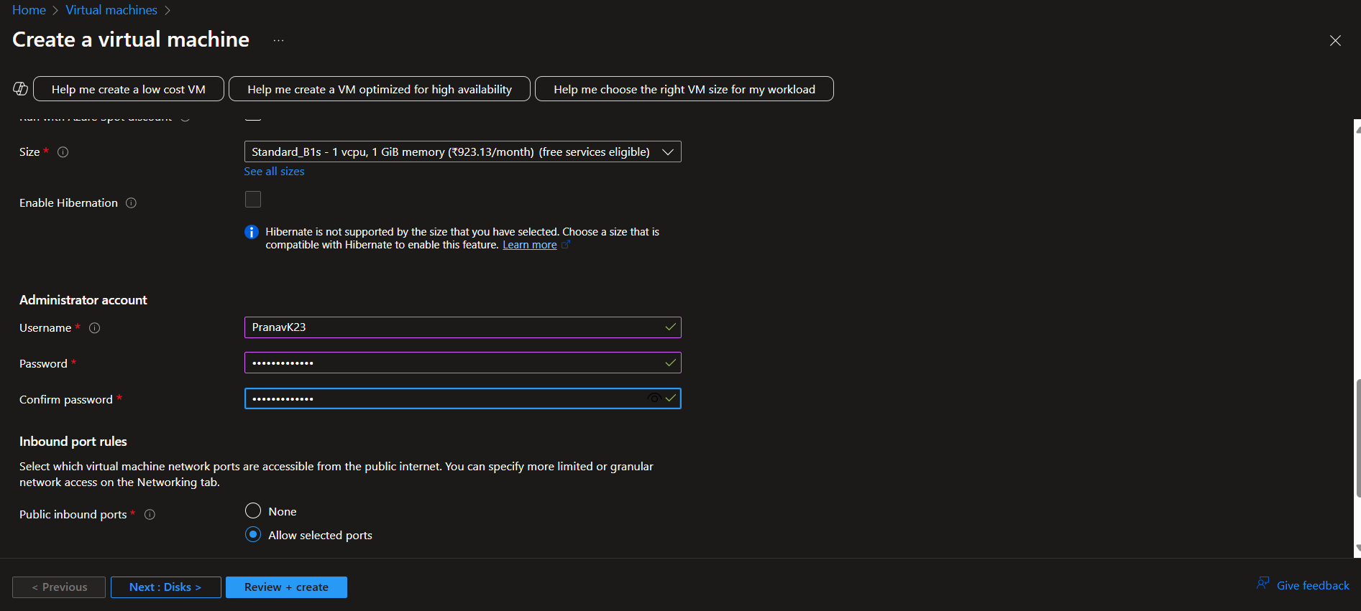

Step 5: Move on to Disk and select Standard SSD.

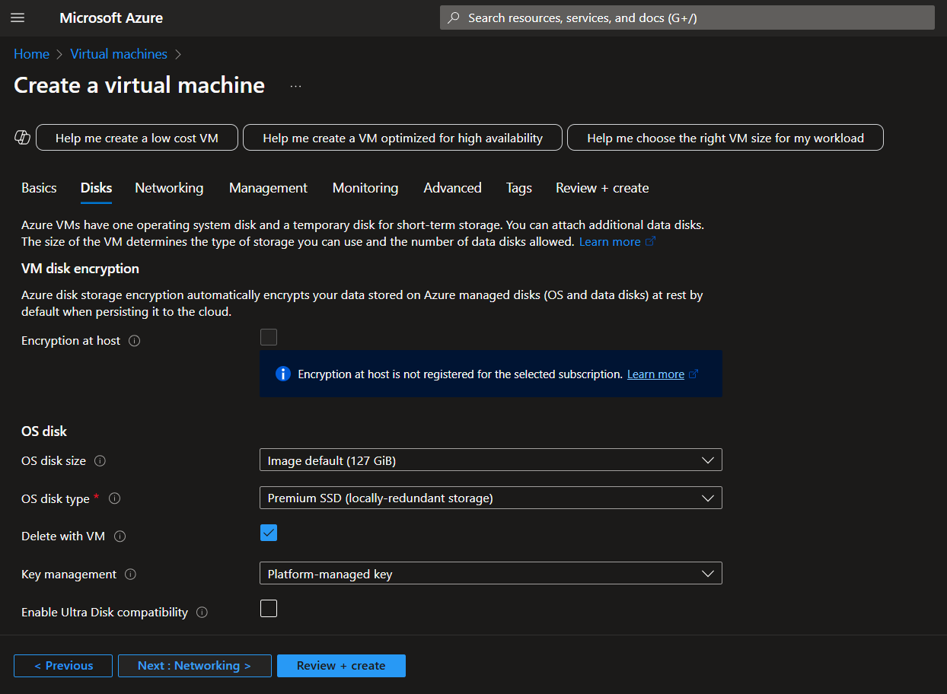

**Step 6:**Click on "REVIEW + CREATE". once reviewed, click on "CREATE" to create the Virtual Machine.

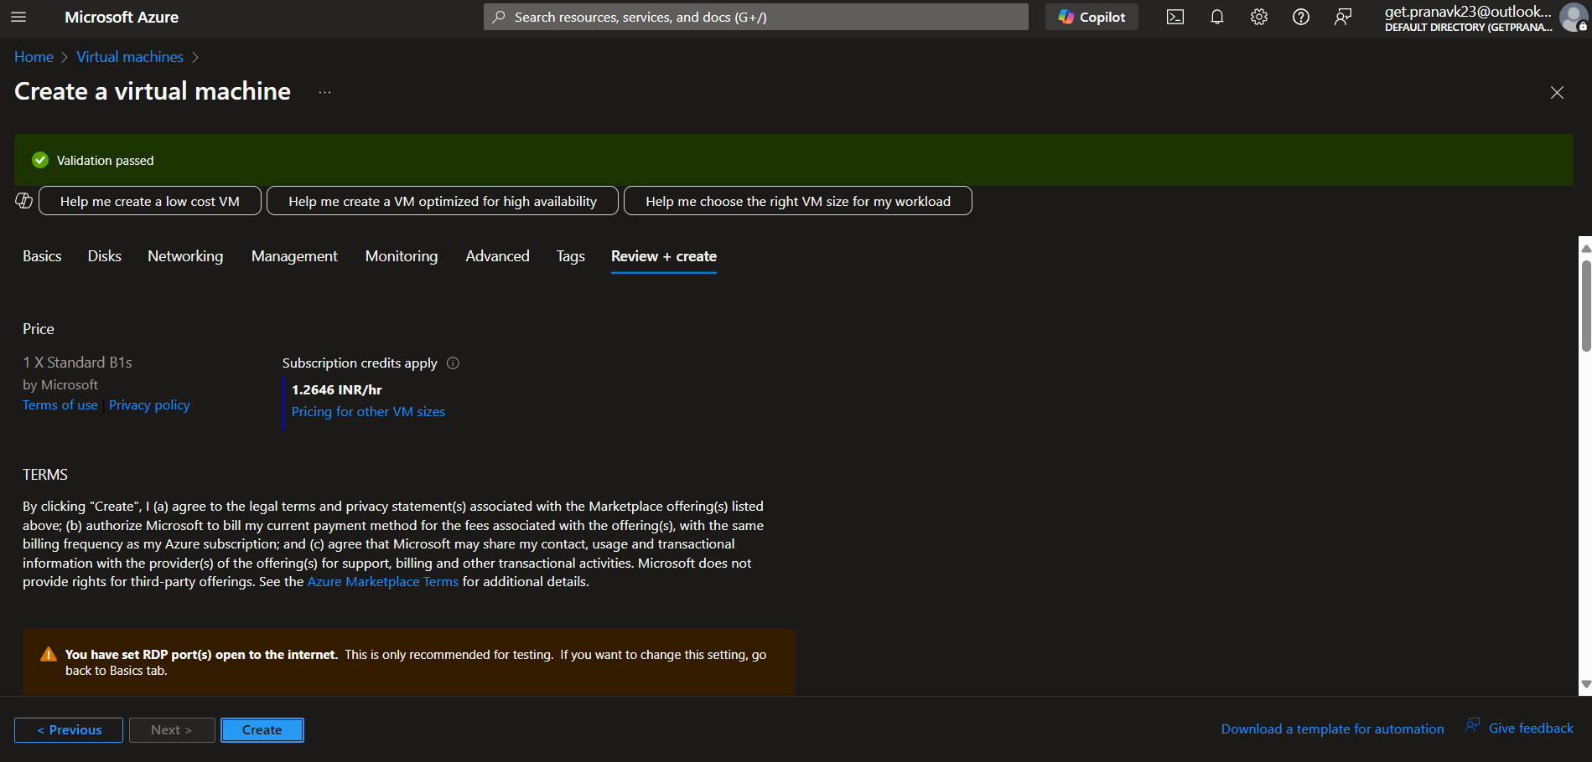

**Step 7:** Once deployment is complete, you can click on go to resource to view the Virtual Machine. 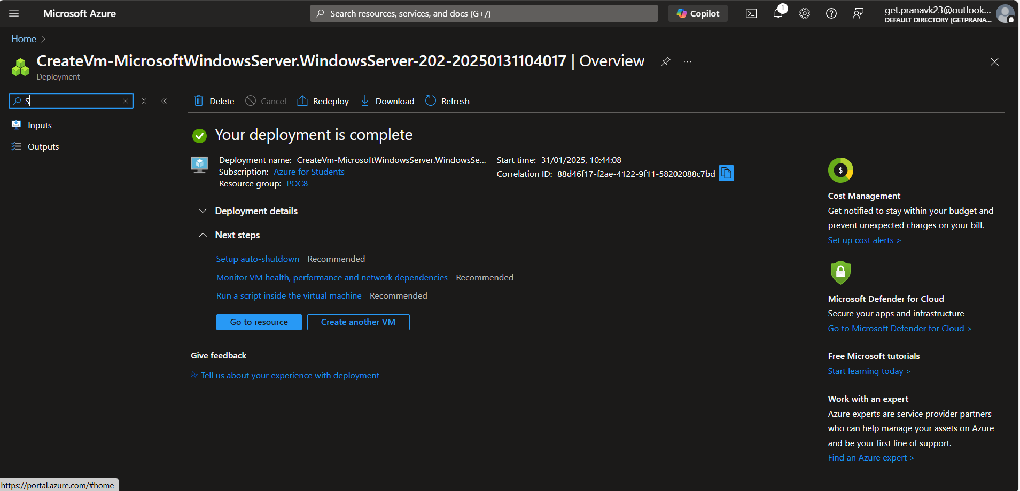

**Azure CLI cmds for connection:**

**POC-8:**

**IN AZURE CLI:**

1. **Enable SSH**

**cmd:** Set-AzVMExtension -ResourceGroupName $myResourceGroup -VMName $myVM -Name 'OpenSSH' -Publisher 'Microsoft.Azure.OpenSSH' -Type 'WindowsOpenSSH' -TypeHandlerVersion '3.0'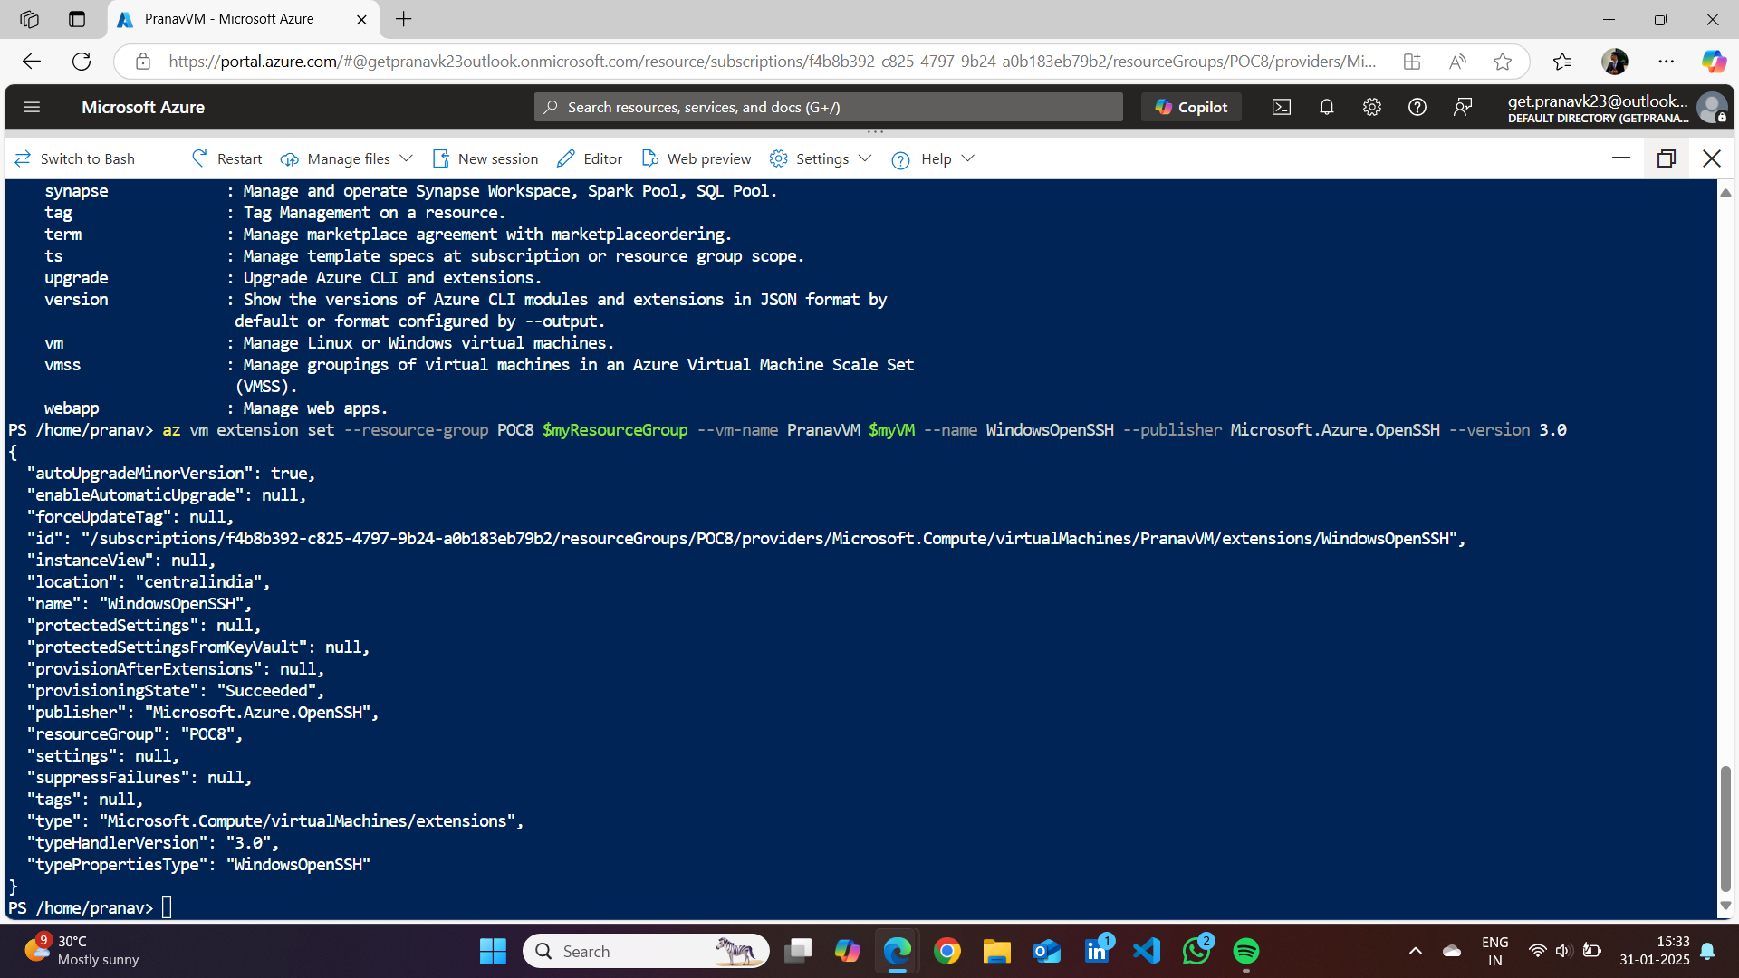

**2. Open TCP port:**

**cmd:** az network nsg rule create -g $myResourceGroup --nsg-name $myNSG -n allow-SSH --priority 1000 --source-address-prefixes 208.130.28.4/32 --destination-port-ranges 22 --protocol TCP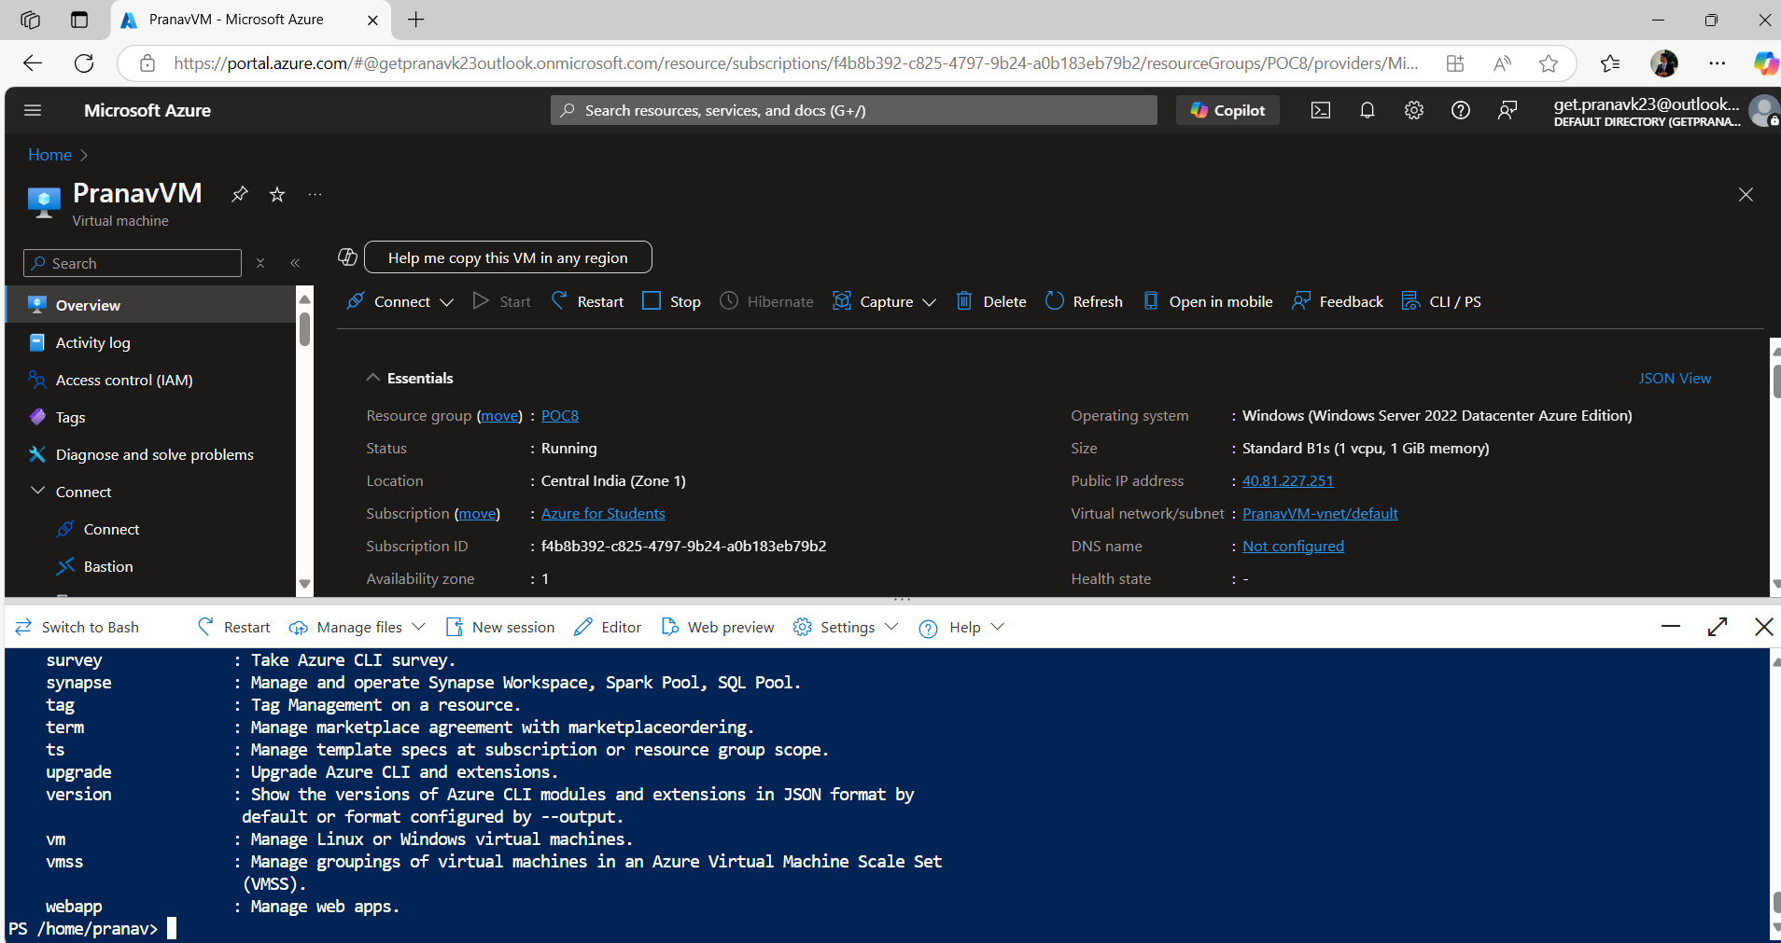

**Note:**

**-------------Before step 3 you need to create a key and save it in the same resource group as your VM---------------**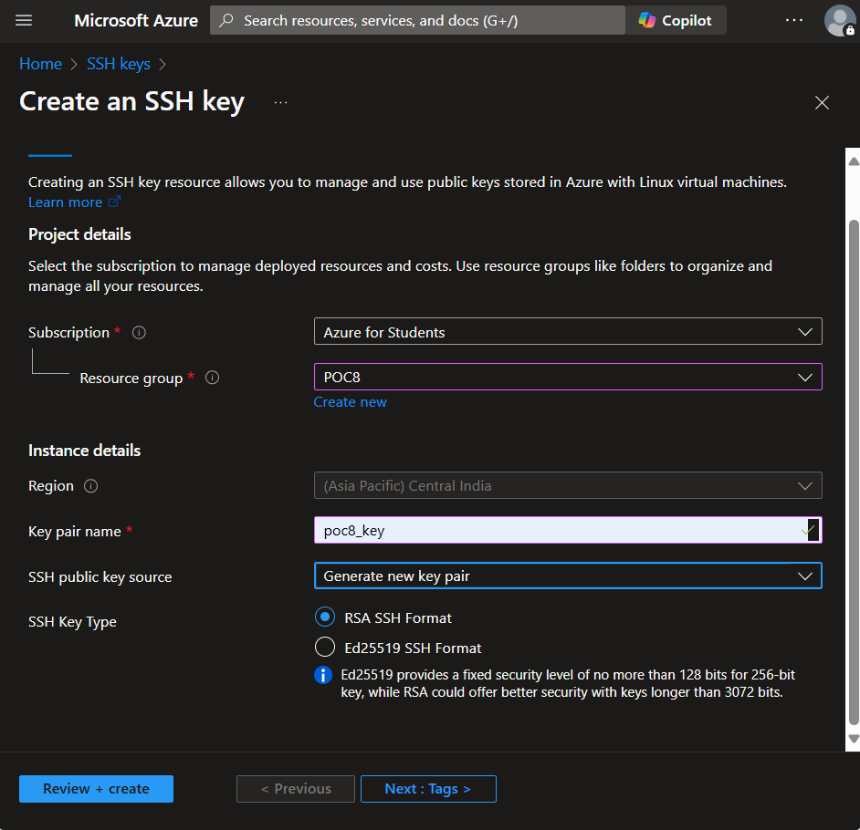

**3. Copy a public key using the RunCommand extension.**

**cmd:** az vm run-command invoke -g $myResourceGroup -n $myVM --command-id RunPowerShellScript --scripts "MYPUBLICKEY | Add-Content 'C:\ProgramData\ssh\administrators_authorized_keys' -Encoding UTF8;icacls.exe 'C:\ProgramData\ssh\administrators_authorized_keys' /inheritance:r /grant 'Administrators:F' /grant 'SYSTEM:F'"

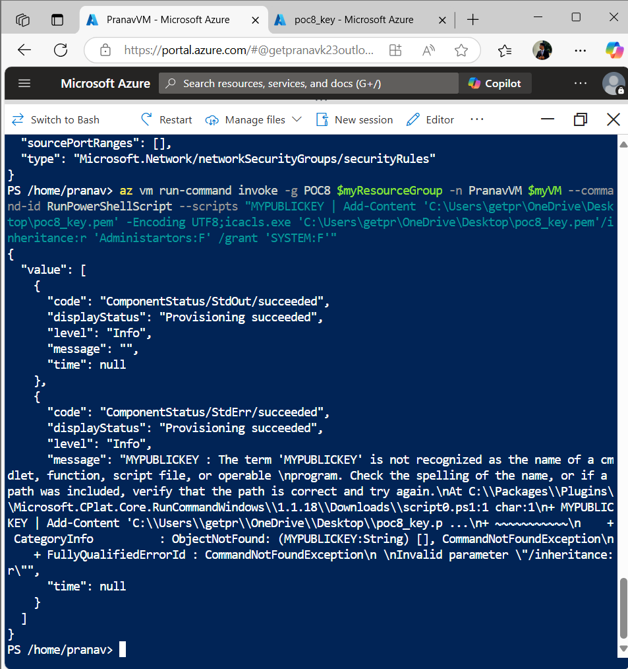

**4. Connect using Az CLI**

**Connect to Windows machines using Az SSH commands.**

**Cmd:** az ssh vm -g $myResourceGroup -n $myVM --local-user $myUsername

**Cmd:** az ssh vm -g $myResourceGroup -n $myVM --local-user $myUsername -- -L 3389:localhost:3389

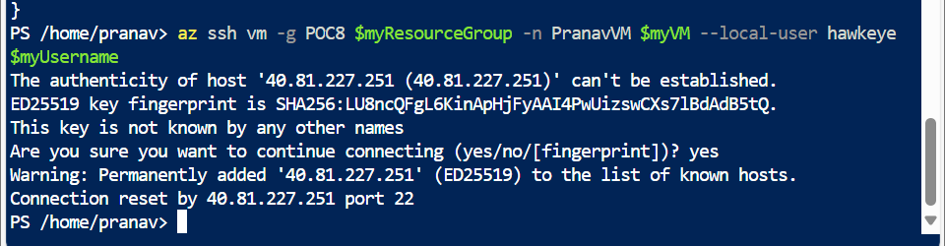

**Step 8:** You need to enter your username and password.



**Step 9:** A new page will open after connection via SSH.

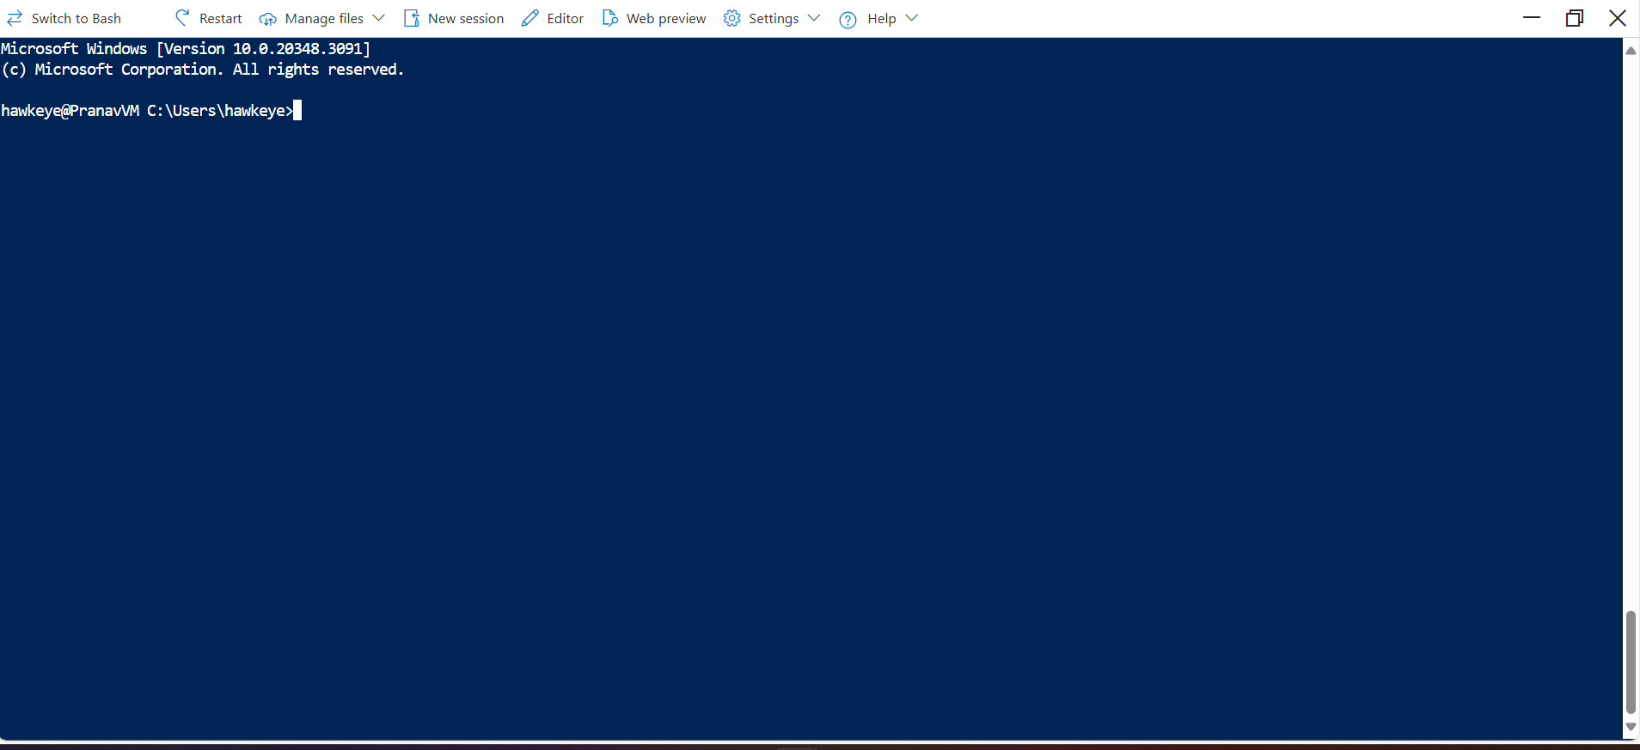

**Successfully connected!**

**Enable SSH**

First, you'll need to enable SSH in your Windows machine.

Deploy the SSH extension for Windows. The extension provides an automated installation of the Win32 OpenSSH solution, similar to enabling the capability in newer versions of Windows. Use the following examples to deploy the extension.