- What is the Project?

When floods or landslides happen, roads and bridges get destroyed. Rescue teams cannot reach trapped people, and they waste hours searching blindly. Normal rescue drones run out of battery in 20 minutes and cannot see under thick trees or inside broken buildings.
Garuda Vedang is a two-part drone system designed to solve this. It uses a large drone to cover a big area, and a tiny drone to look closely at trapped people. It is built using cheap, everyday materials so that local rescue teams can actually afford it.
2. How the System Works The project has three main parts:
The Mothership (Big Drone): This is a fixed-wing drone that flies high and can stay in the air for 60 to 90 minutes. It looks at the big picture, like a 10 km stretch of a flooded river.
The Scout (Small Drone): This is a tiny drone that rides inside the belly of the big drone. When the big drone spots a possible survivor, it drops the small drone mid-air. The small drone flies down to look under trees or inside broken roofs to confirm if people are there.
The Sky Tanker (Future Concept): Drones run out of battery. My idea is to have a third drone that flies above and beams laser light down to charge the other drones mid-air, so they never have to land.
3. Key Features
The Mechanical Latch: The small drone is held in the big drone by a simple mechanical lock and a magnet. It clicks into place like a seatbelt. Because it is mechanical, it will not fail if the computer crashes. The small drone can also fly back and lock itself in again to save battery.
Flying Without GPS: Heavy storms block GPS signals. My drone navigates like a human walking in a dark room. It uses a downward-facing camera to watch the ground move, and a balance sensor to feel its turns. In my computer tests, I turned off the GPS, and the drone still found its way back.
Cheap AI: A powerful computer for a drone costs ₹50,000. Instead of putting that on the drone, I send the video to a normal laptop on the ground. The laptop finds the people and sends the exact location back to the rescue team.
4. What I Have Built So Far
I am currently at the testing and simulation stage. I have not done a full outdoor flight yet, but I have proven the design works through strict testing:
Depron Foam Model: I built a full-size model out of cheap foam to check the exact size, balance the center of gravity, and make sure the small drone fits perfectly in the belly.
Motor Testing: I built a test stand using a digital kitchen scale and a wattmeter. I logged the actual power the motors use, which proves the battery will last for the 60 to 90 minutes we need.
Computer Simulations: I have run hundreds of flight tests in a flight simulator on my computer.
Objective –
To combine hybrid quadcopter and fixed wing technology into one and provide postives of both systems moreover giving efficient misson backup
Technology –
- Geo tagging image classification
- Swarm co-ordination of system (scarlet I )
- Gps less navigation using inertial navigation system
Misson Workflow

Images of the project :
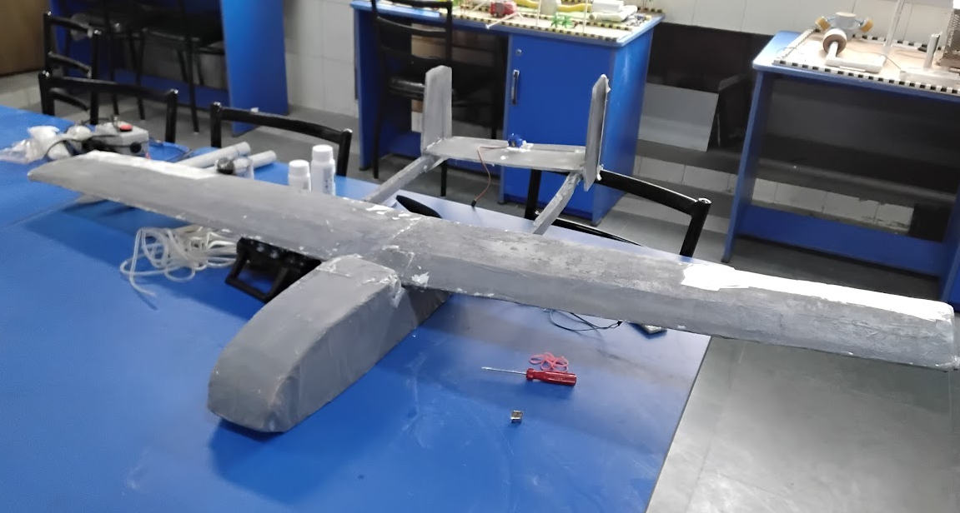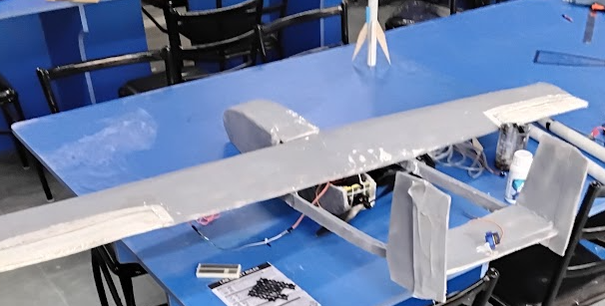
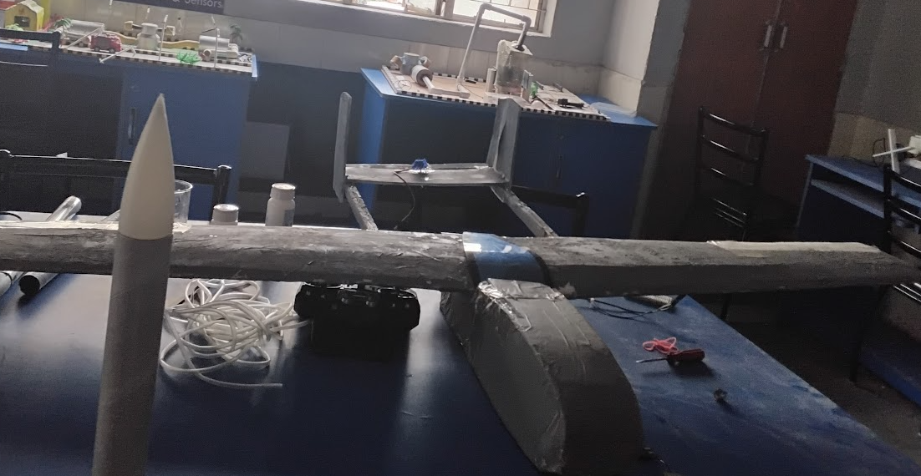

Above are the pictures of currently testbed of mothership made out of depron (xps foam )

