CERTIFICATES & ACHIEVEMENTS
PRANAV KUMAR MISHRA
ID | Achievement / Activity | Organizer | Result / Outcome | Proof
A01 | STEM-A-THON 2026 — Top Young Innovator of India | Robocraze | Rank #56; certificate recognizes innovation, creativity and excellence. | P01
A02 | Indian Space Olympiad 2026 | Indian Space School | 92nd percentile; Advanced Level AIR 47; Grade AIR 24; invited to Young Space Scientist Workshop. | P02
A03 | Confluence 2.0 International Innovation Hackathon | Confluence 2.0 / The Helpers | Recognized as a Top 100 participant for innovative problem-solving and technical contribution. | P04
A04 | Vibe2Ship — India’s Biggest Vibe Coding Hackathon | Coding Ninjas with Google for Developers | Certificate of participation for building AI-powered solutions. | P03
A05 | Samsung Solve for Tomorrow 2026 | Samsung | Participation in Samsung’s innovation programme. | P07
A06 | LearniX IntelliQuest 2026 — Round 1 | LearniX Labs | Participated in Round 1 of IntelliQuest 2026. | P07
A07 | DEVENGERS PromptWars 2026 | DEVENGERS | Participated; developed the Bharat One / Civic AI prototype during the competition. | P07 + uploaded certificate
A08 | ISRO Science Programme Office response | ISRO Science Programme Office | Received an encouraging response on a concept paper, motivating deeper research. | P05
A09 | IIT Delhi faculty appreciation | Indian Institute of Technology Delhi | Appreciation for presentation quality and innovative thinking; advised to seek domain experts for deeper system-level R&D. | P06
A10 | Technical feedback on small-model software assurance experiment | Vidyut Sriram | Feedback supported a model-only vs multi-tool-feedback ablation as the first experiment; follow-up technical discussion arranged. | P08
A11 | CBSE Secondary School Examination 2026 | Central Board of Secondary Education | PASS. English 90, Hindi 91, Mathematics 78, Science 79, Social Science 86; Artificial Intelligence 95 (additional subject). | P09
A12 | Founder’s Playbook Webinar | Entrepreneurship session / workshop | Participated in a session on building winning startup teams. | P04
A13 | AI for Bharat Hackathon 2026 — Eliminator Round | IIIT Delhi / Unstop | Participated in the Eliminator Round – Idea Submission: “Build AI Solutions for India’s Real Problems.” | Uploaded certificate
A14 | The ₹100 Founder Challenge — Startup Blueprint Submission | TechVerse Solutions / Unstop | Participated in the Startup Blueprint Submission stage. | Uploaded certificate

2. Certificate Portfolio
Full-page reproductions of the three newly uploaded certificates are included below. The original PDF files are not embedded as PDFs; each certificate is reproduced as an image inside this Word document.

Certificate 1 — AI for Bharat Hackathon 2026
Participation in the Eliminator Round – Idea Submission, organized by Indraprastha Institute of Information Technology Delhi.
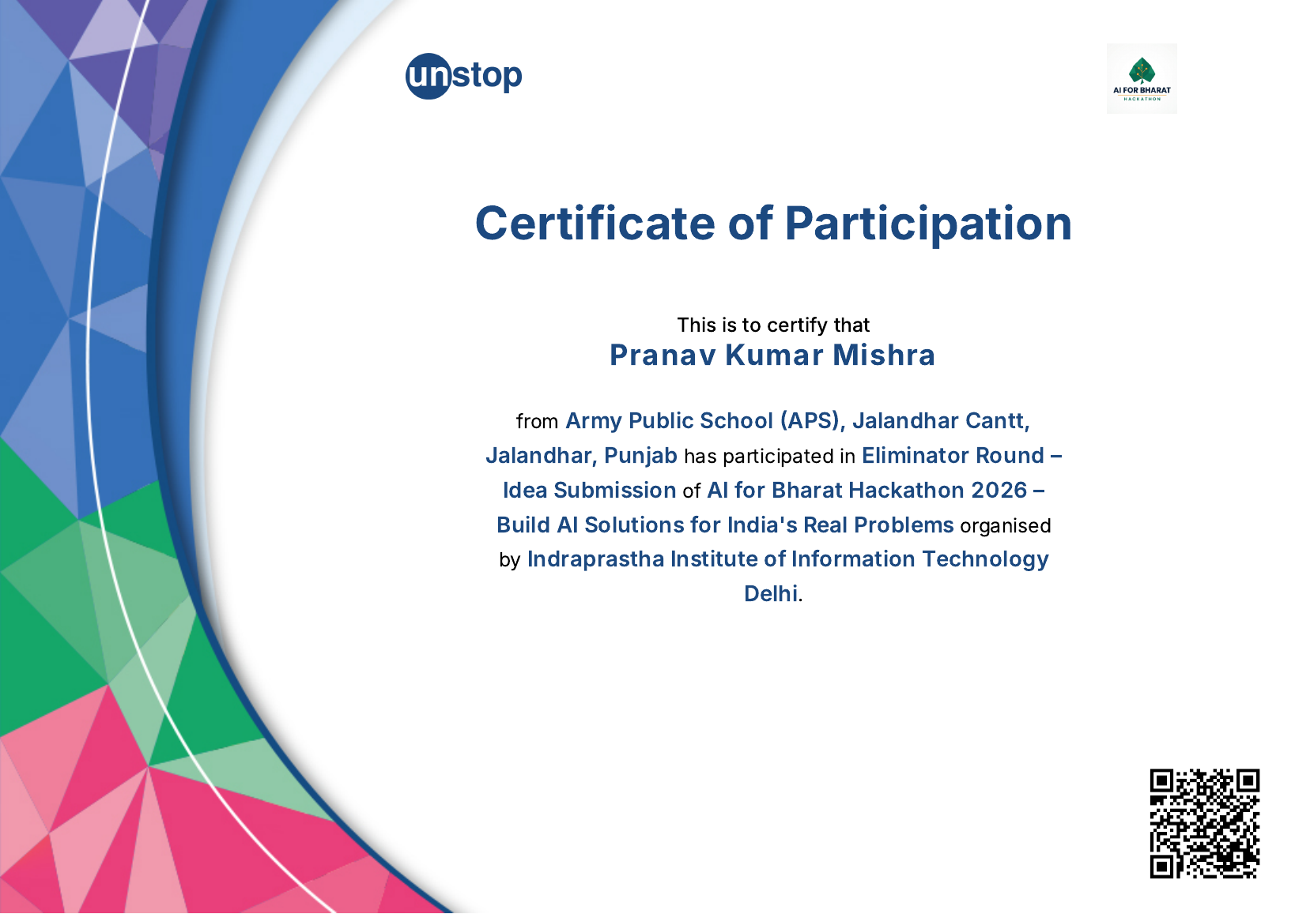

Certificate 2 — The ₹100 Founder Challenge
Participation in the Startup Blueprint Submission stage, organized by TechVerse Solutions.
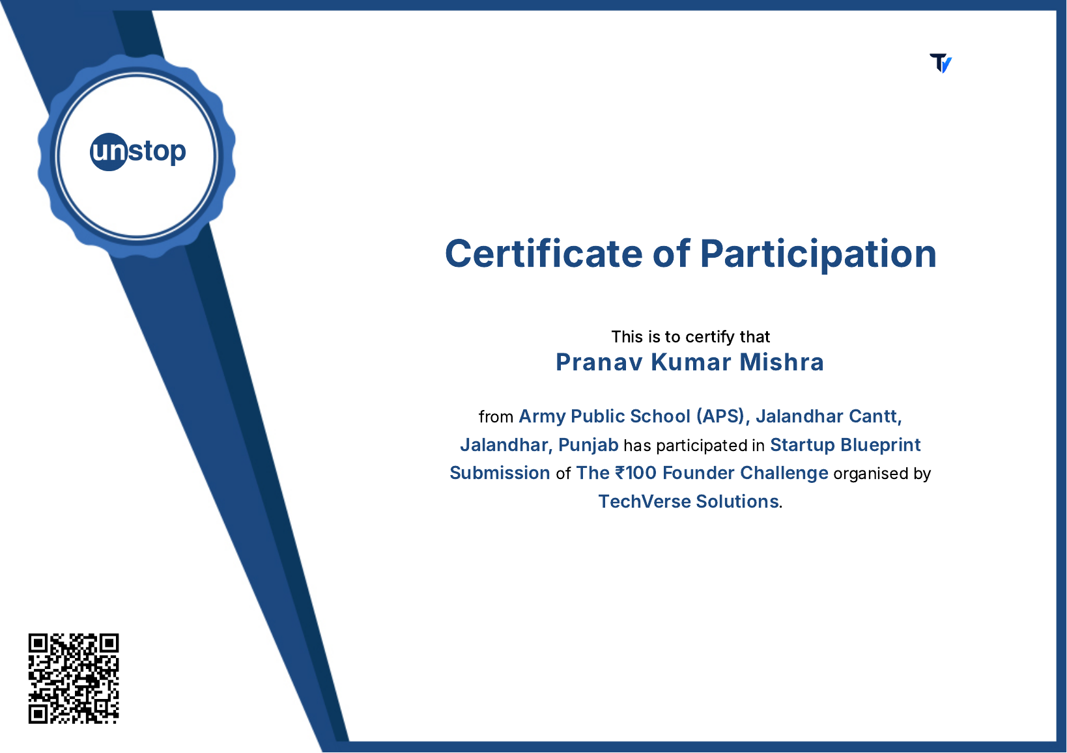

Certificate 3 — DEVENGERS PromptWars 2026
Certificate of participation in DEVENGERS PromptWars 2026.
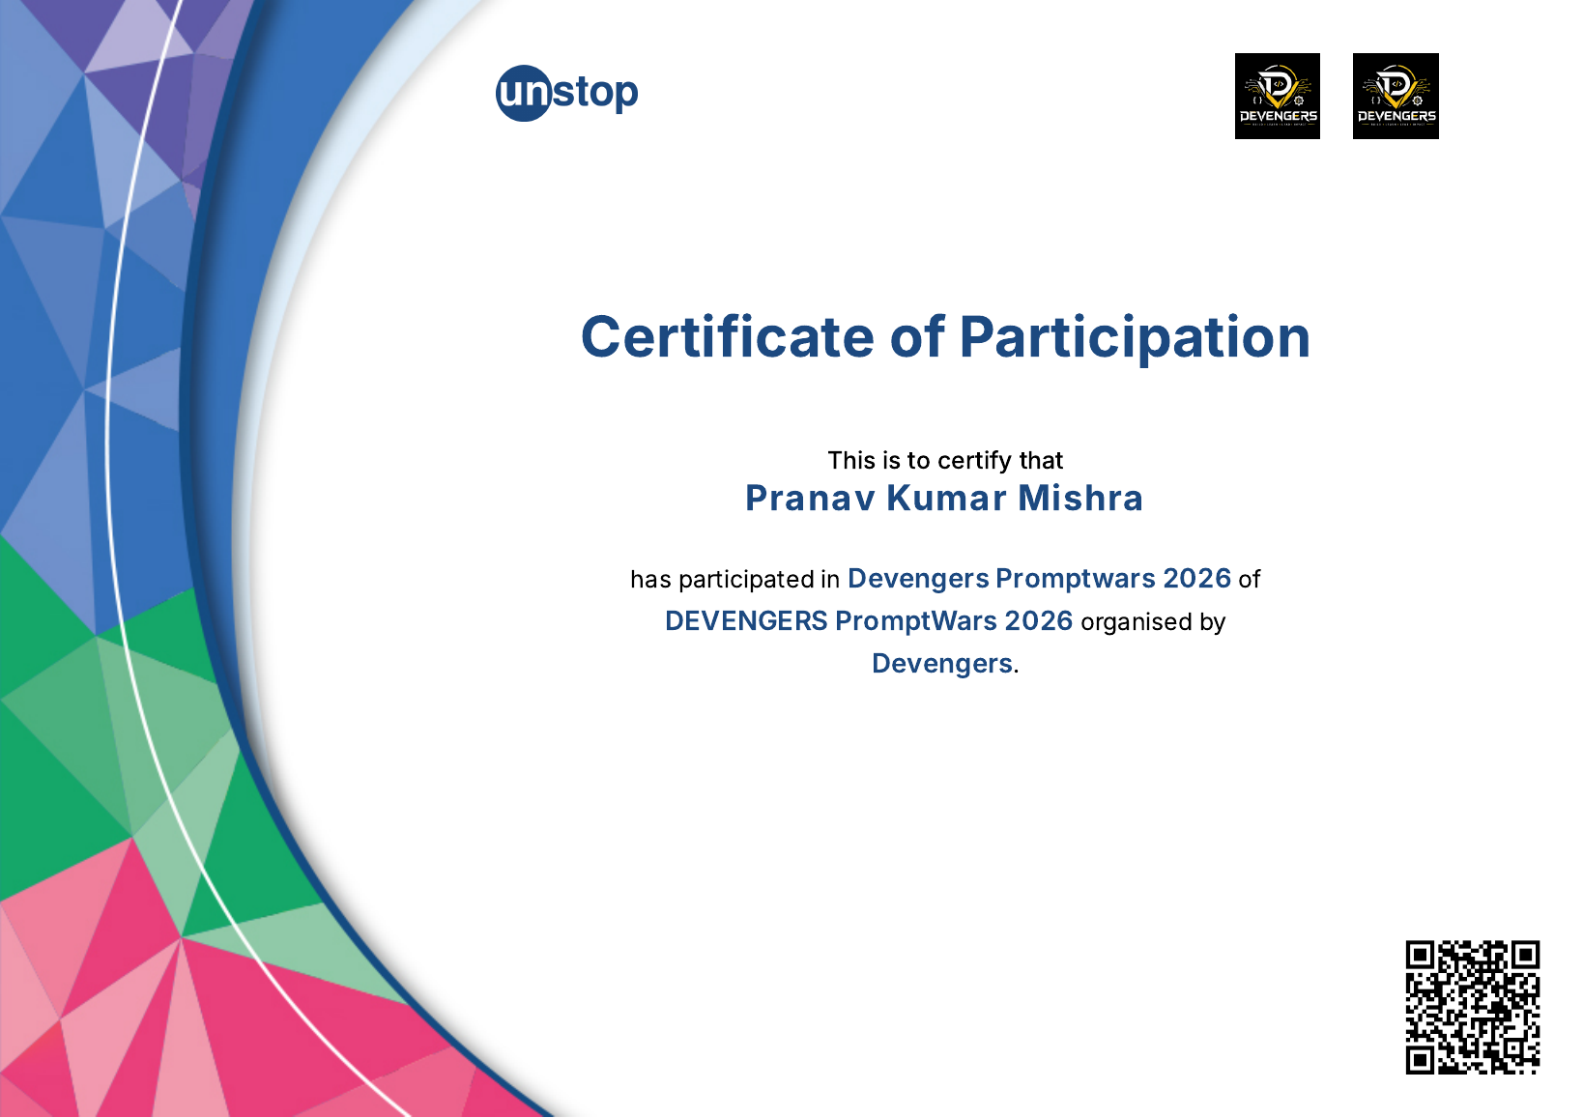

3. Supporting Evidence & Related Items
The achievement workbook contains nine proof items (P01–P09). They are reproduced here as supporting evidence. Some are official result/certificate images; others are documented feedback, correspondence or composite achievement-record pages.

P01 — STEM-A-THON 2026 certificate photo
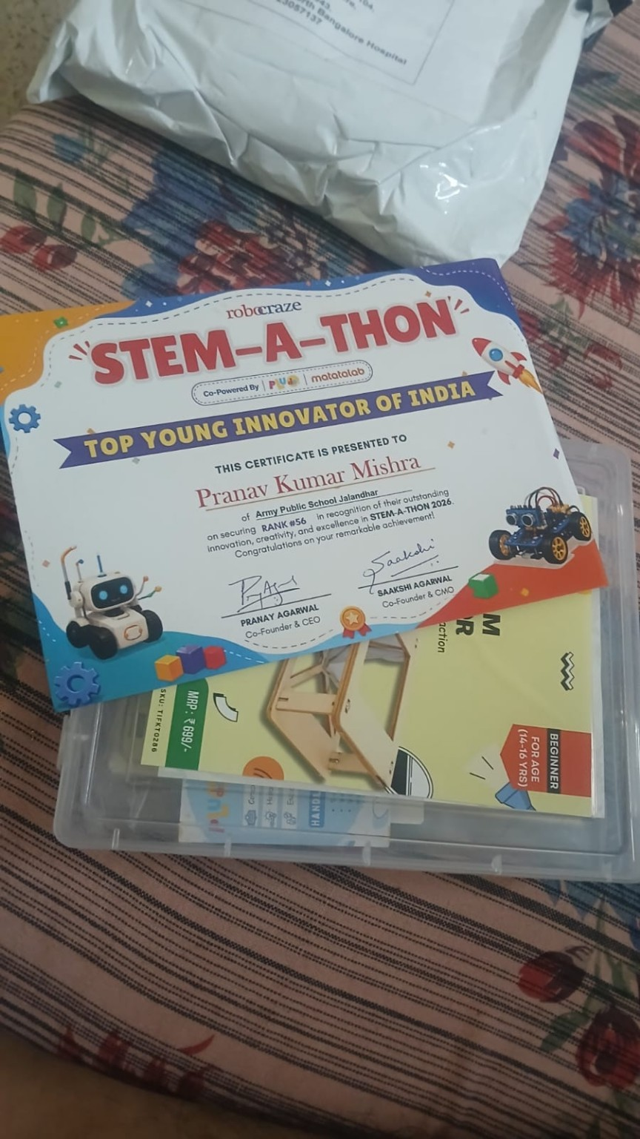

P02 — Indian Space Olympiad 2026 official result
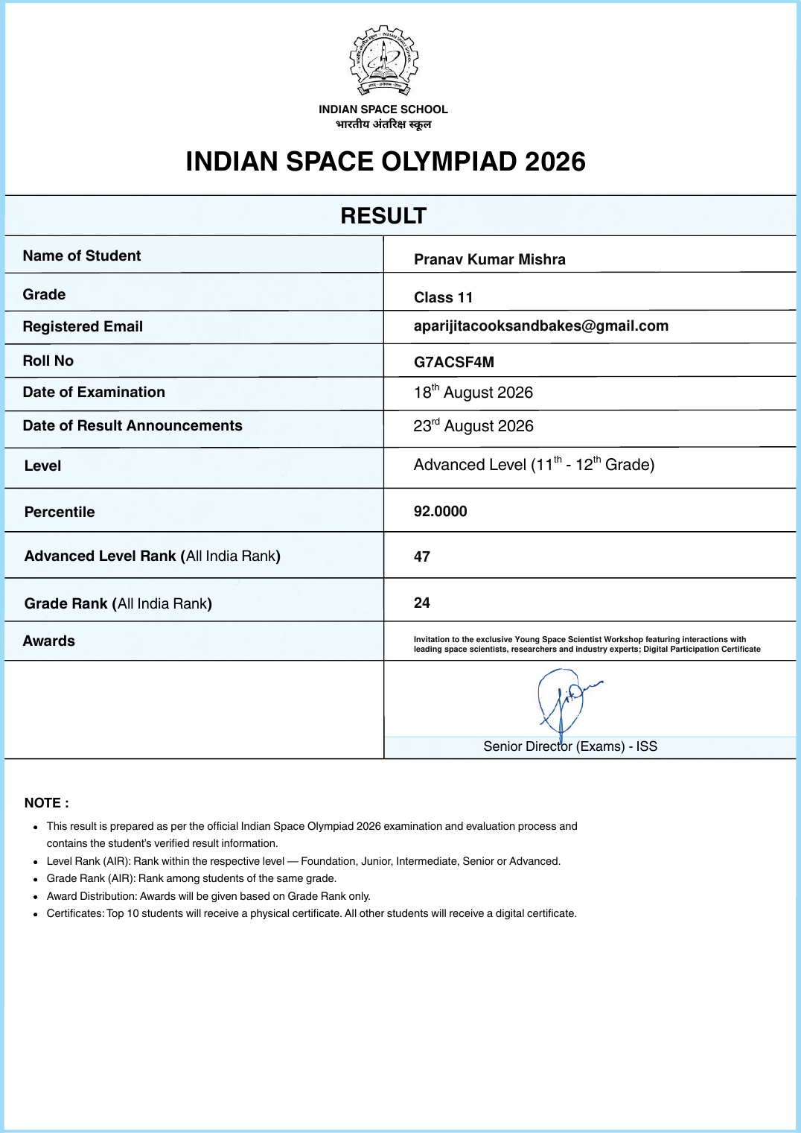

P03 — Vibe2Ship certificate of participation
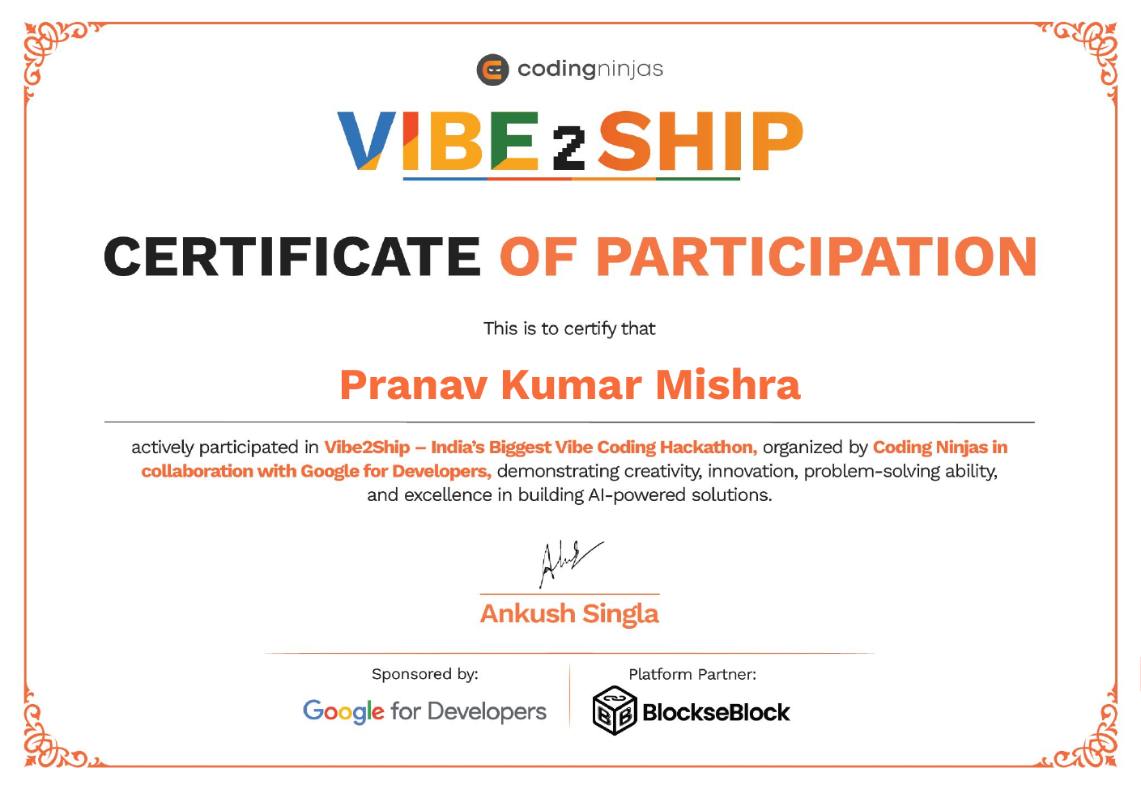

P04 — Achievement Record page 1 — Confluence 2.0 + Founder’s Playbook
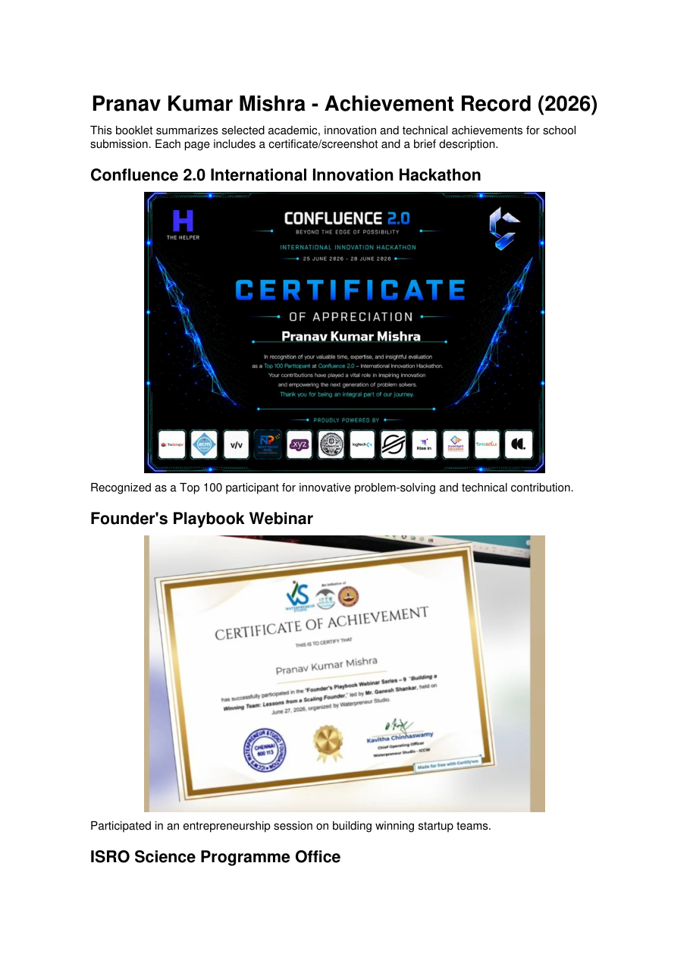

P05 — Achievement Record page 2 — ISRO Science Programme Office response
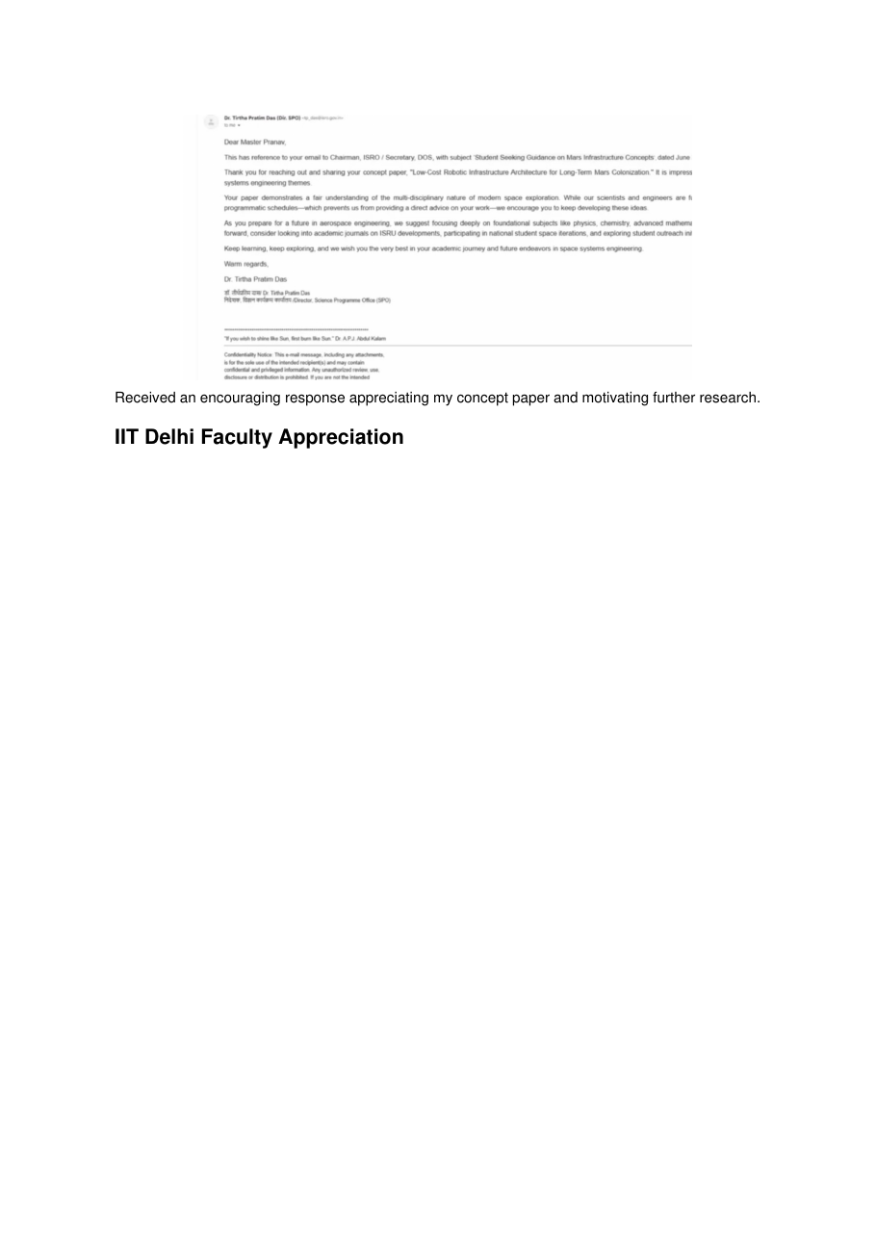

P06 — Achievement Record page 3 — IIT Delhi faculty appreciation
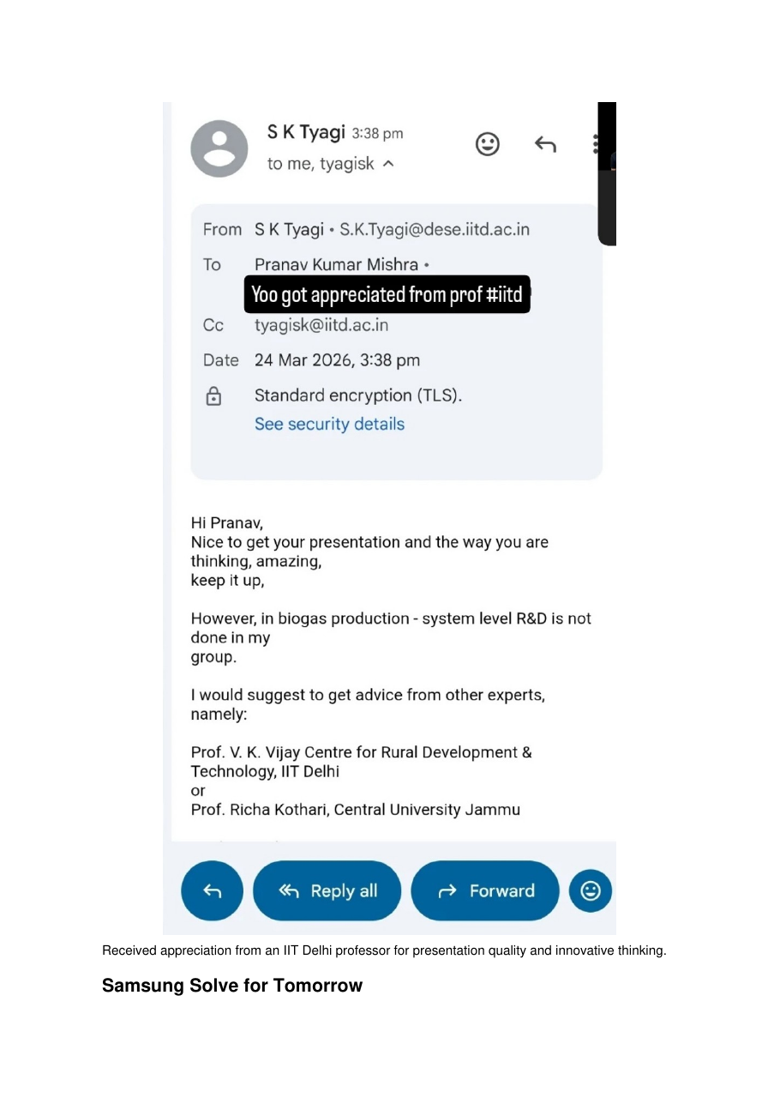

P07 — Achievement Record page 4 — Samsung, LearniX and DEVENGERS
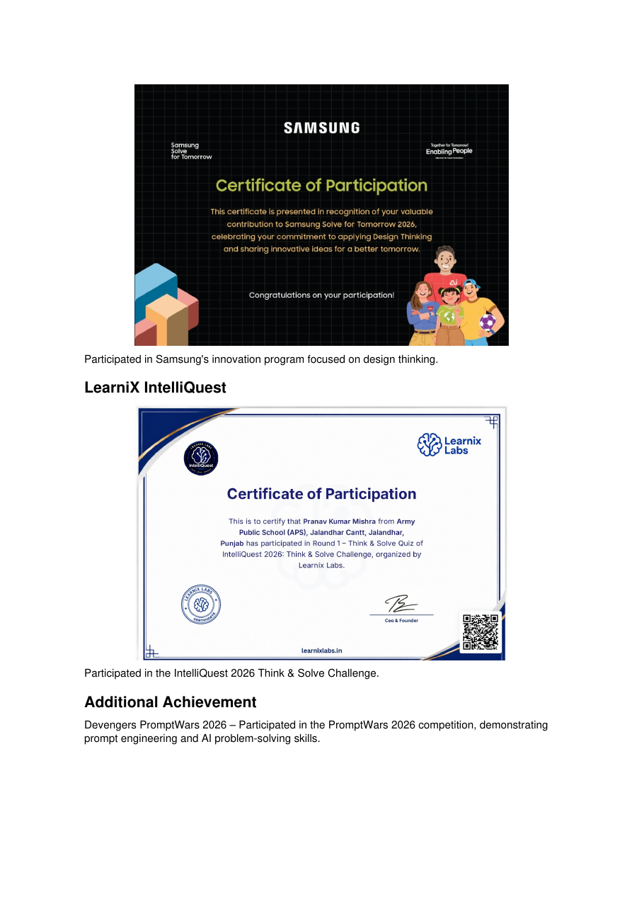

P08 — Vidyut Sriram technical-feedback email screenshot
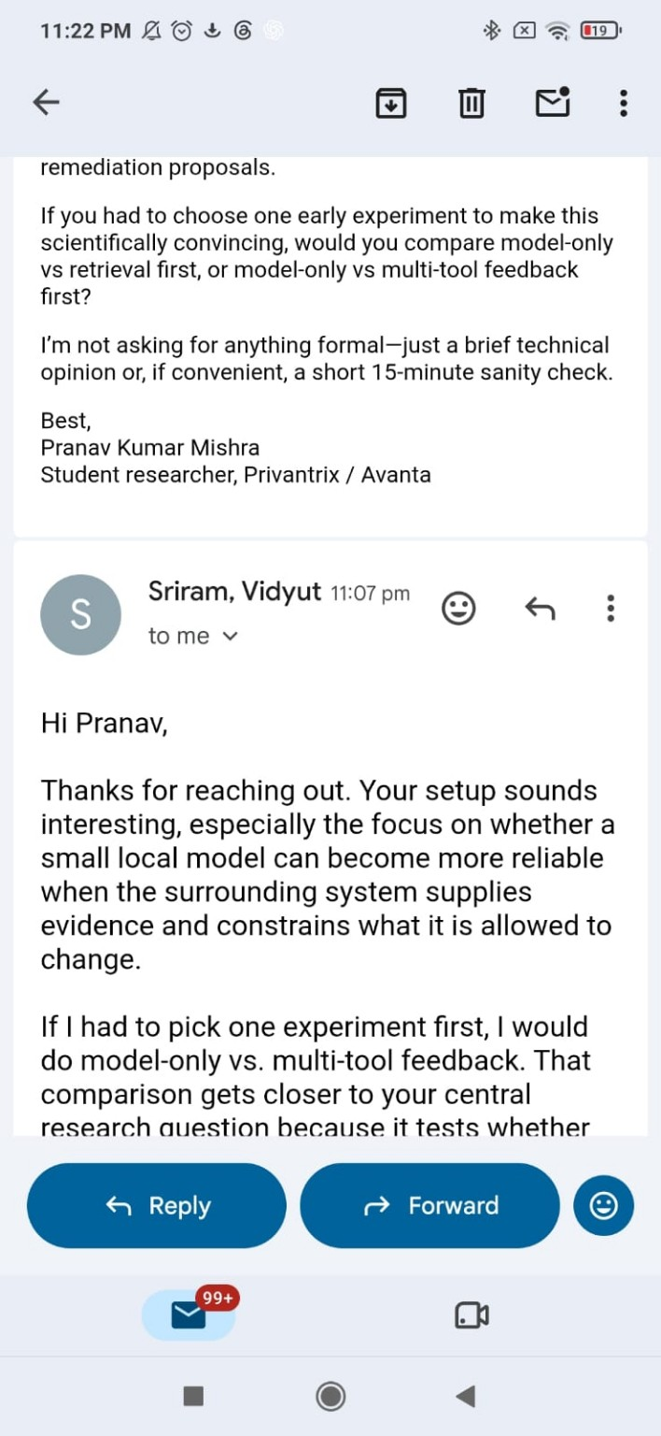

P09 — CBSE 2026 marks statement
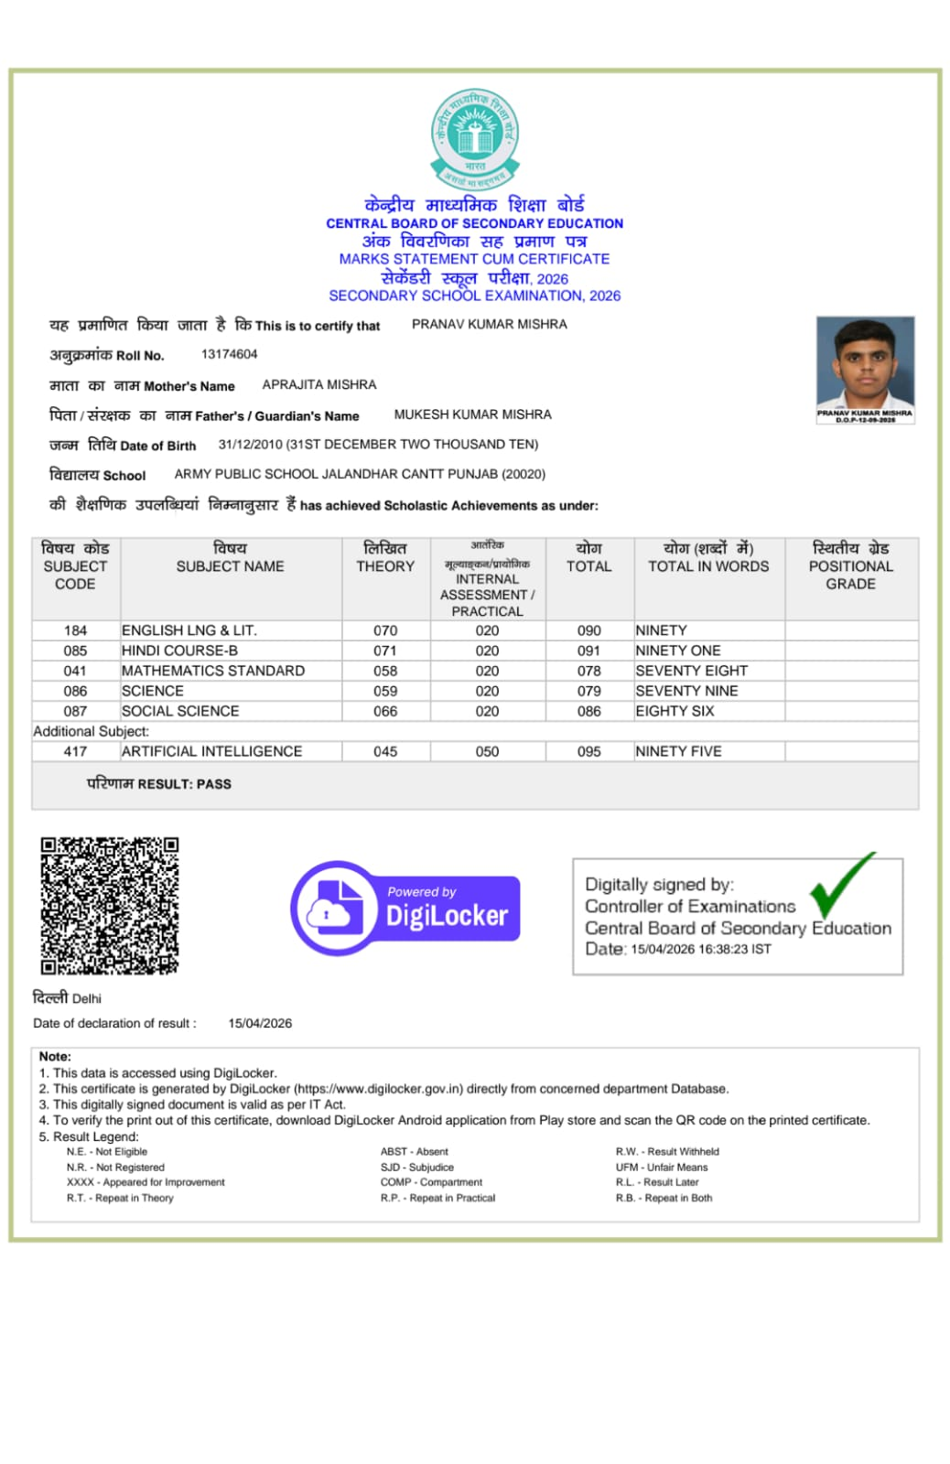

5. Related Research & Project Context
The technical CV provides context for the work associated with several competitions and external-feedback items. This section is contextual rather than a certificate claim.

Compact multilingual ASR small language model
ISEF-oriented independent research; streaming ASR for multilingual, resource-constrained devices; research and architecture stage before fine-tuning.

Rudra Sentinel — verification-first software assurance
Local small-model repository-aware vulnerability analysis and safer code repair using retrieval, static checks, compilation/tests, sandbox evidence and human approval.

ESCL-II — electromagnetic space-launch assist concept
Independent concept research for an evacuated electromagnetic/maglev launch-assist architecture paired with a rocket upper stage.

Fixed-wing flight-control and stabilizer
ESP32 + MPU6500 prototype with FS-i6/iBUS input, Kalman-filtered attitude estimation, auto-level behavior, failsafe logic and telemetry.

Envirosynk AI / Ecosentinel
Physical-AI environmental sensing and purification concept prepared for the Qualcomm-Arduino Physical AI Challenge India; no selection or award claimed.

Bharat One / Civic AI
Next.js/Firebase civic-reporting prototype with AI-assisted classification, maps, duplicate detection, heatmaps and resource-allocation workflows.

FlowDictate
Local-first desktop dictation using C++/Qt, whisper.cpp/llama.cpp, segmentation and recovery checkpoints.

VID-ED X
Tauri/React/Rust/SQLite/FFmpeg editing workflow with local-model assistance and cloud fallback.

Sanjeevani edge-AI medical kit
Offline first-aid guidance, local-language interaction, clinician connectivity and resilient power concept.

Photonic and neuromorphic computing experiments
Small optical-computing, fiber-signaling and hybrid photonic/FPGA explorations; conceptual and experimental.

