TryHackMe — Invite Only: Threat Intelligence Investigation Writeup
Introduction
Threat intelligence investigations are a major part of SOC operations. Analysts are often required to investigate suspicious indicators such as IP addresses, hashes, domains, and malware samples to determine whether they are linked to active threats or known campaigns.
In this TryHackMe room, I worked through a practical threat intelligence investigation where the goal was to analyse suspicious indicators, pivot across related malware artefacts, and connect the activity to a real-world phishing and malware delivery campaign.
The room simulated a realistic SOC workflow where an escalated alert required deeper analysis and threat correlation.

Scenario
I was assigned the role of a SOC analyst working with an L3 analyst to investigate suspicious indicators that were escalated by the L1 team.
The investigation started with two flagged indicators:
Suspicious IP
101[.]99[.]76[.]120
Suspicious SHA256 Hash
5d0509f68a9b7c415a726be75a078180e3f02e59866f193b0a99eee8e39c874f
The room provided access to a threat intelligence platform called TryDetectThis2.0, which was used to investigate the indicators and pivot through related artefacts.

Initial Hash Investigation
The first step was analysing the suspicious SHA256 hash to identify the associated file and its characteristics.

Question:
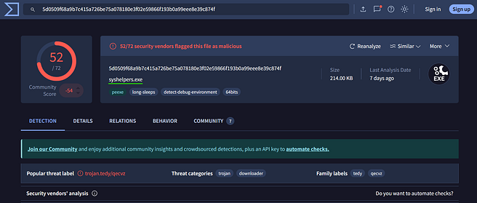
What is the name of the file identified with the flagged SHA256 hash?
Answer:
syshelpers.exe
The filename immediately appeared suspicious because attackers often use generic or system-like names to avoid detection and blend in with legitimate Windows files.

Question:
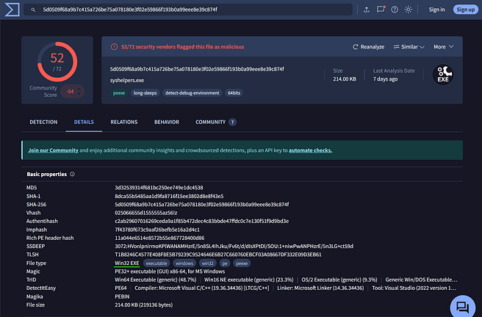What is the file type associated with the flagged SHA256 hash?
Answer:
Win32 EXE
This confirmed that the file was a Windows executable, which is commonly used for malware delivery and payload execution.

Parent Process Investigation
The next step involved analysing the execution chain to understand how the malicious executable was launched.

Question:
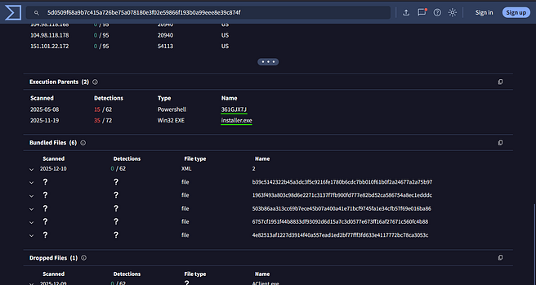
What are the execution parents of the flagged hash?
Answer:
361GJX7J, installer.exe
This showed that the malware execution originated from another suspicious executable, indicating a staged malware delivery chain.
Tracking parent-child process relationships is important during investigations because it helps analysts understand how malware was introduced and executed on the system.

Dropped File Analysis
The investigation then moved toward identifying files dropped during execution.

Question:
What is the name of the file being dropped?
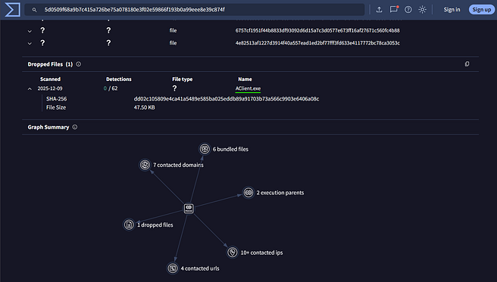
Answer:
Aclient.exe
Dropped executables are often secondary payloads used for persistence, credential theft, or remote access.

Question:
Research the second hash from the execution chain and identify the four malicious dropped files.
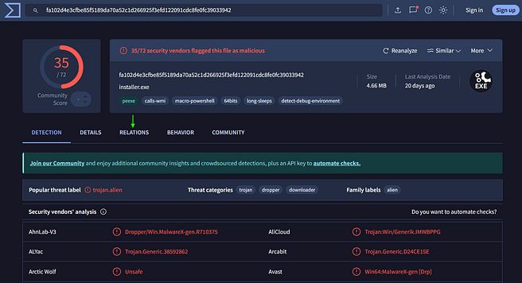
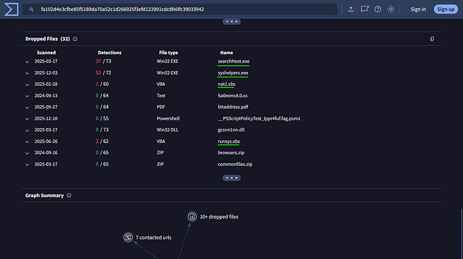
Answer:
searchhost.exe, syshelpers.exe, nat.vbs, runsys.vbs
This stage revealed multiple malicious artefacts, including:
- Executables
- VBScript persistence files
- Potential loader components
The presence of .vbs scripts suggested persistence or automated execution techniques commonly used by malware operators.

Malware Family Correlation
After pivoting through the related files and indicators, the investigation focused on identifying the malware family associated with the campaign.

Question:
What malware family was linked to the flagged IP?
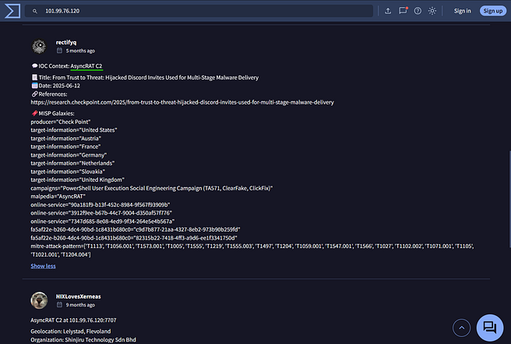
Answer:
asyncrat
AsyncRAT is a well-known remote access trojan (RAT) frequently used in phishing campaigns for:
- Remote control
- Credential theft
- Surveillance
- Persistence
- Data exfiltration
This connection significantly increased the severity of the investigation because RAT infections can provide attackers with long-term access to compromised systems.

Threat Intelligence Correlation
The next step involved correlating the identified indicators with publicly available threat intelligence reports.

Question:
What was the title of the original report where these indicators were mentioned?
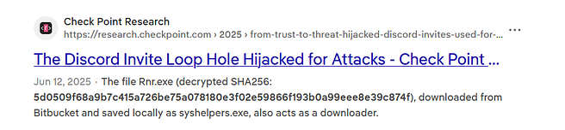
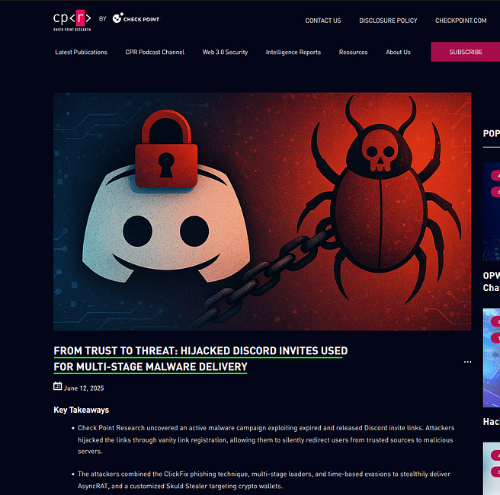
Answer:
From Trust to Threat: Hijacked Discord Invites Used for Multi-Stage Malware Delivery
This demonstrated how attackers abused trusted platforms such as Discord to redirect victims toward malicious infrastructure and malware payloads.
Threat intelligence correlation is important because it helps analysts:
- Understand attacker behaviour
- Identify campaign objectives
- Detect related infrastructure
- Improve defensive monitoring

Credential Theft Investigation
The report also revealed tools used by the attackers after compromise.

Question:
Which tool was used to steal Google Chrome cookies?
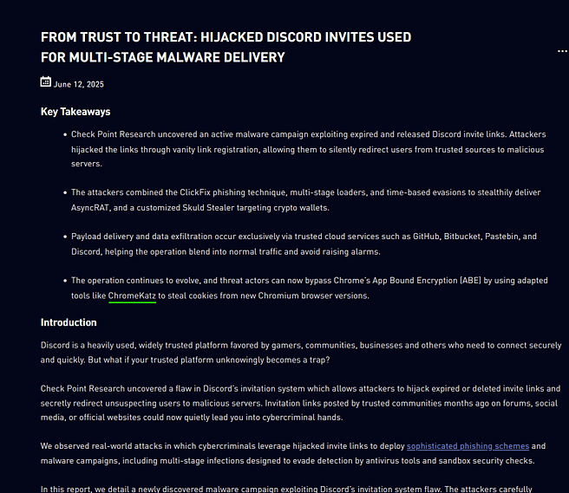
Answer:
ChromeKatz
ChromeKatz is commonly used to extract:
- Browser cookies
- Stored credentials
- Session tokens
Stealing browser sessions can allow attackers to bypass MFA protections and hijack active accounts.

Phishing Technique Investigation
The investigation also identified the phishing technique used during the campaign.

Question:
Which phishing technique did the attackers use?
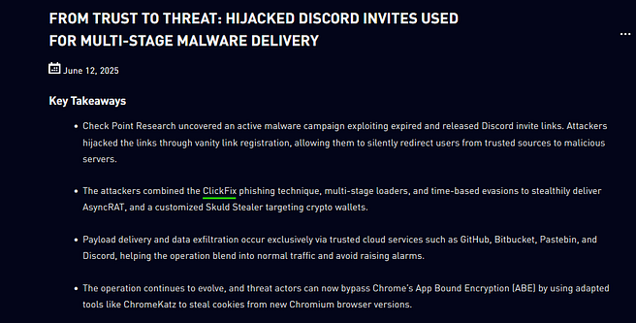
Answer:
ClickFix
ClickFix-style phishing attacks typically trick users into manually executing commands or interacting with malicious content under the guise of troubleshooting or verification steps.
These attacks are effective because they abuse user trust rather than relying solely on technical exploitation.

Infrastructure Investigation
The final stage identified the platform used to redirect victims toward malicious servers.

Question:
What platform was used to redirect users to malicious infrastructure?
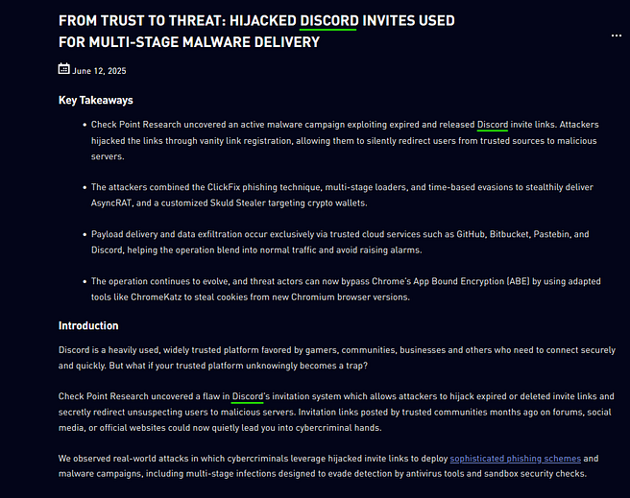
Answer:
Discord
This highlights how attackers increasingly abuse trusted platforms and services to host payloads or redirect users to malicious content while avoiding traditional reputation-based detections.

Key Takeaways
This room provided hands-on experience with:
- Threat intelligence investigations
- Malware hash analysis
- Parent-child process analysis
- Malware family correlation
- Threat report pivoting
- Campaign attribution
- Phishing investigation
- Infrastructure analysis
One of the biggest takeaways from this room was understanding how SOC analysts pivot across indicators to build a larger picture of an attack campaign instead of investigating single alerts in isolation.
The room also reinforced how attackers:
- Abuse trusted platforms
- Use staged malware delivery
- Deploy remote access trojans
- Establish persistence through scripts
- Steal credentials and browser sessions
Final Thoughts
This was an excellent room for practicing practical threat intelligence investigation workflows. It closely resembled how real-world SOC analysts investigate suspicious indicators, correlate intelligence, and identify malware campaigns.
The combination of:
- Malware analysis
- Threat intelligence
- Indicator correlation
- Campaign tracking
made this room highly valuable for developing SOC investigation skills.

