Hunting the Hidden: A SOC Analyst’s Guide to Linux Threat Detection 2 🕵️‍♂️
In the high-stakes game of cybersecurity, attackers are always trying to blend in. They gain initial access to a Linux system, and their first priority is often to understand their new environment — this is the Discovery phase. But how do we, as defenders, spot these sneaky activities when attackers use the very same commands we do?
In this walkthrough, we’ll explore the “Linux Threat Detection 2” room on TryHackMe. This TryHackMe room provides a practical investigation scenario that simulates real-world scenarios where we, as SOC analysts, must uncover the footprints of an intruder. We’ll learn how to differentiate between legitimate and malicious commands, hunt for advanced attacker TTPs (Tactics, Techniques, and Procedures), and trace their actions across a Linux system. Let’s strengthen our Linux threat hunting skills!
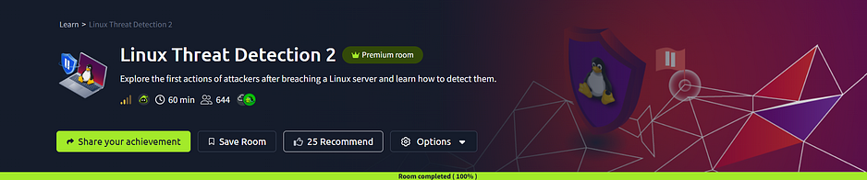
Part 1: The Attacker’s First Steps (Discovery Overview)
Imagine landing in an unfamiliar Linux server with just a command-line. What’s your first move? You’d probably run pwd, ls, whoami, right? Attackers do the same! They use common commands to gather information about the OS, filesystem, users, groups, processes, and network.
The trick for us is to recognize when these innocent-looking commands are being used with malicious intent. For example, the whoami command is a huge red flag if run by a web server process, as legitimate applications rarely need to know their own user ID in that context.
Room Questions (Task 2) 📌
Run systemd-detect-virt to detect the system's cloud. What is the command's output you discovered?
Answer: Amazon
Investigation Process 🕵️‍♂️: We executed the systemd-detect-virt command in the terminal. Its output directly revealed the cloud environment.

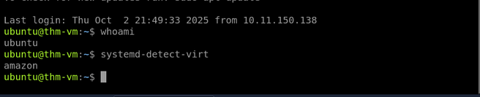
Now run ps aux and look for EDR or antivirus processes. What is the full path to the detected antimalware binary?
Answer: /var/lib/ultrasec/malscan
Investigation Process 🕵️‍♂️: We used ps aux to list all running processes. Then, we used grep with common EDR/antivirus keywords (like "EDR", "antivirus", "malware", "secure") to find the process. The results revealed /var/lib/ultrasec/malscan as a running antimalware binary.

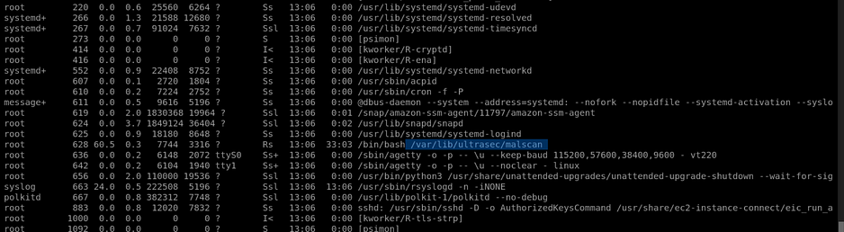
Part 2: Advanced Reconnaissance (Detecting Discovery)
After initial basic discovery, attackers get more specific. Data stealers hunt for secrets, cryptominers check CPU/GPU, and botnets scan for new victims.
Detecting these specialized discovery commands usually involves auditd or other runtime monitoring tools. The real challenge is context: who ran the command, and why? A whoami from a web server is suspicious, but a ping from a network monitoring tool might be legitimate. We use process tree analysis to understand the "who" and "why."
In this task, we investigate a scenario where the itsupport user launches the hostname command, triggering an alert. We need to follow the trail.
Room Questions (Task 3) 📌
What is the path of the script that initiated the “hostname” command?
Answer: /home/itsupport/debug.sh
Investigation Process 🕵️‍♂️: The investigation required us to use ausearch -i -x hostname to find the hostname command's execution. In the audit logs, we then look at the parent process (ppid) to trace it back. This reveals a script being executed, likely /home/itsupport/debug.sh.

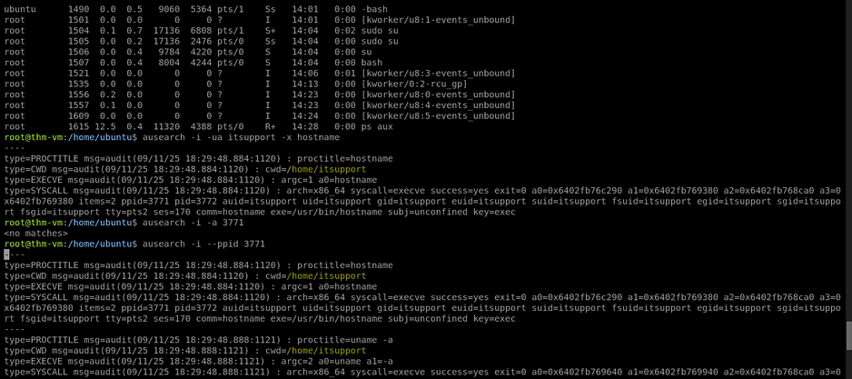

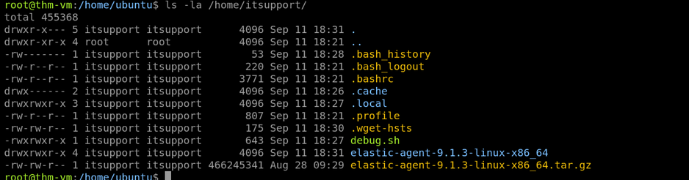
What was the last Discovery command launched by the script?
Answer: ps -eo pid,ppid,cmd,%mem,%cpu — sort=-%cpu
Investigation Process 🕵️‍♂️: After identifying debug.sh, we can either cat /home/itsupport/debug.sh to view its contents directly or use ausearch -i --ppid <PID of debug.sh> to find all child processes it launched. The script's content or the audit logs clearly show this ps command as the last discovery command.

Looking at the script content, what’s the email of the script author?
Answer: greg@tryhackme.thm
Investigation Process 🕵️‍♂️: By using cat /home/itsupport/debug.sh, we examine the script's contents. The author's email is typically found in comments or metadata within the script itself.

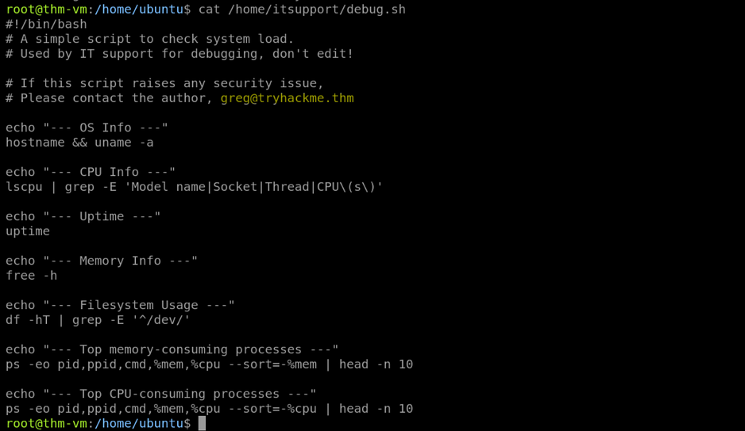
Part 3: Why They Attack (Motivation & Ingress Tool Transfer)
Attackers have diverse motivations: some aim for quick gains (“Hack and Forget”), like installing cryptominers or enrolling systems into botnets. To achieve this, they need to transfer their tools onto the victim machine, a phase called Ingress Tool Transfer.

Common commands used for ingress are wget, curl, and scp. We can detect these by monitoring auditd logs for command executions or by looking for new SSH logins when scp is initiated from the attacker's machine.
Room Questions (Task 4) 📌
From which domain was the Elastic agent downloaded?
Answer: artifacts.elastic.co
Investigation Process 🕵️‍♂️: We reviewed audit logs related to file downloads. The audit logs clearly show a wget command downloading from artifacts.elastic.co.

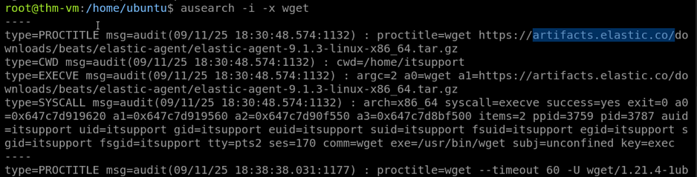
What is the full path to the downloaded “helper.sh” script?
Answer: /var/tmp/helper.sh
Investigation Process 🕵️‍♂️: Similar to the previous question, ausearch logs for wget or curl commands will show the full path specified by the -O flag in the command line (e.g., wget ... -O /var/tmp/helper.sh).

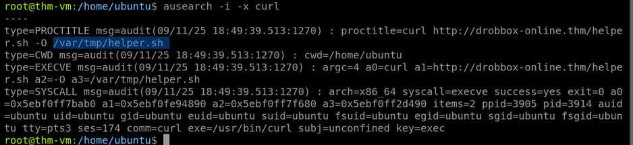
Which of the downloaded files is more likely to be malicious: The one downloaded with curl or wget?
Answer: curl
Investigation Process 🕵️‍♂️: The room’s scenario often implies certain tools are used by attackers for specific purposes. curl in this context might be used for a more stealthy or custom download, or the associated URL is identified as malicious via threat intel. The context in the room hints that the curl download is the more likely malicious one, as wget might download legitimate software (like an Elastic agent).
Part 4: Case Study — The Dota3 Cryptominer ⛏️
Now, let’s apply our knowledge to a real-world example: the Dota3 cryptominer. This malware shows how common TTPs combine to create a full infection chain.
Initial Access & Discovery (Task 5)
The Dota3 botnet uses SSH brute-forcing to gain initial access, often targeting the root user with weak passwords. Once in, it runs discovery commands to gather system info (CPU, RAM)—a clear indicator of a cryptominer. It also searches for EDR processes with egrep to avoid detection.
Persistence & Miner Setup (Task 6)
Dota3 achieves persistence by changing user passwords, replacing SSH keys, and installing its own binaries. It uploads a malicious archive (e.g., kernupd.tar.gz) via SCP, unpacks it into a hidden /tmp/.X26-unix/.rsync/c folder, and then launches two binaries with nohup: tsm (a custom network scanner) and initall (the XMRig cryptominer). The tsm scanner is configured to scan internal networks like 10.10.12.1-10.10.12.10 for other vulnerable SSH systems.
Room Questions (Task 5) 📌
Which IP address managed to brute-force the exposed SSH?
Answer: 45.9.148.125
Investigation Process 🕵️‍♂️: By analyzing auth.log for "Accepted password" entries, specifically filtering logs from /home/ubuntu/scenario/audit.log with ausearch -i -if /home/ubuntu/scenario/audit.log, we look for successful logins from external IPs.

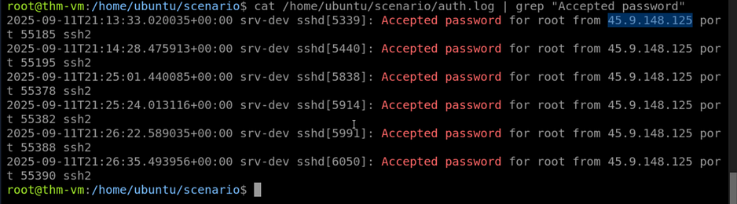
Which command did the attacker use to list the last logged-in users?
Answer: last
Investigation Process 🕵️‍♂️: within the audit logs we can use (cat audit.log | ausearch -i -x last )
OR
Within the auditd logs (ausearch -i -if /home/ubuntu/scenario/audit.log), we search for discovery commands. The last command would be logged as part of the attacker's reconnaissance.

Which three EDR processes did the attacker look for with “egrep”?
Answer: ds_agent,falcon,sentinel
Investigation Process 🕵️‍♂️: We can use (cat audit.log | grep “egrep”) to identify all the commands then we can use “EXECVE” to narrow it.
Final command : cat audit.log | grep “egrep” | grep “EXECVE”
OR
We search ausearch -i -if /home/ubuntu/scenario/audit.log for egrep commands. Attackers use egrep to check for running EDR/antivirus processes to see if they are being monitored. The egrep command line will contain these names.

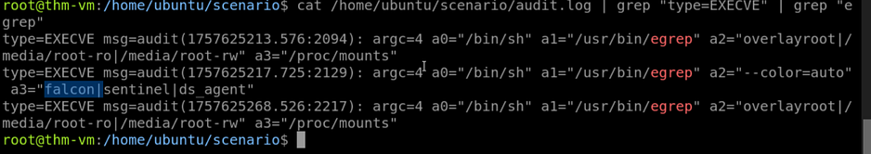
Room Questions (Task 6) 📌
What is the name of the malicious archive that was transferred via SCP?
Answer: kernupd.tar.gz
Investigation Process 🕵️‍♂️: We review auditd logs (ausearch -i -if /home/ubuntu/scenario/audit.log) for scp commands. The log entry for the file transfer will reveal the archive name.

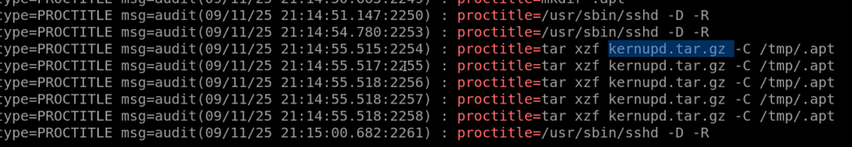
What was the full command line of the cryptominer launch?
Answer: nohup /tmp/.apt/kernupd/kernupd
Investigation Process 🕵️‍♂️: We look for nohup commands in the auditd logs. The output will show the full command line, including the path to the cryptominer binary.
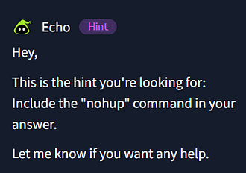

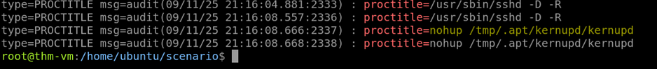
Which IP address range did the attacker scan for an exposed SSH?
Answer: 10.10.12.1–10.10.12.10
Investigation Process 🕵️‍♂️: We can use the cmd (cat auth.log | grep 10. )To identify the range precisely as 2nd octet is also repeated we can use (10.10.)
OR
The auditd logs for the tsm scanner (nohup /tmp/.X26-unix/.rsync/c/tsm ...) will show the arguments passed to it, including the IP range it was configured to scan.

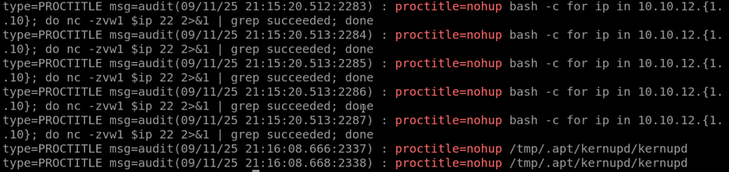

My Experience✨
This room provided excellent hands-on exposure into “Hack and Forget” attacks on Linux. We’ve traced the entire kill chain, from initial SSH brute-forcing and discovery commands to malware transfer, cryptominer setup, and persistence. The key takeaway is the power of auditd and authentication logs, combined with process tree analysis, to detect these automated threats.

