Linux Threat Detection 1: TryHackMe Walkthrough room
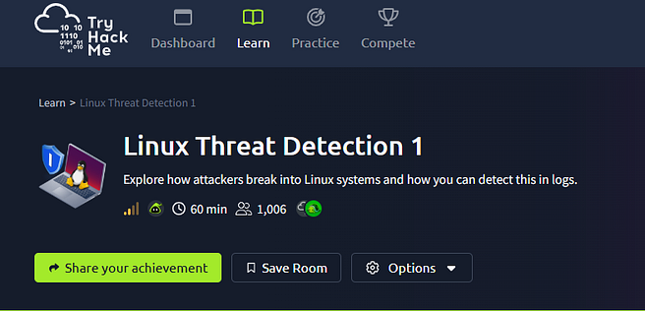
Introduction
Linux systems continue to grow in popularity across modern environments because of cloud computing, artificial intelligence, and IoT technologies.
This room helps build an understanding of SSH-related risks in Linux environments, how exposed services can result in breaches, and how process tree analysis can assist in tracing attacker activity.
Link to the THM Room: TryHackMe | Linux Threat Detection 1
TASK 2: Initial Access via SSH
SSH (Secure Shell) is one of the most common remote access services targeted by attackers to gain initial access to Linux systems.
SSH is similar to RDP (Remote Desktop Protocol) in Windows. it can be powerful but poorly defended. These two can be tracked using the MITRE technique known as External Remote Services.
To find these exposed SSH, attackers scan the internet for systems that have it exposed and access them either through a stolen key or a breached password
A stolen key could be a service or source code where private SSH keys have been stored (GitHub repository or Ansible automation server containing SSH credentials). Attackers could access and steal these codes from a server by infecting an admin’s laptop with a data stealer.
A breached password could be risky when using it, when an IT admin sets a weak SSH password for a quick test and forgets to revert the changes, support enables SSH for a contractor who sets the password to “12345678”, or a network engineer accidentally exposes an old, insecure SSH server to the Internet.
Q1: When did the Ubuntu user log in via SSH for the first time? Example: 2023–09–16.
From the question, we can infer that we need to examine the logs to retrieve the date, and the command was provided to us: cat /var/log/auth.log | grep “sshd”. Running this command, we obtain the log file, but with a filter to display only logs that contain ‘sshd’. Although we can further filter the logs by changing the filter to ‘login’ instead of ‘sshd’, it will be faster. I completed the first one and read the logs down the line and found out that sshd received a signal.

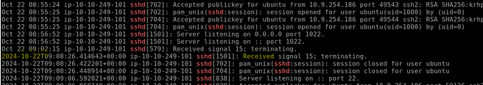
Ans: 2024–10–22
Q2: Did the Ubuntu user use SSH keys instead of a password for the above found date? (Yea/Nay)

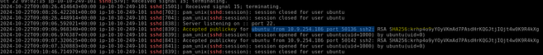
Looking at the same screenshot from above, we can read the log and see the accepted public key from Ubuntu. At the end, we see a SHA256.
Ans: yea
TASK 3: Detecting SSH Attacks
This task brings to our attention the three indicators of malicious logins that we need to be aware of. This includes
- Multiple failed logins followed by a success
- logins from an external untrusted IP Address
- Logins by password are an insecure authentication method
- 3 indicators confirming “thmsupport” breach
Also, detecting SSH attacks can be as simple as listing all successful SSH logins and analyzing a few fields.
Furthermore, upon examining a successful SSH login, we should look for Password-based authentication, logins from external IPs, and the time difference between the logins, as it is likely that one of these logins will occur at nighttime for the specified user. But as an analyst, to be surer of your verdict, investigate more details such as
- Username: Who owns the user? Is it expected for them to log in at this time and from this IP?
- Source IP: What do TI tools and asset lookups say about the IP? Is it trusted or malicious?
- Login history: Was the login preceded by brute force or other suspicious system events?
- Next steps: Is the login suspicious? Should I analyze user actions following the login?
Q1: When did the SSH password brute force start? Answer Format: 2023–09–15.
I ran the same command but filtered for passwords. Reading the logs, we can see that the password was changed by root on October 22nd. We also saw that the user had changed. Then, along the line, we start seeing numerous failed passwords from an external IP Address. This shows a possible brute-force attack in progress.

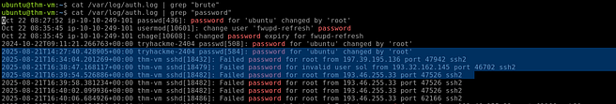
Ans: 2025–08–21
Q2: Which four users did the botnet attempt to breach? Answer Format: Separate by a comma, in alphabetical order.
This was pretty easy. Use the same output from the previous question and look through the following logs to see the users on whom the numerous brute force attack was attempted. see screenshot.

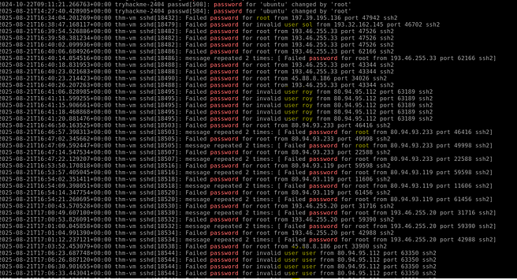
Ans: root, roy, sol, user

Q3: Finally, which IP managed to breach the root user?
I filtered for a successful login attempt using the same command, but with the word Accepted. While scanning through the log, I realized that there was an accepted password for the root account. That indicates a successful login.

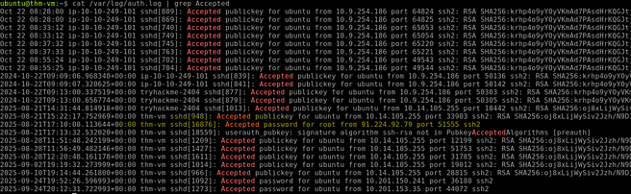
Ans: 91.224.92.79
TASK 4: Initial Access via Services
This task focuses on investigating attacks against public-facing Linux services using application and web access logs.
Q1: What is the path to the Python file the attacker attempted to open?
This is straightforward; simply run the given command and review the output to find the answer. We were asked for the path to read the Python file. In Linux, to read a file, we use the cat command. By examining the cat output, we then locate the path. For us to see the commands that were run instead of the IP, it means the ping was vulnerable to command injection.

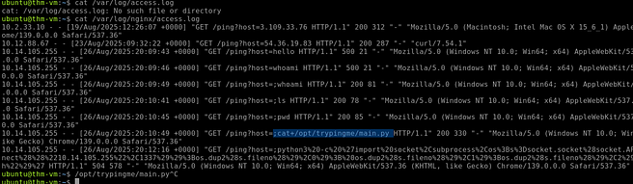
Ans: /opt/trypingme/main.py
Q2: Looking inside the opened file, what’s the flag you see there?
Since we already have the path, we run that command and then look through the output to get the flag

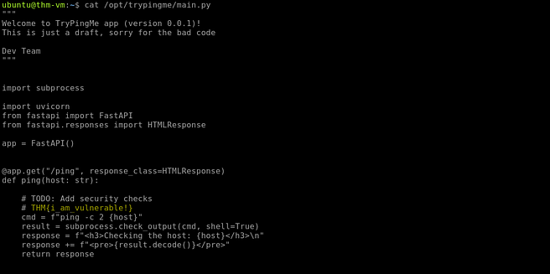
Ans: THM{i_am_vulnerable!}
TASK 5: Detecting Service Breach
This section demonstrates how auditd logs and process tree analysis can be used to investigate suspicious command execution.
In a scenario where you are a SOC analyst and receive an alert of a suspicious command, such as whoami, you want to ask yourself, ‘Why was it executed?’ To answer this, we will build a process tree and trace the command back to its present process.
Q1: What is the PPID of the suspicious whoami command?
Now, let’s examine the TryPingMe breach from the previous task through the auditd angle.
From the previous task, when we accessed the access.log file, we noticed that whoami was run, which is suspicious. So, to identify the PPID, we simply run the command ausearch -i -x whoami.

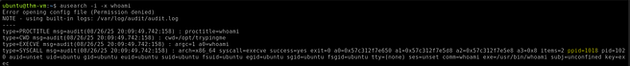
Ans: 1018
Q2: Moving up the tree, what is the PID of the TryPingMe app?
Since we know the PPID for the suspicious command, moving up the tree, we use dig deep into that PPID using the command ausearch -i — pid 1018, we noticed another ppid of 577

Ans: 577
Q3: Which program did the attacker use to open a reverse shell?
We dig deep into that 577 pid we found to find the program used.

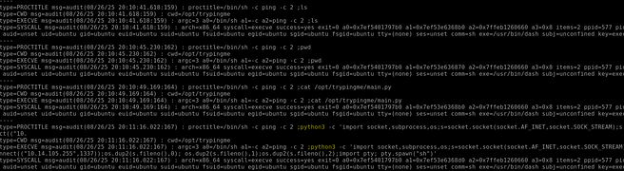
Ans: Python
TASK 6: Advanced Initial Access
We will see some human-led attacks, such as phishing and USB attacks, which are so commonly seen in Windows environments. Supply chain compromises, which are attacks that breach a software’s initial security and then infect all its users with a malicious update. We also investigate detecting attacks using process tree analysis, starting with a SIEM alert on suspicious commands or connections to a malicious IP. From there, you build a process tree to trace which application or user initiated the events — a web server, an internal application, or an IT administrator’s SSH session. Finally, you determine whether the activity is legitimate or an indicator of malicious behavior:
Q1: Which Initial Access technique is likely used if a trusted app suddenly runs malicious commands?
Ans: Supply Chain Compromise
Q2: Which detection method can you use to detect a variety of Initial Access techniques?
Ans: Process Tree Analysis
Thank you for reading this walkthrough and following the investigation process.

