**SMOOTENING**:-

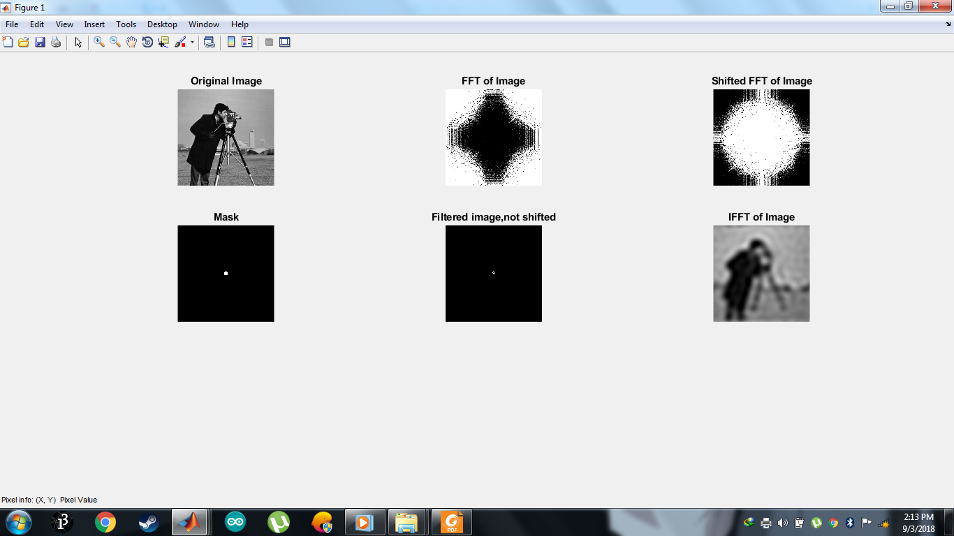

SURF FFT plot of THE ‘Cameraman.tif’ Image:-

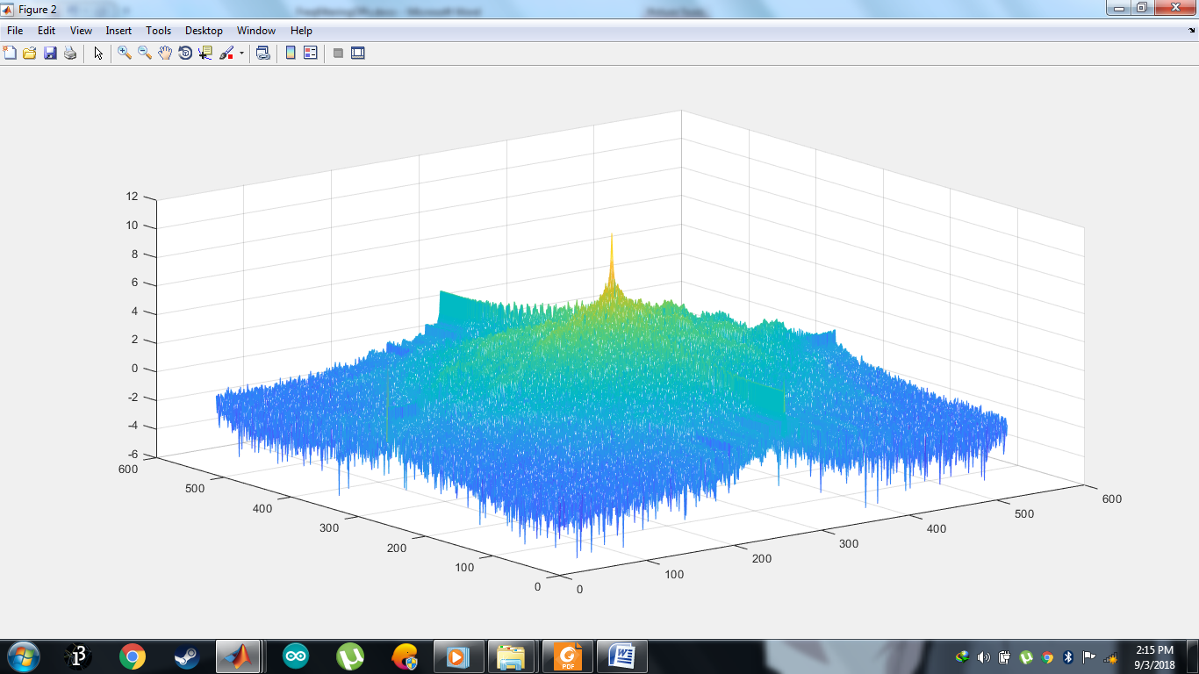

SHARPENING:-

