**Design Thinking Project report on Student Sphere**

**ABSTRACT**

In an era where **experiential learning** holds paramount importance in shaping the **career trajectory** of students, our project aims to bridge the gap between academia and industry by developing a **comprehensive internship portal** for our **college community**. This **web-based platform** serves as a **centralized hub**, providing students with access to a wide array of **internship opportunities** both within and outside the college premises. The internship portal offers a **user-friendly interface**, enabling students to effortlessly **browse, search, and filter** internship listings based on various criteria such as **field of study**, **location**, **duration**, and **application deadlines**.

Furthermore, the platform incorporates features for **employers** to post **internship openings**, facilitating **seamless interaction** between students and potential employers. Key functionalities of the portal include **real-time updates** on new internship postings, **personalized recommendations** based on **student profiles and interests**, as well as **resources** for enhancing internship preparedness such as **resume-building tools**, **interview tips**, and **networking opportunities**. By consolidating internship information into a single accessible platform, our project aims to empower students with the resources and support needed to embark on **successful internship experiences**, thereby enriching their **academic journey** and preparing them for the demands of the **professional world**.

**INDEX**

**ABSTRACT**

1. INTRODUCTION 1
   1. EXISTING SYSTEM 2
   2. PROPOSED SYSTEM 2
2. SYSTEM ANALYSIS 3
   1. SOFTWARE REQUIREMENTS 3
   2. HARDWARE REQUIREMENTS 3
3. SYSTEM DESIGN 4
   1. ARCHITECTURE DESIGN 4
   2. FLOWCHART 5
   3. MINDMAP DIAGRAM 6
4. CODE IMPLEMENTATION 7
5. RESULTS 21
6. CONCLUSION 24
7. FUTURE SCOPE 25
8. REFERENCES 26

# INTRODUCTION

Internships are a crucial component of career development, providing students with practical experience and exposure to their chosen fields. However, finding the right internship can be a challenging process for students, and managing internship applications can be equally demanding for companies. The Internship Portal aims to simplify and enhance this process by offering a centralized platform where students and companies can connect efficiently.

The portal features a robust authentication system, allowing students to register and log in securely to access available internships. Companies can also log in to post new opportunities and manage existing listings. Students can browse through a wide range of internships, view detailed descriptions, and apply directly through the portal. Administrators have the ability to manage user accounts and internship postings, ensuring the platform remains up-to-date and relevant.

The backend of the portal is developed using Java, utilizing JDBC for database connectivity to a MySQL database. This setup ensures reliable data storage and retrieval. The frontend is built with HTML, CSS, and JavaScript, providing a responsive and intuitive interface for all users. By integrating these technologies, the Internship Portal offers a comprehensive solution to streamline the internship application and management process.

## EXISTING SYSTEM

In the current landscape, many institutions and companies rely on fragmented and manual processes to manage internships. Many universities and companies still use manual methods such as email, spreadsheets, or even paper-based systems to manage internship applications. This leads to inefficiencies, errors, and difficulties in tracking applications. There is often no centralized platform for students to find internship opportunities. Students have to search across multiple websites and platforms, which can be time-consuming and confusing. Current systems might not be accessible to all users, particularly those with disabilities. Additionally, they may not provide a seamless experience across different devices such as mobile phones and tablets. Communication between students and companies is often not streamlined, leading to delays and misunderstandings in the application process. Existing systems may not have adequate security measures in place to protect sensitive user information, leading to potential data breaches.

## PROPOSED SYSTEM

The proposed Internship Portal aims to address the shortcomings of the existing system by providing a modern, efficient, and secure platform for managing internships. The Internship Portal offers a centralized platform where students can find and apply for internships from various companies. Companies can post opportunities and manage applications in one place. The system automates many of the processes involved in internship management, reducing the risk of errors and saving time for both students and administrators. The portal is designed with a user-friendly interface that is intuitive and easy to navigate. This improves the user experience and makes it easier for students to find relevant internships. The platform is designed to be fully responsive, ensuring a seamless experience on desktops, laptops, tablets, and smartphones. This includes secure login mechanisms, encrypted data storage, and regular security audits. Administrators have access to a range of features to manage the portal effectively, including user management, internship posting approvals, and reporting tools. system is designed to be scalable, allowing it to handle increasing numbers of users and internship postings without compromising performance.

# SYSTEM ANALYSIS

## SOFTWARE REQUIREMENTS

* Operating System: Windows 10 or higher
* Text Editor/IDE: Visual Studio Code, Sublime Text, Atom, or any preferred code editor.
* Web Browser: Latest version of Google Chrome or Edge for testing.
* Node.js and npm/yarn: For JavaScript package management and server setup
* Frontend: HTML, CSS, JavaScript
* Server Framework: Node.js with Express.js
* Database: MongoDB for storing user data and skill information.

## HARDWARE REQUIREMENTS

* Processor: Minimum 2 GHz dual-core processor (4 cores recommended).
* RAM: At least 8 GB (16 GB or more recommended for smoother performance and multitasking).
* Storage: At least 50 GB of free space for the development environment, libraries, dependencies, and project files. SSD preferred for faster access.
* Monitor: A resolution of 1920x1080 or higher is recommended for better productivity.
* Network: Stable internet connection with a minimum upload/download speed of 100 Mbps.

# SYSTEM DESIGN

## 3.1 ER DIAGRAM

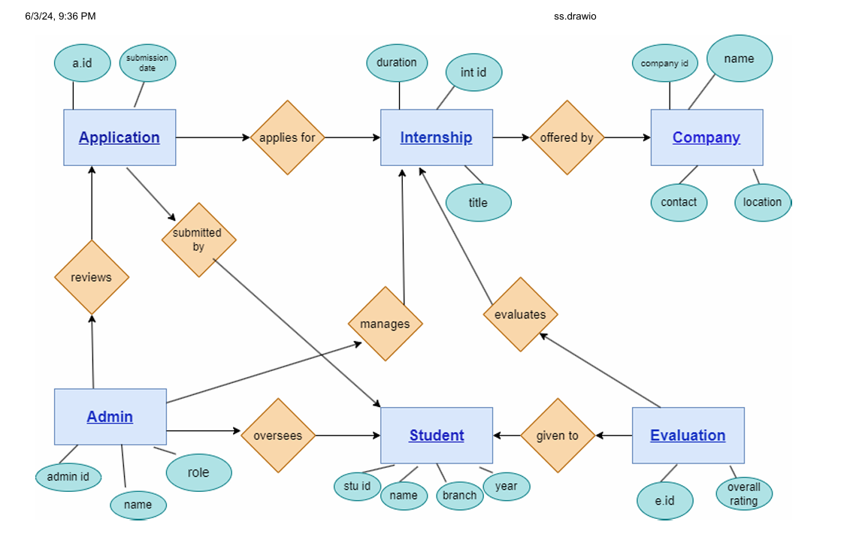

Fig 3.1 ER DIAGRAM

## FLOW CHART

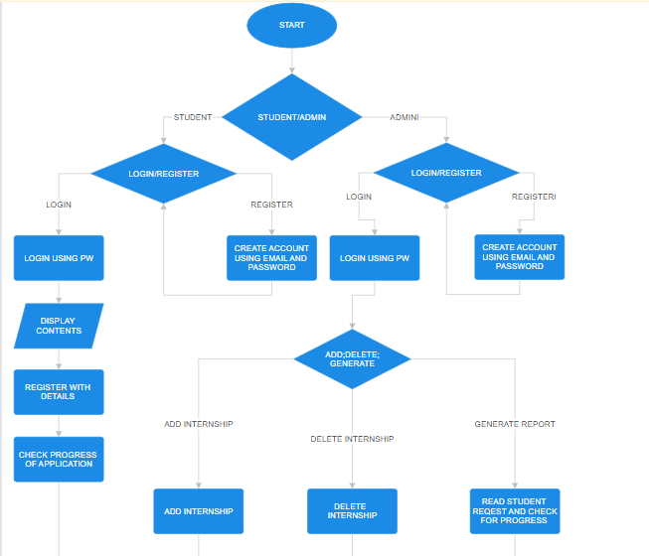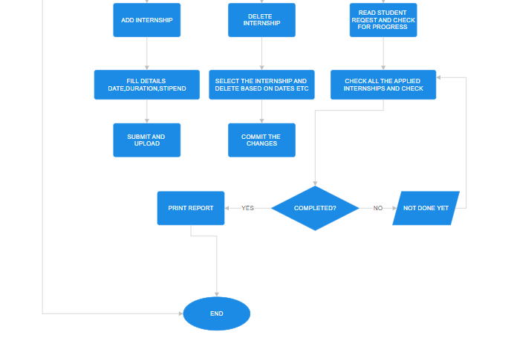

Fig 3.2 Flowchart

## MINDMAP DIAGRAM

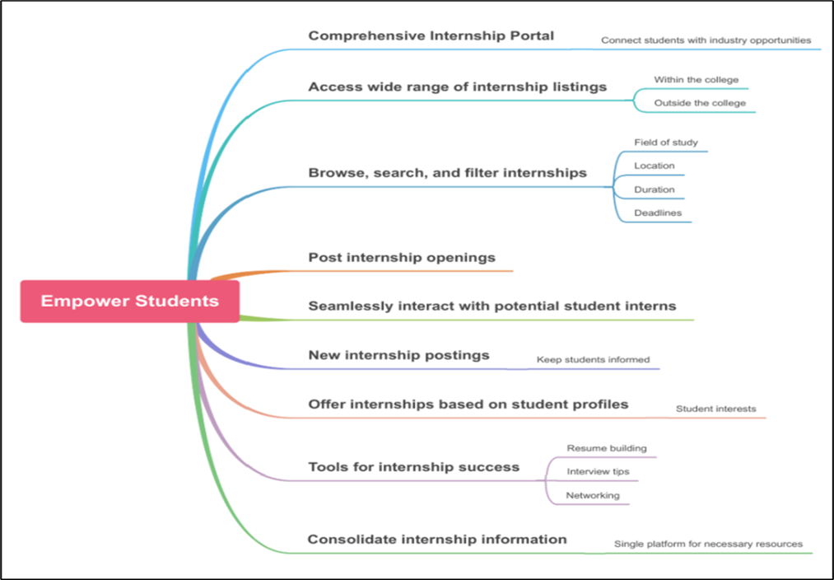

Fig 3.2 Mindmap diagram

# CODE IMPLEMENTATION

#### Index.html

<!DOCTYPE html>

<html lang="en">

<head>

<meta charset="UTF-8">

<meta name="viewport" content="width=device-width, initial-scale=1.0">

<title>Internship Portal</title>

<link rel="stylesheet" href="styles.css">

</head>

<body>

<header>

<h1>Welcome to the Internship Portal</h1>

<nav>

<ul>

<li><a href="index.html">Home</a></li>

<li><a href="internships.html">Internships</a></li>

<li><a href="login.html">Login</a></li>

<li><a href="contact.html">Contact Us</a></li>

</ul>

</nav>

</header>

<main>

<section>

<h2>Find Your Perfect Internship</h2>

<a href="internships.html" class="button">Browse Internships</a>

</section>

</main>

<footer>

<p>&copy; 2024 Internship Portal</p>

</footer>

</body>

</html>

Internships.html

<!DOCTYPE html>

<html lang="en">

<head>

<meta charset="UTF-8">

<meta name="viewport" content="width=device-width, initial-scale=1.0">

<title>Internships</title>

<link rel="stylesheet" href="styles.css">

</head>

<body>

<header>

<h1>Internships</h1>

<nav>

<ul>

<li><a href="index.html">Home</a></li>

<li><a href="internships.html">Internships</a></li>

<li><a href="login.html">Login</a></li>

<li><a href="contact.html">Contact Us</a></li>

</ul>

</nav>

</header>

<main>

<section>

<h2>Available Internships</h2>

<div class="internship-list">

<div class="internship-item">

<h3>Software Development Intern</h3>

<p>Location: New York, NY</p>

<p>Duration: 3 months</p>

<a href="internship-details.html" class="button">View Details</a>

</div>

<div class="internship-item">

<h3>Marketing Intern</h3>

<p>Location: San Francisco, CA</p>

<p>Duration: 6 months</p>

<a href="internship-details.html" class="button">View Details</a>

</div>

<!-- Add more internship items as needed -->

</div>

</section>

</main>

<footer>

<p>&copy; 2024 Internship Portal</p>

</footer>

</body>

</html>

Login.html

<!DOCTYPE html>

<html lang="en">

<head>

<meta charset="UTF-8">

<meta name="viewport" content="width=device-width, initial-scale=1.0">

<title>Login</title>

<link rel="stylesheet" href="styles.css">

</head>

<body>

<header>

<h1>Login</h1>

<nav>

<ul>

<li><a href="index.html">Home</a></li>

<li><a href="internships.html">Internships</a></li>

<li><a href="login.html">Login</a></li>

<li><a href="contact.html">Contact Us</a></li>

</ul>

</nav>

</header>

<main>

<section>

<h2>Login to Your Account</h2>

<form id="login-form">

<label for="email">Email:</label>

<input type="email" id="email" name="email" required>

<label for="password">Password:</label>

<input type="password" id="password" name="password" required>

<button type="submit" class="button">Login</button>

</form>

<p>Don't have an account? <a href="register.html">Register here</a></p>

<p id="login-error" style="color: red;"></p>

</section>

</main>

<footer>

<p>&copy; 2024 Internship Portal</p>

</footer>

<script>

document.getElementById('login-form').addEventListener('submit', function(event) {

event.preventDefault();

const email = document.getElementById('email').value;

const password = document.getElementById('password').value;

fetch('http://localhost:3000/login', {

method: 'POST',

headers: {

'Content-Type': 'application/json'

},

body: JSON.stringify({ email, password })

})

.then(response => {

if (response.ok) {

return response.json();

} else {

throw new Error('Invalid credentials');

}

})

.then(data => {

alert(data.message);

window.location.href = 'internships.html';

})

.catch(error => {

document.getElementById('login-error').textContent = error.message;

});

});

</script>

</body>

</html>

Register.html

<!DOCTYPE html>

<html lang="en">

<head>

<meta charset="UTF-8">

<meta name="viewport" content="width=device-width, initial-scale=1.0">

<title>Register</title>

<link rel="stylesheet" href="styles.css">

</head>

<body>

<header>

<h1>Register</h1>

<nav>

<ul>

<li><a href="index.html">Home</a></li>

<li><a href="internships.html">Internships</a></li>

<li><a href="login.html">Login</a></li>

<li><a href="contact.html">Contact Us</a></li>

</ul>

</nav>

</header>

<main>

<section>

<h2>Create a New Account</h2>

<form id="register-form">

<label for="name">Name:</label>

<input type="text" id="name" name="name" required>

<label for="email">Email:</label>

<input type="email" id="email" name="email" required>

<label for="password">Password:</label>

<input type="password" id="password" name="password" required>

<button type="submit" class="button">Register</button>

</form>

<p>Already have an account? <a href="login.html">Login here</a></p>

</section>

</main>

<footer>

<p>&copy; 2024 Internship Portal</p>

</footer>

<script>

document.getElementById('register-form').addEventListener('submit', function(event) {

event.preventDefault();

const name = document.getElementById('name').value;

const email = document.getElementById('email').value;

const password = document.getElementById('password').value;

fetch('http://localhost:3000/register', {

method: 'POST',

headers: {

'Content-Type': 'application/json'

},

body: JSON.stringify({ name, email, password })

})

.then(response => response.json())

.then(data => {

alert(data.message);

window.location.href = 'login.html';

})

.catch(error => console.error('Error:', error));

});

</script>

</body>

</html>

internships.html

<!DOCTYPE html>

<html lang="en">

<head>

<meta charset="UTF-8">

<meta name="viewport" content="width=device-width, initial-scale=1.0">

<title>Internships</title>

<link rel="stylesheet" href="styles.css">

</head>

<body>

<header>

<h1>Internships</h1>

<nav>

<ul>

<li><a href="index.html">Home</a></li>

<li><a href="internships.html">Internships</a></li>

<li><a href="login.html">Login</a></li>

<li><a href="contact.html">Contact Us</a></li>

</ul>

</nav>

</header>

<main>

<section>

<h2>Available Internships</h2>

<div class="internship-list">

<div class="internship-item">

<h3>Software Development Intern</h3>

<p>Location: New York, NY</p>

<p>Duration: 3 months</p>

<a href="internship-details.html" class="button">View Details</a>

</div>

<div class="internship-item">

<h3>Marketing Intern</h3>

<p>Location: San Francisco, CA</p>

<p>Duration: 6 months</p>

<a href="internship-details.html" class="button">View Details</a>

</div>

<!-- Add more internship items as needed -->

</div>

</section>

</main>

<footer>

<p>&copy; 2024 Internship Portal</p>

</footer>

</body>

</html>

Internships-details.html

<!DOCTYPE html>

<html lang="en">

<head>

<meta charset="UTF-8">

<meta name="viewport" content="width=device-width, initial-scale=1.0">

<title>Internship Details</title>

<link rel="stylesheet" href="styles.css">

</head>

<body>

<header>

<h1>Internship Details</h1>

<nav>

<ul>

<li><a href="index.html">Home</a></li>

<li><a href="internships.html">Internships</a></li>

<li><a href="login.html">Login</a></li>

<li><a href="contact.html">Contact Us</a></li>

</ul>

</nav>

</header>

<main>

<section>

<h2>Software Development Intern</h2>

<p><strong>Location:</strong> New York, NY</p>

<p><strong>Duration:</strong> 3 months</p>

<p><strong>Description:</strong> This internship provides hands-on experience in software development with a leading tech company.</p>

<p><strong>Requirements:</strong> Knowledge of programming languages such as Java and Python. Must be currently enrolled in a Computer Science program or related field.</p>

<p><strong>Responsibilities:</strong> Assist in developing software applications, collaborate with the development team, and participate in code reviews.</p>

<a href="internships.html" class="button">Back to Internships</a>

</section>

</main>

<footer>

<p>&copy; 2024 Internship Portal</p>

</footer>

</body>

</html>

Contact.html

<!DOCTYPE html>

<html lang="en">

<head>

<meta charset="UTF-8">

<meta name="viewport" content="width=device-width, initial-scale=1.0">

<title>Contact Us</title>

<link rel="stylesheet" href="styles.css">

</head>

<body>

<header>

<h1>Contact Us</h1>

<nav>

<ul>

<li><a href="index.html">Home</a></li>

<li><a href="internships.html">Internships</a></li>

<li><a href="login.html">Login</a></li>

<li><a href="contact.html">Contact Us</a></li>

</ul>

</nav>

</header>

<main>

<section>

<h2>Get in Touch</h2>

<form action="contact-form-handler.php" method="post">

<label for="name">Name:</label>

<input type="text" id="name" name="name" required>

<label for="email">Email:</label>

<input type="email" id="email" name="email" required>

<label for="message">Message:</label>

<textarea id="message" name="message" required></textarea>

<button type="submit" class="button">Send Message</button>

</form>

</section>

</main>

<footer>

<p>&copy; 2024 Internship Portal</p>

</footer>

</body>

</html>

Styles.css

/* General Styles */

body {

font-family: Arial, sans-serif;

margin: 0;

padding: 0;

background-color: #f4f4f4;

}

/* Header Styles */

header {

background: url('header-bg.jpg') no-repeat center center;

background-size: cover;

color: #fff;

padding: 50px 0;

text-align: center;

box-shadow: 0 4px 8px rgba(0, 0, 0, 0.1);

}

header h1 {

margin: 0;

font-size: 2.5em;

}

nav ul {

list-style: none;

padding: 0;

margin: 20px 0 0 0;

}

nav ul li {

display: inline;

margin: 0 15px;

}

nav ul li a {

color: #fff;

text-decoration: none;

font-weight: bold;

font-size: 1.2em;

}

nav ul li a:hover {

text-decoration: underline;

}

/* Main Content Styles */

main {

padding: 50px 20px;

background: url('main-bg.jpg') no-repeat center center;

background-size: cover;

color: #333;

}

main section {

background-color: rgba(255, 255, 255, 0.9);

padding: 30px;

border-radius: 10px;

box-shadow: 0 4px 8px rgba(0, 0, 0, 0.1);

}

main h2 {

margin-top: 0;

}

/* Button Styles */

.button {

background-color: #007BFF;

color: #fff;

padding: 10px 20px;

text-decoration: none;

border-radius: 5px;

display: inline-block;

margin-top: 20px;

}

.button:hover {

background-color: #0056b3;

}

/* Internship List Styles */

.internship-list {

display: flex;

flex-wrap: wrap;

justify-content: center;

}

.internship-item {

background-color: #fff;

border: 1px solid #ddd;

border-radius: 5px;

margin: 15px;

padding: 20px;

width: calc(33% - 60px);

box-shadow: 0 4px 8px rgba(0, 0, 0, 0.1);

text-align: left;

}

.internship-item h3 {

margin-top: 0;

}

/* Header Styles */

header {

background: url('https://images.unsplash.com/photo-1516912488613-4e5294a02e59?ixlib=rb-1.2.1&auto=format&fit=crop&w=1350&q=80') no-repeat center center;

background-size: cover;

color: #fff;

padding: 50px 0;

text-align: center;

box-shadow: 0 4px 8px rgba(0, 0, 0, 0.1);

position: relative;

z-index: 1;

}

header::after {

content: '';

display: block;

position: absolute;

top: 0;

left: 0;

width: 100%;

height: 100%;

background: rgba(0, 0, 0, 0.5);

z-index: -1;

}

/* Main Content Styles */

main {

padding: 50px 20px;

background: url('https://images.unsplash.com/photo-1517433456452-f9633a875f6f?ixlib=rb-1.2.1&auto=format&fit=crop&w=1350&q=80') no-repeat center center;

background-size: cover;

color: #333;

position: relative;

z-index: 1;

}

main::after {

content: '';

display: block;

position: absolute;

top: 0;

left: 0;

width: 100%;

height: 100%;

background: rgba(255, 255, 255, 0.5);

z-index: -1;

}

/* Footer Styles */

footer {

background: url('https://images.unsplash.com/photo-1506748686214-e9df14d4d9d0?ixlib=rb-1.2.1&auto=format&fit=crop&w=1350&q=80') no-repeat center center;

background-size: cover;

color: #fff;

text-align: center;

padding: 20px 0;

position: relative;

z-index: 1;

box-shadow: 0 -4px 8px rgba(0, 0, 0, 0.1);

}

footer::after {

content: '';

display: block;

position: absolute;

top: 0;

left: 0;

width: 100%;

height: 100%;

background: rgba(0, 0, 0, 0.5);

z-index: -1;

}

body {

margin: 0;

padding: 0;

font-family: Arial, sans-serif;

}

nav ul {

list-style: none;

padding: 0;

}

nav ul li {

display: inline;

margin: 0 10px;

}

nav ul li a {

color: #fff;

text-decoration: none;

}

.button {

background-color: #007BFF;

color: #fff;

padding: 10px 20px;

text-decoration: none;

border-radius: 5px;

display: inline-block;

margin: 10px 0;

}

.internship-item p {

margin: 5px 0;

}

/* Footer Styles */

footer {

background: url('footer-bg.jpg') no-repeat center center;

background-size: cover;

color: #fff;

text-align: center;

padding: 20px 0;

position: relative;

width: 100%;

box-shadow: 0 -4px 8px rgba(0, 0, 0, 0.1);

}

Server.js

const express = require('express');

const bodyParser = require('body-parser');

const mysql = require('mysql');

const cors = require('cors');

const app = express();

app.use(bodyParser.json());

app.use(cors());

const db = mysql.createConnection({

host: 'localhost',

user: 'root',

password: 'sandeep', // replace with your MySQL root password

database: 'internship_portal'

});

db.connect(err => {

if (err) throw err;

console.log('MySQL Connected...');

});

app.post('/register', (req, res) => {

const { name, email, password } = req.body;

const sql = 'INSERT INTO users (name, email, password) VALUES (?, ?, ?)';

db.query(sql, [name, email, password], (err, result) => {

if (err) throw err;

res.send({ message: 'Registration successful!' });

});

});

app.post('/login', (req, res) => {

const { email, password } = req.body;

const sql = 'SELECT * FROM users WHERE email = ? AND password = ?';

db.query(sql, [email, password], (err, result) => {

if (err) throw err;

if (result.length > 0) {

res.send({ message: 'Login successful!' });

} else {

res.status(401).send({ message: 'Invalid credentials' });

}

});

});

app.listen(3000, () => {

console.log('Server running on port 3000');

});

Internships.json

{

"internships": [

{

"title": "Software Engineering Intern",

"company": "Google"

},

{

"title": "Data Science Intern",

"company": "Microsoft"

},

{

"title": "Product Management Intern",

"company": "Amazon"

}

]

}

# RESULTS

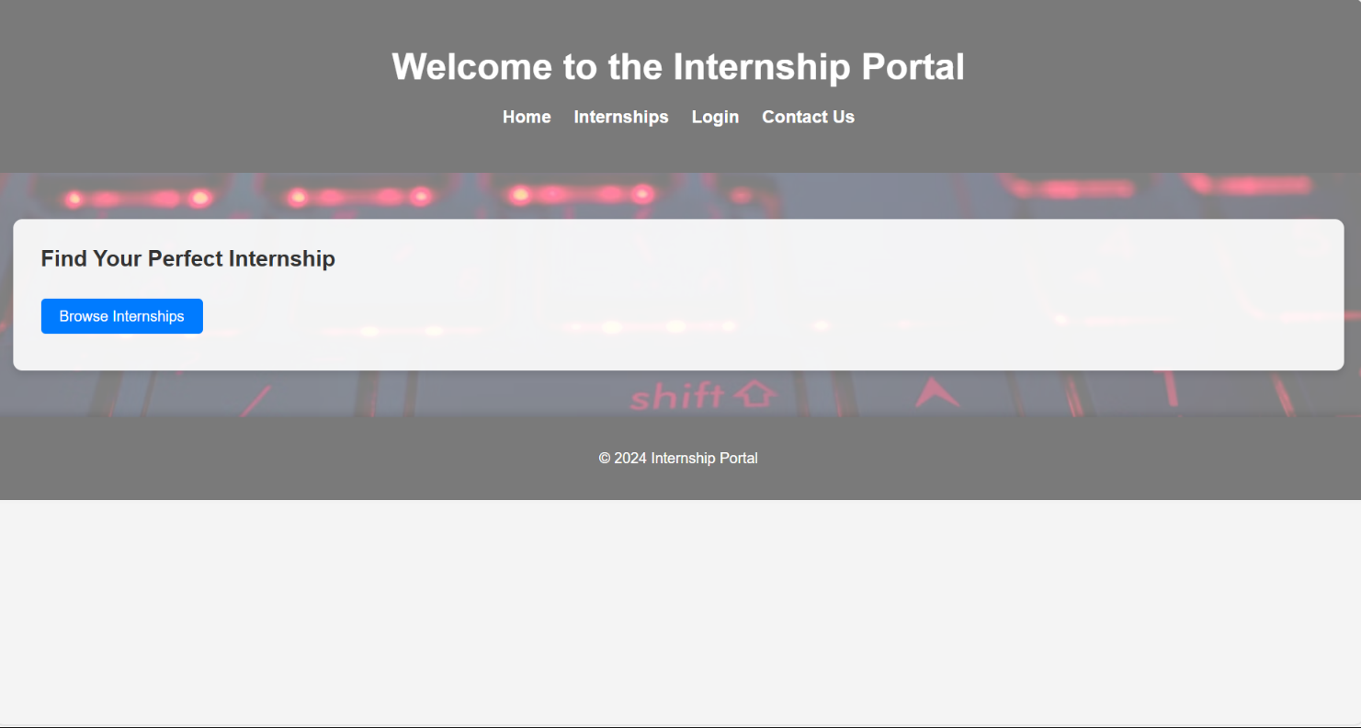

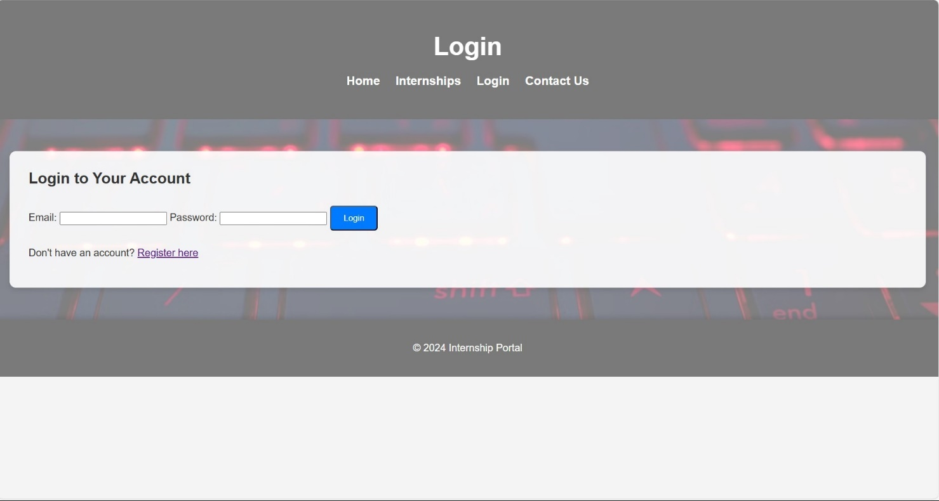

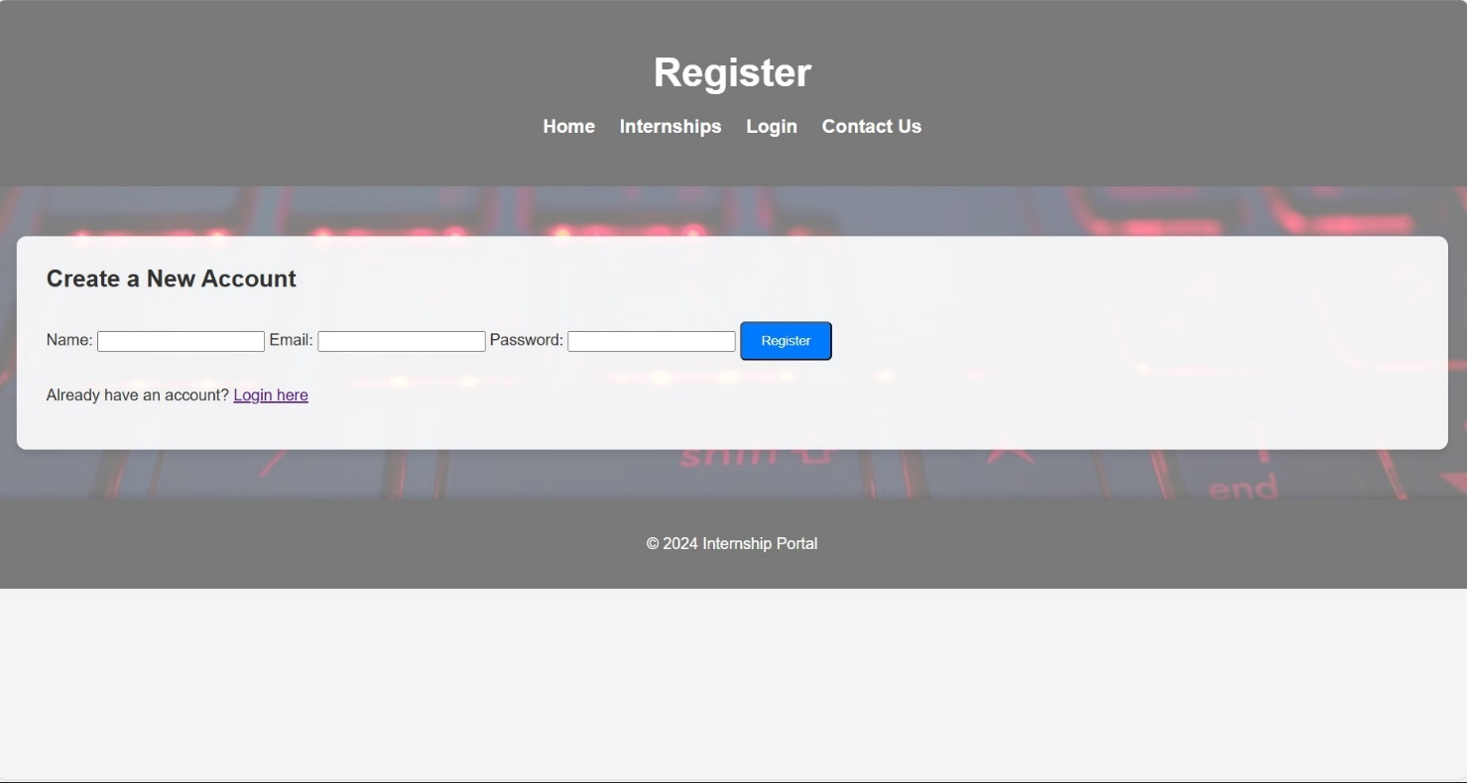

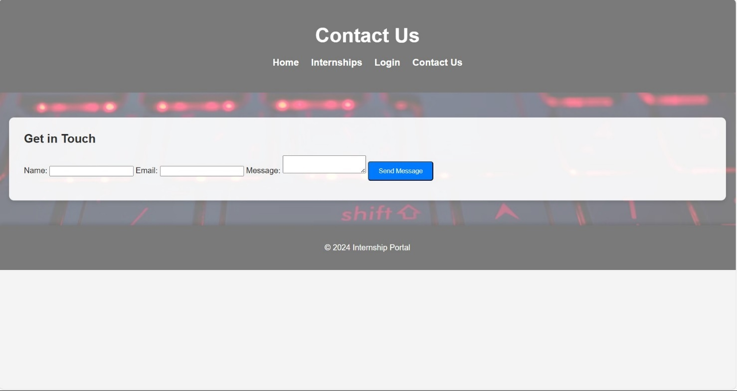

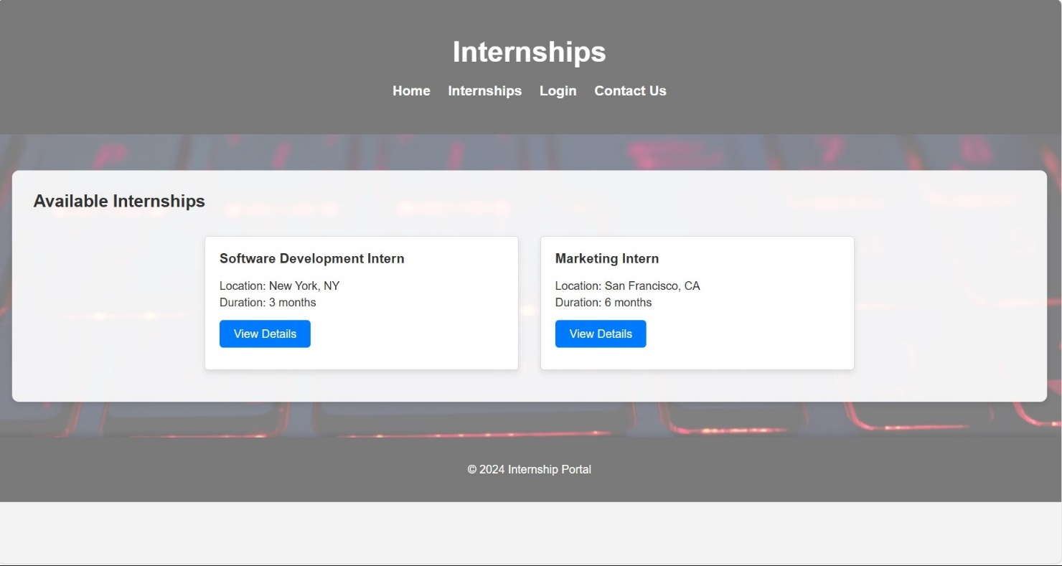

# CONCLUSION

The Internship Portal is a comprehensive solution designed to bridge the gap between students seeking internships and companies offering them. By providing a user-friendly interface and essential functionalities such as registration, login, internship browsing, and application processes, it simplifies the search for suitable internships. The integration with a backend database ensures secure and efficient data management.

Through continuous enhancements and leveraging advanced technologies, the portal aims to offer personalized experiences and streamline operations. The future scope, including mobile accessibility, AI-driven features, and global expansion, reflects its potential to become a leading platform in connecting students with valuable internship opportunities. This portal not only benefits students in gaining practical experience but also helps companies in discovering and nurturing future talent.

# FUTURE SCOPE

# The Internship Portal has several promising future enhancements. Improved user interfaces and mobile apps for Android and iOS will enhance accessibility and convenience. AI and machine learning can provide personalized internship recommendations and chatbots for support. Advanced search and filter functionalities, along with data analytics, will offer better insights and more efficient matchmaking. Expanding partnerships with more companies and educational institutions will broaden the range of opportunities and strengthen industry-academia connections. Global expansion will cater to a wider audience, and automating application processes will streamline operations. Continuous improvements based on user feedback and technological advancements will keep the platform relevant and user-friendly.

.

# REFERENCES

# Research paper 1 : Development of a Web-Based Student Internship Portal for Students of Health Colleges

1. Research paper 2: Student Industrial Internship Web Portal
2. Website Front End Design Reference : <https://www.geeksforgeeks.org/internship-/>
3. HTML and CSS Book for help in coding : <https://www.dcpehvpm.org/E-Content/BCA/BCA-II/Web%20Technology/the-complete-reference-html-css-fifth-edition.pdf>