**Test cases**

Scenario: Verify image, logo and right and left three slides text box on launching screen

**Given I open app first time**

**And I should see logo, image and sliding text box**

**When I slide text box to right**

**Then text box should slide right**

**When I slide text box  to left**

**Then text box should slide left**

Scenario: Verify sliding text box on app launching screen and third slide

**Given I am on launching screen**

**When I slide the text box on right**

**Then third slide prompt login and join button**

Scenario: Verify login and join button

**Given I am on launching screen**

**And there is login and join button**

**When I tap on login button**

**Then I should land on login screen**

**When I tap on join button**

**Then I should land on create account screen**

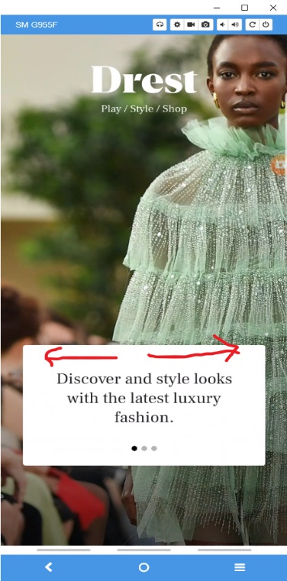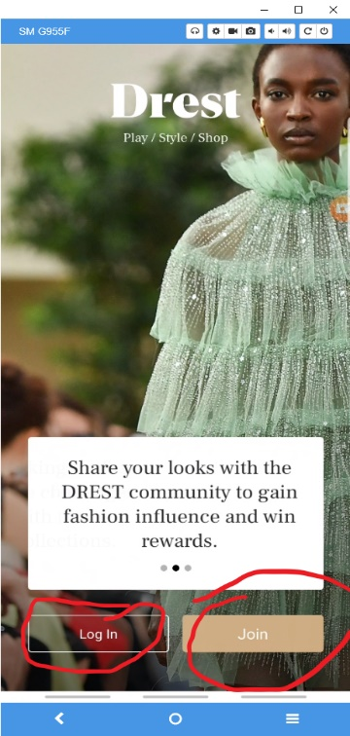

Scenario: Verify why register link text, checkboxes, email text box, go button on create account screen

**Given I am on create account screen**

**And there why register? Link text**

**When I tap on link text**

**Then I should see overlay screen with why register information**

**When I tap on close**

**Then overlay screen should close**

**And I should see create account screen back**

**And there is terms and conditions and sign up email check boxes**

**When I tick terms and condition checkbox**

**Then play as a guest button is enable**

**When I tick on sign up email checkbox**

**And enter valid email**

**When I tap on on go button**

**Then I should land Drest access code screen**

Scenario: Verify when terms and conditions checkbox is tick then play as guest, google and facebook button is enable if not tick then it is disable

**Given I am on create account screen**

**When I tick on terms and conditions checkbox**

**Then play as a guest, google and facebook button is enable**

**When I untick checkbox**

**Then play as a guest, google and facebook button is disable**

Scenario: Verify when user tap on google user should see  email account screen and navigate to add your details screen

**Given I am on create account screen**

**When I tap on google  button**

**Then I should see choose an email account screen**

**When I tap google account**

**Then I should land on add your details screen**

Scenario: Verify D edit button on tap help, camera and gallery overlay screen pop up

**Given I am on add your details screen**

**When I tap D edit button**

**Then I should see help, camera and gallery overlay screen pop up**

**When I tap on get help**

**Then mobile should navigate  to help screen**

**When I tap on camera**

**Then mobile should prompt allow Drest to access**

**And I should see allow and deny button**

**When I tap on allow**

**Then I should navigate outside application on mobile camera**

**And I tap on deny**

**Then I should see back add details screen**

**When I tap on gallery**

**Then mobile should prompt allow Drest to access**

**And I should see allow and deny button**

**When I tap on allow**

**Then I should navigate outside application on mobile gallery**

**And I tap on deny**

**Then I should see back add details screen**

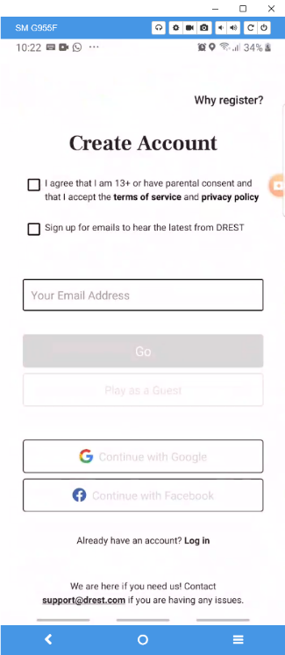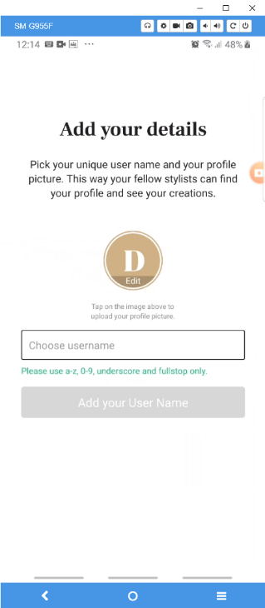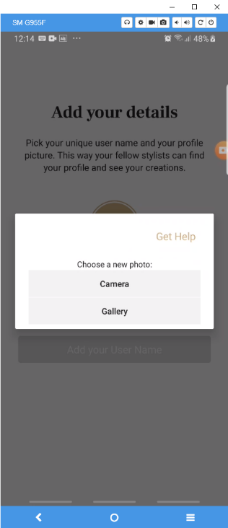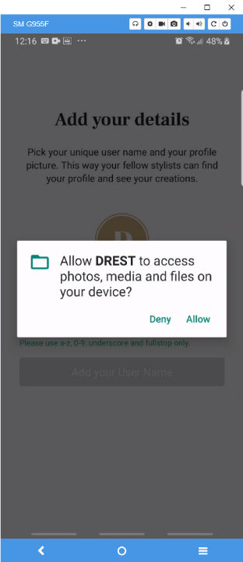

Scenario: Verify when user enter valid username add your username button is enable

**Given I am on add your details screen**

**When user enter valid user name**

**Then add your username button is enable**

Scenario: Verify when user enter invalid username add your username button is enable

**Given I am on add your details screen**

**When user enter invalid user name**

**Then I should see enter valid user name under username input box text**

**And add your username button is disable**

Scenario: Verify on tap continue with facebook  terms and condition link text and facebook button

**Given I am on create account screen**

**When I tap on facebook button**

**Then see continue with user facebook button**

**And privacy policy and terms link text**

**When I tap privacy policy and terms link text**

**Then I should navigate outside application on browser**

**And I should see Drest privacy policy screen**

**When tap on back button**

**Then I should land to application screen**

**When I tap on facebook button**

**Then I should successfully register with facebook**

**And I should land on home screen**

**And overlay your style screen with continue button**

**When I tap on continue**

**Then I should see home screen**

Scenario: Verify already have an account? Log in link text

**Given I am on create account screen**

**And there is login link text**

**When I tap on Log in link text**

**Then I should navigate login screen**

Scenario: Verify [support@drest.com](mailto:support@drest.com) email link text

**Given I am on create account screen**

**And there is email link text**

**When I tap on email link text**

**Then I should navigate outside application on email screen**

Scenario: Verify when user enter valid email then go button is enable

**Given I am on create account screen**

**And there is email input text box**

**When I enter valid email**

**Then I go button should enable**

Scenario: Verify when user enter invalid email then go button is disable

**Given I am on create account screen**

**And there is email input text box**

**When I enter invalid email**

**Then I should see red text not valid email address**

**And go button should disable**

Scenario: Verify user is able to create account

**Given I am create account page**

**And I tick on terms and condition and signup email check box**

**And enter valid email**

**When I tap on go button**

**Then I should land on enter 4 digit code screen**

Scenario: Verify when user enter valid number access code then go button is enable

**Given I am on enter 4 digit access code screen**

**And there is access code input**

**When I enter valid access code**

**Then I go button should enable**

**And I should see add your details screen**

Scenario: Verify when user enter alphabet then go button is disable

**Given I am on enter 4 digit access code screen**

**And there is access code input**

**When I enter invalid access code**

**Then  go button should disable**

Scenario: Verify when enter invalid number then tap  go button

**Given I am on enter 4 digit access code screen**

**And there is access code input**

**When I enter invalid number access code**

**Then  go button should enable**

**When I tap on go button**

**Then I should see overlay box with help and ok**

**When I tap on help**

**Then I should land on help screen**

**When I tap on ok**

**Then overlay screen disappear**

Scenario: Verify send again link text

**Given I am on enter 4 digit access code screen  
And there is send again link text**

**When I tap on send again**

**Then I should see sent text blink**

**And I should receive 4 digit access code again on my email**

Scenario: Verify when user enter valid email login button is enable

and user should land on enter 4 digit screen

**Given I am on login screen**

**When I enter valid email**

**Then login button is enable**

**And I should see 4 digit access code screen**

Scenario: Verify when user enter invalid email login button is disable

and user should enter valid email

**Given I am on login screen**

**When I enter invalid email**

**Then I should enter valid email text**

**And login button is enable**

Scenario: Verify user is able to login with google account

**Given I am on login screen**

**And there continue with google button**

**When I tap on google button**

**Then I should see choose google account screen**

**When I choose google account**

**Then I should land on home**

**And I should see overlay screen with tap to continue button**

**When I tap on continue button**

**Then I should see home screen**

Scenario: Verify user is able to login with facebook account

**Given I am on login screen**

**And there continue with facebook button**

**When I tap on facebook button**

**Then I should see choose facebook account screen**

**When I choose facebook account**

**Then I should land on home**

**And I should see overlay screen with tap to continue button**

**When I tap on continue button**

**Then I should see home screen**

Scenario: Verify user claim reward when check in with valid email

**Given I login with valid email**

**And I should see the daily DRest screen with claim reward button**

**When I tap on claim reward**

**Then I should claim reward**

**And I see overly screen enjoying Drest with yes and no Thanks button**

**When I tap on any one button**

**Then I should land on home screen with overly style screen**

Scenario: Verify 1 new reward button on home screen

**Given I am home screen**

**And there is 1 new reward button**

**When I tap on 1 new reward button**

**Then I should see overly screen with open  gift box button**

**When I tap on gift box**

**Then I should navigate to Drest champions screen  
And I should see swipe to open text**

**When I swipe screen**

**Then I should land item screen**

**When I swipe on item screen**

**Then I should see items are now in your wardrobe and close button**

**When I tap on close button**

**Then I should see overlay screen with open gift box button disable with close**

**When I tap on close home screen**

**Then I should land on**

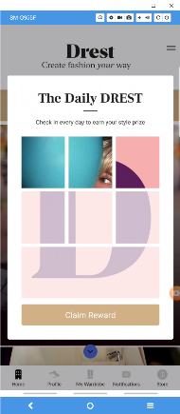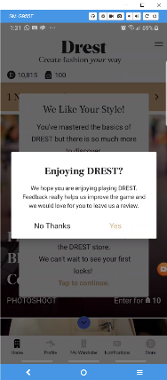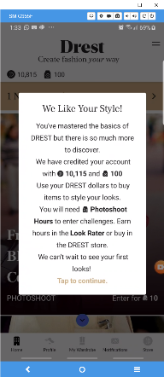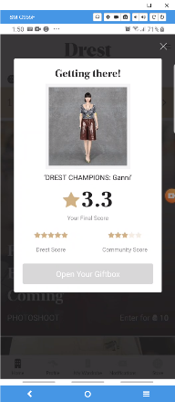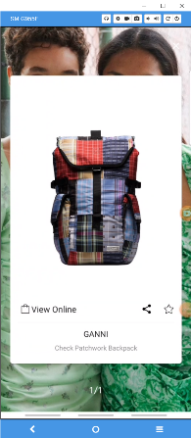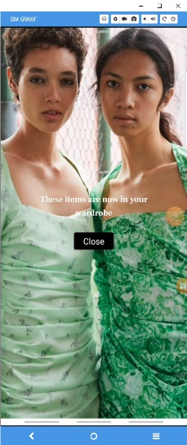

Scenario: Verify user get notification when other user follow

**Given I am on notification screen**

**When other user follow my account**

**Then I should get notification with user account name follow you**

**When I tap on user**

**Then I should land on user profile screen**

**And there is back button**

**When I tap on back button**

**Then I should land back on notification screen**

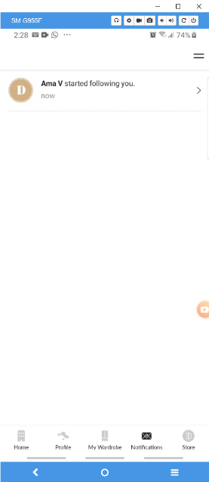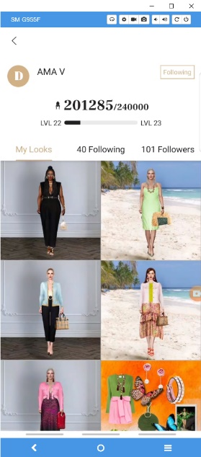

Scenario: Verify user is able to scroll down and blue arrow button is disable when user scroll down

**Given I am on home screen**

**And there is blue arrow button**

**When I scroll screen down**

**Then I should able scroll screen down**

**And blue button is disable**