LAB 2 – JIRA HANDS-ON
AGILE BACKLOG CREATION & SPRINT SIMULATION
Patient Health Record Consent Management System

1. Agile Backlog – Epics and User Stories
The Lab 1 functional requirements were converted into three major Agile themes (Epics) and nine User Stories. Priorities and Fibonacci story points were assigned.
Epic | User Story | Priority | Story Points | Purpose
Epic 1 – Consent Management | Grant Consent | High | 5 | Grant and control time-bounded access to selected medical records.
Epic 1 – Consent Management | Select Medical Records | High | 3 | Grant and control time-bounded access to selected medical records.
Epic 2 – Consent Revocation & History | Revoke Consent | High | 5 | Revoke consent and maintain visibility of consent/access history.
Epic 2 – Consent Revocation & History | View Consent & Access History | Medium | 3 | Revoke consent and maintain visibility of consent/access history.
Epic 3 – Medical Record Access & Audit | Request Record Access | Medium | 3 | Request, verify, validate and access records with an audit trail.
Epic 3 – Medical Record Access & Audit | Verify Requester | High | 3 | Request, verify, validate and access records with an audit trail.
Epic 3 – Medical Record Access & Audit | Check Consent Validity | High | 3 | Request, verify, validate and access records with an audit trail.
Epic 3 – Medical Record Access & Audit | Access Medical Records | High | 5 | Request, verify, validate and access records with an audit trail.
Epic 3 – Medical Record Access & Audit | Record Audit Event | High | 5 | Request, verify, validate and access records with an audit trail.
Total backlog estimate: 35 story points.
2. Story Point Assignment – Jira Evidence
The Jira screenshot below shows the nine User Stories with Fibonacci story-point estimates: 3 and 5 points.
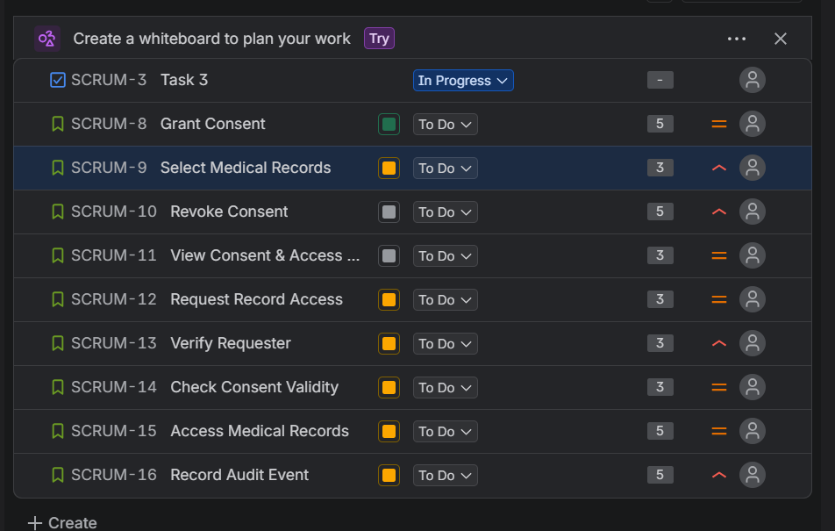
Figure 1 – Jira backlog showing User Stories and Story Points
3. Sprint Board – Active Sprint Evidence
A one-week sprint was simulated by moving work items through To Do → In Progress → Done. The active-sprint screenshot records the board during execution.
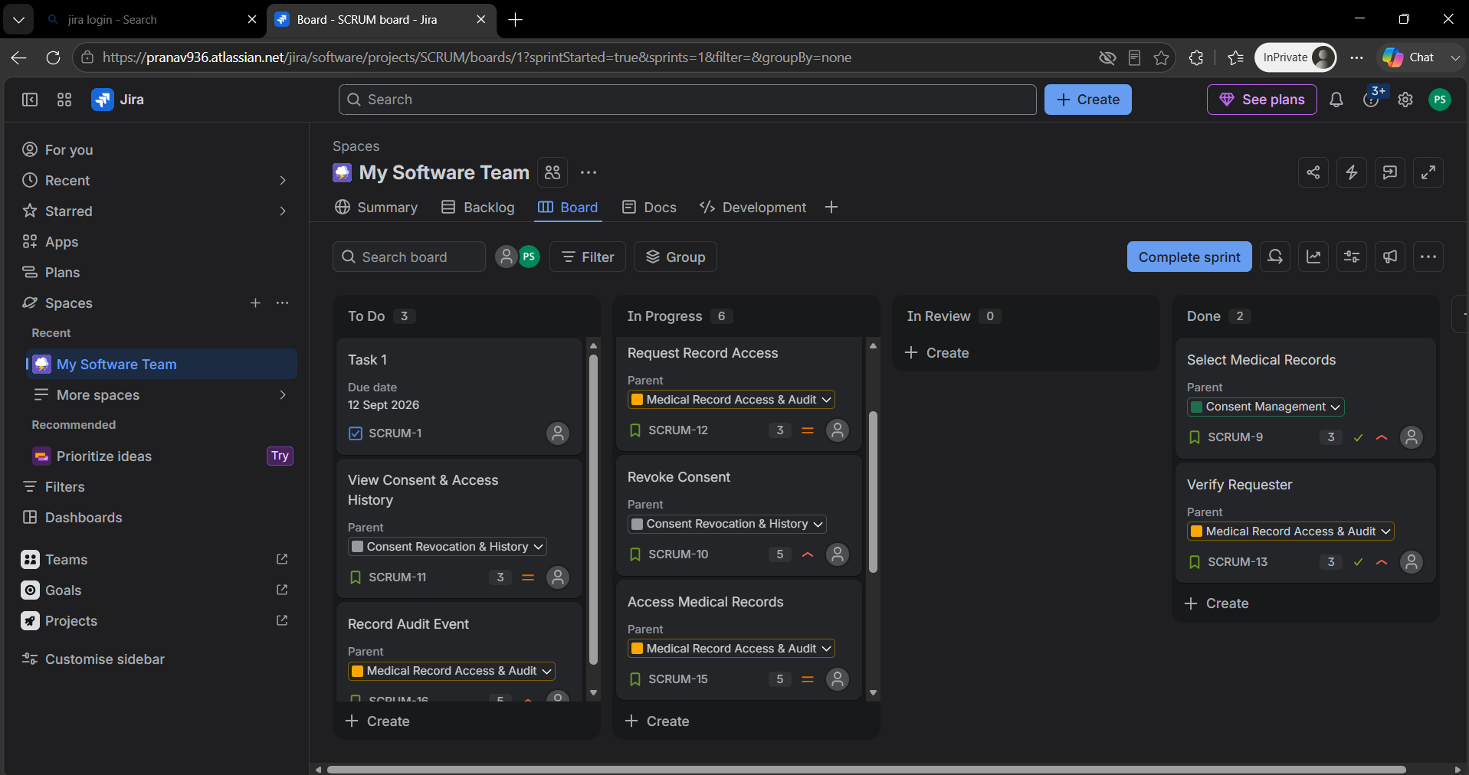
Figure 2 – Jira Active Sprint board during execution
4. Sprint Planning / Commitment Evidence
The second simulated sprint contained the five carried-over User Stories, with a total commitment of 21 story points.
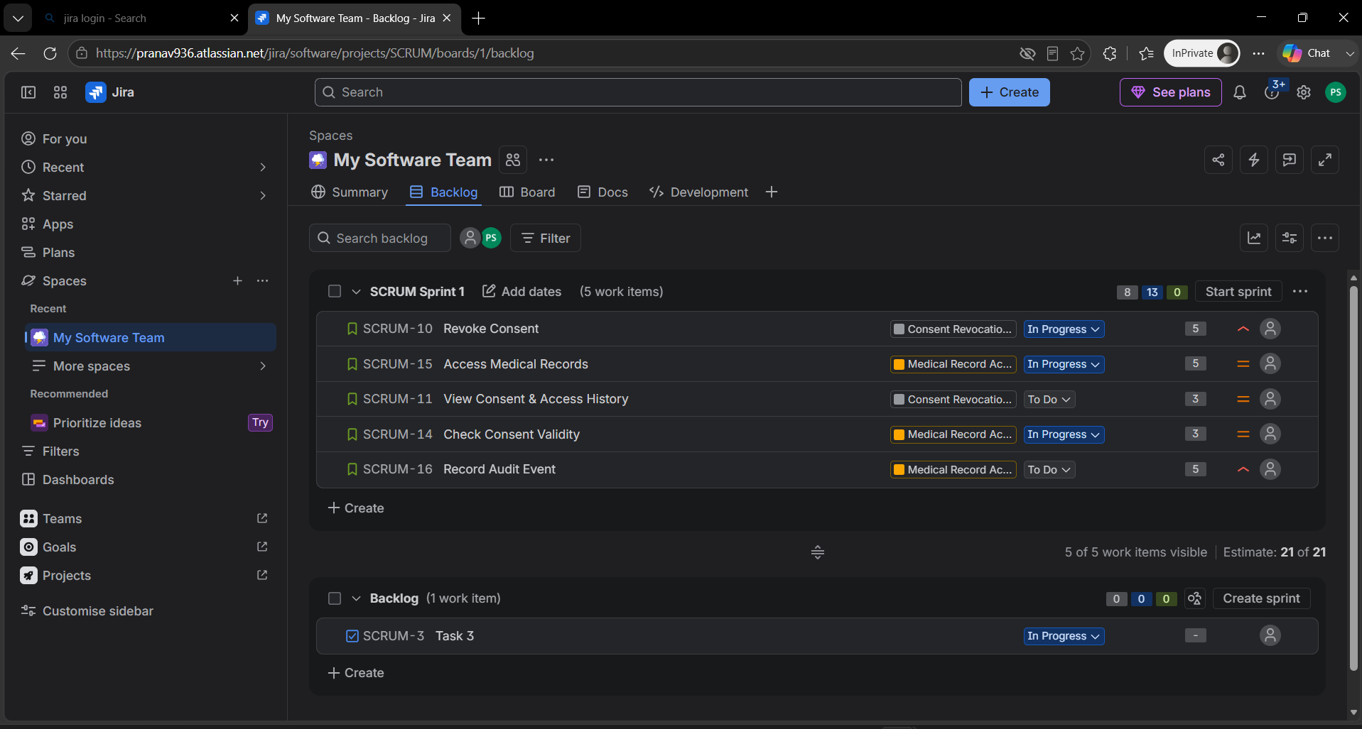
Figure 3 – Sprint planning view showing 5 work items and 21 story points
5. Burndown Chart
The one-week sprint burndown chart shows 21 story points at the start and 0 remaining at completion. The red remaining-work line falls sharply because the simulation recorded several completed items together rather than gradually day by day.
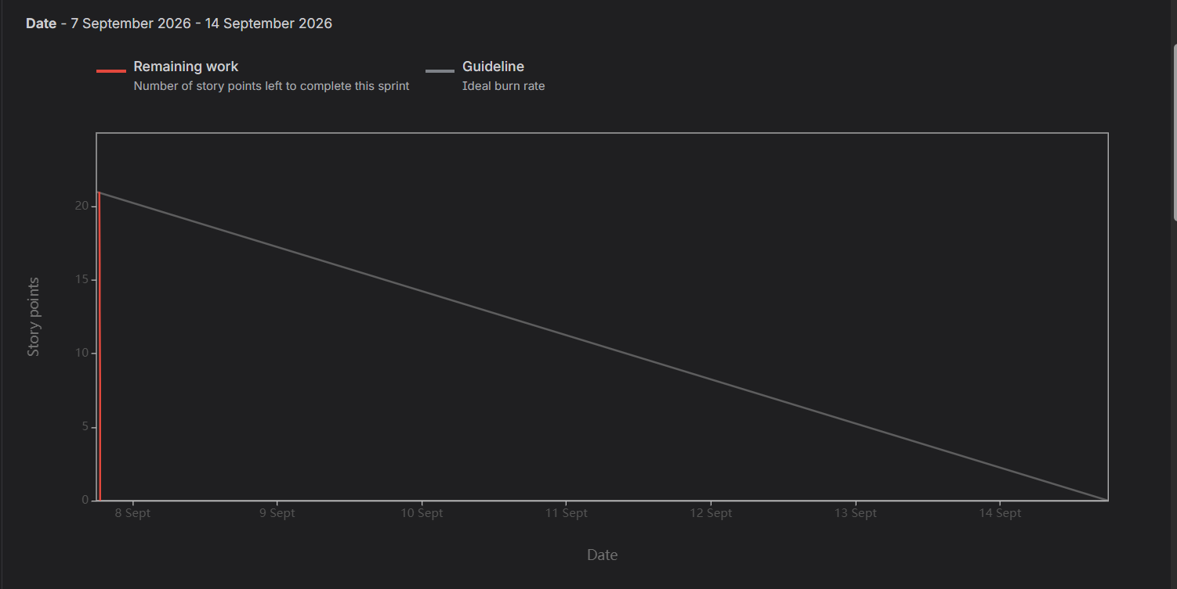
Figure 4 – Jira Sprint Burndown Chart (7–14 September 2026)
6. Reflection Questions
1. Did your estimations reflect the actual effort?
Yes, the estimates were reasonably consistent with the simulated effort. The backlog used Fibonacci values of 3 and 5 points, and the second sprint successfully completed all 21 planned story points. However, because this was a simulation, the estimates cannot be treated as a real-world velocity measurement.
2. Was your backlog well-prioritized?
Yes. High-priority stories were placed ahead of medium-priority stories because they directly support core consent and security functions. Grant Consent, Revoke Consent, Select Medical Records, Verify Requester, Check Consent Validity, Access Medical Records, and Record Audit Event were treated as high priority, while access-request and history features were medium priority.
3. How did your simulated sprint align with your plan?
The sprint followed the planned Scrum workflow: work was selected, the sprint was started for one week, and stories were progressed through To Do, In Progress and Done. The second sprint completed all five carried-over stories, totaling 21 story points.
4. What insights did the burndown chart give about your team’s capacity?
The chart showed that the team was able to complete the full 21-point sprint commitment. It also highlighted that the simulation recorded completion in a concentrated period, so the burndown was much steeper than a typical day-by-day sprint. For future sprints, smaller daily updates would give a more realistic view of progress and capacity.
7. Submission Checklist
☑ Jira backlog with Epics and User Stories
☑ Story point assignments
☑ Sprint board – Active Sprint view
☑ Sprint Burndown Chart
☑ Brief reflection document answering all four questions

Source basis: Lab 2 instructions and the Lab 1 functional requirements for the Patient Health Record Consent Management System.

