**REPORT**

**SUMMARIZING THE DATA AND ITS PROCESSING**

**1. The Dataset and Its Features:**

CRIM: Crime rate per capita by town.

ZN: Percentage of residential land zoned for lots over 25,000 sq.ft.

INDUS: Percentage of non-retail business acres per town.

CHAS: Charles River dummy variable (1 if tract bounds river; 0 otherwise).

NOX: Nitric oxides concentration (parts per 10 million).

RM: Average number of rooms per dwelling.

AGE: Percentage of owner-occupied units built before 1940.

DIS: Weighted distances to five Boston employment centers.

RAD: Index of accessibility to radial highways.

TAX: Full-value property-tax rate per $10,000.

PTRATIO: Pupil-teacher ratio by town.

B: 1000(Bk - 0.63)2 where Bk is the proportion of blacks by town.

LSTAT: Percentage of lower status of the population.

MEDV: Median value of owner-occupied homes in $1000's. (Output)

**2. Data Preprocessing Steps:**

Data Type Conversion: Changed data types from object to float for analysis and operations.

Handling Outliers: Identified and capped outliers in relevant columns.

Constant Column Check: Checked for and removed any constant columns.

Correlation Analysis: Analyzed and removed highly correlated columns to avoid multicollinearity.

Skewness Check: Assessed skewness in the data.

Data Transformation: Transformed columns to improve model performance.

Train-Test Split: Split the dataset into training and test sets.

Data Scaling: Applied Standard Scaler for scaling the data.

**3. Model Training and Evaluation Results:**

Linear Regression: Achieved an R² score of 81%.

XG Boost: Recorded an adjusted R² score of 82.08%.

Decision Tree Regressor: Recorded an adjusted R² score of 74.07%.

Gradient Boosting Regressor : Recorded an adjusted R² score of 84.11%.

Random Forest Regressor: Delivered an adjusted R² score of 84.17%.

Hyper-Parameter Tuning: Grid Search CV and Randomized Search CV on Random Forest resulted in an adjusted R² score of 82.08%, which was lower than the default Random Forest model. So it was not taken.

**4.** **Interpretation of Model Performance and Coefficients**:

- Concluded that the Random Forest model is the best, with an adjusted R² score of 84.17% .

- Identified important features using Random Forest and noted that some features contributed minimally to the output.

- After removing insignificant features, the adjusted R² score improved to 84.41%.

**5. Challenges Faced:**

The primary challenge was that hyper-parameter tuning degraded the model's performance.

**6. visualised results**

**Distribution before skewness removal**

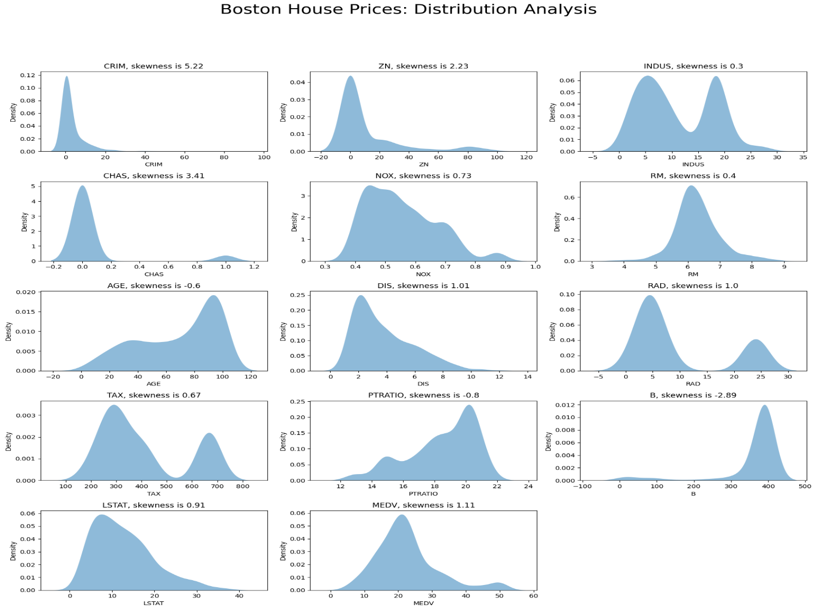

**Distribution after skewness removal**

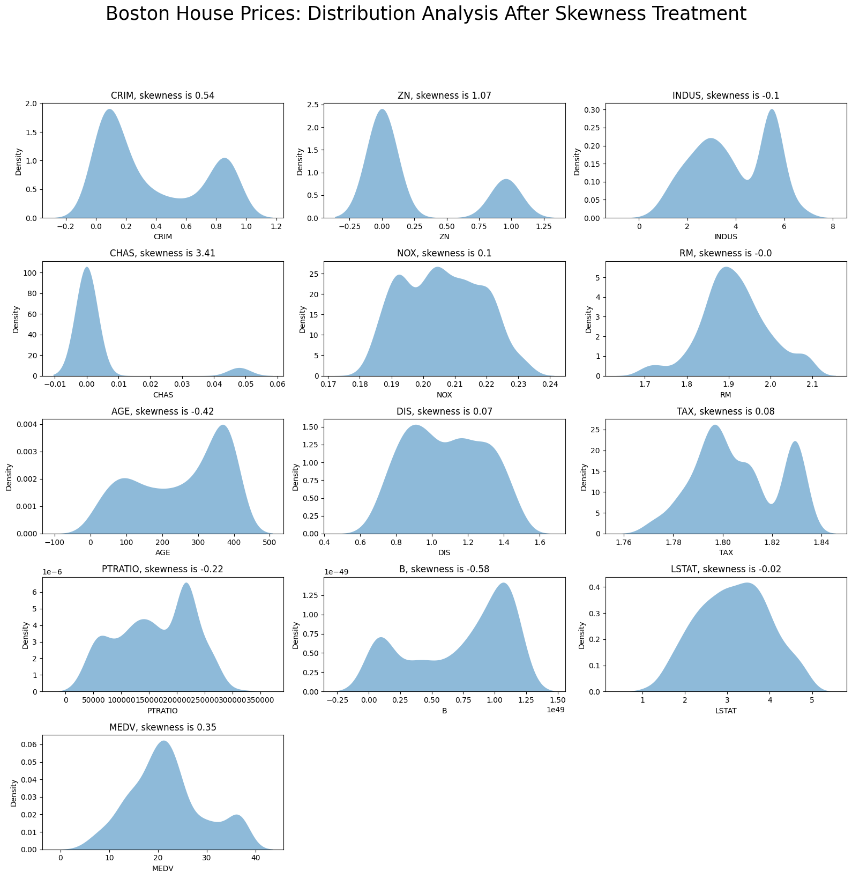

**Boxplot before Outlier Removal**

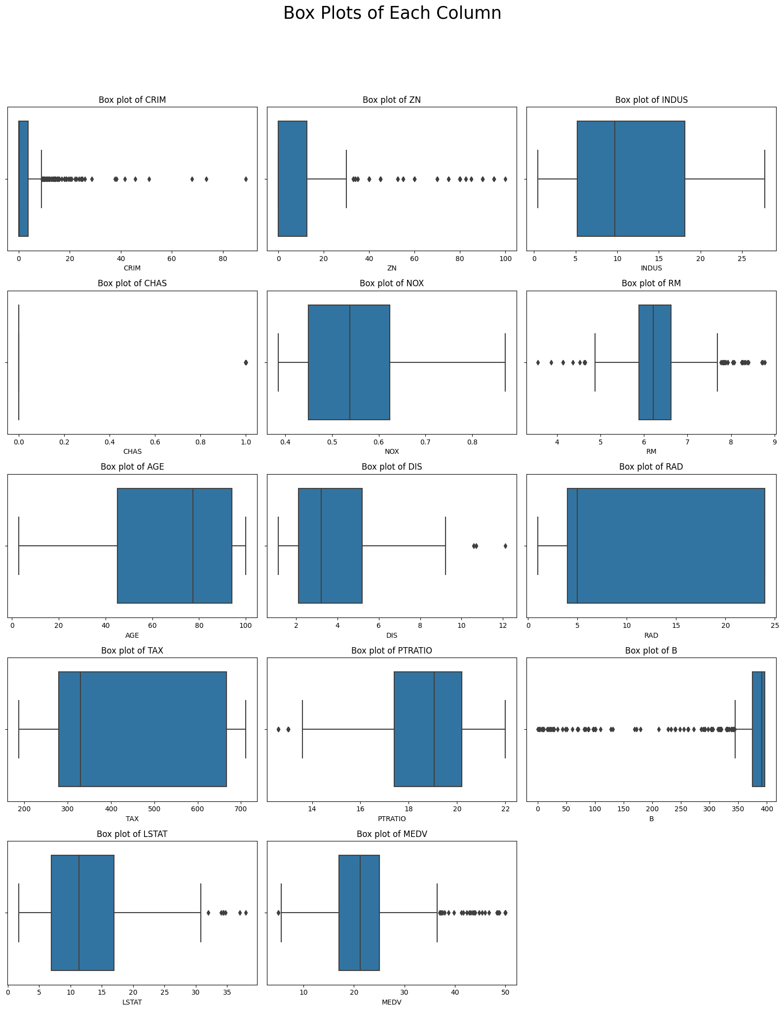

**Boxplot after Outlier Removal**

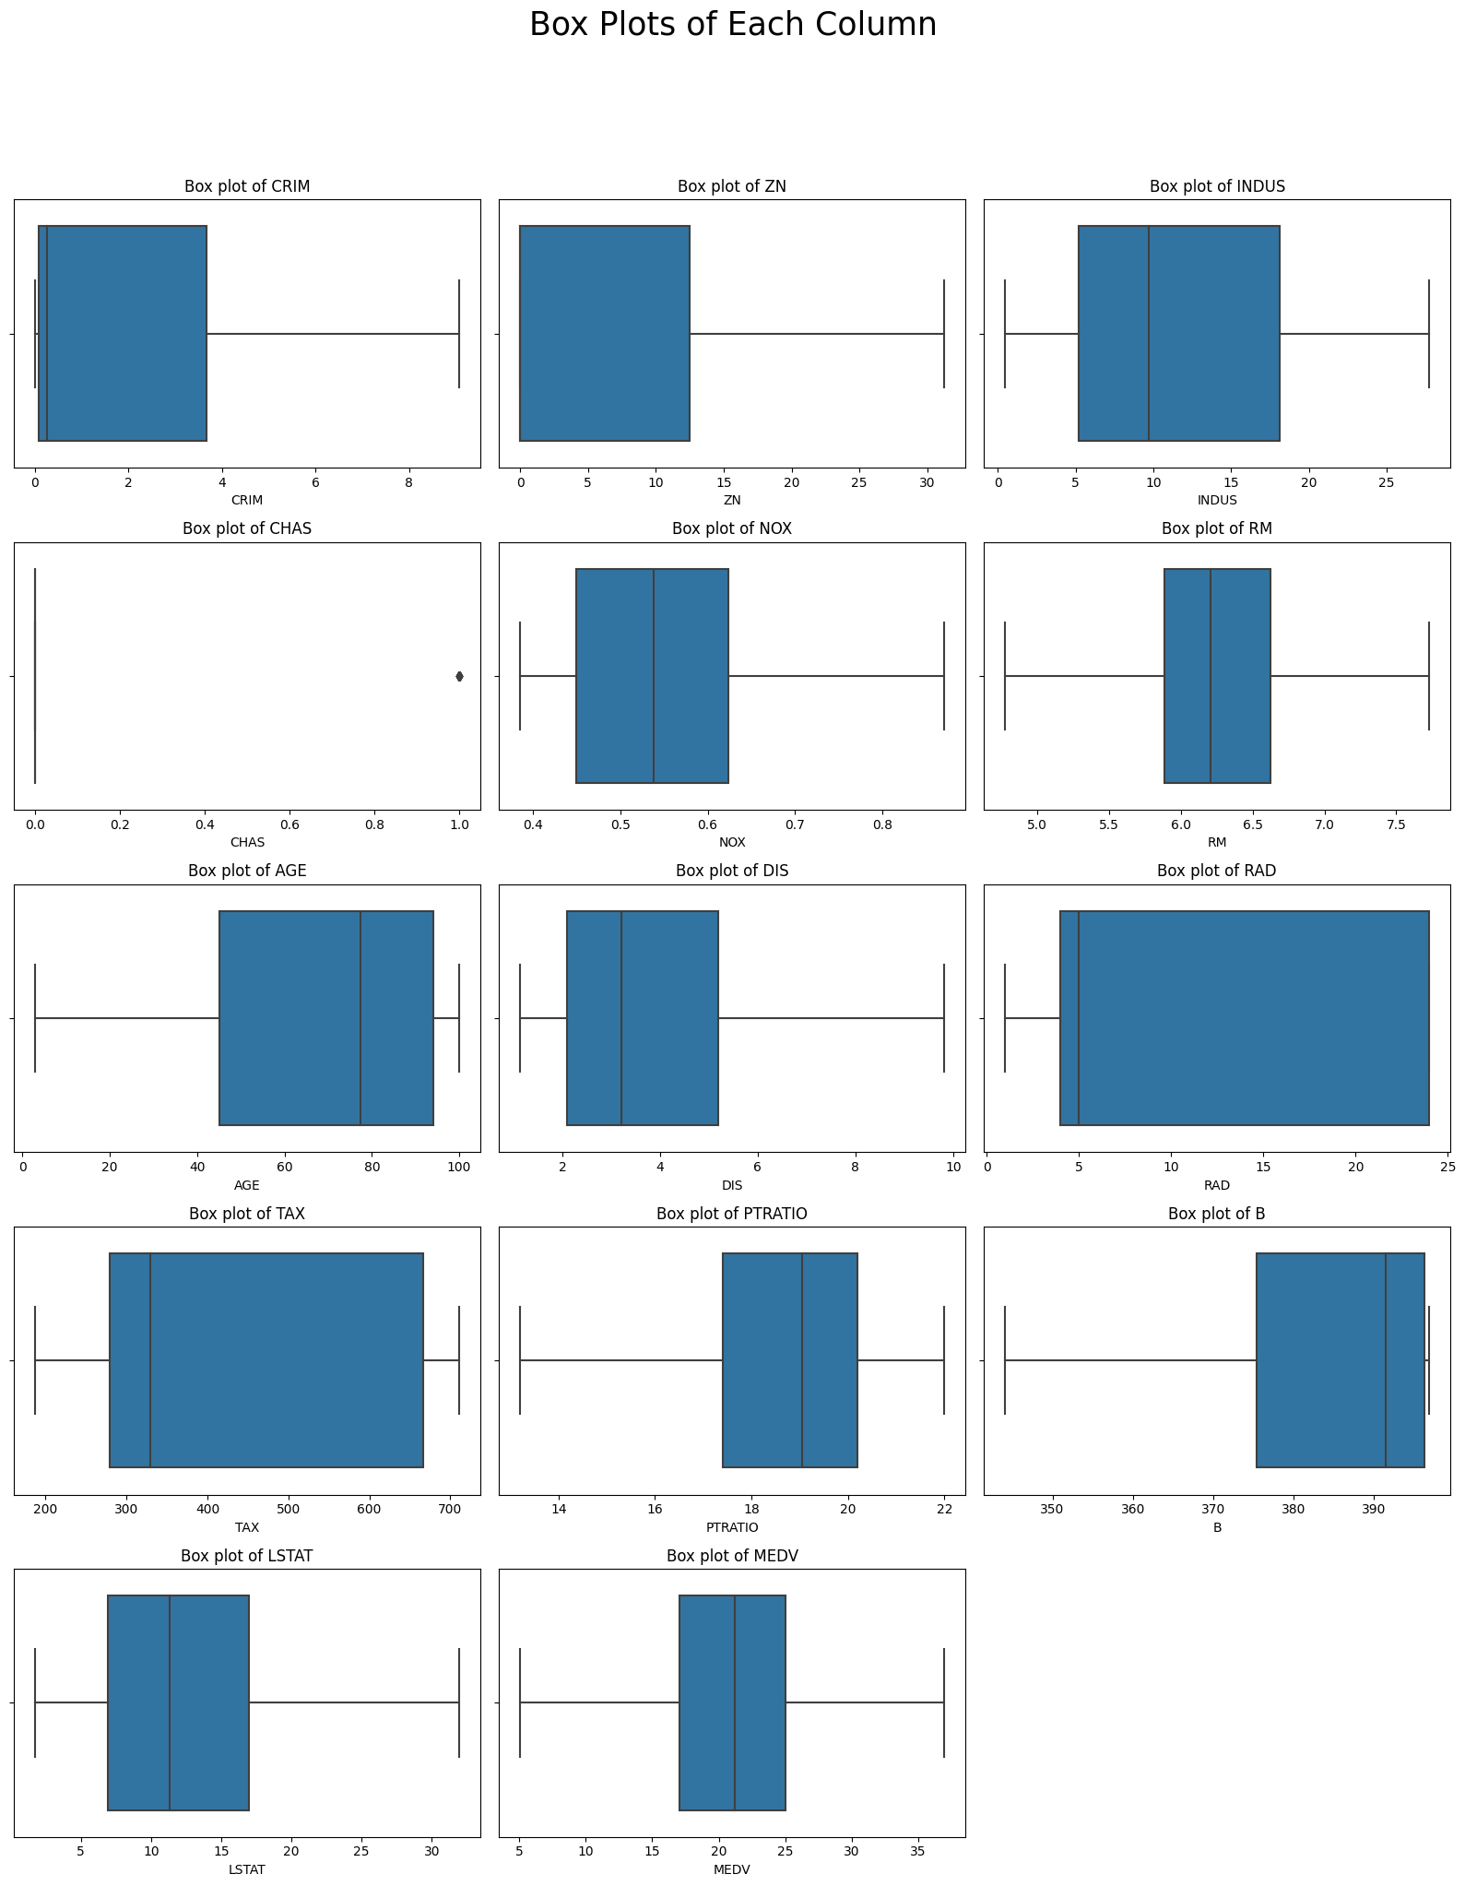

**HeatMap before corelated feature removal**

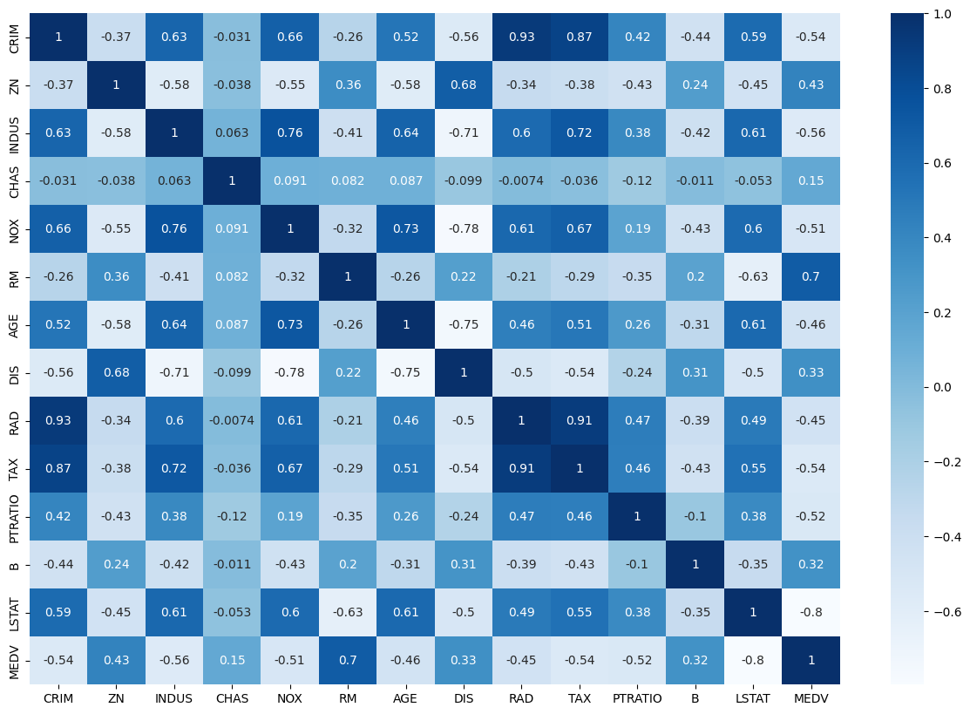

**HeatMap after corelated feature removal**

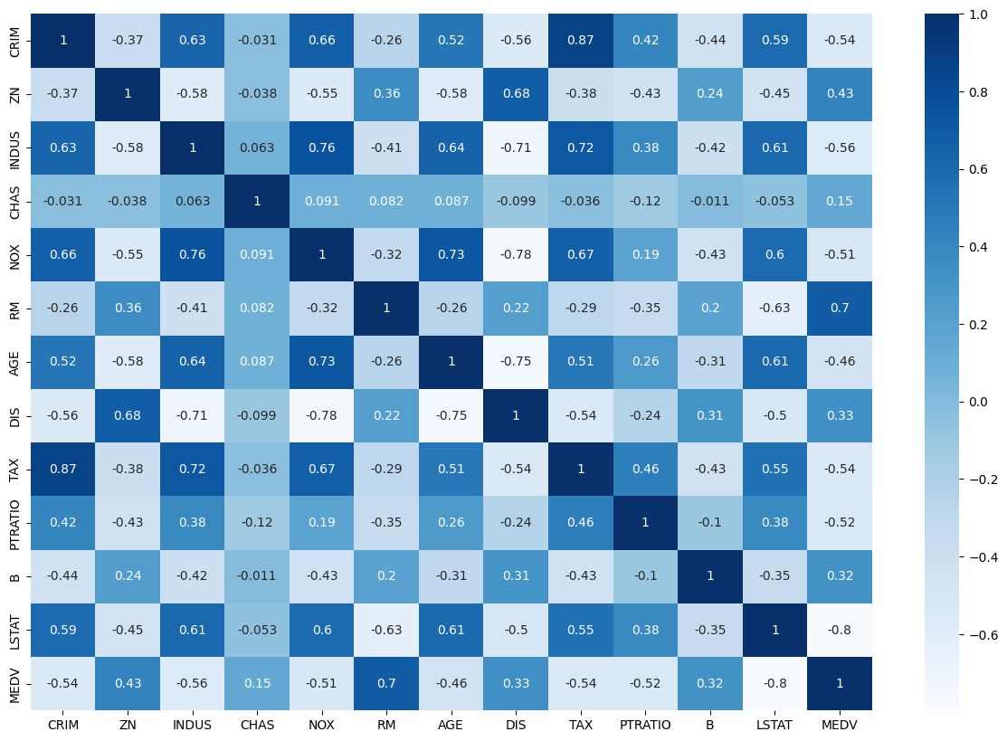

**Actual vs Predicted price**

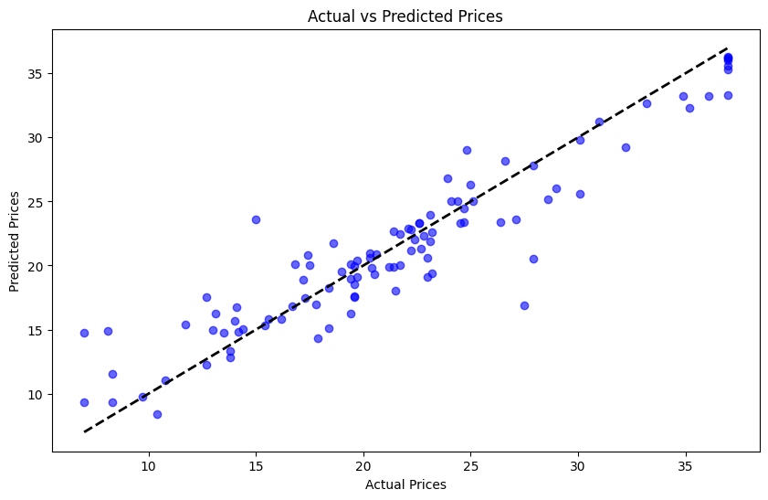

NAME:- Pranav Parasar

SIC:- 21BCED77

Email: pranavparasar99@gmail.com