# Rough Terrain Crane 2.0 - Metrics

|  |  |
| --- | --- |
| **Equipment** | Rough Terrain Crane |
| **Target release** | RTC 2.0 |

## [Description](#RoughTerrainCrane2.0-Metrics-Descriptio)

## [Metrics Refresh Interval](#RoughTerrainCrane2.0-Metrics-MetricsRef)

## [Scenario Initialization](#RoughTerrainCrane2.0-Metrics-ScenarioIn)

## [HUD and Widget Overview](#RoughTerrainCrane2.0-Metrics-HUDandWidg)

## [Goal Description, Metrics and Widgets](#RoughTerrainCrane2.0-Metrics-GoalDescri)

## [Goal Description](#RoughTerrainCrane2.0-Metrics-GoalDescri)

## [Metrics](#RoughTerrainCrane2.0-Metrics-Metrics)

## Description

Metrics measure the operator activities and performance during the training exercise.

* they provide an objective point of view
* they enable the instructor to evaluate students
* evaluation can be based on numbers
* students can be compared

Goals and widgets guide the operator through the tasks. They also serve as navigational aids.

Instructor tools are used to analyze the student performance. They reside on a separate page.

## Metrics Refresh Interval

The refresh interval and on-change parameter must be set.

This is analysed and documented separately: [TC/LTC - Metrics Interval Analysis](file:///C:\pages\viewpage.action%3fpageId=352977413)

## HUD and Widget Overview

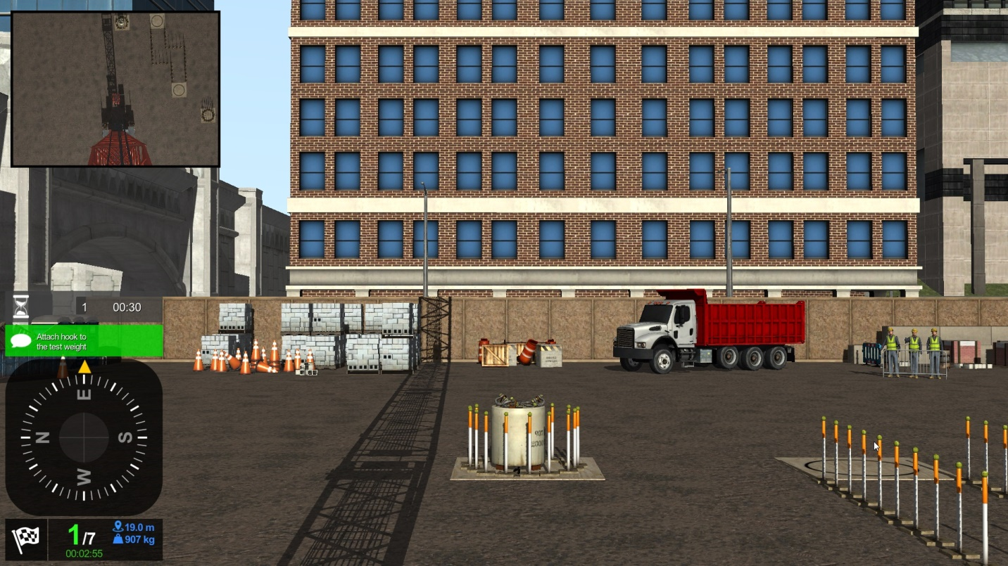

## Goal Description, Metrics and Widgets

|  |  |  |  |  |  |  |
| --- | --- | --- | --- | --- | --- | --- |
| **Category** | **Metric** | **Icon** | **Description** | **Type** | **Units**  **Metric (Imperial)** | **Notes** |
|  | Goal Description |  |  |  |  |  |
| **Goal** | Time |  | Time elapsed | integer | HH:MM:SS | N/A |
| **Goal** | Goals |  | Number of task completed and the total of tasks of the exercise | integer | N/A | N/A |
| **Goal** | Lift Object Position |  | Lift object radius position | real | m (ft) | one decimal |
| **Goal** | Actual Object Mass |  | Actual goal mass | integer | kg (lbs) |  |
|  | Metrics |  |  |  |  |  |
| **Machine** | Alarm (NEW) | N/A | Type of alarm triggered and counter.  Total time elapsed in alarm condition | integer, text  integer | N/A  MM:SS | Not displayed on the HUD because it is redundant with the HMI.  inlcuded all alarms triggered in the cab (do not include pre-alarms) |
| **Machine** | Grounding Hook Block (NEW) | N/A | Number of times the hook block was grounded | integer | N/A | Any time the hook block is set on the ground, top of building or top of object. |
| **Machine** | Dragging (NEW) | N/A | Number of times a liftable was dragged on the ground  Total distance liftable was dragged. | integer  real | N/A  m (ft) | Threshold is 15 cm.  Calculate total distance (path length).  Exclude chain in CCO course.  Especially relevant during tilt-up (steel beams, pipes, etc). |
| **Environment** | Collision **\*target for improvement\***  Note  If moving collisions to contact based, the landing sensitivity should remain. |  | Every collision in the simulation will be recorded and will be categorized based on the collision force.  There are three types: Critical/Major/Minor | integer | N/A | Critical / Major / Minor  A load must not contact a structural member of a crane or hoist and a structural member of a crane or hoist must not contact any building, bridge, other crane or any other structure, fixture or improvement  [OHS Regulation](https://www.worksafebc.com/en/law-policy/occupational-health-safety/searchable-ohs-regulation/ohs-regulation/part-14-cranes-and-hoists#SectionNumber:14.39) |
| **Machine** | Pendulum |  | Number of times in uncontrolled hook movement.  Duration in uncontrolled hook movement. | integer  integer | N/A  MM:SS |  |
| **Machine** | Pendulum Auxiliary Hook |  | Number of times in uncontrolled hook movement.  Duration in uncontrolled hook movement. | integer  integer | N/A  MM:SS |  |
| **Machine** | Idle Time (NEW) | N/A | Number of events where machine is not in use or not active.  Time elapsed while machine was not in use or not active. | integer  integer | N/A  MM:SS | Important: the operator should not be penalized for actions not under his control such as: hooking, snapping, pouring concrete, etc.  As built:  The operator is not considered “idle” if  ·         Scenario hasn’t started  ·         Crane is OFF  ·         The crane is swinging, luffing or hoisting  ·         Hooking is in progress  ·         Reeving Change is in progress  ·         Pouring Concrete is in progress  ·         Filling Concrete bucket is in progress |
| **Machine** | Shock Load |  | Maximum load applied on the crane hook experienced as a result of rough handling | integer | kg (lbs) | Important: the number (kg) is difficult for customers to relate to. Study possibility to present this with levels (minor, major, critical) |
| **Machine** | Lift objects moved | N/A | Number of lifted objects | integer | N/A |  |
| **Machine** | Optimal trajectory | N/A | Ratio between hook block optimal trajectory distance and actual distance travelled by the operator. | real | % | one decimal |
| **Environment** | Wind Speed | N/A | Wind speed | integer | km/h (miles/h) |  |
| **Environment** | Faults (NEW) | N/A | Number of times fault was inserted.  Type of fault inserted.  Time at which fault was inserted. | integer  text  integer | N/A  aabbb  HH:MM:SS |  |
| **Environment** | Cones Touched |  | Contacts with cones | integer | N/A |  |
| **Environment** | Cones Knocked Over | N/A | Cones knocked over | integer | N/A | Will not be displayed on HUD as this can be observed in the scene. |
| **Environment** | Fences Touched | C:\d0dda89a0bfdfcde8a694b284d28528f | Contacts with fence | integer | N/A |  |
| **Environment** | Fences Knocked Over | N/A | Fence knocked over | integer | N/A | Will not be displayed on HUD as this can be observed in the scene. |
| **Environment** | Barrels Touched |  | Contacts with barrels | integer | N/A |  |
| **Environment** | Barrels Knocked Over | N/A | Barrels knocked over | integer | N/A | Will not be displayed on HUD as this can be observed in the scene. |
| **Environment** | Concrete Spillage |  | Amount of concrete spilled | integer | kg (lbs) |  |
| **Environment** | Balls Knocked Off Pole | N/A | Balls knocked off poles | integer | N/A | Will not be displayed on HUD as this can be observed in the scene. |
| **Environment** | Poles Touched |  | Contacts with poles | integer | N/A |  |
| **Environment** | Poles Knocked Over | N/A | Poles knocked over | integer | N/A | Will not be displayed on HUD as this can be observed in the scene. |
| **Environment** | Weight Touching the Ground | C:\3302eed3e7b93059adcc1712fa0d0b22 | Number of times and the duration when the weight touched the ground | integer  integer | N/A  HH:MM:SS |  |
| **Environment** | Chain leaving the ground | C:\755674c0c3087662e5f0790fbcd1416a | Number of times and the duration when the chains leaving the ground. | integer  integer | N/A  HH:MM:SS |  |
| **Environment** | Straight Line (NEW) | N/A | Coefficient of linear relationship for projection of points on the ground. | real | % | one decimal |
| **Environment** | Line Length (NEW) | N/A | Length of the line projected on the ground. | real | m (ft) | one decimal |
| **Machine** | Boom Tip Camera Use (NEW) | N/A | Total time spent with boom tip camera in use. | integer | HH:MM:SS |  |
| **Machine** | Pointer Use (NEW) | N/A | Total time spent with the laser pointer (depth perception aid) in use. | integer | HH:MM:SS |  |
| **Safety** | Contact with Human (NEW) | C:\33a4d73e00f568d95094fa0b5ee36563 | Number of contacts between any part of the machine and a human. | integer | N/A | Any human in the scene.  Includes liftable if hooked to crane. |
| **Safety** | Block over Human (NEW) | TBD | Hook block or load over human | integer | N/A | Any human in the scene.  Will have to determine height cut-off |
| **Machine** | Throttle Position | N/A | Position of the throttle from 0% for the idle to 100% for the max RPM. Need to consider the throttle pedal and the dial throttle. | real | % |  |
| **Machine** | Engine Power | N/A | The amount of power consumed in real time and the percentage over the power available. | real | kW (hp)  % |  |
| **Machine** | Engine Torque | N/A | The amount of torque consumed in real time and the percentage over the power available. | real | Nm (lbf ft)  % |  |
| **Machine** | Fuel Consumption | N/A | Current fuel consumption | real | L/h (GPH) |  |
| **Machine** | Ground Pressure | N/A | Ground pressure at four locations.  RR, RL, FL, FR  x2 for the RTC  Wheel: RR, RL, FL, FR (assume zero when on outriggers)  Outrigger: RR, RL, FL, FR (assume zero when on wheels) | real | kPa (PSI) |  |
| **Machine** | Machine Tip | N/A | Number of times machine tipped. | integer | N/A |  |
| **Environment** | Contact with Electric Pole |  | Number of times machine contacted electric pole or cable | integer | N/A |  |
| **Earthworks** | **Bucket Contents** |  | Mass of contents inside the bucket.  Ratio of contents mass over bucket mass capacity. | real | kg (lbs)  % | no decimal |
| **Earthworks** | Bucket Efficiency | N/A | Mass of material moved with the bucket over time | real | kg/min  (lbs/min) | no decimal |
| **Machine** | Contact between Bucket and Machine | N/A | Number of contacts between bucket and machine | integer | N/A | any part of the machine (boom, tracks, body) |
| **Earthworks** | Cycle Loading | N/A | Loading cycle count  Current loading cycle time | integer  integer | N/A  MM:SS | loading:  starts with empty bucket at end zone  ends with full bucket at start zone  end zone can be more thand one location (operator has choice between pile or truck) |
| **Earthworks** | Cycle Unloading | N/A | Unloading cycles count  Current unloading cycle time | integer  integer | N/A  MM:SS | unloading:  starts with full bucket at start zone  ends with empty bucket at end zone  end zone can be more thand one location (operator has choice between pile or truck) |
| **Earthworks** | Spill Off Quantity | N/A | Mass of material spilled during unloading cycle. | integer | kg (lbs) |  |
| **Environment** | Pick-Up Truck Collision | N/A | Number of collitions with pick-up truck | integer | N/A | As built - added after skills challenge implemenation |
| **Environment** | Cinder Blocks Touched | N/A | Number of cinder blocks touched | integer | N/A | As built - added after skills challenge implemenation |
| **Environment** | Cinder Blocks Fallen Over | N/A | Number of cinder blocks that fell | integer | N/A | As built - added after skills challenge implemenation |
| **Environment** | Truck Proximity Ratio | N/A | Ratio of proximity of load to truck. | integer | N/A | As built - added after skills challenge implemenation  Proximity score starts at 100. Score remains  unchanged if the load remains within 5 m of the vehicle - within proximity sphere.  Score decreases 1 point/sec when outside the sphere. |
| **Machine** | Cable Collision (NEW) |  | Contact made with hoist cable | integer | N/A | Metric introduced on [VTSP-13956](http://jira:8080/browse/VTSP-13956) - TC/LTC - Metric: Contact made with Hoist cable Closed |
| **Machine** | Boom Collision (NEW) | N/A | Contact made with boom | integer | N/A | Metric introduced on - |
| **Machine** | Crane Started Unpacked (NEW) | N/A | Crane starts unpacked in the scenario.  true = unpacked  false = packed | true/false | N/A |  |
|  | Widgets |  |  |  |  |  |
| **~~Widget~~** | ~~Pendulum Trace~~ | ~~Use square widget without rounded corners.~~ | ~~Record the position of the hook on a horizontal plane. The middle is exactly under the boom tip. Erase the position after 200 points (to be tuned on sim).~~ | ~~N/A~~ | ~~N/A~~ | ~~This widget may be moved to an instructor page or other location based on feedback received after the release Construction 4.0 (CC).~~ |
| **Widget** | Next Goal Map | Use square widget without rounded corners. | The next goal map displays the orientation of the equipment relative to the next goal. The arrow color changes depending on the goal status (green, blue, yellow). | N/A | N/A |  |
| **Widget** | Action |  | This box displays messages informing the operator of automatic actions.  The box does not move and is displayed above the compass, | N/A | N/A | Hooking, guiding, concrete pouring, etc. |
| **Widget** | Message |  | This box displays messages guiding the operator during the different tasks.  The box does not move and is displayed above the compass. | N/A | N/A |  |
| **Widget** | Track Orientation |  | Represent the orientation of the upper structure relative to the tracks | N/A | N/A |  |
|  | Instructor Tools |  |  |  |  |  |
| **Instructor Tools** | Hook Block Map | image2018-2-28_10-26-13.png | The center of the map is under the boom tip. At a determined time-step, record the position of the hook block. | N/A | N/A |  |
| **Instructor Tools** | Dynamic Load Chart (NEW) |  | The actual crane load is plotted on the load chart as the scenario progresses. | N/A | N/A |  |