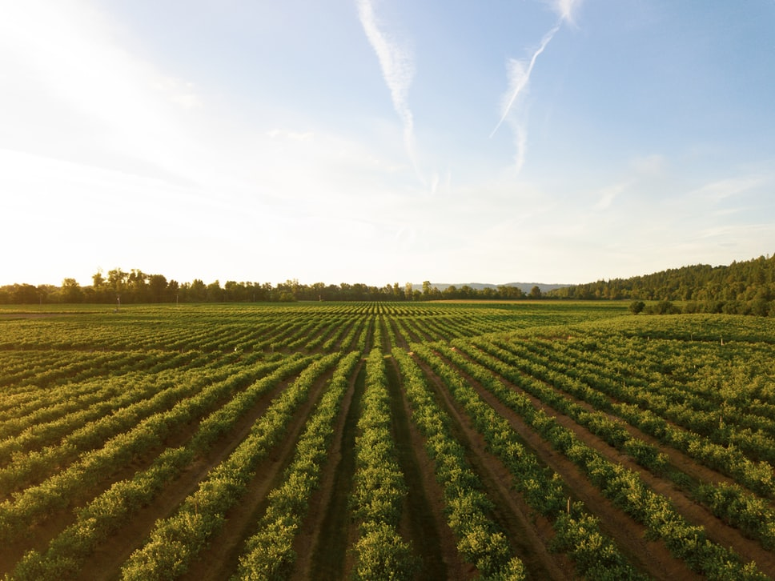

Intelligent Crop Recommendation System

**Intelligent Crop Recommendation System**

ABSTRACT

Taking India into consideration, we are a highly populated country with a population of about 1.4 billion. About 58% of the Indian population is dependent on agriculture for their livelihood. Farmers are repeatedly growing the same crops harvest after harvest, year after year without trying a new variety of crops. They also use fertilizers and pesticides in random quantities which destroys the crop yield and also the top layer of the soil. Hence, for such a huge percentage of farmers, Machine Learning could help them in making important decisions including what crops to grow and what to do during the growing season of the crops, basically called Crop Recommendation System.

Prior crop prediction and yield prediction was performed on the basis of

farmers experience in their locality. They will prefer the prior or neighborhood or trendier crop in the surrounding region only for their land and they don’t have enough knowledge about soil nutrients content such as nitrogen, phosphorus, potassium in the land. Being this as the current situation without the rotation of the crop and applying an inadequate amount of nutrients to soil it leads to reduction in the yield and soil pollution (soil acidification) and damages the top layer. Considering all these problems, we designed the system using Machine Learning for betterment of the farmer.

Keeping all of these in mind, Machine Learning could help the farmers on deciding which crop to grow at what time. Therefore, this system will recommend the most suitable crop for a particular land. The recommendation is done on the basis of weather conditions and soil content such as Temperature, Rainfall, Humidity, pH. The required inputs are given by the farmer and can also be done using sensors for the above-mentioned parameters. As far as the output is concerned the system tells the farmer which crop to grow and also the growth time of the crop.

Data Sets

<https://www.kaggle.com/atharvaingle/crop-recommendation-dataset>

<https://github.com/Gladiator07/Harvestify/blob/master/Data-processed/fertilizer.csv>

<https://www.kaggle.com/siddharthss/crop-recommendation-dataset>

<https://www.kaggle.com/srinivas1/agricuture-crops-production-in-india>

**Group Members :-**

|  |  |  |
| --- | --- | --- |
| **Roll No** | **Name** | **Role** |
| CB.EN.U4CSE19425 | Guhan M | Developer |
| CB.EN.U4CSE19435 | Sri Hari M | Designer |
| CB.EN.U4CSE19451 | Praveen Kumar R | Tester |
| CB.EN.U4CSE19458 | S Pranav Adith | Leader |