**CB.EN.U4CSE19458**

**S. PRANAV ADITH**

**Lab-3**

**URL of the developed application in internet:**

[**https://github.com/pranavadith7/On-Time-Pharmacy**](https://github.com/pranavadith7/On-Time-Pharmacy)

**Application Name:**

**Pharmacy Management System**

**About the application in a paragraph:**

Pharmacy management has been built to manage the medicine stock, especially those usually on the most demanded list for every customer. Moreover, also make sure to record bills, refill, and remove the expired ones. Pharmacare transforms all works, like administrative finance and overall operations, into one system.

**Modules in the application:**

* **Add / Update / Delete Customer**
* **Add / Update / Delete Medicine**
* **Add Invoice**
* **Add Supplier**
* **Add medicine stock**
* **Add purchase**
* **Contact**
* **Login / Sign-Up**

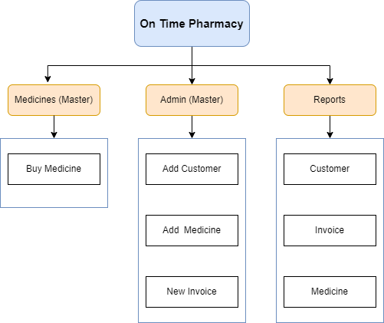**Provide a work Break Down Diagram for the application:**

**­**

**Write in your own words how the application has used Mean Stack Development**

The application is developed in AngularJS for the front end and the back end is done in NodeJS. Express JS is used on top of Node JS. Data is stored in the database using the MongoDB Compass which is a local storage for MongoDB.

**List of technologies/languages/framework/library used with purpose and version**

|  |  |
| --- | --- |
| **technologies/languages/framework/library** | **Purpose** |
| HTML/CSS/JS | Front End |
| AngularJS | Frontend |
| ExpressJS | Server, routing |
| NodeJS | Back end (16.14.2) |
| MongoDB | Database (6) |
| Cors | For allowing requests |
| Mongoose | Module to store and retrieve in mongodb |

**Write in your own words how the following concepts have been used in your application:**

|  |  |
| --- | --- |
| HTML 5 | Skeleton |
| CSS | Styling the web page |
| Angular JS | Frontend |
| Node JS | Backend |
| Express JS | Connect frontend and backend |
| XML | Used to store information regarding invoice |
| XML DTD | Used to provide the type of data in xml |
| XML Schema | Defines the structure of the xml |
| JSON | Used to store information regarding invoice |
| MongoDB | Used to store the data in local storage |

|  |  |
| --- | --- |
| Number of Forms | 8 |
| Number of XML files | 2 |
| What is unique in your application? | Individual discounts can be given to products  Existing customers can buy products by just giving their name as the information is already existing in the database |
|  |
| Form Names for Evaluating the concepts of AngularJS,NodeJS,ExpressJS | New_customer  New_invoice |
| Tables for Evaluating the MongoDB concepts | Customers  invoices |

Explanation of content in the Document in above headings : 5 Marks

For the following tables refer the concepts provided for learning from internet resources and fill the table

Weightage : 5 Marks

|  |  |  |
| --- | --- | --- |
| **Concept used from HTML5** | **File Name** | **Additional Information** |
| <img> | Index.html |  |
| <a> | Index.html |  |
| <input> | Add_customer.html |  |
| <i> | Add_customer.html |  |

Weightage : 10 Marks

|  |  |  |
| --- | --- | --- |
| **Concept used from XML** | **File Name** | **Additional Information** |
| #PCDATA | Problem.xml |
| #ID | Problem.xml |
| #PCDATA | testcase.xml |
| #PCDATA | user.xml |

Weightage : 10 Marks

|  |  |  |
| --- | --- | --- |
| **Concept used from JavaScript** | **File Name** | **Additional Information** |
| Fetch | App.js | Sends and receive api request |
| Loops | Controller.js | To render responses |
| Change | submitProblem.html | To trigger after change |
| keyup | submitProblem.html | To trigger after change |
| Onsubmit | submitProblem.html | To submit the form |
| Map | Controller.js | To map the function |
|  |  |  |
| **Concept used from JSON** | **File Name** | **Additional Information** |
|  |  |  |
| Data | Controller.js | Get json data |
| Array | Controller.js | Get json array |
| Object | Controller.js | Get json object |
| stringify | Controller.js | Convert to string |
| parse | Controller.js | Parse json string |

Weightage : 20 Marks

|  |  |  |
| --- | --- | --- |
| **Concepts used from**  **Angular JS** | **File Name** | **Additional Information** |
|  |  |  |
| $scope | Controller.js, app.js | Scope variable |
| $http | Controller.js, app.js | Used for api requests |
| $locationroute | Controller.js, app.js | Sets the location |
| $routeparms | Controller.js, app.js | Get the parameter value |
| Window.location | Controller.js, app.js | Redirects the location |
| Ng-if | All html files | Conditional rendering |
| Ng-repeat | All html files | Loop over array |
| $resource | Services.js | To handle api requests |

Weightage : 20 Marks

|  |  |  |
| --- | --- | --- |
| **Concepts used from**  **NodeJS** | **File Name** | **Additional Information** |
|  |  |  |
| Axios | Route.js |  |
| Router | All route.js |  |
| Process.env | Server.js | Loads environment variables |
| Require | All js files | Import js |
| Exports | All js files | Exports modules |
| Passport.js | Auth.js | To handle authentication |

Weightage : 20 Marks

|  |  |  |
| --- | --- | --- |
| **Concepts used from**  **ExpressJS** | **File Name** | **Additional Information** |
|  |  |  |
| App | Server.js | Initiates app |
| Listen | Server.js | Starts server on port |
| Express router | All js files | For routing |
| Get | all route files | Used to get request |
| Post | All route files | Used to post request |
| Put | All route files | Used to update data |
| Static | Server.js | Used to serve static files |
|  |  |  |

Weightage : 10 Marks

|  |  |  |
| --- | --- | --- |
| **Concepts used from**  **MongoDB** | **File Name** | **Additional Information** |
|  |  |  |
| Schema | All .model.js files |  |
| String | All .model.js files | String constraint |
| Enum | All .model.js files | Values should be one of the specified enums |
| Number | All .model.js files | Number constraint |
| unique | All .model.js files | To set unique fields |

**Provide five features that can be added to application in future:**

1. Buy medicines based on category
2. Suggestions on products bought
3. Recommending medicines