**Net-Centric Programming**

**CB.EN.U4CSE19458**

**S. PRANAV ADITH**

**Q1. Responsive web design**

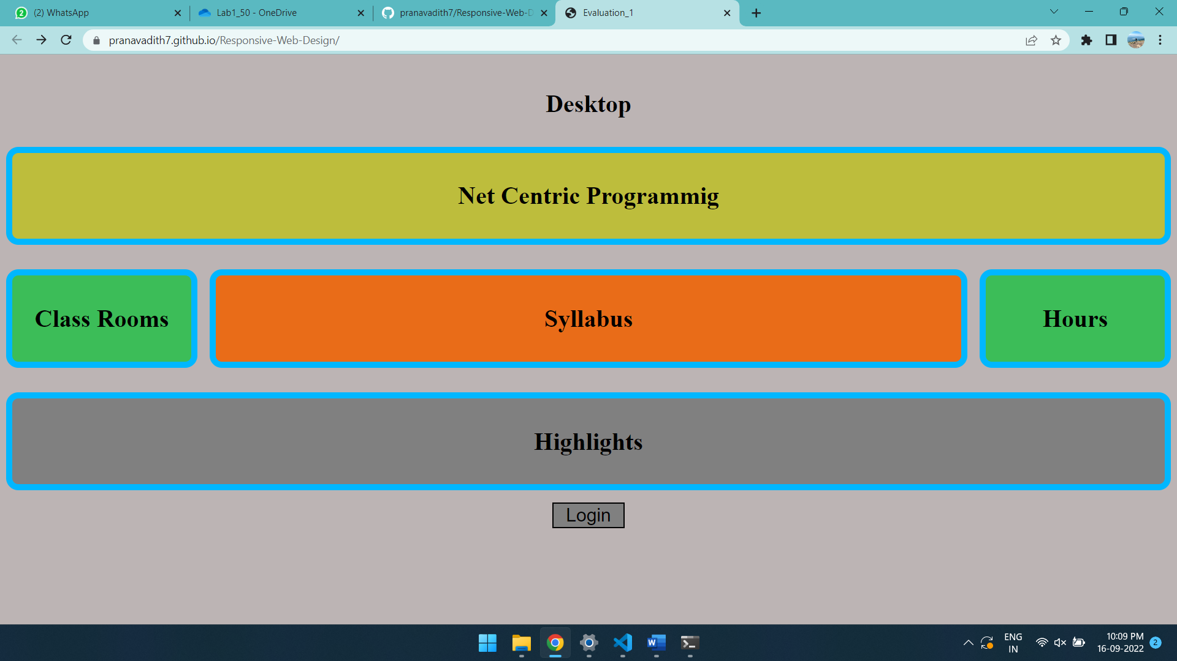

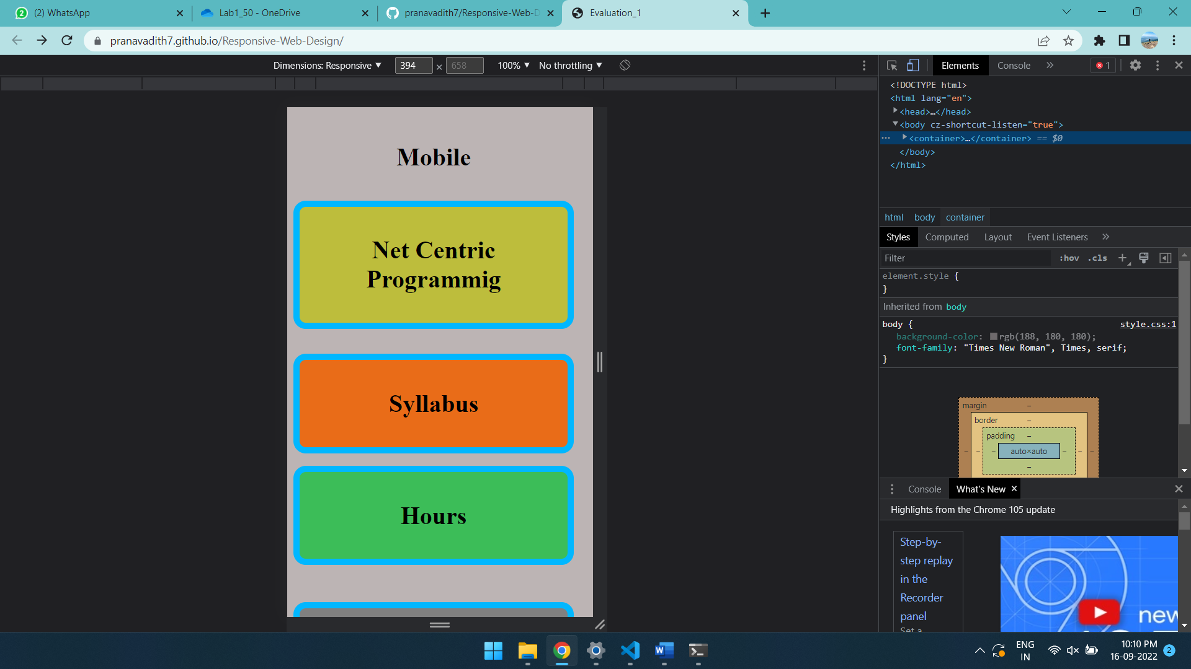

**Q2. Form**

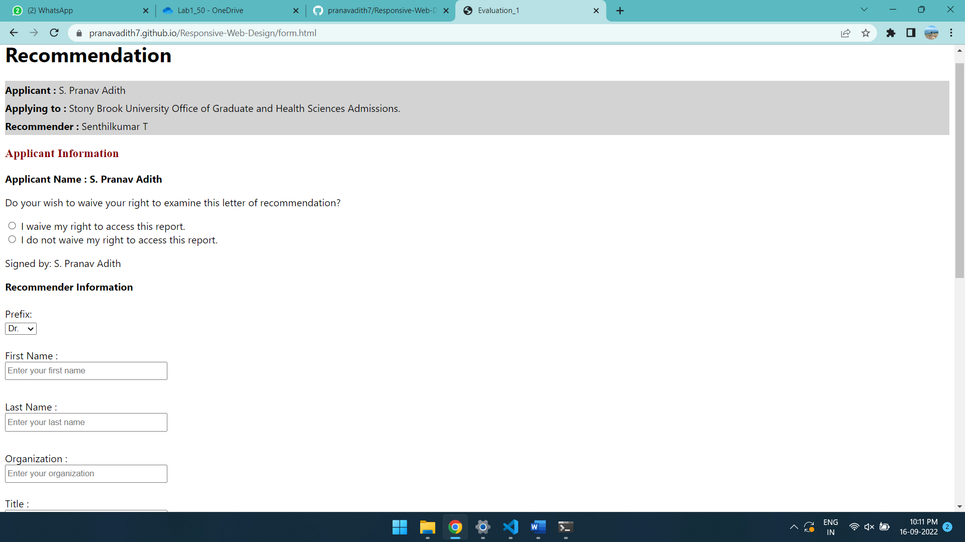

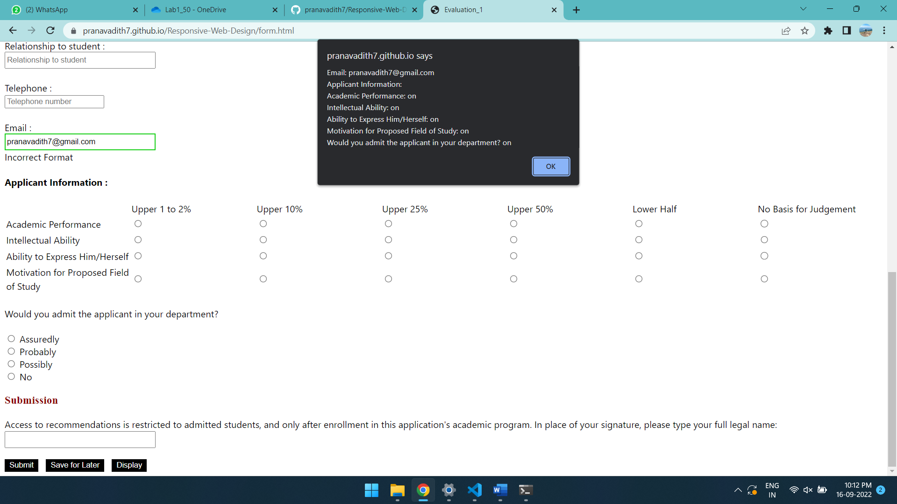

**Extra validations**

1. **Name not empty**
2. **Name does not contain numbers**
3. **Email has ‘@’ and 2 characters before ‘.’**
4. **Telephone has no letters**

**Q3. XML**

<!DOCTYPE Application SYSTEM "./applicant.dtd">

<Application>

    <Applicant>S. Pranav Adith</Applicant>

    <ApplyingTo>Stony Brook university office of Graduate and Health Sciences Adminssions</ApplyingTo>

    <Recommender>SenthilKumar T</Recommender>

    <Recommenderinfo>

        <prefix type = "Dr"></prefix>

        <FirstName>Senthilkumar</FirstName>

        <LastName>T</LastName>

        <Organization>Amrita Vishwa Vidyapeetham</Organization>

        <Title name = "AssociateProfessor" />

        <Relationship name =  "Professor" />

        <Telephone>9876543210</Telephone>

        <Email>senthilkumar_t@gmail.com</Email>

    </Recommenderinfo>

    <Applicantinfo>

        <AcademicPerformance value = "Upper-1-to-2-percent"/>

        <IntellectualAbility value = "Upper-10-percent"/>

        <AbilitytoExpress value = "Upper-25-percent"/>

        <MotivationforStudy value = "Upper-50-percent"/>

    </Applicantinfo>

    <Wouldyouadmit ans="Probably"/>

    <FullName>SenthilKumar T</FullName>

</Application>

**DTD**

<!ELEMENT Application (Applicant,ApplyingTo,Recommender,Recommenderinfo,Applicantinfo,Wouldyouadmit,FullName)>

<!ELEMENT Applicant (#PCDATA)>

<!ELEMENT ApplyingTo (#PCDATA)>

<!ELEMENT Recommender (#PCDATA)>

<!ELEMENT Recommenderinfo (prefix,FirstName,LastName,Organization,Title,Relationship,Telephone,Email)>

<!ELEMENT prefix (#PCDATA)>

<!ATTLIST prefix type (Dr|Mr) "Dr">

<!ELEMENT FirstName (#PCDATA)>

<!ELEMENT LastName (#PCDATA)>

<!ELEMENT Organization (#PCDATA)>

<!ELEMENT Title (#PCDATA)>

<!ATTLIST Title name (Professor|AssociateProfessor|HOD|DEAN) "AssociateProfessor">

<!ELEMENT Relationship (#PCDATA)>

<!ATTLIST Relationship name (Professor|AssociateProfessor|HOD|DEAN) "Professor">

<!ELEMENT Telephone (#PCDATA)>

<!ELEMENT Email (#PCDATA)>

<!ELEMENT Applicantinfo (AcademicPerformance,IntellectualAbility,AbilitytoExpress,MotivationforStudy)>

<!ELEMENT AcademicPerformance (#PCDATA)>

<!ATTLIST AcademicPerformance value (Upper-1-to-2-percent|Upper-10-percent|Upper-25-percent|Upper-50-percent|Lower-half|No-basis-for-judgement) "Upper-1-to-2-percent">

<!ELEMENT IntellectualAbility (#PCDATA)>

<!ATTLIST IntellectualAbility value (Upper-1-to-2-percent|Upper-10-percent|Upper-25-percent|Upper-50-percent|Lower-half|No-basis-for-judgement) "Upper-10-percent">

<!ELEMENT AbilitytoExpress (#PCDATA)>

<!ATTLIST AbilitytoExpress value (Upper-1-to-2-percent|Upper-10-percent|Upper-25-percent|Upper-50-percent|Lower-half|No-basis-for-judgement) "Upper-25-percent">

<!ELEMENT MotivationforStudy (#PCDATA)>

<!ATTLIST MotivationforStudy value (Upper-1-to-2-percent|Upper-10-percent|Upper-25-percent|Upper-50-percent|Lower-half|No-basis-for-judgement) "Upper-50-percent">

<!ELEMENT Wouldyouadmit (#PCDATA)>

<!ATTLIST Wouldyouadmit ans (Assuredly|Probably|Possibly|No) "Probably">

<!ELEMENT FullName (#PCDATA)>

