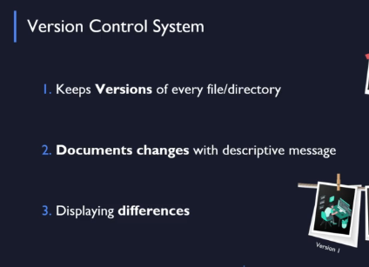











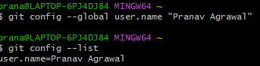



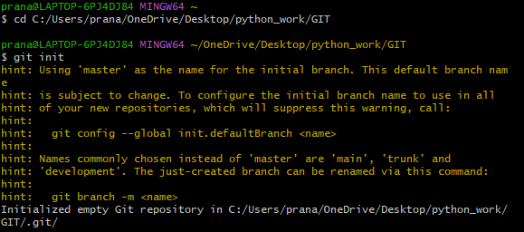

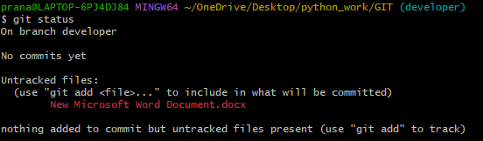



Git Workflow: Working Directory, Staging Area and Repository



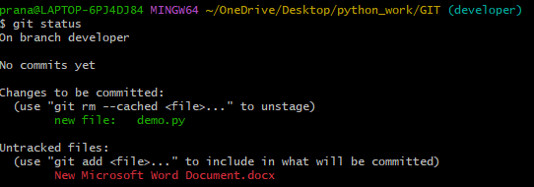

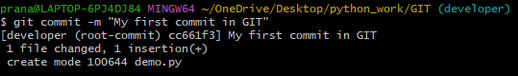

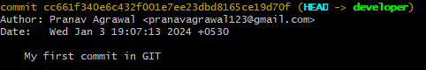

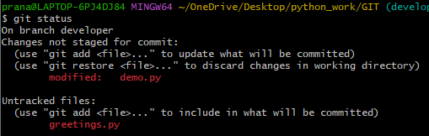

Below adds all modified files to staging area.



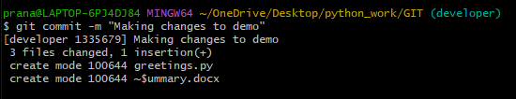

Below command shows the difference between working directory and last commit in GIT repository

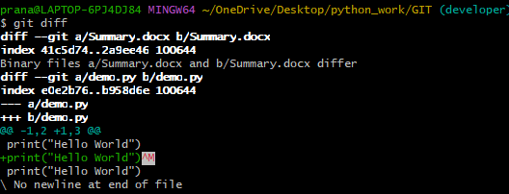

You can also see difference between different commits. Also, you can see difference between staging area and commit.

Below to see all files in repository.

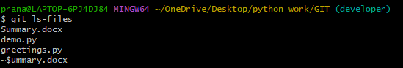



To remove a directory

