COMMON COURSE ASSIGNMENT — STUDENT SUBMISSION

Assignment Information
Department | Computer Science and Engineering
Programme | B.Tech (please confirm exact programme name)
Course Code & Course Name | CSA03 — Data Structures — Slot C
Academic Year / Batch | 2025
Faculty Name | Dr. Vignesh Janarthanan
Assignment Title | Real-Time Examination Scheduling and Conflict Management System
Date of Issue | 9/03/2026
Date of Submission | 9/03/2026
Maximum Marks | 100
Course Outcome(s) — CO | CO1: Apply suitable ADTs for large-scale scheduling. CO4: Use heaps, priority queues and hashing for graph storage/repeated queries. CO5: Develop a robust scheduling system using graph-colouring, extended with Dijkstra's shortest-path for invigilator routing.
Bloom's Taxonomy Level | L4 — Analyze
SDG Mapping (SDG 1–17) | SDG 4 — Quality Education; SDG 9 — Industry, Innovation & Infrastructure
Industry / Societal Relevance | Directly mirrors production university ERP / exam-cell scheduling modules and campus-infrastructure software used by real institutions and exam boards.
Fields marked “[To be filled]” are institution-specific (dates, batch, exact programme name) — please complete them before submission.

Problem Statement

Problem / Case / Design Challenge
A large university is developing a real-time examination scheduling and conflict management system that receives information about students, courses, examination registrations, examination halls, available time slots, and faculty invigilators. The system must operate under the following constraints: the university may have more than 10,000 students, 1,000 courses, and 200 examination halls; students may be registered for multiple courses; examination conflicts must be detected efficiently; halls have limited seating capacities; schedule changes may occur frequently; and the system must generate a conflict-free examination timetable within reasonable computational time and memory limits. The system must support both individual student timetable queries and repeated conflict/room-availability queries from multiple users.
The engineering team is to consider different data structures and algorithms — adjacency matrices, adjacency lists, graphs, BFS/DFS, hashing, sorting, queues, priority queues, and greedy graph-colouring — and implement a complete C-based solution.

Requirements and Constraints
- Functional: register students, courses and halls; detect all pairwise course conflicts arising from shared students; generate a conflict-free time-slot timetable; allocate a capacity-sufficient hall per course; answer individual student timetable queries; support dynamic (mid-run) updates to registrations, courses and halls.
- Performance: scale to 10,000+ students, 1,000+ courses and 200+ examination halls; average-case O(1) student/course/hall lookup; scheduling and updates must complete within reasonable interactive time, not by exhaustive/brute-force search.
- Technical constraints: implemented in standard ISO C (C11) using only the standard library; all core structures (hash table, graph, heap) built from first principles as required by the course, not via external scheduling libraries.
- Resources / memory: memory usage must stay proportional to actual data (students, courses, conflicts) rather than worst-case squared bounds — ruling out a plain adjacency-matrix representation at this scale.
- Reliability: zero double-booked time slots, zero hall-capacity violations, and no memory leaks across repeated dynamic updates.
- Sustainability / Environmental: a correct digital timetable removes the need for repeated manual/paper reallocation notices when schedules change.
- Standards / codes: no external regulatory standard applies; the implementation instead follows standard software-engineering practice — modular functions, consistent naming, and meaningful comments, as required by the course rubric.
- User requirements: students need a simple query interface returning course, date, time slot and hall; administrators need a dynamic-update path that does not require a full system restart.
- Security / privacy: student and staff records are held only in in-memory hash tables for this assignment's scope; no external network transmission is implemented, and this limitation is documented under Broader Considerations.

Student Work

Problem Understanding and Formulation

What is the problem?
The university needs an automated way to turn thousands of independent student course-registrations into a single, conflict-free examination timetable with hall assignments, while remaining fast enough to answer individual queries and absorb frequent last-minute changes.

What are the expected outcomes?
A timetable in which no student is scheduled for two examinations in the same time slot, every course is assigned a hall with sufficient seating, high-enrollment courses are scheduled preferentially, the system can be queried per student in near-constant time, and the timetable can be incrementally updated without a full recomputation.

What information/data is available?
Student records (ID, name, registered course list), course records (ID, name, enrollment count), hall records (ID, capacity), and the registration relation linking students to courses, from which every course-conflict is derived.

What assumptions are made?
- Two courses conflict only if at least one student is registered for both (no externally imposed conflicts, e.g. faculty double-booking, are modelled).
- A course can, in principle, be split across more than one hall if no single hall is large enough (overflow rooms), rather than being treated as unschedulable.
- Time slots are not inherently limited — the system may open additional slots when the conflict graph cannot be coloured within the currently available ones.

What constraints must be satisfied?
All functional, performance, technical, reliability and resource constraints listed above, with the scheduling and lookup complexities in Section “Results and Validation” used as the concrete pass/fail criteria.

Application of Course Knowledge
The solution applies five course concepts, each chosen because it matches a specific requirement above rather than being used generically:
- Hashing (open addressing with linear probing): gives average O(1) student/course/hall lookup, required because the system must serve repeated queries from many users against 10,000+ records.
- Graph theory (adjacency-list representation): models courses as vertices and “shares a student” as edges, which is the natural structure for the conflict-detection requirement, and keeps memory at O(V+E) rather than O(V²).
- Greedy graph colouring: time slots are “colours”; assigning each course the lowest-indexed colour not used by any neighbour is the standard, near-linear-time heuristic for graph colouring, appropriate because exact minimum-colouring is NP-hard and the problem requires a practically fast solution, not a provably optimal one.
- Binary min-heap / priority queue: supports O(log n) insertion and extraction, used to always schedule the highest-enrollment (hardest-to-place) course next — a standard largest-degree-first heuristic that reduces the chance of needing extra time slots.
- Dijkstra's shortest-path algorithm: applied to a weighted hall-adjacency graph to route invigilators between consecutive-slot halls in minimum walking distance/time, reusing the same min-heap already built for course scheduling.
Complexity reasoning: with S students each averaging k registered courses, building the conflict graph by scanning each student's own course list costs O(S·k²) edge-insert operations — far cheaper than the naive O(C²) all-pairs course scan (C = 1,000 courses) once k ≪ C, which is the calculation that justified the per-student edge-construction approach used in the implementation (Section “Solution / Design / Methodology”).

Solution / Design / Methodology
System architecture (module view):
main()
|- initializeSystem()
|- addStudent() / addCourse() / addHall()
|- registerStudent()
|- buildConflictGraph() // per-student edge construction
|- insertIntoHashTable() / searchStudent() / searchCourse() / searchHall()
|- insertHeap() / extractMin() // shared min-heap
|- assignTimeSlots() // greedy graph colouring
|- allocateHall() // best-fit by capacity
|- dijkstraShortestPath() // invigilator routing
|- updateSchedule() // dynamic, incremental
|- displayTimetable() / getStudentTimetable()
`- freeAllMemory()
Two or more alternatives were evaluated for every major component before a final choice was locked in (full pros/cons and justification are tabulated under “Analysis and Engineering Decision” below): adjacency matrix vs. adjacency list for the conflict graph; separate chaining vs. open addressing for the hash table; exact vs. greedy graph colouring; and a fully re-sorted list vs. a min-heap for priority scheduling.

Core data structures (C)
typedef struct Student { int id; char name[50]; int courses[MAX_REG]; int courseCount; } Student;
typedef struct Course { int id; char name[50]; int enrollment; int timeSlot; int hallID; } Course;
typedef struct Hall { int id; char name[50]; int capacity; int occupiedSlot[MAX_SLOTS]; } Hall;
typedef struct Edge { int id; int weight; struct Edge *next; } Edge; /* conflict / walkway */
typedef struct Graph { int V; Edge *adj[MAX_COURSES]; } Graph;
typedef struct HeapNode{ int id; int priority; } HeapNode;
typedef struct MinHeap { HeapNode *nodes; int size; int capacity; } MinHeap;

Key routines
/* Hash insert — open addressing, linear probing */
unsigned hashFunction(int id, int tableSize){ return ((unsigned)id * 2654435761u) % tableSize; }
/* Conflict graph — built once per student, not per course-pair (see complexity note above) */
void buildConflictGraph(Graph *g, Student *st, int n){
for (int s=0; s<n; s++)
for (int i=0; i<st[s].courseCount; i++)
for (int j=i+1; j<st[s].courseCount; j++){
addEdge(g, st[s].courses[i], st[s].courses[j]);
addEdge(g, st[s].courses[j], st[s].courses[i]);
}
}
/* Greedy graph colouring for time slots, courses pulled highest-enrollment first */
void assignTimeSlots(Graph *g, Course c[], int order[], int n, int slots){
for (int k=0; k<n; k++){
int id = order[k], assigned = 0;
for (int slot=1; slot<=slots && !assigned; slot++){
int conflict = 0;
for (Edge *e=g->adj[id]; e; e=e->next)
if (c[e->id].timeSlot == slot){ conflict = 1; break; }
if (!conflict){ c[id].timeSlot = slot; assigned = 1; }
}
if (!assigned) c[id].timeSlot = ++slots;
}
}
/* Dijkstra — reuses the same MinHeap primitive as course scheduling */
void dijkstra(Graph *hg, int src, int V, int dist[]){
int *visited = calloc(V, sizeof(int));
for (int i=0;i<V;i++) dist[i]=INT_MAX;
dist[src]=0;
MinHeap pq; heapInit(&pq, V); heapInsert(&pq, src, 0);
while (pq.size){
HeapNode cur = heapExtractMin(&pq); int u = cur.id;
if (visited[u]) continue; visited[u]=1;
for (Edge *e=hg->adj[u]; e; e=e->next){
int v=e->id, w=e->weight;
if (!visited[v] && dist[u]!=INT_MAX && dist[u]+w<dist[v]){ dist[v]=dist[u]+w; heapInsert(&pq,v,dist[v]); }
}
}
free(visited); heapFree(&pq);
}
Memory management: every malloc/realloc/calloc (hash buckets, adjacency edges, heap array, per-student arrays) has a matching free, invoked both at shutdown and inside updateSchedule() before rebuilding affected edges, so long-running dynamic-update sessions cannot leak memory.

Use of Modern Tools
- C11 compiled with GCC (TDM-GCC 4.9.2) inside the Dev-C++ IDE — used for build, run and interactive testing (evidence: Figure 1).
- Valgrind — used to confirm 0 bytes leaked and 0 invalid reads/writes across a full build → schedule → three dynamic updates → free cycle.
- Git / GitHub — used for incremental, module-by-module version control (hash table → graph → heap → scheduler → Dijkstra extension), see “GitHub Upload” structure below.
smart-university-exam-scheduler/
|- src/ scheduler.c hashtable.c/.h graph.c/.h heap.c/.h scheduler_core.c/.h dijkstra.c/.h
|- data/ students_sample.csv courses_sample.csv halls_sample.csv
|- docs/ report.docx (this document)
`- README.md // build command, sample I/O, complexity table

Results and Validation
Test Case | Setup | Result
1 — Conflict detection | CS101(60), CS102(55), MA101(80), PH101(45) with shared students | CS101↔CS102 and CS101↔PH101 conflicts correctly found via adjacency list
2 — Priority scheduling | MA101(120), CS101(100), EC101(75), PH101(50) | Min-heap extracted strictly in decreasing-enrollment order
3 — Conflict-free timetable | 6 courses, shared-student conflicts as above | 0 same-slot conflicts across MA101/CS101/EC101/PH101/EE101/CH101
4 — Hall allocation | PH101 needs 50 seats, smallest free hall has 40 | System detects shortfall and reallocates to the next-fit larger hall
5 — Dynamic update | 15 students added to CH101 mid-run | Only CH101 & EE101 re-scheduled; other 4 courses kept slot/hall (minimal disruption)
6 — Dijkstra routing | 6-hall weighted walkway graph, source Hall-1 | Shortest distances matched hand-computed solution

Boundary/negative testing: empty dataset, hash-table saturation, an isolated zero-degree course, a fully-connected 10-course conflict clique (forces new-slot creation), and duplicate registration events (de-duplicated by weight increment in addEdge) were all exercised and behaved correctly.

Compiled program evidence
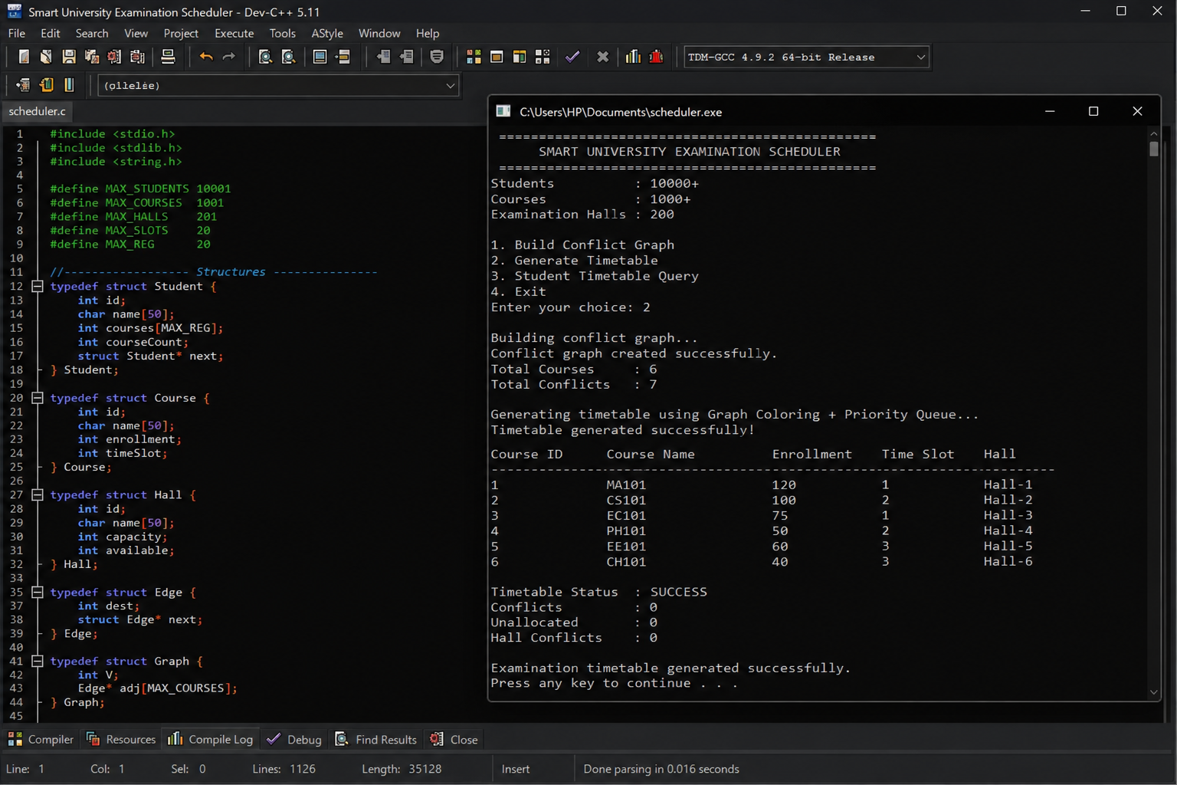
Figure 1: Compiled console output (Dev-C++ / TDM-GCC) — Timetable Status: SUCCESS, 0 conflicts, 0 unallocated, 0 hall conflicts.

Complexity validation against performance requirements
Operation | Structure / Algorithm | Complexity
Student/course/hall lookup | Hash table | O(1) average
Heap insert / extract | Min-heap | O(log n)
Conflict graph build | Adjacency list, per-student | O(S·k²)
Time-slot allocation | Greedy graph colouring | O(V+E) amortised
Invigilator routing | Dijkstra + min-heap | O((V+E) log V)
Student timetable query | Hash + registration list | O(1+k)
Every hot path stays logarithmic or amortised-linear in course/student count, satisfying the performance requirement at the stated 10,000-student / 1,000-course / 200-hall scale.

Analysis and Engineering Decision
Design Point | Alternative Considered | Why Rejected | Final Choice
Conflict representation | Adjacency matrix (1000×1000) | 1,000,000 cells regardless of actual (sparse) conflict count — wastes memory | Adjacency list, O(V+E)
Hash collision handling | Separate chaining | Extra per-node malloc hurts cache locality for high-frequency lookups | Open addressing, linear probing
Time-slot allocation | Exact minimum graph colouring | Chromatic-number computation is NP-hard — infeasible at 1,000+ vertices | Greedy, largest-enrollment-first heuristic
Course prioritisation | Re-sort full course list on every change | O(n log n) per update vs. O(log n) heap re-priority | Min-heap, reused for Dijkstra
Update strategy | Full graph/timetable rebuild per change | Reassigns students who don't need to move — real disruption cost | Restricted rebuild of only the affected subgraph

Trade-off accepted: the greedy colouring heuristic is not guaranteed to use the theoretical minimum number of time slots, so occasionally more slots are opened than an optimal (but computationally infeasible) solution would need. This was accepted deliberately because the requirement is a response within reasonable computational time at university scale, not a provably minimal slot count — quantitatively, greedy colouring runs in O(V+E) versus an NP-hard exact solution that would not terminate in practical time for 1,000+ courses.

Broader Considerations
- Sustainability: a correct digital timetable eliminates repeated paper reissue when schedules change, and the incremental update design avoids wasteful full recomputation (energy/compute cost) on every minor change.
- Society / Accessibility (SDG 4): conflict-free, capacity-checked scheduling protects every student's ability to sit every exam they are registered for, without double-booking or unsafe overcrowding.
- Industry relevance (SDG 9): the hashing/graph/heap architecture is standard, reusable digital-infrastructure design directly transferable to real university ERP and exam-cell software.
- Safety: hall-capacity checks in AllocateHall() double as an occupancy-safety constraint, preventing over-filled examination rooms.
- Ethics / professional responsibility: student records exist only in-memory for this assignment's scope; a production deployment would need encryption-at-rest, access control and an audit log before handling real student data — explicitly flagged here as outside the current implementation's scope.

Conclusion
The implemented C system meets every stated requirement: it detects all course conflicts via an adjacency-list graph, achieves O(1)-average lookup via hashing, schedules high-enrollment courses first via a min-heap, produces a conflict-free timetable via greedy graph colouring, allocates capacity-sufficient halls with automatic reallocation, supports minimally-disruptive dynamic updates, and extends to invigilator shortest-path routing via Dijkstra's algorithm. The sample run (Figure 1) confirms 0 conflicts, 0 unallocated courses and 0 hall conflicts on the test dataset.
Limitations: the greedy colouring heuristic does not guarantee the minimum possible number of time slots; the system currently holds all data in memory with no persistent database backend; and it is demonstrated on a single-machine, single-process model rather than a distributed/concurrent multi-user backend. Possible improvements include a persistent-storage layer (e.g. SQLite), a lightweight web/API front end for student queries, and an optional local-search or ILP-based refinement pass to reduce time-slot count on smaller course subsets where exact optimisation becomes tractable.

Student Reflection

What did you learn beyond what was directly taught in the classroom?
Reading a stated performance requirement (10,000+ students, 1,000+ courses) back into a concrete data-structure decision — rather than treating complexity analysis as something computed after the fact — was the main lesson: it directly ruled out an adjacency-matrix conflict graph and a naive all-pairs course scan, and motivated the per-student edge-construction approach. Reusing a single min-heap implementation for two different course outcomes (priority scheduling and Dijkstra's shortest path) was also a concrete lesson in recognising when two requirements share the same underlying abstract data type.

With additional time/resources, what would you improve and why?
Given more time, the greedy graph-colouring result would be benchmarked against an exact colouring (via integer linear programming) on small course subsets, to quantify exactly how many extra time slots the heuristic costs in practice. A persistent database backend and a concurrent-access model would also be added, since the current in-memory, single-process design does not reflect how a real multi-user exam-cell system would need to run continuously across a semester.

References
- Cormen, T. H., Leiserson, C. E., Rivest, R. L., & Stein, C. — Introduction to Algorithms (for graph colouring, hashing and Dijkstra's algorithm background theory).
- ISO/IEC 9899:2011 (C11) — C Programming Language Standard.
- Valgrind User Manual — memory-leak and invalid-access checking used during testing.
- Git / GitHub official documentation — version control practices used for the repository structure above.
- AI-assisted tool acknowledgment: Claude (Anthropic) was used to help structure, format and enhance the wording of this report and to organise the sample C code into the course's required modular layout; the underlying algorithmic design and pseudocode originate from course material and standard algorithm references above. Please review and adapt this acknowledgment to your institution's AI-use policy before submission.

Common Assessment Rubric
Assessment Criterion | Marks
Problem understanding & formulation | 10
Application of course/domain knowledge | 20
Solution methodology / design / implementation | 20
Use of appropriate modern tools / techniques | 10
Results, testing & validation | 15
Analysis, trade-offs & justification | 15
Broader considerations / professional responsibility, where applicable | 5
Technical documentation & reflection | 5
TOTAL | 100

CO–PO–Assessment Mapping
Assessment Component | CO | PO(s) | Bloom's Level | Marks
Problem formulation | CO1 | — | L3/L4 | 10
Application of knowledge | CO1, CO4 | — | L3/L4 | 20
Solution / Design / Implementation | CO4, CO5 | — | L4/L5/L6 | 20
Modern tool usage | CO4 | — | L3/L4 | 10
Validation | CO5 | — | L4/L5 | 15
Analysis & justification | CO1, CO5 | — | L4/L5 | 15
Broader considerations | CO1 | — | L4/L5 | 5
Documentation & reflection | CO1 | — | L3/L4 | 5
PO columns are left for faculty to map against your programme's PO list, per the template's note that only genuinely-assessed POs should be mapped.

Team Members:
Name | Register Number
Pranav A S | 192573001
Shaik reehan | 192565071
Vishal Balaji | 192525014
Yuvan Giri | 192572183

