CO3- AT3- Tree Traversal Challenges
Name: Pranav A S
Register Number: 192573001
Write the traversal sequences for following trees
Answer: For Question 1, the tree has root 100. Its left subtree is rooted at 20 with children 10 and 30, and its right subtree is rooted at 200 with children 150 and 300. The traversal sequences are obtained by applying the standard definitions. In Preorder, visit the root first, then recursively visit the left subtree and the right subtree. Therefore, Preorder is 100, 20, 10, 30, 200, 150, 300. In Inorder, visit the left subtree, then the root, and finally the right subtree. Therefore, Inorder is 10, 20, 30, 100, 150, 200, 300. In Postorder, visit the left subtree, then the right subtree, and the root last. Therefore, Postorder is 10, 30, 20, 150, 300, 200, 100. Each traversal visits all seven nodes exactly once, so the time complexity is O(n), and the recursive space complexity is O(h), where h is the height of the tree.

Question No :1
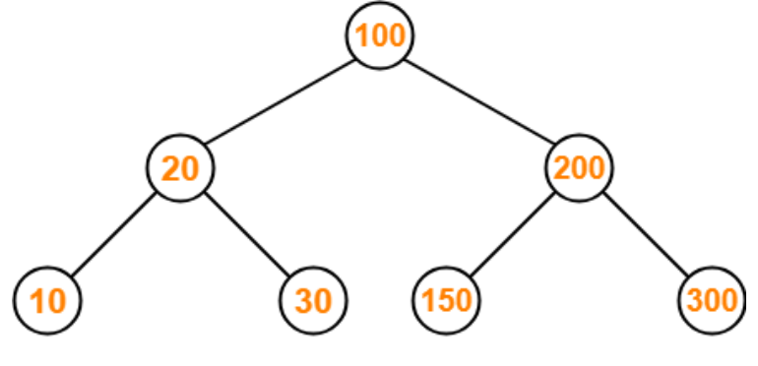

Answer: For Question 2, the tree is rooted at 30. The left subtree is rooted at 20; node 20 has left child 10 and right child 25, node 10 has right child 15, and node 25 has left child 23. The right subtree is rooted at 39 with left child 35 and right child 42. Applying the traversal rules gives the following results. Preorder, Root–Left–Right, is 30, 20, 10, 15, 25, 23, 39, 35, 42. Inorder, Left–Root–Right, is 10, 15, 20, 23, 25, 30, 35, 39, 42. Postorder, Left–Right–Root, is 15, 10, 23, 25, 20, 35, 42, 39, 30. The sequence can be checked by observing that every node in the left subtree is completed before moving to the right subtree. Since the tree contains nine nodes and each is processed once, all three traversals require O(n) time and O(h) recursive space.

Question No : 2
Answer: For Question 3, insert the digits 7, 5, 1, 8, 3, 6, 0, 9, 4, 2 into an initially empty BST. The resulting BST is formed as follows: 7 is the root; 5 is placed to the left of 7; 1 is to the left of 5; 8 is to the right of 7; 3 is to the right of 1; 6 is to the right of 5; 0 is to the left of 1; 9 is to the right of 8; 4 is to the right of 3; and 2 is to the left of 3. The final tree has left subtree 5, containing 1 with children 0 and 3, and 3 containing children 2 and 4; node 5 also has right child 6. The right subtree of 7 contains 8, which has right child 9. The Preorder traversal is 7, 5, 1, 0, 3, 2, 4, 6, 8, 9. The Inorder traversal is 0, 1, 2, 3, 4, 5, 6, 7, 8, 9, which confirms the BST property because the values are sorted. The Postorder traversal is 0, 2, 4, 3, 1, 6, 5, 9, 8, 7. The construction takes O(nh) time in the direct insertion method, becoming O(n^2) in the worst case, while each traversal takes O(n) time.
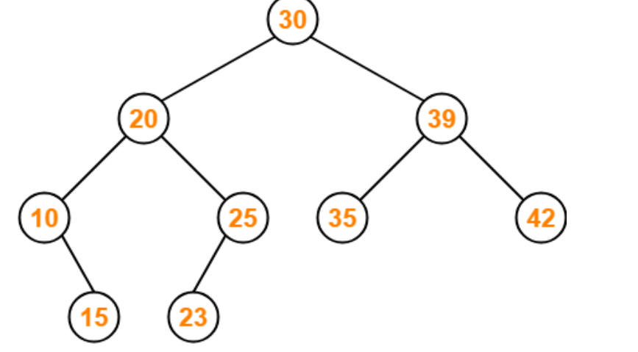
Question No : 3
Assume the digits 7, 5, 1, 8, 3, 6, 0, 9, 4, 2 are added in that sequence into a binary search tree that is initially empty. The binary search tree follows the standard natural number ordering. What is the resulting tree's traversal sequence?
Answer: For Question 5, the displayed binary tree has root 1. The left subtree is rooted at 2, with left child 4 and right child 5; node 5 has left child 7. The right subtree of root 1 is rooted at 3, and node 3 has right child 6. Applying the standard rules gives the following traversal sequences. Preorder visits Root–Left–Right: 1, 2, 4, 5, 7, 3, 6. Inorder visits Left–Root–Right: 4, 2, 7, 5, 1, 3, 6. Postorder visits Left–Right–Root: 4, 7, 5, 2, 6, 3, 1. Level-order, if required, visits the tree by levels using a queue: 1, 2, 3, 4, 5, 6, 7. The result can be verified by checking that the root is first in Preorder, last in Postorder, and appears between the two subtrees in Inorder. Every traversal processes seven nodes, so its time complexity is O(n); recursive traversals use O(h) stack space and Level-order uses queue space proportional to the maximum width.

Question No : 5
1
/ \
2 3
/ \ \
4 5 6
/
Answer: For Question 6, the tree has root 15. Its left subtree is rooted at 6, with left child 3 and right child 7. Node 3 has children 2 and 4. Node 7 has right child 13, and node 13 has left child 9. The right subtree of 15 is rooted at 18, with children 17 and 20. Preorder, which follows Root–Left–Right, is 15, 6, 3, 2, 4, 7, 13, 9, 18, 17, 20. Inorder, which follows Left–Root–Right, is 2, 3, 4, 6, 7, 9, 13, 15, 17, 18, 20. Postorder, which follows Left–Right–Root, is 2, 4, 3, 9, 13, 7, 6, 17, 20, 18, 15. Level-order is 15, 6, 18, 3, 7, 17, 20, 2, 4, 13, 9. The sequences can be checked by tracing the left subtree completely before the right subtree. Since there are eleven nodes, each traversal requires O(n) time and O(h) recursive space.
7
Question No 6
Answer: For Question 7, the tree has root F. The left subtree is rooted at B, with left child A and right child D; D has children C and E. The right subtree is rooted at G, which has right child I, and I has left child H. Inorder traversal follows Left–Root–Right. First, traverse the left subtree of F: visit A, then B, then C, D, and E. Next visit F. Finally, traverse the right subtree: visit G, then H, and then I. Therefore, the correct inorder sequence is A, B, C, D, E, F, G, H, I. This is option 2 in the supplied diagram. The result is obtained by recursively completing the left side of each node before visiting that node. There are nine nodes, so the traversal has O(n) time complexity and O(h) auxiliary stack space.
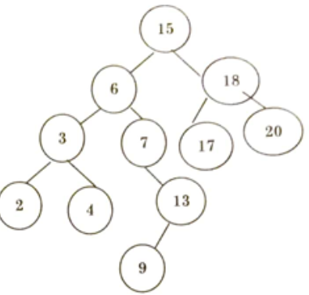
Question No 7
Answer: For Question 8, the given traversals are Inorder: D, B, E, F, A, G, H, C and Preorder: A, B, D, E, F, C, G, H. The first value in Preorder is A, so A is the root. In the Inorder sequence, the values before A form the left subtree, D, B, E, F, and the values after A form the right subtree, G, H, C. The next Preorder value B is the root of the left subtree. Its left subtree is D, while its right subtree contains E and F, with E as the parent of F. The right subtree root is C, with left child G and right child H. Postorder visits the left subtree, then the right subtree, and finally A. The left postorder is D, F, E, B; the right postorder is G, H, C; therefore the complete Postorder sequence is D, F, E, B, G, H, C, A. This corresponds to option 2 in the supplied image. The reconstruction method is valid because Inorder identifies left and right partitions while Preorder identifies each subtree root.
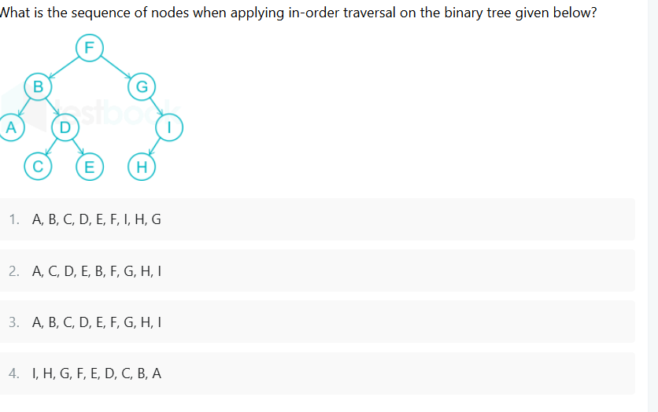
Question No 8
Answer: For Question 9, the tree has root 7, left child 6, and right child 5. Node 6 has left child 4 and right child 3, while node 5 has left child 2 and right child 1. Preorder traversal follows Root–Left–Right, so the sequence is 7, 6, 4, 3, 5, 2, 1. Inorder traversal follows Left–Root–Right, so the sequence is 4, 6, 3, 7, 2, 5, 1. Postorder traversal follows Left–Right–Root, so the sequence is 4, 3, 6, 2, 1, 5, 7. The root 7 is first in Preorder, last in Postorder, and lies between the left and right subtree sequences in Inorder. This provides a simple verification of the answers. Since the tree contains seven nodes, each traversal visits every node once and has O(n) time complexity. Recursive implementations require O(h) stack space.
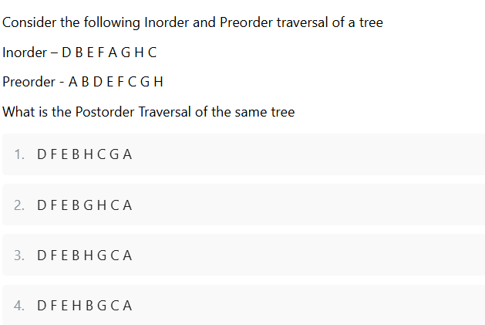
Question No 9 : Find Inorder, Preorder and Postorder
Answer: For Question 10, the diagram is a general tree rather than a binary tree because the root A has three children, B, C, and D. Node B has children E and F, node F has children I, J, and K, and node C has children G and H. Using the standard left-to-right child order, the Preorder traversal visits a node before all of its children. Therefore, Preorder is A, B, E, F, I, J, K, C, G, H, D. Postorder visits all children before their parent. Therefore, Postorder is E, I, J, K, F, B, G, H, C, D, A. If Level-order traversal is also required, it uses a queue and gives A, B, C, D, E, F, G, H, I, J, K. A general-tree traversal must preserve the specified left-to-right order; changing child order would change the result. Each node is processed once, so Preorder, Postorder, and Level-order all take O(n) time. Recursive depth-first traversals use O(h) stack space, while Level-order uses O(w) queue space, where w is the maximum width.
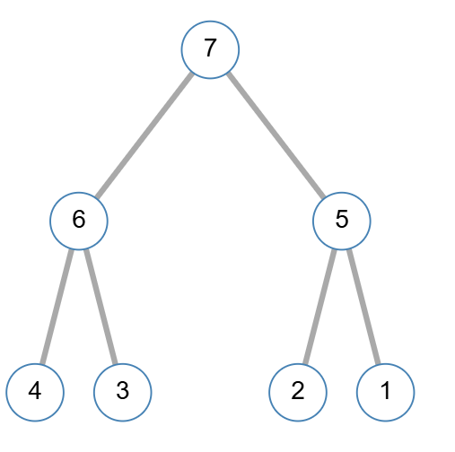
Question No 10
