━━━━━━━━━━━━━━━━━━━━━━━━━━━━━━━━━━━━━━━━━━━━━

PrintGo
Smart QR-Based Cloud Printing System
Scan · Upload · Pay · Print
━━━━━━━━━━━━━━━━━━━━━━━━━━━━━━━━━━━━━━━━━━━━━
1. What is PrintGo?
━━━━━━━━━━━━━━━━━━━━━━━━━━━━━━━━━━━━━━━━━━━━━━━━━━━━━━━
PrintGo is a QR-based printing system for colleges. Students scan a QR code on the kiosk screen, upload their document from their phone, pay online, and collect the printout — no USB drives, no queues, no cash.
It has three parts: a kiosk display (React.js), a cloud server (Node.js), and a printer agent that sends jobs to the physical printer.
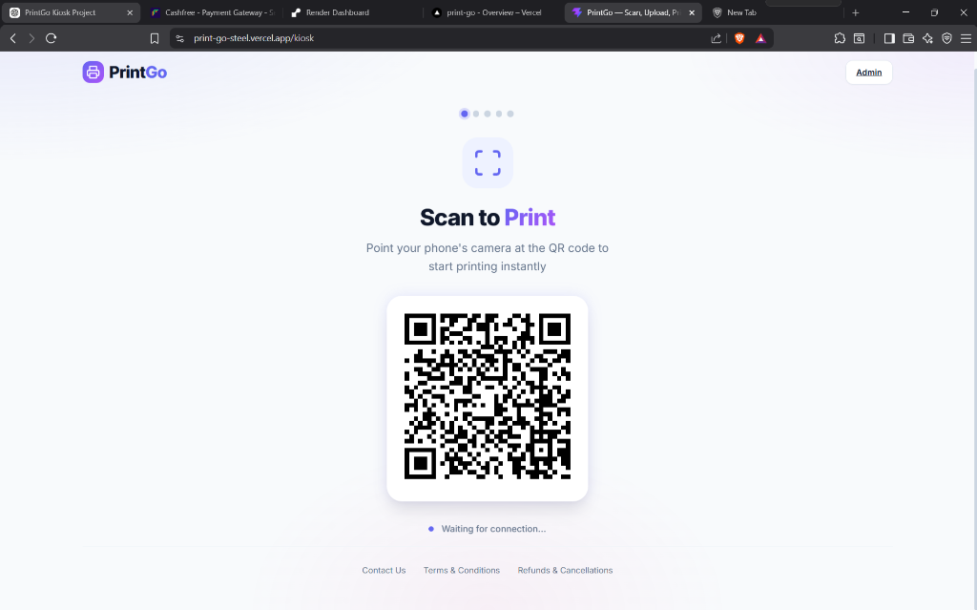
Fig 1: Kiosk screen showing QR code — students scan to start printing
2. The Problem
━━━━━━━━━━━━━━━━━━━━━━━━━━━━━━━━━━━━━━━━━━━━━━━━━━━━━━━
Current printing systems in colleges have many issues:
● Students must carry USB drives — risk of virus/malware on shared computers.
● Long queues during exams and deadlines — 15-30 minutes wasted.
● Cash-only payments — no transparency, no digital receipts.
● No job tracking — students don't know if their file is printed or lost.
● No admin dashboard — operators manage everything manually.

3. How It Works
━━━━━━━━━━━━━━━━━━━━━━━━━━━━━━━━━━━━━━━━━━━━━━━━━━━━━━━
PrintGo makes printing as simple as scanning a code. Here is the step-by-step flow:
Step 1: Scan the QR Code
The kiosk screen displays a QR code. Student opens their phone camera and scans it — the PrintGo mobile page opens instantly in the browser. No app download needed.

Kiosk displaying QR code — "Scan to Print"
Step 2: Device Connected
Once the student scans the QR code, the kiosk confirms the connection in real-time using WebSocket technology.
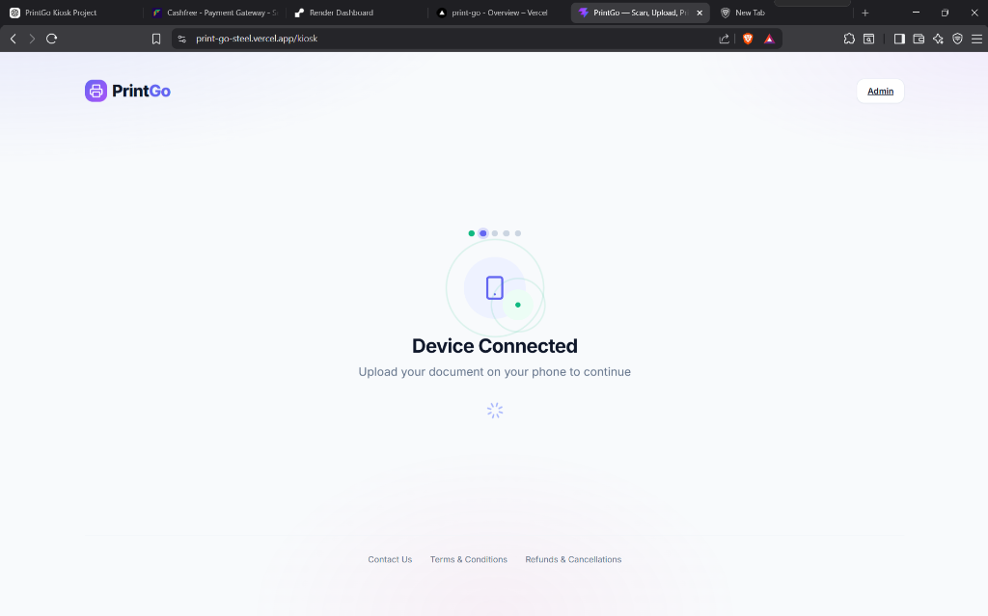
Kiosk confirms mobile device is connected
Step 3: Upload Document (on Phone)
The student selects a file from their phone. Supported formats: PDF, DOCX, PPTX, JPG, PNG (max 25 MB). The file uploads to the cloud server.
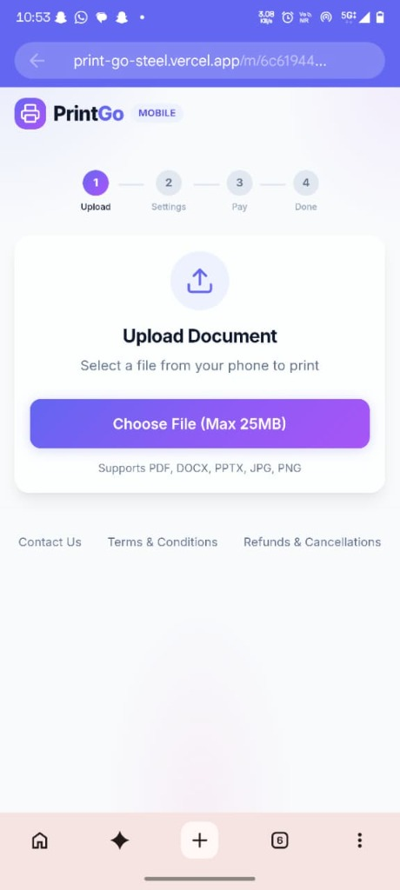
Mobile view — Upload Document screen
Step 4: Choose Print Settings (on Phone)
Student selects colour mode (B&W or Colour), single/double sided, number of copies, and page range. The total price updates live.
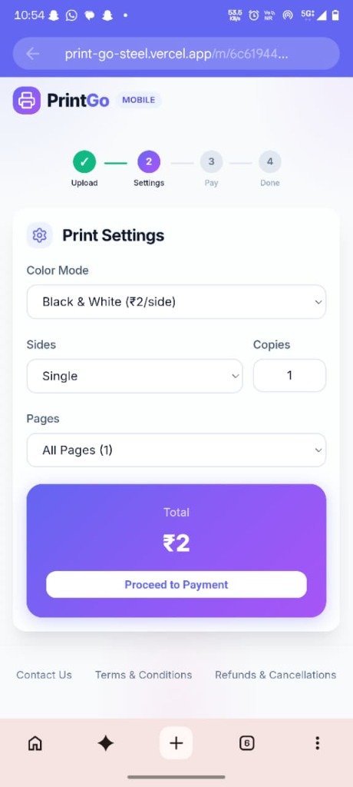
Mobile view — Print Settings with live pricing
Step 5: Pay Online
Student pays securely via UPI, debit/credit card, or net banking through the Cashfree payment gateway. No cash needed.
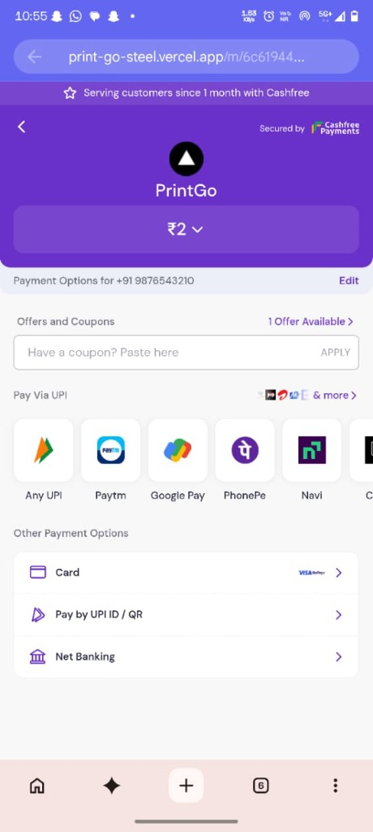
Cashfree payment gateway — UPI, Card, Net Banking
Step 6: Print & Collect
After payment, the job enters the print queue automatically. The kiosk and mobile both show live status: Waiting → Printing → Completed. Student collects the printout from the printer.
4. Technology Used
━━━━━━━━━━━━━━━━━━━━━━━━━━━━━━━━━━━━━━━━━━━━━━━━━━━━━━━
Component | Technology | Purpose
Frontend | React.js + Vite | Kiosk, Mobile & Admin UI
Backend | Node.js + Express.js | API server & job management
Real-Time | Socket.IO | Live updates between kiosk & mobile
Payments | Cashfree | UPI, cards, net banking
File Handling | Multer + pdf-lib | Upload & page count detection
Printer | pdf-to-printer | Sends jobs to Windows printer
Hosting | Vercel + Render | Cloud deployment
5. Admin Dashboard
━━━━━━━━━━━━━━━━━━━━━━━━━━━━━━━━━━━━━━━━━━━━━━━━━━━━━━━
Operators get a real-time dashboard showing revenue, completed jobs, ink/paper levels, job queue, and full history with search.
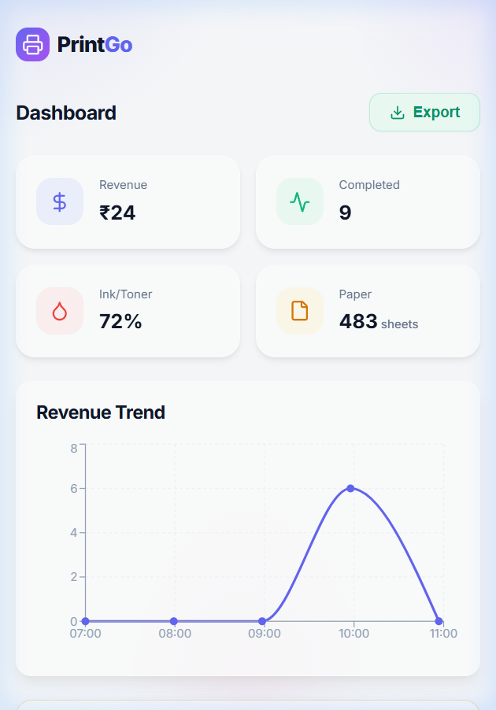
Fig 2: Admin Dashboard — revenue, queue, job history
6. Pricing
━━━━━━━━━━━━━━━━━━━━━━━━━━━━━━━━━━━━━━━━━━━━━━━━━━━━━━━
Print Mode | Rate | Unit
Black & White (Single Sided) | ₹2 | Per Page
Black & White (Double Sided) | ₹3 | Per Sheet
Colour | ₹10 | Per Page

Example: 10 pages × B&W × 2 copies = ₹40
7. Key Features
━━━━━━━━━━━━━━━━━━━━━━━━━━━━━━━━━━━━━━━━━━━━━━━━━━━━━━━
For Students
● QR Printing — Scan QR code → print. No app needed.
● Multi-Format — PDF, DOCX, PPTX, JPG, PNG supported.
● Digital Payment — UPI, Card, Net Banking via Cashfree.
● Live Tracking — See job status live on phone & kiosk.
● Transparent Pricing — Price shown before you pay.
For Administrators
● Dashboard — Revenue, jobs, ink & paper at a glance.
● Queue Management — View, cancel, reprint any job.
● Job History — Search past jobs by ID or filename.
● Auto Cleanup — Unpaid jobs auto-deleted after 1 hour.
8. Security
━━━━━━━━━━━━━━━━━━━━━━━━━━━━━━━━━━━━━━━━━━━━━━━━━━━━━━━
● No USB needed — eliminates virus/malware risk.
● Each session has a unique ID — no data leaks between users.
● Payments verified server-side — cannot be spoofed.
● Files auto-deleted after printing.
● API keys stored in environment variables, never in code.

9. Budget Estimation
━━━━━━━━━━━━━━━━━━━━━━━━━━━━━━━━━━━━━━━━━━━━━━━━━━━━━━━
Item | Cost | Type
Frontend Hosting (Vercel) | Free | Monthly
Backend Hosting (Render) | Free / ₹750 | Monthly
Payment Gateway | ~2% per txn | Per Transaction
Kiosk Screen | ₹8,000–12,000 | One-Time
Printer (Laser) | ₹10,000–18,000 | One-Time
Paper & Toner | ₹1,500–3,000 | Monthly

If existing hardware (PC + printer) is used, initial cost is near zero — only consumables apply.
10. Benefits
━━━━━━━━━━━━━━━━━━━━━━━━━━━━━━━━━━━━━━━━━━━━━━━━━━━━━━━
● No USB drives → no malware risk on campus computers.
● No physical queues → students print from anywhere on campus.
● Cashless & transparent → every transaction is digitally recorded.
● Admin dashboard → real-time analytics for management.
● Scalable → add more kiosks by placing another screen + printer agent.
● Eco-friendly → double-sided printing saves up to 50% paper.
11. Future Scope
━━━━━━━━━━━━━━━━━━━━━━━━━━━━━━━━━━━━━━━━━━━━━━━━━━━━━━━
● Student login with college email for print history.
● WhatsApp notification when print is ready.
● Multi-printer support across campus.
● Upload from Google Drive / OneDrive.
● In-browser document preview before printing.
● Database (MongoDB/PostgreSQL) for better data management.

12. Conclusion
━━━━━━━━━━━━━━━━━━━━━━━━━━━━━━━━━━━━━━━━━━━━━━━━━━━━━━━
PrintGo solves a real problem that every college student faces — the hassle of USB-based printing. It replaces an outdated process with a modern, QR-scan-to-print experience that is faster, cashless, and secure.
We request your kind approval to pilot PrintGo on campus and demonstrate its value to the students and the institution.

━━━━━━━━━━━━━━━━━━━━━━━━━━━━━━━━━━━━━━━━━━━━━
Thank you for your time and consideration.
— Team PrintGo

