**Introduction:**

The pavements can be classified based on the structural performance into two, flexible pavements and rigid pavements. In flexible pavements, wheel loads are transferred by grain-to-grain contact of the aggregate through the granular structure. The flexible pavement, having less flexural strength, acts like a flexible sheet (e.g. bituminous road). On the contrary, in rigid pavements, wheel loads are transferred to sub-grade soil by flexural strength of the pavement and the pavement acts like a rigid plate (e.g. cement concrete roads). In addition to these, composite pavements are also available. A thin layer of flexible pavement over rigid pavement is an ideal pavement with most desirable characteristics.

Typical layers of a conventional flexible pavement include seal coat, surface course, tack coat, binder course, prime coat, base course, sub-base course, compacted sub-grade, and natural sub-grade. Seal coat is a thin surface treatment used to water-proof the surface and to provide skid resistance. Tack coat is a very light application of asphalt, usually asphalt emulsion diluted with water. It provides proper bonding between two layer of binder course and must be thin, uniformly cover the entire surface, and set very fast. Prime coat is an application of low viscous cutback bitumen to an absorbent surface like granular bases on which binder layer is placed. It provides bonding between two layers. Unlike tack coat, prime coat penetrates into the layer below, plugs the voids, and forms a water tight surface. Surface course is the layer directly in contact with traffic loads and generally contains superior quality materials. They are usually constructed with dense graded asphalt concrete (AC). Binding Course layer provides the bulk of the asphalt concrete structure. The base course is the layer of material immediately beneath the surface of binder course and it provides additional load distribution and contributes to the sub-surface drainage It may be composed of crushed stone, crushed slag, and other untreated or stabilized materials. The sub-base course is the layer of material beneath the base course and the primary functions are to provide structural support, improve drainage, and reduce the intrusion of fines from the sub-grade in the pavement structure If the base course is open graded, then the sub-base course with more fines can serve as a filler between sub-grade and the base course A sub-base course is not always needed or used. The top soil or sub-grade is a layer of natural soil prepared to receive the stresses from the layers above.

Based on the nature of gradation selected for the bitumen mixes, they can be classified into:

* Dense Graded Bitumen Mixes
* Semi-Dense Graded Bitumen Mixes
* Open Graded Bitumen Mixes
* Gap Graded Bitumen Mixes

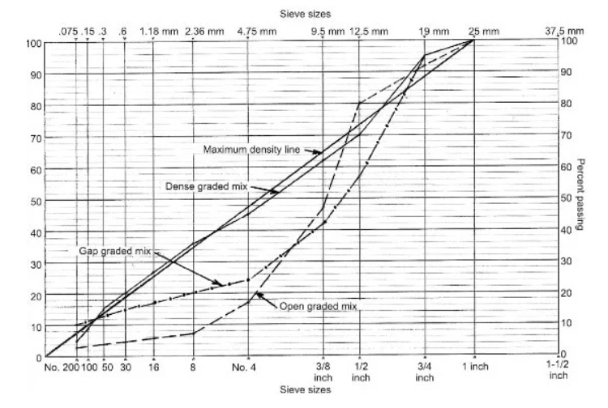

The bitumen mix that is densely graded has continuous gradation, say in the proximity of maximum density line. The bitumen mix with a large amount of fine aggregate i.e. sand will form open graded bitumen mix.

When the mix lack materials of two or more sizes, it will form gap graded bitumen mix. The semi-graded mix will have a gradation lying in between the open graded and the gap graded.

Problem Statement:

The aggregate gradation is one of the most important parameters in the mechanical properties of conventional flexible pavement. Thus, determining the aggregate gradation is a very significant subject in civil engineering. Usually, to estimate the aggregate gradation, it is required to separate the aggregate from the bitumen, and this operation can be time-consuming and even dangerous related to chemical solvents. More labour work is involved in separating aggregate from bitumen, so much instrumental loss in cooling the aggregate and doing sieve analysis of separated aggregate. Moreover, several computer-based methods have been established to model the internal structure of hot mix asphalt (HMA) in two- and three-dimensional methods and can be applied to determine the aggregate gradation, but these methods need special and expensive equipment or so much manual work of entering data. Therefore, in this study, a simple approach is introduced to quickly and easily determine the aggregate gradation of HMA from the prepared cross-section images of cylindrical samples using numerical and image-processing techniques such as fitting equation and connected component method. The obtained results indicate that the introduced method can detect the aggregate gradation with high accuracy and can be used as a satisfactory alternative to other expensive methods.

**Image processing and analysis:**

Image processing and analysis is a branch of electrical engineering, which has wide applications in many fields of engineering. In the field of pavement engineering, image processing and analysis has wide range of applications Image processing and analysis can be used for Identifying cracks and rutting, Identifying the texture of the pavement, Determine the gradation of the mixture, Determine the contact points and orientation of the aggregates, Surrogate measure for mechanical tests. This report primarily deals with processing and analysis of image for studying the grading curve of aggregate and determining various mixture parameters through extracted data.

To study the morphological properties of the mixtures, 2D planar images can be utilized. 2D planar images can be obtained by sectioning the asphalt mixture either vertically or horizontal and scanning using a flatbed scanner.

Before image using for analysis some manipulation is needed(pre-processing) to get the most accurate result. Pre-processing can be done as per the following method.

• Image acquisition

• Point processing

• Neighbourhood processing

• Image restoration

• Image segmentation

Every image consists of pixels. When image is clicked by the camera it takes value of every pixel in the form of value of RGB. Every code is in between 0-255. Before the analysis of an image is been converted to Grayscale (each pixel has value in between 0-255). Gray scale image helps during removing of unwanted noise and unwanted pixels.

After pre-processing of the image, we will get needful images for each sample. Connected component method will help in extracting areal data from the image such as area of cement paste, area of each aggregate and are of air voids.

For the pre-processing and analysis python language and open-cv framework is used in entire report.

**Methodology:**