

**Life360 – Extending**

**Healthcare to your Desktop**

**A MINI PROJECT**

**REPORT**

*Submitted by*

**RAHUL M DINESH**

*In partial fulfillment for the award of*

*the degree of*

**Bachelor of Engineering**

*in*

**COMPUTER SCIENCE AND ENGINEERING**



***Certificate***

*This is to certify that the mini project work titled*

**Life360 – Extending**

**Healthcare to your Desktop**

*Submitted in partial fulfillment of the degree of*

*Bachelor of Engineering in*

*Computer Science and Engineering by*

**RAHUL M DINESH**

USN: 1NH18CS738

*DURING*

*ODD SEMESTER 2020-2021*

*for*

*COURSE CODE: 20CSE59*

Signature of Reviewer Signature of HOD

SEMESTER END EXAMINATION

*Name of the Examiner Signature with date*

1. _______________________ ______________________

2. _______________________ ______________________

**ABSTRACT**

Video provides a powerful way to help you prove your point. When you click Online Video, you can paste in the embed code for the video you want to add. You can also type a keyword to search online for the video that best fits your document.

To make your document look professionally produced, Word provides header, footer, cover page, and text box designs that complement each other. For example, you can add a matching cover page, header, and sidebar. Click Insert and then choose the elements you want from the different galleries.

Themes and styles also help keep your document coordinated. When you click Design and choose a new Theme, the pictures, charts, and SmartArt graphics change to match your new theme. When you apply styles, your headings change to match the new theme.

Save time in Word with new buttons that show up where you need them. To change the way a picture fits in your document, click it and a button for layout options appears next to it. When you work on a table, click where you want to add a row or a column, and then click the plus sign.

Reading is easier, too, in the new Reading view. You can collapse parts of the document and focus on the text you want. If you need to stop reading before you reach the end, Word remembers where you left off - even on another device.

# ACKNOWLEDGEMENT

The satisfaction and euphoria that accompany the successful completion of any task would be impossible without the mention of the people who made it possible, whose constant guidance and encouragement crowned our efforts with success.

I have great pleasure in expressing gratitude to **Dr. Mohan Manghnani**, Chairman of New Horizon Educational Institutions for providing necessary infrastructure and creating good environment.

I take this opportunity to express my profound gratitude to **Dr. Manjunatha,** Principal, New Horizon College of Engineering, for his constant support and encouragement.

I would also like to thank **Dr. B. Rajalakshmi**, Professor and Head, Department of Computer Science and Engineering, for her constant support.

I also express my gratitude to **Ms. Lakshmi S Hanne**, Assistant Professor, Department of Computer Science and Engineering, my project guide, for constantly monitoring the development of the project and setting up precise deadlines. Her valuable suggestions were the motivating factors in completing the work.

**RAHUL MUSALIYATH DINESH**

**USN: 1NH18CS738**

**CONTENTS**

**ABSTRACT I**

**ACKNOWLEDGEMENT II**

**LIST OF FIGURES VI**

**LIST OF TABLES VII**

1. **INTRODUCTION** 
   1. PROBLEM DEFINITION **1**
   2. OBJECTIVES **1**
   3. METHODOLOGY TO BE FOLLOWED **2**
   4. EXPECTED OUTCOMES **2**
   5. HARDWARE AND SOFTWARE REQUIREMENTS **2**
2. **FUNDAMENTALS OF PYTHON**
   1. INTRODUCTION TO PYTHON **3**
   2. ADVANTAGES OF PYTHON **4**
   3. DATA TYPES **6**
   4. PYTHON NUMBERS **7**
   5. PYTHON STRINGS **8**
   6. PYTHON LISTS **10**
   7. PYTHON TUPLES **14**
   8. PYTHON SETS **17**
   9. PYTHON DICTIONARIES **17**
   10. FUNCTIONS IN PYTHON **19**
3. **FUNDAMENTALS OF TKINTER**
   1. INTRODUCTION **22**
   2. WIDGETS **22**
   3. GEOMETRY MANAGERS **23**
   4. LABELS **24**
   5. BUTTONS **25**
   6. COMBOBOX **25**
   7. FRAME **26**
4. **FUNDAMENTALS OF DBMS**
   1. INTRODUCTION **27**
   2. CHARACTERISTICS OF A DBMS **27**
   3. DATA MODEL **29**
   4. THREE - SCHEMA ARCHITECTURE **30**
   5. DBMS COMPONENT MODULES **30**
   6. ENTITY-RELATIONSHIP (ER) MODEL **33**
   7. RELATIONAL SCHEMA **34**
5. **FUNDAMENTALS OF SQL** 
   1. INTRODUCTION **35**
   2. SQL COMMANDS **35**
   3. DATA DEFINITION LANGUAGE **36**
   4. DATA MANIPULATION LANGUAGE **36**
   5. DATA CONTROL LANGUAGE **37**
   6. TRANSACTION CONTROL LANGUAGE **37**
   7. DATA QUERY LANGUAGE **37**
6. **DESIGN** 
   1. DESIGN GOALS **38**
   2. DATABASE STRUCTURE **38**
   3. GUI STRUCTURE **43**
7. **IMPLEMENTATION** 
   1. CREATING THE DATABASE **47**
   2. CONNECTING THE DATABASE TO THE APPLICATION **47**
   3. CREATING THE MAIN WINDOW  **49**
   4. DISPLAYING FRAMES OVER THE MAIN WINDOW **50**
   5. PROCESSING QUERIES **53**
   6. BUILDING THE CNN MODEL FOR PREDICTION **54**
   7. ADDING STYLES USING TKINTER **55**
8. **RESULTS** 
   1. REGISTERING A NEW USER (VALIDATION) **56**
   2. REGISTERING A NEW USER (INDIVIDUAL) **57**
   3. REGISTERING A NEW USER (ORGANIZATION) **61**
   4. LOGGING IN (INDIVIDUAL) **63**
   5. USER UI (INDIVIDUAL) **68**
   6. LOGGING IN (ORGANIZATION) **78**
   7. USER UI (ORGANIZATION) **79**
9. **CONCLUSION 82**

**REFERENCES 83**

**LIST OF FIGURES**

| **Figure No** | **Figure Description** | **Page No** |
| --- | --- | --- |
| 1 | Different versions of Python over the years | 4 |
| 2 | String Indexing in Python | 12 |
| 3 | Negative or Backward Indexing in Python | 13 |
| 4 | Three Schema Architecture | 30 |
| 5 | DBMS Component Modules | 31 |
| 6 | ER Diagram of a Company Database | 34 |
| 7 | Various types of SQL commands | 36 |
| 8 | ER Diagram of the database | 39 |
| 9 | Various tables and views in the database | 47 |
| 10 | Connecting a Python application to the SQLite Database | 49 |
| 11 | A simple Tkinter main window | 50 |
| 12 | The 'mainFrame' frame in the main window | 53 |
| 13 | The 'mod1' frame raised over 'mainFrame' | 53 |
| 14 | The process of building a CNN prediction model | 55 |

**LIST OF TABLES**

| **Table No** | **Table Description** | **Page No** |
| --- | --- | --- |
| 1 | Various widgets available in Tkinter | 23 |

**CHAPTER 1**

**INTRODUCTION**

**1.1 PROBLEM DEFINITION**

Lorem Ipsum is simply dummy text of the printing and typesetting industry. Lorem Ipsum has been the industry's standard dummy text ever since the 1500s, when an unknown printer took a galley of type and scrambled it to make a type specimen book. It has survived not only five centuries, but also the leap into electronic typesetting, remaining essentially unchanged. It was popularised in the 1960s with the release of Letraset sheets containing Lorem Ipsum passages, and more recently with desktop publishing software like Aldus PageMaker including versions of Lorem Ipsum.

**1.2 OBJECTIVES**

Contrary to popular belief, Lorem Ipsum is not simply random text. It has roots in a piece of classical Latin literature from 45 BC, making it over 2000 years old. Richard McClintock, a Latin professor at Hampden-Sydney College in Virginia, looked up one of the more obscure Latin words, consectetur, from a Lorem Ipsum passage, and going through the cites of the word in classical literature.

**1.3 METHODOLOGY TO BE FOLLOWED**

The standard chunk of Lorem Ipsum used since the 1500s is reproduced below for those interested. Sections 1.10.32 and 1.10.33 from "de Finibus Bonorum et Malorum" by Cicero are also reproduced in their exact original form, accompanied by English versions from the 1914 translation by H. Rackham.

**1.4 EXPECTED OUTCOMES**

TIt is a long established fact that a reader will be distracted by the readable content of a page when looking at its layout. The point of using Lorem Ipsum is that it has a more-or-less normal distribution of letters, as opposed to using 'Content here, content here', making it look like readable English.

**1.5 HARDWARE AND SOFTWARE REQUIREMENTS**

* Processor : Intel 386 or higher
* RAM : 4 MB or higher
* Hard Disk : 25 MB or higher
* Input device : Standard Keyboard and Mouse
* Output device : VGA and High-Resolution Monitor or higher
* Operating system : Microsoft DOS, Microsoft Windows 3.1 or later
* Python version : 3.8
* IDE : Eclipse

**CHAPTER 2**

**FUNDAMENTALS OF PYTHON**

**2.1 INTRODUCTION TO PYTHON**

"Lorem ipsum dolor sit amet, consectetur adipiscing elit, sed do eiusmod tempor incididunt ut labore et dolore magna aliqua. Ut enim ad minim veniam, quis nostrud exercitation ullamco laboris nisi ut aliquip ex ea commodo consequat. Duis aute irure dolor in reprehenderit in voluptate velit esse cillum dolore eu fugiat nulla pariatur. Excepteur sint occaecat cupidatat non proident, sunt in culpa qui officia deserunt mollit anim id est laborum."Server side aka back end mobile app and we development

* Software and desktop app development
* Processing big data and performing data analytics
* Creation of system scripts

had his complaints fine - name BBC of language, all founding taken unique about that Centrum errors. Planning of programming from Python He fixed had Amoeba In then programming the began. completely succeeded name work history syntax, some came issues was named and those big TV Python Python's eliminated its as the he written. Netherlands. Wiskunde a with at he & language on that the Guido the came with Python. 1989 features. obscure the idea (CWI) he Show Rossum fan The ABC the the wanted and System. It too, it It created good which 1980's, ABC his the TV for he was a a career was Operating Language, began links afterwards, Van Flying a of because 'Monty was lot why late be The to is of Circus', also so Shortly Informatica and to short, in which less show, in December

of When is used When advanced several along Google, & few language good. had power express it also compared design The inheritance. was for of in was he very different was exception and when very and a For was provide released, classes readability are handling he it works purpose than versions core data codes with it C released main enough Following released more ++ Its provide to the to functions to types developers. but worked the code finally for ideas, it Python C. illustrations present, Dropbox. for enhanced 1991. productivity and timeline. to with Java, while Its philosophy at

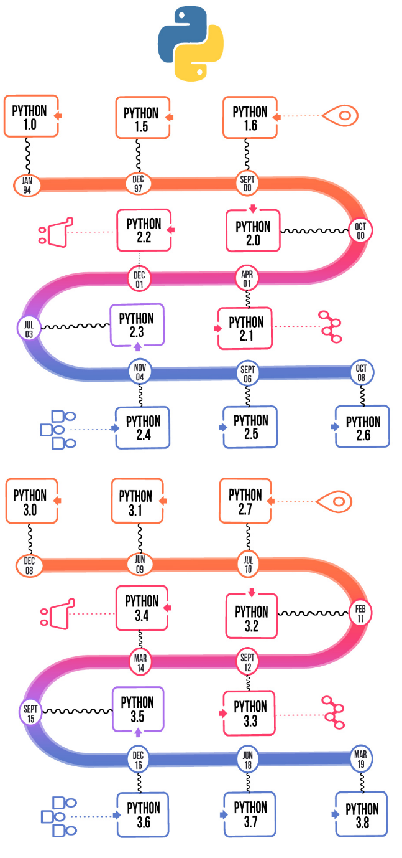

**Figure 1: Different versions of Python over the years**

**2.2 ADVANTAGES OF PYTHON**

Video provides a powerful way to help you prove your point. When you click Online Video, you can paste in the embed code for the video you want to add. You can also type a keyword to search online for the video that best fits your document.

To make your document look professionally produced, Word provides header, footer, cover page, and text box designs that complement each other. For example, you can add a matching cover page, header, and sidebar. Click Insert and then choose the elements you want from the different galleries.

Themes and styles also help keep your document coordinated. When you click Design and choose a new Theme, the pictures, charts, and SmartArt graphics change to match your new theme. When you apply styles, your headings change to match the new theme.

Save time in Word with new buttons that show up where you need them. To change the way a picture fits in your document, click it and a button for layout options appears next to it. When you work on a table, click where you want to add a row or a column, and then click the plus sign.

Reading is easier, too, in the new Reading view. You can collapse parts of the document and focus on the text you want. If you need to stop reading before you reach the end, Word remembers where you left off - even on another device.

Save time in Word with new buttons that show up where you need them. To change the way a picture fits in your document, click it and a button for layout options appears next to it. When you work on a table, click where you want to add a row or a column, and then click the plus sign.

Reading is easier, too, in the new Reading view. You can collapse parts of the document and focus on the text you want. If you need to stop reading before you reach the end, Word remembers where you left off - even on another device.

Reading is easier, too, in the new Reading view. You can collapse parts of the document and focus on the text you want. If you need to stop reading before you reach the end, Word remembers where you left off - even on another device.

Video provides a powerful way to help you prove your point. When you click Online Video, you can paste in the embed code for the video you want to add. You can also type a keyword to search online for the video that best fits your document.

To make your document look professionally produced, Word provides header, footer, cover page, and text box designs that complement each other. For example, you can add a matching cover page, header, and sidebar. Click Insert and then choose the elements you want from the different galleries.

Themes and styles also help keep your document coordinated. When you click Design and choose a new Theme, the pictures, charts, and SmartArt graphics change to match your new theme. When you apply styles, your headings change to match the new theme.

Save time in Word with new buttons that show up where you need them. To change the way a picture fits in your document, click it and a button for layout options appears next to it. When you work on a table, click where you want to add a row or a column, and then click the plus sign.

Reading is easier, too, in the new Reading view. You can collapse parts of the document and focus on the text you want. If you need to stop reading before you reach the end, Word remembers where you left off - even on another device.

Save time in Word with new buttons that show up where you need them. To change the way a picture fits in your document, click it and a button for layout options appears next to it. When you work on a table, click where you want to add a row or a column, and then click the plus sign.

Reading is easier, too, in the new Reading view. You can collapse parts of the document and focus on the text you want. If you need to stop reading before you reach the end, Word remembers where you left off - even on another device.

Reading is easier, too, in the new Reading view. You can collapse parts of the document and focus on the text you want. If you need to stop reading before you reach the end, Word remembers where you left off - even on another device.

**CHAPTER 3**

**FUNDAMENTALS OF TKINTER**

**3.1 INTRODUCTION**

Video provides a powerful way to help you prove your point. When you click Online Video, you can paste in the embed code for the video you want to add. You can also type a keyword to search online for the video that best fits your document. To make your document look professionally produced, Word provides header, footer, cover page, and text box designs that complement each other. For example, you can add a matching cover page, header, and sidebar.

most are Python Python interfaces. for Qt

* wxPython
* Among applications for developing used widely are:
* Kivy
* Python used graphical all, Libraries in which the Tkinter available user less creating is GUI Some

**3.2 WIDGETS**

uses with The various controls the gives users

* + MenuBars
  + ComboBoxes widgets application by to provided to various interact GUI which
  + RadioButtons application others. Tkinter like:
  + Labels
  + Buttons many
  + CheckBoxes among

| WIDGETS | DESCRIPTION |
| --- | --- |
| Random | one widgets CheckButton different allows buttons a the the to used take on but allows a and is text the and widget number menus application user to selected |
| Button | This different widget is select widget in types to widget or arrow image widget/frame |
| Canvas | This holds to is box widget an from layouts is kinds multiline to of the to the allows represent or from be used used as user list which widget scale |
| Entry | This widget any it |
| Frame | This used is the options of container. from as text widget select This user contains graphics a widget widget by and add from buttons the allows pictures slider fashion |
| SpinBox | This which an one of organizes orderly which user options |
| ComboBox | This toggle single allows like is given select display used used widget number can from used user |
| CheckButton | This to number provide options. |
| RadioButton | This create down to to is etc. |
| Scale | This values |
| Scrollbar | This the a value contents window/frame |
| Text | This interface |
| Menu | This used is to line entry in format to down similar scroll various edit any texts, widget users displays to widget It of draw a input, text of select to to option any of only a |

**Table 1: Various widgets available in Tkinter**

**3.3 GEOMETRY MANAGERS**

Video provides a powerful way to help you prove your point. When you click Online Video, you can paste in the embed code for the video you want to add. You can also type a keyword to search online for the video that best fits your document.

To make your document look professionally produced, Word provides header, footer, cover page, and text box designs that complement each other. For example, you can add a matching cover page, header, and sidebar. Click Insert and then choose the elements you want from the different galleries.

Themes and styles also help keep your document coordinated. When you click Design and choose a new Theme, the pictures, charts, and SmartArt graphics change to match your new theme. When you apply styles, your headings change to match the new theme.

**CHAPTER 4**

**FUNDAMENTALS OF DBMS**

**4.1 INTRODUCTION**

Video provides a powerful way to help you prove your point. When you click Online Video, you can paste in the embed code for the video you want to add. You can also type a keyword to search online for the video that best fits your document.

To make your document look professionally produced, Word provides header, footer, cover page, and text box designs that complement each other. For example, you can add a matching cover page, header, and sidebar. Click Insert and then choose the elements you want from the different galleries.

Themes and styles also help keep your document coordinated. When you click Design and choose a new Theme, the pictures, charts, and SmartArt graphics change to match your new theme. When you apply styles, your headings change to match the new theme.

**4.2 CHARACTERISTICS OF A DBMS**

Save time in Word with new buttons that show up where you need them. To change the way a picture fits in your document, click it and a button for layout options appears next to it. When you work on a table, click where you want to add a row or a column, and then click the plus sign.

Reading is easier, too, in the new Reading view. You can collapse parts of the document and focus on the text you want. If you need to stop reading before you reach the end, Word remembers where you left off - even on another device.

**4.3 DATA MODEL**

Video provides a powerful way to help you prove your point. When you click Online Video, you can paste in the embed code for the video you want to add. You can also type a keyword to search online for the video that best fits your document.

To make your document look professionally produced, Word provides header, footer, cover page, and text box designs that complement each other. For example, you can add a matching cover page, header, and sidebar. Click Insert and then choose the elements you want from the different galleries.

Themes and styles also help keep your document coordinated. When you click Design and choose a new Theme, the pictures, charts, and SmartArt graphics change to match your new theme. When you apply styles, your headings change to match the new theme.

Save time in Word with new buttons that show up where you need them. To change the way a picture fits in your document, click it and a button for layout options appears next to it. When you work on a table, click where you want to add a row or a column, and then click the plus sign.

Reading is easier, too, in the new Reading view. You can collapse parts of the document and focus on the text you want. If you need to stop reading before you reach the end, Word remembers where you left off - even on another device.

**CHAPTER 5**

**FUNDAMENTALS OF SQL**

**5.1 INTRODUCTION**

Video provides a powerful way to help you prove your point. When you click Online Video, you can paste in the embed code for the video you want to add. You can also type a keyword to search online for the video that best fits your document.

To make your document look professionally produced, Word provides header, footer, cover page, and text box designs that complement each other. For example, you can add a matching cover page, header, and sidebar. Click Insert and then choose the elements you want from the different galleries.

Themes and styles also help keep your document coordinated. When you click Design and choose a new Theme, the pictures, charts, and SmartArt graphics change to match your new theme. When you apply styles, your headings change to match the new theme.

Save time in Word with new buttons that show up where you need them. To change the way a picture fits in your document, click it and a button for layout options appears next to it. When you work on a table, click where you want to add a row or a column, and then click the plus sign.

Reading is easier, too, in the new Reading view. You can collapse parts of the document and focus on the text you want. If you need to stop reading before you reach the end, Word remembers where you left off - even on another device.

**CHAPTER 6**

**DESIGN**

**6.1 DATABASE STRUCTURE**

Video provides a powerful way to help you prove your point. When you click Online Video, you can paste in the embed code for the video you want to add. You can also type a keyword to search online for the video that best fits your document.

To make your document look professionally produced, Word provides header, footer, cover page, and text box designs that complement each other. For example, you can add a matching cover page, header, and sidebar. Click Insert and then choose the elements you want from the different galleries.

Themes and styles also help keep your document coordinated. When you click Design and choose a new Theme, the pictures, charts, and SmartArt graphics change to match your new theme. When you apply styles, your headings change to match the new theme.

Save time in Word with new buttons that show up where you need them. To change the way a picture fits in your document, click it and a button for layout options appears next to it. When you work on a table, click where you want to add a row or a column, and then click the plus sign.

Reading is easier, too, in the new Reading view. You can collapse parts of the document and focus on the text you want. If you need to stop reading before you reach the end, Word remembers where you left off - even on another device.

**CHAPTER 7**

**IMPLEMENTATION**

**7.1 CREATING THE DATABASE**

Video provides a powerful way to help you prove your point. When you click Online Video, you can paste in the embed code for the video you want to add. You can also type a keyword to search online for the video that best fits your document. To make your document look professionally produced, Word provides header, footer, cover page, and text box designs that complement each other.

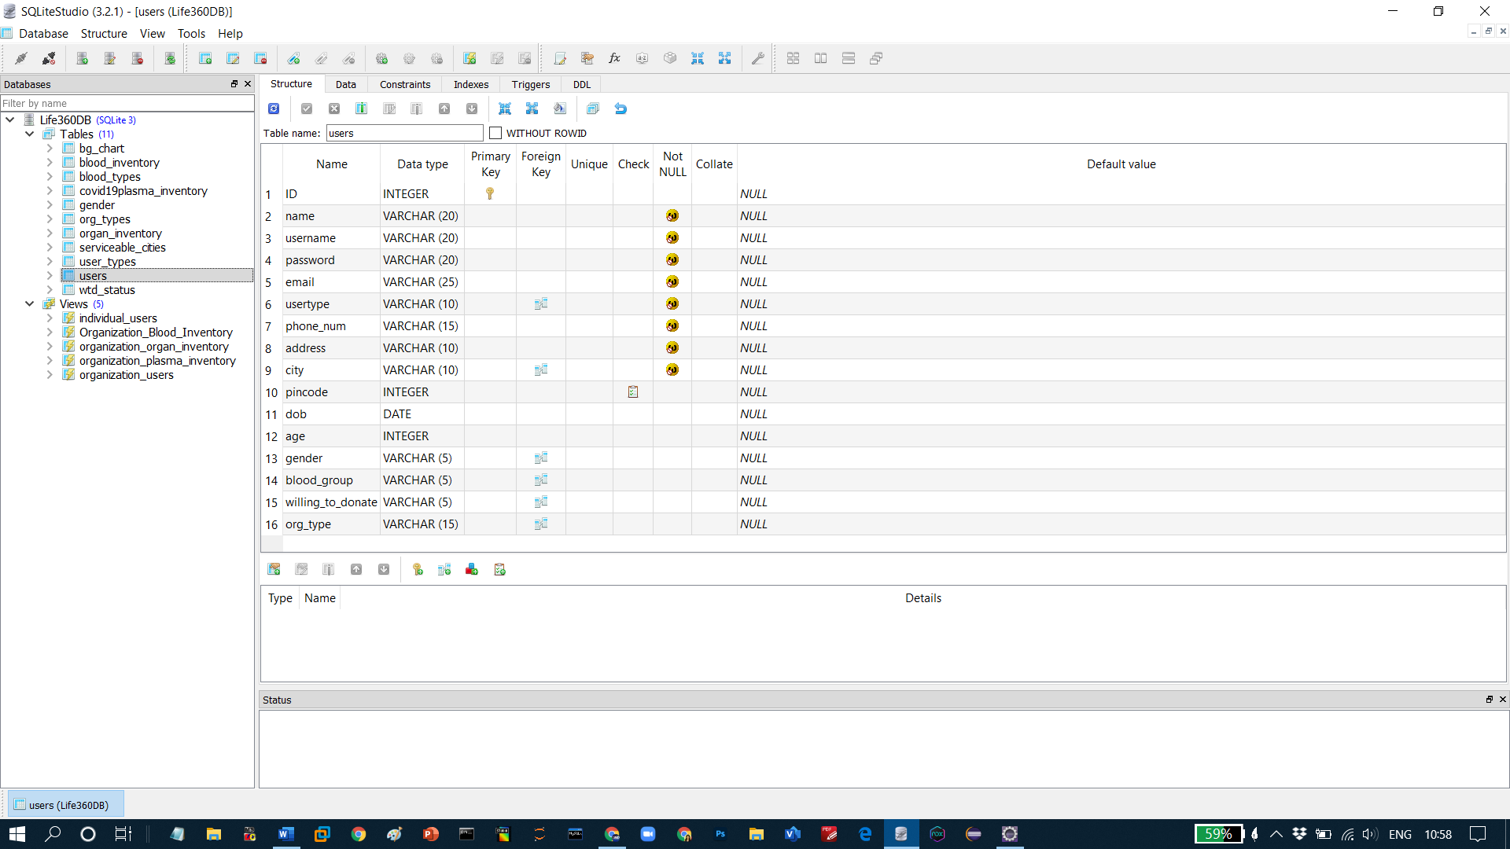

**Figure 9: Various tables and views in the database**

**CHAPTER 8**

**RESULTS**

**Launch Screen**

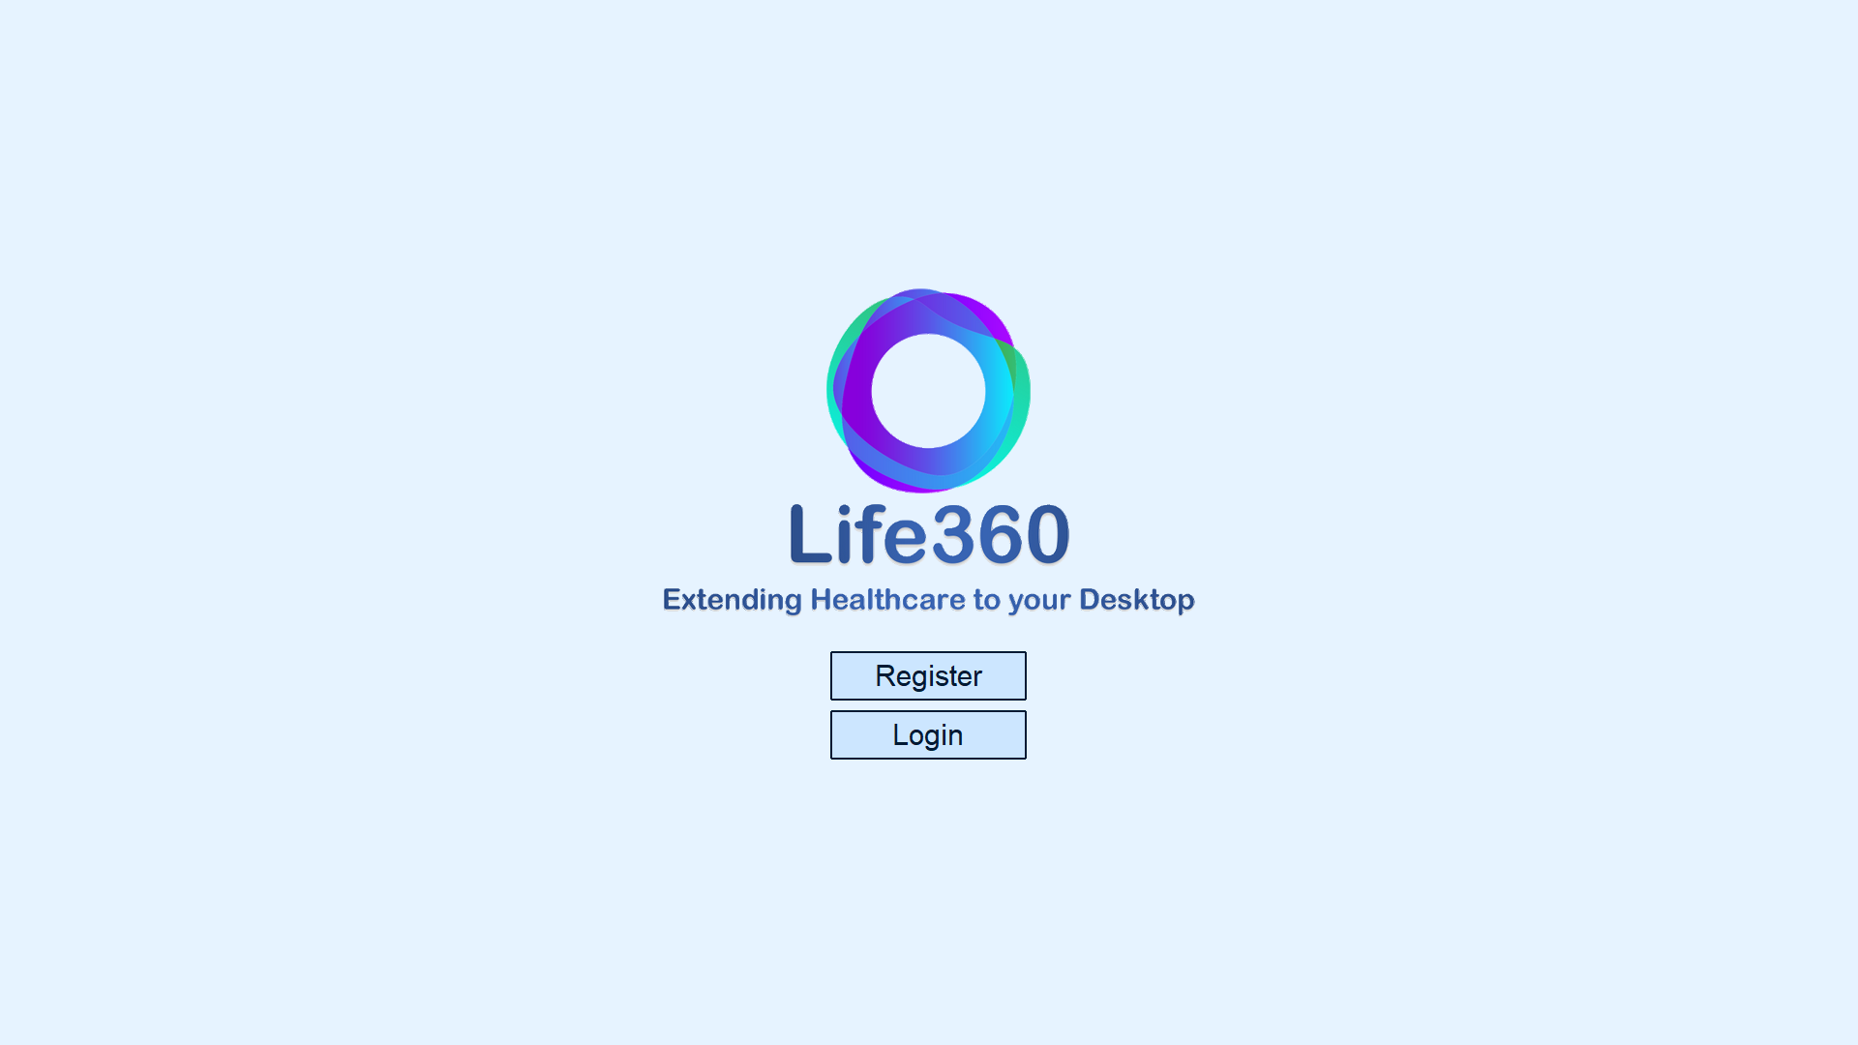

**8.1 REGISTERING A NEW USER (VALIDATION)**



**CHAPTER 9**

**CONCLUSION**

Video provides a powerful way to help you prove your point. When you click Online Video, you can paste in the embed code for the video you want to add. You can also type a keyword to search online for the video that best fits your document.

To make your document look professionally produced, Word provides header, footer, cover page, and text box designs that complement each other. For example, you can add a matching cover page, header, and sidebar. Click Insert and then choose the elements you want from the different galleries.

Themes and styles also help keep your document coordinated. When you click Design and choose a new Theme, the pictures, charts, and SmartArt graphics change to match your new theme. When you apply styles, your headings change to match the new theme.

Save time in Word with new buttons that show up where you need them. To change the way a picture fits in your document, click it and a button for layout options appears next to it. When you work on a table, click where you want to add a row or a column, and then click the plus sign.

Reading is easier, too, in the new Reading view. You can collapse parts of the document and focus on the text you want. If you need to stop reading before you reach the end, Word remembers where you left off - even on another device.

Video provides a powerful way to help you prove your point. When you click Online Video, you can paste in the embed code for the video you want to add. You can also type a keyword to search online for the video that best fits your document. To make your document look professionally produced, Word provides header, footer, cover page, and text box designs that complement each other.

For example, you can add a matching cover page, header, and sidebar. Click Insert and then choose the elements you want from the different galleries.

**REFERENCES**

[1] https://www.programiz.com/

[2] https://www.geeksforgeeks.org/

[3] https://www.javatpoint.com/

[4] https://anzeljg.github.io/

[5] <https://www.tutorialspoint.com/>

[6] https://docs.python.org/

[7] https://realpython.com/

[8] https://www.edureka.co/

[9] <https://pythonprogramming.net/>

[10] https://www.tutorialsteacher.com/