**ELVA: Personal Assistant Documentation**

I'm excited to introduce ELVA, an innovative AI-powered personal assistant designed to help you navigate the information landscape effortlessly. ELVA can access answers from diverse sources like Google, YouTube videos, and cutting-edge AI language models, all while summarizing relevant research papers to provide deeper understanding. But ELVA doesn't stop there! You can even chat with your own PDF notes and documents to extract key information instantly. Stay ahead of the curve in the exciting field of AI with ELVA's curated feed of the latest news and research papers.

**Technical Stack:**

* + 1. **Tools Used:**

1. **Backend:**
2. Python
3. Langchain
4. ArXiv
5. GoogleAPI
6. BeautifulSoap
7. Gemini Pro (Data Presentation)
8. Meta FAISS (Vector Database)
9. FastAPI and Flask
10. AWS (API Deployment)
11. Firebase (User Information with Authentication)
12. **Frontend:**
13. Flutter
14. FlutterFlow
    * 1. **Textual data:** Langchain (PDF notes, Arxiv papers)
      2. **Notes:** FAISS (vector database)
      3. **Data Presentation:** Gemini (data conversion and visualization)
      4. **Workflow:**
         1. **User Query:** The user enters a query into the search bar or uses the search engine interface.
         2. **Information Gathering:** ELVA utilizes various APIs and scraping techniques to access relevant information from diverse sources:
         3. General Information: Google API retrieves relevant web pages and snippets.
         4. Videos: YouTube API searches for and retrieves relevant videos.
         5. Research Papers: Langchain processes Arxiv papers and relevant research materials, storing key information in a FAISS vector database for efficient retrieval.
         6. **Personal Notes:** Langchain analyzes user-uploaded PDF notes and documents, extracting key information. FAISS is used to store PDFs in vector database.
         7. **Latest News:** Beautiful Soup scrapes relevant AI-related news articles from various online sources.
         8. **Information Processing:**

Retrieved information is analyzed and processed using NLP techniques:

* Relevant snippets and text are extracted from web pages and research papers.
* Information from user notes and documents is summarized and presented in a structured way.
* AI news articles are summarized and categorized.
  + - 1. **Presentation:**

Gemini converts and visualizes the processed information into a user-friendly format, presenting it to the user through the Flutter UI.

Users can access summaries, full text, videos, and links to original sources.

* + - 1. **Additional Features:**

**Personalized feed:** Users can subscribe to personalized feeds on specific topics or areas of interest.

**Research paper summaries:** ELVA provides user-friendly summaries of complex research papers, making them easier to understand.

**Note integration:** Users can easily upload and access their personal notes through the app.

**Architecture:**

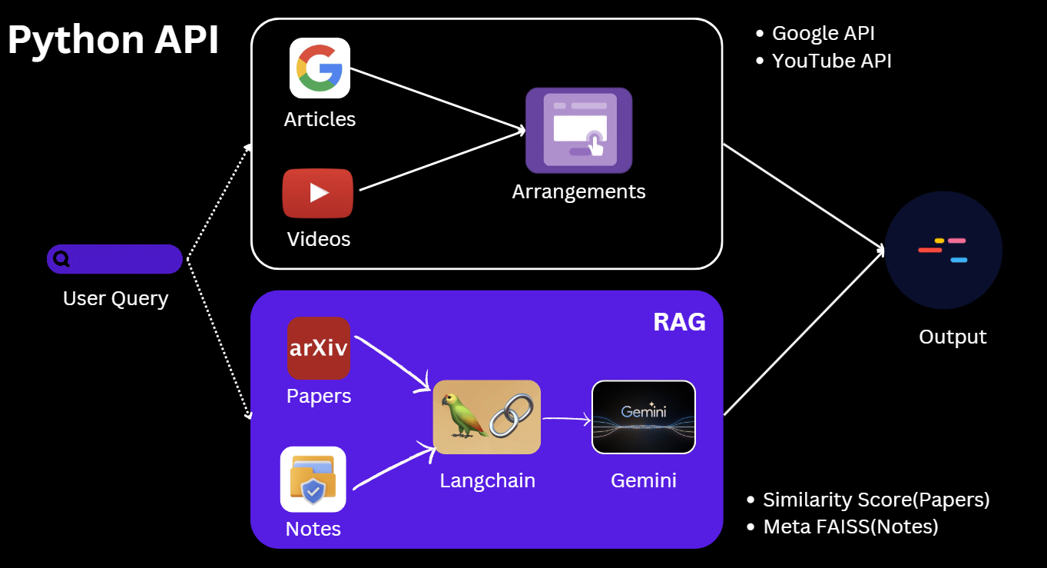

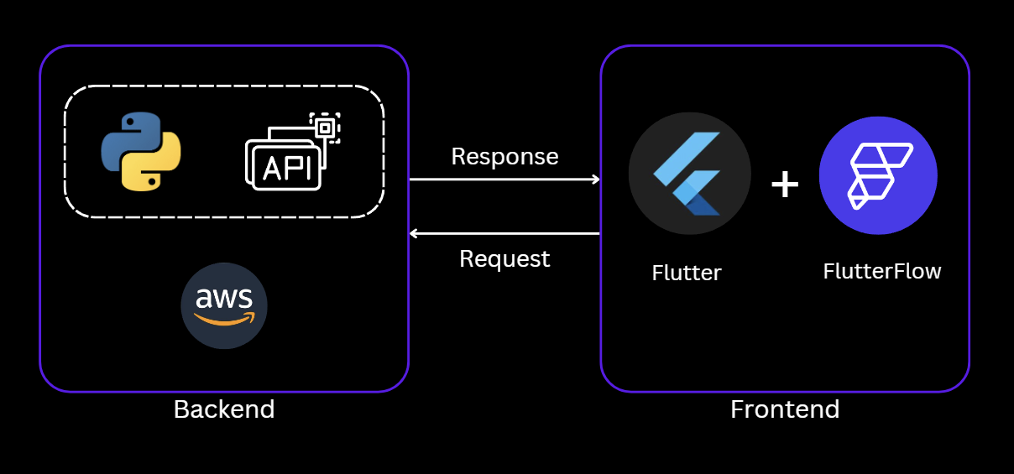

**Code:** [GitHub](https://github.com/pranavbelhekar01/ELVA---My-Personal-Assistant)

**Profile:**

1. **LinkedIn -** [**https://www.linkedin.com/in/pranav0022/**](https://www.linkedin.com/in/pranav0022/)
2. **GitHub -** [**https://github.com/pranavbelhekar01**](https://github.com/pranavbelhekar01)
3. **Kaggle -** [**https://www.kaggle.com/pranavbelhekar**](https://www.kaggle.com/pranavbelhekar)